Title: exercise 5.2

Author: Joann Saeou

Date: 26 May 2020

Modified By: Joann Saeou

Description: exercise 5.2 Querying documents web-420

Description: hello world 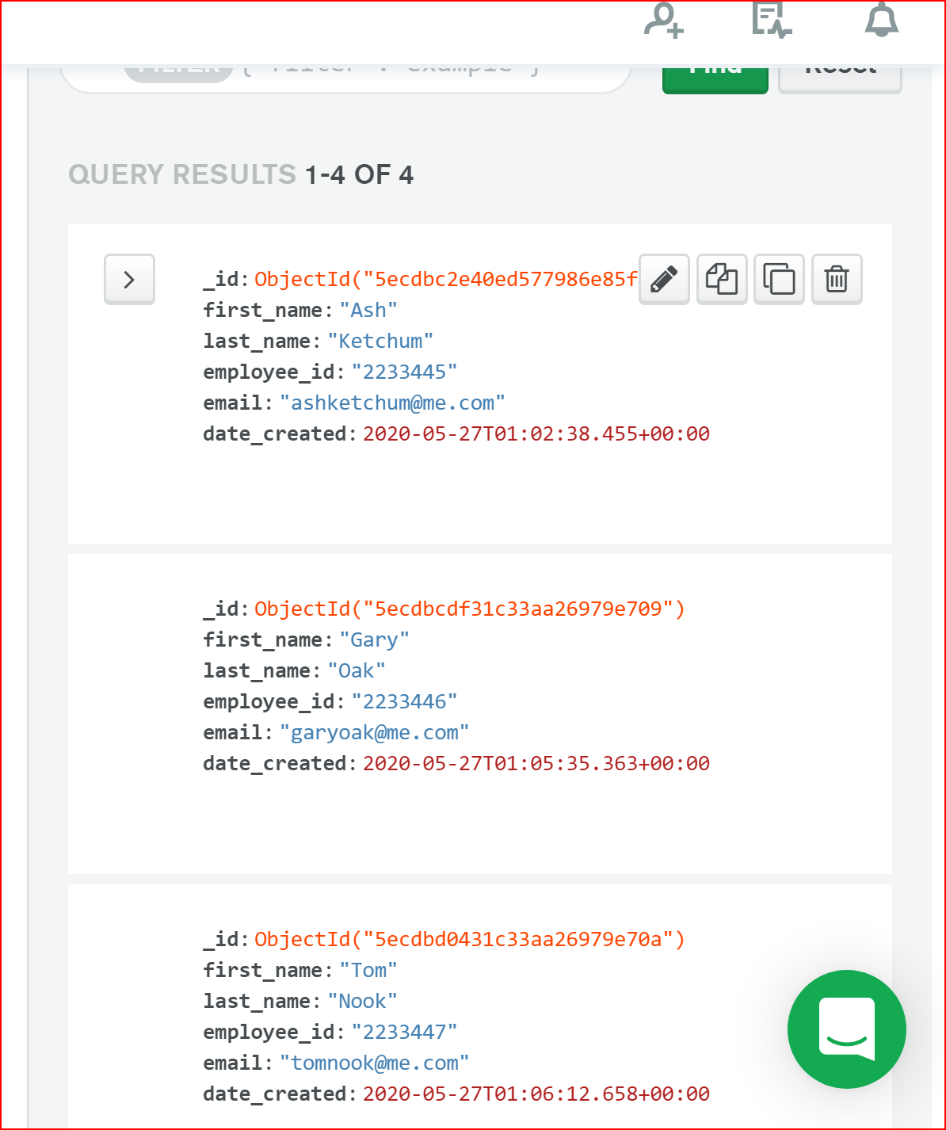

“firstname” “lastName”

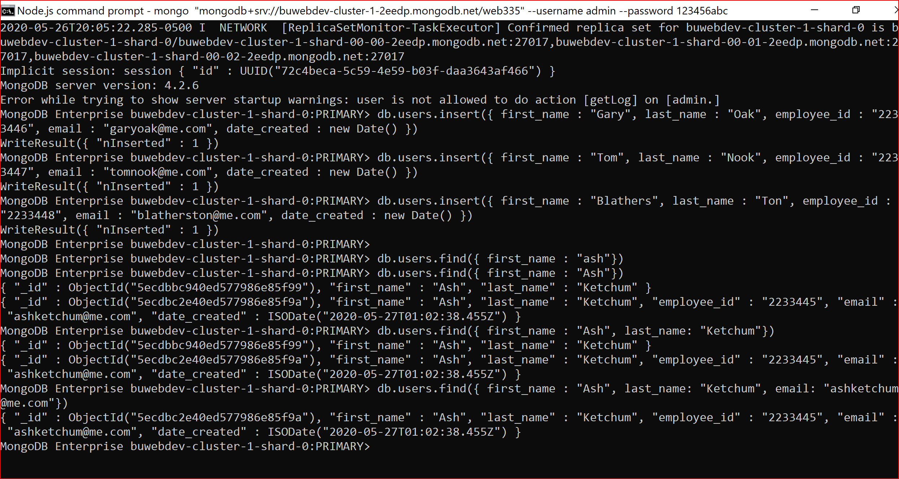

“lastname” “email” “date_created”