GROUP 4 JS/JQuery Wed  
phase 1 – Yee Sin Joan poon

January 31, 2018

# Overview

## Group Details

1. Website Name:
   1. Little Ducklings
2. Color Scheme
   1. Background - #3db4e2
   2. Text Blocks – White
   3. Font Colors - #3db4e2 | #9400d3 | #ffb6c1
3. Sections of Website
   1. Navigation – Devin Treichel
   2. Footer – Joan Poon
   3. Header – Elham Amouhadi
   4. Sidebar – Julie Hou
4. Wireframe

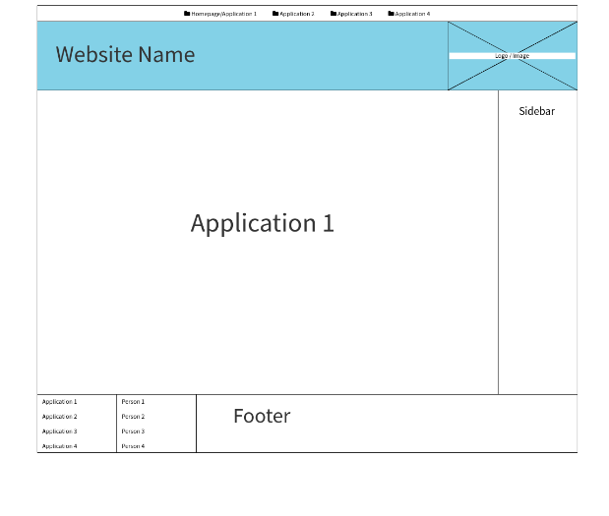

1. List of Applications
   1. Devin Treichel – Memory Game Application
   2. Joan Poon – Simple Painter Application
   3. Julie Hou – Calculator For Kids Application
   4. Elham Amouhadi – Alphabet Learning Flashcards
2. Other Issues
   1. Algorithm for application
   2. Data validation
   3. Check for syntax/logical errors

## Individual Details for Joan Poon

1. Description of my application:
   1. Name: Simple Painter Application
   2. There will be a sketch pad (2D) on the webpage, so that user can draw on it.
   3. There will be a random term on top of the sketch pad, so that the user can draw it.

Sample random terms are: Apple, Tree, Bee, Car, Sun, and so on.

1. User interface details
   1. About generating the random term: it will generate a new term whenever user refreshes the page, user can refresh until they are satisfied/ interested in the term generated.
   2. About the color scheme: it will match the overall outlook of the website
   3. About the sketch pad: user can draw on it by moving and clicking their mouse, or refresh the page to erase everything and start a new drawing
2. Thoughts on how I will accomplish the task (and pseudo code)
   1. For HTML: I am going to create a <h1></h1> for outputting random string,  
      <div></div> to hold the sketch pad  
      and a <canvas></canvas> tag so that I can assign Jquery codes to it
   2. For CSS: I can style the <div> and <canvas> tag to change the background color of the sketch pad, as well as the width and height.
   3. For Javascript and Jquery:
      1. A query selector to select <div> and <canvas> by their id
      2. .mousemove/.mouseup/.mouseleave functions
      3. Set the canvas as a 2D sketch pad by using .getContext
      4. Set a variable to capture the mouse movement
      5. Use (.linewidth) (.lineJoin) (.lineTo) (.stroke()) and so on to “draw”
      6. Add event listener to detect mouse movement, such as click
3. List of things to consider moving forward that could make accomplishing this task more difficult, and how I might address them
   1. My knowledge about BOM and other javascript methods is limited and need more help: I will learn more from W3schools, Mozilla.org and other mediums, and start the code writing process early so that I have more time to work on my application
   2. Lack of communications between groupmates: Encourage everyone to post their progress on group discussion board, have everyone checks in once a week ideally
   3. The sketch pad itself could look dull and too simple: I will try to do more research and improve the outlook of the application, as well as adding as much functions to the application as possible.