Dear Ma'am/Sir,

Good day.

This letter is to express my interest in the job posted on Internet, I'm a graduate of BS. Computer Science and I recently became a Software Engineer graduate of Zuitt Bootcamp Philippines. I have the ability in coding websites and applications using modern technologies such as HTML5, CSS3, React, JavaScript, Tailwindcss, Bootstrap, Node.js, Mongodb, Heroku and Vercel. Familiar with Canva and photoshop

If none of these tech tools is your requirement's, I would definitely like to grow and learn new technologies with your company.

I can be reached anytime via my cell phone, 09273529010 or by email at joanquisto@gmail.com/canonigo.joanaq@gmail.com

Sincerely,

Joana Canonigo
Portfolio: https://canonigo.vercel.app

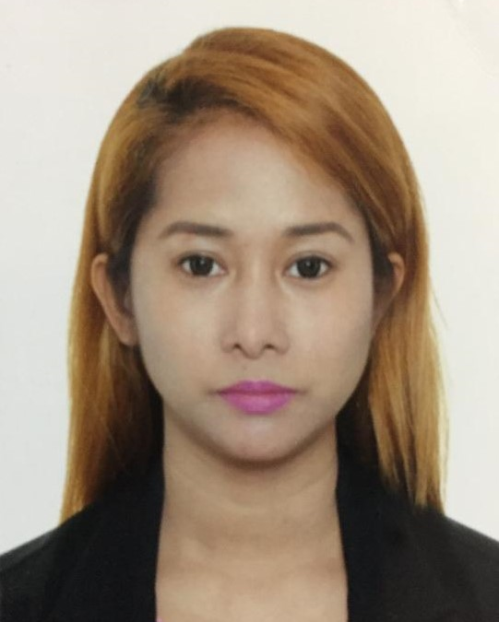

Joana Q. Canonigo
132 Meralco Road Lower Bicutan Taguig City, Manila
Cell No. +639273529010
Email Add: canonigo.joanaq@gmail.com
Skype Add: joanquisto@gmail.com
Portfolio: https://canonigo.vercel.app

To seek for an employment that gives opportunity for career advancement based on merits of performance, in a way of serving the company to the fullest of my abilities, and to develop my personal and professional skills.

PERSONAL QUALIFICATIONS

- Dedicated hard working individual.
- Service oriented and patient.
- Extremely organized and detailed oriented.
- Friendly, courteous and articulate.
- The ability to manage multiple tasks in a pressure environment.

SKILLS

- Can develop a website using tech. tools such as: HTML5, CSS3, ES6, Javascript, Express, Mongoose, Node.js, React.js, Cloudinary, MongoDB, Heroku, Vercel Canva, Bootstrap, Tailwindcss, Photoshop.
- Typing Speed 40 WPM
- Knowledgeable in setting up a network for multiple computers (LAN), from router, switch, server to work stations using Ethernet or fiber cables.
- Proficient with configuration and troubleshooting, wired and wireless internet connection.
- Can support and maintain active directory with multiple groups and users.
- Knowledgeable in assembling computer internal parts and troubleshoot desktop and laptop software applications.
- Advance skills in MS office application suite (Word, Excel, Power Point, Photoshop and Microsoft teams.
- Ability to work in a telnet tool, such as PUTTY.
- Familiar with Microsoft Windows, Mac OS and Linux operating system.

RELATED WORK EXPERIENCES

Assistant Systems Manager
- From June 4, 2021 to November 26, 2021
- Viking Ocean Cruises
Field of responsibility
The Assistant Systems Manager works closely with Systems Manager, Manager of Ship Systems and IT Technical Support Department personnel at corporate office as well to maintain hardware, cabling systems, networks, software and other technical issues. This position assists the Systems Manager in maintaining all IT systems and equipment onboard vessel and provides general support of systems and procedural activities in all departments onboard the vessel.
- Performs daily, voyage, monthly and other computer operations as detailed in Run Books, onboard and Intranet documentation and as requested by shore side IT Management and Support Teams.
- Responsible for reporting and documenting professionally all system changes (hardware, software etc.)
- Provide onboard support and maintenance for all company IT assets, applications, software and hardware, including but not limited to workstations, POS terminals, printers, scanners, peripheral attached devices, mobile devices, networking devices, servers and related hardware.
- Critical calls, issues or requests - high impact on revenue, guest satisfaction, ship operation - must be

responded promptly and professionally 24/7.
- Provides users basic training support in use of common PC software and specialized Property Management Systems.
- Performs other related duties as assigned or as directed. The omission of specific duties does not preclude the supervisor from assigning duties that are logically related to the position.

IBM DAKSH PHILIPPINES (BPO)
- From September 2007 to January 2012
- Located in Hanston Bldg. San Miguel Avenue, Ortigas
Field of responsibility
- Senior Customer Care Specialist of United airlines and Verizon
- Troubleshooting wired internet connection
- installing and maintaining computer systems and networks
- setting up computer workstations, including peripheral devices
- Responsible for providing great customer experience by advising and giving information over the phone using various computer program simultaneously
- Up selling related products
- Meeting the customer’s satisfaction survey
- Booking flight and answer clients queries about account in United airlines

SITEL PHILIPPINES (BPO)
- From October 2006 to July 2007
- Located in Wensum Bldg. San Miguel Avenue, Ortigas
Field of responsibility
- Technical Support Specialist of Verizon
- Troubleshooting wired and wireless internet through broadband connection
- Walk through the client to unbox and connect all cables from the modem to TV, computers and printers
- assisting client on how to download and run applications
- setting up computer workstations, including peripheral devices
- Responsible for providing great customer experience by advising and giving information over the phone using various computer program simultaneously
- Up selling related products
- Meeting the customer’s satisfaction survey

TRAININGS ATTENDED

Linux System Administration (LPIC 1)
UP Diliman Quezon City
(Nov. 10, 17, 24 to Dec. 1 & 8, 2019)

CCNA 1 –Routers and routing Technology
Computer Networking Career and Training Center, Sampaloc Manila
Sept. 24 to Sept. 27, 2019

PC Networking and Administration
Computer Networking Career and Training Center, Sampaloc Manila
Sept. 16 to Sept. 20, 2019

Computer System Servicing NCII
Information Technology Training Center, San Antonio Pasig Metro Manila
Oct. 5, 12, 19, 26 to Nov 9, 2019

EDUCATIONAL ATTAINMENT

Tertiary: Pateros Technological Collage
Sto. Rosario-Kanluran Pateros Metro Manila SY: 2000-2004
Course: Bachelor of Science in Computing Major in Computer Science
Year Graduated: May 28, 2004

Secondary: Taguig National High School
Lower Bicutan Taguig Maetro Manila
Year Graduated: March 29, 2000

Primary: Ricardo P. Cruz Elementary School
Lower Bicutan Taguig Metro Manila
Year Graduated: March 18, 1996

PERSONAL INFORMATION

I was born in Manila on June 3, 1983 and fourth among my five siblings. I am a natural Filipino with a height of 5’1 and a weight of 94 lbs. Single and baptized Catholic.
My parents Name are Wilma Q. Canonigo and Alejandro C. Canonigo residence at 132 Meralco Rd. Lower Bicutan Taguig City.

REFERENCES

Jennifer Ponay Jonacil Rolida
Product Trainer at Concentrix Team Leader at Afni. Inc.
09296883124 / 19985322509 09998432832 / 09081681958

I hereby certify that the above information is true and correct to the best of my knowledge and belief.

Joana Q. Canonigo
Applicant

