SIMATS ENGINEERING
ASSESSMENT TOOL 3
Dry Run Evaluation (Annexure A)
Detail | Information
Course Name | Artificial Intelligence
Course Code | CSA17
Course Outcome Covered | CO2: Experiment search and game-solving techniques such as Greedy Search, A*, CSP, Minimax, and Alpha-Beta pruning with heuristic functions for solving complex AI problems efficiently. (BL3)
Student Name | JOANSWA.J
Register Number | 192572136
Total Marks / Weightage | 50 marks / 40%

Code of Conduct
I JOANSWA.J (192572136) certify that this submission is my original work and that I have adhered to the guidelines specified for this assessment. I understand that any violation of academic integrity rules will result in disciplinary action.
Signature of the student: JOANSWA.J

SOLUTION

Question 1: Greedy Best-First Search
The road network is an undirected graph with step costs on the edges. The heuristic h(n) is the estimated cost from node n to the goal G. Figure 1 shows the graph used in Questions 1 and 2. Greedy best-first search always expands the node in the open list with the lowest h(n), so its evaluation function is f(n) = h(n) and the path cost g(n) is ignored.
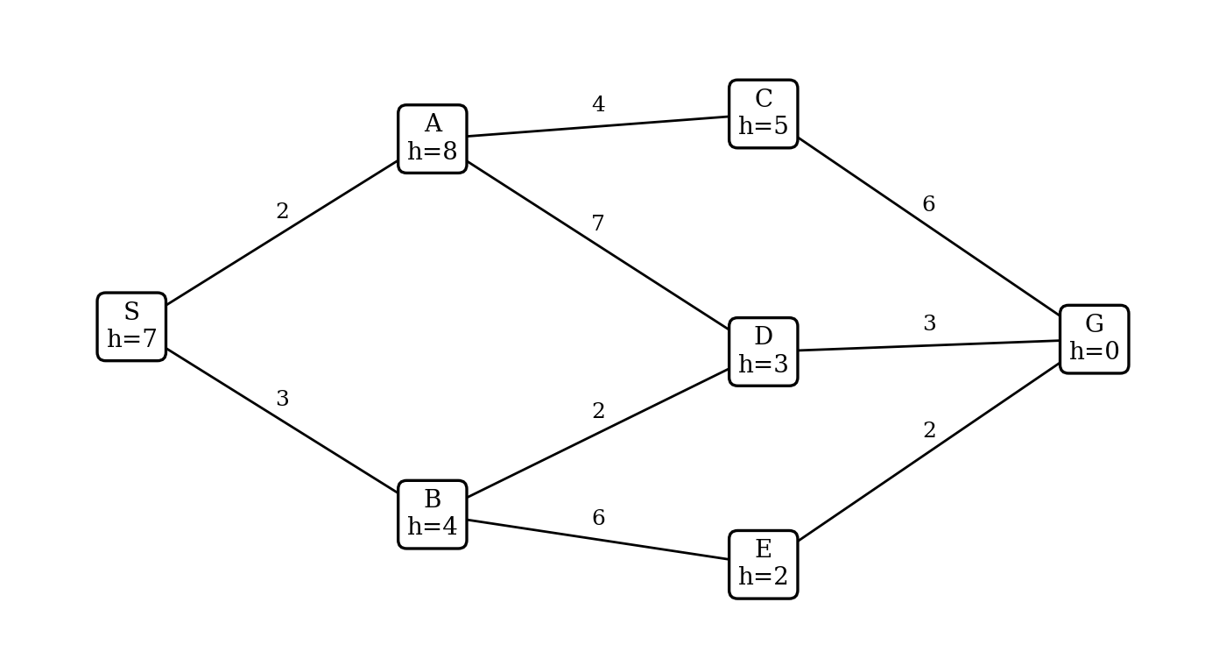
Figure 1: Road network with edge costs and heuristic values h(n)

(a) Dry run of greedy best-first search
Start: S, goal: G. Open list = nodes generated but not yet expanded, written as node: h and kept sorted by h. Nodes already expanded are not added again.
Step | Node expanded | Nodes added to open list | Open list after expansion (node: h) | Closed list
0 | - | S | { S: 7 } | { }
1 | S | A (8), B (4) | { B: 4, A: 8 } | { S }
2 | B | D (3), E (2)  (S already closed) | { E: 2, D: 3, A: 8 } | { S, B }
3 | E | G (0)  (B already closed) | { G: 0, D: 3, A: 8 } | { S, B, E }
4 | G | Goal reached | Stop (G has the lowest h = 0 and passes the goal test) | { S, B, E, G }

(b) Path found and total cost
Path found: S → B → E → G.
Total cost = 3 (S–B) + 6 (B–E) + 2 (E–G) = 11.

(c) Is the path optimal?
The path is not optimal. Comparing it with other paths from S to G:
Path | Calculation | Total cost
S → A → C → G | 2 + 4 + 6 | 12
S → A → D → G | 2 + 7 + 3 | 12
S → B → E → G (Greedy) | 3 + 6 + 2 | 11
S → B → D → G | 3 + 2 + 3 | 8

The path S → B → D → G costs only 8, which is 3 less than the greedy path. At B, greedy chose E because h(E) = 2 looked better than h(D) = 3, but it ignored that the edge B–E costs 6 while the edge B–D costs only 2. Greedy search looks only at the estimated cost to the goal and not at the cost already paid, so it is fast but not guaranteed to be optimal.

Question 2: A* Search

(a) Dry run of A* search
A* expands the node with the lowest f(n) = g(n) + h(n), where g(n) is the cost from S to n. The open list is written as (node: g + h = f). If a node is reached again by a costlier path, the new path is rejected.
Step | Node expanded | Successors generated (g + h = f) | Open list after expansion (node: g + h = f) | Closed list
0 | - | S: 0 + 7 = 7 | { S: 0+7=7 } | { }
1 | S  (f = 7) | A: 2 + 8 = 10  B: 3 + 4 = 7 | { B: 3+4=7, A: 2+8=10 } | { S }
2 | B  (f = 7) | D: 5 + 3 = 8  E: 9 + 2 = 11  (S already closed) | { D: 5+3=8, A: 2+8=10, E: 9+2=11 } | { S, B }
3 | D  (f = 8) | G: 8 + 0 = 8  A via D: g = 12, worse than 2, rejected  (B already closed) | { G: 8+0=8, A: 2+8=10, E: 9+2=11 } | { S, B, D }
4 | G  (f = 8) | Goal reached | Stop (G has the lowest f = 8) | { S, B, D, G }

(b) Path found, cost and comparison with Question 1
Path found: S → B → D → G, with cost 3 + 2 + 3 = 8.
Aspect | Question 1 (Greedy) | Question 2 (A*)
Evaluation function | f(n) = h(n) | f(n) = g(n) + h(n)
Order of expansion | S, B, E, G | S, B, D, G
Path | S → B → E → G | S → B → D → G
Path cost | 11 | 8
Optimal? | No | Yes

A* found a path that is 3 units cheaper (about 27% less than 11). Both searches expanded 4 nodes, so A* gave the optimal path at no extra search cost here. The difference is that A* adds g(n), so at B it saw that E costs 9 + 2 = 11 while D costs 5 + 3 = 8, and chose D.

(c) Admissibility of h(n)
h(n) is admissible if h(n) ≤ h*(n), where h*(n) is the true cheapest remaining cost to G. Checking all six non-goal nodes (four are required):
Node | h(n) | True remaining cost h*(n) | h ≤ h*? | Admissible?
S | 7 | S–B–D–G = 3 + 2 + 3 = 8 | 7 ≤ 8 | Yes
A | 8 | A–D–G = 7 + 3 = 10 (also A–C–G = 10) | 8 ≤ 10 | Yes
B | 4 | B–D–G = 2 + 3 = 5 | 4 ≤ 5 | Yes
C | 5 | C–G = 6 | 5 ≤ 6 | Yes
D | 3 | D–G = 3 | 3 ≤ 3 | Yes
E | 2 | E–G = 2 | 2 ≤ 2 | Yes

For every node h(n) never exceeds the true remaining cost, so the heuristic is admissible. (It is also consistent: for every edge, h(n) ≤ cost + h(next), for example h(S) = 7 ≤ 3 + h(B) = 7.)
Why this matters for A*:
- An admissible h never overestimates, so f(n) is always a lower bound on the cost of any solution through n. When G is chosen for expansion, every other node in the open list has f ≥ that cost, so no cheaper path can exist and A* returns an optimal path.
- If h overestimated, a node on the optimal path could get an inflated f value and be left in the open list. For example, if h(D) were 20, then f(D) = 25 and A* would return the path S–B–E–G with cost 11 instead of 8.

Program (Questions 1 and 2)
The following Python program runs both searches on the given graph and confirms the traces above.
Program:
import heapq

graph = {
"S": {"A": 2, "B": 3},
"A": {"S": 2, "C": 4, "D": 7},
"B": {"S": 3, "D": 2, "E": 6},
"C": {"A": 4, "G": 6},
"D": {"A": 7, "B": 2, "G": 3},
"E": {"B": 6, "G": 2},
"G": {"C": 6, "D": 3, "E": 2},
}
h = {"S": 7, "A": 8, "B": 4, "C": 5, "D": 3, "E": 2, "G": 0}

def search(start, goal, use_g):
open_list = [(h[start], 0, start, [start])]
closed = set()
best_g = {start: 0}
while open_list:
f, g, node, path = heapq.heappop(open_list)
if node in closed:
continue
closed.add(node)
print("Expand", node, "(g =", g, ", f =", f, ")")
if node == goal:
return path, g
for nb, cost in graph[node].items():
g2 = g + cost
if nb not in closed and (not use_g or g2 < best_g.get(nb, 1e9)):
best_g[nb] = g2
f2 = g2 + h[nb] if use_g else h[nb]
heapq.heappush(open_list, (f2, g2, nb, path + [nb]))
print(" open:", sorted([(x[0], x[2]) for x in open_list if x[2] not in closed]))

print("--- Greedy best-first ---")
print(search("S", "G", False))
print("--- A* ---")
print(search("S", "G", True))
Output:
--- Greedy best-first ---
Expand S (g = 0 , f = 7 )
open: [(4, 'B'), (8, 'A')]
Expand B (g = 3 , f = 4 )
open: [(2, 'E'), (3, 'D'), (8, 'A')]
Expand E (g = 9 , f = 2 )
open: [(0, 'G'), (3, 'D'), (8, 'A')]
Expand G (g = 11 , f = 0 )
(['S', 'B', 'E', 'G'], 11)
--- A* ---
Expand S (g = 0 , f = 7 )
open: [(7, 'B'), (10, 'A')]
Expand B (g = 3 , f = 7 )
open: [(8, 'D'), (10, 'A'), (11, 'E')]
Expand D (g = 5 , f = 8 )
open: [(8, 'G'), (10, 'A'), (11, 'E')]
Expand G (g = 8 , f = 8 )
(['S', 'B', 'D', 'G'], 8)

Question 3: Constraint Satisfaction Problem (Map Colouring)

(a) Formulation as a CSP
Component | Definition
Variables | WA, NT, SA, Q, NSW, V (the six regions)
Domains | D(each region) = { Red (R), Green (G), Blue (B) }
Constraints | Neighbouring regions must have different colours:  WA ≠ NT, WA ≠ SA, NT ≠ SA, NT ≠ Q, SA ≠ Q, SA ≠ NSW, SA ≠ V, Q ≠ NSW, NSW ≠ V
Degree of each region | SA = 5 (WA, NT, Q, NSW, V); NT = 3 (WA, SA, Q); Q = 3 (NT, SA, NSW); NSW = 3 (SA, Q, V); WA = 2 (NT, SA); V = 2 (SA, NSW)

Constraint graph: each node is a region and each edge is a not-equal constraint between two neighbours (Figure 2). This is a binary CSP, and it is the graph colouring problem with 3 colours.
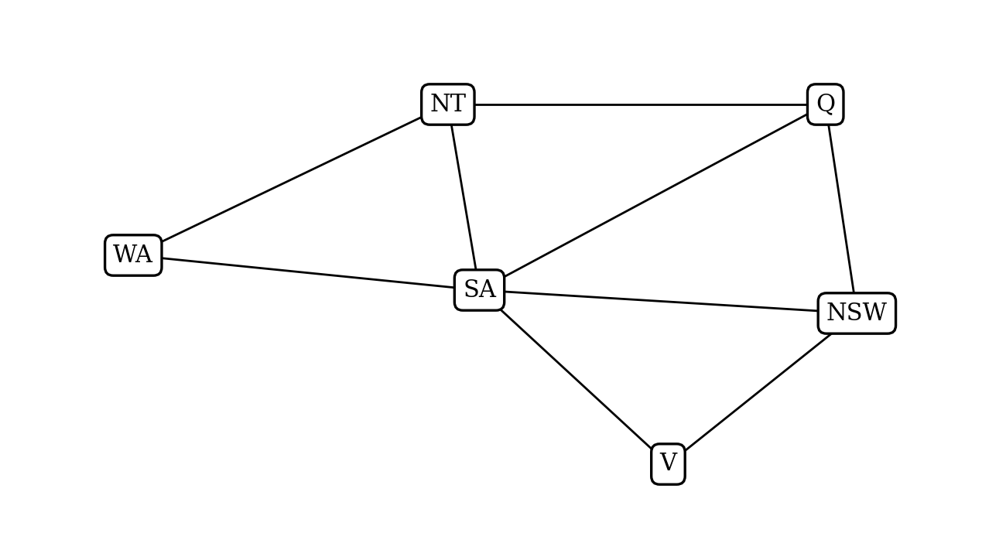
Figure 2: Constraint graph (9 edges)

(b) Backtracking search with forward checking and MRV
Rules followed: choose the region with the fewest legal colours (MRV); break ties by the degree heuristic (most unassigned neighbours), then by the order WA, NT, SA, Q, NSW, V; try colours in the order R, G, B. After every assignment, forward checking removes that colour from the unassigned neighbours.
Initial domains: every region {R, G, B}.
Step | Region chosen and reason | Colour | Updated domains of unassigned regions
1 | SA: all regions have 3 colours (tie in MRV). Degree: SA = 5, the highest. | R | WA {G,B}, NT {G,B}, Q {G,B}, NSW {G,B}, V {G,B}
2 | NT: all have 2 colours. Unassigned neighbours: WA = 1, NT = 2, Q = 2, NSW = 2, V = 1. NT, Q and NSW tie, so the order picks NT. | G (R not in domain) | WA {B}, Q {B}, NSW {G,B}, V {G,B}
3 | Q: WA and Q have 1 colour each. Unassigned neighbours: WA = 0, Q = 1 (NSW). | B | WA {B}, NSW {G}, V {G,B}
4 | NSW: WA and NSW have 1 colour each. Unassigned neighbours: WA = 0, NSW = 1 (V). | G | WA {B}, V {B}
5 | WA: WA and V both have 1 colour and 0 unassigned neighbours, so the order picks WA. | B | V {B}
6 | V: the only region left. | B | None left

Final colouring:
Region | Colour | Neighbours and check
SA | Red | WA, NT, Q, NSW, V are all not Red
NT | Green | WA (B), SA (R), Q (B) are different
Q | Blue | NT (G), SA (R), NSW (G) are different
NSW | Green | SA (R), Q (B), V (B) are different
WA | Blue | NT (G), SA (R) are different
V | Blue | SA (R), NSW (G) are different

All 9 constraints are satisfied. The search needed 6 assignments and no backtracking.

(c) How MRV and the degree heuristic reduce the search effort
MRV (fail-first): choosing the region with the fewest legal colours means the most constrained region is handled first. If a region is going to run out of colours, this is discovered early, high in the tree, so a large branch is cut off before effort is wasted. In part (b), after step 2 the regions WA and Q had only one colour left, so their colours were forced and no guessing was needed.
Degree heuristic: at the start every region had 3 colours, so MRV could not decide. Choosing SA, which touches 5 other regions, removed Red from five domains in one step (forward checking), which cut the remaining search space the most. Together the two heuristics made every later choice almost forced, so the solution was found without any backtracking.

Program (Question 3)
Program:
order = ["WA", "NT", "SA", "Q", "NSW", "V"]
colours = ["R", "G", "B"]
nbrs = {r: set() for r in order}
for a, b in [("WA","NT"),("WA","SA"),("NT","SA"),("NT","Q"),("SA","Q"),
("SA","NSW"),("SA","V"),("Q","NSW"),("NSW","V")]:
nbrs[a].add(b); nbrs[b].add(a)

def solve(domains, assign):
if len(assign) == 6:
return assign
free = [r for r in order if r not in assign]
# MRV, then degree (unassigned neighbours), then fixed order
v = min(free, key=lambda r: (len(domains[r]),
-len([n for n in nbrs[r] if n not in assign]),
order.index(r)))
for c in colours:
if c not in domains[v]:
continue
new = {k: list(x) for k, x in domains.items()}
ok = True
for n in nbrs[v]:
if n not in assign:
if c in new[n]:
new[n].remove(c)
if not new[n]:
ok = False
if ok:
assign[v] = c
print("Assign", v, "=", c, {k: x for k, x in new.items() if k not in assign})
result = solve(new, assign)
if result:
return result
del assign[v]
return None

print(solve({r: list(colours) for r in order}, {}))
Output:
Assign SA = R {'WA': ['G', 'B'], 'NT': ['G', 'B'], 'Q': ['G', 'B'], 'NSW': ['G', 'B'], 'V': ['G', 'B']}
Assign NT = G {'WA': ['B'], 'Q': ['B'], 'NSW': ['G', 'B'], 'V': ['G', 'B']}
Assign Q = B {'WA': ['B'], 'NSW': ['G'], 'V': ['G', 'B']}
Assign NSW = G {'WA': ['B'], 'V': ['B']}
Assign WA = B {'V': ['B']}
Assign V = B {}
{'SA': 'R', 'NT': 'G', 'Q': 'B', 'NSW': 'G', 'WA': 'B', 'V': 'B'}

Question 4: Minimax with a Heuristic Evaluation Function

(a) Minimax values of every node
The root is a MAX node. Its two children are MIN nodes, each MIN node has two MAX children, and each MAX node has two leaves. MAX nodes take the larger child value and MIN nodes take the smaller child value.
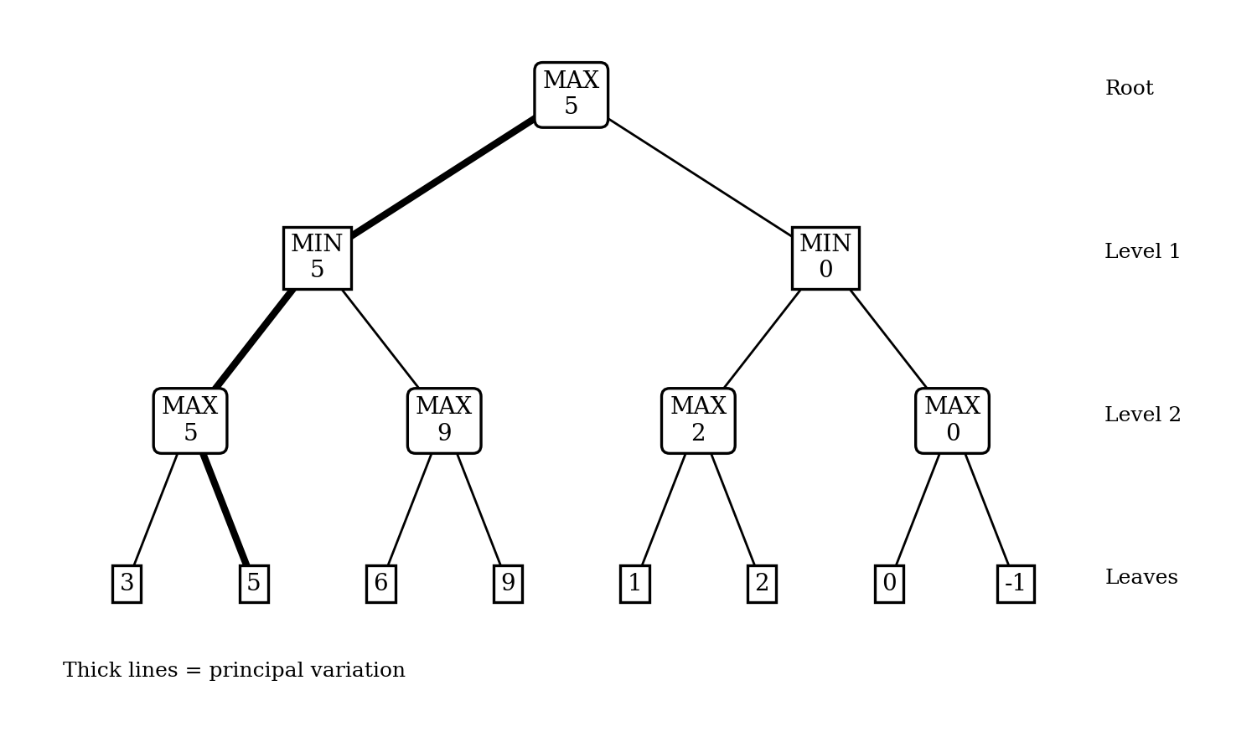
Figure 3: Game tree with backed-up minimax values
Node | Type | Children values | Backed-up value
Left MAX node 1 (leaves 3, 5) | MAX | 3, 5 | 5
Left MAX node 2 (leaves 6, 9) | MAX | 6, 9 | 9
Right MAX node 1 (leaves 1, 2) | MAX | 1, 2 | 2
Right MAX node 2 (leaves 0, -1) | MAX | 0, -1 | 0
Left MIN node | MIN | 5, 9 | min = 5
Right MIN node | MIN | 2, 0 | min = 0
Root | MAX | 5, 0 | max = 5

(b) Best first move and principal variation
- Best first move: the left move (to the left MIN node), because its value is 5 whereas the right move gives only 0.
- Principal variation: Root → left MIN node → left MAX node 1 → leaf 5. In words: MAX plays left; MIN chooses the left MAX node (value 5, which is smaller than 9); MAX then picks the leaf 5 (larger than 3). The value of the game is 5.

(c) Evaluation function for tic-tac-toe
E = (number of lines still open for X) − (number of lines still open for O). A line is open for a player if it contains none of the opponent's marks. The board is:
X | O
 | X
 |  | O

There are 8 lines in total (3 rows, 3 columns, 2 diagonals):
Line | Cells | Open for X? | Open for O?
Row 1 | X, O, empty | No (has O) | No (has X)
Row 2 | empty, X, empty | Yes | No (has X)
Row 3 | empty, empty, O | No (has O) | Yes
Column 1 | X, empty, empty | Yes | No (has X)
Column 2 | O, X, empty | No (has O) | No (has X)
Column 3 | empty, empty, O | No (has O) | Yes
Diagonal top-left to bottom-right | X, X, O | No (has O) | No (has X)
Diagonal top-right to bottom-left | empty, X, empty | Yes | No (has X)
Total |  | 3 | 2

E = 3 − 2 = 1. The positive value means the board is slightly better for X than for O.

Program (Question 4)
Program:
leaves = [3, 5, 6, 9, 1, 2, 0, -1]

def minimax(node, is_max, depth=0):
if isinstance(node, int):
return node
vals = [minimax(c, not is_max, depth + 1) for c in node]
v = max(vals) if is_max else min(vals)
print(" " * depth, "MAX" if is_max else "MIN", vals, "->", v)
return v

tree = [[[3, 5], [6, 9]], [[1, 2], [0, -1]]]
print("Root value =", minimax(tree, True))

# Part (c): tic-tac-toe evaluation E = open lines for X - open lines for O
board = ["X", "O", " ",
" ", "X", " ",
" ", " ", "O"]
lines = [(0,1,2),(3,4,5),(6,7,8),(0,3,6),(1,4,7),(2,5,8),(0,4,8),(2,4,6)]
open_x = sum(1 for l in lines if all(board[i] != "O" for i in l))
open_o = sum(1 for l in lines if all(board[i] != "X" for i in l))
print("Open for X =", open_x, ", open for O =", open_o, ", E =", open_x - open_o)
Output:
MAX [3, 5] -> 5
MAX [6, 9] -> 9
MIN [5, 9] -> 5
MAX [1, 2] -> 2
MAX [0, -1] -> 0
MIN [2, 0] -> 0
MAX [5, 0] -> 5
Root value = 5
Open for X = 3 , open for O = 2 , E = 1

Question 5: Alpha-Beta Pruning

(a) Dry run of alpha-beta pruning
The tree has 16 leaves: root (MAX), 2 MIN nodes (N1, N2), 4 MAX nodes (M1 to M4) and 8 MIN nodes (m1 to m8). Alpha (α) is the best value found so far for MAX and beta (β) is the best (lowest) value found so far for MIN along the path. A branch is pruned as soon as β ≤ α. Children are visited from left to right. Figure 4 shows the tree.
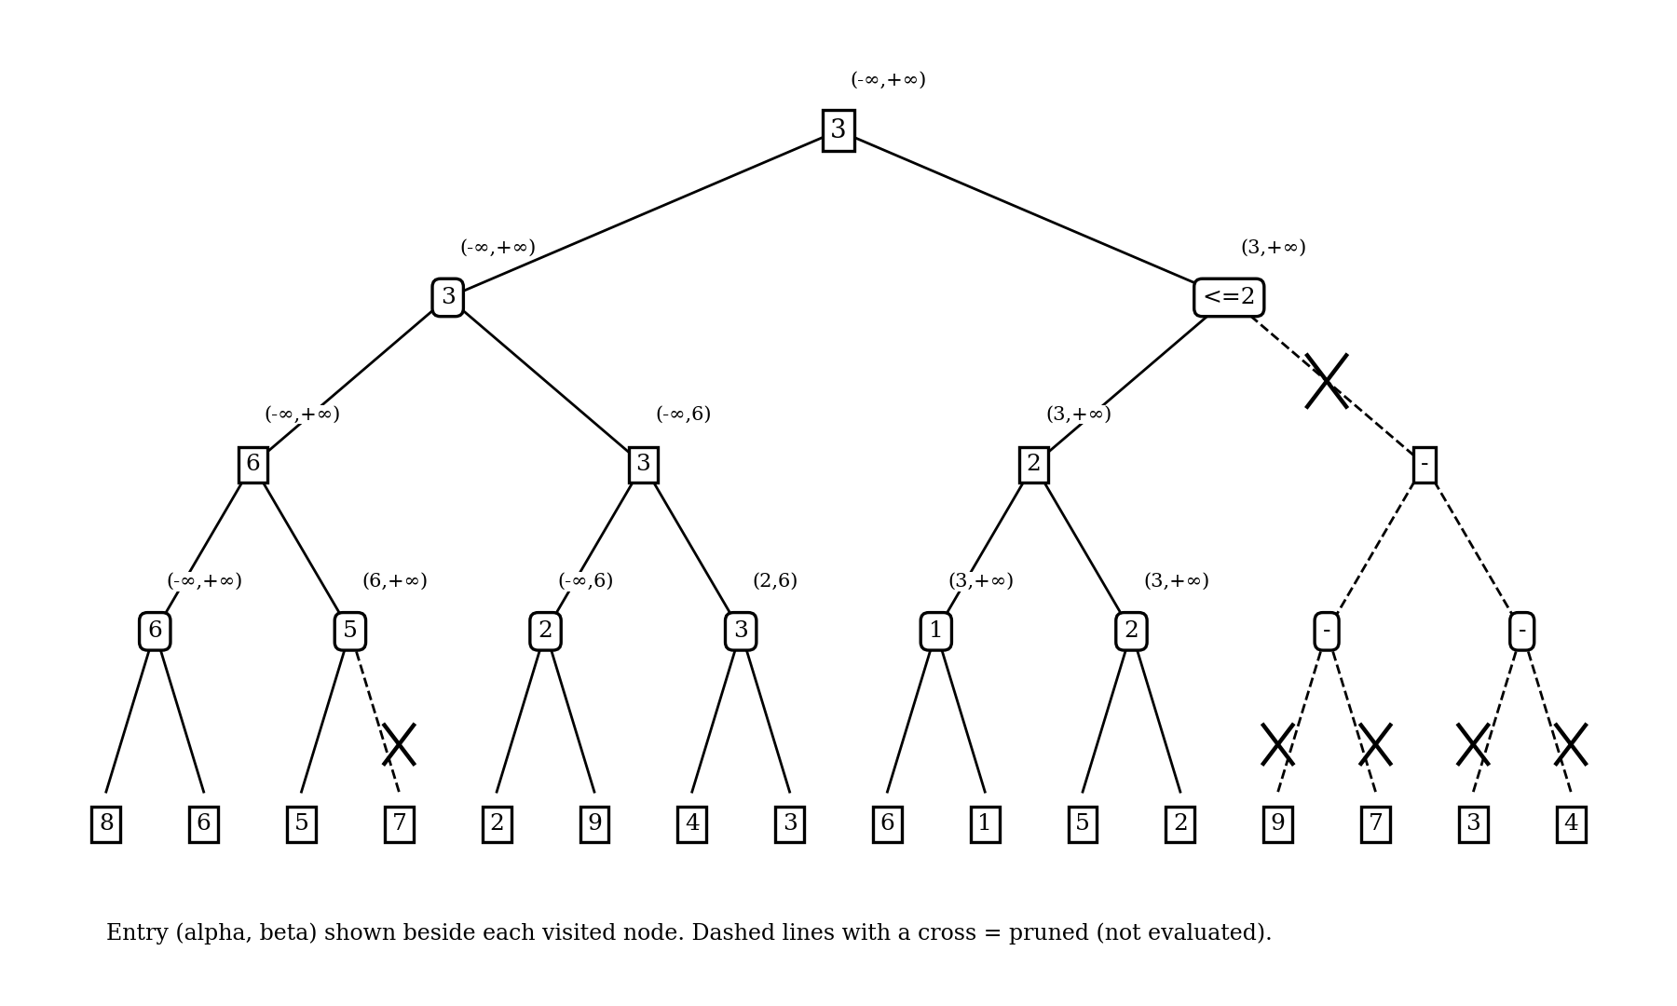
Figure 4: Alpha-beta tree with (α, β) values; dashed lines with a cross are pruned
Node visited | Entry (α, β) | What happens | Value returned
Root (MAX) | (-∞, +∞) | Visit N1 first | 3
N1 (MIN) | (-∞, +∞) | Visit M1 first | 3
M1 (MAX) | (-∞, +∞) | Visit m1, then m2 | 6
m1 (MIN) | (-∞, +∞) | Leaves 8, 6: β = 8, then β = 6. No cut. M1 gets α = 6 | 6
m2 (MIN) | (6, +∞) | Leaf 5: β = 5 ≤ α = 6, prune leaf 7 | 5
M2 (MAX) | (-∞, 6) | N1 now has β = 6. Visit m3, then m4 | 3
m3 (MIN) | (-∞, 6) | Leaves 2, 9: β = 2, then stays 2. M2 gets α = 2 | 2
m4 (MIN) | (2, 6) | Leaves 4, 3: β = 4, then β = 3 (3 > α = 2, no cut). M2 = 3 | 3
N1 (MIN) |  | min(6, 3) = 3. Root gets α = 3 | 3
N2 (MIN) | (3, +∞) | Visit M3 first | ≤ 2
M3 (MAX) | (3, +∞) | Visit m5, then m6 | 2
m5 (MIN) | (3, +∞) | Leaves 6, 1: β = 6, then β = 1 (cut-off but no leaf left) | 1
m6 (MIN) | (3, +∞) | Leaves 5, 2: β = 5, then β = 2 (cut-off but no leaf left). M3 = max(1, 2) = 2 | 2
N2 (MIN) | (3, 2) | β = 2 ≤ α = 3: prune M4 and its whole subtree (leaves 9, 7, 3, 4) | ≤ 2
Root (MAX) |  | max(3, 2) = 3 | 3

Pruned branches: (1) the leaf 7 under m2, and (2) the subtree M4 (with m7, m8 and leaves 9, 7, 3, 4) under N2.
Value of the root = 3, reached through the left MIN node N1.

(b) Leaves evaluated and comparison with plain minimax
- Leaves evaluated by alpha-beta: 11 of 16 (the 5 skipped leaves are 7, 9, 7, 3 and 4).
- Plain minimax evaluates all 16 leaves, so alpha-beta saved 5 evaluations (about 31%).
Check with plain minimax:
Level | Values (left to right) | Rule
MIN nodes m1 to m8 | min(8,6)=6, min(5,7)=5, min(2,9)=2, min(4,3)=3, min(6,1)=1, min(5,2)=2, min(9,7)=7, min(3,4)=3 | MIN
MAX nodes M1 to M4 | max(6,5)=6, max(2,3)=3, max(1,2)=2, max(7,3)=7 | MAX
MIN nodes N1, N2 | min(6,3)=3, min(2,7)=2 | MIN
Root | max(3, 2) = 3 | MAX

Plain minimax gives a root value of 3, which is the same as alpha-beta. The pruned branches (7, and the subtree 9, 7, 3, 4) could not change the answer: N2 can be at most 2, which is already worse for MAX than 3.

(c) Effect of move ordering on pruning
Alpha-beta always returns the correct value, but the amount of pruning depends on the order in which children are visited. Pruning is largest when the best moves are examined first: strong (high) moves first at MAX nodes and weak (low) moves first at MIN nodes. Then α and β become tight early and more branches satisfy β ≤ α.
- Good ordering: in m2 the leaf 5 came before 7, so a single leaf was enough to cut the node. If the leaves had been ordered 7, 5, nothing would have been saved there. For this tree (b = 2, depth d = 4) perfect ordering needs only about b^(d/2) + b^(d/2) − 1 = 4 + 4 − 1 = 7 leaves.
- Bad ordering: if the best moves are examined last, no cut-offs happen and all 16 leaves are evaluated, exactly as in plain minimax.
- This tree: the given order is between the two extremes, giving 11 leaves. With perfect ordering alpha-beta searches roughly O(b^(d/2)) nodes instead of O(b^d), which lets the engine look about twice as deep in the same time.

Program (Question 5)
Program:
leaves = [8, 6, 5, 7, 2, 9, 4, 3, 6, 1, 5, 2, 9, 7, 3, 4]
count = 0

def ab(lo, hi, depth, alpha, beta, is_max):
global count
if depth == 4:
count += 1
return leaves[lo]
mid = (lo + hi) // 2
best = float("-inf") if is_max else float("inf")
for i, (a, b) in enumerate([(lo, mid), (mid, hi)]):
v = ab(a, b, depth + 1, alpha, beta, not is_max)
if is_max:
best = max(best, v); alpha = max(alpha, best)
else:
best = min(best, v); beta = min(beta, best)
if beta <= alpha:
if i == 0:
print("PRUNE at depth", depth, "node leaves", lo, "-", hi - 1,
"alpha =", alpha, "beta =", beta)
break
return best

root = ab(0, 16, 0, float("-inf"), float("inf"), True)
print("Root value =", root, "| leaves evaluated =", count, "of 16")
Output:
PRUNE at depth 3 node leaves 2 - 3 alpha = 6 beta = 5
PRUNE at depth 1 node leaves 8 - 15 alpha = 3 beta = 2
Root value = 3 | leaves evaluated = 11 of 16

Summary of Results
Question | Technique | Result
1 | Greedy Best-First Search | Path S → B → E → G, cost 11 (not optimal; S → B → D → G costs 8)
2 | A* Search | Path S → B → D → G, cost 8 (optimal); h(n) is admissible
3 | CSP (MRV + degree + forward checking) | SA = R, NT = G, Q = B, NSW = G, WA = B, V = B; no backtracking
4 | Minimax and evaluation function | Root value 5, best move is left; E = 3 − 2 = 1
5 | Alpha-Beta Pruning | Root value 3; 11 of 16 leaves evaluated; same as minimax

