SIMATS ENGINEERING
ASSESSMENT TOOL 1
Scenario Based Assignment (Annexure A)
Detail | Information
Course Name | Artificial Intelligence
Course Code | CSA17
Course Outcome Covered | CO2: Experiment search and game-solving techniques such as Greedy Search, A*, CSP, Minimax, and Alpha-Beta pruning with heuristic functions for solving complex AI problems efficiently. (BL3)
Student Name | JOANSWA.J
Register Number | 192572136
Total Marks / Weightage | 50 marks / 35%

Code of Conduct
I JOANSWA.J (192572136) certify that this submission is my original work and that I have adhered to the guidelines specified for this assessment. I understand that any violation of academic integrity rules will result in disciplinary action.
Signature of the student: JOANSWA.J

SOLUTION

Question 1: Campus Delivery Robot (Greedy Search)
The robot starts at the Gate and must reach the Auditorium. The campus is treated as a graph in which locations are nodes and roads are edges with the given distances. The straight-line distance to the Auditorium is the heuristic value h(n). Figure 1 shows the map.
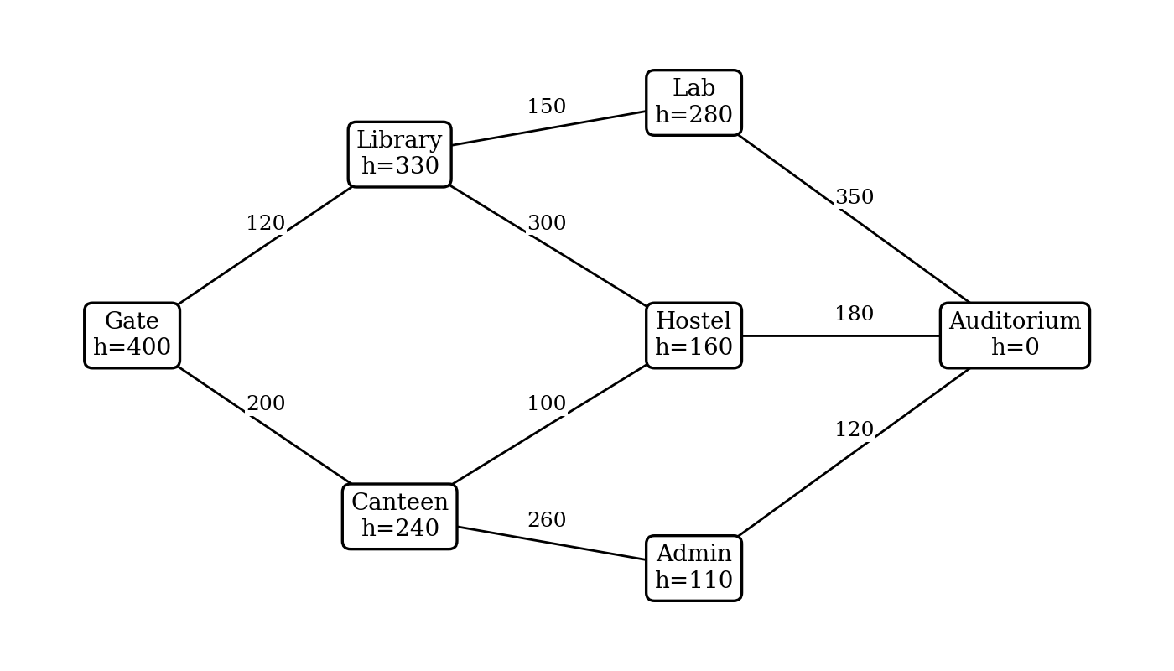
Figure 1: Campus map with road distances (metres) and straight-line values h(n)

(a) Search strategy used
The robot is using Greedy Best-First Search, which is an informed (heuristic) search technique. Justification:
- At every junction it chooses the neighbour with the smallest straight-line distance to the Auditorium, so the evaluation function is f(n) = h(n).
- It does not consider the distance already travelled, g(n), so the cost of the path so far is ignored.
- It always moves to the node that merely looks closest to the goal, which makes it fast but not always optimal.

(b) Trace of the robot's decisions
Step | Location expanded | Candidate locations (straight-line value h) | Chosen (lowest h) | Remark
1 | Gate | Library (330), Canteen (240) | Canteen (240) | Library stays unexplored
2 | Canteen | Hostel (160), Admin (110)  (Gate already visited) | Admin (110) | Hostel (160) is passed over
3 | Admin | Auditorium (0)  (Canteen already visited) | Auditorium (0) | Goal found
4 | Auditorium | Goal reached | - | Stop

(c) Route taken, total distance and optimality
Route taken: Gate → Canteen → Admin → Auditorium.
Total distance = 200 + 260 + 120 = 580 m.
This route is not guaranteed to be the shortest. Comparing it with the other possible routes:
Route | Calculation | Total (m)
Gate → Library → Lab → Auditorium | 120 + 150 + 350 | 620
Gate → Library → Hostel → Auditorium | 120 + 300 + 180 | 600
Gate → Canteen → Admin → Auditorium (Greedy) | 200 + 260 + 120 | 580
Gate → Canteen → Hostel → Auditorium | 200 + 100 + 180 | 480

The route Gate → Canteen → Hostel → Auditorium is only 480 m, so the greedy route is 100 m longer (about 21%). Greedy chose Admin because 110 m looked closer than Hostel's 160 m, but it ignored that the road from Canteen to Admin is 260 m while the road from Canteen to Hostel is only 100 m. A heuristic-only choice can therefore be misled.

Question 2: Improved Navigation Rule (A* Search)

(a) New strategy and why it guarantees the shortest route
The new rule uses A* Search with the evaluation function f(n) = g(n) + h(n), where g(n) is the distance travelled so far and h(n) is the straight-line distance to the Auditorium.
- A* includes the real cost already travelled, so a cheap-looking but expensive road is no longer favoured blindly.
- The heuristic is admissible (it never overestimates the true remaining distance), so f(n) is never larger than the real cost of the best route through n.
- When the Auditorium is selected for expansion its f value equals its true cost g, and every other node waiting in the frontier has an f value at least as large. Because those values are lower bounds, none of them can lead to a cheaper route, so the first route found is the shortest.

(b) Trace of the new rule
Step | Node expanded | Candidate | g | h | f = g + h | Remark
1 | Gate  (f = 400) | Library  Canteen | 120  200 | 330  240 | 450  440 | Canteen has the lowest f, expanded next
2 | Canteen  (f = 440) | Hostel  Admin | 300  460 | 160  110 | 460  570 | Frontier: Library 450, Hostel 460, Admin 570
3 | Library  (f = 450) | Lab  Hostel (via Library) | 270  420 | 280  160 | 550  580 | Hostel via Library (580) is worse than 460 via Canteen, so it is dropped
4 | Hostel  (f = 460) | Auditorium | 480 | 0 | 480 | Frontier: Auditorium 480, Lab 550, Admin 570
5 | Auditorium  (f = 480) | - | 480 | 0 | 480 | Lowest f in frontier, goal reached

New route: Gate → Canteen → Hostel → Auditorium, with total distance 200 + 100 + 180 = 480 m.

(c) Safety of the heuristic and comparison with Question 1
The straight-line value is safe to use if it never exceeds the true shortest remaining road distance. Checking all six locations (four are required):
Location | h(n) straight-line | True shortest remaining distance | h(n) ≤ true? | Safe?
Gate | 400 | Gate–Canteen–Hostel–Auditorium = 480 | 400 ≤ 480 | Yes
Library | 330 | Library–Hostel–Auditorium = 300 + 180 = 480 | 330 ≤ 480 | Yes
Canteen | 240 | Canteen–Hostel–Auditorium = 100 + 180 = 280 | 240 ≤ 280 | Yes
Lab | 280 | Lab–Auditorium = 350 | 280 ≤ 350 | Yes
Hostel | 160 | Hostel–Auditorium = 180 | 160 ≤ 180 | Yes
Admin | 110 | Admin–Auditorium = 120 | 110 ≤ 120 | Yes

In every case h(n) is less than or equal to the true remaining distance, so the heuristic is admissible and A* is safe to use. (It is also consistent: for every road, h(n) ≤ road cost + h(next), for example 240 ≤ 100 + 160 for Canteen–Hostel, so no node needs to be re-expanded.)
Comparison of the two routes:
Aspect | Question 1 (Greedy) | Question 2 (A*)
Evaluation function | f(n) = h(n) | f(n) = g(n) + h(n)
Route | Gate → Canteen → Admin → Auditorium | Gate → Canteen → Hostel → Auditorium
Total distance | 580 m | 480 m
Nodes expanded | 3 (Gate, Canteen, Admin) | 4 (Gate, Canteen, Library, Hostel)
Optimal? | Not guaranteed (not optimal here) | Yes (admissible heuristic)

The A* route is 100 m shorter (about 17% less than 580 m). The price is one extra node expansion (Library), which is a small cost for a guaranteed shortest route.

Program (Questions 1 and 2)
The following Python program runs both rules on the campus graph and confirms the traces above.
Program:
import heapq

graph = {
"Gate": {"Library": 120, "Canteen": 200},
"Library": {"Gate": 120, "Lab": 150, "Hostel": 300},
"Canteen": {"Gate": 200, "Hostel": 100, "Admin": 260},
"Lab": {"Library": 150, "Auditorium": 350},
"Hostel": {"Library": 300, "Canteen": 100, "Auditorium": 180},
"Admin": {"Canteen": 260, "Auditorium": 120},
"Auditorium": {"Lab": 350, "Hostel": 180, "Admin": 120},
}
h = {"Gate": 400, "Library": 330, "Canteen": 240, "Lab": 280,
"Hostel": 160, "Admin": 110, "Auditorium": 0}

def search(start, goal, use_g):
# use_g = False -> Greedy (f = h); use_g = True -> A* (f = g + h)
frontier = [((0 if use_g else 0) + h[start], 0, start, [start])]
closed = set()
while frontier:
f, g, node, path = heapq.heappop(frontier)
if node in closed:
continue
closed.add(node)
print("Expand", node, "g =", g, "h =", h[node], "f =", f)
if node == goal:
return path, g
for nb, d in graph[node].items():
if nb not in closed:
g2 = g + d
f2 = g2 + h[nb] if use_g else h[nb]
print(" candidate", nb, "g =", g2, "h =", h[nb], "f =", f2)
heapq.heappush(frontier, (f2, g2, nb, path + [nb]))

print("--- Greedy best-first ---")
print(search("Gate", "Auditorium", False))
print("--- A* ---")
print(search("Gate", "Auditorium", True))
Output:
--- Greedy best-first ---
Expand Gate g = 0 h = 400 f = 400
candidate Library g = 120 h = 330 f = 330
candidate Canteen g = 200 h = 240 f = 240
Expand Canteen g = 200 h = 240 f = 240
candidate Hostel g = 300 h = 160 f = 160
candidate Admin g = 460 h = 110 f = 110
Expand Admin g = 460 h = 110 f = 110
candidate Auditorium g = 580 h = 0 f = 0
Expand Auditorium g = 580 h = 0 f = 0
(['Gate', 'Canteen', 'Admin', 'Auditorium'], 580)
--- A* ---
Expand Gate g = 0 h = 400 f = 400
candidate Library g = 120 h = 330 f = 450
candidate Canteen g = 200 h = 240 f = 440
Expand Canteen g = 200 h = 240 f = 440
candidate Hostel g = 300 h = 160 f = 460
candidate Admin g = 460 h = 110 f = 570
Expand Library g = 120 h = 330 f = 450
candidate Lab g = 270 h = 280 f = 550
candidate Hostel g = 420 h = 160 f = 580
Expand Hostel g = 300 h = 160 f = 460
candidate Auditorium g = 480 h = 0 f = 480
Expand Auditorium g = 480 h = 0 f = 480
(['Gate', 'Canteen', 'Hostel', 'Auditorium'], 480)

Question 3: Scheduling Placement Workshops (CSP)

(a) Type of problem and formulation
This is a Constraint Satisfaction Problem (CSP), similar to graph colouring: the workshops are nodes, a conflict is an edge, and the time slots are the colours. A solution gives every workshop one slot so that no constraint is violated.
Component | Definition
Variables | W1, W2, W3, W4, W5 (one slot for each workshop)
Domains | D(W1) = D(W2) = D(W5) = {Morning, Afternoon, Evening}  D(W3) = {Afternoon, Evening} (trainer not free in the Morning)  D(W4) = {Morning, Afternoon} (hall not free in the Evening)
Binary constraints | W1 ≠ W2, W1 ≠ W3, W2 ≠ W3, W2 ≠ W4, W3 ≠ W5, W4 ≠ W5 (workshops sharing students must be in different slots)
Unary constraints | W3 ≠ Morning, W4 ≠ Evening (already applied to the domains above)
Conflict degree | W1: 2 (W2, W3), W2: 3 (W1, W3, W4), W3: 3 (W1, W2, W5), W4: 2 (W2, W5), W5: 2 (W3, W4)

(b) Building the timetable (MRV with forward checking)
Rules followed: pick the workshop with the fewest remaining slots (MRV); break ties by the number of unscheduled conflicting workshops, then by workshop number; try slots in the order Morning, Afternoon, Evening. M = Morning, A = Afternoon, E = Evening.
Initial remaining slots: W1 {M, A, E}, W2 {M, A, E}, W3 {A, E}, W4 {M, A}, W5 {M, A, E}.
Step | Workshop chosen and reason | Slot assigned | Remaining slots of unscheduled workshops
1 | W3: W3 and W4 tie with 2 slots each. W3 has 3 unscheduled conflicts (W1, W2, W5) against 2 for W4. | Afternoon (Morning is not in its domain) | W1 {M, E}, W2 {M, E}, W4 {M, A}, W5 {M, E}
2 | W2: W1, W2, W4, W5 all have 2 slots. Unscheduled conflicts: W1 = 1, W2 = 2, W4 = 2, W5 = 1. W2 and W4 tie, so the lower number W2 is taken. | Morning | W1 {E}, W4 {A}, W5 {M, E}
3 | W4: W1 and W4 both have 1 slot. Unscheduled conflicts: W1 = 0, W4 = 1 (W5). | Afternoon | W1 {E}, W5 {M, E}
4 | W1: only 1 slot left. | Evening | W5 {M, E}
5 | W5: the last workshop. Morning is tried first and breaks no constraint. | Morning | None left

Final valid timetable:
Time slot | Workshops | Check
Morning | W2, W5 | W2 and W5 share no students
Afternoon | W3, W4 | W3 and W4 share no students; W3 not in Morning, W4 not in Evening
Evening | W1 | Alone in its slot

All six conflicts are satisfied: W1 (Evening) differs from W2 (Morning) and W3 (Afternoon); W2 (Morning) differs from W3 (Afternoon) and W4 (Afternoon); W5 (Morning) differs from W3 (Afternoon) and W4 (Afternoon). No backtracking was needed.

(c) Why MRV reduces the search effort, and the no-slot case
Choosing the workshop with the fewest remaining slots first is the fail-first idea. The most constrained workshop is the one most likely to run out of slots, so a dead end is discovered early, high in the search tree, and a whole branch is cut off before effort is wasted on the easy workshops. It also keeps the branching factor small at the top of the tree (here W3 had only 2 choices instead of 3) and, together with forward checking, makes later choices almost forced, as seen with W1 and W4.
If a workshop ended up with no slot left (an empty domain), forward checking detects the dead end immediately. The algorithm would then backtrack: undo the most recent assignment, restore the removed slots, and try the next slot for that workshop; if all its slots fail it goes back one more level. If no timetable exists at all, a constraint has to be relaxed, for example by adding a fourth time slot or changing the trainer or hall availability.

Program (Question 3)
Program:
slots = ["Morning", "Afternoon", "Evening"]
conflicts = {("W1","W2"),("W1","W3"),("W2","W3"),("W2","W4"),("W3","W5"),("W4","W5")}
nbrs = {w: set() for w in ["W1","W2","W3","W4","W5"]}
for a, b in conflicts:
nbrs[a].add(b); nbrs[b].add(a)

domains = {w: list(slots) for w in nbrs}
domains["W3"].remove("Morning") # trainer not available
domains["W4"].remove("Evening") # hall not available

def solve(domains, assign):
if len(assign) == 5:
return assign
free = [w for w in domains if w not in assign]
# MRV, then degree (unscheduled conflicts), then workshop number
w = min(free, key=lambda x: (len(domains[x]),
-len([n for n in nbrs[x] if n not in assign]), x))
for s in domains[w]:
new = {k: list(v) for k, v in domains.items()}
ok = True
for n in nbrs[w]:
if n not in assign:
if s in new[n]:
new[n].remove(s)
if not new[n]:
ok = False
if ok:
assign[w] = s
print("Assign", w, "=", s, {k: v for k, v in new.items() if k not in assign})
r = solve(new, assign)
if r:
return r
del assign[w]
return None

print(solve(domains, {}))
Output:
Assign W3 = Afternoon {'W1': ['Morning', 'Evening'], 'W2': ['Morning', 'Evening'], 'W4': ['Morning', 'Afternoon'], 'W5': ['Morning', 'Evening']}
Assign W2 = Morning {'W1': ['Evening'], 'W4': ['Afternoon'], 'W5': ['Morning', 'Evening']}
Assign W4 = Afternoon {'W1': ['Evening'], 'W5': ['Morning', 'Evening']}
Assign W1 = Evening {'W5': ['Morning', 'Evening']}
Assign W5 = Morning {}
{'W3': 'Afternoon', 'W2': 'Morning', 'W4': 'Afternoon', 'W1': 'Evening', 'W5': 'Morning'}

Question 4: Two-Player Game (Minimax)

(a) Technique and assumption
The bot should use the Minimax algorithm, an adversarial search for two-player, turn-based, zero-sum games. X is the MAX player (wants the highest score) and O is the MIN player (wants the lowest score for X). The assumption is that Player O is rational and plays optimally, so at each of its turns it chooses the reply that gives X the smallest score.
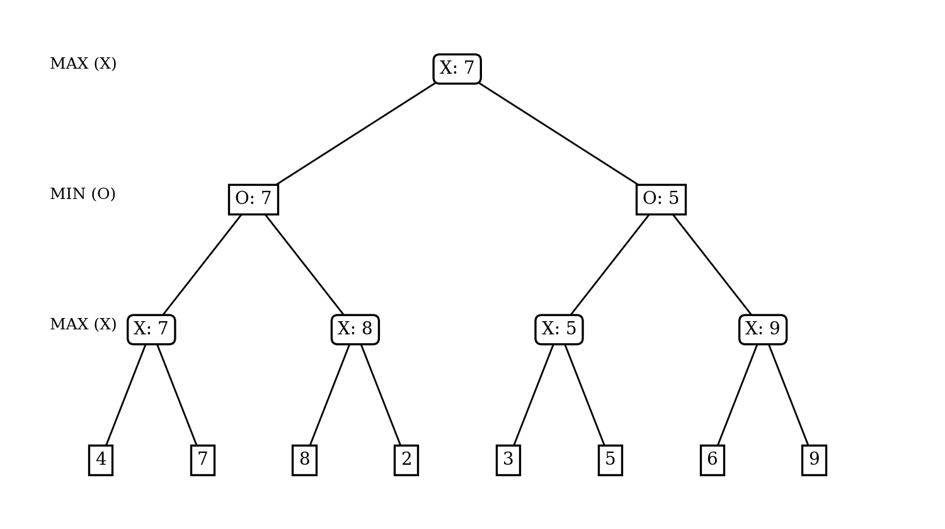
Figure 2: Game tree with minimax values

(b) Value of every node
Node | Player to move | Children values | Value
X node after left reply (4, 7) | X (MAX) | 4, 7 | 7
X node after left reply (8, 2) | X (MAX) | 8, 2 | 8
X node after right reply (3, 5) | X (MAX) | 3, 5 | 5
X node after right reply (6, 9) | X (MAX) | 6, 9 | 9
O node after X's left move | O (MIN) | 7, 8 | min = 7
O node after X's right move | O (MIN) | 5, 9 | min = 5
Starting position (root) | X (MAX) | 7, 5 | max = 7

(c) Best first move, guaranteed score and sequence of play
- Best first move: the left move, because it leads to a value of 7, whereas the right move leads to only 5.
- Score X can guarantee: 7, whatever Player O does.
- Sequence of play: X plays the left move; O chooses the reply that leads to the (4, 7) node, since min(7, 8) = 7; X then chooses the second final move and scores 7.

Program (Question 4)
Program:
tree = [[[4, 7], [8, 2]], [[3, 5], [6, 9]]] # X -> O -> X -> scores

def minimax(node, is_max):
if isinstance(node, int):
return node
vals = [minimax(c, not is_max) for c in node]
print("MAX" if is_max else "MIN", "node children", vals, "->",
max(vals) if is_max else min(vals))
return max(vals) if is_max else min(vals)

print("Value of root =", minimax(tree, True))
Output:
MAX node children [4, 7] -> 7
MAX node children [8, 2] -> 8
MIN node children [7, 8] -> 7
MAX node children [3, 5] -> 5
MAX node children [6, 9] -> 9
MIN node children [5, 9] -> 5
MAX node children [7, 5] -> 7
Value of root = 7

Question 5: Depth-Limited Game Engine (Alpha-Beta Pruning)

(a) Evaluation using alpha-beta pruning
The method used is Alpha-Beta Pruning. Alpha (α) is the best value found so far for the engine (MAX) and beta (β) is the best (lowest) value found so far for the opponent (MIN) inside the current branch. A branch is cut as soon as β ≤ α. The moves are examined from left to right (M1, M2, M3).
Step | Position examined | α | β | Action
1 | M1, reply 1 = 6 | -∞ | 6 | β = 6, continue
2 | M1, reply 2 = 9 | -∞ | 6 | min(6, 9) = 6, continue
3 | M1, reply 3 = 7 | -∞ | 6 | min(6, 7) = 6. M1 = 6, so α becomes 6
4 | M2, reply 1 = 4 | 6 | 4 | β = 4 ≤ α = 6: prune. Skipped: M2 replies 8 and 10. M2 ≤ 4 cannot beat 6
5 | M3, reply 1 = 7 | 6 | 7 | 7 > 6, continue
6 | M3, reply 2 = 5 | 6 | 5 | β = 5 ≤ α = 6: prune. Skipped: M3 reply 12. M3 ≤ 5 cannot beat 6

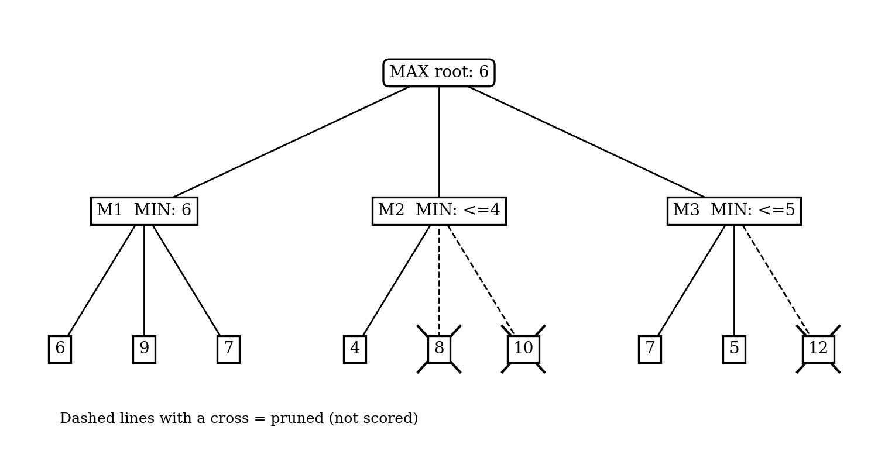
Figure 3: Alpha-beta tree (dashed lines with a cross are pruned positions)

(b) Positions scored, move chosen and verification
- Positions actually scored: 6 out of 9 (M1: 3, M2: 1, M3: 2). The 3 skipped positions are 8, 10 and 12.
- Move chosen: M1, with a value of 6.
Check against examining all 9 positions:
Engine move | Opponent's scores | Opponent picks (min) | Engine picks (max)
M1 | 6, 9, 7 | 6 | 6 (best)
M2 | 4, 8, 10 | 4
M3 | 7, 5, 12 | 5

Full minimax gives max(6, 4, 5) = 6 with move M1, which is the same as the alpha-beta result. The skipped positions (8, 10 and 12) could not change the decision.

(c) Effect of move ordering and need for an evaluation function
Move ordering: alpha-beta skips more positions when the strongest moves are examined first, because a high α is set early and later branches are cut sooner. Here M1 (the best move) was examined first, giving 3 cuts. If the order were M2, M3, M1, no position could be skipped: M2 gives α = 4, M3 gives 5, and M1 is then scored fully, so all 9 positions are examined. With perfect ordering, alpha-beta examines roughly the square root of the positions that minimax does (about O(b^(d/2)) instead of O(b^d)), which lets the engine search about twice as deep in the same time.
Need for an evaluation function: the game is too large to search to the end, so the engine stops at a fixed depth where positions are not yet wins or losses. An evaluation function gives these non-final positions a numerical score (for example material, mobility, position and safety), so that minimax and alpha-beta can compare moves. The quality of the engine's play depends directly on how good this function is, and it must also be fast to compute.

Program (Question 5)
Program:
scores = {"M1": [6, 9, 7], "M2": [4, 8, 10], "M3": [7, 5, 12]}
alpha, beta = float("-inf"), float("inf")
best, count = None, 0
for move, leaves in scores.items():
b = beta
for s in leaves:
count += 1
print(move, "score", s, "alpha =", alpha, "beta =", min(b, s))
b = min(b, s)
if b <= alpha:
print(" prune: remaining replies of", move, "skipped")
break
if b > alpha:
alpha, best = b, move
print("Chosen", best, "value", alpha, "| positions scored =", count)
Output:
M1 score 6 alpha = -inf beta = 6
M1 score 9 alpha = -inf beta = 6
M1 score 7 alpha = -inf beta = 6
M2 score 4 alpha = 6 beta = 4
prune: remaining replies of M2 skipped
M3 score 7 alpha = 6 beta = 7
M3 score 5 alpha = 6 beta = 5
prune: remaining replies of M3 skipped
Chosen M1 value 6 | positions scored = 6

Summary of Results
Question | Technique | Result
1 | Greedy Best-First Search | Gate → Canteen → Admin → Auditorium, 580 m (not optimal)
2 | A* Search | Gate → Canteen → Hostel → Auditorium, 480 m (optimal)
3 | CSP (MRV + forward checking) | W1 Evening, W2 Morning, W3 Afternoon, W4 Afternoon, W5 Morning
4 | Minimax | X plays the left move and guarantees a score of 7
5 | Alpha-Beta Pruning | M1 with value 6; 6 of 9 positions scored, 3 pruned

