Choose your car app
Documentation by Joanta Tudor-Vasile

1.UML diagrams
-Host webapp

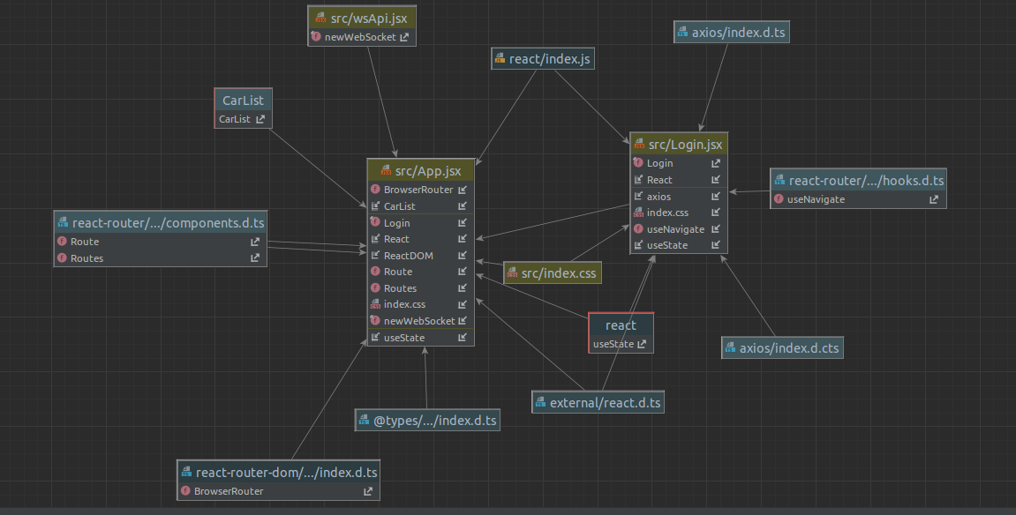

- Remote webapp

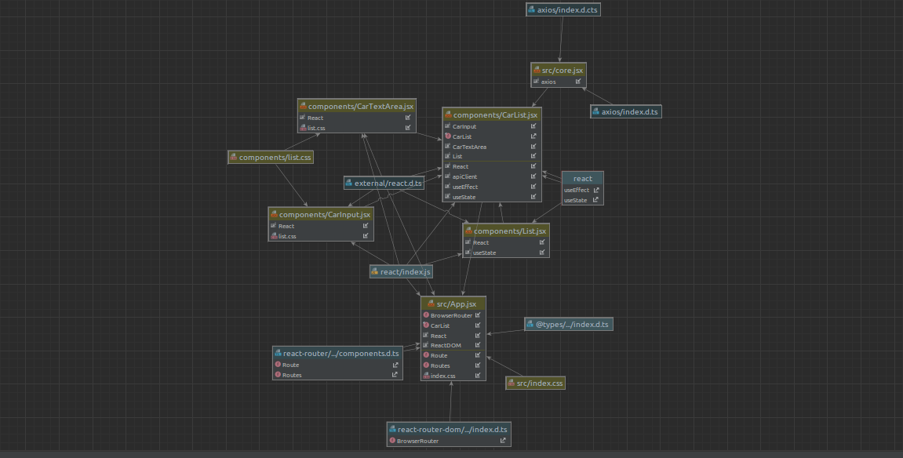
-auth microservice
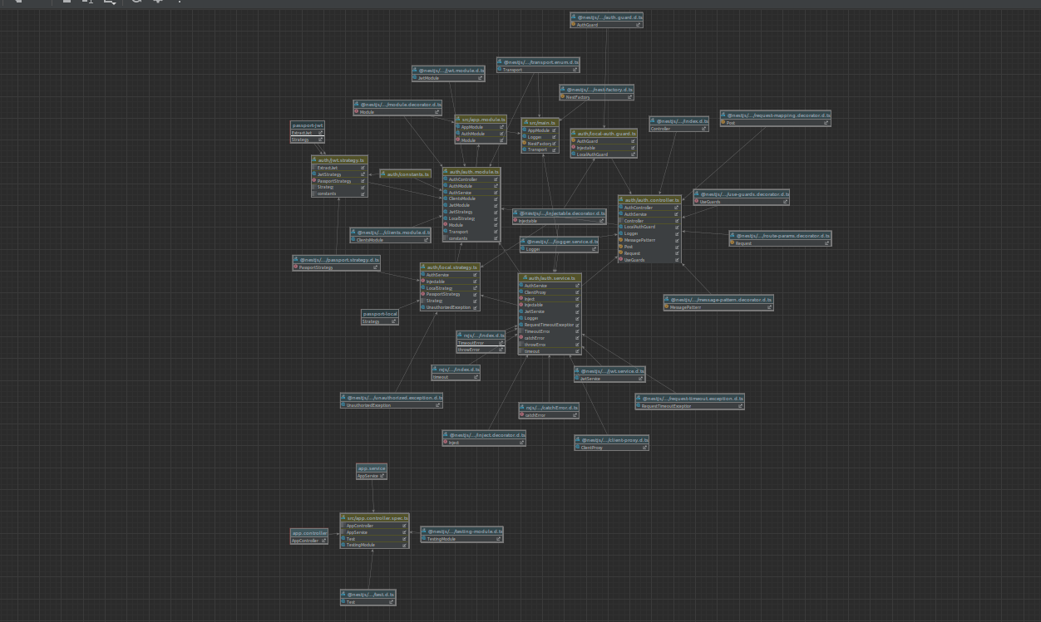
-user microservice
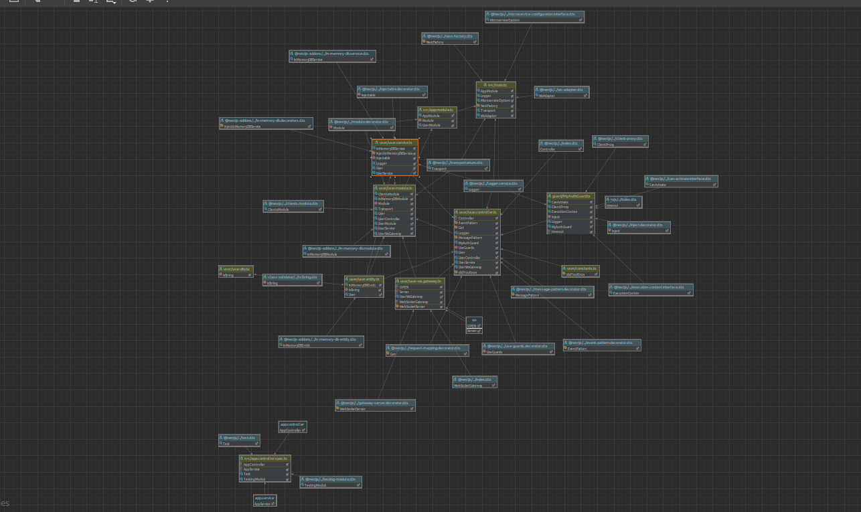

-car microservice
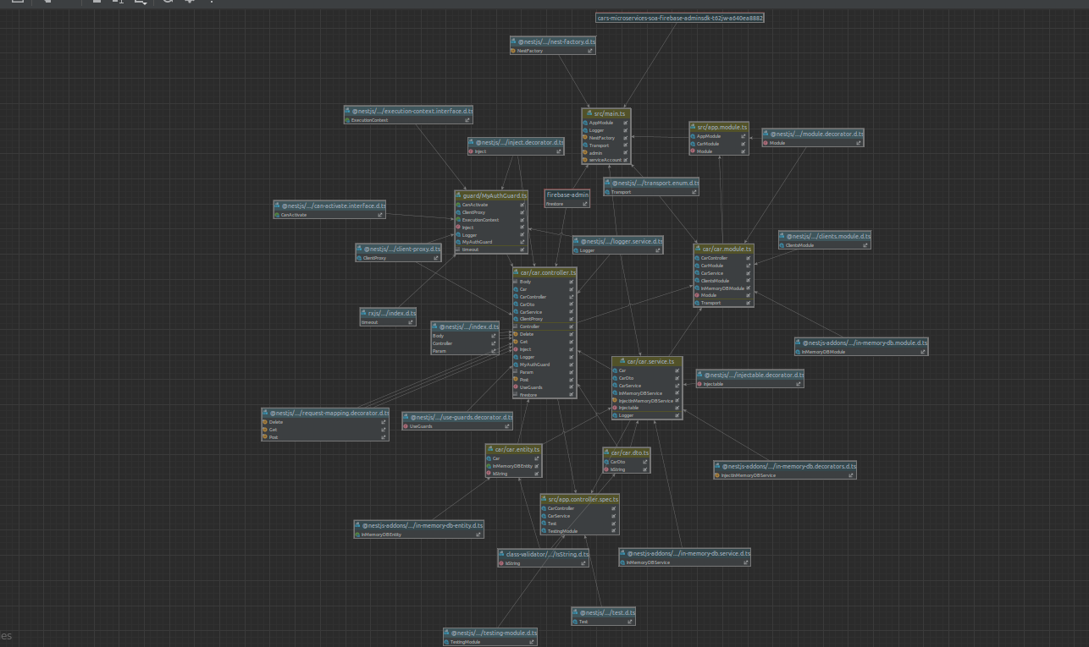

2.SOA Patterns
a) Access token
Auth microservice is used to provide authentication and authorization. App delivers functionalities using secured REST and using messaging pattern, each request is first filtered by Auth microservice to detect if permissions to access the resource should be granted.

b)Messaging
Microservices are communicating via message exchanges over channels. For example., Auth microservice requests User microservice to validate credentials.

c)Single service per host
Improves securicty, resource utilization and fault isolation. Each microservice is running independently on its own host to protect it from decoupling.

d)Decompose by business capability
Microservices were separated based on business capabilities to facilitate high cohesion and low coupling. For exampe., car microservice is responsible for handling only car related operations.

e)Domain event
Publish an event whenever data changes.

