
SCHOOL OF COMPUTER SCIENCE AND BIOINFORMATICS
DEPARTMENT OF COMPUTER SCIENCE AND IT
RESEARCH PROJECT II

POULTRY MANAGEMENT SYSTEM
A PROJECT REPORT DOCUMENTATION SUBMITTED IN THE DEPARTMENT OF COMPUTER SCIENCE AND IT IN PARTIAL FULFILLMENT OF THE DEGREE OF BACHELOR OF BUSINESS INFORMATION TECHNOLOGY
MUTHONI JOANVALLEY WANGUI
REG NO:BBIT/MG/3050/09/20
SUPERVISOR:MR CLEOPHAS MOCHOGE MAY-AUG 2024

DECLARATION
I certify that this project is my original work and has not been presented for a degree in any other University or any other award.
Signature………………………….…. Date…………………………………...
Name: Muthoni Joanvalley Wangui
Reg no: BBIT/MG/3050/09/20
Department: Commerce
This project was submitted for examination with the approval from my supervisor:
Supervisor
Mr. Cleophas Mochoge.

Department of computer science
Kabarak University.
Signature………………………………. Date………………………………

DEDICATION
This work is dedicated to my parents for their invaluable effort to enable me attain this level of education

ACKNOWLEDGEMENTS
I wish to sincerely acknowledge my supervisor Mr. Cleophas Mochoge for tirelessly guiding me through the whole process of the project.

ABSTRACT
The Poultry Management System (PMS) is a comprehensive solution designed to optimize and streamline poultry farming operations. This system integrates various aspects of poultry management such as egg production tracking, data management , and financial management, into a single, user-friendly platform. By leveraging advanced technologies such as data analytics and cloud computing, the PMS enhances the efficiency and productivity of poultry farms. The system supports inventory management and provides financial insights, aiding farmers in cost control and profitability analysis. The PMS aims to reduce manual labor, minimize human errors, and ensure optimal living conditions for poultry, leading to improved animal welfare and higher production yields. It is designed to be scalable, catering to the needs of small-scale farmers as well as large commercial poultry operations. The integration of mobile applications allows farmers to manage their operations remotely, providing flexibility and continuous oversight. Poultry is the world’s most widespread bird species and a major contributor to ammonia and greenhouse gas emissions. To enhance poultry productivity, enterprises have adopted new technological innovations for managing and monitoring poultry farms. One critical component of modern poultry farms is the smart poultry management system. These systems allow decision-making related to feeding processes and aim to reduce CO₂ and NH₃ emissions. However, there is limited research on using multi-criteria decision models in poultry farming, where productivity improvement, welfare enhancement, and greenhouse gas reduction are considered simultaneously. Smart poultry management systems provide tools for production planning and scheduling. By aligning production schedules with market demand and resource availability, farmers can optimize breeding, hatching, and production cycles. This optimization minimizes wastage, optimizes resource utilization, and maximizes profitability.

TABLE OF CONTENTS
DECLARATION 2
DEDICATION 3
ACKNOWLEDGEMENTS 4
ABSTRACT 5
TABLE OF CONTENTS 6
1.1Background of the study 7
1.3 Research objectives 8
1.3.1 General objectives 8
1.3.2 Specific objectives 8
LITERATURE REVIEW 9
2.1.1 Implications of record keeping farm information 11
RESEARCH METHODOLOGY 15
CHAPTER FOUR 18
CHAPTER FIVE 25

CHAPTER ONE

1.1Background of the study
The poultry industry is a vital component of global agriculture, providing a significant source of protein through meat and eggs. As the demand for poultry products continues to rise, the industry faces challenges related to efficiency, productivity, animal health, and sustainability. Traditional poultry farming methods often rely heavily on manual labor and subjective decision-making, which can lead to inefficiencies, increased costs, and potential welfare issues. In recent years, advancements in technology have opened new opportunities for improving poultry farm management. The integration of data analytics and automation has the potential to revolutionize the industry. These technologies enable real-time monitoring of poultry health and environmental conditions, precise control over feeding and medication, and detailed tracking of production metrics. By leveraging these innovations, farmers can enhance their operational efficiency, reduce waste, and improve animal welfare. Despite the benefits, the adoption of advanced technologies in poultry farming is not without challenges. Many farmers, particularly those operating on a smaller scale, may lack the technical expertise or financial resources to implement these systems. Additionally, there is a need for user-friendly interfaces that can make complex data accessible and actionable for farmers with varying levels of technological proficiency. The development of a Poultry Management System (PMS) aims to address these challenges by providing an integrated, scalable, and user-friendly solution. This system is designed to support the diverse needs of poultry farms, from small family-owned operations to large commercial enterprises. By automating routine tasks and providing actionable insights through data analysis, the PMS helps farmers make informed decisions that enhance productivity, reduce costs, and promote sustainable practices. This study explores the development and implementation of the Poultry Management System, examining its impact on efficiency, productivity, and sustainability in poultry farming. It also assesses the barriers to adoption and proposes strategies to facilitate the widespread use of this technology in the poultry industry.

1.2 Problem statement
The poultry industry faces several critical challenges that hinder its efficiency, productivity, and sustainability. Poultry farms generate a vast amount of data related to production and health. Managing and analyzing this data manually is cumbersome and hence the need for data management. The manual nature of many farming tasks increases the labor burden on farmers, reducing their efficiency and increasing operational costs hence the need of an automated poultry management system.

1.3 Research objectives

1.3.1 General objectives
1. To develop and assess the impact of an integrated Poultry Management System (PMS) on poultry farming operations.

1.3.2 Specific objectives
1. To design and implement an integrated PMS that integrated data analytics and automation to streamline various aspects of poultry farm management.
2.To create a user-friendly interface that is accessible to farmers with varying levels of technological proficiency.
3.To reduce manual labor and increase efficiency in routine farming operations.
4.To automatically manage data and ensure its effectiveness.

1.4 Justification of the study
The development and implementation of a Poultry Management System (PMS) are crucial for addressing several challenges such as health monitoring and data management. Automating routine tasks such as data entry, updating data reduces the time and labor required, allowing farmers to focus on strategic decision-making and other critical tasks. As the agriculture industry faces labor shortages, automation and efficient management systems become critical in maintaining productivity without increasing labor costs.
1.5 Significance of the study
The development and implementation of a Poultry Management System (PMS) carry substantial significance for various stakeholders within the poultry industry. The PMS reduces the manual labor required for routine tasks such as data management and health monitoring. This automation leads to streamlined operations and allows farm personnel to focus on more strategic tasks. The agricultural sector often faces labor shortages, and automation provided by the PMS can help mitigate this issue by reducing the dependency on manual labor
1.6 Research questions
1.How can an integrated Poultry Management System (PMS) be designed and implemented to streamline poultry farm management effectively?
2.How does the automation of routine tasks through the PMS affect the overall labor requirements and efficiency of poultry farms?
3.How does data analytics help in informed decision making?
4.How does a Poultry Management System improve the effectiveness of data management?

LITERATURE REVIEW
2.0 INTRODUCTION
The integration of technology into poultry management has been a significant focus in recent years, with Precision Livestock Farming (PLF) systems leading the charge. These systems utilize IoT devices, sensors and data analytics to monitor and manage various aspects of poultry farming, including health, environment, record keeping /data management and resource usage.
2.1 Record keeping
Over the past decade educators have promoted record keeping by developing systems and software .Yet farm record keeping is still a neglected firm activity (Doye et al ,2000), ( Lasley & Agnistch (2002) found out of a sample of 1960 farmers polled in lowa state ,a third of them dislike record keeping/paperwork. Hewlett(undated) noted that several options exist for handling farm information system, which range from paper forms to be filled by hand to computerized systems. (Tham Agykum et al ,(2010) established in a study of 50 poultry farmers in Ga-East Municipality in Ghana that 100% of the respondents kept some form of farm record .Most farmers keep their records manually (Jeyabalan et al,2010).One of the six respondents in a case study research by (Doye et al ,2000) was keeping records manually before he purchased a computer .(Ryde &Nuthall (1984) stated that the majority (80%) of farmers kept their records hand written that is in books, ledgers. (Alvarez& Nuthall (2001 )studied a sample of 290 farmers in Canterbury ,New Zealand. They found out that farmers kept both financial and production records. No respondent kept financial record in their memory. Additionally 26.20 % of the respondents kept a manual .About 54.48% kept computerized records . About 20% kept feed records in their memory whilst majority (48.97%) used manual recording for feeds. About 17% of the 290 respondents used computers for feed recording. (Ferrer et al ,(2003) established that 97% of respondents owned computers and applied it for record keeping among other uses.( Tham, Agykem et al ,(2010) concluded that a large proportion (82%) of poultry farmers sampled kept their records manually that is in books, sheets of papers and temporarily on walls to later transfer into record books. Only 2% adopted the computerized system using mainly Microsoft office Excel and 16% tended to use both systems manual and computerized. Indeed farm information systems include both manual and computerized records (Doye et al, 2000). Computerized record keeping systems improve timeliness and accuracy of decision making. (Jayabalan et al, (2010) noted that manual record keeping is time consuming , tedious to find important data and make decisions. Studies by ( Battle et al,(1990), (Battle et al, (1995) found many farmers used computers for record keeping and financial analysis.

2.1.1 Implications of record keeping farm information
The ultimate purpose of automatic record keeping is to improve the level of performance by achieving better results running to the farm more competently or reducing the possibility of poor future performances.(Jeyabalan et al,2010). (Chagunda et al, (2006) have established the efficiency of farm output can be increased through the practice of using a simple, precise understandable and easy to maintain record systems such as automatic systems .In an earlier study( Mishra et al ,(1999) had observed that formal record keeping systems are associated with higher farm profits. This was to be expected since computer adoption requires a relatively small fixed initial investment and the benefits of better record keeping are likely to be significant (Grisham et al,2007) .(Silver et al,2006) further added that the productivity of the small scale farmers can be enhanced by proper management practice emphasing that the most important management tool is a proper record keeping. (Devonish et al ,2000) ,(Chapman et al,2006) and( Tham, Agyekum et al ,(2010) have provided evidence that record keeping enhanced opportunities of obtaining credit. Farmers are also able to provide needed information continuously for state and national policy desiions (Johl&Kapur,2001).This is vividly observed in farm management associations(FMA) in the Us where according to( Doye et al,2004) FMA have been in existence more than a century and have provided substantial data for use of farmers and research as well as planning at the state and federal level. Indeed FMAS are a means to promoting record keeping among farmers (Gustafson et al, 1990)
2.2 Operational Efficiency and Automation
Automation technologies in poultry management have been shown to streamline operations significantly. Automated feeding systems, environmental controls and health monitoring reduce labor requirements and ensure precise management of resources. For instance, automated feeders and climate control systems help maintain optimal conditions for poultry growth, leading to better productivity and cost efficiency (Banhazi & Black, (2009)​ .
2.3 Health Monitoring and Animal Welfare
PLF systems enhance animal welfare by providing continuous monitoring and early disease detection. Wearable sensors and environmental monitors track vital health indicators, allowing for prompt intervention when issues arise. This proactive approach reduces mortality rates and improves the overall health of the flock. Studies indicate that PLF development has focused more on improving animal health and welfare than merely increasing production efficiency (Gebhardt,Henrich et al., 2019)​
2.4 Economic Viability
The adoption of PLF systems can lead to substantial economic benefits through cost savings and improved productivity. Efficient resource management reduces wastage while detailed analytics support informed decision-making. The scalability of these systems makes them suitable for both small and large operations, promoting economic stability in the poultry sector (Berckmans et al, 2017)​ . (Williams & Davis (2020) highlight the economic advantages of implementing modern poultry management systems, including reduced labor costs, improved production efficiency, and higher profitability . These systems not only enhance productivity but also contribute to the overall economic viability of poultry farming operations.
2.5 Sustainability
Sustainable poultry farming practices are supported by PLF systems through optimized resource use and waste reduction. Continuous environmental monitoring ensures conditions are kept within optimal ranges, minimizing the ecological footprint. This contributes to the overall sustainability of poultry farming operations (Tullo et al, 2019)​.
2.6 Environmental conditions
Maintaining optimal environmental conditions is crucial for poultry welfare and productivity. Environmental control systems regulate temperature, humidity and ventilation within poultry houses.( Kim & Lee (2018) found that these systems significantly reduce stress among poultry, leading to better health outcomes and higher productivity .( Johnson et al, 2017) underscores the importance of climate control in preventing heat stress and improving the overall living conditions for poultry .
2.7 Automated Feeding Systems
Automated feeding systems are designed to deliver precise amounts of feed to poultry, thereby improving feed efficiency and reducing waste. According to (Smith & Jones (2018), these systems have demonstrated significant improvements in growth rates and feed conversion ratios by ensuring consistent and optimal nutrition . (Brown et al ,2019) emphasizes that automated feeders also reduce labor costs and enhance overall farm management efficiency .
2.8 Data Analytics and Decision Support Systems
The integration of data analytics into poultry management allows for informed decision-making based on real-time and historical data. (Singh & Kaur (2019) demonstrate that data analytics can optimize various aspects of poultry farming, including feed management, disease prevention, and production forecasting . (Miller & White (2020) discuss the role of decision support systems (DSS) in analyzing data and providing actionable insights to improve operational efficiency .
2.9 Implementation challenges
Despite the benefits, the implementation of advanced poultry management systems faces several challenges. (Adams et al, 2019) notes that the high initial cost of these systems can be a barrier for small-scale farmers , resistance to change and need for technical expertise. (Lee & Park (2018) point out that technical expertise is required to operate these systems effectively, which may not be readily available in all farming communities . Additionally,( Chen & Zhao (2020) highlight concerns regarding data privacy and security, which need to be addressed to ensure the safe use of digital technologies in poultry farming . Future efforts should focus on making these technologies more affordable and providing adequate training to farmers to overcome these obstacles (Banhazi et al, 2012)​.

2.9.1 Case Studies and Applications
Precision poultry farming (PPF) integrates various technologies to monitor and manage individual birds. (Thompson & Green (2019) report significant improvements in productivity and animal welfare in farms that have adopted PPF approaches .( Nelson et al, 2018) discusses the sustainability benefits of modern poultry management practices, which help in optimizing resource use and reducing the environmental footprint of poultry farming .

RESEARCH METHODOLOGY
3.1. Research Design
The study adopts a mixed-methods approach, combining both quantitative and qualitative research methods. This approach allows for a comprehensive understanding of the effectiveness, challenges and benefits of poultry management systems.
3.2 Quantitative Research
This involves the collection and analysis of numerical data to measure the performance metrics of poultry management systems, such as feed conversion ratios, mortality rates and production output.
3.3 Qualitative Research
This involves gathering insights from stakeholders through interviews and focus groups to understand their experiences, challenges and perceptions of the system.
3.4 Surveys and Questionnaires
Administered to poultry farmers, workers and poultry farm managers to gather data on system usage, efficiency, and satisfaction.
3.5 Observation
Direct observation of poultry farms implementing management systems to collect real-time data on system performance and animal welfare and those that conduct their activities manually to be able to identify the challenges they face.
3.6 Secondary Data
Analyzing existing research, articles and reports on poultry management systems to identify trends, best practices and gaps in the current knowledge.
Reviewing reports from companies that develop poultry management technologies to understand the features and claimed benefits of their systems.
3.7 Use case diagram

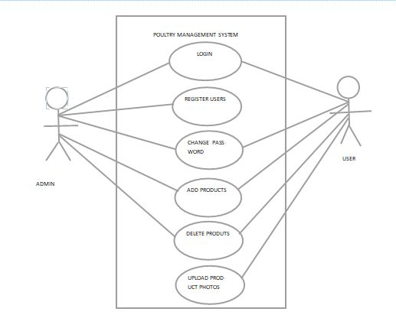

3.8 Context diagram

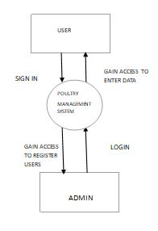

3.9 Data flow diagram
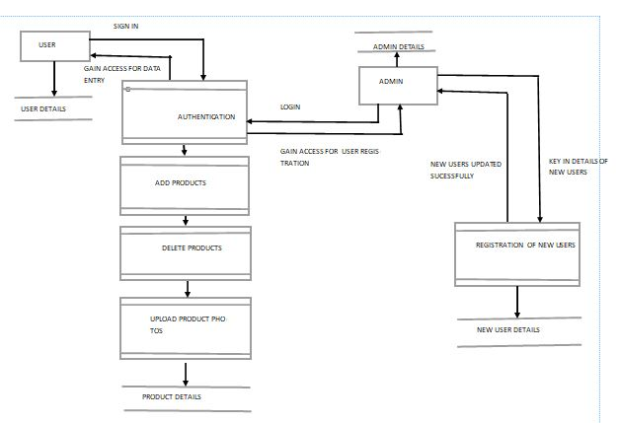

CHAPTER FOUR

4.1 System implementation and deployment
The system architecture consists of three main components the front end interface for users to interact with the back end system for processing and authentication and the relevant information. These components are interconnected to ensure seamless communication and functionality.
4.2 Front end development
The front end was developed using HTML and CSS to create an intuitive and user friendly experience .Below is an except of the code used.
4.3 User interface design
The user interface design priotized simplicity and functionality. Screenshots of key interface modules including the login page and verification result page are provided below.

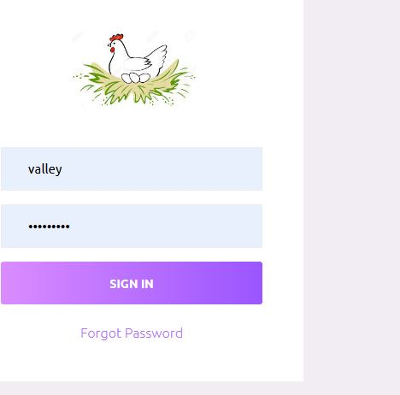

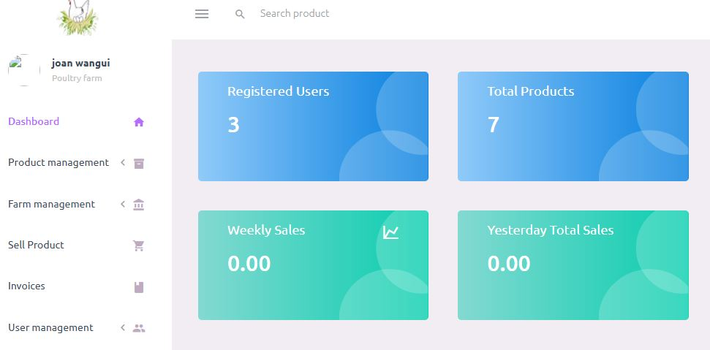

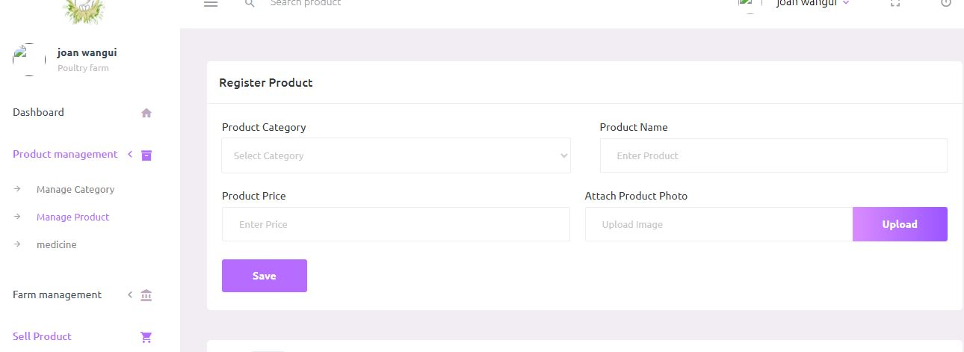

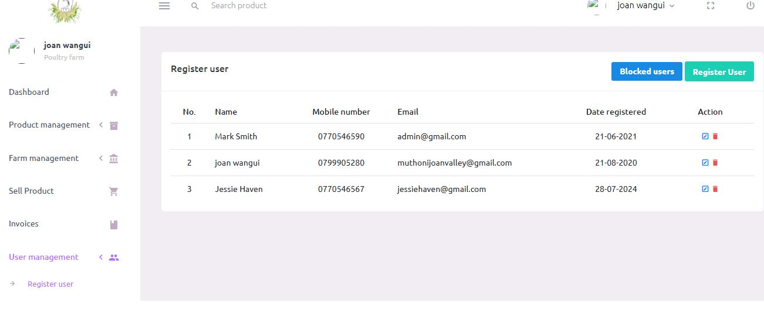
4.4 Backend development
The backend was developed using PHP and MYSQL and run through xamp .Javascript was used for scripting.

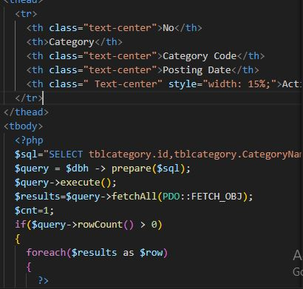

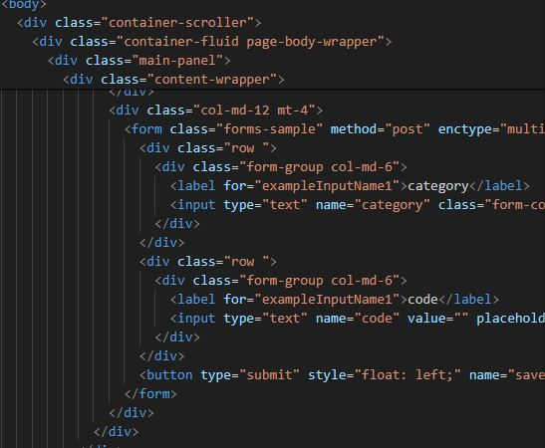

4.4.1Database design models
The database design consisted of tables to store user credentials such as passwords, email addresses and phone numbers.Its a blueprint for structuring and organizing data within the systems backend.

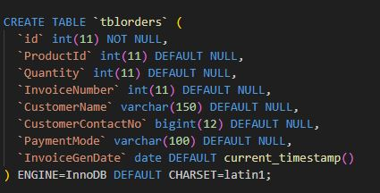

CHAPTER FIVE

5.1 Recommendations
As technoloLgy evolves,the future of poultry management systems is likely to incorporate advanced features to enhance efficiency,productivity and sustainability.Here are some forward looking recommendations.
Integration with IoT:
Automated data collection on environmental conditions,feed and water levels,bird health and behaviour.Real time alerts for issues such as temperature changes,equipment failures or abnormal animal behaviour.
AI and machine Learning :
Predictive models for disease outbreaks,production levels and consumption patterns.AI driven insights to optimize feeding schedules,health interventions and resource allocation.
Blockchain Technology
Blockchain for tracking the entire supply chain from farm to consumer,ensuring transparency in production processes.Enhanced food safety through immutable records of health treatments,feed types and processing dates.
5.2 Conclusion
The future of poultry management systems promises to revolutionize the industry through advanced technologies such as IoT,AI,blockchain,robotic and cloud based solutions.These innovations aim to enhance efficiency,productivity,sustainability and biosecurity ultimately leading to smarter and more sustainable poultry farming practices.By taying informed and adopting these technologies,poultry farmers can better manage their operations,improve animal welfare and meet the growing demands of a changing market.As the industry evolves,the key to success will be the seamless integration of these advanced systems into everyday farm management,coupled with continuous learning and adaptation.

References

POULTRY MANAGEMENT SYYSTEM
Banhazi, T., & Black, J. (2009). Precision livestock farming: Tools and concepts. Animal Production Science, Vol 49(6), PP 403-412.
Berckmans, D. (2017). General introduction to precision livestock farming. Animal Frontiers, Vol 7(1),PP 6-11.
Gebhardt-Henrich, S. G., et al. (2019). A systematic review of precision livestock farming in the poultry sector: Is technology focused on improving bird welfare? Animals, Vol 9(9), PP 614.
Tullo, E., Finzi, A., & Guarino, M. (2019). Review: Environmental impact of livestock farming and Precision Livestock Farming as a mitigation strategy. Science of The Total Environment, Vol 650, PP 2751-2760.
Banhazi, T. M., Lehr, H., Black, J. L., Crabtree, H., Schofield, C. P., Tscharke, M., & Berckmans, D. (2012). Precision livestock farming: An international review of scientific and commercial aspects. International Journal of Agricultural and Biological Engineering, Vol 5(3),
Tham-Agyekum,E,K,Appiah,P.&Nimoh,F.(2010).Asssessing farmrecord keeping behaviour among small scale poultry farmers in the Ga East Municipality.Journal of Agricultural Science, Vol 2(4), PP 52-62.

Johl,S.S.,&Kapur,T.R(2001).Fundamentals of Farm Business Management.Kaylani Publishers,PP.253-259

Jeyabalan,V.(2010).Individual cow recording and analysis system for small scale dairy farmers in Malaysia.International Journal of Computer Applications, Vol 8(11).

Nuthall,P(2004).Case studies of interactions of farm profitability and the use of a farm computer.Computer and Electronics in Agriculture, Vol 42, PP 19-30

Gustafson,C.R.,Neilson.E &Mohart,M.J.(1990).Comparison of the financial results of record keeping and average farms in North Dakota.North Central Journal of Agricultural Economics, Vol 12(2).
Doye,D.(2004).The use of electronic technology in teaching farm record keeping.American Journal of Agricultural Economics, Vol 86(3),PP 762-766.

Adedeji OS,Ajayi,Amao SR,Aiyedun JO;Extent of commercial poultry productionin Saki West local government area of Oyo tate.Trasnational Journal of Science andTechnology,2013;Vol 3(5): PP 68-81.

Battle,M.T,E.&Schnitkey.G.D.(1990).Computer use by Ohio commercial farmers.American Journal of Agricultural Economics, Vol 4, PP 935-945

APPENDICES
SYSTEM REQUIREMENTS
The selection of appropriate hardware and software will facilitate efficient and effective functionality of the system.

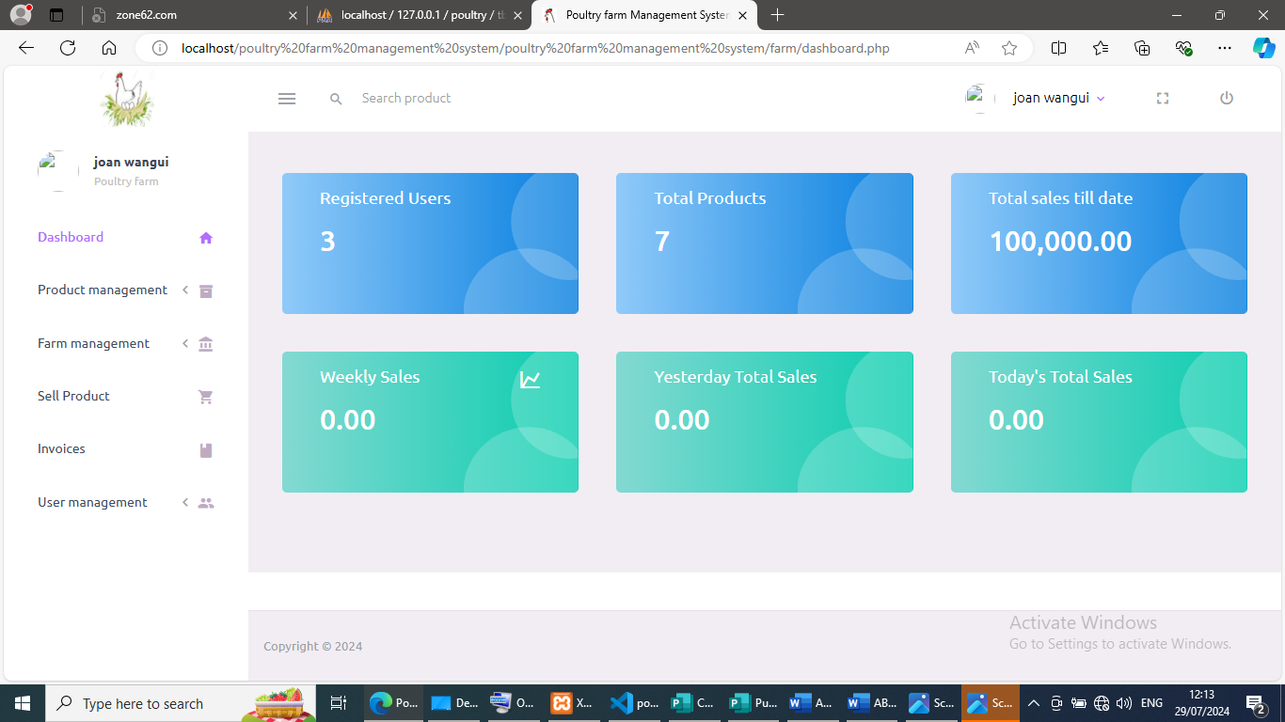
SIGN IN
CHANGE PASSWORD

ADD PRODUCTS
EDIT AND DELETE PRODUCTS
REGISTER USERS

SIGN IN
CHANGE PASSWORD
ADD PRODUCTS
VIEW AND DELETE PRODUCTS
REGISTER USERS
MONITOR SYSTEM PERFOMANCE

DELETE USERS

ADMIN

USER
ADMIN
USER

