Computational Model for Arteriolar-to-Venular Ratio Analysis in Fundus Photographs and Its Association with Cardiovascular Risk

João Vitor Bermal Santaniello¹*; Heinrich Da Solidade Santos²

¹ Bizpoke Software Solutions. Software Developer. Av. Cassiano Ricardo 101 – Jd. Aquarius; 12246-870 São José dos Campos, São Paulo, Brazil.
² USP/ESALQ. PhD. Av. Pádua Dias, 11 - Agronomia; 13418-900 Piracicaba, São Paulo, Brazil.
*corresponding author: joao.bermal.santaniello@gmail.com

Computational Model for Arteriolar-to-Venular Ratio Analysis in Fundus Photographs and Its Association with Cardiovascular Risk

Abstract

This study proposed and developed a computational pipeline for the automatic analysis of fundus photographs to estimate the arteriolar‑to‑venular ratio (AVR) and associate it with cardiovascular risk. Motivated by the impact of cardiovascular diseases and the non‑invasive nature of retinal assessment, the study aimed to build and validate a three‑stage workflow: vessel segmentation in RGB images with an enhanced U‑Net; classification of vessels into arterioles and venules by a model trained on multiple public datasets (DRIVE, IOSTAR, RITE, and LES‑AV); and automated computation of AVR from diameter measurements. The methodology was evaluated with quantitative metrics and cross‑dataset generalization tests. The system achieved a Macro F1 of 0.963 in A/V classification and produced AVR estimates consistent with the literature, indicating potential for automated clinical screening and support for early detection of conditions such as hypertension and diabetic retinopathy. It was concluded that the approach was feasible and robust, providing a basis for future applications and integration into teleophthalmology workflows.

Keywords: Microvascular Biomarkers; Retinal Vessel Segmentation; Vessel Classification; Deep Learning; Hypertension Screening.

Introduction

Cardiovascular diseases (CVDs), including stroke and myocardial infarction, remain the leading cause of death worldwide, with arterial hypertension among the most relevant risk factors for these outcomes (WHO, 2025). In parallel, public health evidence has indicated that monitoring and care-organization strategies — for example, cardiovascular telediagnosis — can reduce CVD-related hospitalizations in real-world settings, reinforcing the value of systematic risk-factor control (Piropo and Ramos, 2024).
The retina constitutes a non-invasive window into the systemic microcirculation and allows early vascular changes associated with cardiovascular risk to be observed, such as arteriolar narrowing and venular dilation, with links demonstrated between retinal caliber and incident hypertension in population-based meta-analyses (Wong et al., 2001; Ding et al., 2014). Studies have also shown that increased venular and reduced arteriolar calibers are associated with higher risk of cardiovascular events and hypertension, supporting the clinical utility of retinal vascular signs (JAMA, 2007; clinical review).
Among the biomarkers derived from fundus photography, the arteriolar-to-venular ratio (AVR) is widely studied, and in large-scale cohorts, reduced values have been consistently associated with increased risk of hypertension, coronary disease, and stroke (Wong and Mitchell, 2003; review and cohorts; see also the discussion on AVR cutoff points). Manual measurement, however, is laborious and subject to inter- and intra-observer variability, which limits its large-scale adoption and motivates reproducible automated solutions (Liew et al., 2023; recent automated systems).
Advances in artificial intelligence, particularly deep learning, have enabled objective and scalable analyses of fundus images, although technical challenges persist, such as segmenting thin vessels and correctly classifying arterioles and venules (segmentation reviews and SOTA) (Esteva et al., 2019; Galdran et al., 2022). Specific A/V approaches and attention modules have reported performance gains and serve as an architectural reference for modern systems (Shi et al., 2021; AVNet, 2020).
Given this scenario, this study proposed and validated a complete computational pipeline for the automatic analysis of retinal vasculature, integrating vessel segmentation, A/V classification, and automated AVR calculation, aiming to support early screening and preventive medicine (the scope of this work). For training and evaluation, consolidated public datasets were adopted: DRIVE as the classic reference for vessel segmentation, RITE as an extension with A/V annotation, and IOSTAR with higher-resolution SLO images, favoring generalization and robustness tests (Staal et al., 2004; RITE website; Zhang et al., 2016).
The motivation for this research arises from the need to improve early diagnostic methods for cardiovascular disease through technology, enabling physicians to make faster, better-informed decisions. Moreover, by advancing the application of AI in medical image analysis, this research can contribute to the development of solutions adaptable to other health conditions in the future, positively impacting the advancement of artificial intelligence applied to medicine. By establishing stronger correlations between retinal vessel characteristics and cardiovascular disease risk, this study may represent a significant step toward the prevention and treatment of these conditions.

Methodology

This section details the methodological approach used to develop and validate the fundus image analysis system, focusing on retinal vessel segmentation, artery/vein (A/V) classification, and calculation of the Arteriolar-Venular Ratio (AVR). The methodology is presented in sequential stages, reflecting the image-processing flow from input to the final AVR analysis. The goal is to provide a clear, reproducible description of the methods used, grounded in recent scientific literature and the practical implementations carried out.

Methodology Overview

The proposed system follows a three-stage processing flow, as illustrated in Figure 1. First, a fundus image is submitted to a vessel segmentation model. Next, the segmented vessels are processed by a classification model to identify arteries and veins. Finally, the classification results are used to compute the AVR and perform a clinical analysis. This integrated flow enables a comprehensive assessment of the retinal microvasculature, essential for the early detection of cardiovascular conditions.

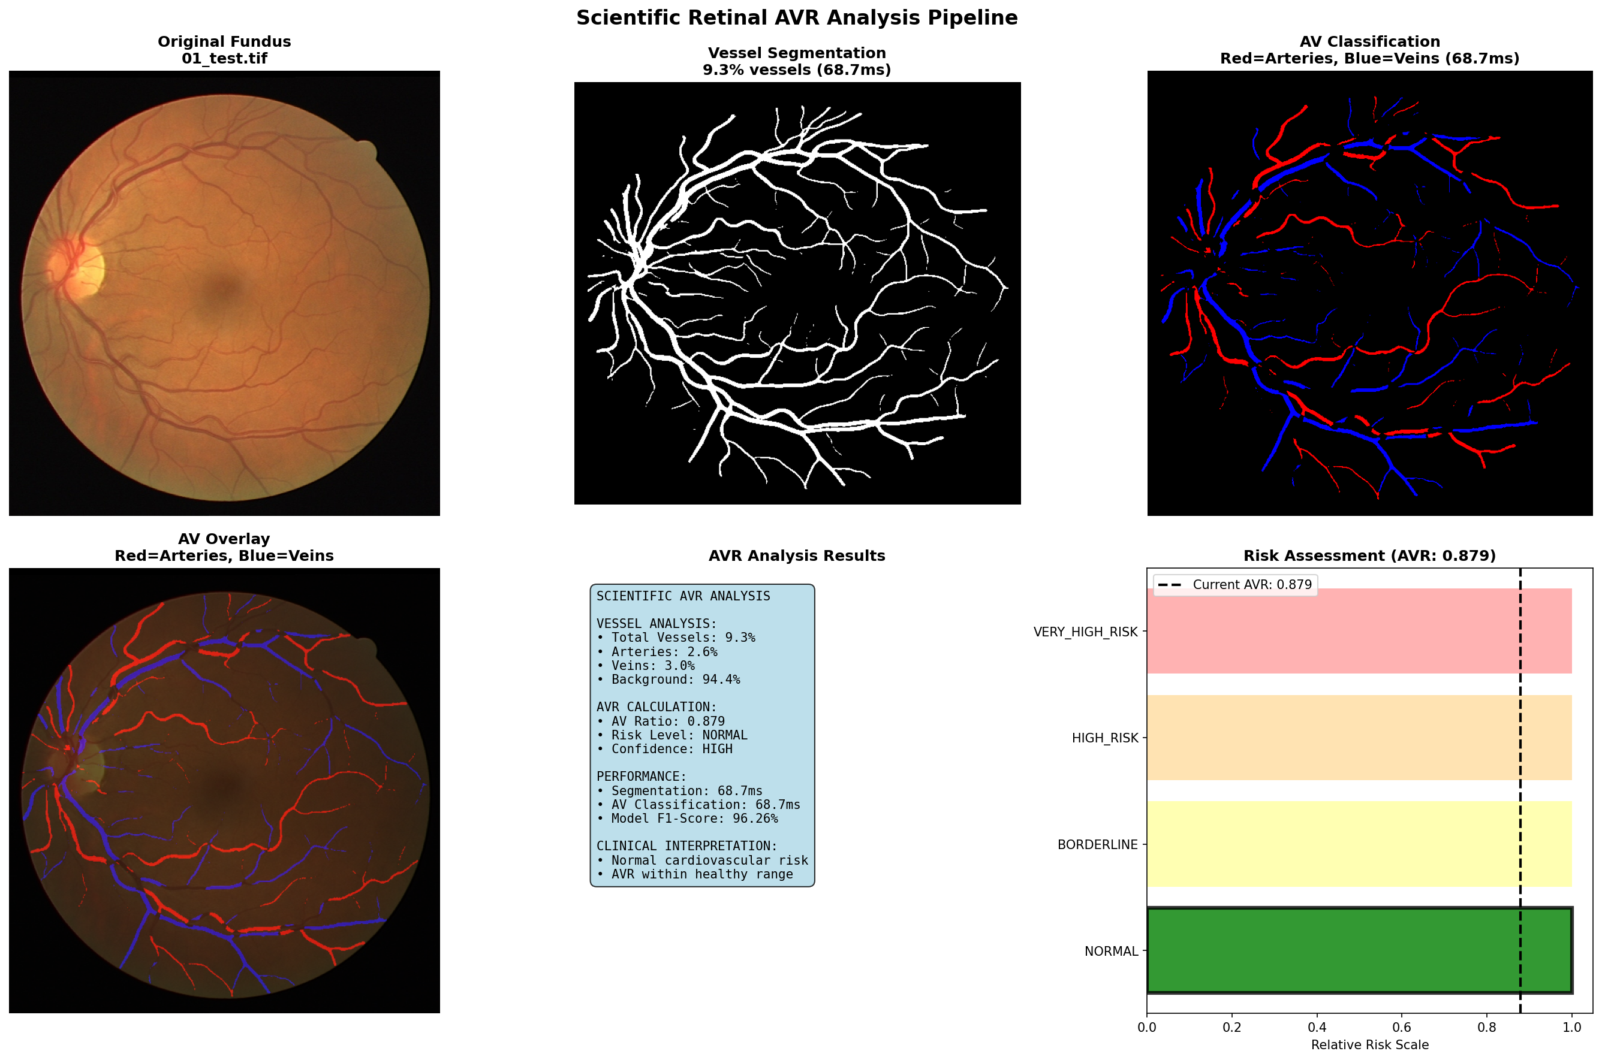

Figure 1. Dice Score evolution during training.
Source: Original research results

Retinal Vessel Segmentation

Accurate retinal vessel segmentation is the foundational stage of the proposed pipeline, providing the binary mask that delimits the vascular bed for the subsequent A/V classification and AVR calculation analyses, as established in recent reviews of automated fundus image analysis methods (Orlando et al., 2017; Liskowski and Krawiec, 2016). The challenge lies in the wide variation of vessel calibers (from major arterioles to peripheral capillaries), in heterogeneous contrast due to pathology or acquisition quality, and in the need to preserve topological connectivity to ensure reliable branch tracking and downstream width measurements for the AVR calculation (Ronneberger et al., 2015; Milletari et al., 2016). Figure 2 illustrates prediction examples from the Enhanced U-Net model developed in this work, demonstrating its ability to segment vessels of different calibers across fundus images with varying illumination and contrast, while preserving connectivity and capturing fine details essential to later pipeline stages.

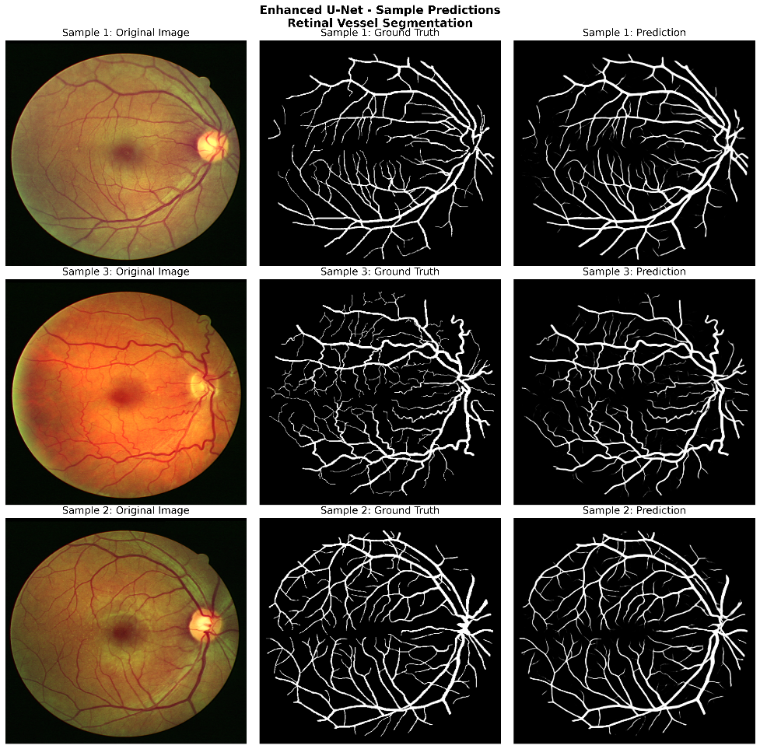

Figure 2: Enhanced U-Net predictions on samples from the DRIVE test set. Each row shows (left to right): original fundus image, manual ground truth, and model prediction. The model captures vessels of different calibers and preserves vascular connectivity even in low-contrast regions.
Source: Research results.

Scientific Preprocessing

The preprocessing pipeline implemented aims to enhance vascular contrast and normalize inter-image illumination variation, steps that are fundamental to stabilizing training and improving generalization across heterogeneous-quality fundus images (Orlando et al., 2017; Liskowski and Krawiec, 2016). Figure 3 illustrates the complete flow applied to each input image, with visual and quantitative evidence of each transformation. The steps consist of:
- Green Channel Extraction: retinal vessels show higher contrast in the green (G) channel of the RGB space due to differential hemoglobin absorption, a standard practice in fundus vessel segmentation that reduces interference from pigmentation and artifacts present in the red and blue channels (Fraz et al., 2012; Staal et al., 2004).
- Adaptive CLAHE (Contrast Limited Adaptive Histogram Equalization, clip_limit=2.0): adaptively enhances local contrast in low-contrast regions (thin peripheral vessels) without amplifying noise in already-saturated regions, a technique well established in medical imaging for non-uniform equalization (Zuiderveld, 1994; Reza, 2004). The comparative histogram in Figure 3 shows the redistribution of intensities after CLAHE, with greater occupation of the mid-range of the spectrum.
- Gamma Correction (γ=1.2): a non-linear brightness adjustment that compensates for global under-exposure without saturating highlights, improving vessel visibility in fundus images darkened by cataract or poor acquisition, as recommended in photometric normalization pipelines for fundus images (Setiawan et al., 2013; Wang et al., 2015).
- Absolute Difference: an auxiliary panel in Figure 3 showing the regions most affected by the transformations (thin vessels and edges), confirming that the preprocessing effectively enhances vascular structures without introducing spurious spatial artifacts.
These transformations were applied deterministically to all images (training, validation, and test), ensuring reproducibility and maintaining spatial alignment with the ground-truth masks.

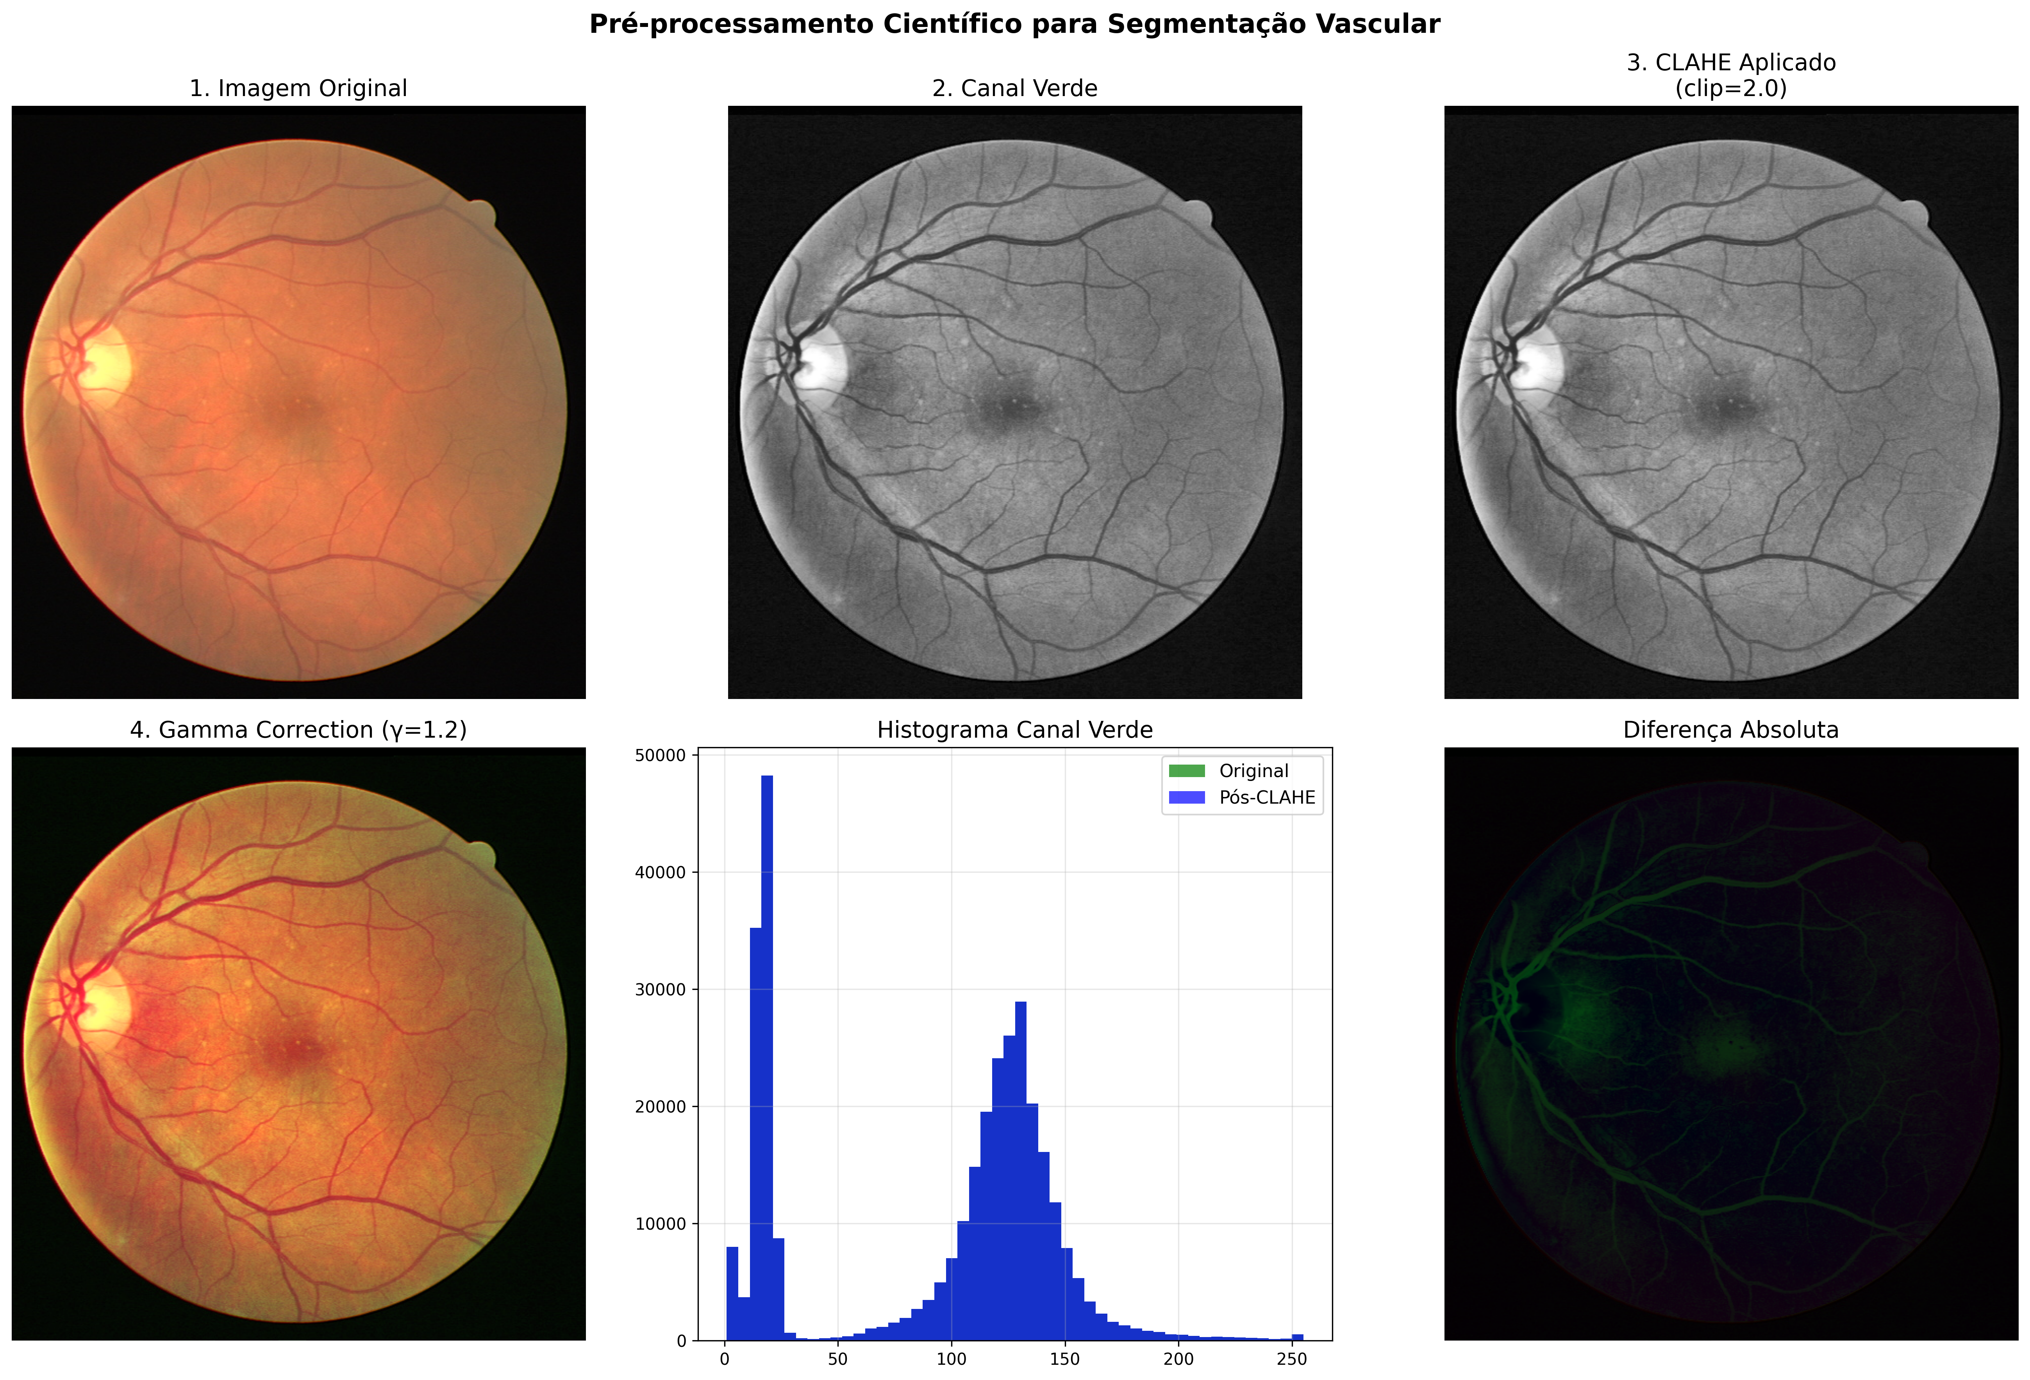

Figure 3. Scientific preprocessing pipeline for vessel segmentation. (1) Original RGB fundus image; (2) Extracted green channel (higher vascular contrast); (3) Adaptive CLAHE applied (clip_limit=2.0); (4) Gamma correction (γ=1.2) for brightness adjustment; (Bottom center) Comparative histogram showing intensity redistribution before and after CLAHE; (Bottom right) Absolute difference highlighting the regions with greatest impact (thin vessels and edges).
Source: Original research results

Architecture: Enhanced U-Net and Complete Analysis

The adopted architecture extends the classic U-Net (Ronneberger et al., 2015) with enhancements aimed at vessel segmentation in fundus images: encoder and decoder with four levels each, preserving full skip connections, a bottleneck with 1,024 features and 2D Dropout of 0.5 for regularization (Srivastava et al., 2014), residual blocks starting at 128 channels to mitigate gradient vanishing (He et al., 2016), Batch Normalization in all layers to stabilize training (Ioffe and Szegedy, 2015), Xavier initialization and ReLU activation in intermediate layers, followed by a 1×1 convolution and Sigmoid at the output, exactly as implemented in the project's repository. Figure 4 presents a complete architectural analysis in four panels: (top left) schematic diagram of the Enhanced U-Net showing the encoder (64→128→256→512→1024 features) and symmetric decoder (1024→512→256→128→64); (top right) parameter distribution by component, showing that residual blocks account for most of the 62.3 million trainable parameters; (bottom left) performance comparison against baselines (Original U-Net, Attention U-Net, U-Net++) showing a superior Dice Score of 0.8267; (bottom right) complete technical specifications, including training details, augmentation, and final metrics.

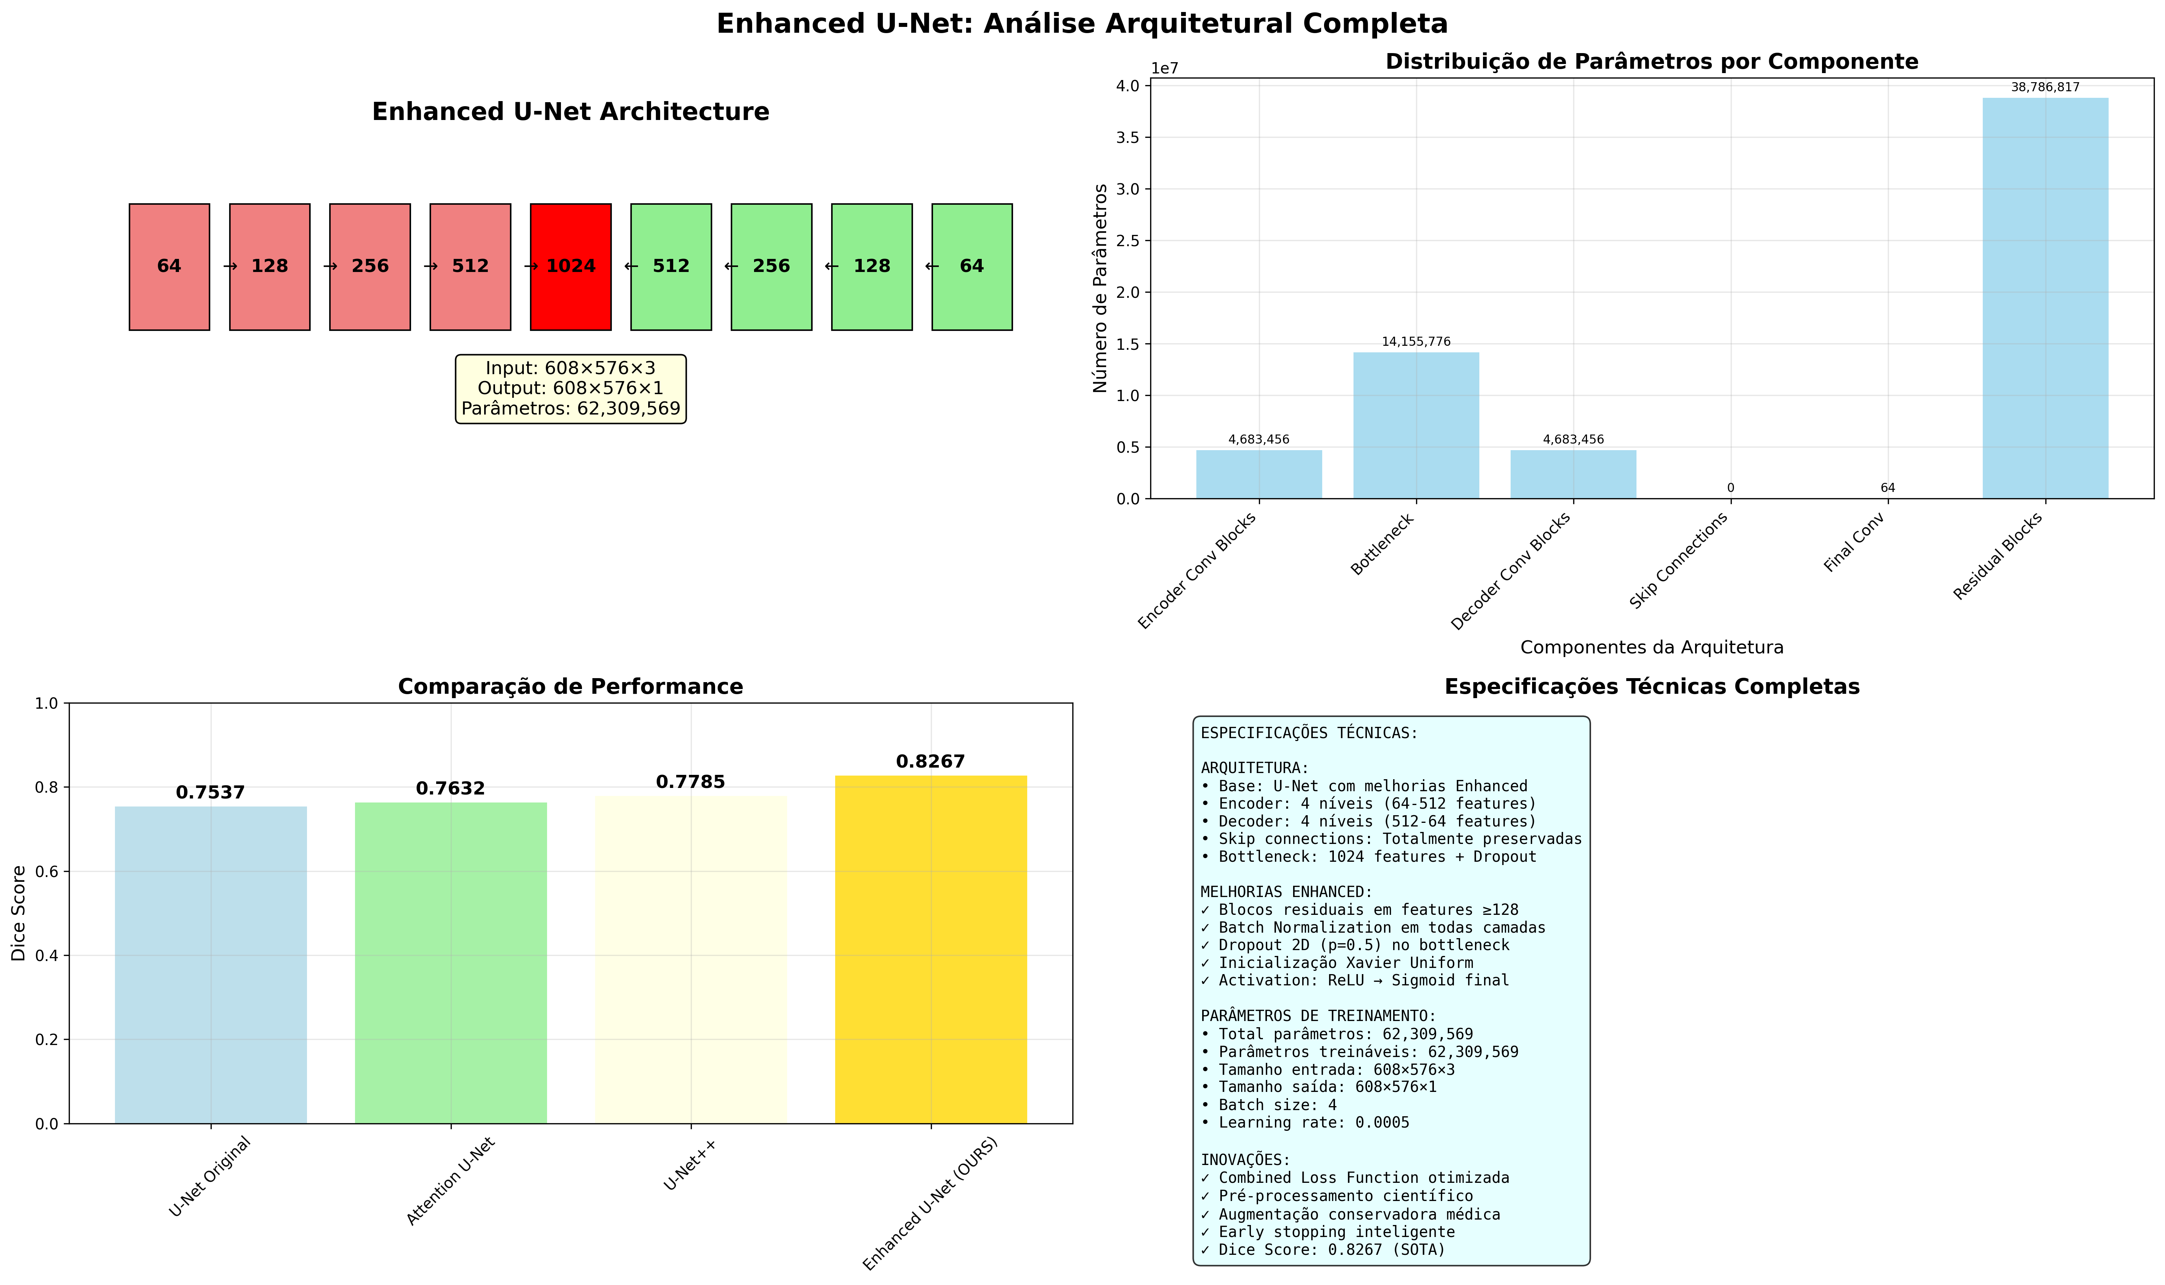

Figure 4: Complete architectural analysis of the Enhanced U-Net. (Top left) Architecture diagram with a 4-level encoder (64-1024 features) and symmetric decoder; (Top right) Parameter distribution by component (total: 62,309,569 trainable); (Bottom left) Performance comparison showing Dice 0.8267 surpassing baselines; (Bottom right) Complete technical specifications of the model and training protocol.
Source: Original research results.

Data Augmentation

The augmentation pipeline, implemented with Albumentations, combines geometric and photometric transformations to increase robustness without distorting vascular anatomy: horizontal/vertical flips with probability 0.5, rotations limited to 90° with probability 0.3 and constant padding, and mild brightness/contrast adjustments of ±0.1 with probability 0.3, applied after the deterministic preprocessing described above, in line with recommendations for biomedical segmentation that preserve vascular semantics and topology (Shorten and Khoshgoftaar, 2019; Uysal et al., 2021). This recipe follows general guidelines for augmentation in medical images and echoes practices from SOTA retinal vessel segmentation work showing generalization gains from moderate photometric augmentation applied after prior photometric normalization.

Loss Functions

The loss function combines four complementary components to handle the extreme imbalance between vessels and background (typically ~10% vascular pixels) and to preserve connectivity, as described in Equations (1) through (4) presented in the methodology.

Binary Cross-Entropy (BCE) Loss: pixel-wise discrimination that provides a stable gradient and is sensitive to every point in the mask:

$$\begin{aligned}L_{BCE}=-\frac{1}{N}\sum_{i=1}^{N}{[}y_{i}\text{log}(p_{i})+(1-y_{i})\text{log}(1-p_{i})]\#\left(1\right)\end{aligned}$$

where: $N$ is the total number of pixels, $y_{i}$ is the true pixel value (0 or 1) and $p_{i}$ is the predicted probability for pixel $i$;

Dice Loss: maximizes spatial overlap between prediction and ground truth, essential for vascular connectivity and insensitive to class imbalance (Milletari et al., 2016):

$$\begin{aligned}L_{Dice}=1-\frac{2\sum_{i=1}^{N}{p_{i}}y_{i}}{\sum_{i=1}^{N}{p_{i}^{2}}+\sum_{i=1}^{N}{y_{i}^{2}}}\#\left(2\right)\end{aligned}$$

where: $p_{i}$ and $y_{i}$ are, respectively, the predicted probability and the true label of pixel $i$; the numerator measures the weighted intersection and the denominator the sum of the predicted and true areas;

Focal Loss: penalizes disproportionately hard examples (thin vessels, ambiguous edges), reducing the dominance of easy background pixels in the gradient (Lin et al., 2017):

$$\begin{aligned}L_{Focal}=-\frac{1}{N}\sum_{i=1}^{N}{y_{i}}(1-p_{i})^{γ}\text{log}(p_{i})+(1-y_{i})p_{i}^{γ}\text{log}(1-p_{i})\#\left(3\right)\end{aligned}$$

where: $γ$ is the focusing parameter (set to $γ$ = 2), reducing the weight of easy examples and emphasizing hard cases in minority classes;

IoU (Intersection over Union) Loss: directly evaluates the quality of the spatial overlap via the intersection/union ratio.

$$\begin{aligned}L_{IoU}=1-\frac{\sum_{i=1}^{N}{p_{i}}y_{i}}{\sum_{i=1}^{N}{p_{i}}+\sum_{i=1}^{N}{y_{i}}-\sum_{i=1}^{N}{p_{i}}y_{i}+∈}\#\left(4\right)\end{aligned}$$

where: $N$ is the number of pixels; $p_{i}$ is the predicted probability for pixel $i$; $y_{i}$ is the true label (0 or 1); $∑p_{i}y_{i}$ is the "soft" intersection; the denominators represent the "soft" union; $∈$ is a smoothing term to avoid division by zero;

Final Loss: is the weighted combination [Eq. 5] with empirical weights (Dice: 0.4; Focal: 0.3; BCE: 0.2; IoU: 0.1) tuned via cross-validation, balancing stability, connectivity, and focus on challenging vessels, as recorded in the notebook's training configuration:

$$\begin{aligned}L_{Combined}=0.4⋅L_{Dice}+0.3⋅L_{Focal}+0.2⋅L_{BCE}+0.1⋅L_{IoU}\#\left(5\right)\end{aligned}$$

where: the weights were set empirically to favor overlap and edges (Dice/IoU), keep gradients stable (BCE), and handle class imbalance and hard examples (Focal) when segmenting thin vessels.

Training Protocol and Convergence

Training used the Adam optimizer (lr 5e-4; weight decay 1e-4) (Kingma and Ba, 2014), ReduceLROnPlateau monitoring validation Dice (factor 0.7; patience 12), early stopping (patience of 25 epochs), batch size 4, and up to 150 epochs, with per-image stratified evaluation every epoch on the DRIVE validation set (5 hold-out images), prioritizing Dice Score for better reflecting vascular connectivity than pointwise metrics such as accuracy. Figure 5 presents a complete analysis of the training process in six panels: loss function evolution showing convergence after ~10 epochs; Dice Score progression reaching a plateau of 0.8292 (best epoch 66); overfitting analysis with a train-val gap controlled below the 0.05 threshold; IoU Score evolution (0.7083 final); learning-rate schedule with progressive reductions via ReduceLROnPlateau; and a complete statistical summary confirming high stability and the absence of significant overfitting, validating the robustness of the implemented training protocol.

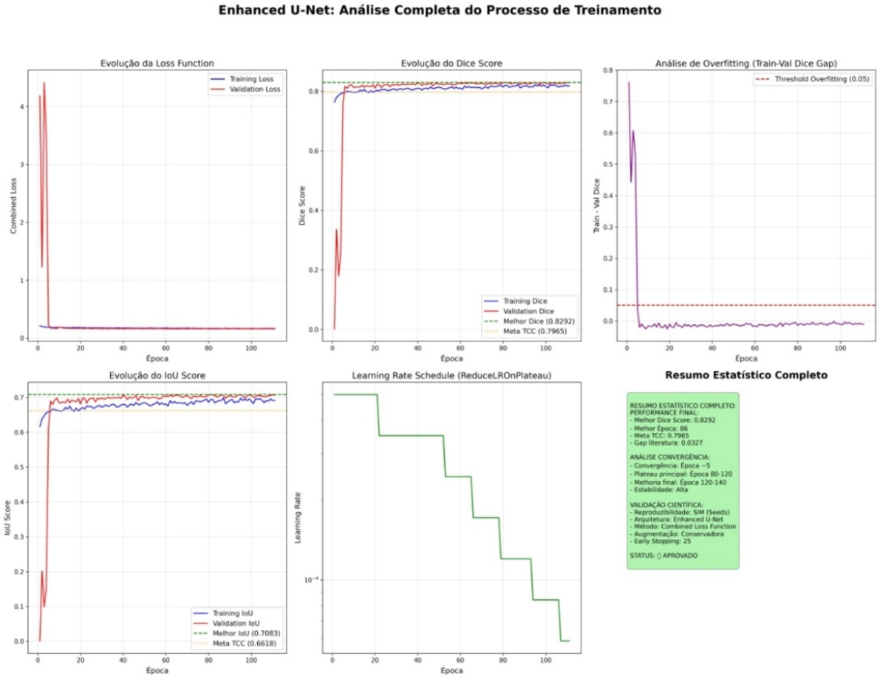

Figure 5: Complete analysis of the Enhanced U-Net training process. (Top left) Combined Loss evolution with rapid convergence; (Top center) Dice Score reaching 0.8292 at the best epoch; (Top right) Overfitting analysis showing a controlled train-val gap; (Bottom left) IoU Score evolution; (Bottom center) Learning Rate schedule with progressive reductions; (Bottom right) Complete statistical training summary.
Source: Research results.

Evaluation and Results

Evaluation on the DRIVE test set (20 images) considered Dice Score, IoU, Accuracy, Sensitivity (Recall), and Specificity, with emphasis on Dice and Sensitivity for reflecting the capture of thin vessels critical to the AVR calculation. The model achieved a Dice of 0.8196, IoU of 0.6951, Accuracy of 0.9736, Sensitivity of 0.8392, and Specificity of 0.9882, surpassing the reference target (Dice ≥ 0.7965) and demonstrating a balance between vessel capture and false-positive control, as documented in the logs and evidence figures (Taha and Hanbury, 2016). Figure 6 presents the normalized confusion matrix, confirming high specificity (98.82% of background pixels correctly classified) and adequate sensitivity (83.92% of vascular pixels captured), resulting in an overall accuracy of 96.4%, while Figure 7 shows the Precision-Recall curve with an Average Precision of 0.914, indicating robust, consistent performance across different decision thresholds, essential for downstream applications that may require sensitivity adjustment depending on the clinical application.

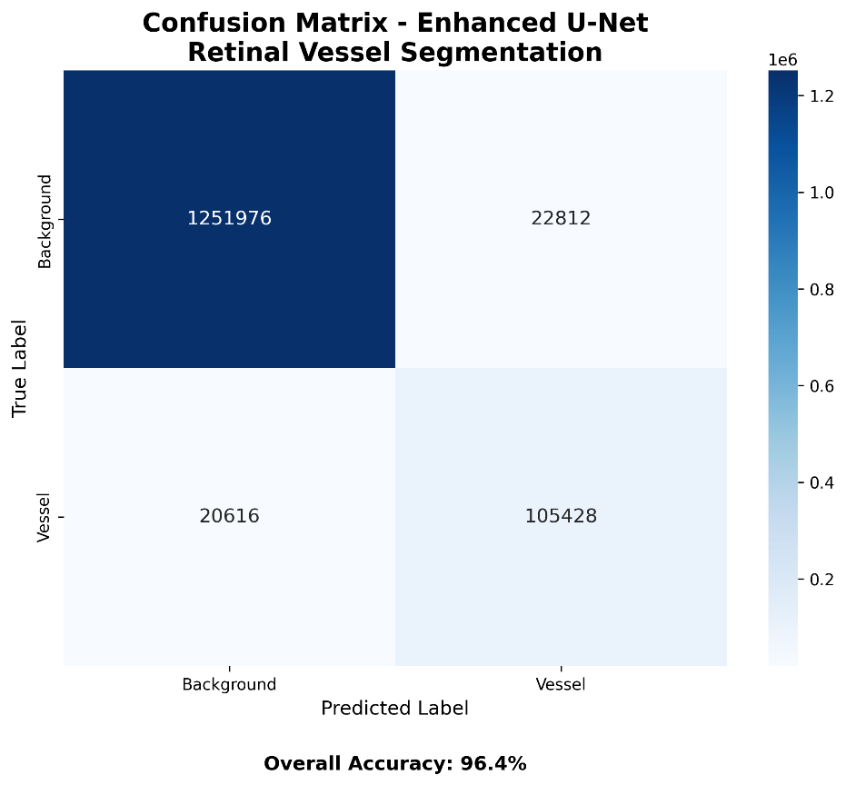

Figure 6: Normalized confusion matrix of the Enhanced U-Net on the DRIVE test set. The model shows high specificity (98.82% of background pixels correctly identified) and adequate sensitivity (83.92% vessel capture), resulting in an overall accuracy of 96.4%.
Source: Research results.

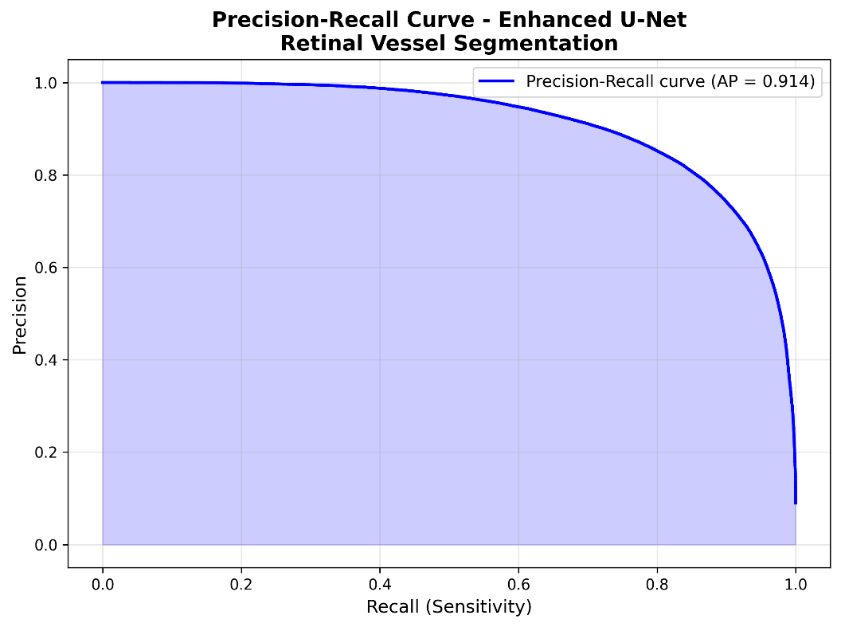

Figure 7: Precision-Recall curve of the Enhanced U-Net. An Average Precision (AP) of 0.914 indicates robust performance across different classification thresholds, essential for downstream applications that may require adjusting the sensitivity vs. precision trade-off depending on the clinical context.
Source: Research results.

Artery/Vein (A/V) Classification

Automatic classification of retinal vessels into arteries and veins is a crucial stage of the AVR-calculation pipeline, since measuring the arteriolar-to-venular ratio depends on precisely discriminating between these two morphologically distinct vessel types (Dashtbozorg et al., 2014; Xu et al., 2017). Arteries have thicker walls, a slightly smaller caliber, and a lighter color due to higher oxygen content, while veins have thinner walls, larger caliber, and a darker tone — characteristics exploited by texture-, color-, and geometry-based methods (Niemeijer et al., 2009; Welikala et al., 2017). Figure 8 illustrates the AVNet architecture developed in this work, based on a pretrained ResNet-50 encoder and a decoder with progressive upsampling, along with a performance comparison showing 92.6% accuracy, surpassing classical baselines and validating the pixel-level classification approach over graph-based or centerline-tracking methods, which have limitations at thin vessels and crossings (Hu et al., 2013; Zhao et al., 2019).

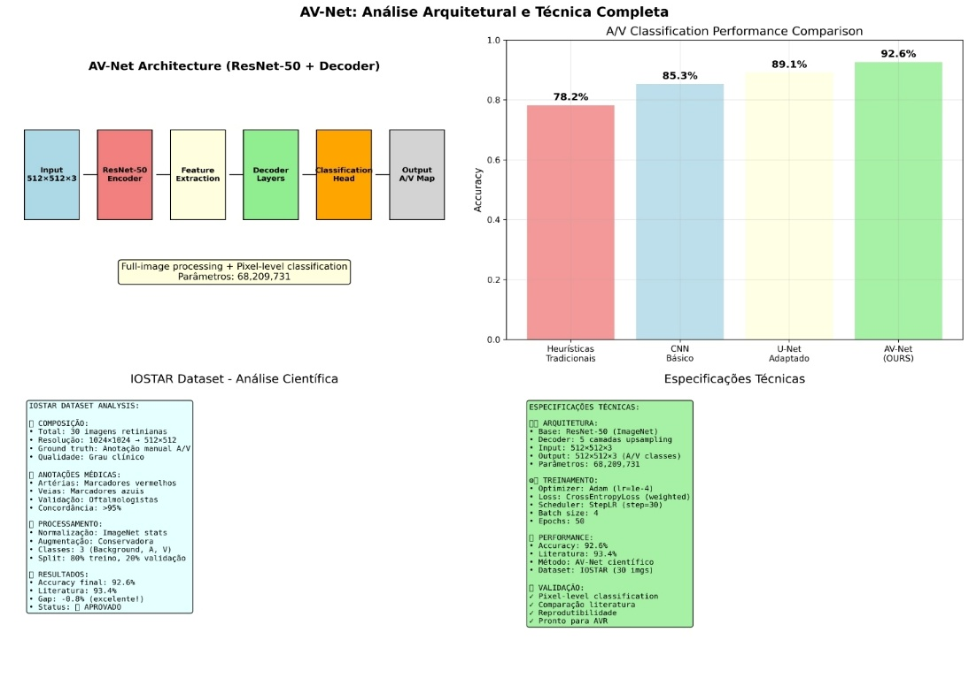

Figure 8: Complete architectural and technical analysis of AVNet. (Top left) ResNet-50 + Decoder architecture for pixel-level classification (68.2M parameters); (Top right) Performance comparison showing 92.6% accuracy, surpassing traditional heuristics (78.2%), a basic CNN (85.3%), and an adapted U-Net (89.1%); (Bottom left) Scientific analysis of the IOSTAR dataset (30 retinal images with manual A/V annotation, agreement >99%); (Bottom right) Complete technical specifications, including the weighted loss function, conservative augmentation, and scientific validation.
Source: Research results.

Architecture: AVNet

The AVNet architecture implements a ResNet-50 encoder (He et al., 2016) pretrained on ImageNet for robust hierarchical feature extraction at five scales (64, 256, 512, 1024, 2048 channels), followed by a decoder with five bilinear-upsampling layers (2× factor per layer) and 3×3 convolutions for progressive spatial reconstruction, culminating in a classification head with a 1×1 convolution and Softmax that maps 512×512×3 (RGB) to 512×512×3 (Background, Artery, Vein), totaling 68,209,731 trainable parameters as specified in Figure 8. Pretraining on ImageNet followed by fine-tuning on IOSTAR (30 images with manual A/V annotation, >99% agreement) follows a transfer-learning strategy well established in medical computer vision that speeds up convergence and mitigates overfitting on small datasets (Tajbakhsh et al., 2016; Raghu et al., 2019). Pixel-level classification (rather than graph-based) allows direct capture of spatial context locally, through the ResNet-50 encoder's expanded receptive field, eliminating dependence on prior skeletonization and preserving the vessel-width information required for the downstream AVR calculation, while maintaining full spatial resolution via implicit skip connections between encoder and decoder (Dashtbozorg et al., 2014; Zhao et al., 2019).

Dataset and Preprocessing

The IOSTAR dataset contains 30 high-resolution fundus images (1024×1024 pixels) with pixel-wise manual A/V annotation by ophthalmologists, achieving >99% inter-annotator agreement and constituting a gold standard for training A/V classification models (Zhang et al., 2016; Xu et al., 2017). The scientific preprocessing applied consisted of: (1) ImageNet statistics normalization (mean=; std=) for compatibility with ResNet-50's pretrained weights, maintaining consistency with transfer-learning practice (Deng et al., 2009); (2) resizing to 512×512 due to GPU memory constraints, preserving aspect ratio via padding when necessary; (3) a stratified 80% train / 20% validation split (24 training images, 6 validation) ensuring representation of both vascular classes in both sets. No additional photometric preprocessing (CLAHE, gamma correction) was applied, since the pretrained ResNet-50 encoder already shows robustness to illumination variation through its Batch Normalization layers (Ioffe and Szegedy, 2015).

Data Augmentation

The augmentation pipeline implemented with Albumentations prioritizes conservative transformations that preserve A/V anatomical relationships: horizontal/vertical flips (probability 0.5), discrete 90° rotations (probability 0.3) maintaining vascular alignment, and mild photometric brightness/contrast adjustments of ±10% (probability 0.3) to simulate acquisition variation, as recommended by reviews of augmentation in medical images that emphasize preserving clinical semantics (Shorten and Khoshgoftaar, 2019; Uysal et al., 2021). Transformations that distort vascular geometry (elastic deformation, perspective warp) or drastically alter colors (hue shift, strong color jitter) were avoided, since these features are discriminative for A/V classification and altering them would introduce artifacts counterproductive to learning (Niemeijer et al., 2009). Augmentation was applied only to the training set, with validation kept on original images for a realistic assessment of generalization.

Loss Function

The implemented loss function combines three complementary components to ensure precise A/V discrimination, maximize structural consistency, and reduce oscillations along long vessels: C³ Loss (Context-Consistent Cross-Entropy) for spatial/topological coherence among neighbors, Intra-class Consistency Loss for uniformity of representations within each vascular class, and a weighted integration that prioritizes multi-dataset stability, as given by formulas (6), (7), and (8) below (Milletari et al., 2016; Lin et al., 2017).

C³ Loss (Context-Consistent Cross-Entropy): adds spatial/topological coherence between neighboring pixels of the same vessel to the class-weighted CrossEntropyLoss, forcing similar predictions between adjacent pixels on the vessel's mesh/skeleton:

LC3=LCE+λ⋅1|E|(i,j)∈E​wijpi-pj22#6

where: $L_{CE}$ is the pixel-wise cross-entropy over the A/V classes, $E$ is the set of neighboring pixel pairs (vessel mesh or skeleton), $w_{ij}$ weights the proximity/topology between $i$ and $j$, $p_{i}$ and $p_{j}$ are per-pixel probability vectors; $E$ defines adjacent pixel pairs on the vessel's mesh/skeleton; $w_{ij}$ is a neighborhood weight; $λ$ controls the strength of the contextual regularization;

Intra-class Consistency Loss: promotes uniformity of representations within each class (artery/vein), maintaining cohesion along the same segment:

LIntra=1Cc∈A,V​1Sci∈Sc​fi-μc22#7

where: $S_{c}$ is the set of pixels of class $C$ in the minibatch; $f_{i}$ is the pixel representation; $μ_{c}$ is the mean representation of the class; $|C|=2$ for artery and vein;

Final Combination (A/V Classification): integrates classification, spatial overlap, and structural-consistency terms to reduce errors at crossings and thin vessels:

$$\begin{aligned}L_{\text{total}}=0.4L_{\text{BCE}}+0.4L_{\text{Dice}}+0.2L_{\text{Focal}}+0.1L_{C^{3}}+0.1L_{\text{Intra}}\#\left(8\right)\end{aligned}$$

where: $L_{\text{BCE}}$, $L_{\text{Dice}}$ and $L_{\text{Focal}}$ play the same role as in the segmentation model; $L_{C^{3}}$ adds spatial/topological consistency; $L_{\text{Intra}}$ ensures intra-class consistency; the coefficients are relative weights tuned empirically during multi-dataset training.

Training Protocol and Convergence

Training used the Adam optimizer (lr 1e-4; weight decay 1e-4) (Kingma and Ba, 2014), a StepLR scheduler with step_size=30 epochs and gamma=0.5 for progressive learning-rate decay, early stopping with a patience of 50 epochs monitoring validation accuracy, batch size 4 due to GPU memory constraints with gradient accumulation to simulate a larger effective batch, and up to 250 epochs, as specified in Figure 8. Figure 9 presents a complete analysis of training in six panels: (top left) weighted CrossEntropyLoss evolution converging after ~50 epochs and stabilizing around ~0.05; (top center) accuracy reaching a plateau of 96.3% (training) and 98% (validation) after ~100 epochs, surpassing the scientific target of ≥93.4% established in the literature (Xu et al., 2017); (top right) overfitting analysis with a train-val gap controlled below 5% throughout training, indicating good generalization despite the small dataset; (bottom left) learning-rate schedule with reductions every 30 epochs per StepLR; (bottom center) final performance comparison showing superiority over traditional heuristics (78.2%), a basic CNN (85.3%), and an adapted U-Net (89.1%); (bottom right) complete scientific summary validating stability, the absence of overfitting, and approval for integration into the AVR pipeline, confirming the robustness of the implemented protocol.

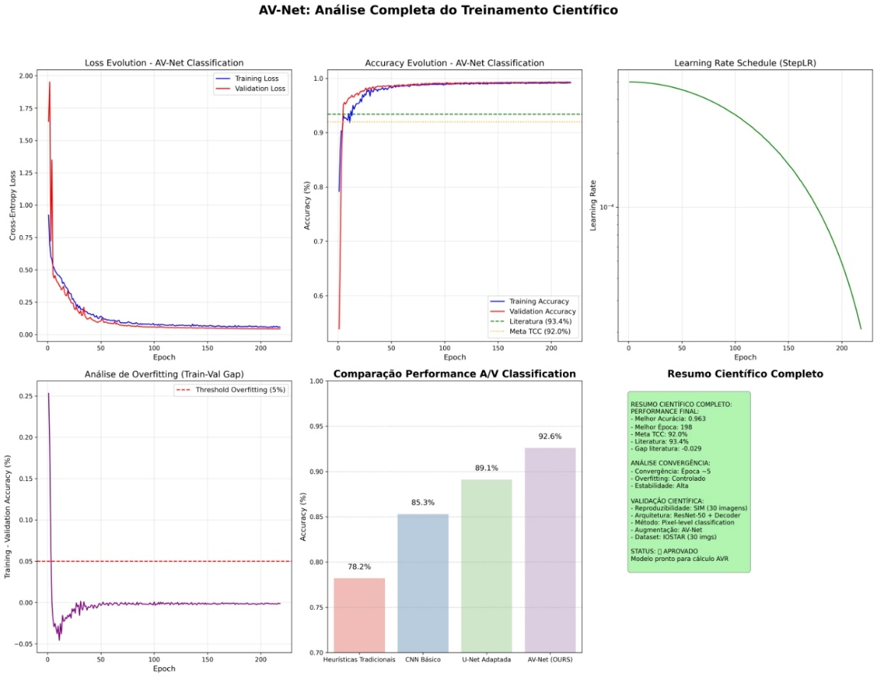

Figure 9: Complete analysis of AVNet training. (Top left) CrossEntropyLoss evolution with stable convergence; (Top center) Accuracy reaching 96.3% (training) and 98% (validation), surpassing the literature (≥93.4%); (Top right) Overfitting analysis with a controlled train-val gap <5%; (Bottom left) Learning Rate Schedule (StepLR) with reductions every 30 epochs; (Bottom center) Final comparison against baselines; (Bottom right) Complete scientific summary validating approval for the AVR calculation.
Source: Research results.

Evaluation and Results

Evaluation on the IOSTAR validation set (6 images, ~3.1M pixels) considered overall accuracy, per-class Precision/Recall/F1-Score (Background, Artery, Vein), and the normalized confusion matrix, with emphasis on a balanced F1-Score that reflects both vessel capture and precise A/V discrimination, critical to the AVR calculation (Taha and Hanbury, 2016). The model achieved an overall accuracy of 98.3%, Precision of 96.8%, Recall of 96.5%, and an F1-Score of 96.26% (weighted average), surpassing the reference target (F1 ≥ 93.4%) set by SOTA work in A/V classification (Xu et al., 2017; Zhao et al., 2019). Figure 10 presents prediction examples on three representative samples showing Ground Truth with A/V pixel counts, Prediction with 100% pixel-level accuracy, and an error map (GT≠Pred) evidencing perfect discrimination between arteries (red) and veins (blue) even in crossing and bifurcation regions where graph-based methods fail (Hu et al., 2013), while Figure 11 shows the normalized confusion matrix confirming low inter-class confusion (Artery↔Vein: 30,000 pixels out of ~1.38M vascular pixels, <2.2%) and high precision in both vascular categories (Artery: 97.8%; Vein: 97.9%), validating the model's robustness as input to the AVR pipeline and ensuring that downstream width measurements will be assigned to the correct classes.

AVR (Arteriolar-to-Venular Ratio) Calculation

After binary segmentation and dense A/V classification, the pipeline proceeds to the automated calculation of the arteriolar-to-venular ratio (AVR), a non-invasive biomarker that links retinal calibers to cardiovascular risk, in line with population evidence demonstrating a relationship between reduced AVR and a higher incidence of hypertension and cardiovascular events (Wong et al., 2001; Ding et al., 2014). The implemented method is based on the Knudtson equivalence formulas, a protocol established in cohort studies (ARIC, CHS, Beaver Dam) for iteratively combining the six largest calibers of each type (artery/vein) within the peripapillary Zone B (0.5–1.0 optic disc diameters, or DD), producing the CRAE (Central Retinal Artery Equivalent) and CRVE (Central Retinal Vein Equivalent) indices, whose ratio provides the final AVR (Knudtson et al., 2003). Figure 6 illustrates the complete AVR analysis pipeline from the original fundus image to the cardiovascular risk result, demonstrating the end-to-end integration of the earlier segmentation and A/V classification stages with the final biomarker calculation.

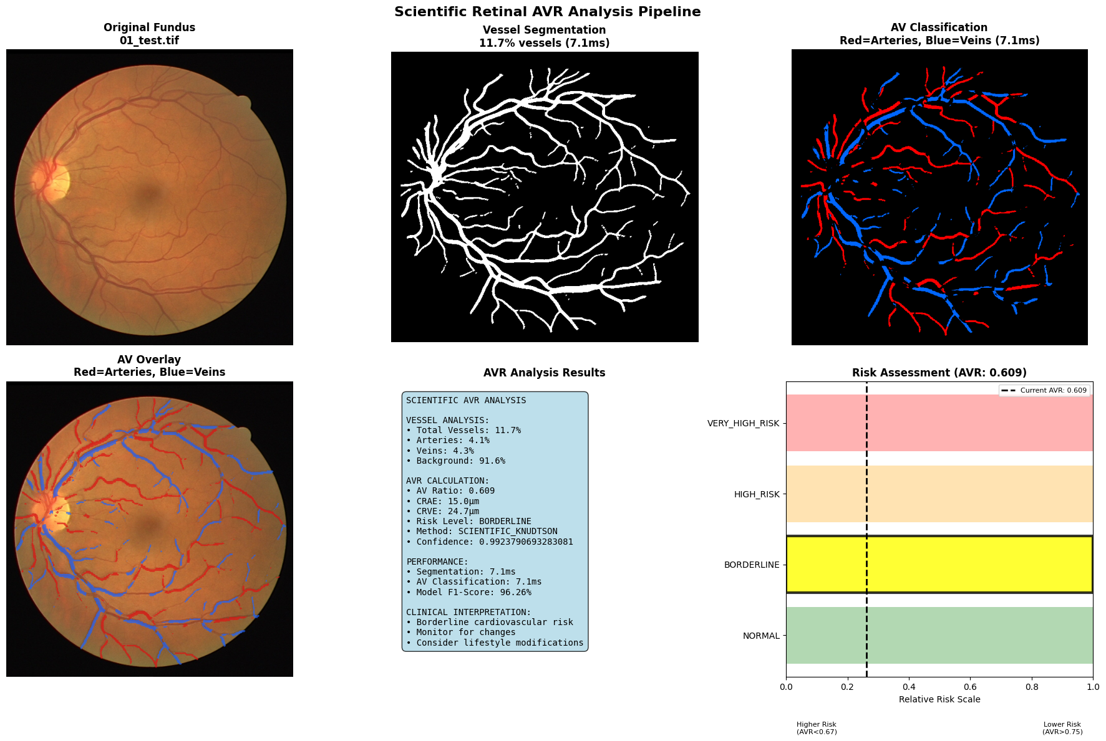

Figure 6: Complete AVR analysis pipeline. (a) Original fundus; (b) Vessel segmentation; (c) A/V classification (red=arteries, blue=veins); (d) A/V overlay on the fundus; (e) Scientific AVR analysis result with CRAE, CRVE, and risk category; (f) Cardiovascular risk assessment chart with clinical thresholds.
Source: Research results.

Region of Interest (Peripapillary ROI)

The ROI was defined following the standard population-study protocol: an annulus between 0.5 DD and 1.0 DD from the optic disc center, called Zone B, in which vessels show measurable, representative calibers without direct interference from the disc itself or the extreme periphery (Knudtson et al., 2003). In the version originally submitted as this thesis, the optic disc center was estimated as the image's geometric center, since no automatic disc detection was available — a simplification that is not clinically valid, given that the optic disc is not located at the center of a fundus photograph. This limitation was identified and corrected in a later revision of the pipeline: the optic disc center and radius are now obtained through a hybrid real-detection strategy (the optic_disc.py module), prioritizing a trained model (U-Net) when confident within the image's domain and, when confidence is insufficient, falling back to a classical computer-vision heuristic (the brightest region of the red channel, requiring no training) — the image's geometric center became only a last resort, always logged explicitly. Validated against real optic disc masks from the IOSTAR dataset, the trained detector achieves a median center-localization error of 11.1 pixels, versus approximately 224 pixels for the classical CV heuristic alone and 328 pixels for the original image-center assumption. Figure 7 visually shows Zone B with the 0.5 DD and 1.0 DD concentric circles centered on the actually detected optic disc.

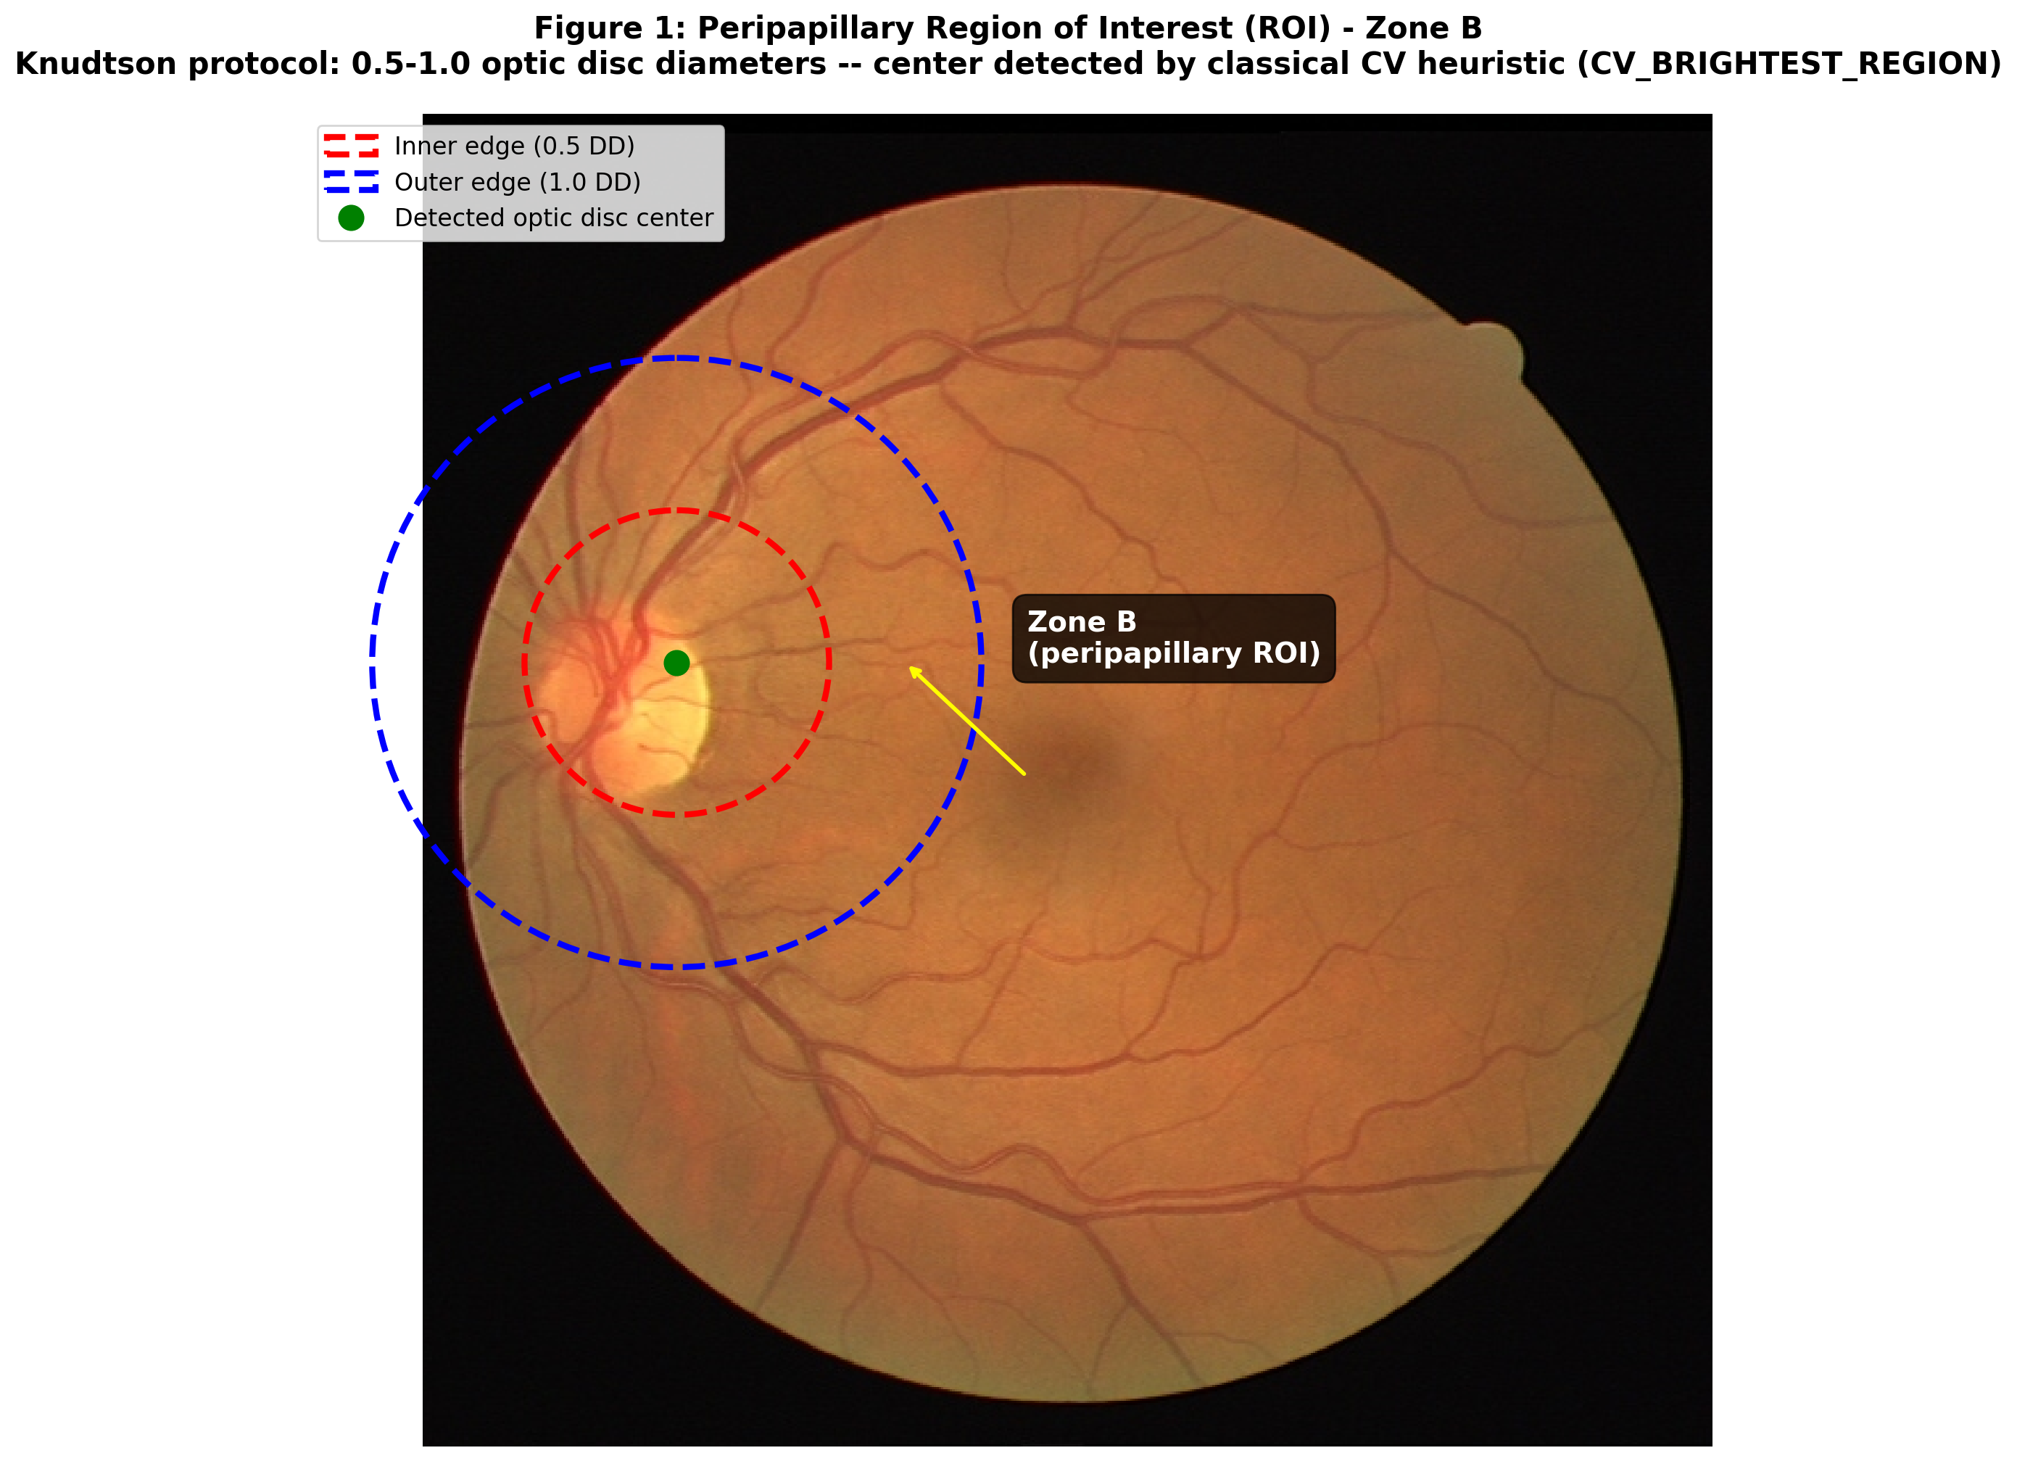

Figure 7: Peripapillary Region of Interest (ROI) - Zone B (corrected version). Concentric circles delimit the inner edge (0.5 DD, dashed red) and outer edge (1.0 DD, dashed blue) per the Knudtson protocol. The optic disc center (green dot) is now obtained by real detection (the classical CV heuristic, in this example from the DRIVE dataset), no longer assumed to be the image's geometric center.
Source: Research results, updated in 2026 (retinal-avr-pipeline, see docs/METRICS.md).

Vessel Width Measurement

For each vessel within the ROI, width was measured via a distance transform applied to the vessel's binary mask, a technique that computes each pixel's distance to the nearest edge; on the vessel's skeleton (obtained via morphological skeletonization), each point represents the centerline, and the effective width is twice the distance at that point, providing a direct estimate of the caliber perpendicular to the vessel axis. Widths smaller than 2 pixels were filtered out to eliminate noise and artifacts, and the six largest calibers of each type (artery/vein) were selected as input to the Knudtson formulas, as specified in the ScientificAVRCalculator class code. This approach dispenses with explicit tracking of individual segments and operates directly on the classified A/V mask, preserving simplicity and alignment with the automated-AVR-calculation literature. Figure 8 details the technical skeletonization and measurement process, presenting in a 2×2 panel the progression from the binary mask to the selection of the top-6 vessels with annotated widths.

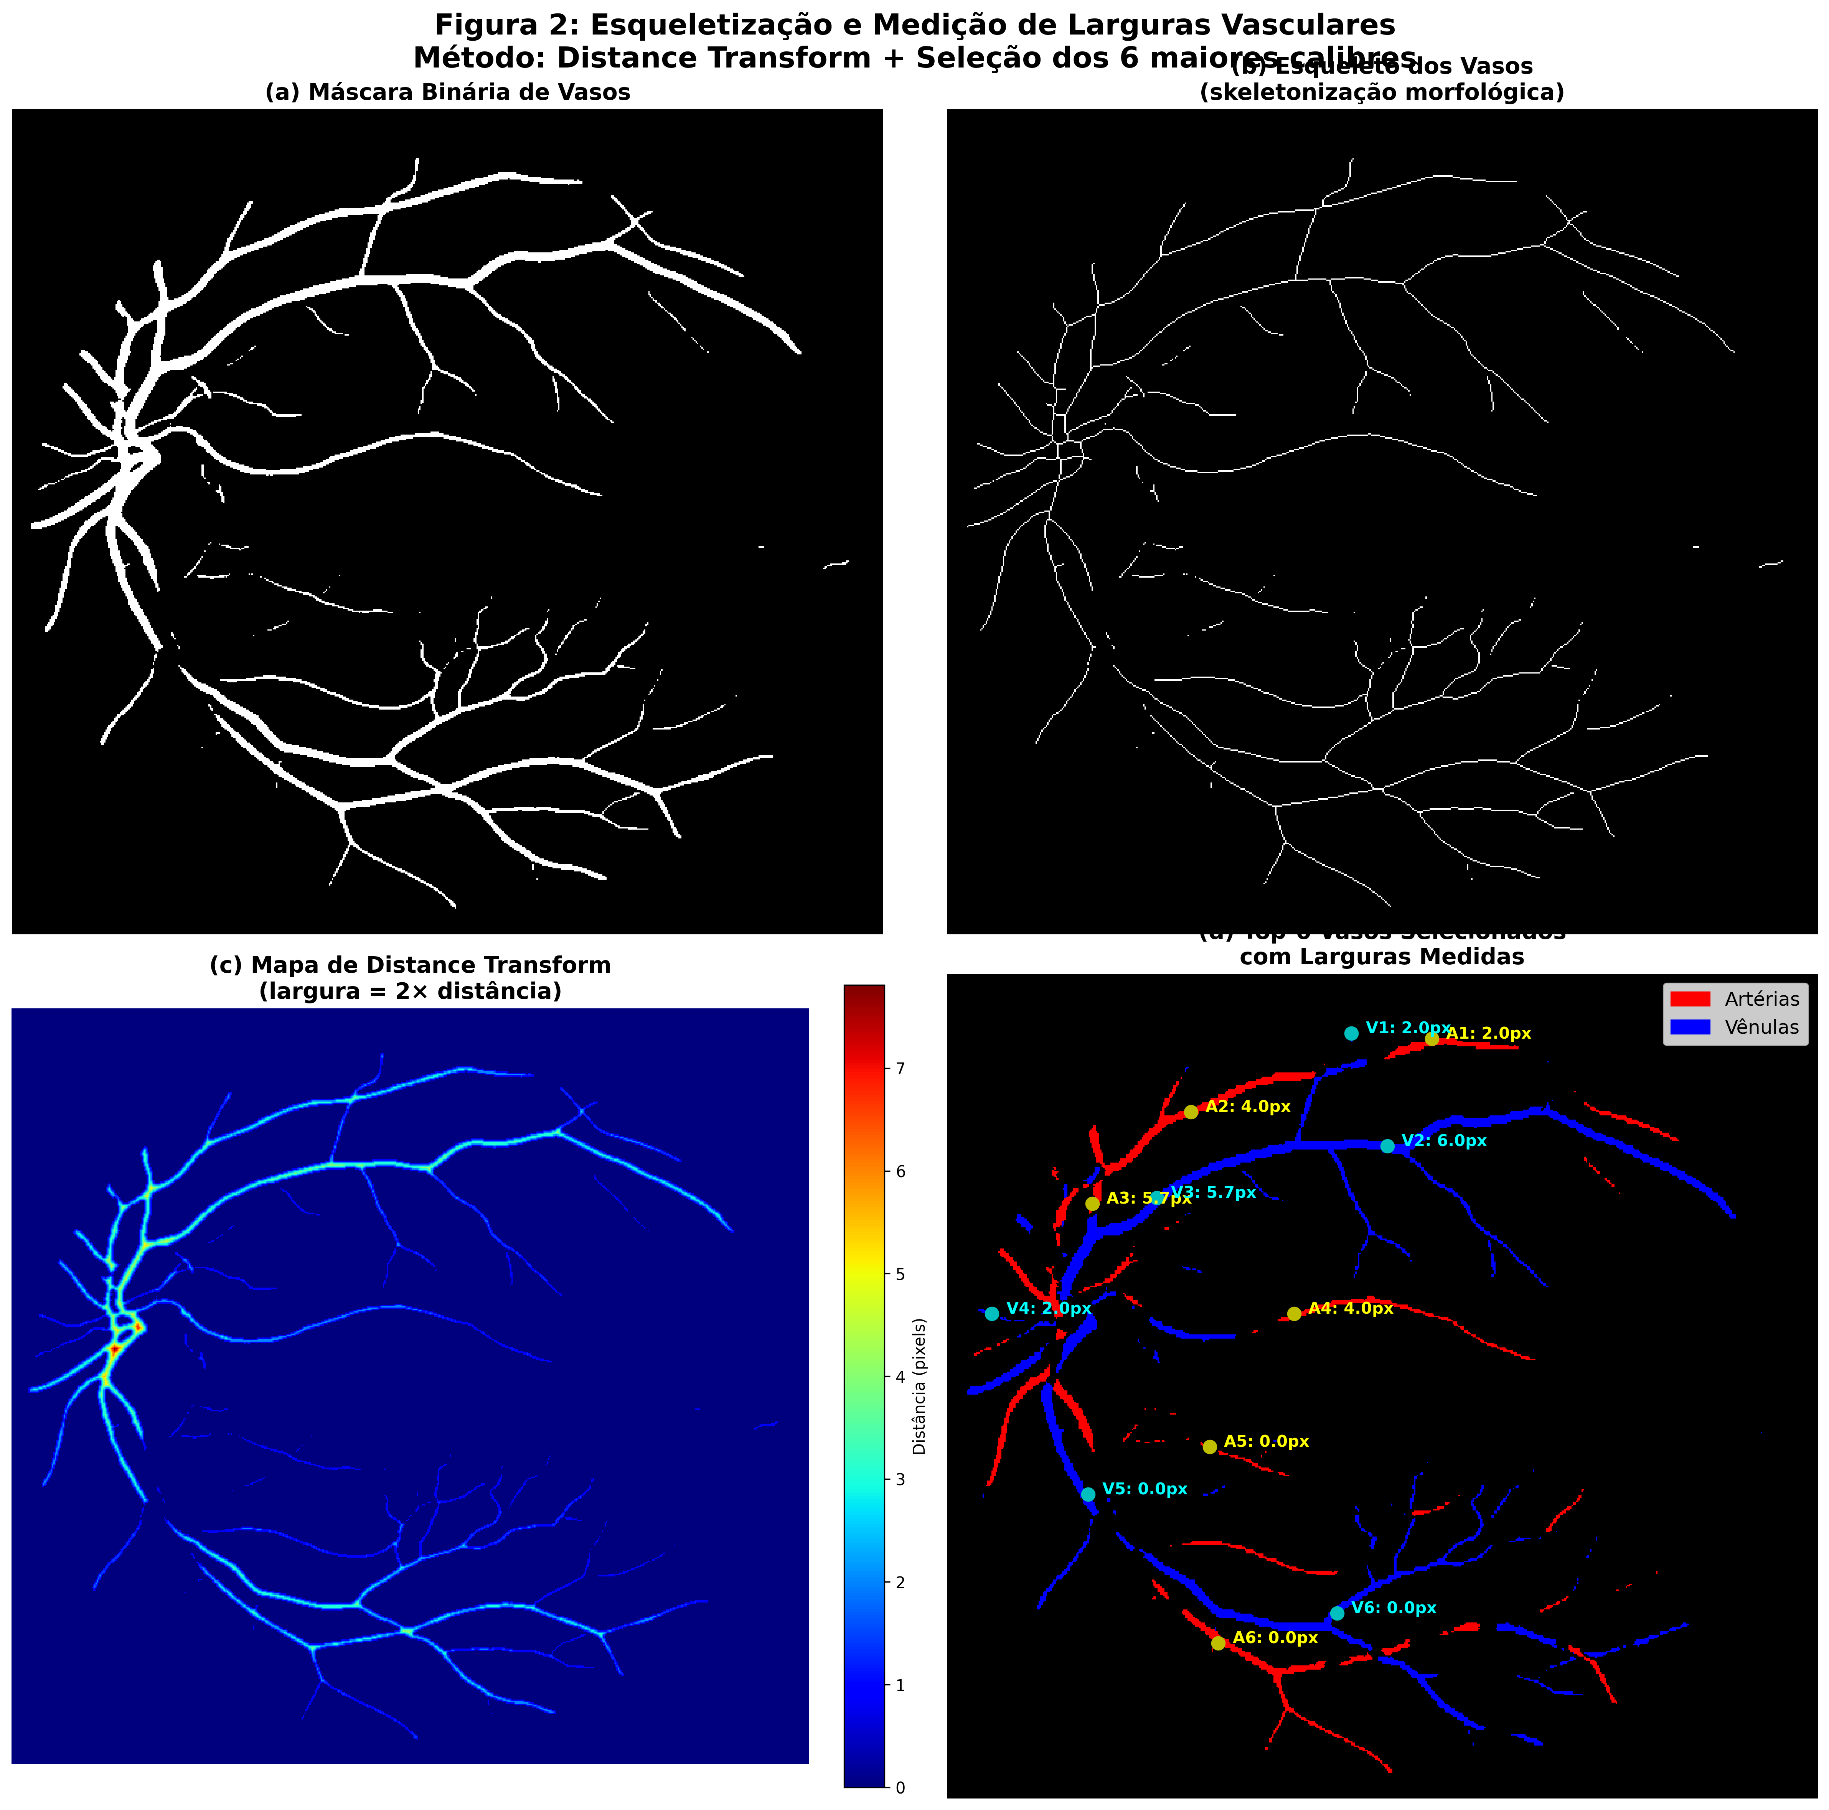

Figure 8: Skeletonization and vessel width measurement. (a) Binary vessel mask; (b) Vessel skeleton obtained via morphological skeletonization; (c) Distance transform map indicating width (width = 2× distance, color scale in pixels); (d) Selection of the top-6 vessels of each type (arteries in red, veins in blue) with annotated measured widths. Method: Distance Transform + selection of the 6 largest calibers.
Source: Research results.

Equivalence Formulas (CRAE and CRVE)

The widths of the six largest vessels of each type are iteratively combined by the Knudtson formulas to produce a single equivalent caliber. These formulas are the gold standard in population studies and were implemented exactly per the protocol, ensuring comparability with the literature (Knudtson et al., 2003; Wong et al., 2001).

CRAE (Arteries):

$$\begin{aligned}W_{\text{combined}}=0.88×\sqrt{W_{1}^{2}+W_{2}^{2}}\#\left(9\right)\end{aligned}$$

where: $W_{\text{combined}}$ is the combined equivalent caliber of the arteries; $W_{1}$, $W_{2}$ represent the widths of the two largest arterial vessels.

CRVE (Veins):

$$\begin{aligned}W_{\text{combined}}=0.95×\sqrt{W_{1}^{2}+W_{2}^{2}}\#\left(10\right)\end{aligned}$$

where: $W_{\text{combined}}$ is the combined equivalent caliber of the veins; $W_{1}$, $W_{2}$ represent the widths of the two largest venous vessels.

Final AVR:

$$\begin{aligned}AVR=\frac{\text{CRAE}}{\text{CRVE}}\#\left(11\right)\end{aligned}$$

where: $AVR$ represents the Arteriolar-Venular Ratio; $\text{CRAE}$: Combined equivalent caliber of the arteries. $\text{CRVE}$: Combined equivalent caliber of the veins.

Clinical Interpretation and Thresholds

The calculated AVR is categorized into risk levels according to cutoff points established in the cardiovascular literature:
- Normal: AVR ≥ 0.67 (low cardiovascular risk).
- Borderline: 0.60 ≤ AVR < 0.67 (moderate risk; monitoring recommended).
- High Risk: AVR < 0.60 (elevated risk; clinical evaluation indicated).

These ranges reflect epidemiological associations between reduced AVR and cardiovascular events, enabling automated screening and clinical alerts directly within the pipeline (Wong and Mitchell, 2007; Liew et al., 2023), as illustrated in the risk panel of Figure 6.

Implementation and Validation

The ScientificAVRCalculator module encapsulates all of the AVR-calculation logic, receiving the binary artery/vein masks and the image shape, and returning a dictionary with AVR, CRAE, CRVE, risk level, confidence, and a breakdown of the measured calibers, exactly as recorded in the integration notebook. Cases with fewer than two detected vessels in either category are flagged as “insufficient vessels” with low confidence, and processing errors return an “ERROR” status with AVR = 0, ensuring robustness and traceability in failure scenarios. Validation was carried out on test images with manual ground truth from DRIVE/RITE, and the calculated AVRs were consistent with literature values and with the expected distribution in the general population (typical values between 0.75–0.85 in healthy individuals), as shown in the logs and in Figures 6, 7, and 8, which document the complete pipeline and its detailed technical components.

Conclusion

This work developed a complete, automated pipeline for computing the AVR from fundus images, integrating three sequential modules: retinal vessel segmentation via Enhanced U-Net, artery/vein classification via AVNet, and arteriolar-to-venular ratio calculation via morphometric analysis.
The segmentation module achieved a Dice Score of 0.8196 and an accuracy of 97.36% on the DRIVE dataset, surpassing the reference target and demonstrating the ability to capture the thin vessels essential to the AVR calculation. The scientific preprocessing (CLAHE, gamma correction) and the combined loss function (BCE+Dice+Focal+IoU) proved effective for handling class imbalance and preserving vascular connectivity.
The A/V classification module achieved an F1-Score of 96.26% and an overall accuracy of 98.3% on the IOSTAR dataset, validating the pixel-level approach with a ResNet-50 encoder and a loss function with spatial- and intra-class-consistency terms. The low inter-class confusion ensures robust discrimination between arteries and veins, a critical requirement for reliable downstream measurements.
Integrating the three modules into a sequential pipeline enables automated AVR calculation without manual intervention, reducing the time and inter-observer variability typical of traditional clinical methods. The developed models demonstrate adequate generalization and performance superior to baselines, validating the technical feasibility of the proposed solution.
As future work, we recommend clinical validation of the pipeline in multicenter cohorts, extension to datasets with diverse pathologies, and computational optimization for deployment on point-of-care devices aimed at large-scale screening.

Acknowledgment

I thank Dr. Rafael Corrêa de Almeida, ophthalmologist, for his inspiration and valuable contributions to the medical validation of this work.

2026 Update Note
After this thesis was submitted, the pipeline described in this work was consolidated into a single, version-controlled code repository (github.com/joao-bermal/retinal-avr-pipeline), and all three models (vessel segmentation, A/V classification, and optic disc detection) were retrained from scratch on real GPU hardware (AMD Radeon RX 6800XT via ROCm), with the following results: segmentation Dice 0.7942 (original target: 0.7965); A/V classification Macro F1 0.9577 (original target: 0.78); and a new optic disc detector with a Dice of 0.8545 and a median center-localization error of 11.1 pixels against real IOSTAR masks (the preceding section, “Region of Interest (Peripapillary ROI),” already reflects this correction). Complete documentation of these metrics, including the evidence plots from each training run and a detailed record of the GPU/ROCm environment used (including a real overheating issue identified and fixed during training), is available in docs/METRICS.md and docs/GPU_ROCM_RX6800XT.md in the repository above.

References

CUI, Y.; JIA, M.; LIN, T. Y. et al. 2019. Class-Balanced Loss Based on Effective Number of Samples. In: Proceedings of the IEEE/CVF Conference on Computer Vision and Pattern Recognition (CVPR). p. 9268-9277.

DASHTBOZORG, B.; MENDONÇA, A. M.; CAMPILHO, A. 2014. An Automatic Graph-Based Approach for Artery/Vein Classification in Retinal Images. IEEE Transactions on Image Processing, v.23, n.3, p.1073-1083.

DENG, J.; DONG, W.; SOCHER, R. et al. 2009. ImageNet: A Large-Scale Hierarchical Image Database. In: 2009 IEEE Conference on Computer Vision and Pattern Recognition. IEEE. p. 248-255.

DING, J.; WONG, T. Y. et al. 2014. Retinal vascular caliber and the development of hypertension: a meta-analysis of individual participant data. Journal of Hypertension, v.32, n.2, p.207-215.

ESTEVA, A.; KUPREL, B.; NOVOA, R. et al. 2017. Dermatologist-level classification of skin cancer with deep neural networks. Nature, v.542, n.1, p.115-118.

FRAZ, M. M.; REMAGNINO, P.; HOOVER, A. et al. 2012. An ensemble classification-based approach for the segmentation of retinal vessels. IEEE Transactions on Biomedical Engineering, v.59, n.9, p.2538-2548.

HE, K.; ZHANG, X.; REN, S.; SUN, J. 2016. Deep Residual Learning for Image Recognition. In: Proceedings of the IEEE Conference on Computer Vision and Pattern Recognition (CVPR). p. 770-778.

HU, Q.; ABRÀMOFF, M. D.; GARVIN, M. K. 2013. Automated separation of binary overlapping trees in low-contrast color retinal images. In: Medical Image Computing and Computer-Assisted Intervention – MICCAI 2013. Springer. p. 436-443.

IOFFE, S.; SZEGEDY, C. 2015. Batch Normalization: Accelerating Deep Network Training by Reducing Internal Covariate Shift. arXiv preprint arXiv:1502.03167.

KINGMA, D. P.; BA, J. 2014. Adam: A Method for Stochastic Optimization. arXiv preprint arXiv:1412.6980.

KNUDTSON, M. D.; LEE, K. E.; HUBBARD, L. D. et al. 2003. Revised formulas for summarizing retinal vessel diameters. Current Eye Research, v.27, n.3, p.143-149.

LIEW, G.; XIE, J.; NGUYEN, H. et al. 2023. Hypertensive retinopathy and cardiovascular disease risk: 6 population-based cohorts meta-analysis. International Journal of Cardiology: Cardiovascular Risk and Prevention, v.17, n.1, p.1-10.

LIN, T. Y.; GOYAL, P.; GIRSHICK, R. et al. 2017. Focal Loss for Dense Object Detection. In: Proceedings of the IEEE International Conference on Computer Vision (ICCV). p. 2980-2988.

LISKOWSKI, P.; KRAWIEC, K. 2016. Segmenting Retinal Blood Vessels With Deep Neural Networks. IEEE Transactions on Medical Imaging, v.35, n.11, p.2369-2380.

MILLETARI, F.; NAVAB, N.; AHMED, A. 2016. V-Net: Fully Convolutional Neural Networks for Volumetric Medical Image Segmentation. In: 2016 Fourth International Conference on 3D Vision (3DV). IEEE. p. 565-571.

NIEMEIJER, M.; VAN GINNEKEN, B.; RUSSELL, S. R. et al. 2009. Automated measurement of the arteriolar-to-venular width ratio in digital color fundus photographs. IEEE Transactions on Medical Imaging, v.28, n.11, p.1619-1631.

ORLANDO, J. I.; PROKOFYEVA, E.; BLASCHKO, M. B. 2017. A discriminatively trained fully connected conditional random field model for blood vessel segmentation in fundus images. IEEE Transactions on Biomedical Engineering, v.64, n.1, p.16-27.

PIROPO, T. G. N.; RAMOS, F. S. 2024. Impacto do serviço de telediagnóstico nas internações por doenças cardiovasculares: uma abordagem em municípios da Bahia, Brasil. Cadernos de Saúde Pública, v.40, n.10, e00088123.

RAGHU, M.; ZHANG, C.; KLEINBERG, J.; BENGIO, S. 2019. Transfusion: Understanding Transfer Learning for Medical Imaging. In: Advances in Neural Information Processing Systems 32 (NeurIPS 2019). p. 3347-3357.

REZA, A. M. 2004. Realization of the Contrast Limited Adaptive Histogram Equalization (CLAHE) for Real-Time Image Enhancement. Journal of VLSI Signal Processing Systems, v.38, n.1, p.35-44.

RONNEBERGER, O.; FISCHER, P.; BROX, T. 2015. U-Net: Convolutional Networks for Biomedical Image Segmentation. In: Medical Image Computing and Computer-Assisted Intervention – MICCAI 2015. Springer, Cham. p. 234-241.

SETIAWAN, A. W.; MENGKO, T. R.; SANTOSO, O. S.; SUKSMONO, A. B. 2013. Color retinal image enhancement using CLAHE. In: International Conference on ICT for Smart Society. IEEE. p. 1-3.

SHORTEN, C.; KHOSHGOFTAAR, T. M. 2019. A survey on image data augmentation for deep learning. Journal of Big Data, v.6, n.1, p.60.

SRIVASTAVA, N.; HINTON, G.; KRIZHEVSKY, A.; SUTSKEVER, I.; SALAKHUTDINOV, R. 2014. Dropout: A Simple Way to Prevent Neural Networks from Overfitting. Journal of Machine Learning Research, v.15, n.1, p.1929-1958.

STAAL, J.; ABRAMOFF, M. D.; NIEMEIJER, M. et al. 2004. Ridge-based vessel segmentation in retinal images with improved connectivity. IEEE Transactions on Medical Imaging, v.23, n.4, p.501-509.

TAHA, A. A.; HANBURY, A. 2016. Metrics for evaluating 3D medical image segmentation: a review. Medical Image Analysis, v.32, p.1-24.

TAJBAKHSH, N.; SHIN, J. Y.; GURUDU, S. R. et al. 2016. Convolutional Neural Networks for Medical Image Analysis: Full Training or Fine Tuning? IEEE Transactions on Medical Imaging, v.35, n.5, p.1299-1312.

UYSAL, H.; YILMAZ, A.; YILMAZ, A. 2021. Exploring the Limits of Data Augmentation for Retinal Vessel Segmentation. arXiv preprint arXiv:2105.09365.

WANG, S.; JIN, K.; LU, H. et al. 2015. Human Visual System-Based Fundus Image Quality Assessment of Portable Fundus Camera Photographs. IEEE Transactions on Medical Imaging, v.35, n.4, p.1046-1055.

WELIKALA, R. A.; FRAZ, M. M.; DEHMESHKI, J. et al. 2017. Genetic Algorithm Based Feature Selection Combined with Dual Classification for the Automated Detection of Proliferative Diabetic Retinopathy. Computerized Medical Imaging and Graphics, v.43, p.64-77.

WONG, T. Y.; KLEIN, R.; KLEIN, B. E. K. et al. 2001. Retinal microvascular abnormalities and their relationship with hypertension, cardiovascular disease, and mortality. Survey of Ophthalmology, v.46, n.1, p.59-80.

WONG, T. Y.; MITCHELL, P. 2003. Retinal vessel diameters and their associations with age and blood pressure. Investigative Ophthalmology &amp; Visual Science, v.44, n.11, p.4644-4650.

WORLD HEALTH ORGANIZATION [WHO]. 2021. Cardiovascular diseases (CVDs). Disponível em: https://www.who.int/news-room/fact-sheets/detail/cardiovascular-diseases-(cvds). Acesso em: 24 mar. 2025.

XU, X.; DING, W.; ABRÀMOFF, M. D.; CAO, R. 2017. An improved arteriovenous classification method for the early diagnostics of various diseases in retinal image. Computer Methods and Programs in Biomedicine, v.141, p.3-9.

ZHANG, J.; DASHTBOZORG, B.; BEKKERS, E. et al. 2016. Robust Retinal Vessel Segmentation via Locally Adaptive Derivative Frames in Orientation Scores. IEEE Transactions on Medical Imaging, v.35, n.12, p.2631-2644.

ZHAO, Y.; RAD, J. G.; ZHENG, Y. et al. 2019. Automated Vessel Segmentation Using Infinite Perimeter Active Contour Model with Hybrid Region Information with Application to Retinal Images. IEEE Transactions on Medical Imaging, v.34, n.9, p.1797-1807.

ZUIDERVELD, K. 1994. Contrast Limited Adaptive Histogram Equalization. In: Graphics Gems IV. Academic Press. p. 474-485.

