Universidade de Lisboa


Faculdade de Ciências
Departamento de Química e Bioquímica | Abordagens Ómicas em Bioquímica e Biotecnologia

Prof. Margarida Gama Carvalho | Prof. Francisco Rodrigues Pinto

Final Project

Methylone and MDMA mice model frontal cortex neuroplastogen activity
– An analysis –

Student: | João Matias – 64430  Vítor Medeiros – 56351  Sofia Lopes – 58175
Studies: | Biochemistry | Bioinformatics
Semester: | 1st

Lisboa, December 23th, 2024
Table of Contents
1 Introduction 1
1.1 Base Study 2
2 Methods 3
2.1 Data Analysis 3
2.2 Differential Expression Analysis 4
2.3 Pathway Analysis 4
2.4 Pathway and gene enrichment pathway comparison 4
3 Results 5
3.1 Differential Expression Analysis 5
3.2 Pathway Analysis 6
4 Discussion 8
5 Conclusion 9

List of Figures
Fig. 1: a. MDMA b. Methylone 2
Fig. 2: Volcano plots show significantly regulated genes in the frontal cortex after treatment with (a) methylone or (b) MDMA compared to vehicle-injected controls (N = 6 per group). Light gray dots represent genes that were not significantly changed by either treatment. 6
Fig. 3: The top ten upregulated pathways for (a) MDMA and (b) methylone 7
Fig. 4: The top ten downregulated pathways for (a) MDMA and (b) methylone 8
List of Tables
Tab. 1: Comparison of Up and Downregulated genes in FC and AMY 6
Tab. 2: Comparison of Up and Downregulated genes in FC and AMY 7

List of Abbreviations and Symbols
MDMA | 3,4-Methylenedioxymethamphetamine
PTSD | Post Traumatic Stress Disorder
SSRI | Selective serotonin reuptake inhibitor
MDMA-AT | MDMA Assisted Therapy
MDD | Medically diagnosed depression
GPCRs | G-protein-coupled-receptors
GEO Database | Gene Expression Omnibus Database
FC | Frontal Cortex
GO | Gene Ontology
KEGG | Kyoto Encyclopedia of Genes and Genomes
log₂FC | log₂ fold change
FDR | False discovery Rate
AMY | Amygdala

Abstract
Our work investigates the neuroplastogenic activity of Methylone and MDMA in the frontal cortex of rodents, assessing their potential therapeutic effects for Post-Traumatic Stress Disorder (PTSD) and Major Depressive Disorder (MDD). Using RNA sequencing data from treated mice, we conducted differential gene expression and pathway enrichment analyses to evaluate the effects of each compound. The results highlight distinct and overlapping patterns of gene modulation, with Methylone exhibiting a more selective effect compared to MDMA, suggesting a lower likelihood of off-target effects. Both compounds significantly upregulated synaptic pathways, consistent with their proposed neuroplastogenic effects, while MDMA displayed broader activity, affecting metabolic and cellular stress pathways. These findings emphasize the therapeutic promise of Methylone as a targeted treatment option with fewer side effects. Future research should further explore the molecular mechanisms underlying these effects to better understand their applicability in PTSD and MDD treatment.

Keywords: PTSD, MDMA, Methylone, neuroplastogen, RNA sequencing, pathway analysis, frontal cortex.

Introduction
Post-traumatic stress disorder (PTSD) is a mental condition that develops most often as result of exposure to war, sexual assault and other types of trauma. PTSD greatly lowers the quality of life of a patient. It has been reported that patients suffering from the condition have higher likelihood of having alcohol and drug abuse problems, other anxiety disorders and even affective disorders like mania and dysthymia (a type of long-term depression)[]. Strangely enough there seems to be a strong correlation between the previously married (separated, divorced, or widowed) than the currently married for both men and women, controlling for age. Suicide attempts have been reported, via questionnaire, to be ten times higher between non PTSD and PTSD patients (0.5 and 6.5% respectively)[].
There are several treatment types for PTSD using psychological therapies, pharmacotherapy or both[]. Common pharmacotherapies for PTSD include SSRIs (antidepressants) that are second-generation antidepressants like introduced in the 1980s, these were a major advancement over first-generation drugs due to their higher selectivity and fewer side effects[]. Some notable examples of second generation SSRIs include S-Citalopram (Escitalopram), Citalopram and Fluoxetine (Prozac).
MDMA-AT has recently been subject of discussion for the treatment of PTSD, showing promising results in patient outcomes[].
However available pharmacotherapies are limited, take weeks to show modest benefit (in the case of SSRIs it can be from 2-6 weeks)^{[4]} and remain ineffective for up to 40% of patients.
Methylone, an MDMA analogue, is being studied as a potential PTSD treatment due to its rapid and long-lasting antidepressant and anti-anxiety effects seen in preclinical research. This work examined how methylone affects gene activity and brain pathways in the frontal cortex of mice brains tied to PTSD and MDD. We also compared its effects to MDMA, which has shown promise in PTSD treatment, to identify similarities and differences between the two compounds[]. Figure 1 shows the chemical structures of the two compounds.
a. b.
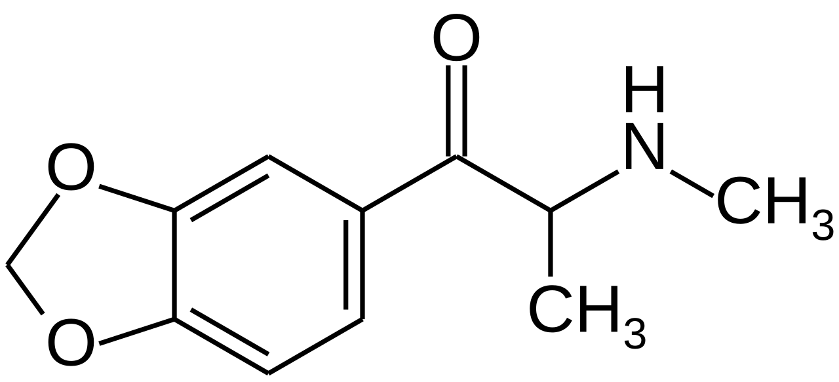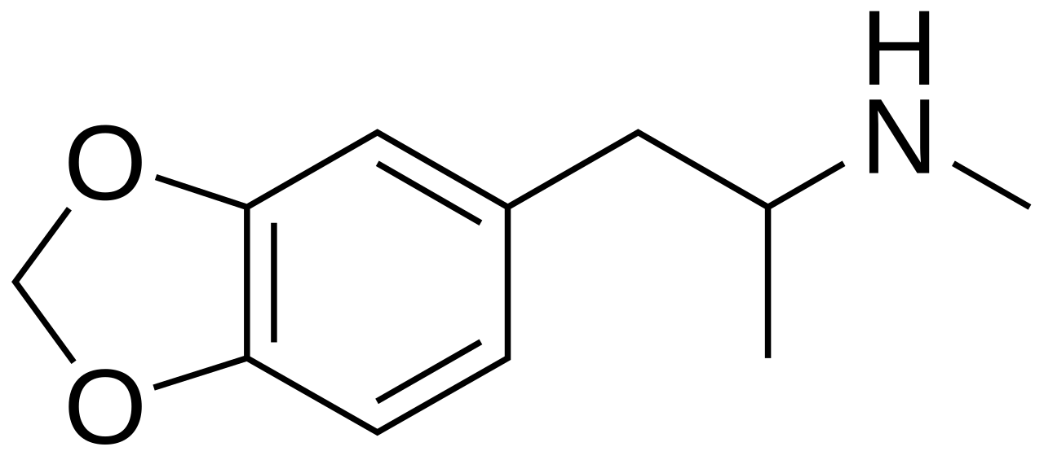
Fig. 1: a. MDMA b. Methylone
Source: Wikipedia

Base Study
All our data was extracted from (Warner-Schmidt et al., 2024)^{[6]}, in this study monoamine binding, uptake and release along with a high-throughput screen to assess agonist and antagonist activities across 168 GPCRs in vitro were done. Our focus however will be on the RNA-seq data produced in the experiments. RNA-seq was used to examine changes in the amygdala and frontal cortex, two brain regions linked to emotional learning and commonly impacted by PTSD and MDD. Rats were treated with either a single dose of methylone or MDMA (both at 10 mg/kg, administered via intraperitoneal injection), and their responses were compared to control groups (vehicle), the brains were harvested and frozen 8h post injection. All the groups were composed of 6 individual rats (Vehicle, n=6; MDMA, n=6; Methylone, n=6). The purpose of the RNA-seq data was to identify which genes, pathways, and/or functions were commonly regulated by methylone and MDMA, with the hypothesis that they might underlie therapeutic activity. In contrast, genes and pathways regulated by either drug alone might reflect off-target effects.

Methods
The data produced in the (Warner-Schmidt et al., 2024) study was obtained from the GEO Database with the following ascension number: GSE253280. We extracted the 18 available samples from the database related to the FC (Frontal Cortex) experiments. Samples were named FC_”condition”_x. Where “condition” could be either Methylone, MDMA or Vehicle and x is the number of the sample (1 through 6). These are .txt files that contain the GeneID, location, strand length, gene count and more. Since we didn’t use the raw data from the study these files had been previously analyzed in the matters of quality of raw data by the authors. However, for our analysis we created corresponding files for each of the sample files containing only the GeneID and respective count number (first and last column of each row in the .txt files). In the course of our work we also used the dplyr[] R package to handle our datasets. All our files and R code can be found on GitHub under the repository: https://github.com/joao-matias0/omics.

Data Analysis
For our analysis we used the R-Studio to treat and analyze the data. The first part of the analysis consisted on the merging of all the data from the individual .txt files into one table with the following columns: Common Name (gene); condition (x16); GeneID. After having our data correctly assembled we proceeded to do a differential expression analysis, using the DESeq2[] R package followed by Gene Set Enrichment Analysis (GSEA). Then with the clusterProfiler[] R package and the org.Rn.eg.db[] library from Bioconductor we proceeded with pathway analysis of the differentially expressed genes using the Gene Ontology[,] database and the KEGG database[,,].

Differential Expression Analysis
For our differential expression analysis we used a table containing the GeneID and respective count numbers of the genes in the 18 samples. In out table the first 6 columns of the count number are “Vehicle”, 7-12 are “Methylone” and 13-18 are “MDMA”. Using DESeq2 we estimated variance-mean dependence in count data comparing the control condition to both drugs. We filtered significant genes with an adjusted p value cutoff of 0.05 (adjusted p-value < 0.05) and extracted subsets of the differentially expressed genes by log₂ fold change, with upregulated genes considered with a log₂FC > 0 and downregulated genes considered with a log₂FC < 0.

Pathway Analysis
Using our lists of differentially expressed genes we proceeded with a pathway analysis in order to find specific pathways and functions that are being affected by the presence of both drugs in the tissue. To do this we used the clusterProfiler R package to search for enriched pathways using our list of differentially expressed genes in the GO database and KEGG database. To adjust for the FDR we used the Benjamini-Hochberg method in order to limit the amount of FDRs by adjusting p-values. Furthermore a p-value cutoff of 0.05 and a q-value cutoff of 0.2 were used (meaning only results with an FDR below 20% are retained). The list of enriched pathways were saved as separate .csv files.

Pathway and gene enrichment pathway comparison
To further understand the effects of methylone and MDMA on the target tissue we proceeded with a comparison analysis between their enriched pathways by crossing the results from the individual pathway analysis of both drugs. In addition to this, and to better understand the genes that are involved in the therapeutic effect of both drugs we decided to cross the lists of differentially expressed genes of both drugs (up and down regulated separately) to obtain list of common differentially expressed genes in both drugs. We also sorted and analyzed the top ten enriched GO terms from both drugs from our pathway analysis results.

Results

Differential Expression Analysis
The summary of our differential expression analysis can be found on Table 1, where we list the number or upregulated genes and downregulated genes for both conditions (MDMA and Methylone) in the frontal cortex and the genes regulated by both drugs, the results from the amygdala analysis by (Warner-Schmidt et al., 2024) are also represented.
 | Downregulated |  |  | Upregulated
Location | MDMA | Methylone | Both | MDMA | Methylone | Both
FC | 939 | 78 | 21 | 495 | 55 | 29
AMY | 871 | 111 | 97 | 548 | 10 | 9
Tab. 1: Comparison of Up and Downregulated genes in FC and AMY
Source: Own creation
The lists of the differentially expressed genes as well as the genes regulated by both drugs can be found in out GitHub repository.
To better understand the regulatory effect of both drugs we produced Volcano Plots using several R packages including ggplot2[], to capture the differences between expression magnitude and gene significance Figure 2.
a. b.
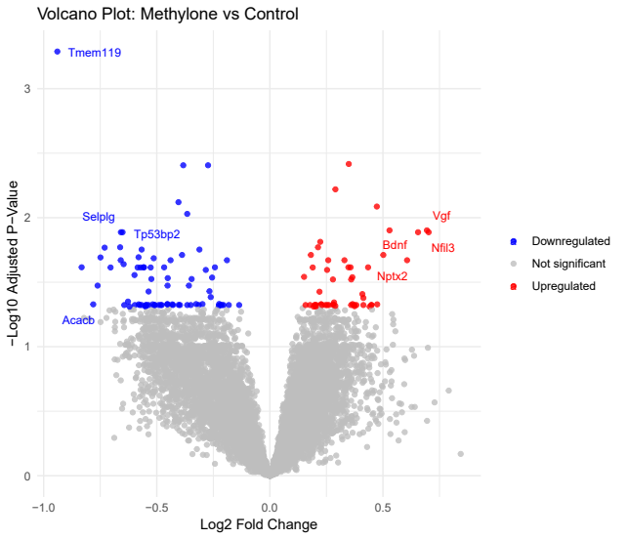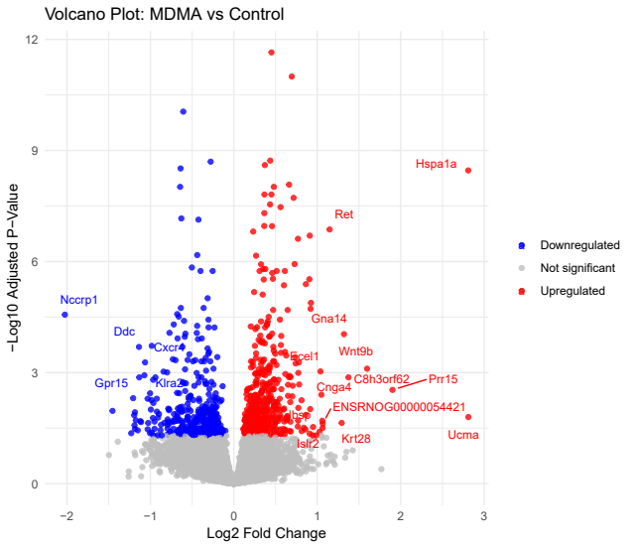
Fig. 2: Volcano plots show significantly regulated genes in the frontal cortex after treatment with (a) methylone or (b) MDMA compared to vehicle-injected controls (N = 6 per group). Light gray dots represent genes that were not significantly changed by either treatment.
Source: Own Creation

Pathway Analysis
Our pathway analysis yielded very different results when using the GO database or KEGG database. The quantification of enriched pathways found in the gene list for each pathway is outlined in Table 2.
 | Downregulated |  | Upregulated
Database | MDMA | Methylone | MDMA | Methylone
KEGG | 8 | 1 | 4 | 0
GO | 66 | 38 | 53 | 19
Tab. 2: Comparison of Up and Downregulated genes in FC and AMY
Source: Own creation
In general, the KEGG results weren’t very elucidative. The GO database results made it clear that MDMA is involved in many more enrichment pathways than methylone. Furthermore, it seems that both drugs upregulate a number of pathways involved in synaptic processes, however MDMA has a much more broad set of effects outside of those expected. Both drugs downregulate pathways involved in metabolic processes of associated with the catabolism of several biomolecules (especially fats) again with MDMA having much more broad effects. The top ten upregulated pathways for both drugs are shown in Figure 3 and the same is shown for downregulated pathways in Figure 4.
It is clear from these results and from what was previously found by (Warner-Schmidt et al., 2024) that methylone has much more targeted effects on synaptic pathways in mice. Our work however had considerably different outcome on predicted upregulated pathways by methylone in the FC.
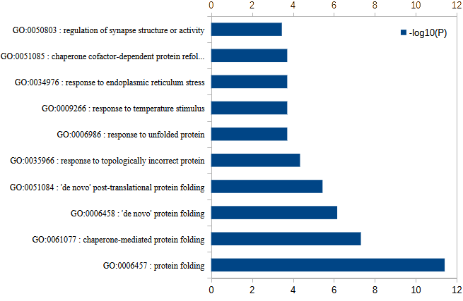a. MDMA b. Methylone
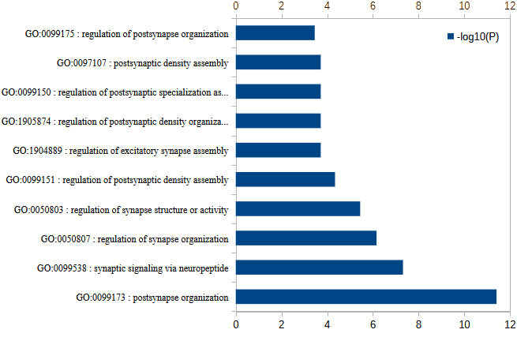
Fig. 3: The top ten upregulated pathways for (a) MDMA and (b) methylone
Source: Own Creation
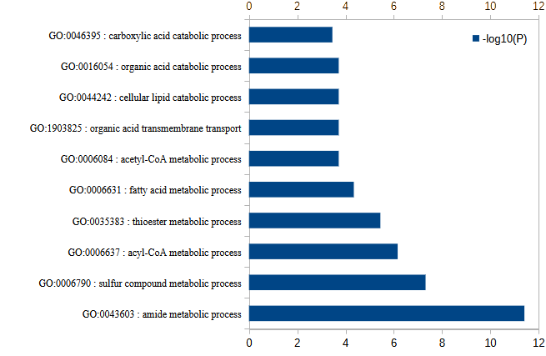a. MDMA b. Methylone
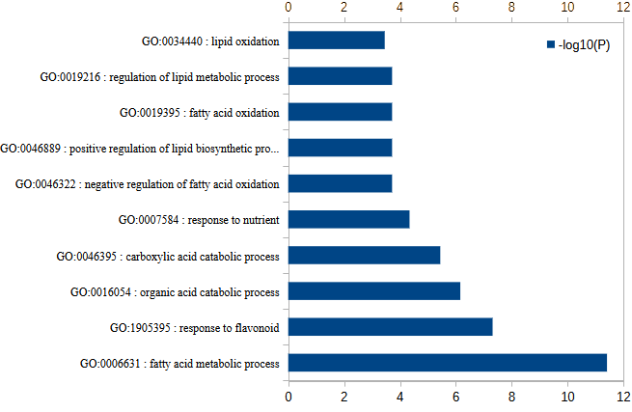
Fig. 4: The top ten downregulated pathways for (a) MDMA and (b) methylone
Source: Own Creation

Discussion
In total, the findings of our work show differential and overlapping actions of methylone and MDMA in modulating gene expression and pathways in FC of mice, extending previous evidence for their therapeutic potential to treat PTSD and MDD.
Specific and shared patterns of gene regulation were evidenced with both methylone and MDMA. Notably, methylone showed a more selective pattern of modulation, up- or downregulating fewer genes compared to MDMA. Such specificity of action suggests lower potential for off-target effects and may render it safer in therapeutic use. In contrast, the larger pattern of MDMA gene regulation would suggest an action across many neural pathways, to which therapeutic efficacy and side effect profile might be attributed. Furthermore, genes regulated by both drugs were identified, and as was postulated by (Warner-Schmidt et al., 2024), these genes might me responsible for the therapeutic effect of both drugs, hence further research into pathways in the brain involving these genes might be important for the study of PTSD and MDD.
Pathway analysis indicated that both compounds upregulate synaptic related processes, in agreement with their reputed neuroplastogenic effects. However, the broader pathway enrichment with MDMA suggested more far reaching effects beyond mere synaptic modulation, including targeting metabolic and cellular stress response pathways. This difference thus highlights the potential of methylone as a targeted and specific treatment in PTSD and MDD. Most particularly in the metabolic pathways of lipid catabolism, this downregulation observed could correspond to a conserved neuroprotective mechanism[].
The selectivity of methylone, with fewer genes differentially expressed a proxy for off target effects are reasons that this drug deserves further investigation for treating PTSD with fewer side effects.
To better understand how these compounds affect the brain however, studies like (Warner-Schmidt et al., 2024) are fundamental, due to the inclusion of other brain regions like the amygdala that were quantified and thus a more broad sense of the action of these drugs in various areas of brain tissue was possible.

Conclusion
Our work compared the effects of MDMA and methylone on mice brain tissue in the frontal cortex and exhibited significant modulation of genes and pathways affecting the neuroplastogenic activity of both drugs, showing a broader effect of MDMA on secondary pathways, while methylone presented a more targeted and specific regulation with less off target effects. Our analysis highlights the importance of these drugs, for the treatment of MDD and PTSD, showing that methylone is a good candidate for further research in the treatment of these conditions.

Appendices
Appendix I: List of genes upregulated and downregulated by both drugs
Upregulated | Downregulated
Dnajb5 | Acacb
Mier2 | Scarb2
Prrt1 | Sox9
Nptx2 | Abat
C12h12orf43 | Tp53bp2
Vgf | Fam210b
Etv5 | Acss1
Dgkg | Abcb1a
Camk1g | Acadl
Syt13 | Arnt2
Nfil3 | S1pr1
Lrfn2 | Acsl3
Gne | Rcbtb2
Ddost | Gpam
Arhgap39 | Bloc1s5
Shisa7 | Cplx3
Ncoa5 | Ppfibp2
Egr3 | Slc16a1
Zfp428 | Atp13a5
Lrfn1 | Mlxipl
Psrc1
Tmem198
Numbl
Galnt9
Bdnf
Ensa
Ppp1r12c
Selenom
Source: Own creation

Kessler, R. C., Sonnega, A., Bromet, E., Hughes, M., & Nelson, C. B. (1995). Posttraumatic stress disorder in the National Comorbidity Survey. Archives of general psychiatry, 52(12), 1048–1060. https://doi.org/10.1001/archpsyc.1995.03950240066012
Sareen, J., Cox, B. J., Stein, M. B., Afifi, T. O., Fleet, C., & Asmundson, G. J. (2007). Physical and mental comorbidity, disability, and suicidal behavior associated with posttraumatic stress disorder in a large community sample. Psychosomatic medicine, 69(3), 242–248. https://doi.org/10.1097/PSY.0b013e31803146d8
Martin, A., Naunton, M., Kosari, S., Peterson, G., Thomas, J., & Christenson, J. K. (2021). Treatment Guidelines for PTSD: A Systematic Review. Journal of clinical medicine, 10(18), 4175. https://doi.org/10.3390/jcm10184175
Patrick, G. L. (2017). An introduction to medicinal chemistry. Oxford University Press.
Mitchell, J.M., Ot’alora G., M., van der Kolk, B. et al. MDMA-assisted therapy for moderate to severe PTSD: a randomized, placebo-controlled phase 3 trial. Nat Med 29, 2473–2480 (2023). https://doi.org/10.1038/s41591-023-02565-4
Warner-Schmidt, J., Stogniew, M., Mandell, B., Rowland, R. S., Schmidt, E. F., & Kelmendi, B. (2024). Methylone is a rapid-acting neuroplastogen with less off-target activity than MDMA. Frontiers in Neuroscience, 18, 1353131. doi:10.3389/fnins.2024.1353131
Wickham H, François R, Henry L, Müller K, Vaughan D (2023). dplyr: A Grammar of Data Manipulation_. R package version 1.1.4, <https://CRAN.R-project.org/package=dplyr>.
Love MI, Huber W, Anders S (2014). “Moderated estimation of fold change and dispersion for RNA-seq data with DESeq2.” Genome Biology, 15, 550. doi:10.1186/s13059-014-0550-8.
Yu, G., Wang, L. G., Han, Y., & He, Q. Y. (2012). clusterProfiler: an R package for comparing biological themes among gene clusters. Omics : a journal of integrative biology, 16(5), 284–287. https://doi.org/10.1089/omi.2011.0118
Carlson, M. (2017). org.Rn.eg.db. doi:10.18129/B9.BIOC.ORG.RN.EG.DB
Ashburner et al. Gene ontology: tool for the unification of biology. Nat Genet. 2000 May;25(1):25-9. DOI: 10.1038/75556
The Gene Ontology Consortium. The Gene Ontology knowledgebase in 2023. Genetics. 2023 May 4;224(1):iyad031. DOI: 10.1093/genetics/iyad031
Kanehisa, M., & Goto, S. (2000). KEGG: kyoto encyclopedia of genes and genomes. Nucleic Acids Research, 28(1), 27–30. doi:10.1093/nar/28.1.27
Kanehisa, Minoru. (2019). Toward understanding the origin and evolution of cellular organisms. Protein Science: A Publication of the Protein Society, 28(11), 1947–1951. doi:10.1002/pro.3715
Kanehisa, Minoru, Furumichi, M., Sato, Y., Kawashima, M., & Ishiguro-Watanabe, M. (2023). KEGG for taxonomy-based analysis of pathways and genomes. Nucleic Acids Research, 51(D1), D587–D592. doi:10.1093/nar/gkac963
Ggplot: H. Wickham. ggplot2: Elegant Graphics for Data Analysis. Springer-Verlag New York, 2016.
Yang, D., Wang, X., Zhang, L., Fang, Y., Zheng, Q., Liu, X., Yu, W., Chen, S., Ying, J., & Hua, F. (2022). Lipid metabolism and storage in neuroglia: role in brain development and neurodegenerative diseases. Cell & bioscience, 12(1), 106. https://doi.org/10.1186/s13578-022-00828-0

