Universidade de Lisboa


Faculdade de Ciências
Departamento de Química e Bioquímica | Abordagens Ómicas em Bioquímica e Biotecnologia

Prof. Margarida Gama Carvalho | Prof. Francisco Rodrigues Pinto

Final Project

Methylone and MDMA mice model frontal cortex neuroplastogen activity
– An analysis –

Student: | João Matias – 64430  Vítor Medeiros –  Sofia Lopes –
Studies: | Biochemistry | Bioinformatics
Semester: | 1st

Lisboa, December 23th, 2024
Table of Contents
1 Introduction 1
1.1 Base Study 2
2 Methods 3
3 Results 4
4 Discussion 5
5 Conclusion 6
6 References 8

List of Figures
Appendices
Appendix I: 6

List of Abbreviations and Symbols
MDMA | 3,4-Methylenedioxymethamphetamine
PTSD | Post Traumatic Stress Disorder
SSRI | Selective serotonin reuptake inhibitor
MDMA-AT | MDMA Assisted Therapy
MDD | Medically diagnosed depression
GPCRs | G-protein-coupled-receptors

Abstract
a

Keywords:

Introduction
Post-traumatic stress disorder (PTSD) is a mental condition that develops most often as result of exposure to war, sexual assault and other types of trauma. PTSD greatly lowers the quality of life of a patient. It has been reported that patients suffering from the condition have higher likelihood of having alcohol and drug abuse problems, other anxiety disorders and even affective disorders like mania and dysthymia (a type of long-term depression)[]. Strangely enough there seems to be a strong correlation between the previously married (separated, divorced, or widowed) than the currently married for both men and women, controlling for age. Suicide attempts have been reported, via questionary, to suffer more than a ten fold increase between non PTSD and PTSD patients (0.5 and 6.5% respectively)[].
There are several treatment types for PTSD using psychological therapies, pharmacotherapy or both[]. Common pharmacotherapies for PTSD include SSRIs (antidepressants) that are second-generation antidepressants like introduced in the 1980s, these were a major advancement over first-generation drugs due to their higher selectivity and fewer side effects[]. Some notable examples of second generation SSRIs include S-Citalopram (Escitalopram), Citalopram and Fluoxetine (Prozac).
MDMA-AT has recently been subject of discussion for the treatment of PTSD, showing promising results in patient outcomes[].
However available pharmacotherapies are limited, take weeks to show modest benefit (in the case of SSRIs it can be from 2-6 weeks)^{[4]} and remain ineffective for up to 40% of patients.
Methylone is being studied as a potential PTSD treatment due to its rapid and long-lasting antidepressant and anti-anxiety effects seen in preclinical research. This work examined how methylone affects gene activity and brain pathways in the frontal cortex of mice brains tied to PTSD and MDD, with a focus on neuroplasticity-related genes. We also compared its effects to MDMA, which has shown promise in PTSD treatment, to identify similarities and differences between the two compounds[]. Figure 1 shows the chemical structures of the two compounds.
a. b.
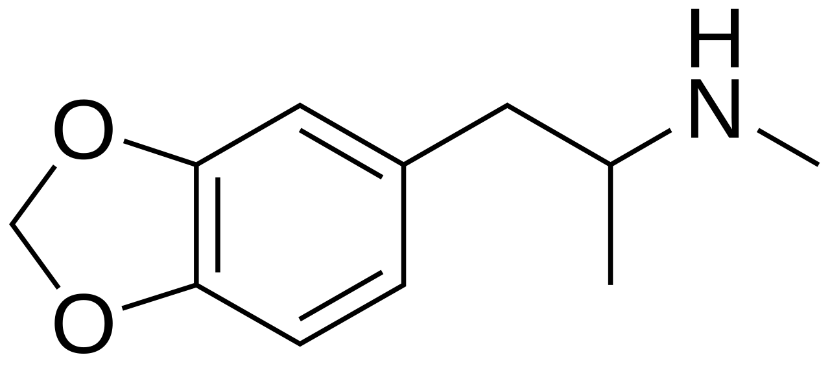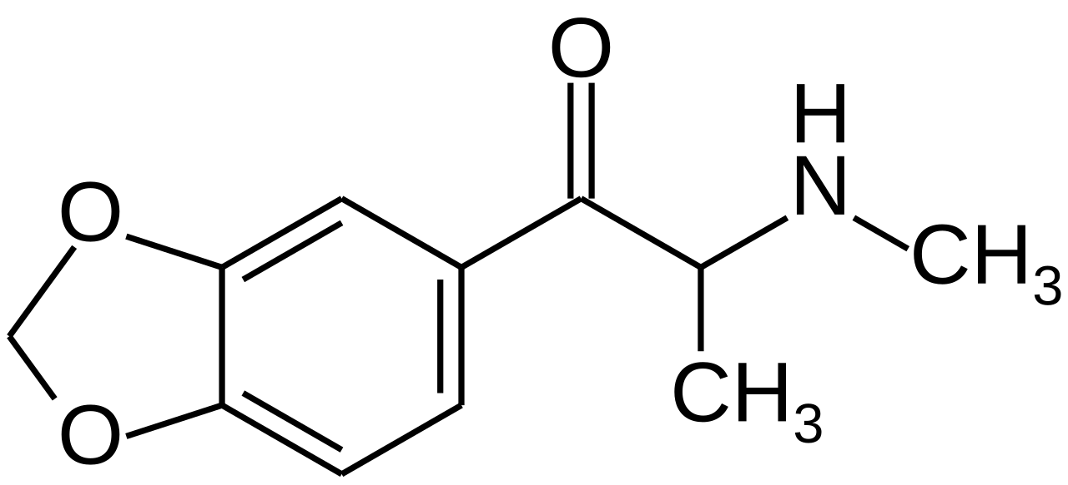
Fig. 1: a. MDMA b. Methylone
Source: Wikipedia

Base Study
All our data was extracted from Warner-Schmidt et al^{[6]}, in this study monoamine binding, uptake and release along with a high-throughput screen to assess agonist and antagonist activities across 168 GPCRs in vitro were done. Our focus however will be on the RNA-seq data produced in the experiments. RNA-seq was used to examine changes in the amygdala and frontal cortex, two brain regions linked to emotional learning and commonly impacted by PTSD and MDD. Rats were treated with either a single dose of methylone or MDMA (both at 10 mg/kg, administered via intraperitoneal injection), and their responses were compared to control groups (vehicle), the brains were harvested and frozen 8h post injection. All the groups were composed of 6 individual rats (Vehicle, n=6; MDMA,n=6; Methylone, n=6). The purpose of the RNA-seq data was to identify which genes, pathways, and/or functions were commonly regulated by methylone and MDMA, with the hypothesis that they might underlie therapeutic activity. In contrast, genes and pathways regulated by either drug alone might reflect off-target effects.

Methods

Results

Discussion

Conclusion
Appendices
Appendix I:

References

Kessler, R. C., Sonnega, A., Bromet, E., Hughes, M., & Nelson, C. B. (1995). Posttraumatic stress disorder in the National Comorbidity Survey. Archives of general psychiatry, 52(12), 1048–1060. https://doi.org/10.1001/archpsyc.1995.03950240066012
Sareen, J., Cox, B. J., Stein, M. B., Afifi, T. O., Fleet, C., & Asmundson, G. J. (2007). Physical and mental comorbidity, disability, and suicidal behavior associated with posttraumatic stress disorder in a large community sample. Psychosomatic medicine, 69(3), 242–248. https://doi.org/10.1097/PSY.0b013e31803146d8
Martin, A., Naunton, M., Kosari, S., Peterson, G., Thomas, J., & Christenson, J. K. (2021). Treatment Guidelines for PTSD: A Systematic Review. Journal of clinical medicine, 10(18), 4175. https://doi.org/10.3390/jcm10184175
Patrick, G. L. (2017). An introduction to medicinal chemistry. Oxford University Press.
Mitchell, J.M., Ot’alora G., M., van der Kolk, B. et al. MDMA-assisted therapy for moderate to severe PTSD: a randomized, placebo-controlled phase 3 trial. Nat Med 29, 2473–2480 (2023). https://doi.org/10.1038/s41591-023-02565-4
Warner-Schmidt, J., Stogniew, M., Mandell, B., Rowland, R. S., Schmidt, E. F., & Kelmendi, B. (2024). Methylone is a rapid-acting neuroplastogen with less off-target activity than MDMA. Frontiers in Neuroscience, 18, 1353131. doi:10.3389/fnins.2024.1353131

