Universidade de Lisboa


Faculdade de Ciências
Departamento de Química e Bioquímica | Abordagens Ómicas em Bioquímica e Biotecnologia

Prof. Margarida Gama Carvalho | Prof. Francisco Rodrigues Pinto

Final Project

Methylone and MDMA mice model frontal cortex neuroplastogen activity
– An analysis –

Student: | João Matias – 64430  Vítor Medeiros –  Sofia Lopes –
Studies: | Biochemistry | Bioinformatics
Semester: | 1st

Lisboa, December 23th, 2024
Table of Contents
1 Introduction 1
1.1 Base Study 2
2 Methods 3
2.1 Data Analysis 3
2.2 Differential Expression Analysis 4
2.3 Pathway Analysis 4
2.4 Pathway and gene enrichment pathway comparison 4
3 Results 6
3.1 Differential Expression Analysis 6
3.2 Pathway Analysis 7
4 Discussion 8
5 Conclusion 9
6 References 11

List of Figures
Fig. 1: a. MDMA b. Methylone 2
Fig. 2: Volcano plots show significantly regulated genes in the frontal cortex after treatment with (a) methylone or (b) MDMA compared to vehicle-injected controls (N = 6 per group). Light gray dots represent genes that were not significantly changed by either treatment. 6
Appendices
Appendix I: 10
List of Tables
Tab. 1: Comparison of Up and Downregulated genes in FC and AMY 6
Tab. 2: Comparison of Up and Downregulated genes in FC and AMY 7

List of Abbreviations and Symbols
MDMA | 3,4-Methylenedioxymethamphetamine
PTSD | Post Traumatic Stress Disorder
SSRI | Selective serotonin reuptake inhibitor
MDMA-AT | MDMA Assisted Therapy
MDD | Medically diagnosed depression
GPCRs | G-protein-coupled-receptors
GEO Database | Gene Expression Omnibus Database
FC | Frontal Cortex
GO | Gene Ontology
KEGG | Kyoto Encyclopedia of Genes and Genomes
log₂FC | log₂ fold change
FDR | False discovery Rate
AMY | Amygdala

Abstract
a

Keywords:

Introduction
Post-traumatic stress disorder (PTSD) is a mental condition that develops most often as result of exposure to war, sexual assault and other types of trauma. PTSD greatly lowers the quality of life of a patient. It has been reported that patients suffering from the condition have higher likelihood of having alcohol and drug abuse problems, other anxiety disorders and even affective disorders like mania and dysthymia (a type of long-term depression)[]. Strangely enough there seems to be a strong correlation between the previously married (separated, divorced, or widowed) than the currently married for both men and women, controlling for age. Suicide attempts have been reported, via questionary, to suffer more than a ten fold increase between non PTSD and PTSD patients (0.5 and 6.5% respectively)[].
There are several treatment types for PTSD using psychological therapies, pharmacotherapy or both[]. Common pharmacotherapies for PTSD include SSRIs (antidepressants) that are second-generation antidepressants like introduced in the 1980s, these were a major advancement over first-generation drugs due to their higher selectivity and fewer side effects[]. Some notable examples of second generation SSRIs include S-Citalopram (Escitalopram), Citalopram and Fluoxetine (Prozac).
MDMA-AT has recently been subject of discussion for the treatment of PTSD, showing promising results in patient outcomes[].
However available pharmacotherapies are limited, take weeks to show modest benefit (in the case of SSRIs it can be from 2-6 weeks)^{[4]} and remain ineffective for up to 40% of patients.
Methylone, an MDMA analogue, is being studied as a potential PTSD treatment due to its rapid and long-lasting antidepressant and anti-anxiety effects seen in preclinical research. This work examined how methylone affects gene activity and brain pathways in the frontal cortex of mice brains tied to PTSD and MDD, with a focus on neuroplasticity-related genes. We also compared its effects to MDMA, which has shown promise in PTSD treatment, to identify similarities and differences between the two compounds[]. Figure 1 shows the chemical structures of the two compounds.
a. b.
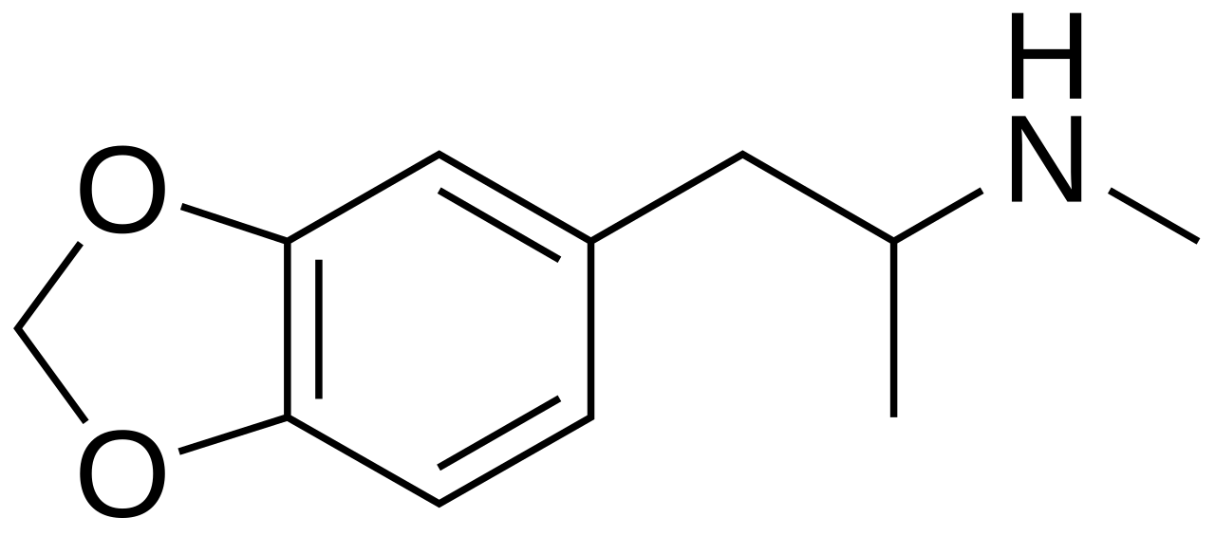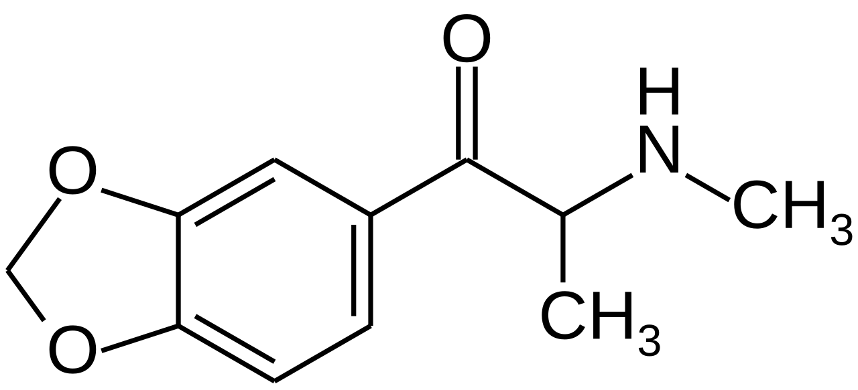
Fig. 1: a. MDMA b. Methylone
Source: Wikipedia

Base Study
All our data was extracted from Warner-Schmidt et al^{[6]}, in this study monoamine binding, uptake and release along with a high-throughput screen to assess agonist and antagonist activities across 168 GPCRs in vitro were done. Our focus however will be on the RNA-seq data produced in the experiments. RNA-seq was used to examine changes in the amygdala and frontal cortex, two brain regions linked to emotional learning and commonly impacted by PTSD and MDD. Rats were treated with either a single dose of methylone or MDMA (both at 10 mg/kg, administered via intraperitoneal injection), and their responses were compared to control groups (vehicle), the brains were harvested and frozen 8h post injection. All the groups were composed of 6 individual rats (Vehicle, n=6; MDMA, n=6; Methylone, n=6). The purpose of the RNA-seq data was to identify which genes, pathways, and/or functions were commonly regulated by methylone and MDMA, with the hypothesis that they might underlie therapeutic activity. In contrast, genes and pathways regulated by either drug alone might reflect off-target effects.

Methods
The data produced in Warner-Schmidt et al study was obtained from the GEO Database with the following ascension number: GSE253280. We extracted the 18 available samples from the database related to the FC (Frontal Cortex) experiments. Samples were named FC_”condition”_x. Where “condition” could be either Methylone, MDMA or Vehicle and x is the number of the sample (1 through 6). These are .txt files that contain the GeneID, location, strand length, gene count and more. Since we didn’t use the raw data from the study these files had been previously analyzed in the matters of quality of raw data by the authors. However, for our analysis we created corresponding files for each of the sample files containing only the GeneID and respective count number (first and last column of each row in the .txt files). In the course of our work we also used the dplyr[] R package to handle our datasets. All our files and R code can be found on GitHub under the repository: https://github.com/joao-matias0/omics.

Data Analysis
For our analysis we used the R-Studio to treat and analyze the data. The first part of the analysis consisted on the merging of all the data from the individual .txt files into one table with the following columns: Common Name (gene); condition (x16); GeneID. After having our data correctly assembled we proceeded to do a differential expression analysis, using the DESeq2[] R package followed by Gene Set Enrichment Analysis (GSEA). Then with the clusterProfiler[] R package and the org.Rn.eg.db[] library from Bioconductor we proceeded with pathway analysis of the differentially expressed genes using the Gene Ontology[,] database and the KEGG database[,,].

Differential Expression Analysis
For our differential expression analysis we used a table containing the GeneID and respective count numbers of the genes in the 18 samples. In out table the first 6 columns of the count number are “Vehicle”, 7-12 are “Methylone” and 13-18 are “MDMA”. Using DESeq2 we estimated variance-mean dependence in count data comparing the control condition to both drugs. We filtered significant genes with an adjusted p value cutoff of 0.05 (adjusted p-value < 0.05) and extracted subsets of the differentially expressed genes by log₂ fold change, with upregulated genes considered with a log₂FC > 0 and downregulated genes considered with a log₂FC < 0.

Pathway Analysis
Using our lists of differentially expressed genes we proceeded with a pathway analysis in order to find specific pathways and functions that are being affected by the presence of both drugs in the tissue. To do this we used the clusterProfiler R package to search for enriched pathways using our list of differentially expressed genes in the GO database and KEGG database. To adjust for the FDR we used the Benjamini-Hochberg method in order to limit the amount of FDRs by adjusting p-values. Furthermore a p-value cutoff of 0.05 and a q-value cutoff of 0.2 were used (meaning only results with an FDR below 20% are retained). The list of enriched pathways were saved as separate .csv files.

Pathway and gene enrichment pathway comparison
To further understand the effects of methylone and mdma on the target tissue we proceeded with a comparison analysis between their enriched pathways by crossing the results from the individual pathway analysis of both drugs. In addition to this, and to better understand the genes that are involved in the therapeutic effect of both drugs we decided to cross the lists of differentially expressed genes of both drugs (up and down regulated separately) to obtain list of common differentially expressed genes in both drugs. We also sorted and analyzed the top ten enriched GO terms from both drugs from our pathway analysis results.

Results

Differential Expression Analysis
The summary of our differential expression analysis can be found on Table 1, where we list the number or upregulated genes and downregulated genes for both conditions (MDMA and Methylone) in the frontal cortex and the genes regulated by both drugs, the results from the amygdala analysis by (Warner-Schmidt et al., 2024) are also represented.
 | Downregulated |  |  | Upregulated
Location | MDMA | Methylone | Both | MDMA | Methylone | Both
FC | 939 | 78 | 21 | 495 | 55 | 29
AMY | 871 | 111 | 97 | 548 | 10 | 9
Tab. 1: Comparison of Up and Downregulated genes in FC and AMY
Source: Own creation
The lists of the differentially expressed genes as well as the genes regulated by both drugs can be found in out GitHub repository.
To better understand the regulatory effect of both drugs we produced Volcano Plots using several R packages including ggplot2[], to capture the differences between expression magnitude and gene significance Figure 2.

a. b.
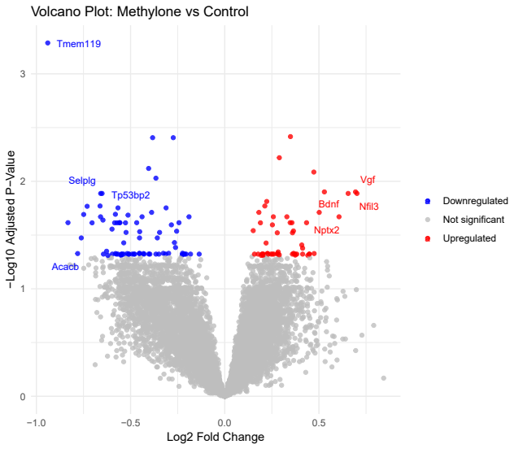
Fig. 2: Volcano plots show significantly regulated genes in the frontal cortex after treatment with (a) methylone or (b) MDMA compared to vehicle-injected controls (N = 6 per group). Light gray dots represent genes that were not significantly changed by either treatment.
Source: Own Creation

Pathway Analysis
Our pathway analysis yielded very different results when using the GO database or KEGG database. The quantification of enriched pathways found in the gene list for each pathway is outlined in Table 2.
 | Downregulated |  | Upregulated
Database | MDMA | Methylone | MDMA | Methylone
KEGG | 8 | 1 | 4 | 0
GO | 66 | 38 | 53 | 19
Tab. 2: Comparison of Up and Downregulated genes in FC and AMY
Source: Own creation
In general, the KEGG results weren’t very elucidative. The GO database results made it clear that MDMA is involved in many more enrichment pathways than methylone. Furthermore, it seems that both drugs upregulate a number of pathways involved in synaptic processes, however MDMA has a much more broad set of effects outside of those expected. Both drugs downregulate pathways involved in metabolic processes of associated with the catabolism of several biomolecules (especially fats) again with MDMA having much more broad effects. The top ten upregulated pathways for both drugs are shown in Figure 3 and the same is shown for downregulated pathways in Figure 4.
a. MDMA b. Methylone
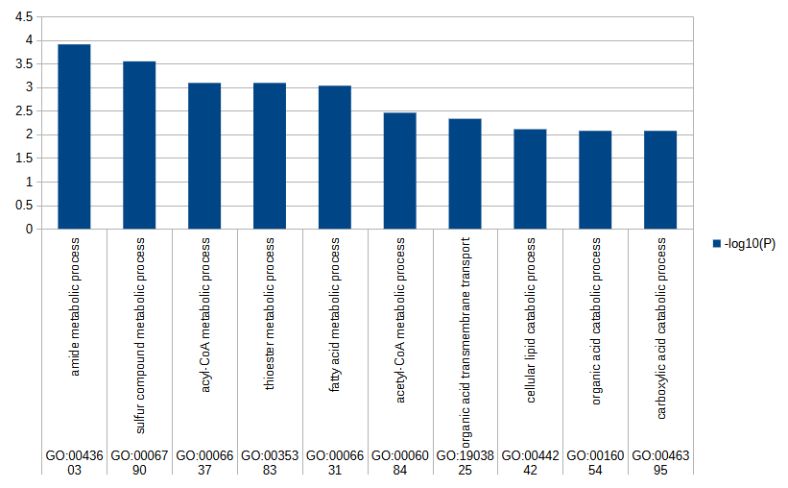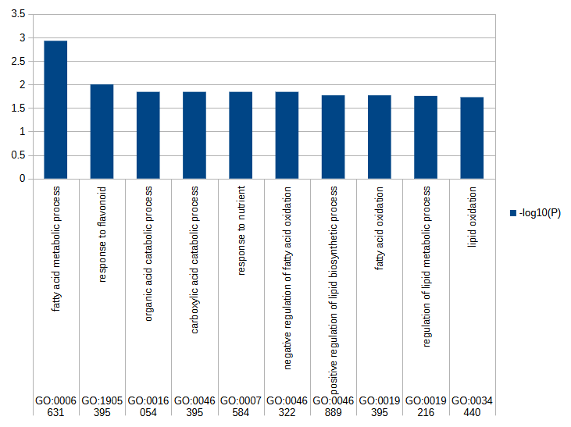
Fig. 3: a. MDMA b. Methylone
Source: Wikipedia

Discussion
The authors hypothesize that the common genes are responsible for the therapeutic activity.

Conclusion
Appendices
Appendix I:

References

Kessler, R. C., Sonnega, A., Bromet, E., Hughes, M., & Nelson, C. B. (1995). Posttraumatic stress disorder in the National Comorbidity Survey. Archives of general psychiatry, 52(12), 1048–1060. https://doi.org/10.1001/archpsyc.1995.03950240066012
Sareen, J., Cox, B. J., Stein, M. B., Afifi, T. O., Fleet, C., & Asmundson, G. J. (2007). Physical and mental comorbidity, disability, and suicidal behavior associated with posttraumatic stress disorder in a large community sample. Psychosomatic medicine, 69(3), 242–248. https://doi.org/10.1097/PSY.0b013e31803146d8
Martin, A., Naunton, M., Kosari, S., Peterson, G., Thomas, J., & Christenson, J. K. (2021). Treatment Guidelines for PTSD: A Systematic Review. Journal of clinical medicine, 10(18), 4175. https://doi.org/10.3390/jcm10184175
Patrick, G. L. (2017). An introduction to medicinal chemistry. Oxford University Press.
Mitchell, J.M., Ot’alora G., M., van der Kolk, B. et al. MDMA-assisted therapy for moderate to severe PTSD: a randomized, placebo-controlled phase 3 trial. Nat Med 29, 2473–2480 (2023). https://doi.org/10.1038/s41591-023-02565-4
Warner-Schmidt, J., Stogniew, M., Mandell, B., Rowland, R. S., Schmidt, E. F., & Kelmendi, B. (2024). Methylone is a rapid-acting neuroplastogen with less off-target activity than MDMA. Frontiers in Neuroscience, 18, 1353131. doi:10.3389/fnins.2024.1353131
Wickham H, François R, Henry L, Müller K, Vaughan D (2023). dplyr: A Grammar of Data Manipulation_. R package version 1.1.4, <https://CRAN.R-project.org/package=dplyr>.
Love MI, Huber W, Anders S (2014). “Moderated estimation of fold change and dispersion for RNA-seq data with DESeq2.” Genome Biology, 15, 550. doi:10.1186/s13059-014-0550-8.
Yu, G., Wang, L. G., Han, Y., & He, Q. Y. (2012). clusterProfiler: an R package for comparing biological themes among gene clusters. Omics : a journal of integrative biology, 16(5), 284–287. https://doi.org/10.1089/omi.2011.0118
Carlson, M. (2017). org.Rn.eg.db. doi:10.18129/B9.BIOC.ORG.RN.EG.DB
Ashburner et al. Gene ontology: tool for the unification of biology. Nat Genet. 2000 May;25(1):25-9. DOI: 10.1038/75556
The Gene Ontology Consortium. The Gene Ontology knowledgebase in 2023. Genetics. 2023 May 4;224(1):iyad031. DOI: 10.1093/genetics/iyad031
Kanehisa, M., & Goto, S. (2000). KEGG: kyoto encyclopedia of genes and genomes. Nucleic Acids Research, 28(1), 27–30. doi:10.1093/nar/28.1.27
Kanehisa, Minoru. (2019). Toward understanding the origin and evolution of cellular organisms. Protein Science: A Publication of the Protein Society, 28(11), 1947–1951. doi:10.1002/pro.3715
Kanehisa, Minoru, Furumichi, M., Sato, Y., Kawashima, M., & Ishiguro-Watanabe, M. (2023). KEGG for taxonomy-based analysis of pathways and genomes. Nucleic Acids Research, 51(D1), D587–D592. doi:10.1093/nar/gkac963
Ggplot: H. Wickham. ggplot2: Elegant Graphics for Data Analysis. Springer-Verlag New York, 2016.

