Amplifir

Architecture and Design

Note: Until the first production release of the codebase, this document will only be versioned through Git. After the first production release, all versions of this document must be declared on the first page and copies of each version must exist on the repository.

Created By: João Pedro Martins Neves

General Guidelines
- All files must be saved as UTF-8.
- Internal system (server, database, etc.) DateTimes and Timestamps must be UTC, only presentation code should be presented as local date-times.
- The line-endings/line-breaks should be LF, instead of Windows CRLF, to provide better multiplatform support. .NET Core is multi-platform.
- Use spaces, not tabs.
- You must insert a space after opening and before closing non-empty parenthesis.

Solution Architecture

- UI/
  - Presentation/ (Angular code)
  - Web/ (ASP.NET Core server)
    - Controllers/
    - Filters/
    - (...)
  - Desktop/ (Electron.NET)
  - Mobile/
- Core/
  - Interfaces/
  - Exeptions/
  - DTOs/
  - DomainServices/
  - Enums/
  - Models/
  - Entities/
  - Utilities/
- ApplicationTypeFactory/ (Core)
- Infrastructure/
  - DataAccess/
  - Logging/
  - Services/
    - Email/
    - SMS/
- Infrastructure.DatabaseCode/ (code representing the database schema and content)
- Tests/

Database
The database is PostgreSQL.
The following diagram describes the database schema.
The developer should use it only as a visual representation and he must use the code present in the project “Amplifir\Amplifir.Infrastructure.DatabaseCode” as the true and complete representation of the DB, with its definitive data types, checks, indexes, etc.
When a change is made to the database schema, it must be reflected on the Infrastructure.DatabaseCode project’s code before deployment. Only after that, the diagram and this document should be updated.
The code must be written by hand and not auto-generated.
The diagram is made using MySQL Workbench diagram tool.

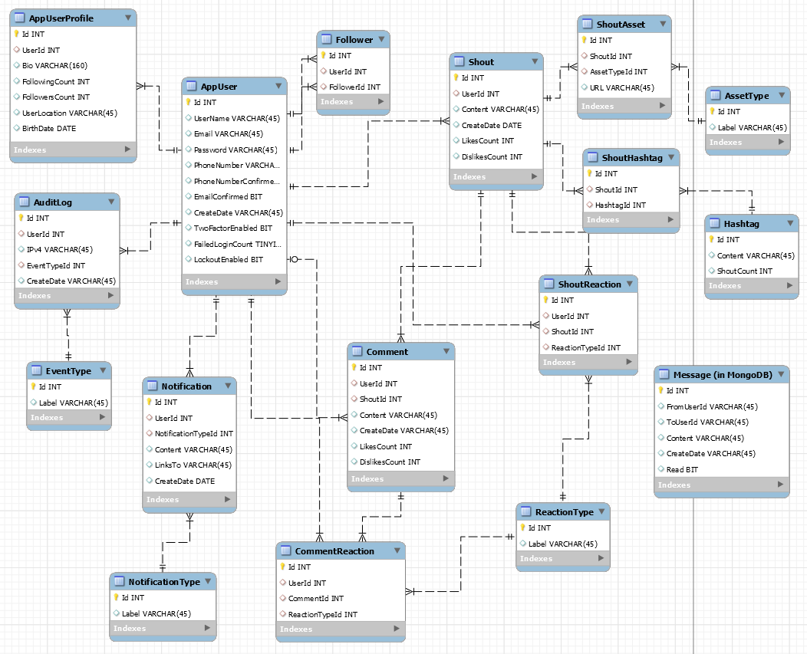

API Documentation
The API documentation is generated through NSwag, using the OpenAPI definition.
It is available through “https://<Amplifir-link>/swagger”.

