The CM32M433R MCU
Original post: https://www.rvmcu.com/quickstart-show-id-13.html

1. Chip introduction
The CM32M4xxR series chips are the first low-power and large-capacity microcontrollers based on RISC-V architecture launched by China Mobile Xinsheng Technology. This series of MCUs has the characteristics of high performance, high reliability, high security, and low power consumption, and can be widely used in smart door locks, IoT gateways, interactive panels, measurement and control terminals, student education, consumer electronics and other related fields.
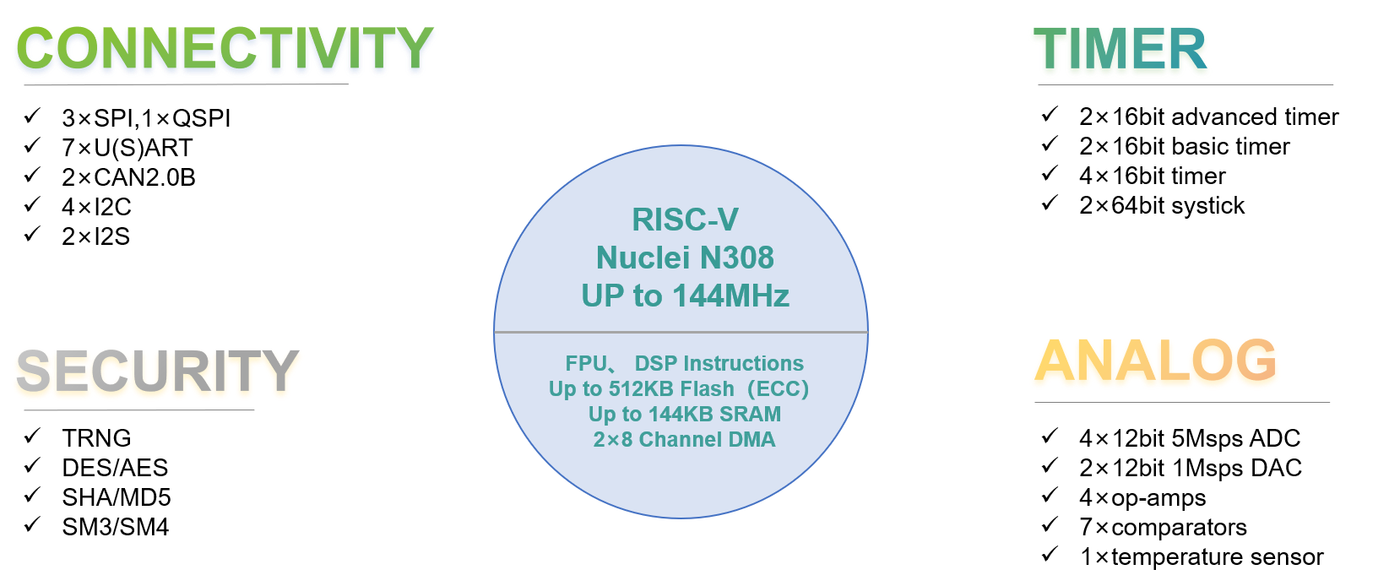
- Core: Nuclei N308 (RV32IMACFP)
- Main frequency: 144MHz
- Memory: built-in 512KB Flash, 144KB SRAM
- Operating voltage: 1.8V ~ 3.6V
- Built-in cryptographic algorithm hardware acceleration engine
- Peripheral Resources: timers (General Purpose Timer, Advanced Timer, Basic Timer), SPI, I2S, QSPI, I2C, USART, UART, CAN, ADC, DAC, TSC, GPIO

2. Related documents
- CM32M433R reference manual: https://www.rvmcu.com/app/quickstart/skins/default/doc/CM32M4xxR-user-guide-V1.4.pdf
- CM32M433R data sheet: https://www.rvmcu.com/app/quickstart/skins/default/doc/CM32M4xxR-datasheet-V1.4.pdf
- Nuclei N-level Instruction Architecture Manual: https://www.rvmcu.com/quickstart-show-id-1.html.
- Nuclei N300 series processor core databook: https://www.nucleisys.com/upload/file/2020/02/1582893657-2424.pdf

3. Purchase links
Retail purchase
Taobao: https://item.taobao.com/item.htm?id=677606472384
Volume Purchase
Contact: Manager Han
Tel: +86 18111213896
E-mail: hanyongchao@cmiot.chinamobile.com

The CM32M433R-START development board
Original post: https://www.rvmcu.com/quickstart-show-id-14.html

1. Introduction
CM32M433R-START is a RISC-V development board based on China Mobile's CM32M433R MCU. It features an on-board emulator and Arduino-compatible female headers.
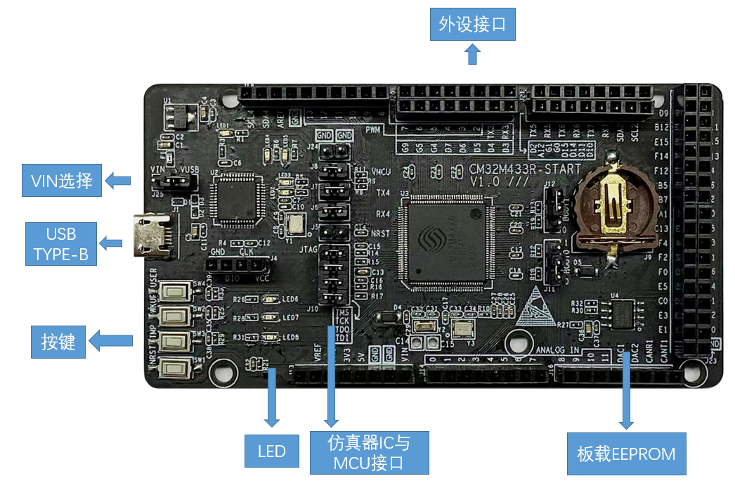
CM32M433R-START development board features:
- Microcontroller: CM32M433R
  - Core: Nuclei N308 (RV32IMACFP)
  - Main frequency: 144MHz
  - Memory: 512KB Flash, 144KB SRAM
  - Working voltage: 1.8~3.6V
  - Peripheral resources: Timers (4 general-purpose timers, 2 advanced timers, 2 basic timers) SPI3, I2S2, QSPI1, I2C4, UART4, CAN2, ADC2, DAC2
- Power supply mode: USB or 5V DC external power supply
- Size: 10.1*5.3cm
- Peripherals and interfaces:
  - USB Micro-B interface: download, debug, power supply
  - Arduino-compatible standard single row 2.54mm female headers
  - JTAG interface: MCU and debugger can be separated to work independently
  - Reset button
  - 3 user buttons
  - 3 user LED

2. Related documents
Introduction to the CM32M433R: see previous chapter
CM32M433R-START development board schematic: https://www.rvmcu.com/app/quickstart/skins/default/doc/cm32m433r-start-sch.pdf
CM32M433R-START development board user manual: https://www.rvmcu.com/app/quickstart/skins/default/doc/CM32M433R-START-User-Manual-V1.pdf

3. Purchase links
Taobao: https://item.taobao.com/item.htm?id=671656606437
Aliexpress: https://www.aliexpress.com/item/1005004333840765.html

