Discoverer Neo
Quick guide
For the MANAGER role
Version 2.0.1

Contents
Your role in one page 1
Maps 2
Sharing a map 3
Viewing, running and exporting 4
Map builder 5
Schedules 6
Runs and Exports 7
Users 8
Data modeling 9
Custom Functions and Data Sources 10
Settings 11

Your role in one page
You are a Manager. You see, run, export, schedule and share every map. Data modeling is limited to business areas where an administrator gave you a grant.
You can | You cannot
See, run, export and schedule every map | Change or delete a map you do not own (unless shared with you at Can edit)
Share any map and change any share | See SQL or the database plan
Copy any map to make your own | Create users, data sources or business areas, or give grants
Give a map to a new owner | See other people's runs, exports or schedules
Manage custom functions | Use Security, Audit Log or Migration
Read, test and introspect data sources | Import tables from a data source

Note: Security, Audit Log and Migration are for administrators only. They are not in your sidebar.
Seeing a map does not give you its data. A run needs a business-area grant on every folder the map uses. Without one you get Not entitled to run.
Sign in with your Email and Password, then click Sign in. Sign out from your name menu with Log out.

Maps
The Maps page lists every map. A map is a report (a worksheet in Oracle Discoverer).
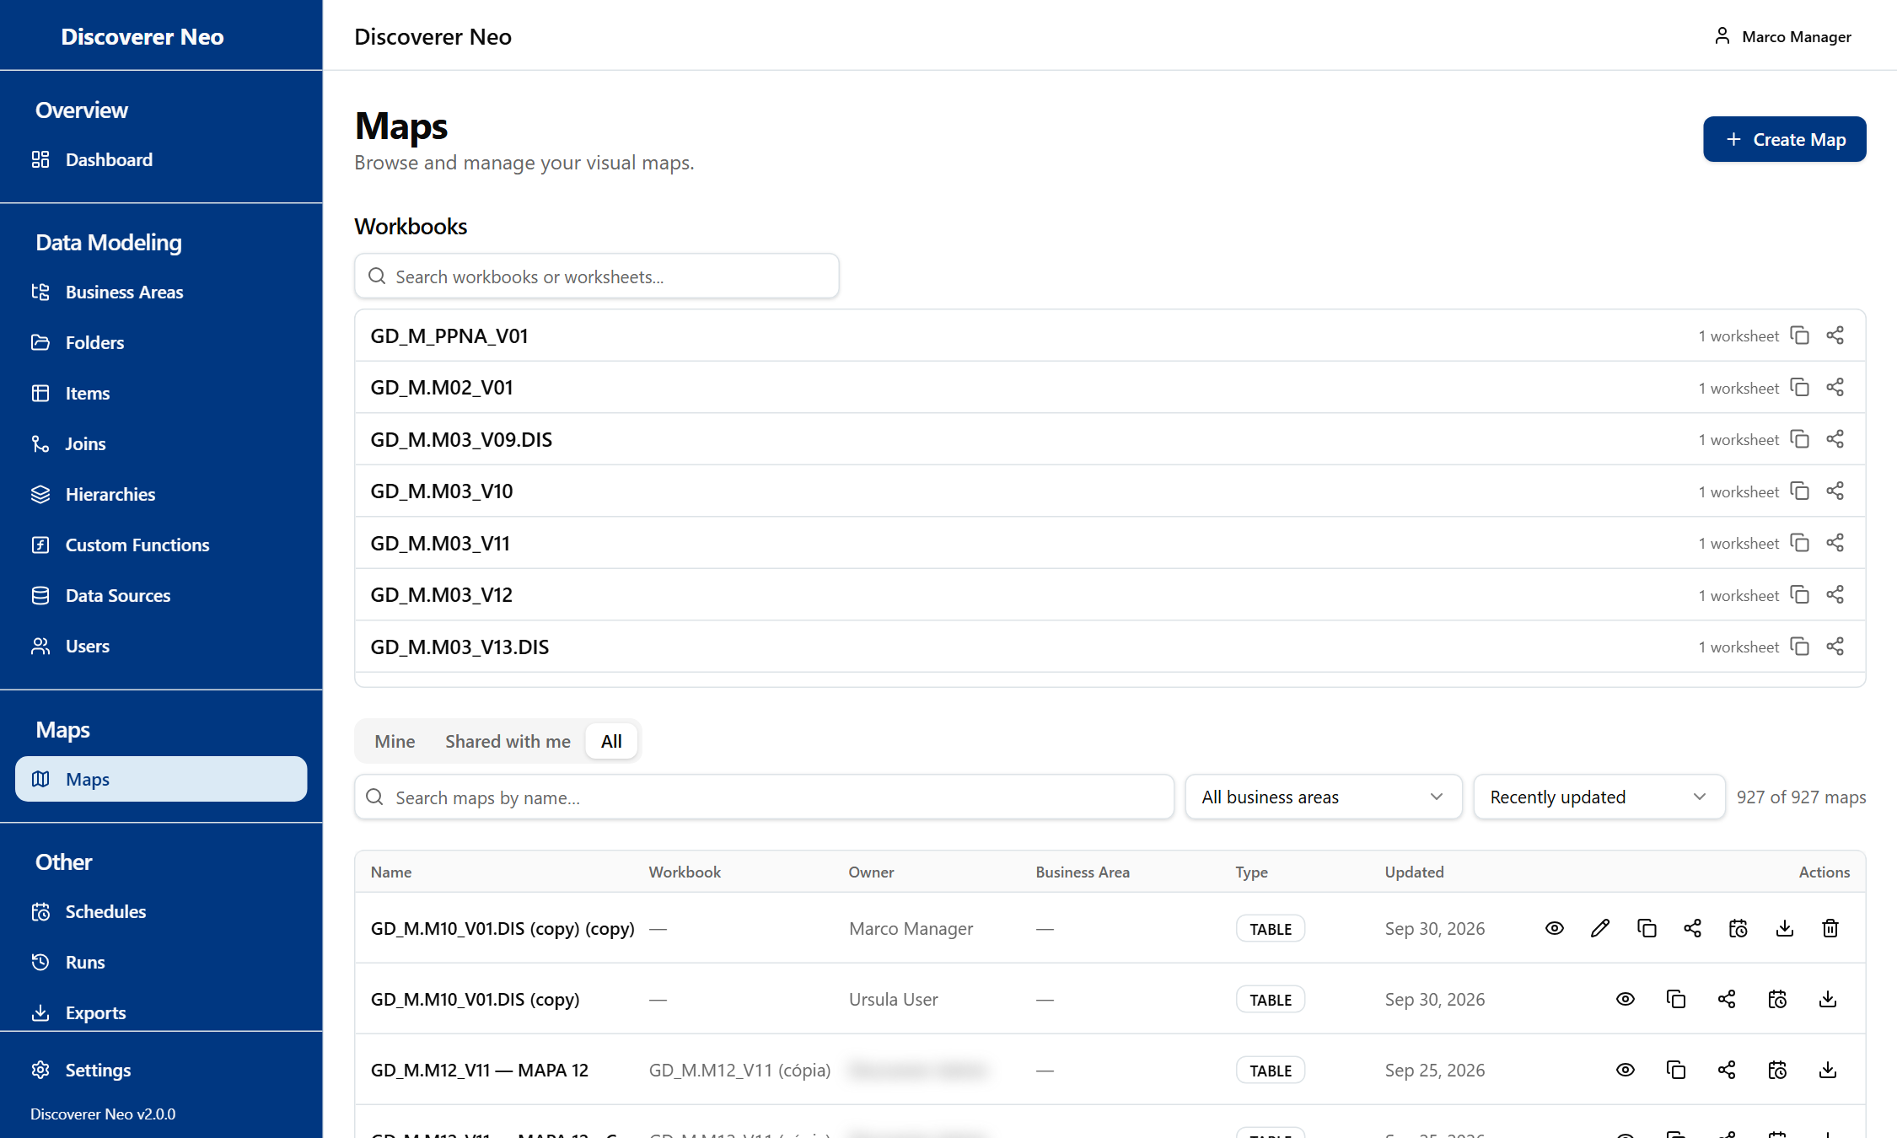
The Maps list, All tab, with Copy, Share, Schedule and Export icons on each row.
- Choose a tab: Mine, Shared with me or All.
- Narrow the list with Search maps by name… or the Business Area filter.
- Click the Eye icon to open a map and run it.
- Click the Copy icon to make your own copy. It is private to you.
- Click the Share icon to give someone access.

Icon | What it does
Pencil | Change the map. Only your own maps or Can edit shares.
Trash | Delete. Only your own maps. An administrator must restore it.
Calendar | Schedule this map.

Sharing a map
Sharing decides what another person may do with one map.
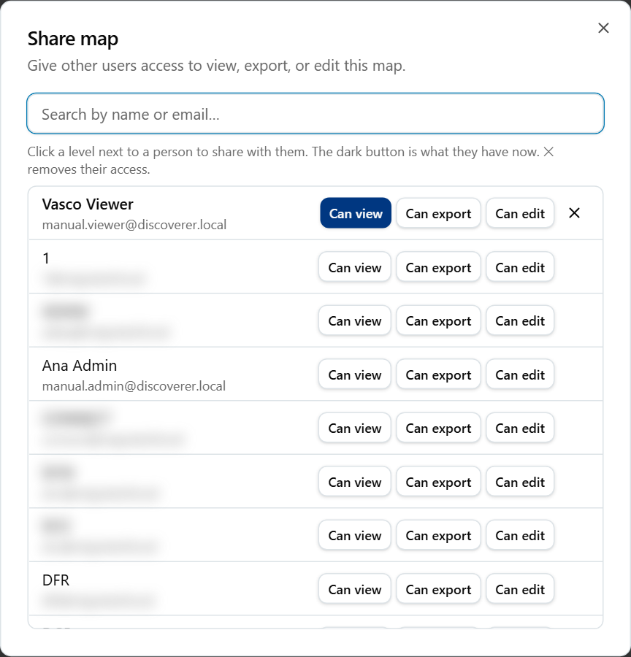
The Share map dialog with a search box and Can view, Can export and Can edit buttons.
- Click the Share icon on the map.
- Search for a person by name or email.
- Click a level next to their name. The dark button is their current level.
- Click the X next to a name to remove access.

Level | What it means
Can view | Open and run only.
Can export | Also export and schedule.
Can edit | Also change the map.

Viewing, running and exporting
The viewer runs a map and shows its rows. It never changes the map.
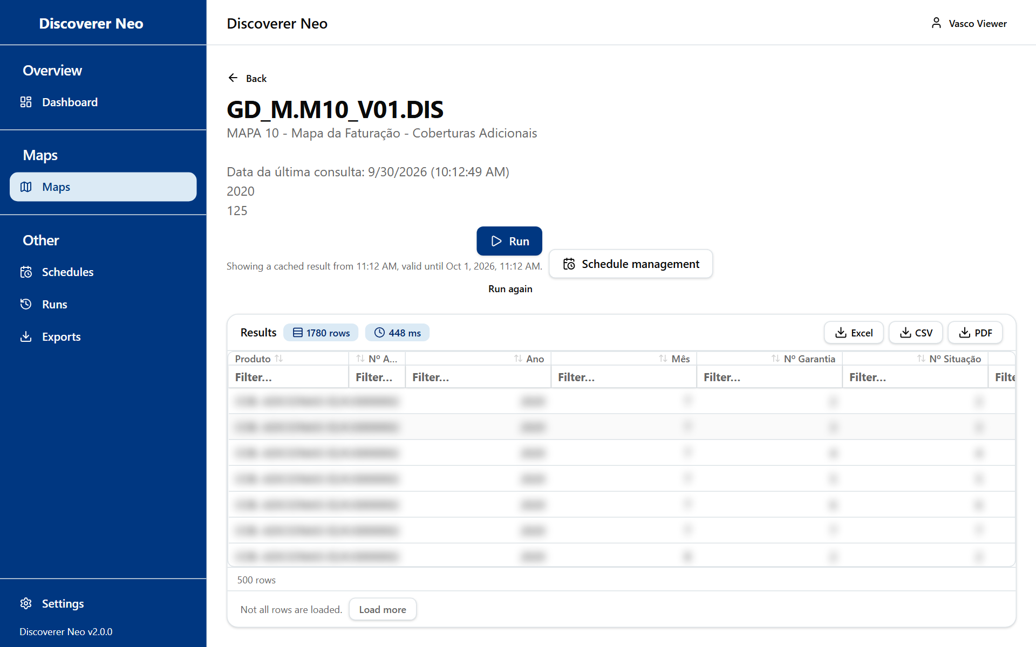
A completed run with Excel, CSV and PDF buttons over the results grid.
- Open the map with the Eye icon.
- Click Run. Answer the Run parameters questions if they appear.
- Read the rows. Click a header to sort. Double-click a row to see its raw rows.
- Click Excel, CSV or PDF to export.
- Find the file later on Exports. Files are kept for 7 days.

A result stays valid for 24 hours. Run again forces a fresh run.

Map builder
Use the builder to make or change a map. You can save a new map only with a CREATE grant on its business area. You can save an existing map only if you own it or hold Can edit. To change someone else's map, copy it first.
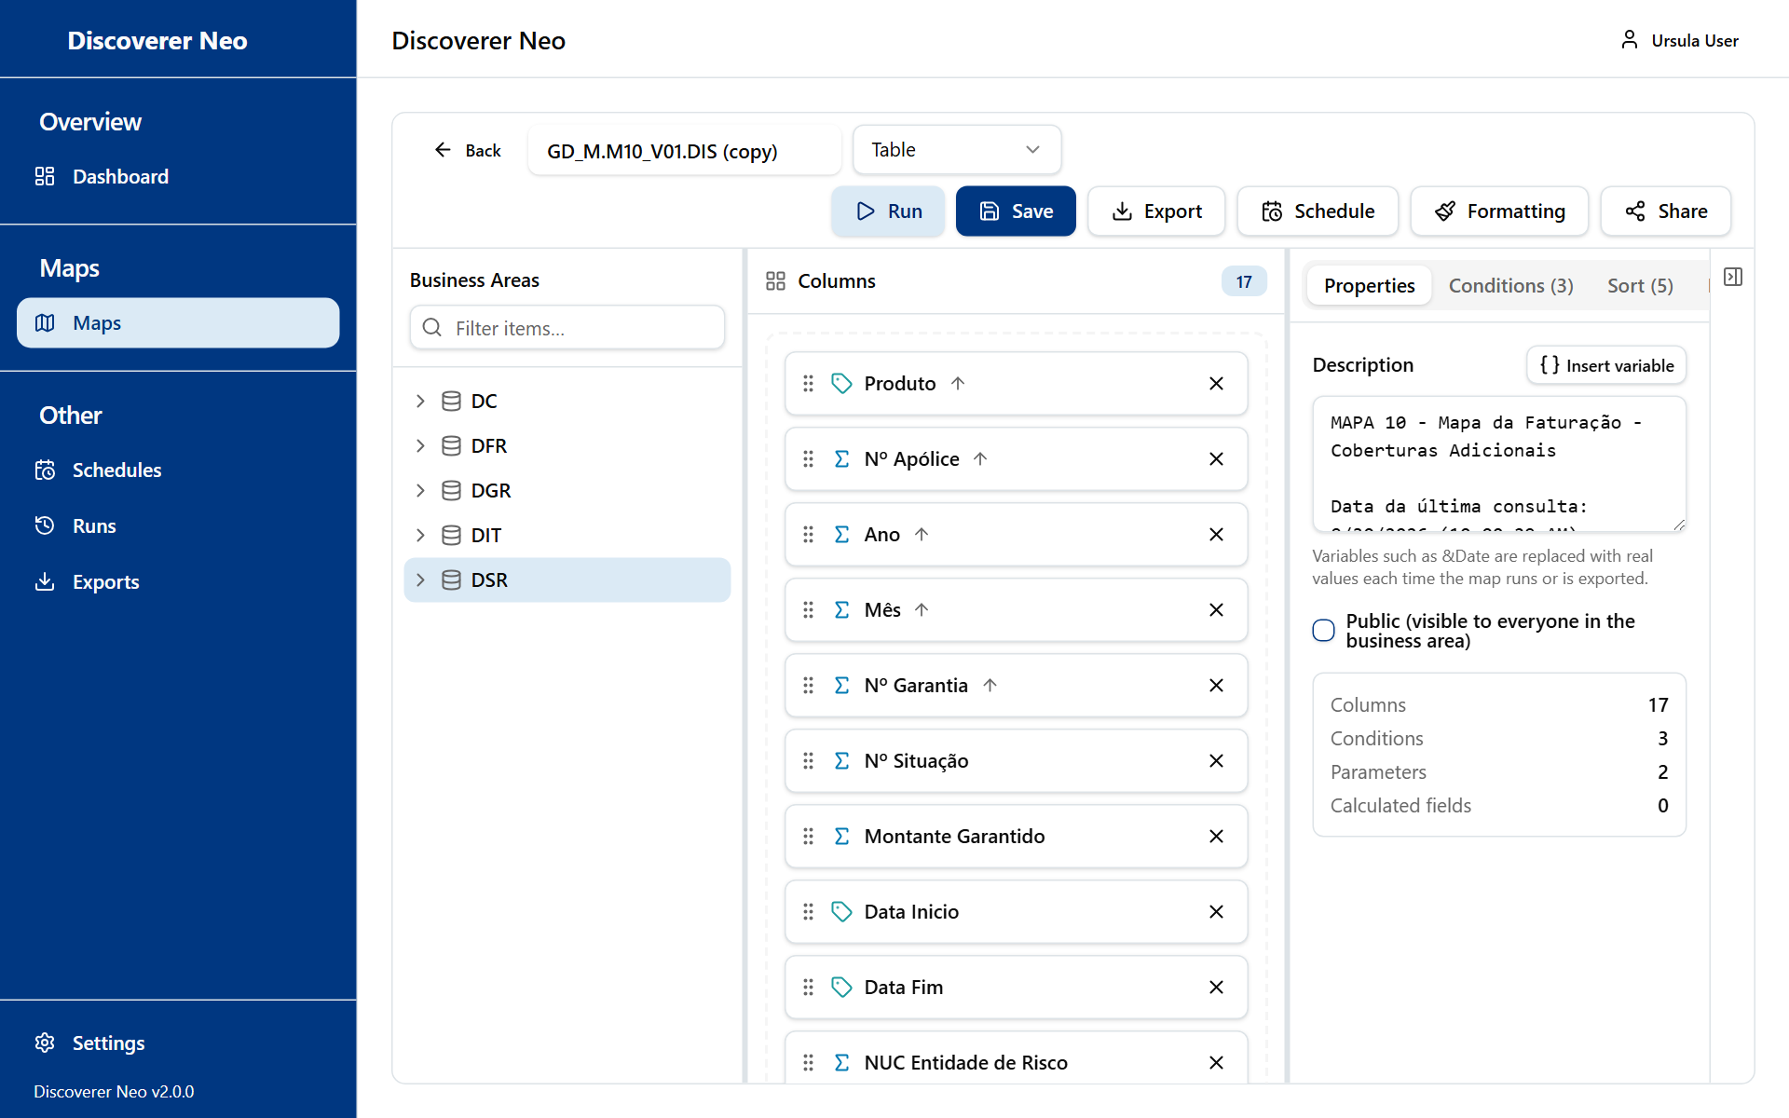
The map builder with the Business Areas tree, the columns canvas and the Properties panel.
- Click Create Map, or the Pencil icon on your own map.
- Drag items from the Business Areas tree onto Columns. All columns must come from one business area.
- Click a column to set its Aggregation, Sort direction or Format mask.
- Use the tabs Conditions, Sort, Parameters and Calculated Fields if needed.
- Click Save, then Run. Nothing saves by itself.

Schedules
A schedule runs a map on a timetable and stores the result. You see only your own schedules.
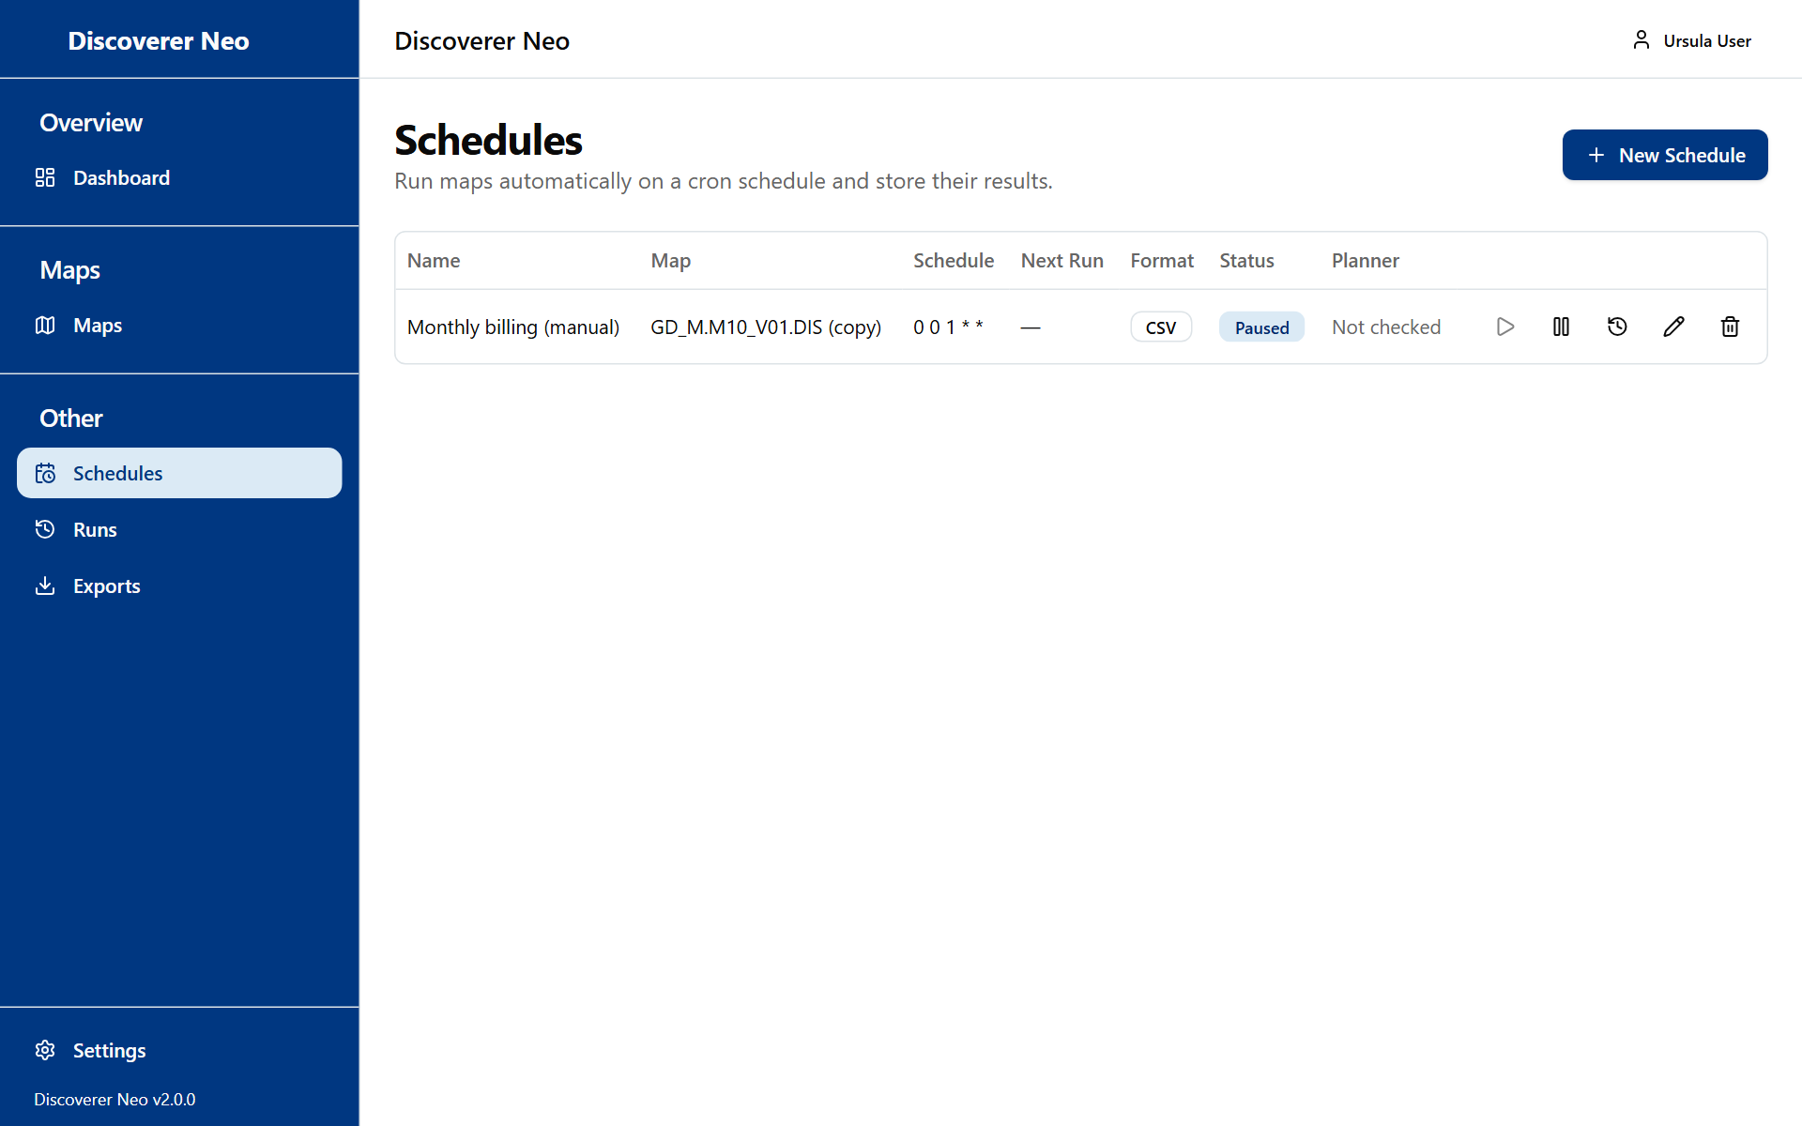
The Schedules page with a paused schedule and its action icons.
- On Maps, click the Calendar icon of the map. To schedule someone else's map, use this icon.
- Type a Name.
- Choose Frequency, Timezone and Output Format.
- Click Save.
- Click Run now to test. Open History to see results.

Choice | Meaning
Daily (midnight), Weekly (Sunday, midnight), Monthly (1st, midnight) | Ready-made timetables.
Custom | Your own five-field cron expression.
Excel (.xlsx), CSV | Format of the stored result.

The schedule runs as you, so your grants decide what data it reads.

Runs and Exports
Runs lists your own runs. Exports lists your own export files. You do not see other people's.
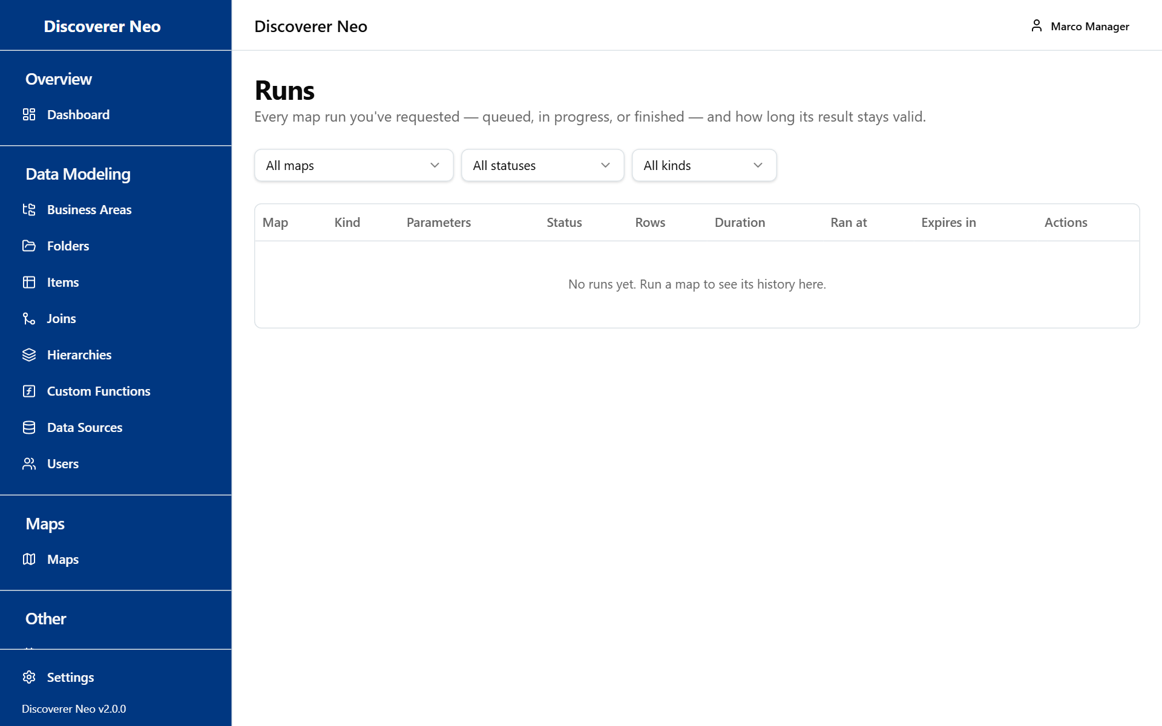
The Runs page with map, status and kind filters and the list of runs.
- Click Runs to see waiting, running and finished runs.
- Click the Open icon to see a stored result. Use Run again to repeat it.
- Click Cancel on a queued run to stop it.
- Click Exports, then the Download icon on a Completed row.

Users
The Users page is read-only for you. You can list accounts and fix map access.
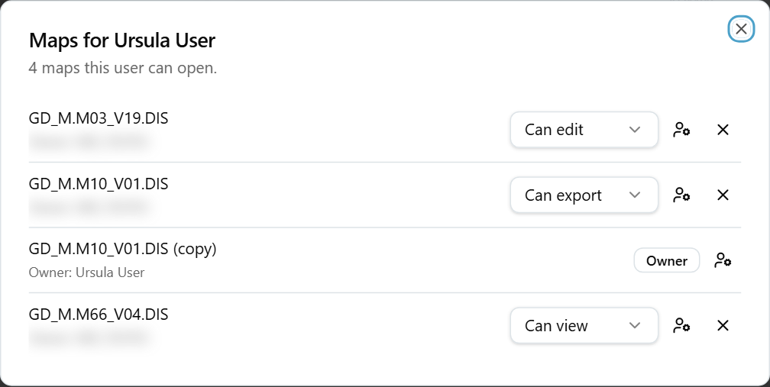
The Maps dialog for a user, with share-level selects and owner and remove icons.
- Click the row icon Maps this user can open.
- To change a shared map, use the level list next to it.
- To take a shared map away, click the X.
- To hand a map over, click the owner icon and choose the New owner.

Warning: The new owner can change, share and delete the map.
Creating, editing and deleting users is for administrators.

Data modeling
The pages Business Areas, Folders, Items, Joins and Hierarchies list only business areas where you hold a grant. Your grant level sets what you may do.
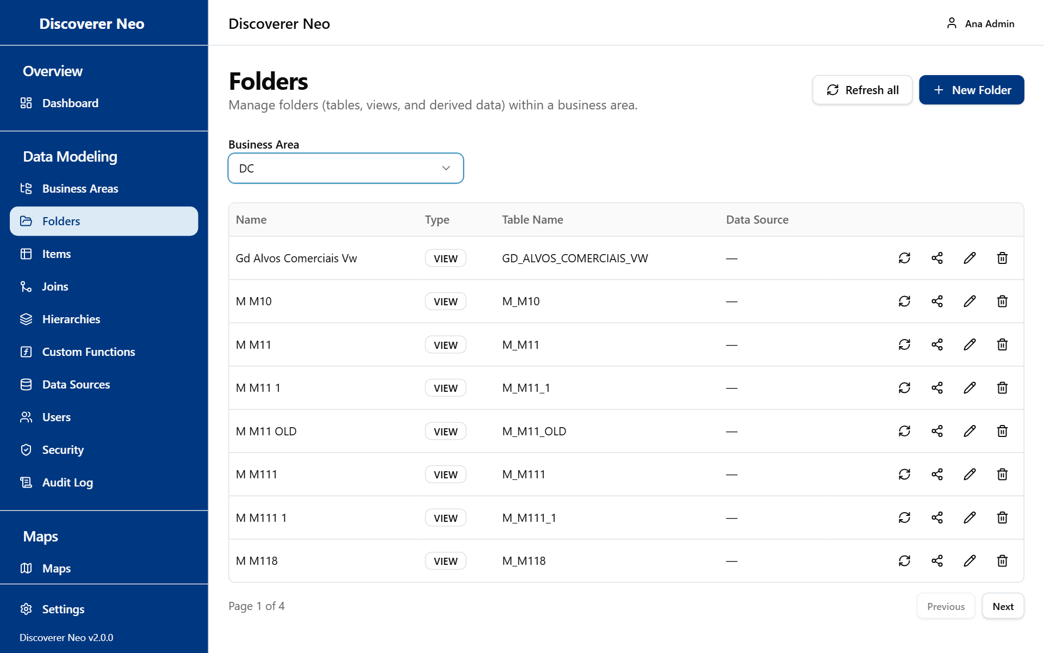
The Folders page with a business area chosen and its folders listed.
Grant | What you may do
VIEW, EXPORT, SCHEDULE | Read folders, items, joins and hierarchies.
CREATE | Also add folders, items, joins and hierarchies.
EDIT | Also change them, and refresh folders from the database.
DELETE | Also delete them.

- Choose a Business Area. If the list is empty, ask an administrator for a grant.
- To add a folder: click New Folder, choose a Data Source, click Discover Tables, pick a table, click Save.
- To connect two folders: on Joins, click New Join, click Suggest Joins, then Save.

New Business Area, Delete on a business area and grant changes are for administrators, even though the screen shows them. The system refuses them.

Custom Functions and Data Sources
Custom Functions are database functions that calculated items can call. You have full rights. Data Sources are saved database connections. You can only look and test.
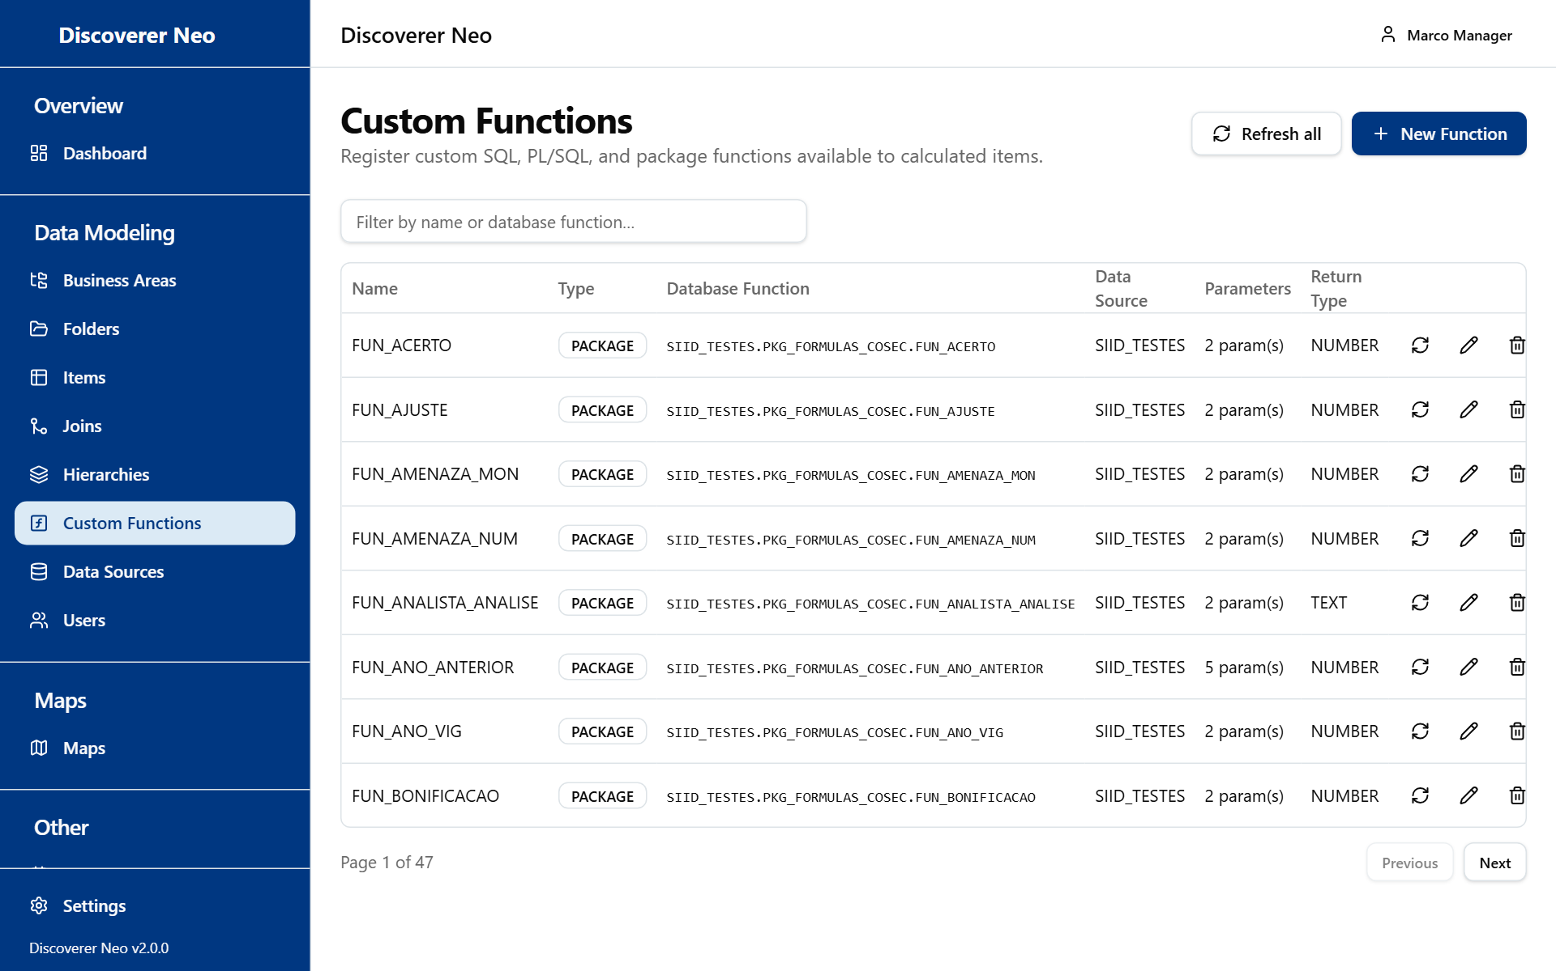
The Custom Functions page with the list, Refresh all and New Function.
- On Custom Functions, click New Function.
- Choose a Data source, type part of a name in Find a function, click Search.
- Click a result to fill the dialog, then click Save.
- Use Refresh all to re-read every function from Oracle.
- On Data Sources, click Test connection to check a connection.

New Data Source, Edit, Delete and Import on a data source are for administrators. The system refuses them.

Settings
Open Settings from the sidebar or your name menu.
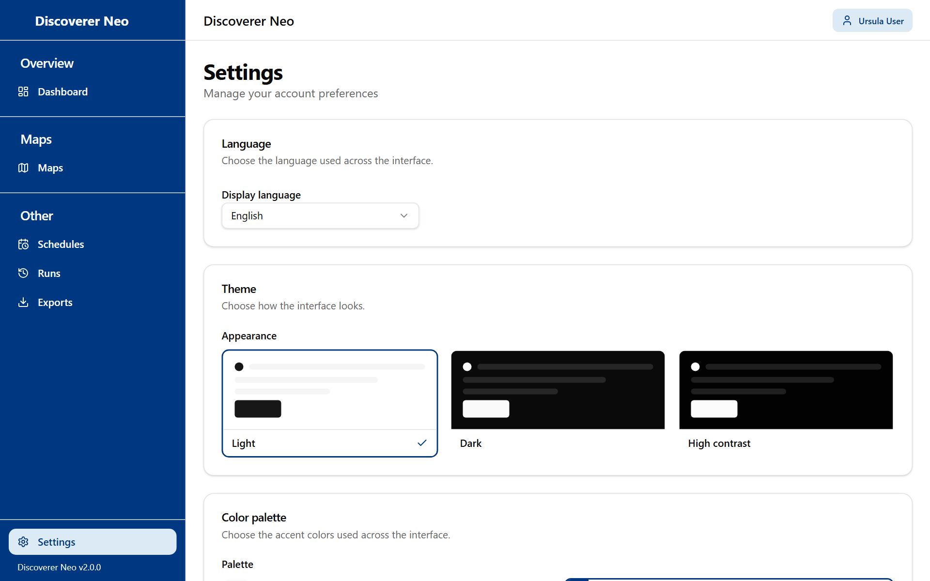
The Settings page with the Language, Theme and Color palette cards.
- Choose your Display language, Appearance and Palette.
- Click Save. Without it the choice does not follow you to other computers.

To change your password, open /change-password. It needs at least 12 characters. There is no reset link. Ask an administrator if you forget it.

