Discoverer Neo
Quick guide
For the USER role
Version 2.0.1

Contents
Your role in one page 1
Dashboard 2
Maps 3
Run and export 4
Build and edit a map 5
Runs and Exports 6
Schedules 8
Settings 9

Your role in one page
You have the USER role. A map is a report. A business area is a group of related data.
You can | You cannot
See your own, public and shared maps | See other people's private maps
Run maps, and export or schedule them when the share level allows | Export a map shared as Can view
Copy a map and edit your copy | Change maps you do not own, unless shared as Can edit
Create maps where you hold the create right | Create maps in other business areas
Share and delete your own maps | Share or delete other people's maps
Change your language and theme | Open administration pages

Share levels: Can view = run only. Can export = run, export, schedule. Can edit = all of that plus change the map.
Sign in with Email and Password, then Sign in. A temporary password must be changed first (at least 12 characters). To leave, click your name, then Log out.
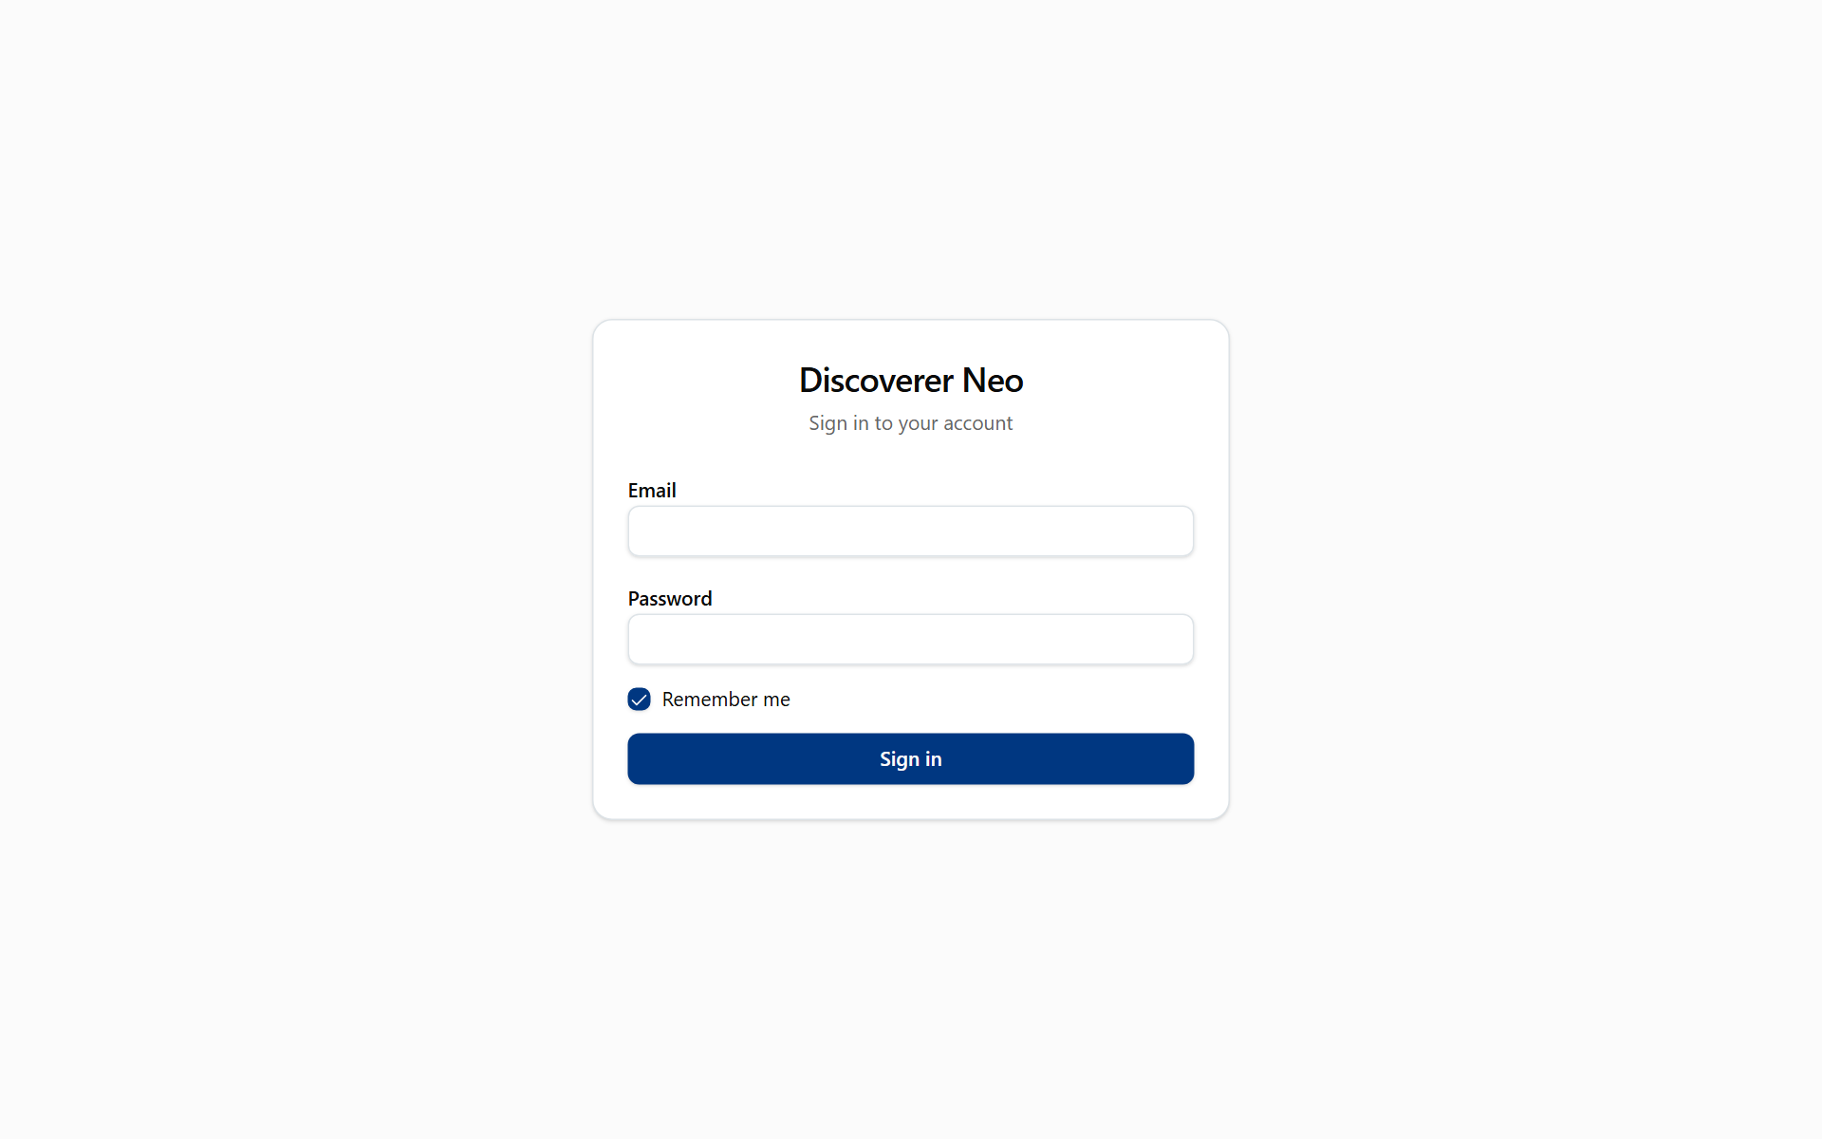
The sign-in page with Email, Password, Remember me and the Sign in button.

Dashboard
The first page after sign-in. It is read-only.
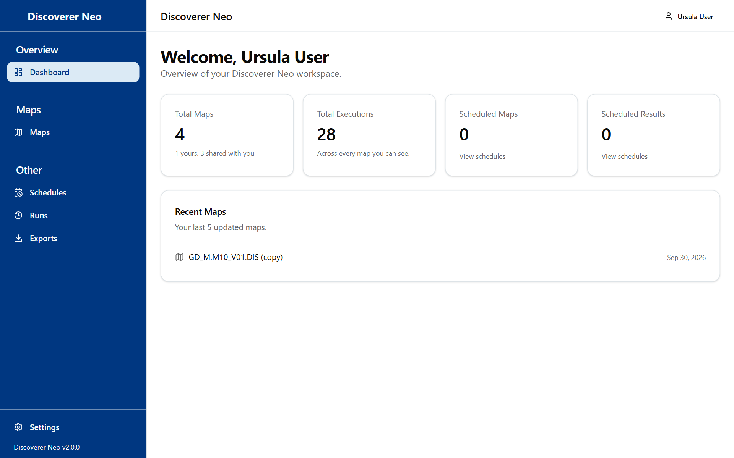
The dashboard with summary cards and the Recent Maps list.
- Read Total Maps and Total Executions for a summary.
- Read Scheduled Maps and Scheduled Results for your schedules. Click View schedules to open them.
- Click a map in Recent Maps (your last 5) to open it in the builder.

Maps
The list of your reports. Tabs: Mine, Shared with me, All.
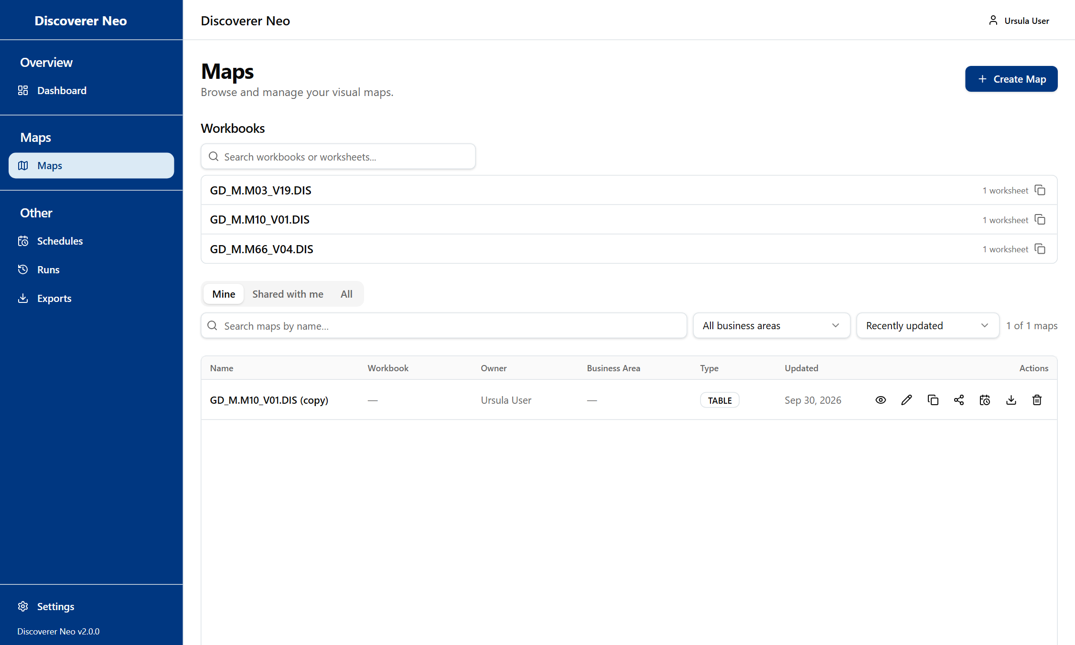
The Maps list, Mine tab, showing the action icons on the map row.
- Search by name or pick a Business Area.
- Click the eye icon to open the viewer.
- Click the Copy icon to make your own copy.
- Click the Share icon (your own maps) to give access.
- Click Create Map to build a new one.

Icon | Use
Eye | Open and run
Pencil | Edit (own or Can edit)
Copy | Your own copy
Share | Set Can view, Can export, Can edit, or ✕ to remove
Calendar | Schedule (own, Can export, Can edit)
Trash | Delete (own only, only an administrator can restore)

Run and export
The viewer runs a map and shows the rows.
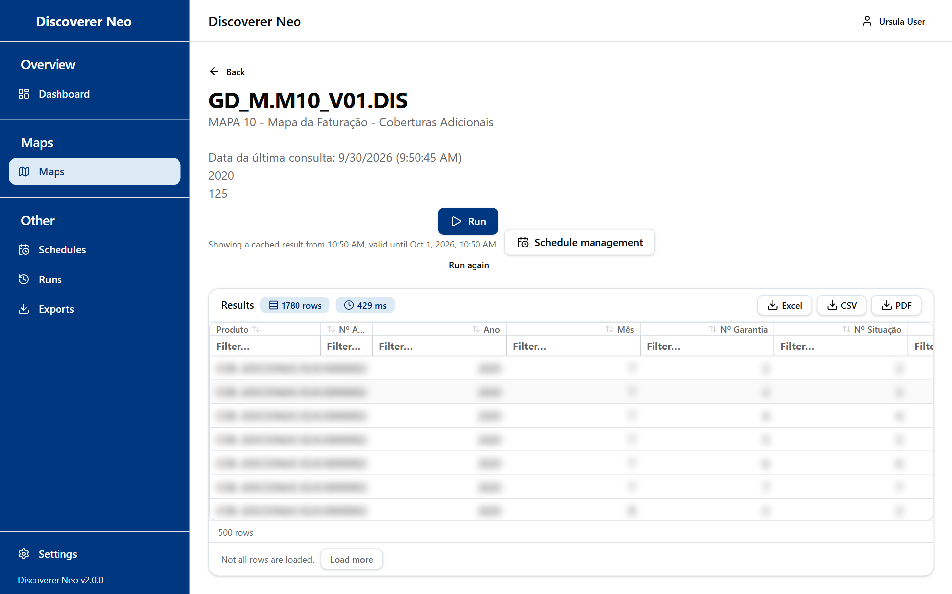
The map viewer after a completed run, with the results grid and export buttons.
- Open the map with the eye icon.
- Click Run. Fill in Run parameters if asked.
- Read the results. Click a header to sort, double-click a row for Drill to Detail.
- Click Excel, CSV or PDF to export.
- Click Run again for fresh data. A result stays valid for 24 hours.

Choice | Line
PDF dialog | Pick Paper size (A4, A3, Letter), Orientation and columns
Not entitled to run | You have no access to the data. Ask your administrator
Forbidden on export | The map is Can view only. Ask for Can export

Build and edit a map
Build a map from items of one business area. Only where you hold the create right.
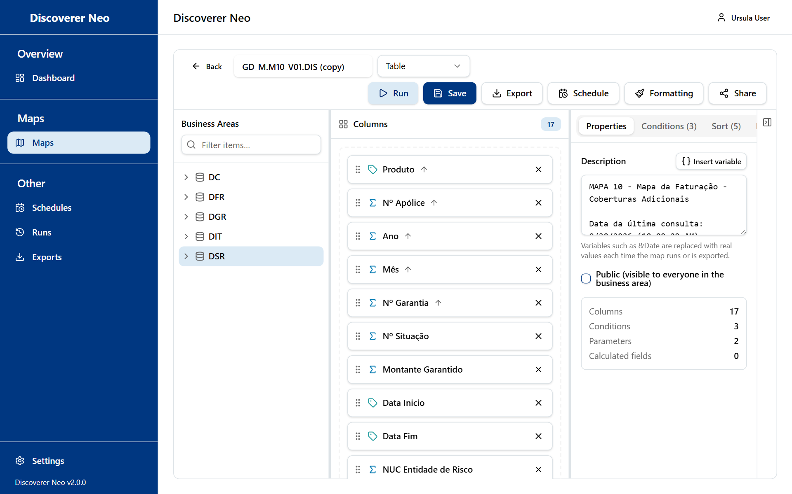
The map builder with the Business Areas tree, the columns canvas and the Properties panel.
- Click Create Map.
- Drag items from the Business Areas tree into Columns. The first item sets the business area.
- Set filters in Conditions, sorting in Sort, prompts in Parameters.
- Type a name and click Save. Nothing saves by itself.
- Click Run to test.

Tab | Use
Properties | Description and Public box (visible to every user)
Conditions | Filters, fixed or Prompt at runtime
Sort | Sort levels
Parameters | Values asked at run time
Calculated Fields | New column from a formula

Formatting colours cells that meet a rule. It needs a saved map.

Runs and Exports
Runs lists your runs. Exports lists your files.
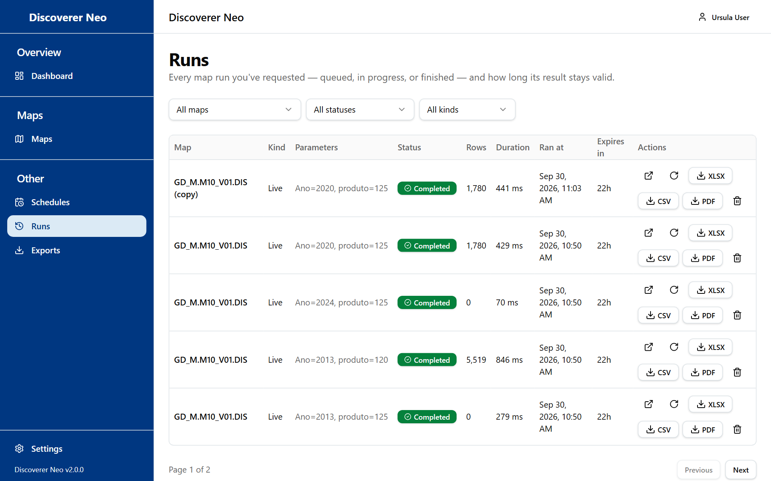
The Runs page with filters and the table of runs and their export buttons.
- Open Runs to see status, rows and Expires in.
- Click Open to see a stored result, or Run again.
- Click XLSX, CSV or PDF to download a result.
- Open Exports and click Download for a finished file.

Choice | Line
Cancel | Only for a queued run
Delete | Removes the run for good
Files | Kept 7 days

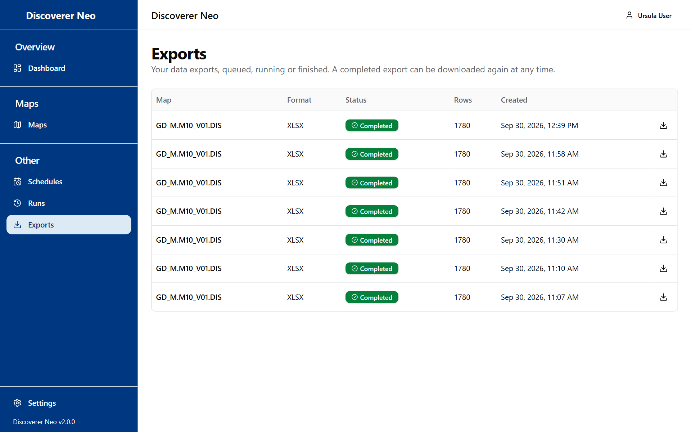
The Exports page listing export jobs with a Download button on finished ones.

Schedules
Runs a map by itself and stores the result on the server. Nothing is emailed.
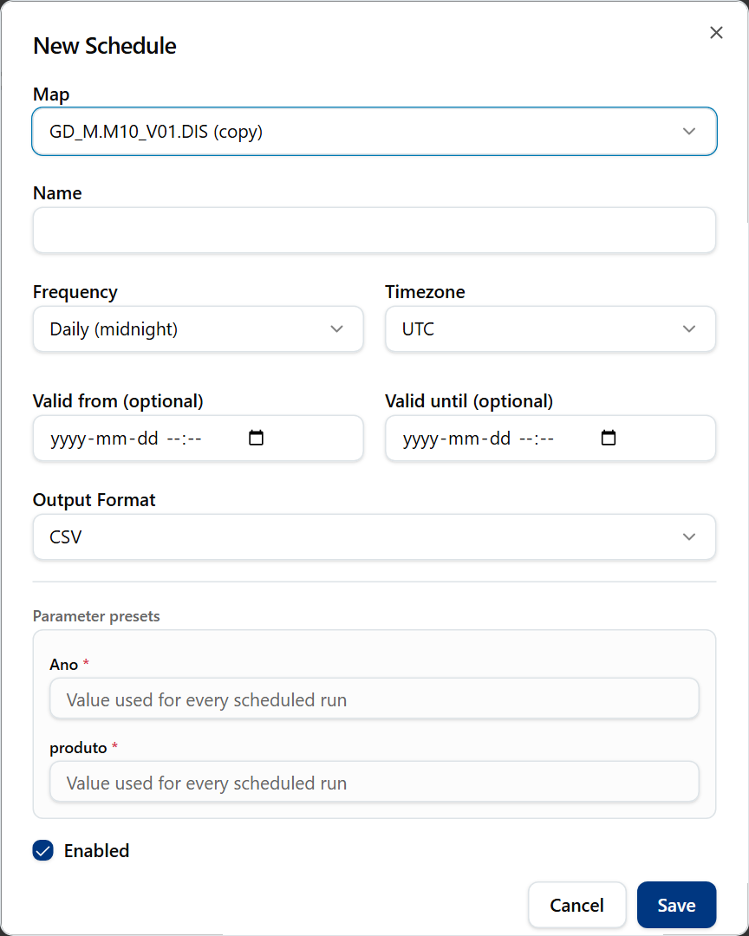
The New Schedule dialog with map, name, frequency, timezone and output format.
- Click New Schedule, or the calendar icon on Maps.
- Choose the Map (own, or shared as Can export or Can edit).
- Type a Name.
- Choose Frequency, Timezone and Output Format.
- Fill in Parameter presets, then click Save.
- Use Run now, Pause, History to manage it.

Choice | Line
Frequency | Daily (midnight), Weekly (Sunday, midnight), Monthly (1st, midnight), Custom (cron, e.g. 0 9 * * 1-5)
Output Format | Excel (.xlsx) or CSV
Public map | Cannot be scheduled

Settings
Open Settings from the sidebar.
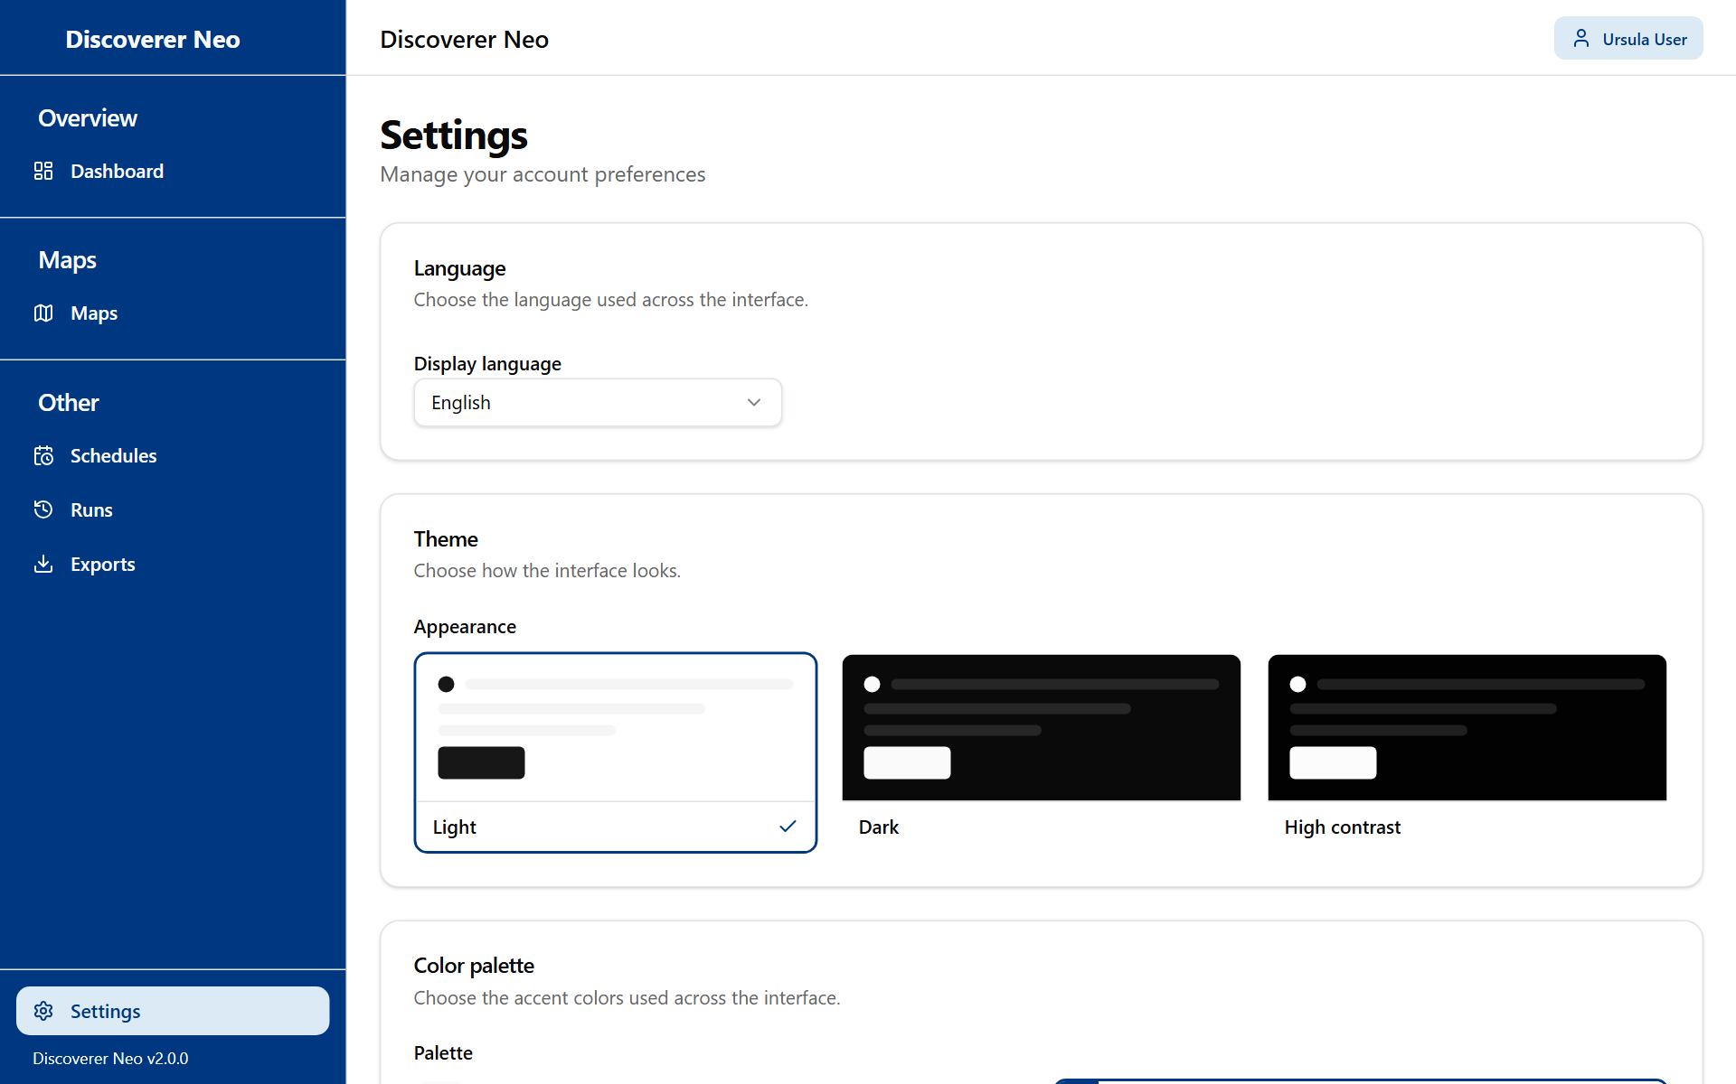
The Settings page with the Language, Theme and Color palette cards.
- Pick a Display language.
- Pick Light, Dark or High contrast.
- Pick a Palette (not with High contrast).
- Click Save. Without it the choice stays on this browser only.

