Discoverer Neo
Complete guide
For the VIEWER role
Version 2.0.1

Contents
Your role at a glance 1
Where your access comes from 1
Sign in, change your password, sign out 2
Dashboard 3
Maps 4
The map viewer 6
Run parameters 6
Read the results 7
When a run does not work 7
Export (only if your access allows) 8
Runs 9
Exports 10
Schedules 11
Settings 12
Common questions 13
Glossary 14

Your role at a glance
Discoverer Neo replaces Oracle Discoverer. A map is a report (in Oracle Discoverer this was a worksheet). A workbook is a group of maps. A business area is a group of related data. You have the VIEWER role. Your main job is to open maps, run them and read the results.
You can | You cannot
See your own maps, public maps and maps shared with you | See private maps that nobody shared with you
Run a map and read its results, sort, filter and drill down | Copy a map or a workbook
Export results, if the map is public or shared with you at Can export or Can edit | Export a map shared with you at Can view only
See your own runs and exports | See other people's runs or exports
Choose your language, theme and colours | Open the administration pages (they are not in your menu)

The VIEWER role has one fixed limit: you cannot copy maps or workbooks. Everything else depends on what has been given to you for each map and each business area. See the next section.

Where your access comes from
The role does not decide what you can run, export or schedule. These three things do.
- The map. You see a map if you created it, if its owner made it Public, or if someone shared it with you. A grant on a business area does not show you maps.
- The share level. Most maps reach you as a share. The level tells you what you may do.
- Your business-area grants. To read the data of a map, your administrator must have given you access to the business areas it uses. Without that, the run fails with "Not entitled to run".

Situation | Open and run | Export | Schedule | Change the map
Shared with you: Can view | Yes | No | No | No
Shared with you: Can export | Yes | Yes | Yes | No
Shared with you: Can edit | Yes | Yes | Yes | Yes
Public map you do not own | Yes | Yes | No | No

This guide covers what you do most: finding a map, running it and reading it. Exporting, scheduling and editing work only when the map is shared with you at the needed level. Those parts are short at the end of each chapter.
If a map you need is missing, ask its owner to share it with you.

Sign in, change your password, sign out
- Open the address your administrator gave you.
- Type your Email and Password.
- Leave Remember me ticked to stay signed in after you close the browser. Untick it on a shared computer.
- Click Sign in.

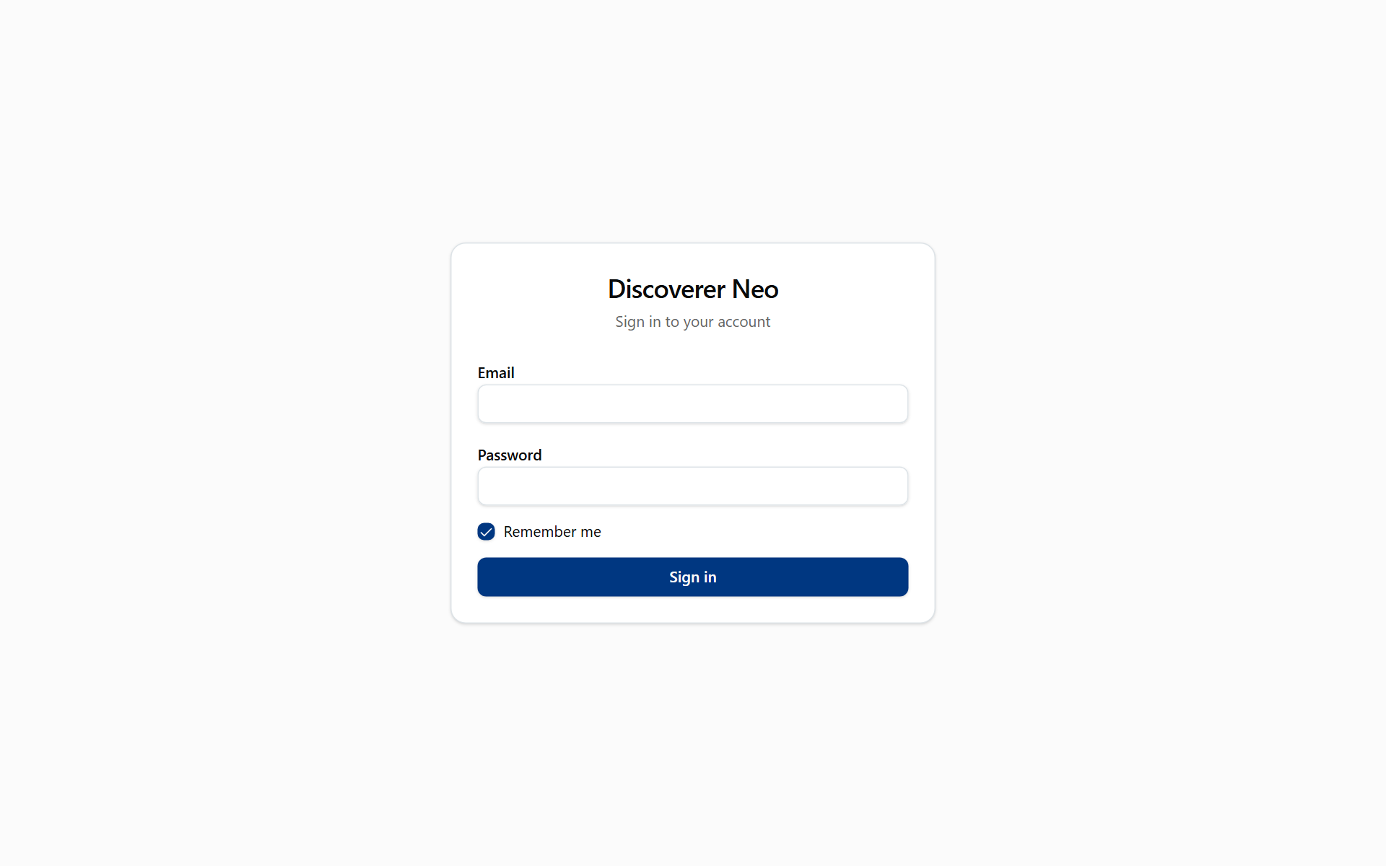
The sign-in page with Email, Password, Remember me and the Sign in button.
If your account was created with a temporary password, the Change your password page opens first. Fill in Temporary password, New password (at least 12 characters, different from the old one) and Confirm new password, then click Change password.
If you forget your password, ask your administrator to reset it. To sign out, click your name in the top-right corner, then Log out. This ends your session. To use Discoverer Neo again, sign in again.

Dashboard
The Dashboard is the first page after sign-in. It is a summary. It is read-only.
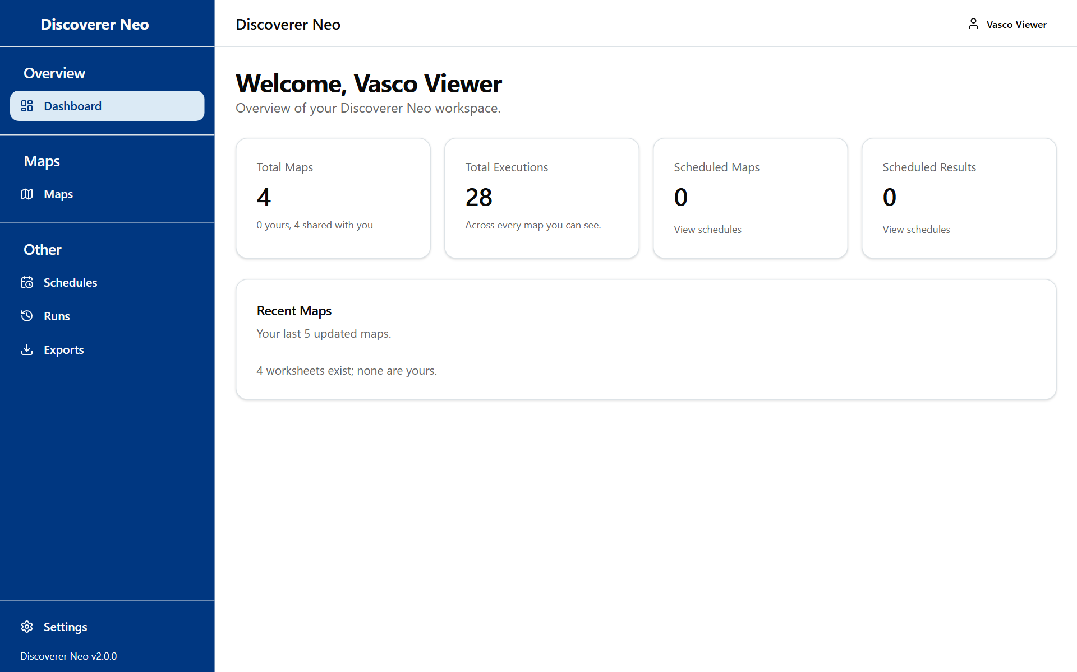
The Viewer dashboard with its short sidebar and summary cards.
Card | What it shows
Total Maps | The maps you can open, with how many are yours and how many are shared with you (public maps are counted there too)
Total Executions | Runs of the maps you can see, by anyone
Scheduled Maps and Scheduled Results | Your own schedules. These are usually zero for you
Recent Maps | Maps you created. Usually empty for you

Maps
The Maps page is your list of reports. Use it to find a map and open it.
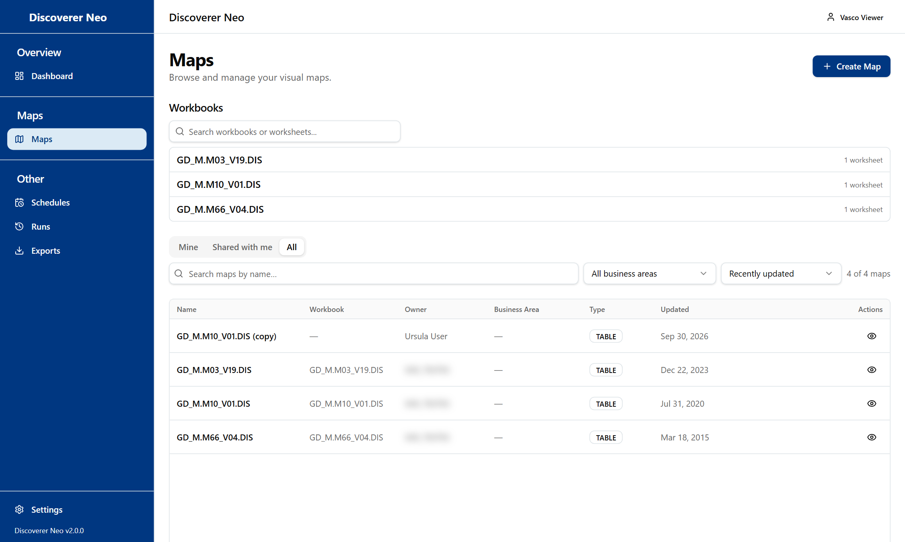
The Maps list, All tab, where each map has only the Open icon.
Control | What it does
Mine, Shared with me, All | Your own maps, maps shared with you, or everything you can see. If you own nothing, the page opens on All
Search maps by name… | Filters by name as you type
Business Area filter | Shows one business area. All business areas removes the filter
Sort by | Recently updated or Name (A–Z)
Clear | Removes the search and the filter
Map name or eye icon | Opens the map in the viewer

The table shows Name, Workbook, Owner, Business Area, Type, Updated and Actions.
You do not see a Copy icon, and there is no Copy workbook button. That is by design for your role.
Above the table, Workbooks lists the workbooks that contain your maps. Type in Search workbooks or worksheets..., click a workbook to open it, then click a worksheet to open the viewer.
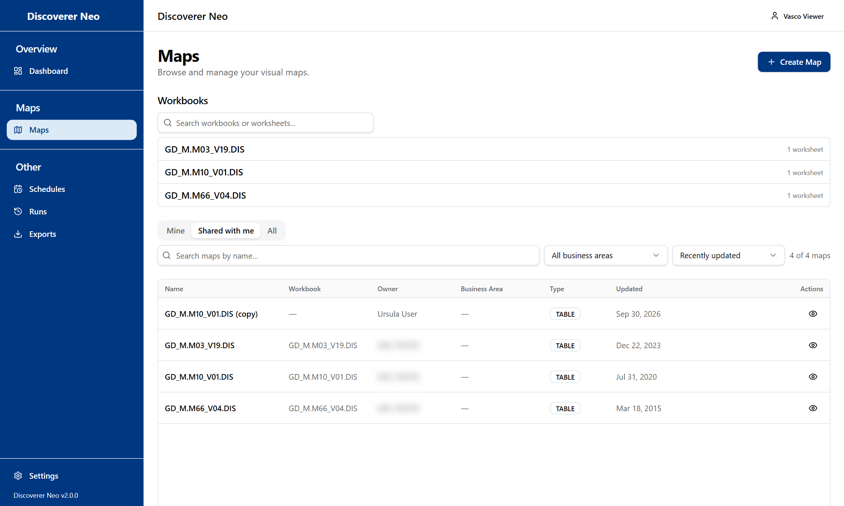
The Maps list, Shared with me tab, with the Workbooks card and only the Open icon.
Note: Some icons on a row (for example the pencil, the calendar or the trash) only work if you own the map or it was shared with you at a high enough level. If you click one and the server refuses, you see "Forbidden". Nothing is changed.
Example: to find the demo map, type GD_M.M10_V01.DIS in the search box and click its name.

The map viewer
The viewer runs a map and shows its rows. You spend most of your time here.
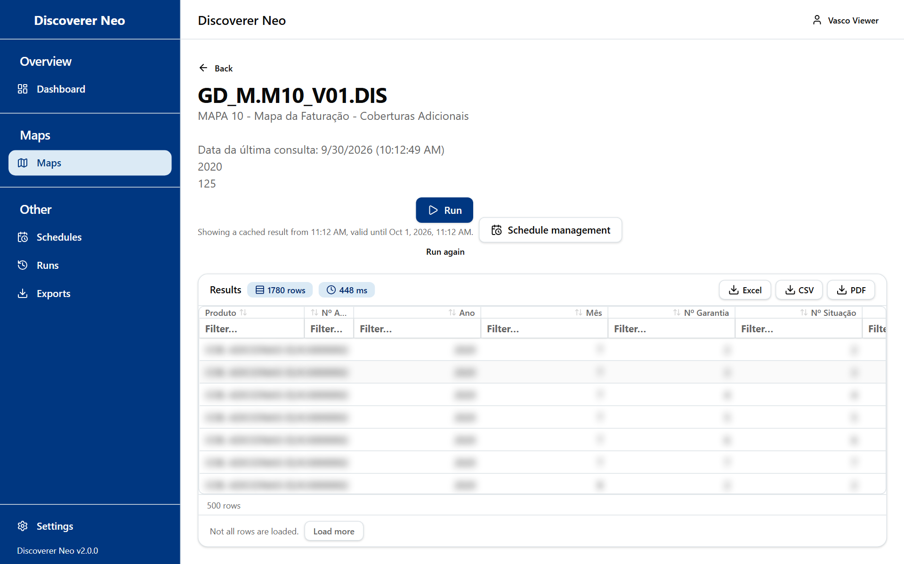
A completed run with Excel, CSV and PDF buttons over the results grid.
Button or control | What it does
Back | Returns to the previous page
Run | Runs the map. If the map asks for values, a dialog opens first
Run again | Runs again with the same values and skips the saved result. It appears after a run has finished
Cancel | Stops a run that is still waiting in the queue

Under the buttons, a status line shows Queued, Running… or the time of the result and how long it stays valid (24 hours). "Showing a cached result" means you ran this map with the same values recently. Click Run again to get fresh data.

Run parameters
Some maps ask for values, such as a date. In Run parameters, fill in each input (a red means required) and click Run. Cancel* closes the dialog.
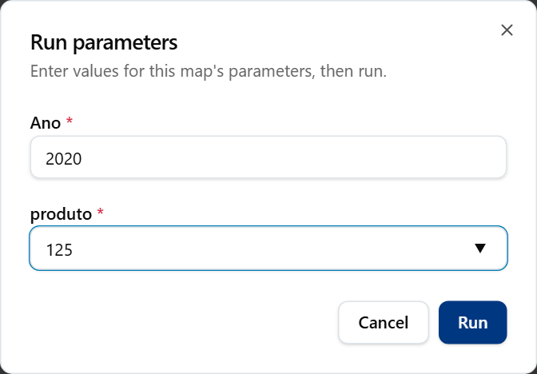
The Run parameters dialog with both required values filled in.

Read the results
Item | What it means
Results, row and ms badges | How many rows came back and how long it took
More rows available | The result was cut. Only part of the rows was returned
Column header (click) | Sorts by that column: ascending, descending, none
Filter… box under a header | Filters the rows you have loaded
Group badge, Total for …, Grand total | Rows are grouped and subtotalled. Sorting or filtering pauses them
Double-click a row | Drill to Detail: shows the raw rows behind that row
Load more | Loads the next 500 rows
Coloured cells | Rules the owner set to highlight values

A crosstab map shows a pivot table.

When a run does not work
What you see | What it means
Not entitled to run (red) | You may see the map but you have no access to its data. Ask your administrator
Request declined or Worksheet not run (amber) | The map is built in a way that cannot be run safely. The box says why. Tell the map's owner
Query timed out | The query took too long. Try again later or tell the owner
Map not found | The map was deleted or is not shared with you any more

Export (only if your access allows)
The Excel, CSV and PDF buttons appear under the results after a run. They work for public maps and for maps shared with you at Can export or Can edit.
Button | What it does
Excel | Downloads an Excel file
CSV | Downloads a CSV file
PDF | Opens Export to PDF: choose Paper size (A4, A3, Letter), Orientation (Portrait, Landscape) and the columns, then Export

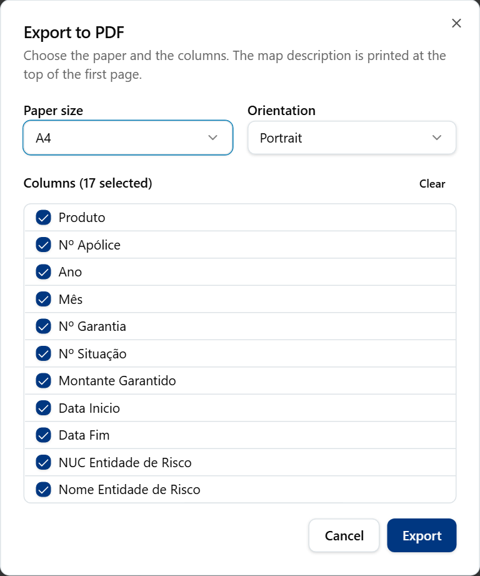
The PDF export dialog with orientation, page size, title and font options.
Note: If the map is shared with you at Can view only, the buttons are still on the screen, but the export fails with "Forbidden". Ask the owner for Can export.

Runs
The Runs page lists every map run you started. Use it to find a result again without running the map a second time.
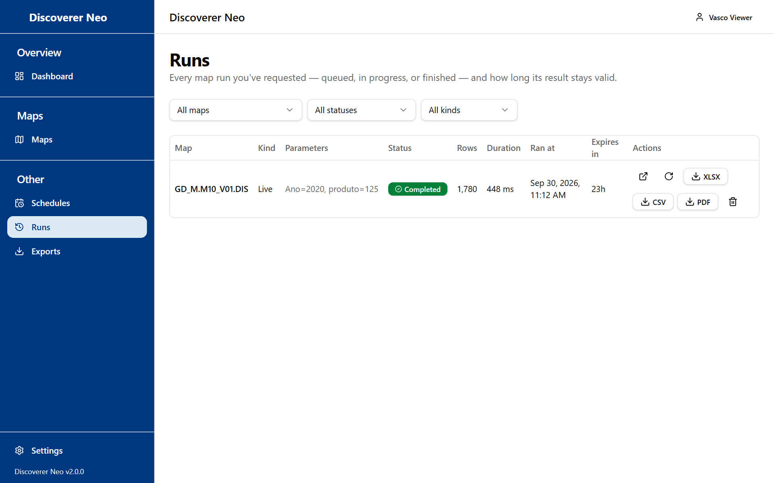
The Runs page listing the Viewer's own runs.
Control | What it does
Map, Status and Kind filters | Narrow the list. Kind is Live (you ran it) or Scheduled
Open icon | Opens the stored result
Run again icon | Starts a run with the same values
XLSX, CSV, PDF | Downloads a result, if your access allows export
Cancel icon | Cancels a run that is still queued
Delete icon | Deletes a finished run for good

The table shows Map, Kind, Parameters, Status, Rows, Duration, Ran at, Expires in and Actions. A live result stays 24 hours. When Expires in says Expired, run the map again. You see only your own runs.

Exports
The Exports page lists the files you asked for.
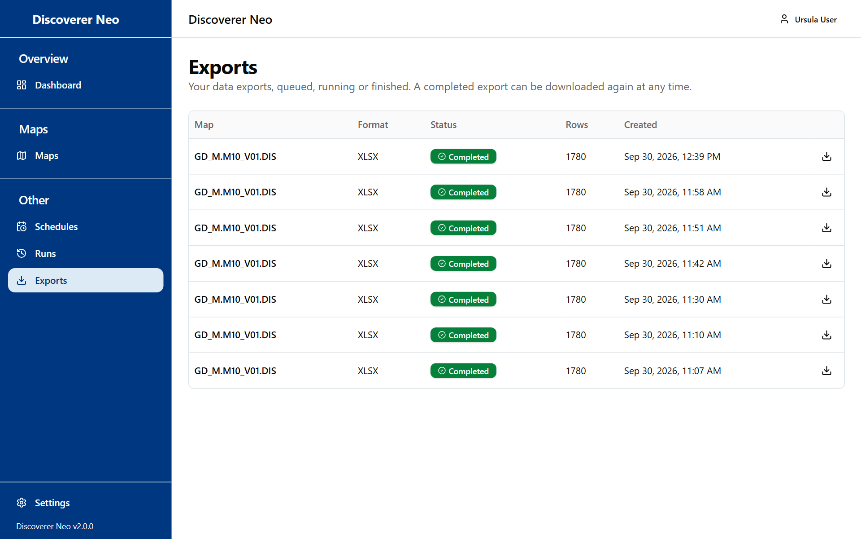
The Exports page listing export jobs with a Download button on finished ones.
The table shows Map, Format, Status (Queued, Running, Completed, Failed), Rows and Created. Click the Download icon on a completed row. Files are kept for 7 days. If the download fails, export again from the viewer. If you never export, this page stays empty.

Schedules
The Schedules page lists timetables that run a map by itself. It is yours only if you own a map or have Can export or Can edit on it. With Can view or a public map you cannot schedule. Those maps are not in the Map list of New Schedule.
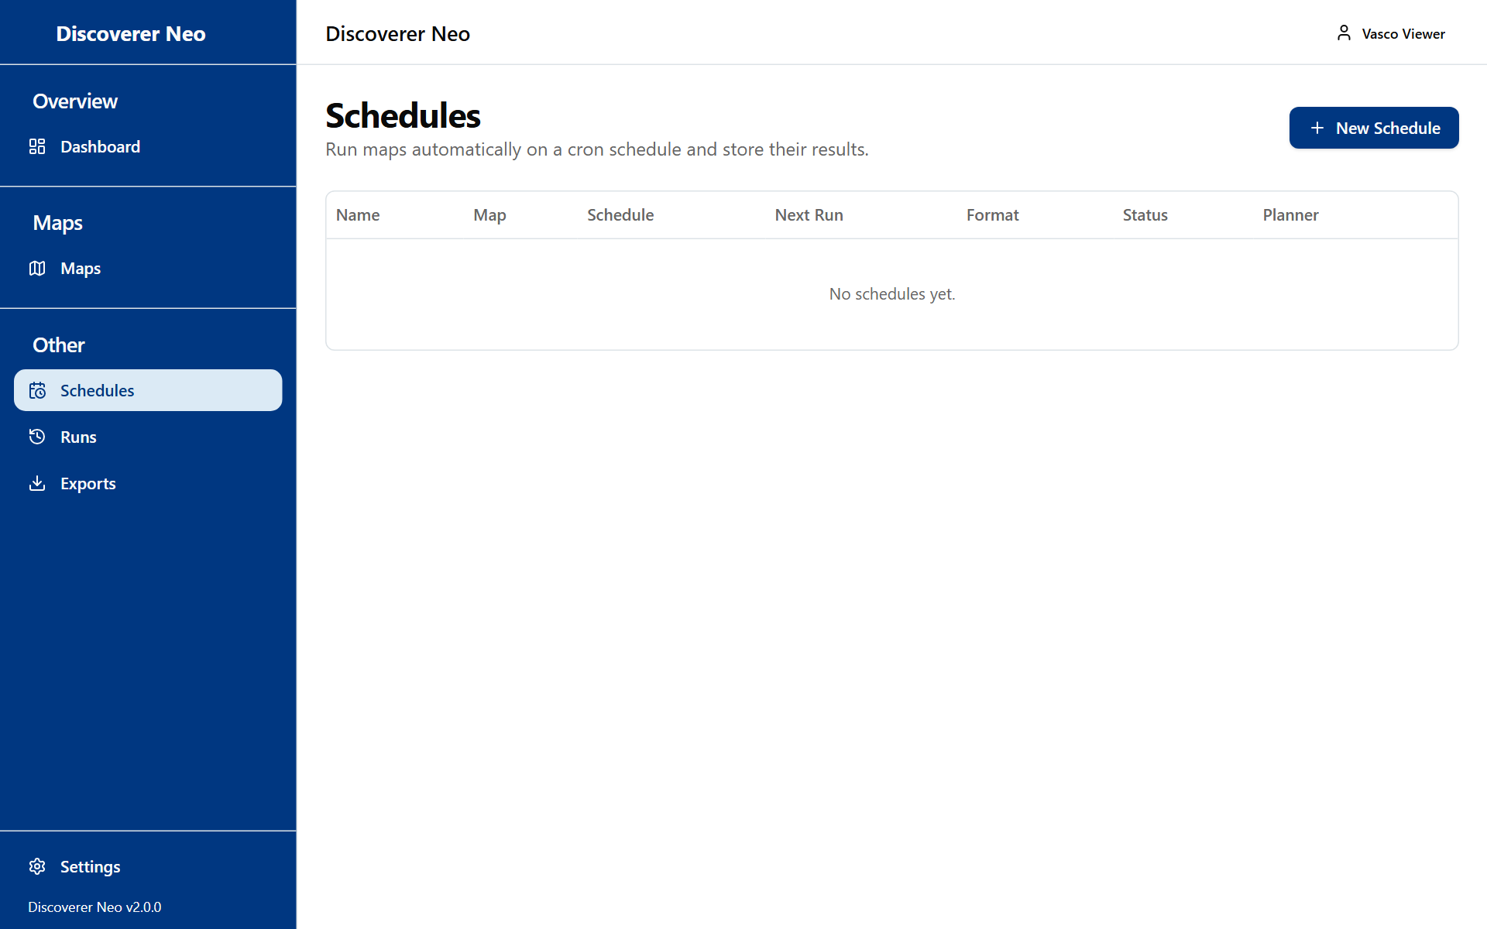
The Schedules page with the message No schedules yet.
If you do have the right level:
- Click New Schedule, or the calendar icon on Maps.
- Choose the Map and type a Name.
- Choose Frequency (Daily (midnight), Weekly (Sunday, midnight), Monthly (1st, midnight) or Custom), Timezone and Output Format (Excel (.xlsx) or CSV).
- Click Save.

Use the icons on each row to Run now, Pause or Enable, see History, Edit or Delete. Results stay on the server. Nothing is sent by email.

Settings
Settings changes how the application looks for you. Open it from the sidebar or from your name.
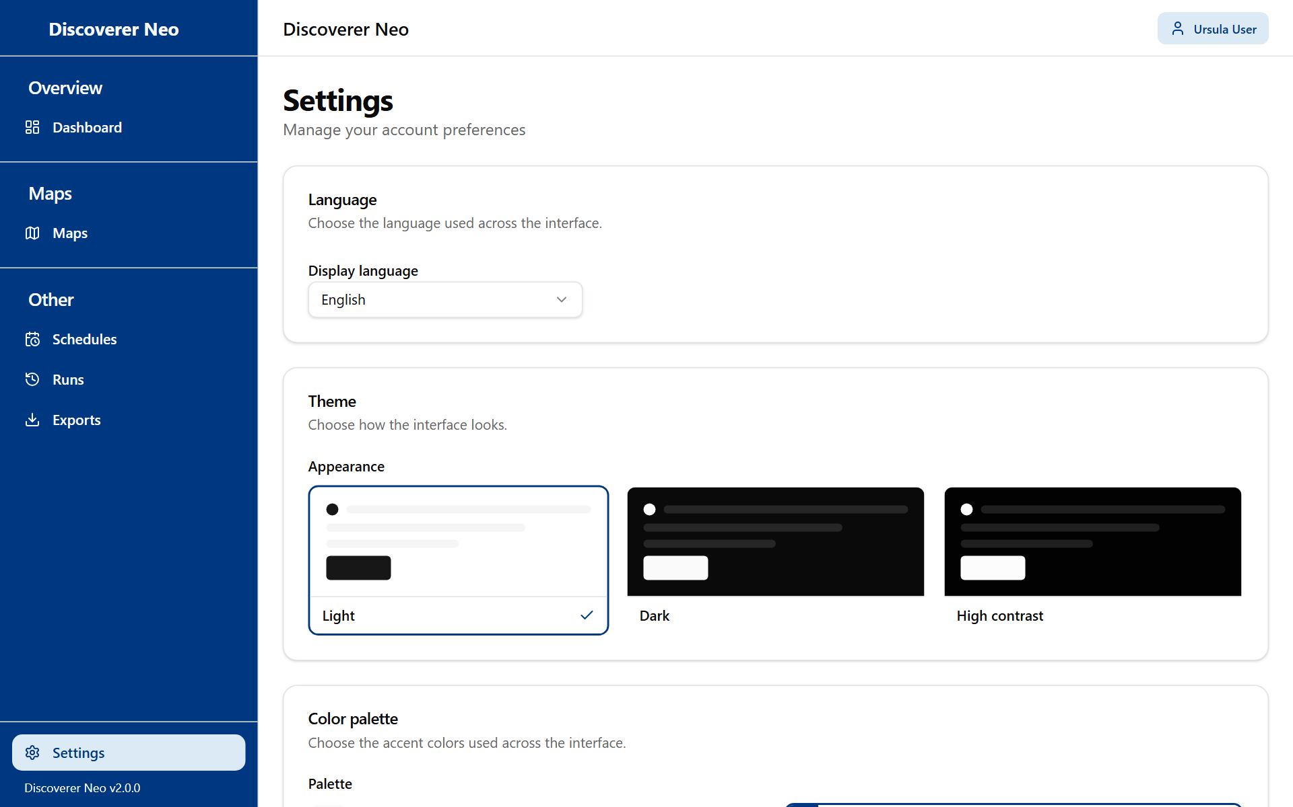
The Settings page with the Language, Theme and Color palette cards.
Control | What it does
Display language | English, Português (Portugal), Français (France), Español (España)
Appearance | Light, Dark, High contrast
Palette | Classic, Navy, Forest, Wine, Ocean, Ochre. Not available with High contrast
Save | Keeps your choices on your account

Your choices show at once. Click Save to keep them on every device.

Common questions
I cannot see a map that a colleague sees. You see only your own, public and shared maps. Ask the owner to share it. Managers and administrators see every map.
Why is there no Copy icon? The VIEWER role cannot copy maps or workbooks. Ask the owner or your administrator.
I get "Not entitled to run". You have no access to the data of that map. Ask your administrator.
Excel, CSV or PDF says "Forbidden". The map is shared with you at Can view only. Ask the owner for Can export.
The Edit or Schedule icon does nothing. Those need Can edit or Can export on the map, or ownership.
My result says Expired. Live results stay 24 hours. Click Run again.
I cannot find an old export. Files are removed after 7 days.
I forgot my password. Ask your administrator to reset it.

Glossary
Term | Meaning
Map | A report. In Oracle Discoverer this was a worksheet
Workbook | A group of maps
Business area | A group of related data
Run | One execution of a map that produces a result
Export | A file (Excel, CSV or PDF) made from a result
Schedule | A timetable that runs a map by itself
Share | Access to a map given by its owner: Can view, Can export or Can edit
Public map | A map every user can open, run and export
Parameter | A value the map asks for when you run it

