DISCOVERER NEO
Guide for the USER Role
User manual

This guide is for people whose account has the USER role. It tells you what you can do, where to find it, and what to ask your administrator for.
Discoverer Neo replaces Oracle Discoverer. The reports you knew as worksheets are called maps here. A workbook is still a group of worksheets.
September 2026

Contents
1. What the USER role can do 4
Where your access comes from 4
2. Signing in 5
First sign-in with a temporary password 5
3. The screen 6
Dashboard 6
4. Finding a map 7
Browse by workbook 7
5. Running a map 8
Parameters 8
What happens after you click Run 8
When Run is grey 9
When a map is declined (amber panel) 9
6. Reading the results 10
Group breaks and totals 10
Why a total is empty 10
Sort, search and columns 10
Drill to detail 11
Yellow note above the results 11
Crosstabs 11
7. Exporting results 12
Why the export buttons are missing 12
The Exports page 12
8. Sharing maps 13
Share your own map 13
Maps shared with you 13
9. Building and changing maps 14
Create a map 14
Useful column settings 14
Parameters 14
Conditional formatting 14
Copy a map 14
No mouse needed 14
10. Scheduling maps 15
Create a schedule 15
Custom frequency (cron) 15
Manage schedules 16
Schedules from Oracle Discoverer 16
11. The Runs page 17
12. Settings 18
13. Problems and what to do 19
What to tell your administrator 19

1. What the USER role can do
You can | You cannot
Run maps you have access to | Create or change business areas, folders, items, joins or data sources
Export results to Excel, CSV and PDF | Manage users, security or the audit log
Schedule maps to run automatically | Run the migration from Oracle Discoverer
Create and edit your own maps (if your administrator lets you) | See other users' runs
Share your own maps with colleagues | Share a map that someone else owns
Choose your language and theme

The menu shows only what your role can use. If you do not see a page that a colleague sees, they have a different role.

Where your access comes from
Your role is only half of the picture. Your administrator also gives you access to business areas (groups of related data). You can open a map in one of these ways:
- You created it. You can always run, edit, export, schedule, share and delete your own maps.
- Someone shared it with you. What you can do depends on the share level (see section 8).
- It is public. Every user can open, run and export a public map.
- Your administrator gave you create or edit rights in its business area. You can then work with the maps in that area.
If a map you need is not in your list, ask your administrator or the map's owner.

2. Signing in
- Open the Discoverer Neo address your administrator gave you.
- Enter your Email and Password.
- Click Sign In.
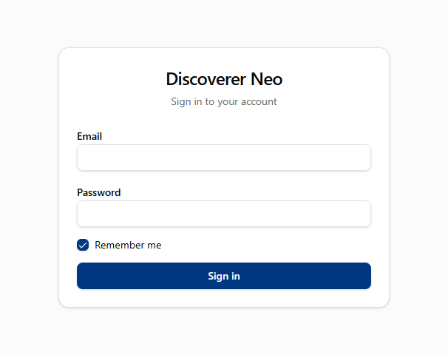
Figure 1 — The sign-in screen

First sign-in with a temporary password
If your account came from Oracle Discoverer, your administrator gives you a temporary password. It has 16 characters, for example ufNnRksjgR7U%M6X.
- Sign in with your email and the temporary password.
- The Change your password screen opens. You cannot skip it.
- Enter the temporary password again, then your new password two times.
- The dashboard opens. The temporary password stops working.
Your new password must have at least 12 characters. It must be different from the temporary password.
Tip: the temporary password has no capital O, no zero, no small l and no one. These characters are easy to mix up, so they are not used.
If you lose the temporary password, ask your administrator to reset it.
To sign out, click your email in the top-right corner, then Log out.

3. The screen
The left menu has these items:
Menu item | What it is for
Dashboard | Your numbers at a glance and your recent maps
Maps | Find, open, run and build maps
Schedules | Maps that run automatically
Runs | Every run you started, and its result
Exports | Files you exported
Settings (bottom) | Language and theme

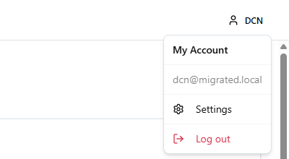
Figure 2 — The user menu, with Log out

Dashboard
- Total Maps — the maps you can see.
- Total Executions — how many times you ran a map.
- Scheduled Maps — how many of your schedules are active.
- Scheduled Results — how many results your schedules made.
- Recent Maps — the last 5 maps you changed.
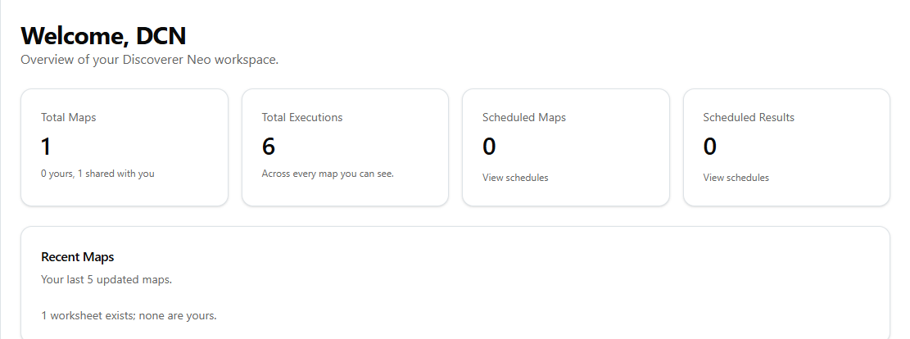
Figure 3 — The Dashboard

4. Finding a map
- Click Maps.
- Choose a tab:
  - Mine — maps you created.
  - Shared with me — maps other people shared with you.
  - All — every map you are allowed to see. This includes maps that came from Oracle Discoverer.
- Search by name, filter by business area, or sort by name or by date.
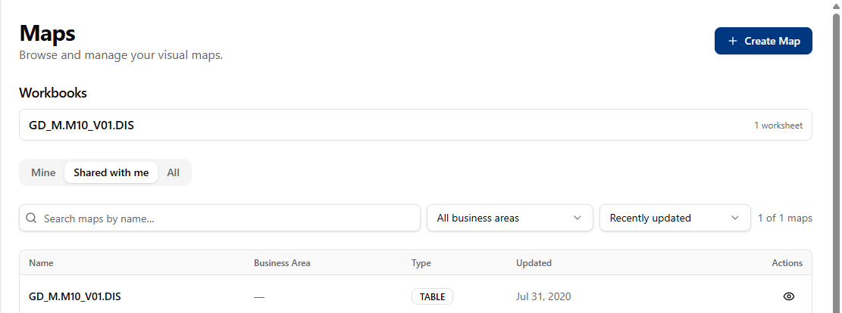
Figure 4 — The Maps page, with the Workbooks panel and the tabs

Browse by workbook
The Workbooks panel groups maps the way Discoverer saved them. Click a workbook to see its worksheets in their original order. Click a worksheet to open it. You only see the worksheets you are allowed to see.

5. Running a map
- Open the map.
- Click Run.

Parameters
Many maps ask for values before they run, for example a start date and an end date. A Run parameters window opens.
- Fill in every field with a red *. These fields are required.
- Leave an optional field empty to use its saved default.
- Click Run.
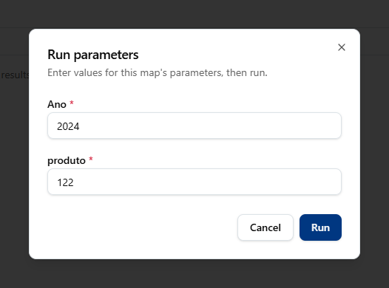
Figure 5 — The Run parameters window
If you click Run and nothing seems to happen, look for this window. The map waits until you fill it in.
Pick-lists. Most fields show a list of the values that are in the database now. Click the field or start to type. You can still type any value. If a column has too many values, the field says "Too many values to list — type to search". Type two or three characters to see matches.
Dates. Type dates in the format that the field shows.

What happens after you click Run
A run goes through these steps:
- Queued — the run waits its turn. Your runs go one at a time, in order.
- Running — the database is working on it.
- Completed — the rows show in the table.
If you run the same map with the same values again, and a valid result exists, Neo shows that result at once. It is marked Result reused. Click Run again to get fresh data.
A result stays available for up to one day. After that, you must run the map again.

When Run is grey
The reason shows under the button. No output columns means the map has no columns to show. Open the map in the builder and add a column.
Two other messages can show after you click Run:
- Not entitled to run — you can open the map, but you cannot run it on this data. Ask your administrator.
- Could not connect to the data source — the database is not available. Try again later. If it continues, tell your administrator.

When a map is declined (amber panel)
Sometimes Neo can build the query but cannot promise that the numbers are correct. It then shows an amber panel, not a red error. The panel tells you what you asked for, why Neo cannot answer, and what to change. Oracle Discoverer declined the same kinds of query.
This is not a fault. Change the map as the panel tells you, or ask the map's owner to change it.

6. Reading the results
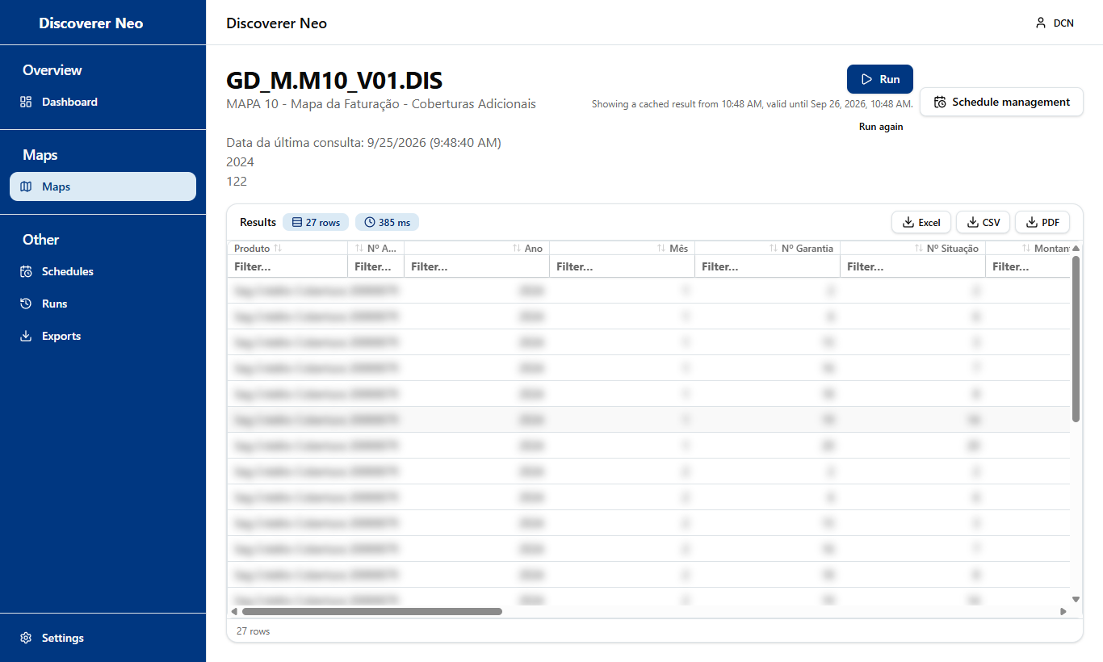
Figure 6 — The results of a run (data blurred)

Group breaks and totals
- Group breaks — a grouped column shows its value once, on the first row of each group. Its header has a Group badge.
- Subtotals — a line at the end of each group, for example Total for EMEA.
- Grand totals — a bold line at the bottom.
Totals use all the rows that match the filters, not only the rows on the screen.
When you sort or filter the table, the groups and subtotals stop. The table becomes a plain list. Clear the sort to get the groups back. A note at the bottom tells you when this happens.

Why a total is empty
Sometimes a total cell is empty on purpose. This happens when the columns come from different sets of rows, and adding them together gives a wrong number. Oracle Discoverer did the same. The rows in the table are correct. Only the total is not shown. The note at the bottom says how many totals are empty.

Sort, search and columns
- Click a column header to sort: first click A → Z, second click Z → A, third click removes the sort.
- Use the search box to filter the rows on the screen. This does not run the query again.
- Drag the edge of a column header to change its width.

Drill to detail
Double-click a row to see the detail rows behind it. For example, double-click a total to see the rows that make it.

Yellow note above the results
A yellow note lists settings that this run could not use, for example a sort on a column that the report does not show. The rows are still correct.

Crosstabs
Maps from Oracle Discoverer arrive as tables, also when the original was a crosstab (a pivot table). Discoverer did not save which columns went across the top. If you can edit the map, open a column in the builder and set Crosstab edge to Across the top.

7. Exporting results
- Run the map and wait until it shows Completed.
- Click Excel, CSV or PDF.
- Excel and CSV download the file to your computer at once. PDF first opens a window: choose the paper and the columns, then click Export.
- The file also goes on the Exports page. You can download it again from there.
Format | Use it for
Excel (.xlsx) | Reports and analysis
CSV | Loading the data into other tools
PDF | Printing and sending a fixed layout

All formats keep the group breaks, subtotals and totals that you see on the screen.
You need the Can export share (or higher) to export a map that someone else owns.

Why the export buttons are missing
Export uses the rows that a run already saved. It does not run the query again. The buttons show only when the run is Completed and its result has not expired. Click Run again to get a new result that you can export.

The Exports page
Click Exports to see all your exports and their status: Queued, Running, Completed or Failed. Files are kept for 7 days. Then they are deleted. Download the files you want to keep.
You can leave the page while a large export runs. Come back to Exports later.
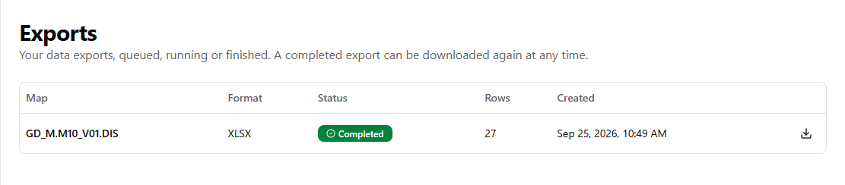
Figure 7 — The Exports page

8. Sharing maps

Share your own map
You can share only the maps that you created.
- Open your map.
- Click Share.
- Choose a colleague.
- Choose the level:
Level | What your colleague can do
Can view | Open and run the map
Can export | Open, run, export and schedule the map
Can edit | All of the above, and change the map

- Click Share.
To change a level, choose a new one in the list. To stop sharing, click Remove. The change applies at once.
Give the lowest level that your colleague needs.
Public maps. If you make a map Public, every user can open, run and export it.

Maps shared with you
Open Maps → Shared with me. What you can do depends on the level you got. A Can edit share lets you change the map, but you cannot share it with other people. Only the owner can do that.
Your own data rights still apply. A share gives you the map, not new data rights. If you see Not entitled to run, ask your administrator for access to the data.

9. Building and changing maps
You can build a map only in a business area where your administrator gave you the right to create maps. If Create Map gives an error, ask for this right.

Create a map
- Click Maps, then Create Map.
- Choose a business area.
- Enter a Name. You can add a Description.
- Choose a Map Type: TABLE (the usual one), CROSSTAB (pivot table), PAGE_DETAIL or CHART.
- Add columns: choose items from the list on the left. Drag them to change the order.
- Add filters (conditions), parameters and calculated fields if you need them.
- Click Save.

Useful column settings
- Sort order — 1, 2, 3 … for a sort on more than one column.
- Aggregation — SUM, COUNT, AVG, MIN or MAX. The other columns become the groups.
- Group and break — show a value once per group and add a subtotal.
- Query only, do not show — the query uses the column, but the table does not show it.
- Format mask — for example 999,999.00 or DD-MON-YYYY. Each reader sees the format in their own language.

Parameters
A parameter asks for a value when the map runs. The name can have only letters, digits and underscores, and must start with a letter, for example start_date.

Conditional formatting
After you save the map, click Formatting to colour cells or rows that match a rule. The rules also apply to exports.

Copy a map
Click Duplicate to make your own copy of a map. For a map that someone else owns, you need the right to create maps in its business area.

No mouse needed
Every drag action has a keyboard key. Use Tab to go to an item, then its Add button. To move a column, go to its grip handle, press Space, use the arrow keys, then press Space again.

10. Scheduling maps
A schedule runs a map for you at set times and keeps the results.
You can schedule your own maps, and maps shared with you at Can export or higher.

Create a schedule
- Click Schedules, then New Schedule.
- Choose the Map.
- Enter a Name.
- Choose a Frequency: Daily (midnight), Weekly (Sunday, midnight), Monthly (1st, midnight), or Custom.
- Choose the Timezone.
- Optional: set Valid from and Valid until.
- Choose the Output Format: Excel or CSV.
- If the map has parameters, fill in the Parameter presets. Every run uses these values.
- Tick Enabled, then save.
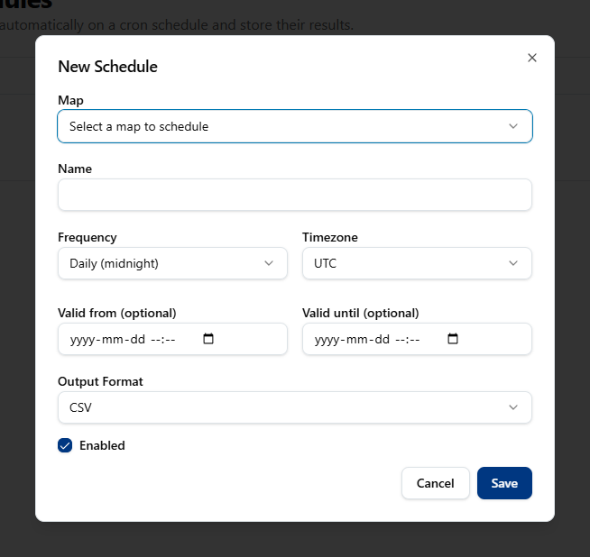
Figure 8 — The New Schedule window

Custom frequency (cron)
Custom uses a cron expression with five parts: minute hour day-of-month month day-of-week.
When | Expression
Every day at 09:00 | 0 9 * * *
Monday to Friday at 08:00 | 0 8 * * MON-FRI
Every Monday at 09:00 | 0 9 * * MON
Every 4 hours | 0 */4 * * *
The first day of each month at midnight | 0 0 1 * *

Manage schedules
In the Schedules list, each schedule has these actions: Run now, Pause or Enable, History, Edit and Delete.
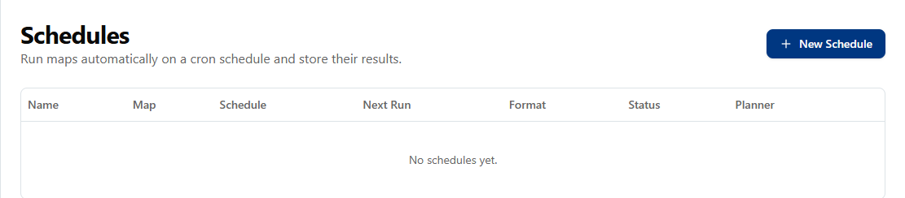
Figure 9 — The Schedules page
Click History to see each run, its status, rows and duration. Click Open to see the rows, or XLSX, CSV or PDF to download them.

Schedules from Oracle Discoverer
Schedules that came from Oracle Discoverer arrive disabled. They do not run until someone enables them. Before you enable one, look at the Planner column:
Planner | Meaning
Not checked | No check yet. You can enable it and see the result.
FLAT(...) or REWRITE(...) | The map can run correctly.
REFUSE(...) | The map cannot give a correct answer. Each run fails. Fix the map first.
UNPLANNABLE | The map has a data problem from the migration. Ask your administrator.

A failed scheduled run does not try again automatically.

11. The Runs page
Click Runs to see every run that you started, live or scheduled. You see its status, rows, duration and when its result expires.
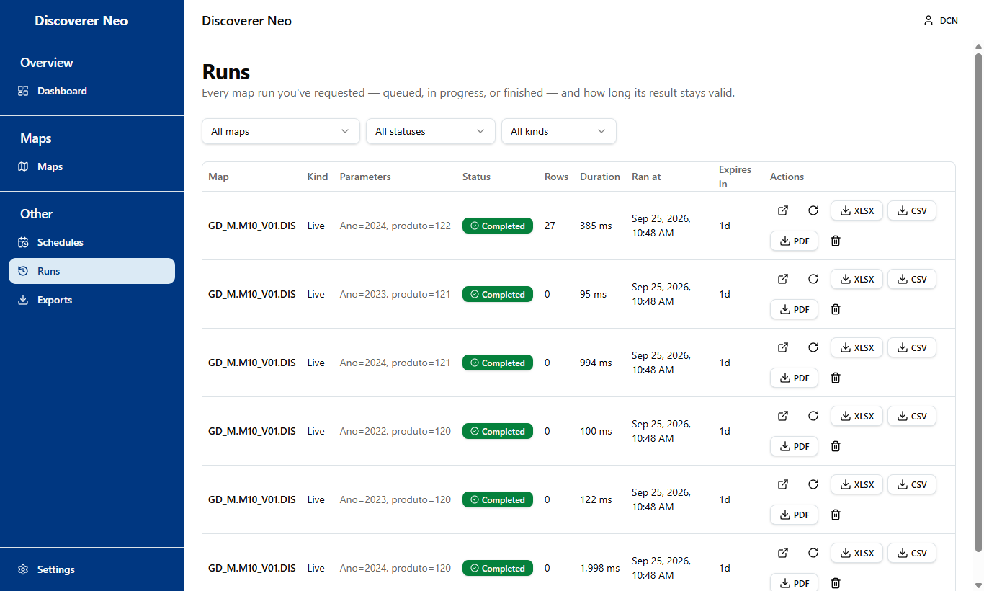
Figure 10 — The Runs page
- Open — show the rows of that run.
- Run again — run with the same values.
- Cancel — stop a run that is still queued.
- Delete — remove a finished run.
- XLSX / CSV / PDF — download the saved rows.
Use the Map filter to see the runs of one map only.

12. Settings
- Click Settings at the bottom of the menu.
- Choose a Language: English, Português (Portugal), Français (France) or Español (España).
- Choose a Theme: Light, Dark or High-Contrast.
- Click Save.
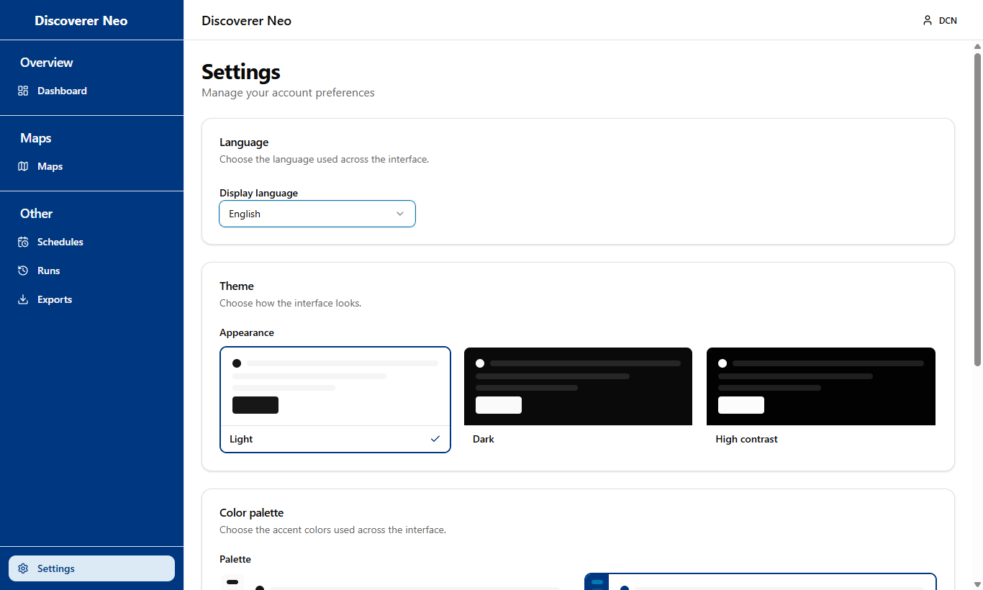
Figure 11 — The Settings page
The screen changes at once so you can try each choice. If you do not click Save, the change is lost when you reload the page.
Your settings follow you to every computer and browser.

13. Problems and what to do
Problem | What to do
I cannot find a map | Look in All. If it is not there, ask the owner to share it, or ask your administrator for access.
Run does nothing | Look for the Run parameters window and fill in the red * fields.
Not entitled to run | Ask your administrator for access to the data.
Could not connect to the data source | Wait and try again. If it continues, tell your administrator.
Amber panel | The map cannot give a correct number. Change it as the panel says, or ask the owner.
No rows | Check the filters and the parameter values.
The query takes too long | Use smaller date ranges or more filters.
No export buttons | The result expired or is not complete. Click Run again.
Export Failed | Export fewer rows (add filters), or try another format.
Create Map or Duplicate gives an error | Ask your administrator for the right to create maps in that business area.
I cannot share a map | You can share only maps you created. Ask the owner.
My language or theme went back | You did not click Save in Settings.
The schedule did not run | Check that it is Enabled and look at its Planner value.

What to tell your administrator
When you ask for help, give:
- the map name,
- what you clicked,
- the exact message on the screen,
- the date and time.

