Discoverer Neo
Quick guide
For the ADMIN role
Version 2.1.0

Contents
Your role in one page 1
Dashboard and Maps 2
Map builder and viewer 3
Runs, Exports and Schedules 4
Business Areas and Grants 5
Folders, Items, Joins, Hierarchies 6
Custom Functions and Data Sources 8
Users 9
Security Policies and Audit Log 10
Migration 11

Your role in one page
You are an administrator. You can use every page. A map is a report (in Oracle Discoverer, a worksheet). A business area is a group of related data.
You can | You cannot
Open, change, share, copy and delete every map | Delete or deactivate your own account
Build maps anywhere, without a grant | Download another user's export
See SQL and plan of a map | See other users' schedules in the list
See every user's runs
Set up business areas, folders, items, joins, hierarchies, functions, data sources
Manage users, grants, security policies
Read the audit log and run migrations

Sign in: type Email and Password, click Sign in. Sign out from your name menu with Log out. Settings (language, theme, palette) needs Save to stick.
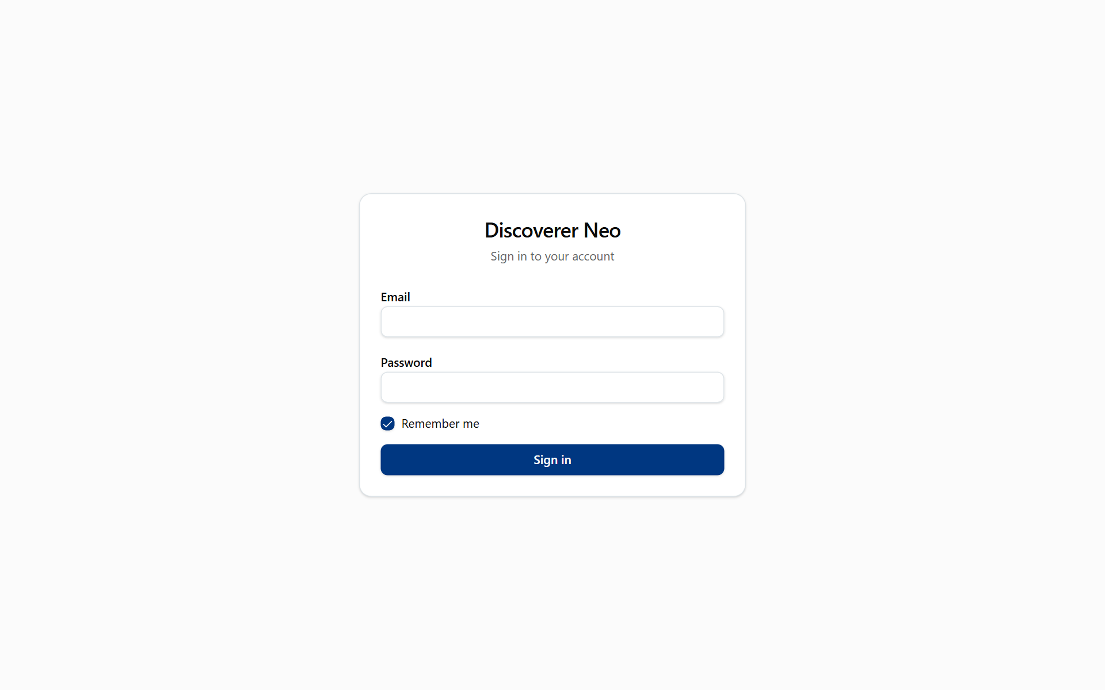
The sign-in page with Email, Password, Remember me and the Sign in button.

Dashboard and Maps
The Dashboard counts maps, runs and your schedules. Maps lists every map in the system.
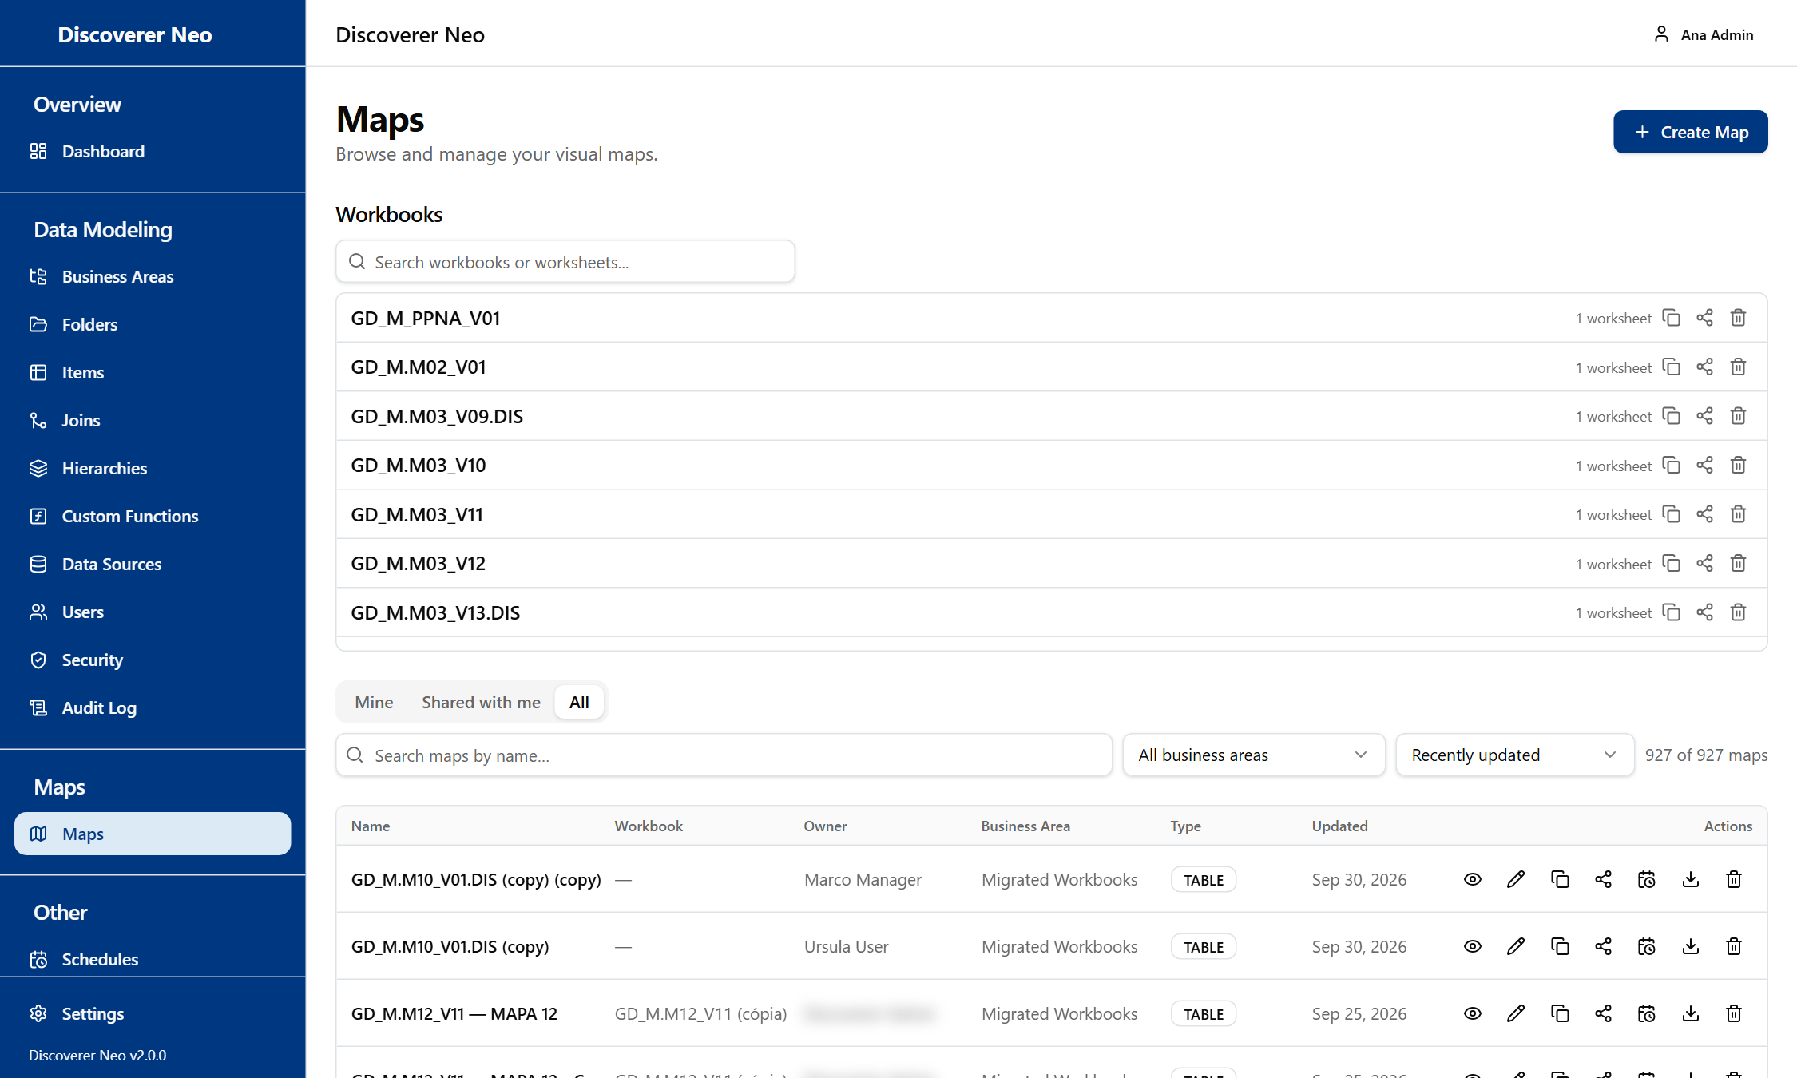
The Maps list, All tab, with every row icon and the Workbooks section above.
- Open Maps. Use the tabs Mine, Shared with me, All.
- Find a map with the search box or the Business Area filter.
- Click the Eye icon to run it, the pencil to change it.
- Click the Share icon to give access.
- Click the Trash icon to delete (only an administrator can restore).

Choice | Meaning
Can view | Open and run only.
Can export | Also export and schedule.
Can edit | Also change the map. Cannot re-share.
Copy icon | Your own private copy.

Map builder and viewer
The builder makes a map. The viewer runs it.
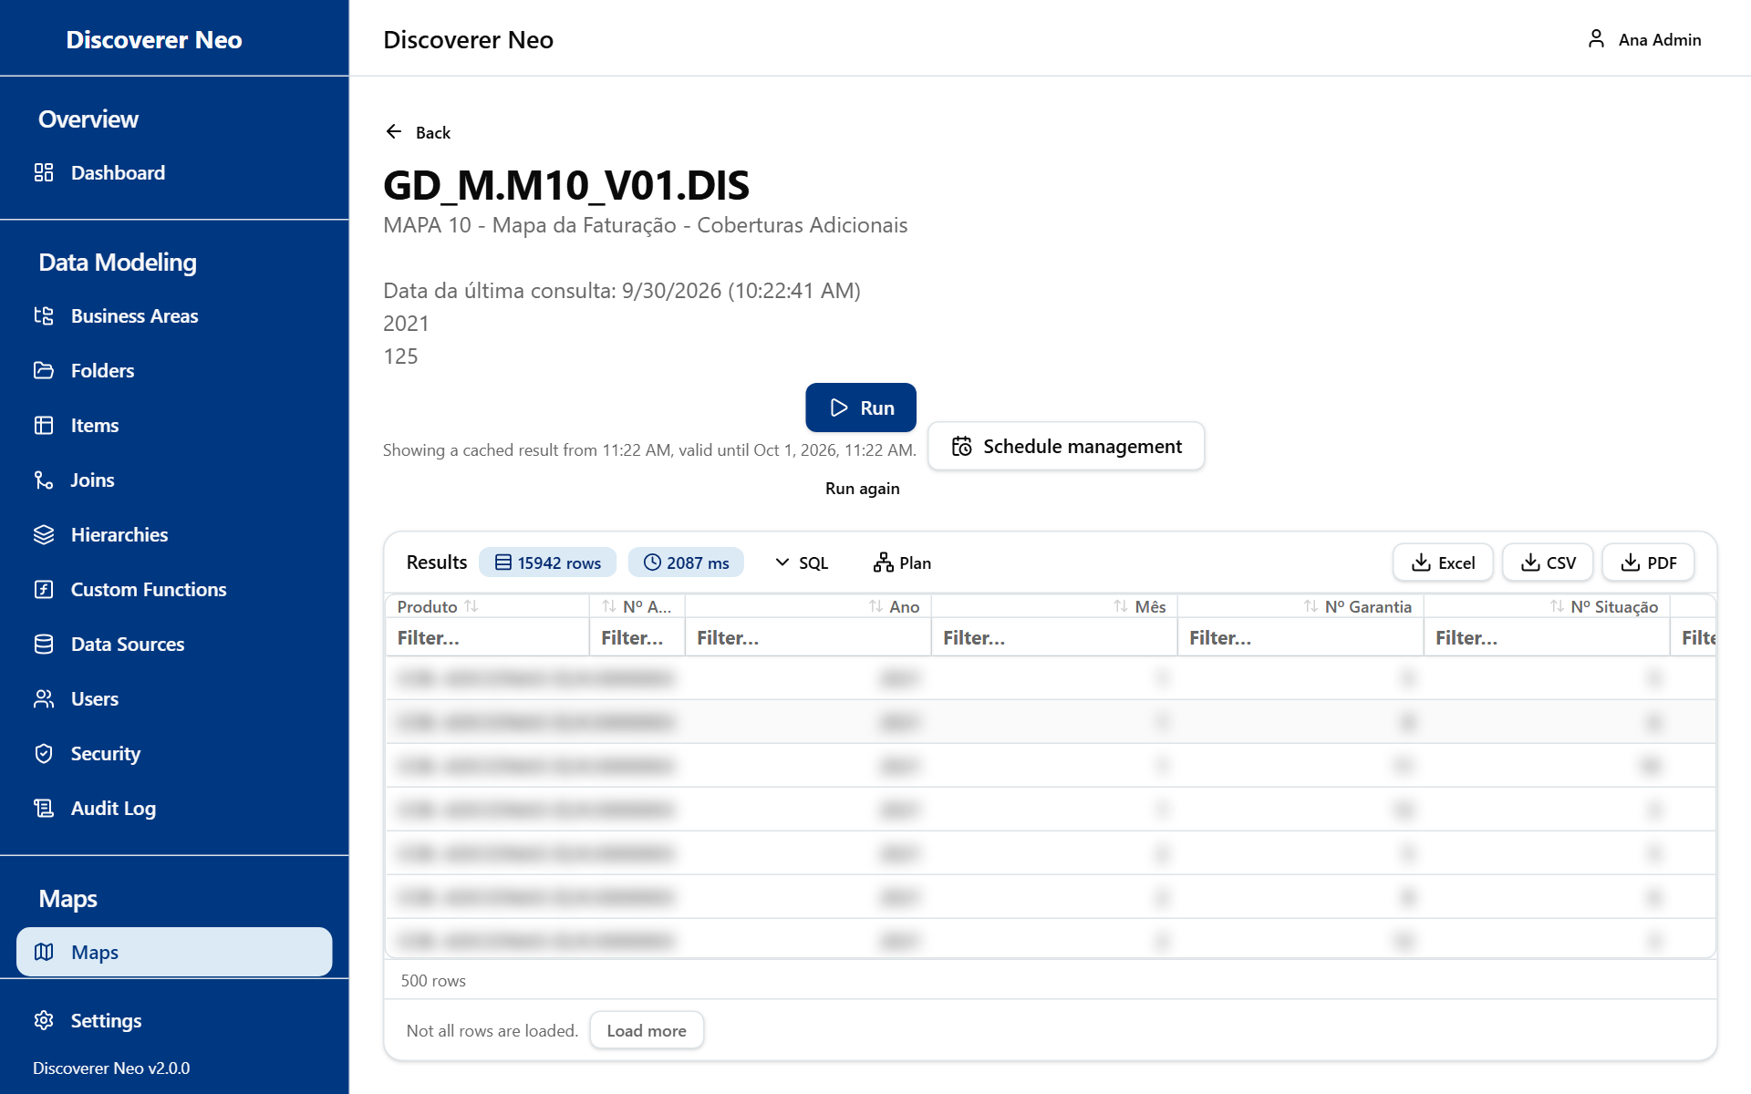
Run results with the SQL and Plan buttons beside the Excel, CSV and PDF buttons.
- Click Create Map.
- Drag items from the Business Areas tree onto the canvas. The first item fixes the business area.
- Click a column to set Aggregation, sort or format.
- Add Conditions, Parameters or Calculated Fields in the right tabs if needed.
- Click Save, then Run.
- Export with Excel, CSV or PDF. You also see SQL and Plan.

Choice | Meaning
Public (Properties) | Every signed-in user can open and export it.
Aggregation | NONE, SUM, COUNT, AVG, MIN, MAX.
Run again (viewer) | New run, skips the stored result.
PDF | Choose paper (A4, A3, Letter) and orientation.

Runs, Exports and Schedules
A run is one execution of a map (kept 24 hours). An export is a file made from a run (kept 7 days). A schedule runs a map by itself.
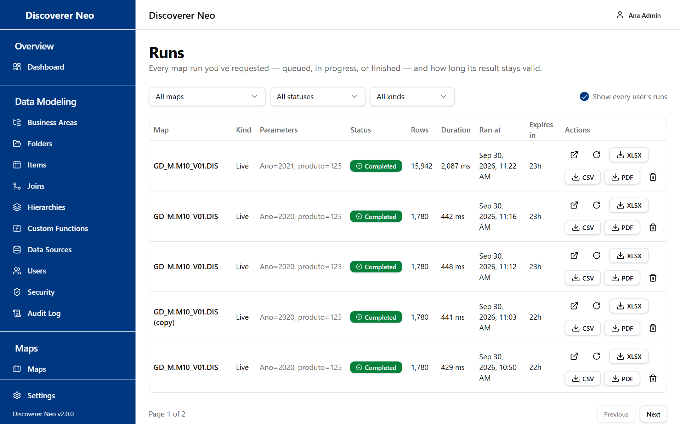
The Runs page with every user's runs shown.
- In Runs, tick Show every user's runs to see everyone's.
- Click Open to see a result, or XLSX, CSV, PDF to export it.
- In Exports, click the Download icon. You see only your own files.
- In Schedules, click New Schedule. Pick the map, Frequency, Timezone and Output Format. Click Save.
- Use History to open or export past results.

Choice | Meaning
Frequency | Daily (midnight), Weekly (Sunday, midnight), Monthly (1st, midnight), Custom (cron).
Output Format | Excel (.xlsx) or CSV.
Run now | Runs a schedule at once.

Business Areas and Grants
A business area groups folders. A grant gives a person access to its data. A grant never shows a map.
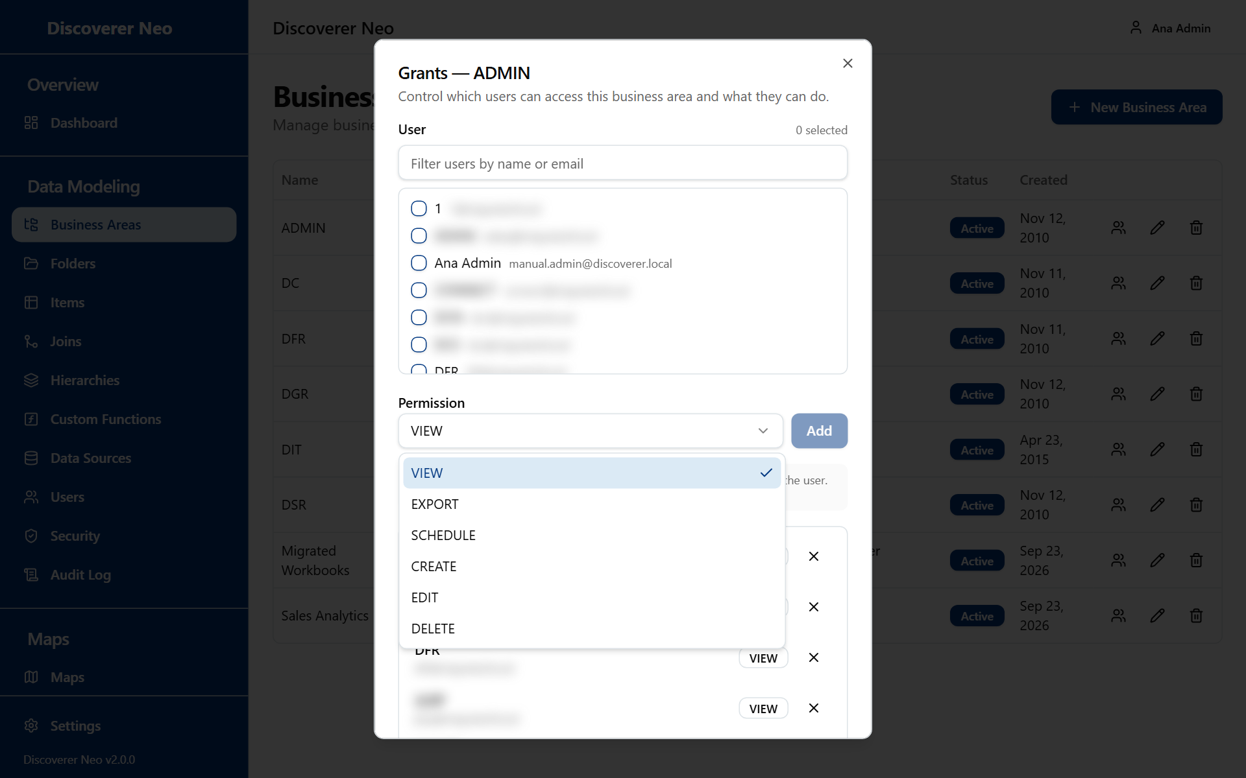
The Manage grants dialog with the Permission list open.
- Open Business Areas. Click New Business Area, type a Name, click Save.
- Click the Manage grants icon.
- Tick the people. Choose Permission. Click Add.
- Click Revoke to take a grant away.

Level | Meaning
VIEW | Read data, run shared maps.
EXPORT, SCHEDULE | Same as VIEW. Rights come from the map's share.
CREATE | Also create maps, folders, items, joins, hierarchies.
EDIT | Also change the area and its objects.
DELETE | Also delete those objects.

A Manager never changes the model. For a Manager, CREATE and above only let them create maps.

Folders, Items, Joins, Hierarchies
A folder is a table or view. An item is a column. A join connects two folders. A hierarchy is a drill-down list.
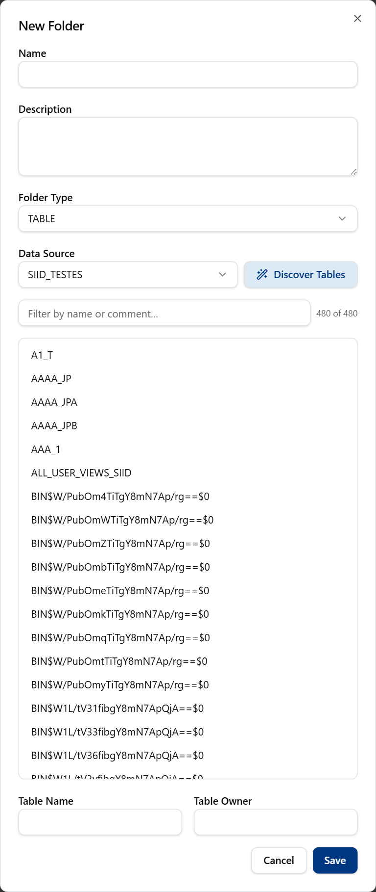
The New Folder dialog after Discover Tables, listing the tables found.
- Choose a business area in Folders. Click New Folder.
- Choose the Data Source, click Discover Tables, click a table.
- Tick the columns to create as items. Click Save.
- In Joins, click New Join. Choose two folders, click Suggest Joins, choose a Join Type. Click Save.
- In Hierarchies, click New Hierarchy, add levels top to bottom. Click Save.
- Use Refresh all to re-read tables after the database changed.

Choice | Meaning
Folder Type | TABLE, VIEW, DERIVED, COMPLEX, JOIN, SUMMARY.
Join Type | INNER, LEFT, RIGHT.
Item Type | Database (CO), Created (CI), Calculated (CU), Join (JI), Hierarchy (HI), Aggregation (AG), Function (FU).

Custom Functions and Data Sources
A data source is a saved database connection. A custom function is an Oracle function that calculated items can call.
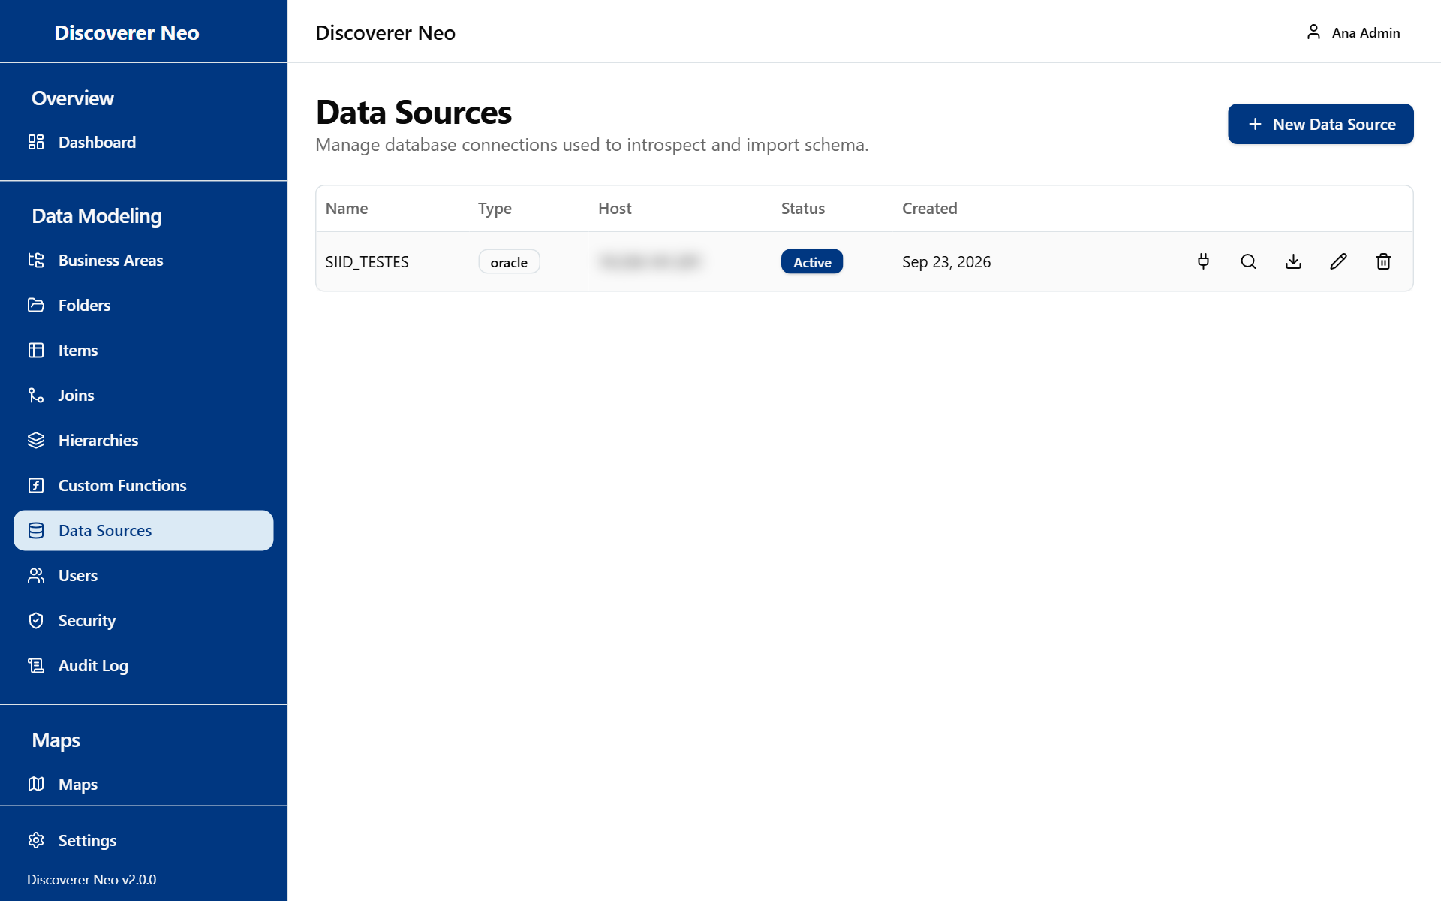
The Data Sources page with a table of connections and five row icons.
- In Data Sources, click New Data Source. Fill Name, Connection Type, Host, Port, Username, Password. Click Save.
- Click Test connection.
- Click Import tables to make many folders at once.
- In Custom Functions, click New Function. Choose the data source, search Oracle, click a result. Click Save.

Choice | Meaning
Connection Type | Oracle or PostgreSQL.
Function Type | SQL, PLSQL, PACKAGE.
Refresh all | Re-reads functions from Oracle.

Users
Add people, set roles, switch accounts off, hand maps to others.
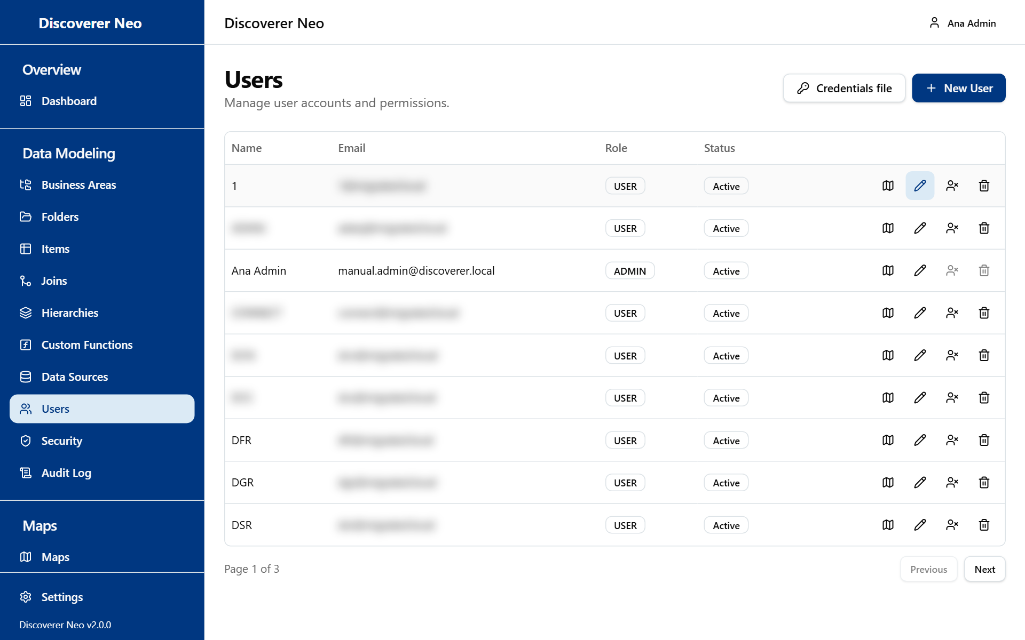
The Users page with the Credentials file and New User buttons and row icons.
- Click New User. Type Name, Email, Password (8 or more), choose Role. Click Save.
- Click Credentials file to give temporary passwords to migrated accounts. Hand each person only their line.
- Click the Maps this user can open icon to see what they see. Change a share level or give a map to a New owner.
- To stop access, click Deactivate. Click Activate to undo.

Choice | Meaning
ADMIN | Everything.
MANAGER | Sees, runs, exports, schedules and shares every map. Edits MANAGER, USER and VIEWER accounts. Never changes the data model, custom functions or data sources.
USER | Own, public and shared maps.
VIEWER | Like USER, but cannot copy maps.
Deactivate | Keeps the account. Reversible.
Delete | Removes the account for good. Cannot be undone.

Security Policies and Audit Log
A policy filters which rows people see. The Audit Log shows who did what.
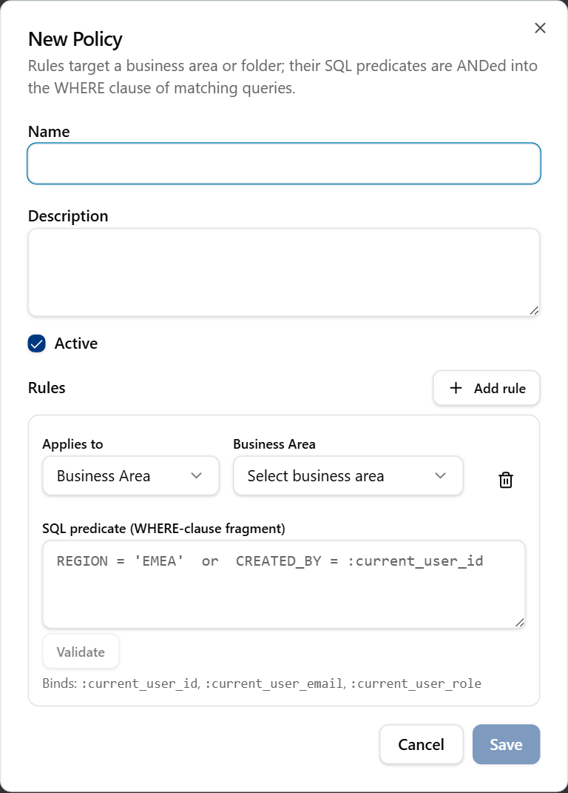
The New Policy dialog with a name, description and one rule.
- In Security, click New Policy. Type a Name.
- Choose Applies to (Business Area or Folder) and the target.
- Type the SQL predicate, for example {alias}.REGION = 'NORTH'. Click Validate. Click Save.
- Click the Assignments icon. Choose User or Role. Click Assign.
- In Audit Log, filter by User, Action or From/To. Click a View details icon for the full entry.

Warning: A folder with no policy follows an installation setting. In closed mode (the default) nobody sees its rows, you included. In open mode everyone with a grant sees all rows.

Migration
Migration imports an Oracle Discoverer EUL (its stored business areas, folders, workbooks and users). It writes a lot into this database.
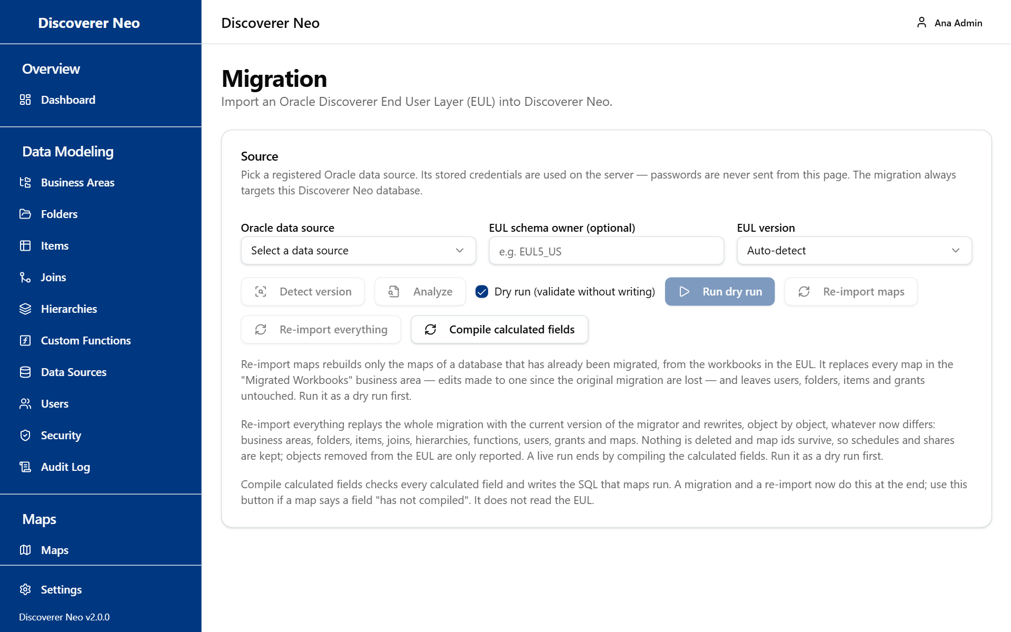
The Migration page with the Source card, its buttons and help text.
- Register the Oracle connection in Data Sources.
- In Migration, choose the Oracle data source. Click Detect version, then Analyze.
- Leave Dry run ticked. Click Run dry run. Read the report and log.
- Untick Dry run and click Run migration.
- In Users, click Credentials file so migrated people can sign in.
- Move maps from "Migrated Workbooks" to the right business area.

Choice | Meaning
Re-import maps | Rebuilds maps only. Replaces every map in "Migrated Workbooks". Edits, schedules and shares of those maps are lost.
Re-import everything | Rewrites what differs. Deletes nothing. Keeps ids, schedules, shares.
Compile calculated fields | Use if a map says a field "has not compiled".

Warning: Always do a dry run first.

