Discoverer Neo
Complete guide
For the USER role
Version 2.1.0

Contents
Your role at a glance 1
Where your access comes from 1
Sign in, change your password, sign out 2
Dashboard 4
Maps 5
Tabs, search and filters 5
Row actions 6
Workbooks 6
Copy a map 7
Share a map you own 7
The map viewer 9
Run parameters 10
Read the results 10
Export the results 10
Building and editing maps 12
Toolbar 12
Add columns 13
Configure a column 13
Right panel tabs 14
Conditional formatting 15
Run from the builder and refused runs 16
Example: build a small map 16
Runs 17
Exports 19
Schedules 20
New Schedule 21
History 22
Settings 23
Common questions 24
Glossary 25

Your role at a glance
Discoverer Neo replaces Oracle Discoverer. A map is a report (in Oracle Discoverer this was a worksheet). A workbook is a group of maps. A business area is a group of related data. You have the USER role. It lets you open and run maps, export and schedule them, and build maps of your own.
You can | You cannot
See your own maps, public maps and maps shared with you | See private maps that nobody shared with you
Run a map and look at its results | Run a map on data you have no access to
Export results to Excel, CSV or PDF, if the map's share level allows it | Export a map that is shared with you at Can view only
Schedule a map, if you own it or it is shared with you at Can export or Can edit | Schedule a public map you do not own
Copy any map you can see and change your copy | Change a map you do not own, unless it is shared with you at Can edit
Create a new map, but only in a business area where your administrator gave you the create right | Create maps in other business areas
Share and delete maps that you own | Share or delete maps that belong to someone else
See your own runs, exports and schedules | See other people's runs, exports or schedules
Choose your language, theme and colours | Open the administration pages (they are not in your menu)

Where your access comes from
Three things decide what you can do. Your role is only the first.
- The map. You see a map if you created it, if its owner made it Public, or if someone shared it with you. A grant on a business area does not show you maps.
- The share level. For a map you do not own, the share level tells you what you may do. See the table below.
- Your business-area grants. Your administrator gives you rights on business areas. To read the data of a map, you need access to the data it uses. To create a new map, you need the create right in that business area. Without it, the map runs fail with "Not entitled to run", or saving a new map fails.

Situation | Open and run | Export | Schedule | Change the map
You own the map | Yes | Yes | Yes | Yes
Shared with you: Can view | Yes | No | No | No
Shared with you: Can export | Yes | Yes | Yes | No
Shared with you: Can edit | Yes | Yes | Yes | Yes
Public map you do not own | Yes | Yes | No | No

Note: Only the owner can share or delete a map. A person who has Can edit cannot share it further.
If a map you need is missing, ask its owner to share it with you.

Sign in, change your password, sign out
- Open the address your administrator gave you.
- Type your Email and Password.
- Leave Remember me ticked if you want to stay signed in after you close the browser. Untick it on a shared computer.
- Click Sign in.

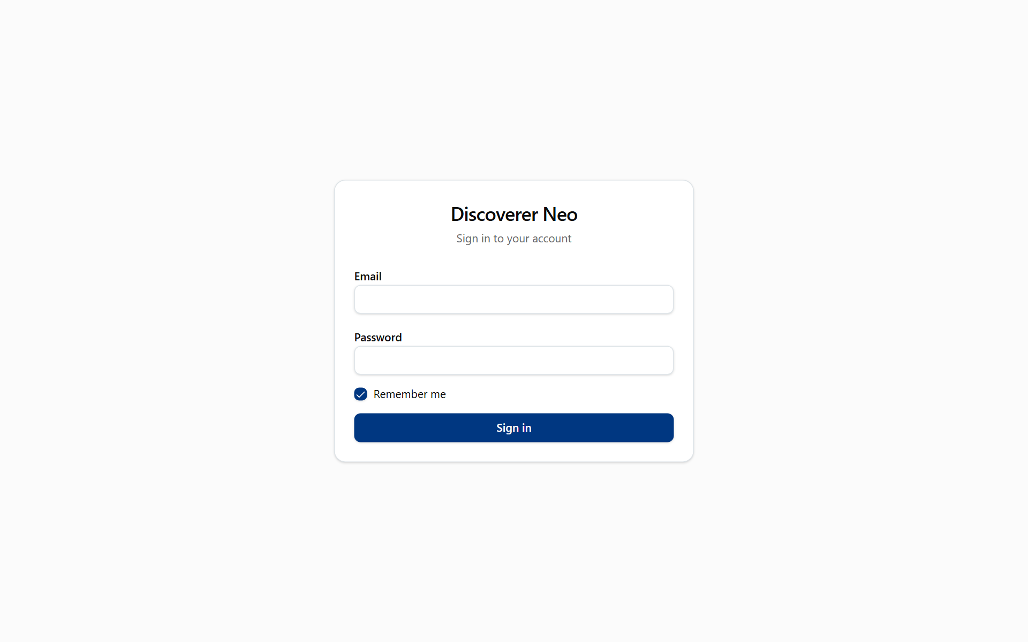
The sign-in page with Email, Password, Remember me and the Sign in button.
If your account was created with a temporary password, the Change your password page opens first. You cannot use the rest of the application until you change it.
Field | What to type
Temporary password (or Current password) | The password you use now
New password | At least 12 characters. It must be different from the current one
Confirm new password | The same new password again

Click Change password. The dashboard opens.
If you forget your password, ask your administrator to reset it. There is no self-service reset.
To sign out, click your name in the top-right corner, then Log out. This ends your session. To use Discoverer Neo again, sign in again.
Note: After 5 wrong passwords in a row your account is locked for 15 minutes. Wait, then try again.

Dashboard
The Dashboard is the first page after sign-in. It gives you a quick summary. It is read-only. You use it to see how much you have and to jump to your last maps.
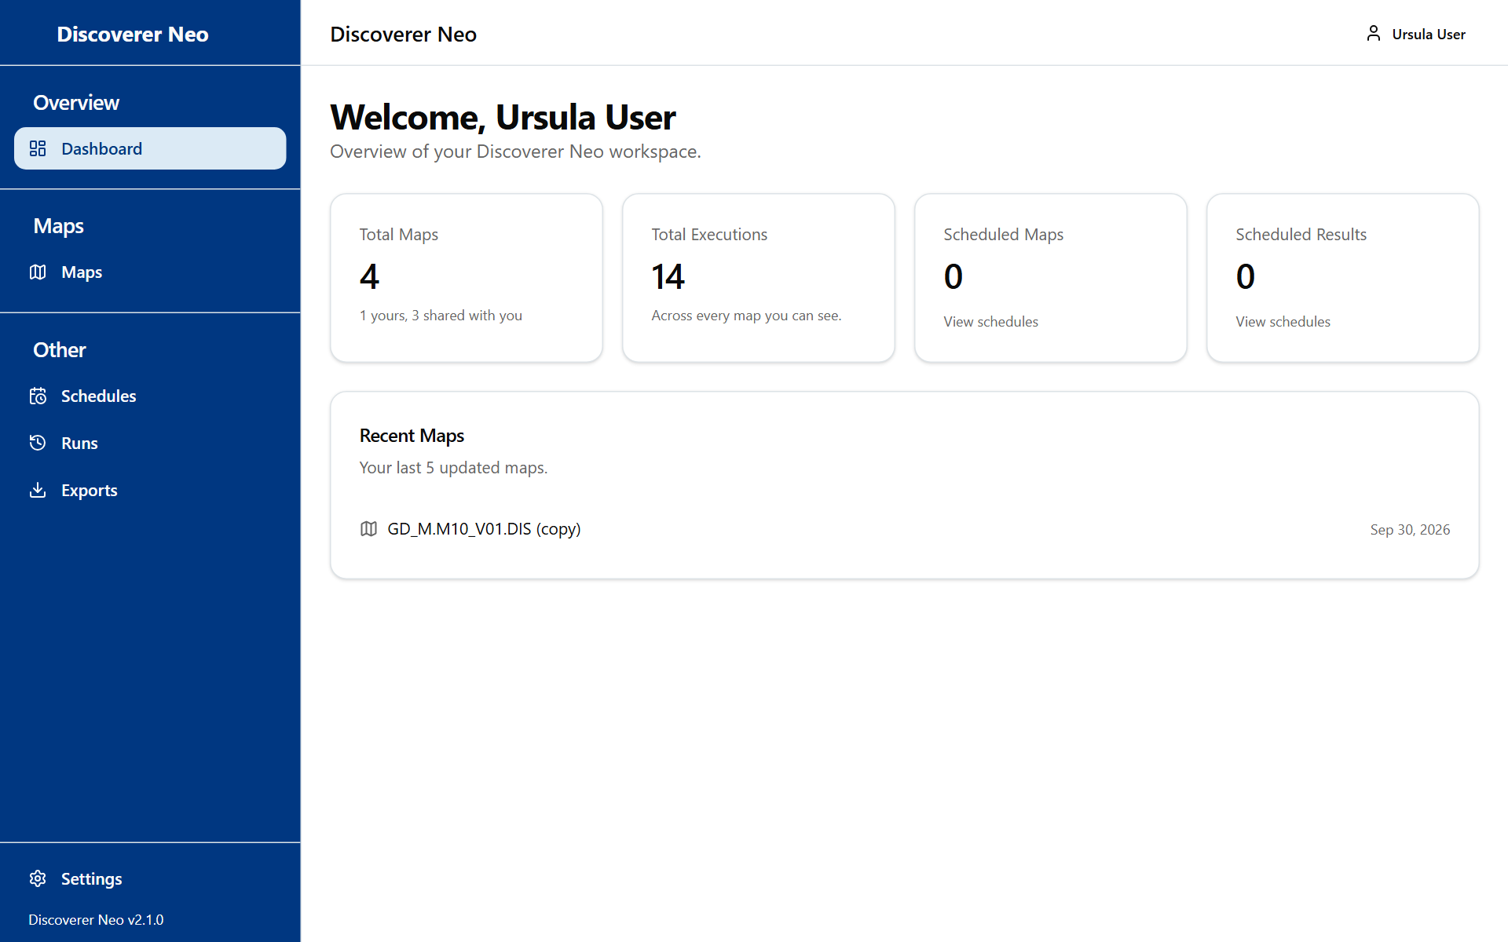
The dashboard with summary cards and the Recent Maps list.
Card | What it shows
Total Maps | The maps you can open. The line below says how many are yours and how many are shared with you (public maps are counted there too)
Total Executions | Runs of the maps you can see, by anyone
Scheduled Maps | Maps for which you have at least one active schedule
Scheduled Results | Results stored by your schedules
Recent Maps | Your last 5 maps that you created, newest first. Click one to open it in the map builder
View schedules (link on two cards) | Opens the Schedules page

If you have created no maps, Recent Maps says that none are yours.

Maps
The Maps page is your list of reports. You use it to find a map, run it, copy it, share it or delete it.
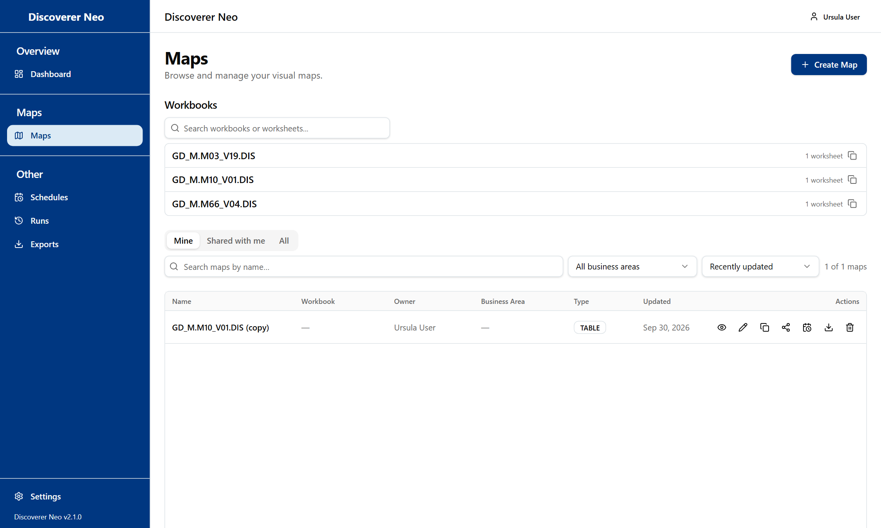
The Maps list, Mine tab, showing the action icons on the map row.

Tabs, search and filters
Control | What it does
Mine | Maps you created
Shared with me | Maps that others shared with you, at any level
All | Everything you can see: your own, public and shared maps
Search maps by name… | Filters the list by name as you type
Business Area filter | Shows only maps of one business area. All business areas removes the filter
Sort by | Recently updated or Name (A–Z)
Clear | Resets the search and the business area. It only appears when a filter is on
Create Map | Opens the map builder for a new map

The table shows Name, Workbook, Owner, Business Area, Type, Updated and Actions. If you own no maps, the page opens on All.

Row actions
Each row has icons. Hover over an icon to read its tip.
Icon | What it does
Map name | Opens the map in the builder if you may change it, otherwise in the viewer
Eye | Opens the viewer, where you run the map and see the rows
Pencil | Opens the map builder. Only for your own maps and maps shared with you at Can edit
Copy | Makes your own private copy and opens it. You become its owner
Share | Opens the Share map dialog. Only for maps you own
Calendar | Opens Schedules with this map chosen. Only for maps you own or that are shared at Can export or Can edit
Download | Opens the viewer, where you export
Trash | Deletes the map. Only for your own maps

Note: The calendar and download icons for shared maps appear on the Shared with me tab. On the All tab, open the map in the viewer instead.
Warning: Only an administrator can bring back a deleted map. Delete map? asks you to confirm with Delete.

Workbooks
Above the table, a Workbooks section appears when some of your maps belong to a workbook.
Control | What it does
Search workbooks or worksheets... | Filters by workbook or worksheet name
Workbook row | Click to open the list of its worksheets. Click a worksheet to open the viewer
Pencil on a worksheet | Edit. Only for worksheets you created
Copy | Copy workbook: makes a new workbook with a private copy of each worksheet
Trash | Delete workbook: deletes the workbook and all its worksheets. Only if you own every worksheet

The Share workbook button is not for your role. Share each map you own with its own Share icon.
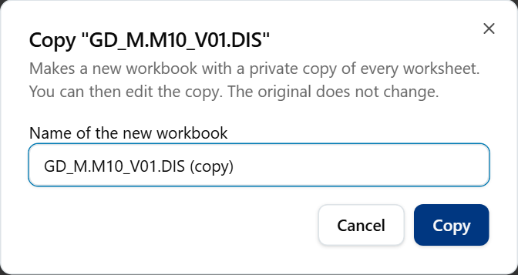
The Copy workbook dialog with the name field for the new workbook.
Example: to copy the demo map, find GD_M.M10_V01.DIS, click the Copy icon and confirm. Your copy opens in the builder, and you can change it freely. The original stays as it was.

Copy a map
- Find the map in the list.
- Click the Copy icon.
- The copy opens in the builder with the message "Map copied. You are now editing your copy."
- Change what you need and click Save.

Running the copy still needs access to the data. Copying does not give you that.

Share a map you own
- Click the Share icon on your map.
- Search a person by name or email.
- Click a level next to their name. The dark button is the level they have now.
- To remove access, click the ✕ next to their name.

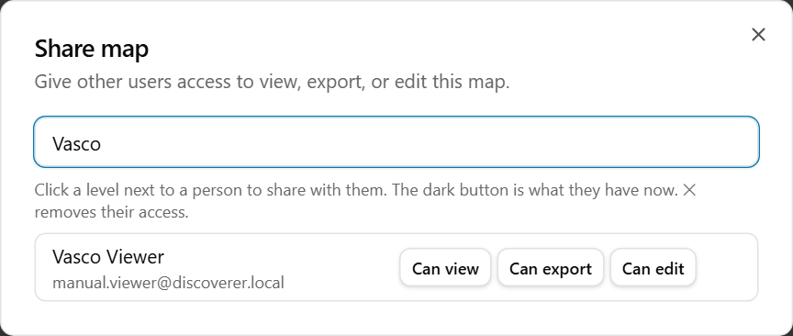
The Share map dialog with a matching person and Can view, Can export and Can edit buttons.
Option | What it means / when to pick it
Can view | The person can open and run the map. They cannot export, schedule or change it
Can export | As above, and they can export the result and put the map on a schedule
Can edit | All of the above, and they can also change the map. They still cannot share or delete it
✕ | Removes their access

If the map is public, the dialog says "This map is public — anyone with the link can view it." and shows Copy link. Use it to send the address to a colleague.

The map viewer
The viewer opens when you click a map name (for a map you cannot edit) or the eye icon. You use it to run a map and read its results.
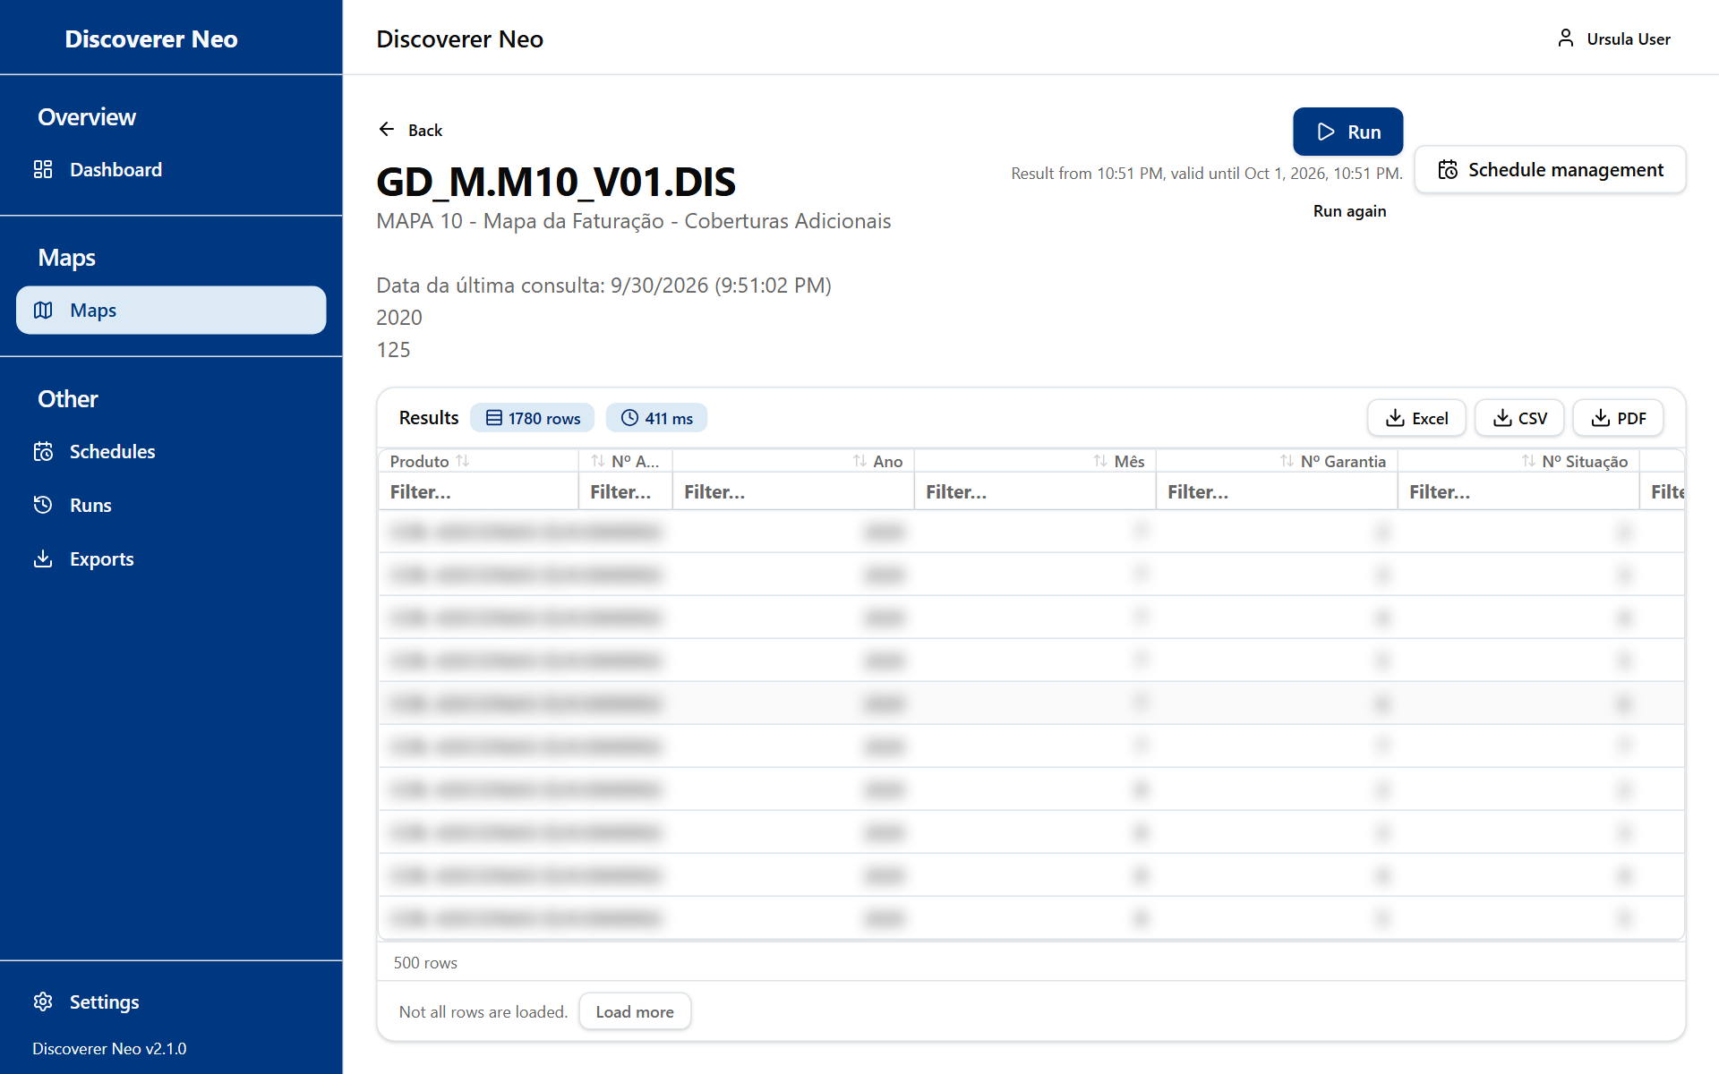
The map viewer after a completed run, with the results grid and export buttons.
Button or control | What it does
Back | Returns to the page you came from
Run | Runs the map. If the map asks for values (parameters), a dialog opens first
Run again | Runs the map again with the same values and skips the saved result. It appears after a run has finished
Cancel | Stops a run that is still waiting in the queue. It is not offered once the run has started
Schedule management | Opens the Schedules page

While a run is going, a line under the buttons shows Queued or Running…. When it is done, it shows the time and how long the result stays valid (24 hours). If you ran the same map with the same values recently, you may see "Showing a cached result". Use Run again to get fresh data.
If a map has no columns, the viewer tells you that there is nothing to run.

Run parameters
Some maps ask you for values, such as a date or a region. The Run parameters dialog shows one input per parameter. A red means the value is required. For some values the dialog suggests the real values from the data. Click Run to start, or Cancel* to close.
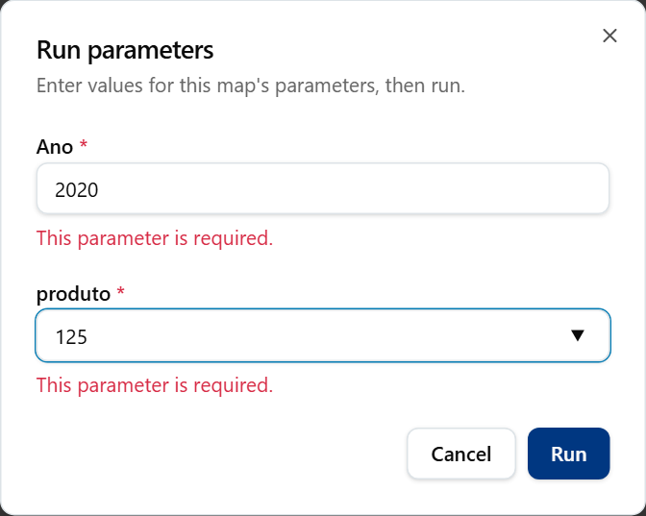
The Run parameters dialog with both required values filled in.

Read the results
Item | What it means
Results header with row and ms badges | How many rows came back and how long it took
More rows available | The result was cut. Only part of the rows was returned
Column header (click) | Sorts by that column: ascending, descending, none
Filter… box under a header | Filters the rows you have loaded
Group badge, Total for …, Grand total | The map groups rows and shows subtotals. Sorting or filtering pauses them
Double-click a row | Drill to Detail: shows the raw rows behind that row
Load more | Loads the next 500 rows
Coloured cells | Rules the map owner set (conditional formatting)

A crosstab map shows a pivot table when a column is placed Across the top.

Export the results
Under the results, use these buttons. They appear once a run has finished.
Button | What it does
Excel | Downloads an Excel file
CSV | Downloads a CSV file
PDF | Opens Export to PDF, where you choose the paper and the columns

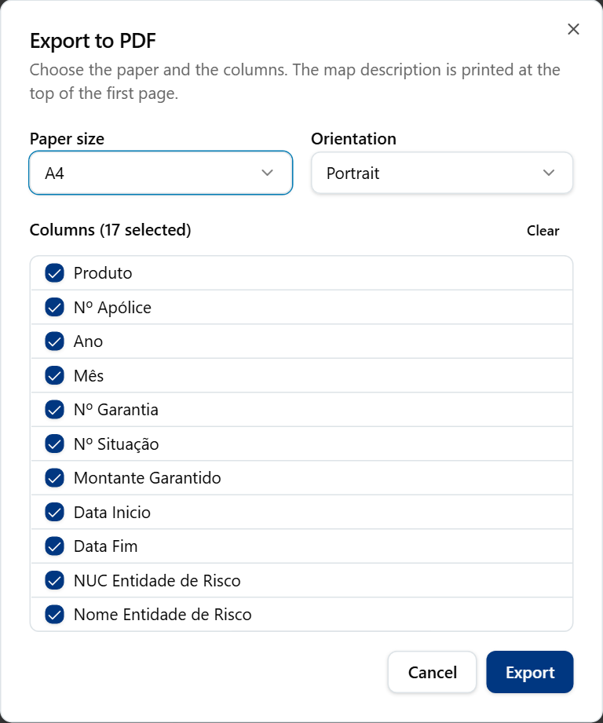
The PDF export dialog with orientation, page size, title and font options.
Option in Export to PDF | What it means / when to pick it
Paper size: A4, A3, Letter | A4 is the default. Pick A3 for wide tables, Letter for US paper
Orientation: Portrait, Landscape | Landscape fits more columns
Columns | Tick the columns to print. Select all and Clear switch them all

Click Export. The file is made in the background. Find it later on the Exports page.
Note: The export buttons show for every map. If your access to the map is Can view only, the export fails with "Forbidden". Ask the owner for Can export.
Example: open GD_M.M10_V01.DIS, click Run, then Excel.

Building and editing maps
You can build a new map only in a business area where your administrator gave you the create right. You can change an existing map if you own it or it is shared with you at Can edit. The builder opens from Create Map, from the pencil icon, or from Recent Maps.
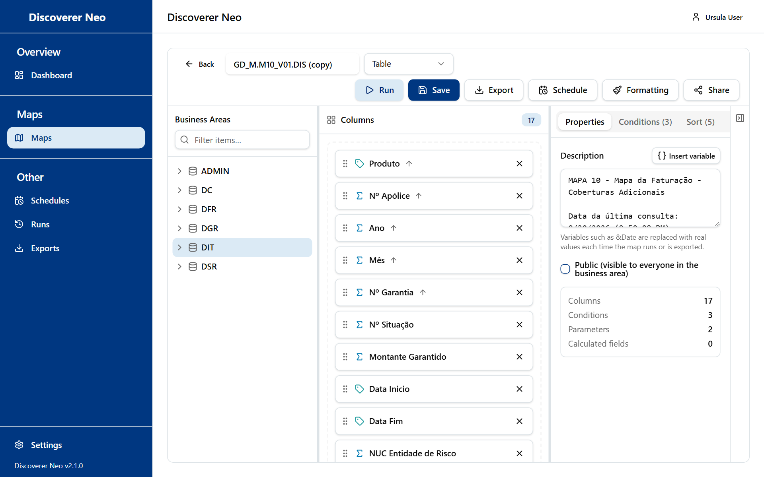
The map builder with the Business Areas tree, the columns canvas and the Properties panel.
The builder has a toolbar on top, a Business Areas tree on the left, the Columns area in the middle, and a settings panel with five tabs on the right. You can drag the edges to resize the panels.
Warning: The builder never saves by itself. Click Save. If you leave the page, unsaved changes are lost.

Toolbar
Button or control | What it does
Back | Returns to the previous page
Map name box | The name of the map
Map type list | Table, Crosstab, Page-Detail or Chart. Only Crosstab changes how results look. The other three show a plain table
● Unsaved | Shows that you have changes that are not saved
Run | Saves the map if it is new or changed, then runs it
Save | Saves the map. Needs at least one column
Export | Menu with Map definition (.xml), which downloads the map design, not the data. Data export is under the results
Schedule | Opens Schedules with this map chosen. Needs a saved map
Formatting | Opens Conditional formatting. Needs a saved map
Share | Opens Share map. Needs a saved map. Only the owner can change shares
Collapse panel / Expand panel | Hides or shows the right panel

Add columns
- In the Business Areas tree on the left, open a business area, then a folder. A folder holds items (a folder is like a table).
- Drag an item onto the Columns area, or click the + next to it. A sigma icon marks a measure (a number you add up). A tag icon marks a dimension (a label).
- All columns of one map must come from the same business area. The first column you add sets it. You cannot pick the area yourself.
- Use the Filter items… box to find an item by name.
- Drag the grip on a column to reorder. Click X to remove it. Click the column chip to configure it.

If you see "No business areas.", you have no access to any business area yet. Ask your administrator.
Note: The tree shows every business area you have any right on. You can build a map with only viewing rights, but Save for a new map fails without the create right.

Configure a column
Click a column chip. Changes apply to the draft. Click Save in the dialog, then Save on the map.
Field | What it does
Display name | Heading of the column. Empty means the item name
Aggregation | NONE, SUM, COUNT, AVG, MIN or MAX
Sort direction | None, Ascending, Descending
Format mask and Presets | A number or date format. Presets: Number (1,234), Decimal (1,234.00), Currency ($1,234.00), Percent (12.3%), Date (DD-MON-YYYY), Date (YYYY-MM-DD)
Sort order | Position of this column when you sort by several
Column width (px) | Width of the column
Placement | None, Group by (axis), Measure or Page item
Crosstab edge | Down the side or Across the top. Only for crosstabs
Group and break | Hides repeated values and adds a subtotal each time the value changes
Query only, do not show | The column is used for filters and totals but is not shown

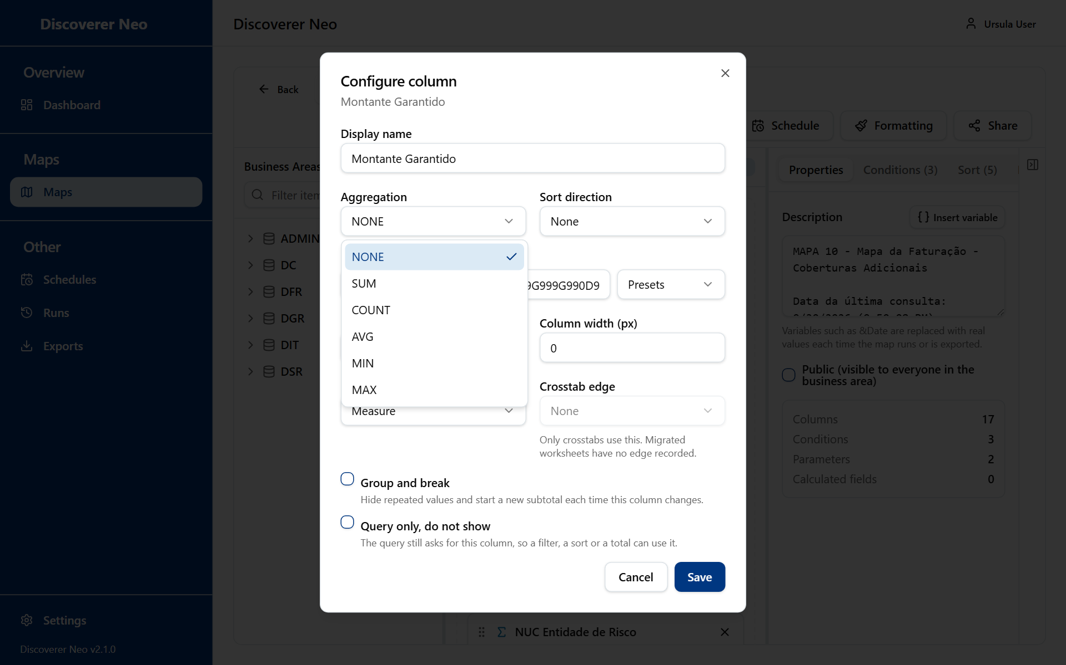
The Configure column dialog with the Aggregation list open.

Right panel tabs
Tab | What it is for
Properties | Description (printed above results and exports), Insert variable (Run date, Run time, Workbook name, Worksheet name, or a parameter) and the Public box
Conditions | Filters. Add Condition, choose the item, the operator (=, <>, <, >, <=, >=, LIKE, IN, BETWEEN, IS NULL) and the value. Choose Static value or Prompt at runtime. Select two or more rows and click Group to join them with OR. Use Ungroup to undo
Sort | Add Sort: choose a column and a direction. Drag to change the order
Parameters | Values people are asked at run time. Each has a name, a type (STRING, NUMBER, DATE, LIST), a default and a Required box. If every parameter has a default, the prompt is skipped
Calculated Fields | A new column from a formula. Click Add Calculated Field, name it, then click the formula to open the Formula editor

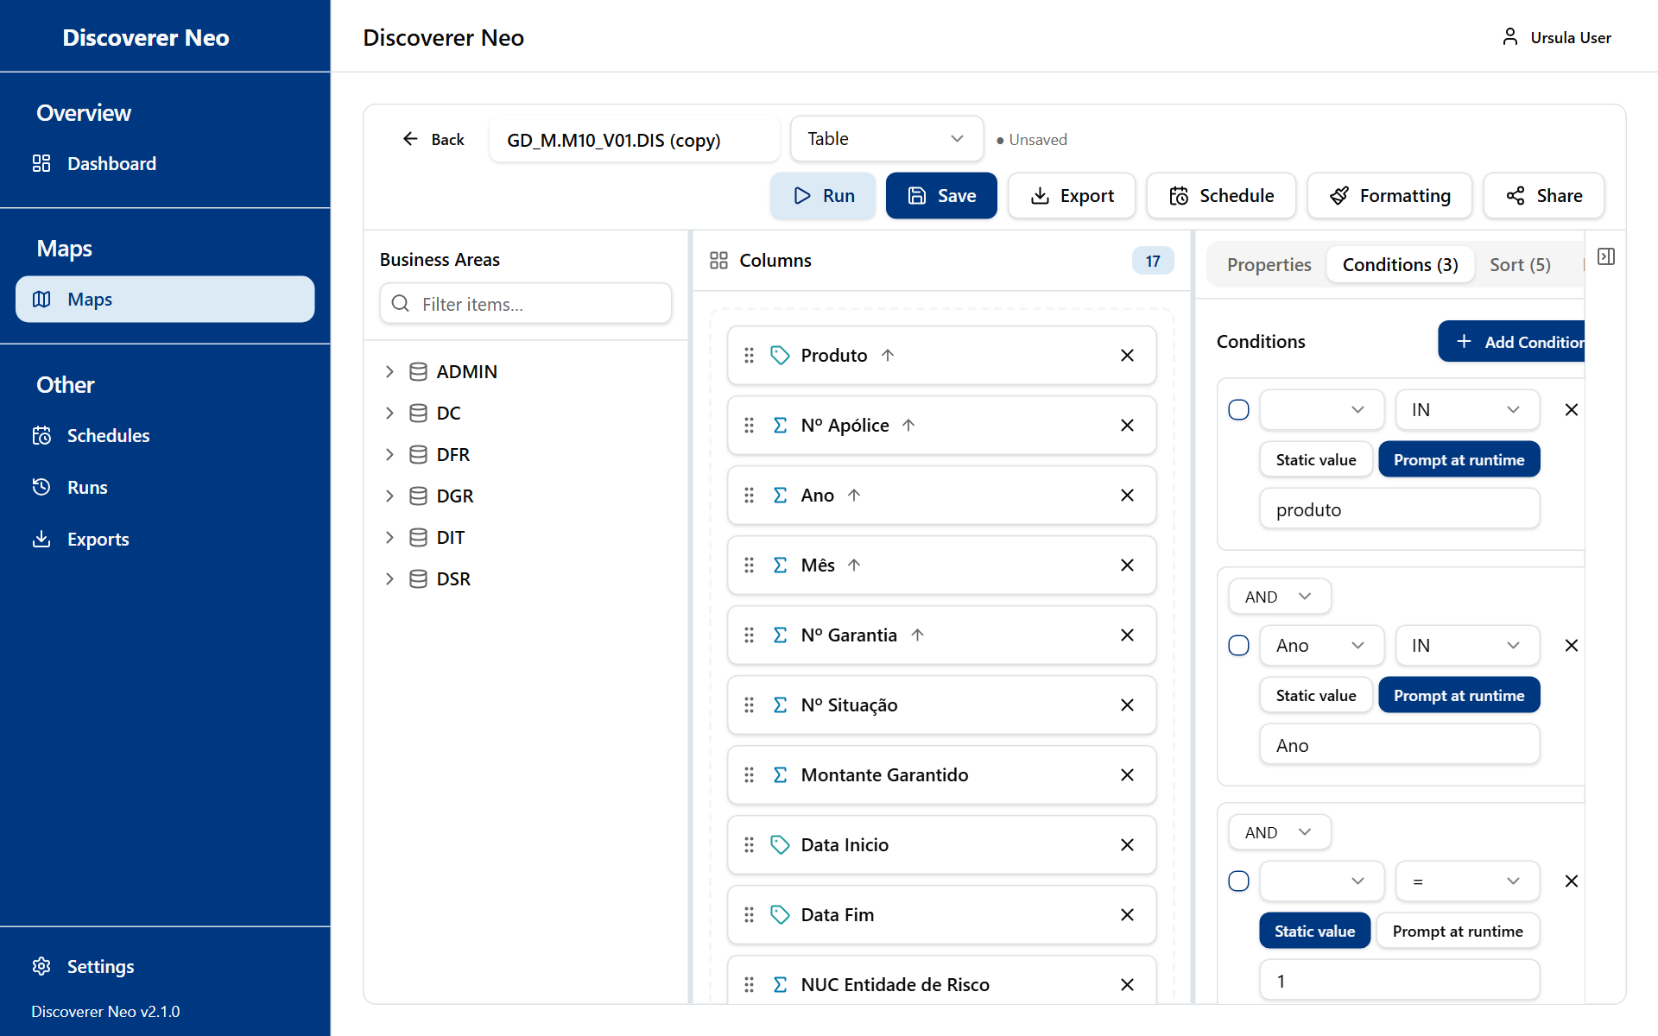
The Conditions tab listing the map's conditions with operator and value or prompt controls.
Warning: The Public box makes the map visible and exportable to every user of the application, not only to one business area. Data access rules still apply to the data. Use it with care.
The Formula editor has function buttons (for example ROUND, UPPER, TO_CHAR, NVL, CASE) and your columns. Test formula runs it on the first 5 rows. It needs a saved map.

Conditional formatting
Click Formatting to colour cells or rows that meet a rule. Rules are saved at once. They are not part of the map's Save. You can add or delete rules only on maps you own or can edit.
Field | What it means
Column | The column to test
Apply to | Cell or Row
Operator | Equals, Not equals, Greater than, Less than, Greater than or equal to, Less than or equal to, Like (% and _ wildcards), In list, Between, Is empty
Value | What to compare with. Use low,high for Between
Background color, Text color | Colours. Clear removes one
Bold, Italic, Underline | Text style

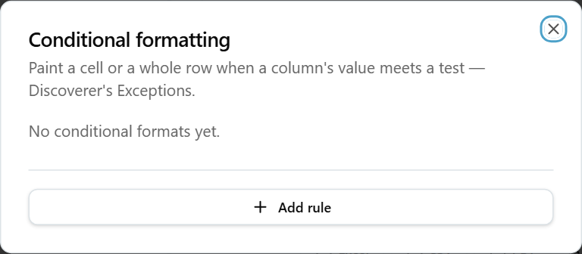
The Formatting dialog with the rules list and the Add rule controls.

Run from the builder and refused runs
Run opens a Results panel at the bottom. It works like the viewer. If you have only viewing rights on a map, do not edit it first: the automatic save would be refused.
Sometimes the planner declines a map. An amber box explains why and what to change. Typical causes are folders that are not connected, or totals from two sets of detail rows. Remove the column that causes it, or ask your administrator to define the missing join. A red banner Not entitled to run means you have no access to the data of one of the folders.

Example: build a small map
- Click Create Map on the Maps page.
- Open a business area and drag two items into Columns.
- Type a name in the map name box.
- Click Save. The map now has its own address.
- Click Run.
- Click Share if a colleague should see it.

Runs
The Runs page lists every map run you started, waiting, running or finished. You use it to find a result again, or to run it again.
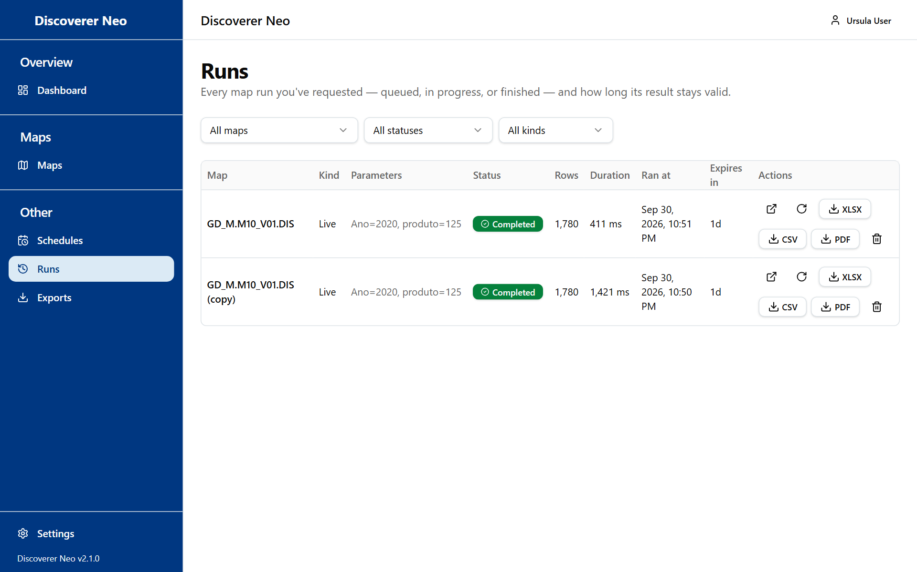
The Runs page with filters and the table of runs and their export buttons.
Control | What it does
Map filter | Shows one map. All maps shows all
Status filter | All statuses, Queued, Running, Completed, Failed, Cancelled
Kind filter | All kinds, Live (you ran it) or Scheduled
Map name | Opens the viewer
Open icon | Opens the stored result
Run again icon | Starts a run with the same values. It says Result reused if a valid result already exists
XLSX, CSV, PDF | Downloads the run's result. Only for finished, valid results, and only if your access allows export
Cancel icon | Cancels a run that is queued. Not offered for a running run
Delete icon | Deletes a finished, failed or cancelled run and its rows. It cannot be undone

The table shows Map, Kind, Parameters, Status, Rows, Duration, Ran at, Expires in and Actions. Expires in tells you how long the stored result stays: 24 hours for a live run, longer for scheduled runs. When it says Expired, run the map again.
You see only your own runs. The page refreshes by itself while a run is going.

Exports
The Exports page lists the files you asked for. You use it to download a file again.
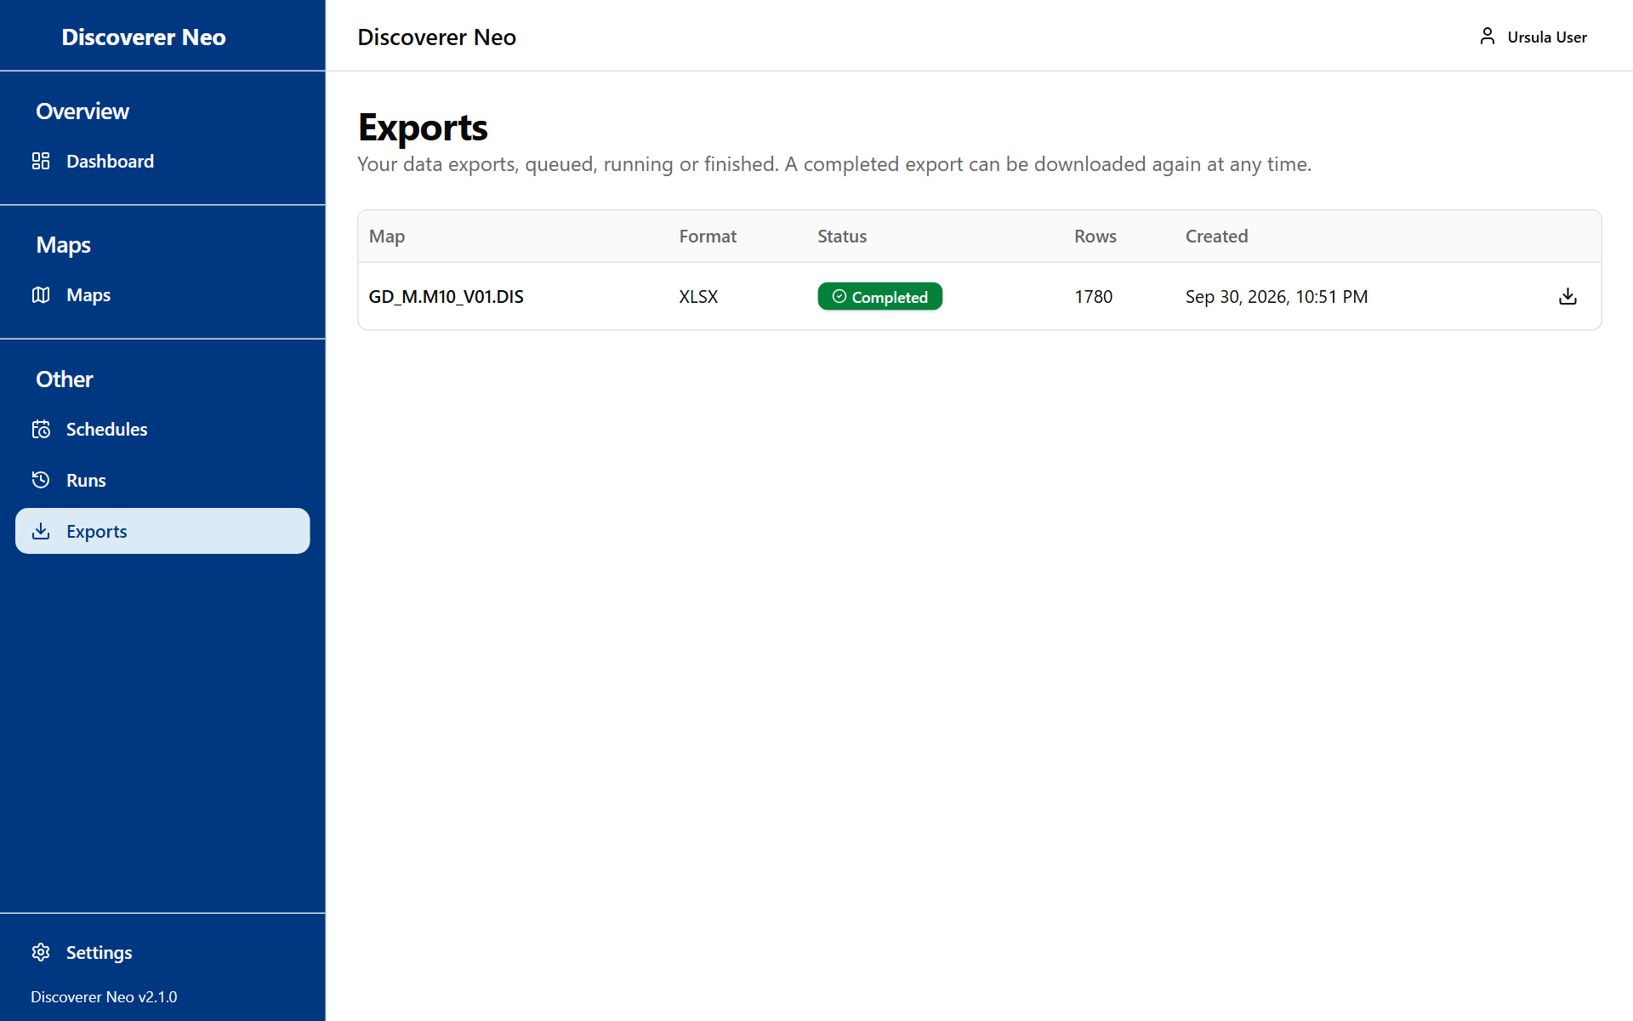
The Exports page listing export jobs with a Download button on finished ones.
Control | What it does
Table | Map, Format (XLSX, CSV, PDF), Status (Queued, Running, Completed, Failed), Rows, Created. Hover over Failed to read why
Download icon | Downloads a completed file

Note: Files are kept for 7 days, not for ever. If a download fails, make the export again from the viewer. Download also fails if your export access to the map was removed.
You cannot create exports here. Create them in the viewer, on Runs or in a schedule's history.

Schedules
The Schedules page runs a map by itself at set times and stores the results. You use it for reports you need every day, week or month.
You can schedule a map that you own, or that is shared with you at Can export or Can edit. A public map or a Can view share cannot be scheduled. A schedule runs as you, with your data access.
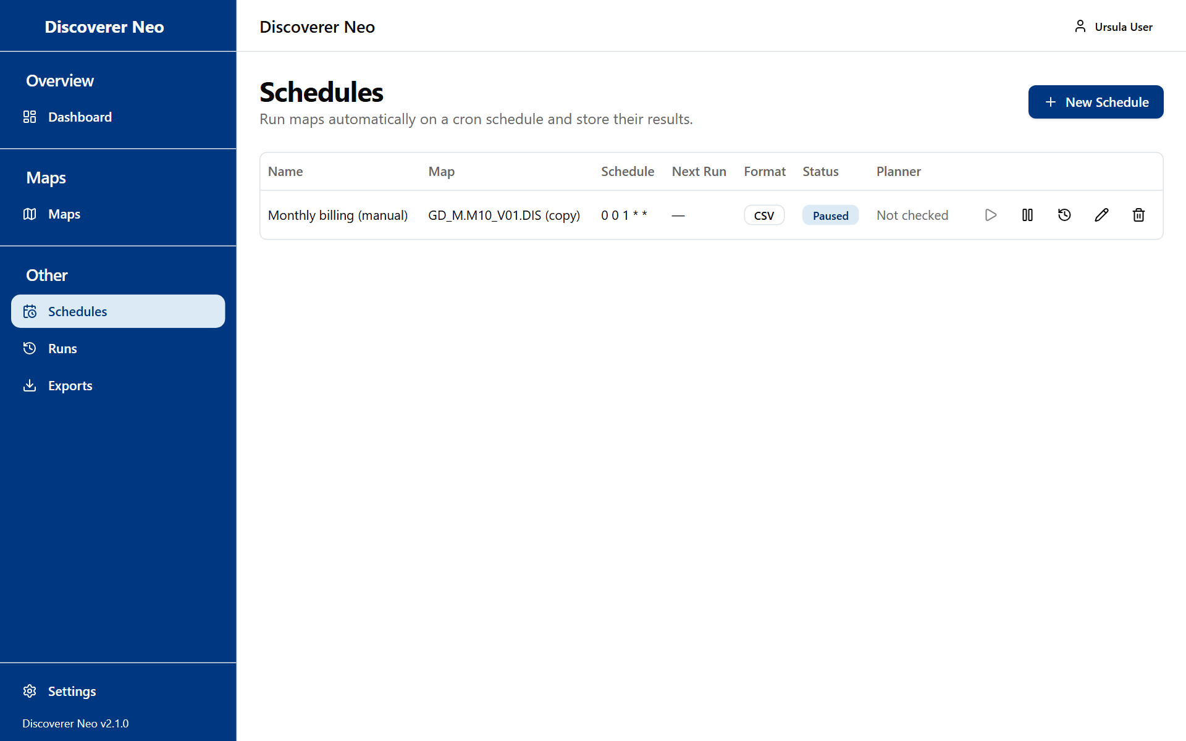
The Schedules page with a paused schedule and its action icons.
Control | What it does
New Schedule | Opens the dialog to create one
Table | Name, Map, Schedule, Next Run, Format, Status (Active or Paused), Planner
Play icon (Run now) | Starts one run at once. Disabled while paused
Pause / Enable icon | Stops or restarts the schedule
History icon | Shows the last 50 runs
Edit icon | Opens Edit Schedule. The map cannot be changed
Delete icon | Deletes the schedule and its history. It cannot be undone

The Planner column is filled in for schedules migrated from Oracle Discoverer. It says whether the migrated schedule could be planned. You cannot change it. Not checked means nothing was recorded.

New Schedule
- Click New Schedule. You can also click the calendar icon on Maps, and the map is already chosen.
- Choose the Map. The list shows your maps and maps shared with you, marked "(shared)". A map shared with you at Can view is not in the list, because that level does not allow a schedule.
- Type a Name.
- Choose a Frequency, a Timezone and an Output Format.
- Fill in the Parameter presets if the map has parameters.
- Keep Enabled ticked and click Save.

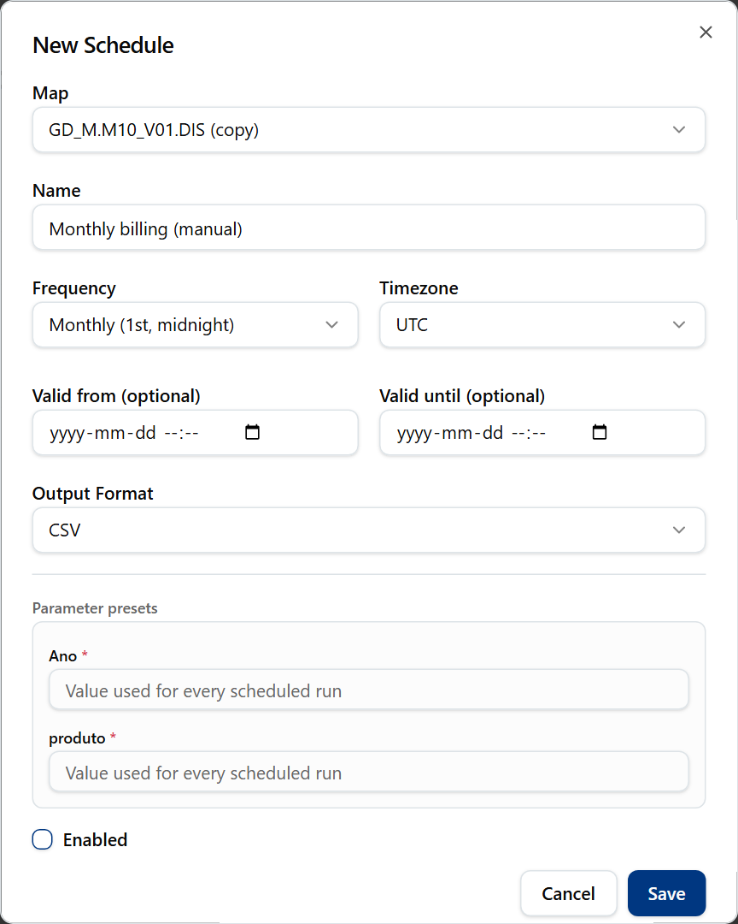
The New Schedule dialog filled in, with a monthly frequency and Enabled unticked.
Field | What it means / when to pick it
Frequency: Daily (midnight) | Every day at 00:00 in the chosen timezone
Frequency: Weekly (Sunday, midnight) | Every Sunday at 00:00
Frequency: Monthly (1st, midnight) | On the 1st of each month at 00:00
Frequency: Custom | You type a Cron expression, five fields: minute, hour, day of month, month, day of week. For example 0 9 * * 1-5 is 09:00 on weekdays
Timezone | The clock used by the schedule. UTC is the default
Valid from (optional), Valid until (optional) | The schedule does not run before or after these times
Output Format: Excel (.xlsx) or CSV | The file type of the stored result. CSV is the default
Parameter presets | The values used for every run. Required ones are marked *
Enabled | If unticked, the schedule waits until you enable it

History
History shows Executed, Status (SUCCESS, FAILED, TIMEOUT), Rows and Duration. For each result, Open shows it, and XLSX, CSV and PDF create a file (if your access allows export). Expires says how long the result stays, 30 days by default.
Results stay on the server. Nothing is sent by email.

Settings
Settings changes how the application looks for you. Open it from the sidebar or from your name in the top-right corner. The settings belong to your account and follow you to other computers.
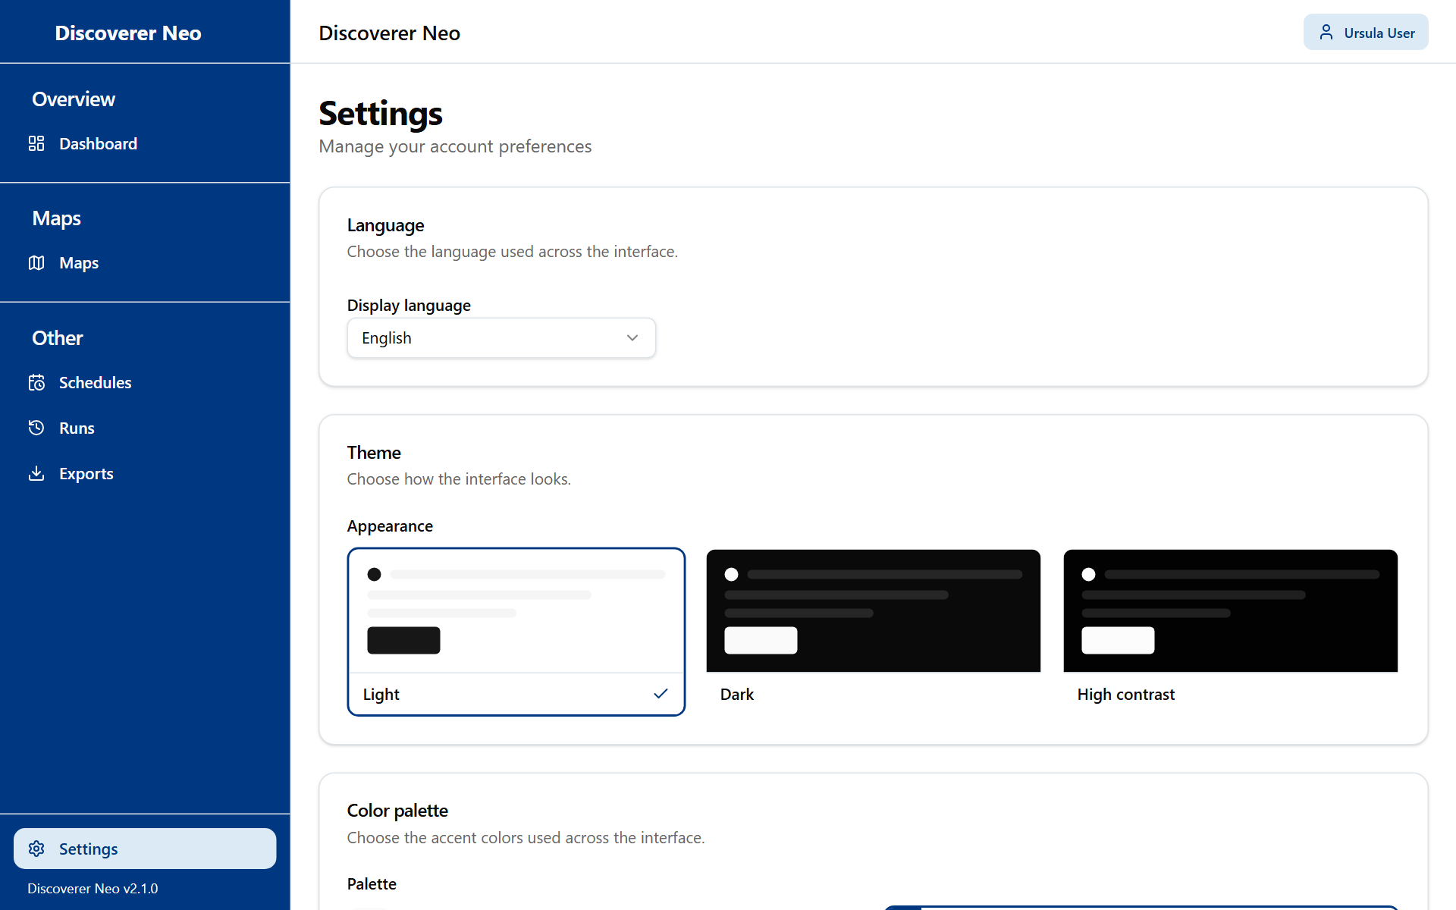
The Settings page with the Language, Theme and Color palette cards.
Control | What it does
Display language | English, Português (Portugal), Français (France), Español (España)
Appearance | Light, Dark, High contrast
Palette | Classic, Navy, Forest, Wine, Ocean, Ochre. Not available with High contrast
Save | Keeps your choices on your account

Your choices show at once. They are only kept on every device after you click Save.

Common questions
I cannot see a map that a colleague sees. Maps are visible if you own them, if they are public, or if they were shared with you. Being in the same business area is not enough. Ask the owner to share it. A manager or administrator sees every map, so your colleague may have another role.
I opened a map and the run says "Not entitled to run". You can see the map, but you have no access to the data of one of its folders. Ask your administrator for access to that business area.
I clicked Excel and got "Export failed" or "Forbidden". The map is shared with you at Can view. Ask the owner for Can export.
I cannot save my new map. Saving needs the create right in the map's business area. Ask your administrator.
The Edit icon is missing. You may change only your own maps and maps shared at Can edit. Copy the map, then edit your copy.
I cannot schedule a map. You need to own it, or hold Can export or Can edit. Public maps cannot be scheduled.
My result says Expired. Live results stay 24 hours. Run the map again.
I cannot find an old export. Files are removed after 7 days. Export again.
I forgot my password. Ask your administrator to reset it.
I do not see Business Areas, Users or Migration. These pages are for other roles.

Glossary
Term | Meaning
Map | A report. In Oracle Discoverer this was a worksheet
Workbook | A group of maps
Business area | A group of related data. Your administrator gives you rights on it
Folder | A set of related items inside a business area, like a table
Item | One field. A dimension is a label, a measure is a number you add up
Run | One execution of a map that produces a result
Export | A file (Excel, CSV or PDF) made from a result
Schedule | A timetable that runs a map by itself and stores the result
Share | Giving another user access to a map you own: Can view, Can export or Can edit
Public map | A map any user can open, run and export. It cannot be scheduled by others
Parameter | A value the map asks for when you run it
Cron expression | Five fields that say when a schedule runs

