Discoverer Neo
Complete guide
For the MANAGER role
Version 2.2.0

Contents
Your role at a glance 1
You can / You cannot 1
Where your access comes from 1
How to sign in, change your password, and sign out 2
Dashboard 5
Users 6
Maps for a person 6
Example: give a map to a colleague who takes over 7
Maps 9
Finding a map 9
What each icon does 10
Copy a map to build your own 10
Share a map 10
Map builder 12
What you may save 12
The toolbar 12
Build a map 13
Configure column 13
The five settings tabs 14
Conditional formatting 16
Refused maps 16
Map viewer 17
Export to PDF 18
Example: run and export GD_M.M10_V01.DIS 18
Schedules 19
Parameters that follow the run date 21
Example: schedule a weekly run 22
Runs 23
Exports 24
Settings 25
Common questions 26
Glossary 27

Your role at a glance
You are a Manager. You see every map in Discoverer Neo, run it, export it, schedule it and share it. You look after who can open what, and you look after the Manager, User and Viewer accounts. You do not change the data model, custom functions or data sources. That is an administrator's job.
A map is a report (in Oracle Discoverer this was a worksheet). A workbook is a group of maps. A business area is a group of related data. A folder is one table or view inside a business area, and an item is one column of a folder.

You can / You cannot
You can | You cannot
See every map, including private ones | Change a map you do not own, unless it is shared with you at Can edit
Run, export and schedule every map (the data rules below still apply) | Delete a map you do not own
Share any map, and change or remove any share | See the SQL text or the database plan of a run
Copy any map to make your own version | Change business areas, their grants, folders, items, joins or hierarchies, whatever grant you hold
Hand a map over to another owner | Create or delete users, or give anyone the ADMIN role
See Manager, User and Viewer accounts, and which maps each person can open | See or change administrator accounts
Edit, activate and deactivate Manager, User and Viewer accounts | See other people's runs, exports or schedules
Build maps on the business areas you hold a grant on | Use Custom Functions, Data Sources, Security, Audit Log or Migration (administrators only)

Note: Business Areas, Folders, Items, Joins, Hierarchies, Custom Functions, Data Sources, Security, Audit Log and Migration are for administrators only. They are not in your sidebar.

Where your access comes from
Three things decide what you can do.
- Your role. As a Manager you can see, run, export, schedule and share every map. This does not depend on shares.
- Shares. You can change a map only if you own it or someone shared it with you at Can edit. Being a Manager does not add that right.
- Business-area grants. An administrator gives you a grant on a business area. A grant has a level. Each level includes the ones before it.

Grant level | What it lets you do in that business area
VIEW | Read its data. Use its folders and items in the map builder.
EXPORT | Same as VIEW. Export and schedule rights on a map come from how the map is shared.
SCHEDULE | Same as VIEW. Export and schedule rights on a map come from how the map is shared.
CREATE | Everything in VIEW, plus create new maps.
EDIT | Same as CREATE for you. The extra model rights of this level are for administrators only.
DELETE | Same as CREATE for you. The extra model rights of this level are for administrators only.

Unlike an administrator, you get no bypass. Two rules follow.
- You can see and run every map, but the data comes second. A run or export needs a grant on every folder the map uses. Without it the run fails with Not entitled to run. Ask an administrator for the grant.
- A grant does not make maps appear. You already see all maps because you are a Manager.

How to sign in, change your password, and sign out
- Open the Discoverer Neo address in your browser.
- Type your Email and Password.
- Leave Remember me ticked to stay signed in after you close the browser. Untick it on a shared computer. Then you are signed out when you close the browser.
- Click Sign in. You land on the Dashboard.

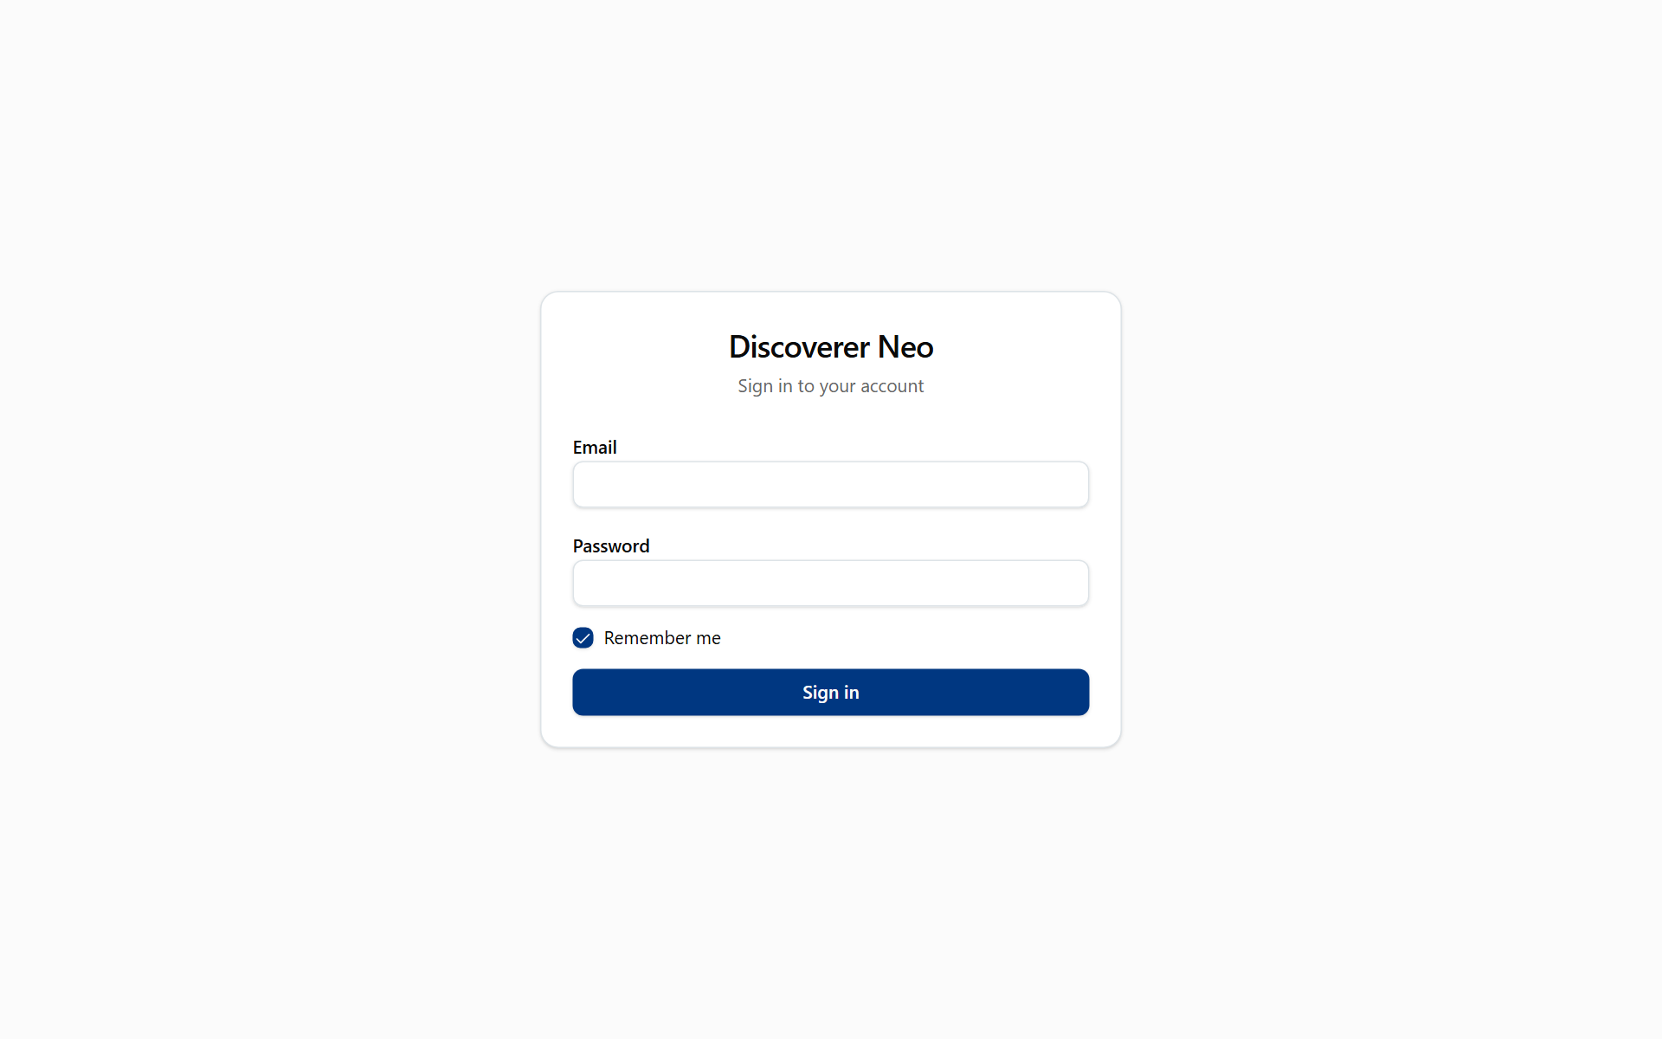
The sign-in page with Email, Password, Remember me and the Sign in button.
If you type a wrong password five times, the account is locked for 15 minutes. Wait, then try again. There is no "forgot password" link. Ask an administrator to reset it.
If your account has a temporary password, Discoverer Neo sends you to Change your password and nothing else works until you finish it.
To change your password at any time, open the address /change-password in the same browser window. Enter your current password, then the new one twice. The new one must have at least 12 characters and be different from the old one.
To sign out, click your name at the top right and choose Log out. This ends your session. To use Discoverer Neo again, sign in again.
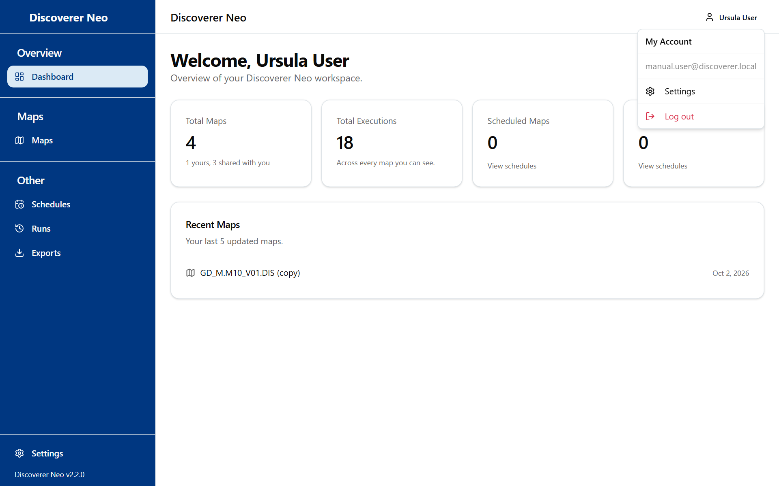
The account menu open, with Settings and Log out.

Dashboard
The Dashboard is the first page you see. It gives you numbers only. Nothing on it changes data.
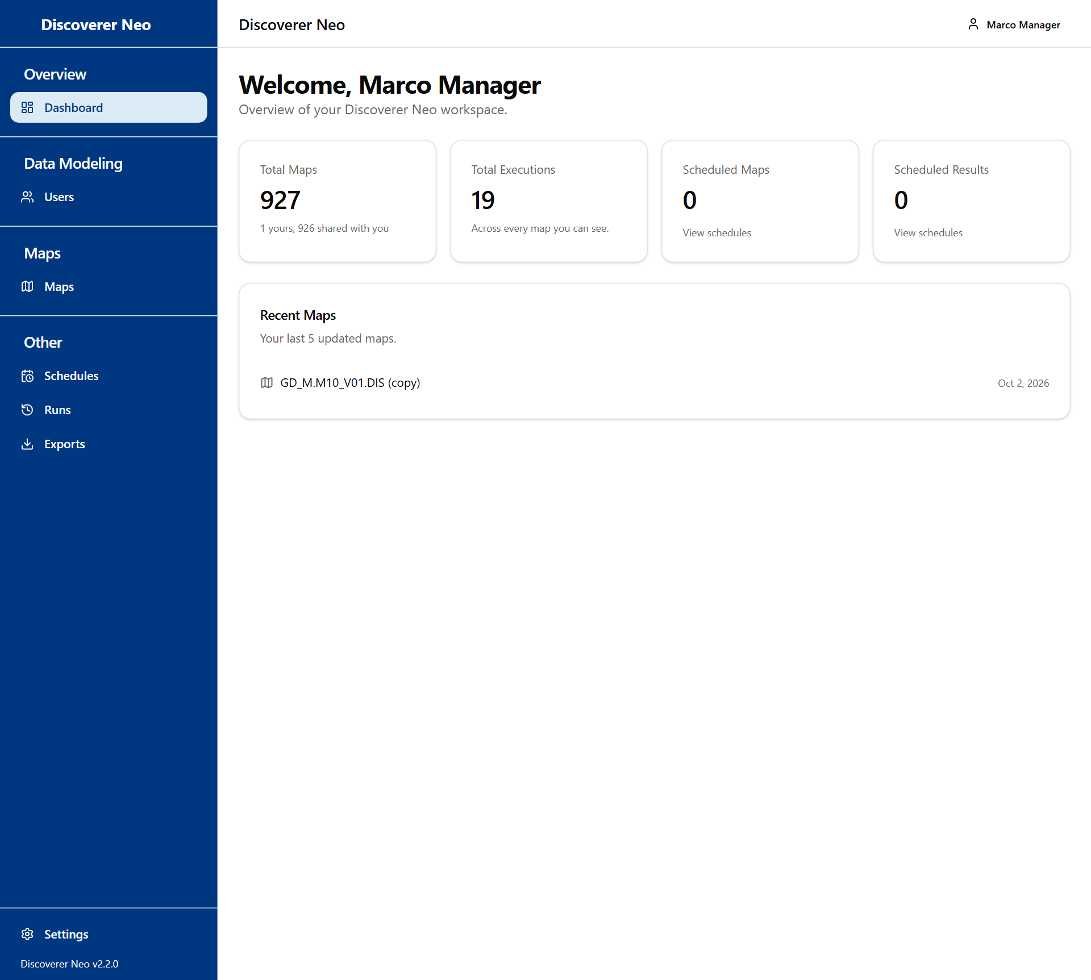
The Manager dashboard with the sidebar and summary cards.
Card | What it shows for you
Total Maps | Every active map in the system. The line below splits it into "yours" and "shared with you". For you, "shared with you" means everyone else's maps, including private ones.
Total Executions | All logged runs, by anyone, of the maps you can see.
Scheduled Maps | Maps that have at least one active schedule made by you.
Scheduled Results | Stored results made by your own schedules.
Recent Maps | The last five maps you created. Click one to open it in the builder.

The View schedules link on two cards opens the Schedules page.

Users
Use the Users page to look after Manager, User and Viewer accounts, to find out which maps a person can open, and to fix who owns or shares a map. Administrator accounts are not in your list.
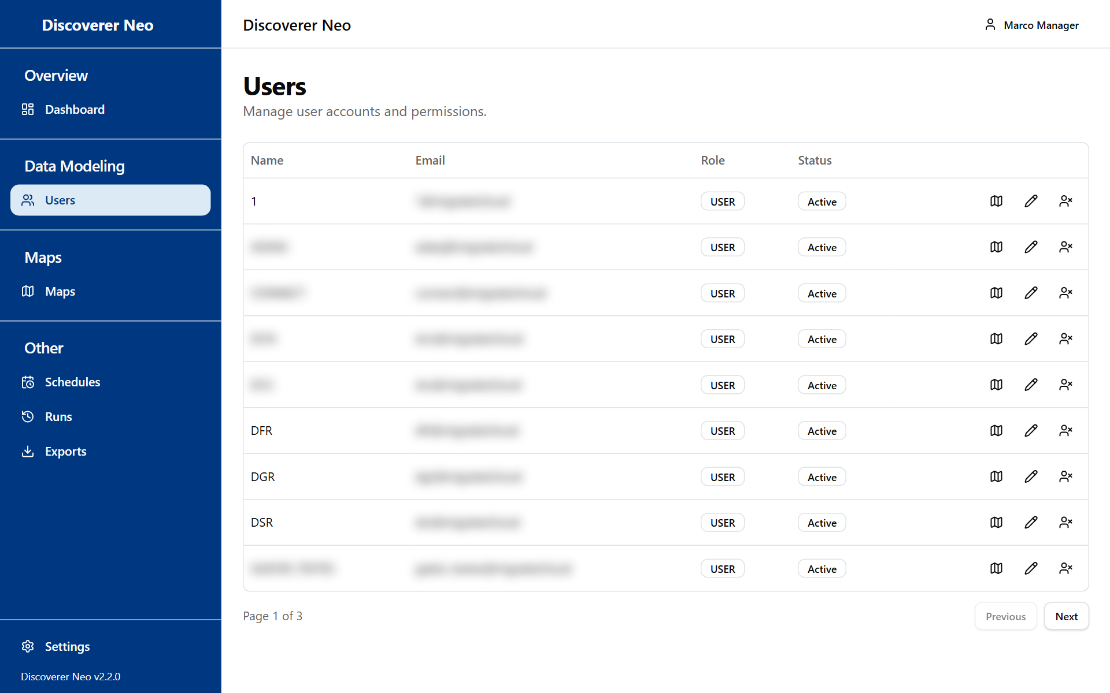
The Users list for a Manager, without administrators and without New User or Credentials file buttons.
The list shows Name, Email, Role and Status (Active or Inactive).
Button or control | What it does
Row icon Maps this user can open | Opens the maps of that person. See below.
Row icon Edit | Changes the name, email, password or role. The role can be MANAGER, USER or VIEWER. Leave Password empty to keep it.
Row icon Deactivate / Activate | Stops the person from signing in, or lets them sign in again. You cannot deactivate yourself.

You cannot create or delete users, give the ADMIN role, or issue a credentials file. Ask an administrator.

Maps for a person
Click the row icon Maps this user can open. The dialog Maps for {name} lists every map that person sees.
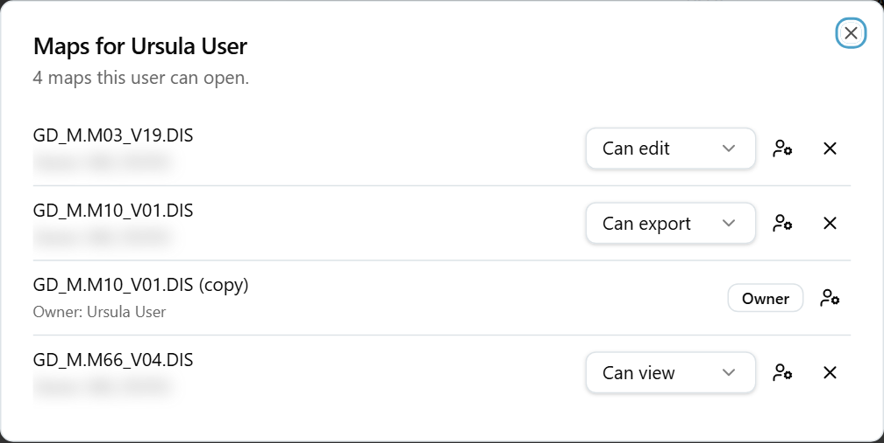
The Maps dialog for a user, with share-level selects and owner and remove icons.
Button or control | What it does
Map name | Opens the map in the viewer.
Owner: {name} | Shows who owns the map.
Badge | Says why the person sees the map.
Share level select | Changes what the person may do with a shared map.
Owner icon | Opens the New owner list.
New owner | Choose a person to give the map to.
Remove icon (X) | Removes the map from that person. No confirmation.

Option (badge) | What it means
Owner | The person owns the map.
Shared | Someone shared the map with the person. You can change or remove this.
Public | The map is public.
Manager role | The person is a manager and sees all maps.

Option (share level) | What it means / when to pick it
Can view | Can open and run the map. Cannot export, schedule or change it.
Can export | Can open and run the map, export its result, and put it on a schedule.
Can edit | Can do all of the above, and also change the map.

Example: give a map to a colleague who takes over
- Click Users, then the row icon Maps this user can open for the current owner.
- Find the map. Click the owner icon.
- In New owner, choose the colleague.
- Wait for the message Owner changed.

Warning: The new owner can change, share and delete the map. Their own earlier share of it is dropped. You do not become an editor of the map by handing it over.

Maps
The Maps page lists every map in the system. You see everything, including private maps. Seeing a map does not mean you can read its data. The data rules from the first chapter still apply.
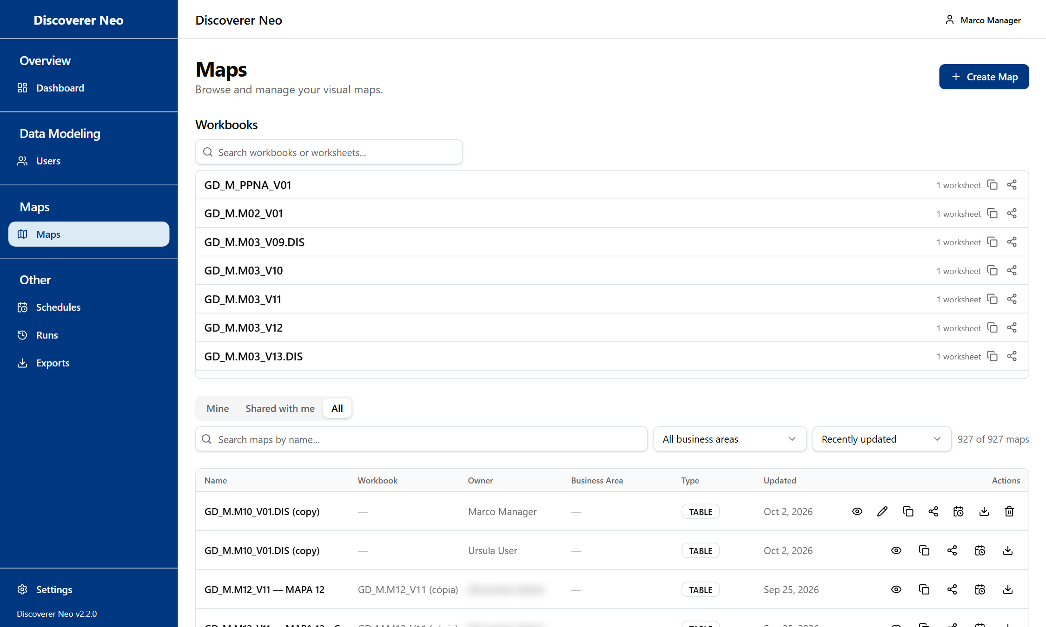
The Maps list, All tab, with Copy, Share, Schedule and Export icons on each row.

Finding a map
Control | What it does
Mine tab | Maps you created.
Shared with me tab | Maps someone shared with you at any level.
All tab | Every map in the system.
Search maps by name… | Filters by name.
Business Area filter | Shows one business area. Choose All business areas to reset.
Sort by | Recently updated or Name (A–Z).
Clear | Resets the search and filter.

The Workbooks section at the top groups maps by workbook. Click a workbook to see its maps. Click a map to open it.

What each icon does
Icon | What it does
Eye | Opens the viewer so you can run the map.
Pencil | Opens the builder. Shown only for maps you own, or that are shared with you at Can edit.
Copy | Makes your own copy, which you can then change. Works for any map.
Share | Opens Share map. Works for any map.
Calendar | Opens Schedules with this map chosen.
Download | Opens the viewer, where you export.
Trash | Deletes the map. Shown only for your own maps.

The workbook row has its own icons. Copy makes a private copy of every map in the workbook. Share gives someone every map of the workbook. Trash deletes a workbook only if you own every map in it.
Warning: A deleted map can only be brought back by an administrator.

Copy a map to build your own
- Find the map and click the Copy icon.
- For a workbook, type a name in Name of the new workbook and click Copy.
- The copy opens in the builder. It is private to you.

Example: copy GD_M.M10_V01.DIS, then add a column to your copy. The original does not change.

Share a map
- Click the Share icon on the map.
- Search for a person by name or email.
- Click a level next to their name: Can view, Can export or Can edit. The dark button is what they hold now.
- To take access away, click the X next to their name.

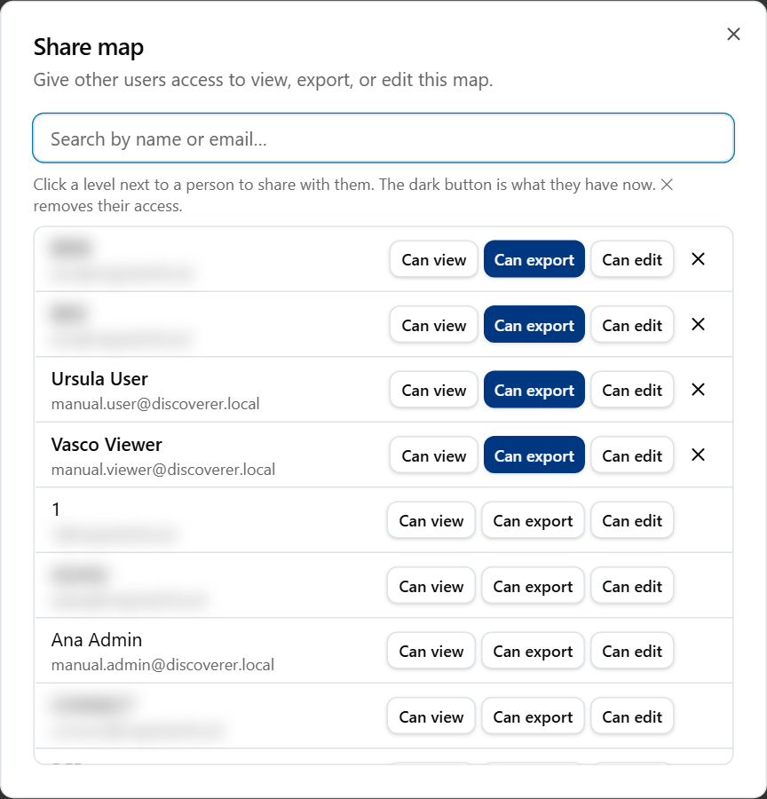
The Share map dialog with a search box and Can view, Can export and Can edit buttons.
The dialog also shows a notice when the map is public, with Copy link. Anyone with the link can view it. This dialog does not switch a map between public and private. That switch is on the map's Properties tab, and only someone who can edit the map may save it.
For a workbook, the same dialog fans one share out to every map you can see in it. It tells you which maps could not be shared.

Map builder
Use the builder to make a map or change one. You reach it with Create Map, the Pencil icon, or by copying a map.
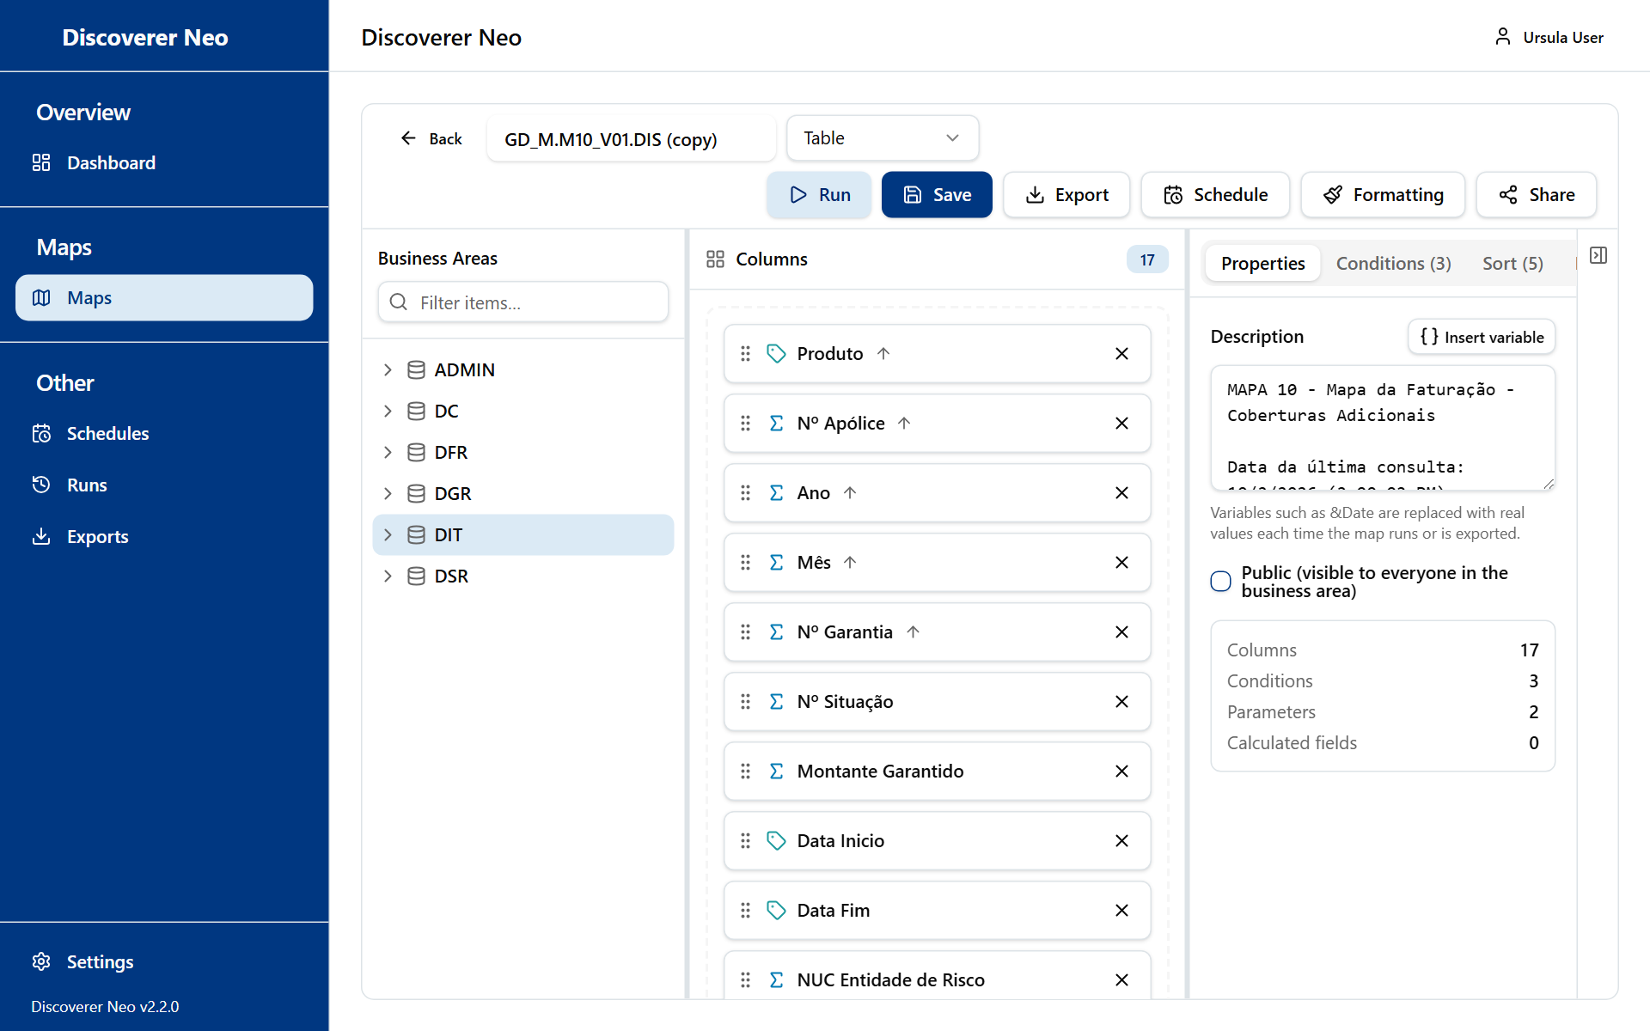
The map builder with the Business Areas tree, the columns canvas and the Properties panel.

What you may save
Situation | Can you save?
A new map | Yes, if you hold a CREATE grant or higher on the business area.
A map you own | Yes.
A map shared with you at Can edit | Yes.
Any other map | No. Save fails with "Forbidden". Copy the map first, then edit your copy.

The builder opens for every map, even one you cannot save. You only find out when you click Save.

The toolbar
Button or control | What it does
Back | Returns to the page you came from. Unsaved changes are lost without a warning.
Map name box | Sets the map name.
Map type list | Table, Crosstab, Page-Detail or Chart. Only Crosstab changes how the result looks. The others show as a plain table.
● Unsaved | Reminds you there are changes you have not saved.
Run | Saves the map if it is new or changed, then runs it.
Save | Saves your changes. Nothing saves by itself. If nothing changed, it shows No changes to save.
Export > Map definition (.xml) | Downloads the map definition. It holds no data rows. Needs a saved map.
Schedule | Opens Schedules with this map chosen. Needs a saved map.
Formatting | Opens conditional formatting. Needs a saved map.
Share | Opens Share map. Needs a saved map.

Build a map
- In the Business Areas tree on the left, open a business area and a folder. Only areas where you hold a grant are listed.
- Drag items onto the Columns canvas, or click the plus button next to an item. Measures have a sigma icon, dimensions a tag icon.
- Every column of a map must come from one business area. The first column you add decides which one.
- Click a column to open Configure column. Change what you need, then click Save in that dialog.
- Add conditions, sorting and parameters on the right-hand tabs.
- Click Save on the toolbar. Then click Run.

Use Filter items… above the tree to find an item by name.

Configure column
Field | What it does
Display name | Column heading. Blank uses the item name.
Aggregation | Total for this column.
Sort direction | None, Ascending or Descending.
Format mask | How numbers and dates look. Presets fills it for you.
Sort order | Position of this column when you sort by several.
Column width (px) | Width in pixels.
Placement | See below.
Crosstab edge | Where an axis column goes in a crosstab.
Group and break | Hides repeated values and starts a subtotal when the value changes.
Query only, do not show | The query uses the column, but the result hides it.

Option (Placement) | What it means
None | No special role.
Group by (axis) | The column groups the rows.
Measure | The column holds a value that is totalled.
Page item | The column becomes a page filter.

Option (Crosstab edge) | What it means
None | Not used in a crosstab.
Down the side | Values run down the left side.
Across the top | Values run across the top.

Option (Presets) | What it fills in
Number (1,234) | 999,999,999
Decimal (1,234.00) | 999,999,999.00
Currency ($1,234.00) | $999,999,999.00
Percent (12.3%) | 990.0%
Date (DD-MON-YYYY) | DD-MON-YYYY
Date (YYYY-MM-DD) | YYYY-MM-DD

The five settings tabs
Tab | What it is for
Properties | The Description printed above the results and on every export, the Public (visible to everyone in the business area) tick box, and counts. Insert variable adds values such as the run date.
Conditions | Filters.
Sort | Sort levels.
Parameters | Questions asked when the map runs.
Calculated Fields | New columns from a formula.

Warning: Public makes the map viewable and exportable by every signed-in person, not only people in the business area. Their data rights still apply.
Conditions. Click Add Condition. Choose the Item, an Operator and a value. Choose Static value for a fixed value, or Prompt at runtime to ask each time. For a prompt, give the parameter a name that you have defined on the Parameters tab. Select two or more conditions and click Group to join them with OR. Use Ungroup to undo it.
Option (Operator) | What it means
= | Equal to.
<> | Not equal to.
< and > | Less than, greater than.
<= and >= | Less than or equal, greater than or equal.
LIKE | Matches a pattern with % and _.
IN | Matches any of a list, separated by commas.
BETWEEN | Between two values, low then high.
IS NULL | The value is empty.

Sort. Choose a column, click Add Sort, then pick Ascending or Descending. Drag a level to change its priority.
Parameters. Click Add Parameter. Give it a unique name, a type and, if you like, a default. Tick Required to refuse a blank answer. If every parameter has a default, Run skips the question.
Option (parameter type) | What it means
STRING | Text.
NUMBER | A number.
DATE | A date.
LIST | Several values separated by commas.

Calculated Fields. Click Add Calculated Field, name it, then click the formula button. In the Formula editor, type a formula or click function and column buttons to insert them. Test formula runs it on the first five rows of a saved map. It needs a grant on the data.

Conditional formatting
Click Formatting to colour cells or whole rows by a rule, for example red when a value is below zero. Rules are saved at once and are not part of Save. You need to own the map or hold Can edit on it to add or delete rules. Otherwise the system refuses with "Forbidden".
Field | What it means
Column | The column to test.
Apply to | Cell or Row.
Operator | Equals, Not equals, Greater than, Less than, Greater than or equal to, Less than or equal to, Like (% and _ wildcards), In list, Between or Is empty.
Value | What to compare with. Hidden for Is empty.
Background color, Text color | Colours. Clear removes one.
Bold, Italic, Underline | Text style.

Refused maps
Some map shapes are declined before they run, for example folders with no join, or totals that would be counted twice. An amber box explains why and what to change. Add a join, remove columns, or split the map in two.

Map viewer
The viewer runs a map and shows its rows. It never changes the map. You reach it with the Eye icon, or from Runs and Exports.
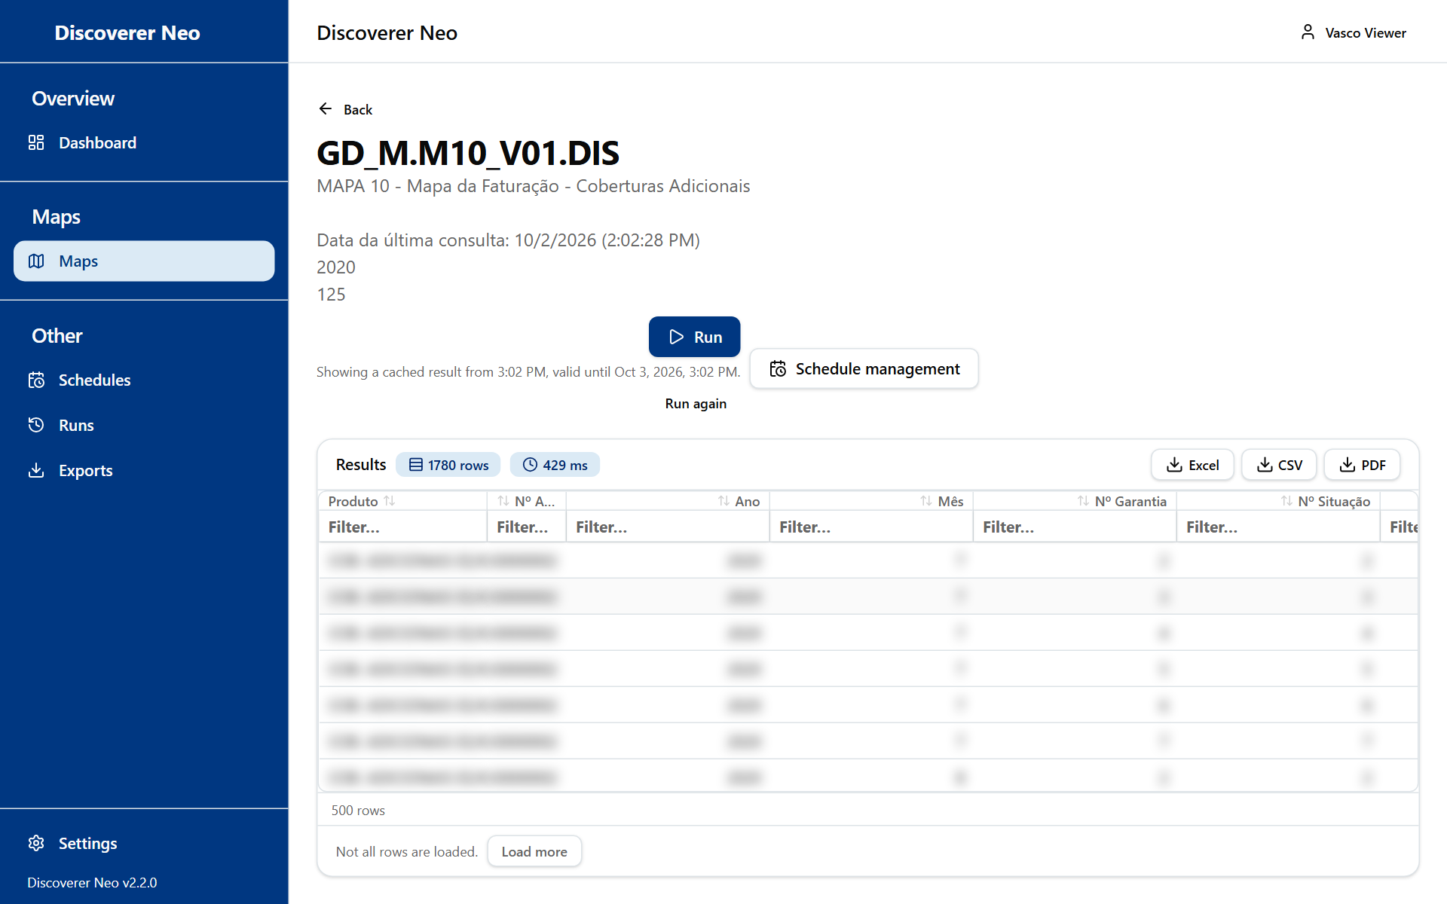
A completed run with Excel, CSV and PDF buttons over the results grid.
Button or control | What it does
Run | Runs the map. If a parameter has no default, Run parameters opens first.
Run again | After a finished run, asks for a fresh run with the same values.
Cancel | Cancels a run that is still waiting in the queue. A run already in progress cannot be cancelled here.
Schedule management | Opens Schedules.
Excel, CSV, PDF | Export the finished result.
Load more | Loads the next 500 rows.
Header click | Sorts by that column.
Filter… under a header | Filters the rows already loaded.
Double-click a row | Opens Drill to Detail, the raw rows behind that row.

The status line under Run says whether the result is fresh or was reused. A result stays valid for 24 hours. If you run the same map with the same values again in that time, you get the stored result. Use Run again to force a new one.
Run and Export need a grant on every folder of the map. Without it a red Not entitled to run box appears. Ask an administrator for the grant.
You do not see the SQL and Plan buttons. They are for administrators.
The Run parameters dialog asks one question per parameter. A red star marks a required one. Where the parameter feeds a filter on an item, a picker suggests the real values. It needs a grant on that area.

Export to PDF
Click PDF to open Export to PDF.
Field | What it means
Paper size | A4, A3 or Letter.
Orientation | Portrait or Landscape.
Columns | Tick the columns to print. Select all and Clear toggle them all.

Click Export. The map description prints at the top of the first page.

Example: run and export GD_M.M10_V01.DIS
- Open Maps, find GD_M.M10_V01.DIS and click the Eye icon.
- Click Run. Answer the questions if any appear.
- When the rows appear, click Excel.
- Open Exports to download the file.

Schedules
A schedule runs a map by itself on a timetable and stores the result. You see only your own schedules, even though you can schedule any map.
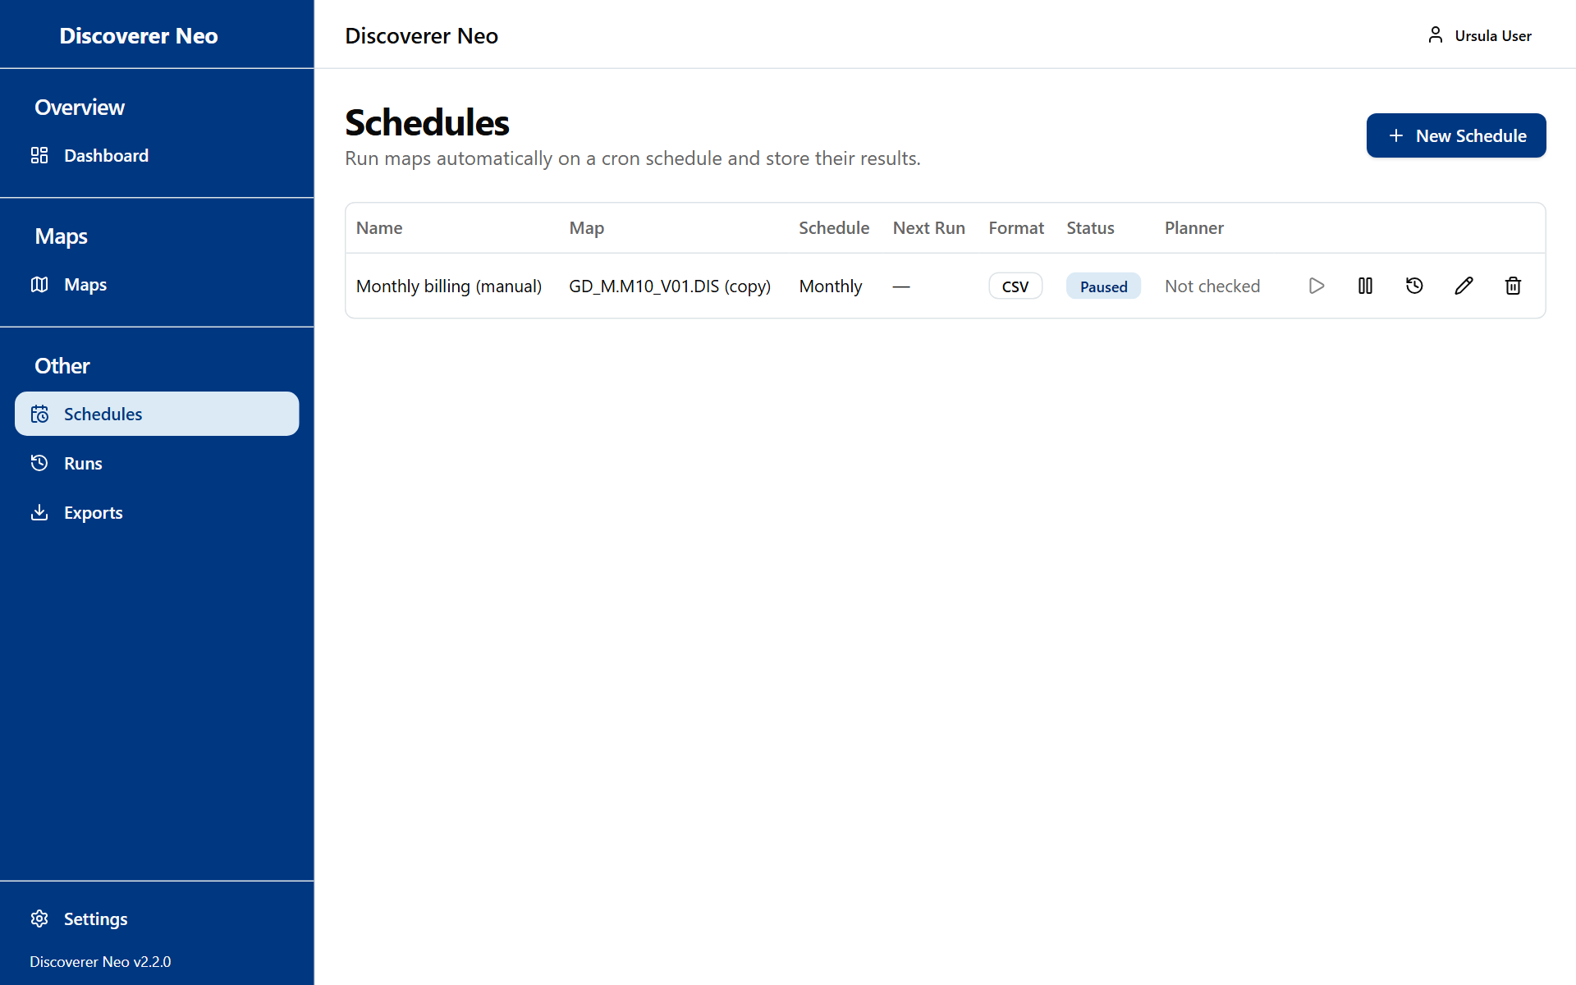
The Schedules page with a paused schedule and its action icons.
To schedule a map you do not own, use the Calendar icon on the Maps page. The map list in the New Schedule dialog holds only your own maps and maps shared with you.
A schedule runs as you. Your business-area grants decide whether it can read the data.
Button or control | What it does
New Schedule | Opens the dialog.
Row icon Run now | Runs it at once. Not available while paused.
Row icon Pause or Enable | Switches the schedule off or on.
Row icon History | Opens Execution History.
Row icon Edit | Changes the schedule. You cannot change its map.
Row icon Delete | Deletes the schedule and its history after you confirm. It cannot be undone.

The Status column shows Active or Paused. The Planner column is filled by the migration. You cannot change it.
Field in the dialog | What it means
Map | The map to run.
Name | The schedule name.
Frequency | See below.
Timezone | The clock the times use. Default: your computer's timezone.
Time | The hour and minute of the run. Shown for every frequency except Custom (cron).
Day of the week | Shown for Weekly.
Day of the month | 1 to 28, or Last day. Days 29 to 31 are not offered, so no short month is skipped. Shown for Monthly, the longer frequencies and Yearly.
Month | Shown for Yearly.
Cron expression | Shown for Custom (cron). Five fields: minute, hour, day of month, month, day of week.
Valid from and Valid until | Optional dates. The schedule runs only in between.
Output Format | See below.
Parameter presets | The value of every map parameter: a Fixed value, or Relative to the run date (see below).
Enabled | Off means it never runs by itself.

Option (Frequency) | What it means
Daily | Every day at the Time you choose.
Weekly | Once a week, on the Day of the week you choose.
Fortnightly (1st and 16th) | On the 1st and the 16th of each month.
Monthly | Once a month, on the Day of the month you choose.
Every 2 months | In January, March, May, July, September and November.
Quarterly | In January, April, July and October.
Every 4 months | In January, May and September.
Every 6 months (semester) | In January and July.
Yearly | Once a year, on the Month and Day of the month you choose.
Custom (cron) | You write a Cron expression: five fields, minute, hour, day of month, month, day of week. Example: 0 9 * * 1-5 is 09:00 on weekdays.

Option (Output Format) | What it means
Excel (.xlsx) | A spreadsheet.
CSV | A plain text table. The default.

Execution History lists the last 50 results with Executed, Status, Rows and Duration. Each has XLSX, CSV and PDF buttons and an Open icon. Results are kept for 30 days. Then the export buttons disappear.

Parameters that follow the run date
Each parameter in Parameter presets has a choice: Fixed value or Relative to the run date. A fixed value is the same on every run. A relative value changes with the date the schedule runs, so a monthly report always covers the right month.
A relative value has three parts:
- Move the run date by a number. Use -1 for the period before, 0 for the current one.
- The period: days, weeks, fortnights, months, quarters, semesters or years.
- then use the: that date, the first or last day of that week, fortnight, month, quarter, semester or year, its year (number) or its month (number 1-12).

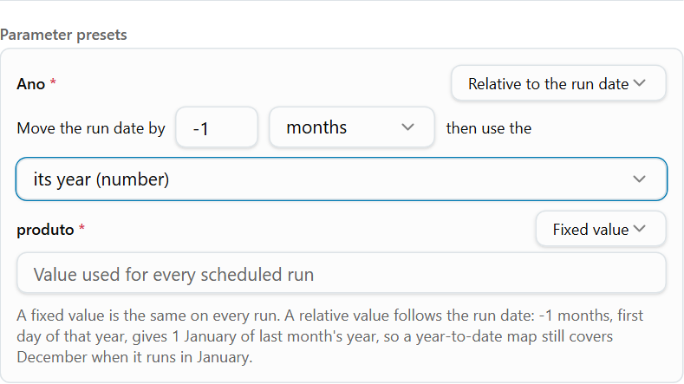
Parameter presets with one fixed value and one value relative to the run date.
You want | Start date | End date
Last month | -1 months, first day of that month | -1 months, last day of that month
The year so far, up to last month | -1 months, first day of that year | -1 months, last day of that month
A fixed start, a moving end | Fixed value, for example 2026-01-01 | -1 months, last day of that month
Last quarter | -1 quarters, first day of that quarter | -1 quarters, last day of that quarter
Yesterday | -1 days, that date | -1 days, that date

For a parameter that asks for a year or a month as a number, use its year (number) or its month (number 1-12). A week starts on Monday. A fortnight is the 1st to the 15th, or the 16th to the end of the month.
Tip: -1 months, first day of that year still gives the whole of last year when the schedule runs in January. A Fixed value does not move: a fixed 2026-01-01 still starts in 2026 when the schedule runs in 2027.
The Next Run column shows the date of the next run and, under it, the values that run will use. Check it after you save.
You can give one map more than one schedule, each with its own frequency and values. Example: one monthly schedule for last month, and one yearly schedule for last year.

Example: schedule a weekly run
- On Maps, click the Calendar icon of the map.
- Type a Name. Set Frequency to Weekly, Day of the week to Monday and Time to 07:00.
- Choose your Timezone and Output Format.
- Click Save.
- Click the Run now icon to check it works. Then open History.

Runs
Runs lists every run you requested, whether it is waiting, running or finished. It shows only your own runs, not other people's.
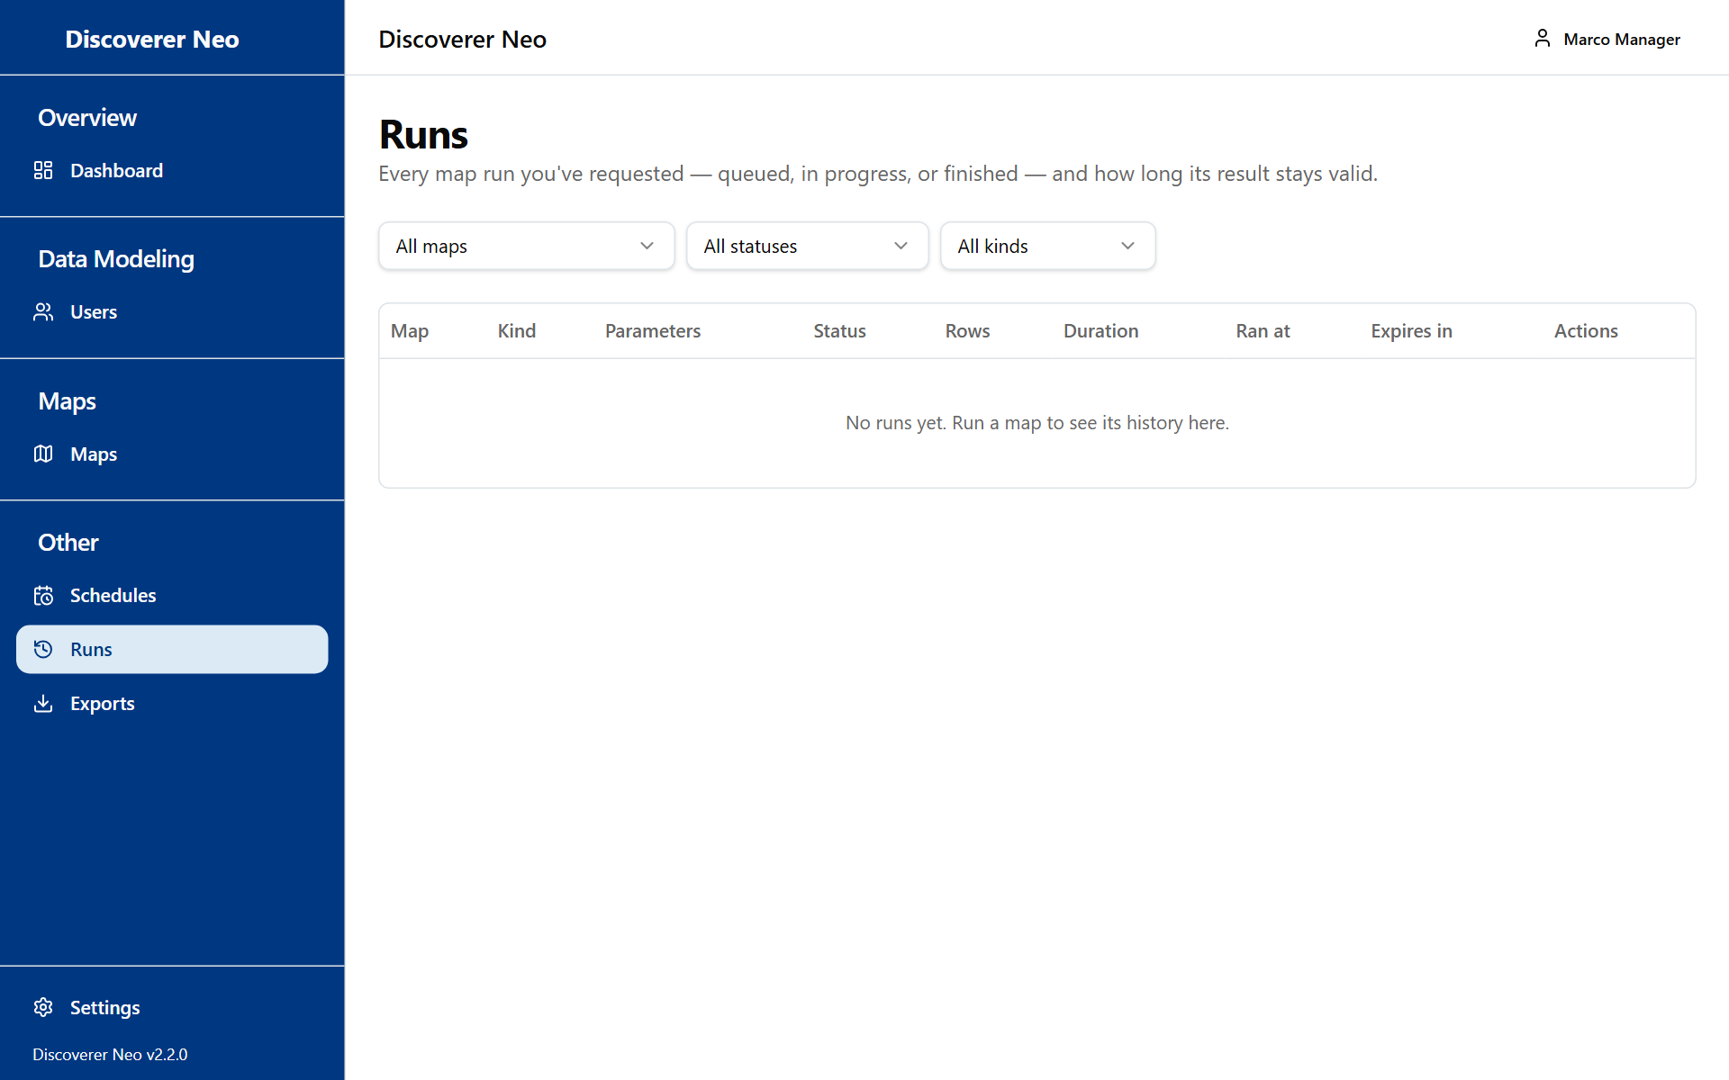
The Runs page with map, status and kind filters and the list of runs.
Button or control | What it does
Map, Status, Kind filters | Narrow the list. Kind is Live or Scheduled.
Map name | Opens the viewer.
Open icon | Opens the stored result of that run.
Run again icon | Requests the same run again.
XLSX, CSV, PDF | Export a finished run that has not expired.
Cancel icon | Cancels a run that is still queued.
Delete icon | Deletes a finished run and its stored rows. It cannot be undone.

The Expires in column shows how long the result is kept. The Show every user's runs box is for administrators only, so you do not see it. A run of a map you can no longer open disappears from your list.

Exports
Exports lists the files you asked for. You see your own only.
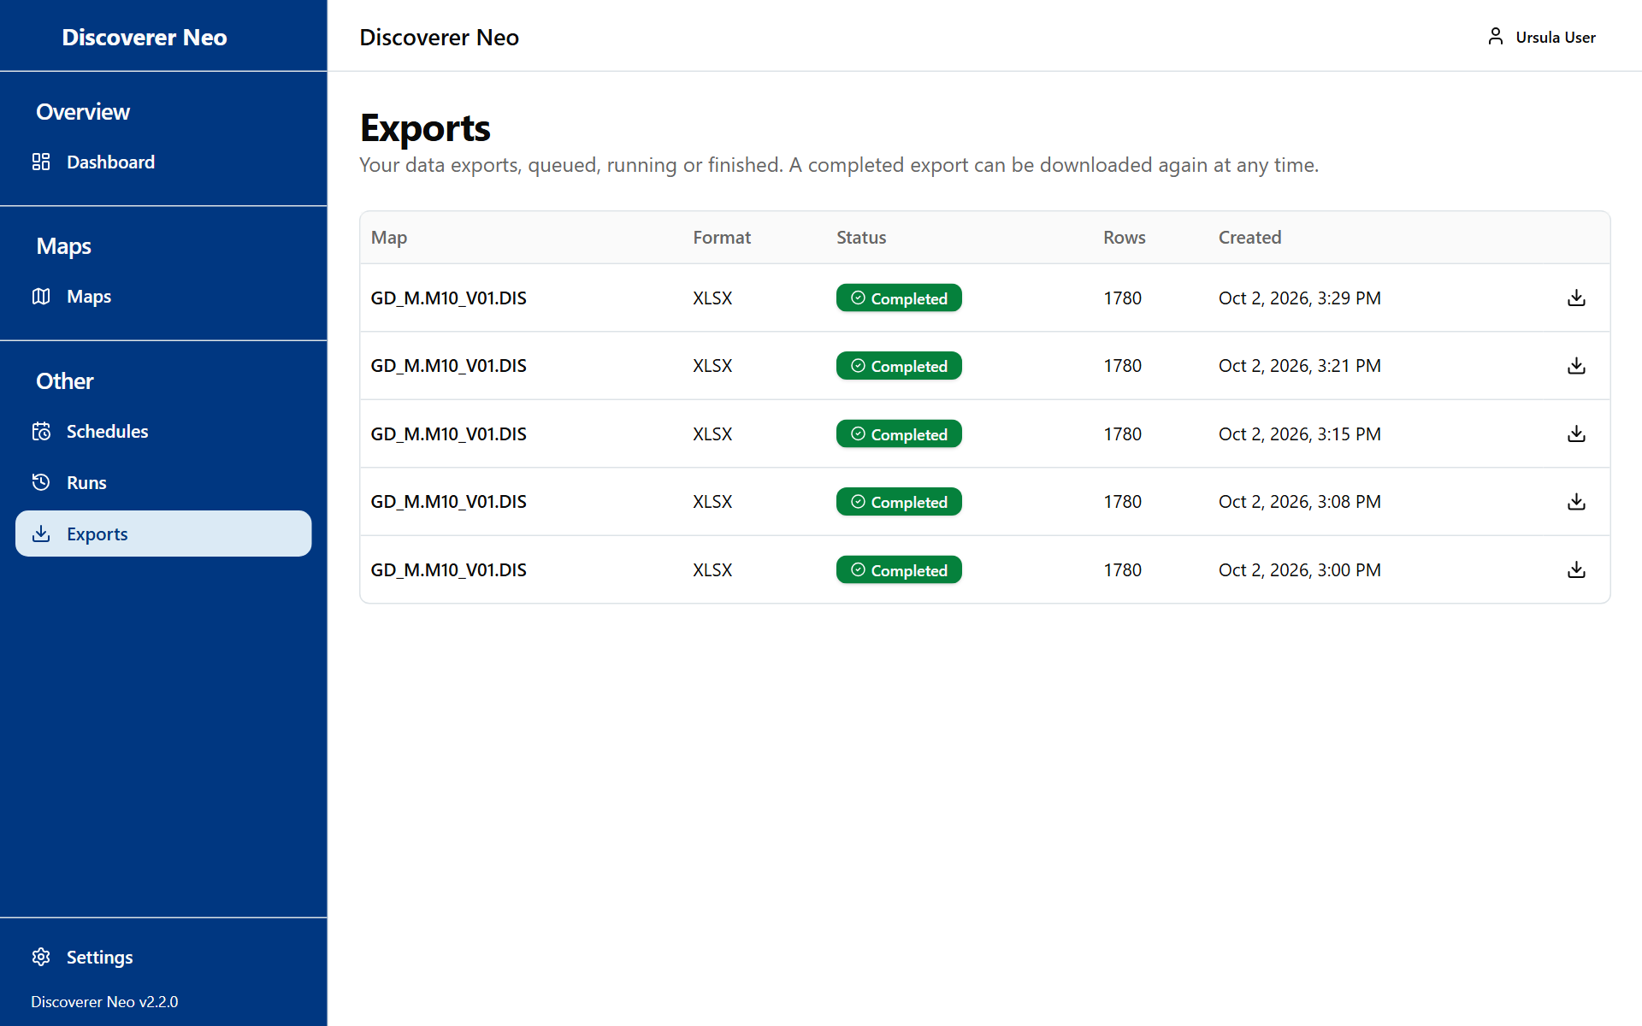
The Exports page listing export jobs with a Download button on finished ones.
Button or control | What it does
Download icon | Downloads a finished file.

The Status shows Queued, Running, Completed or Failed. Point at a failed status to read the reason. Files are kept for 7 days. After that the download fails. Export again from a fresh run.

Settings
Open Settings from the sidebar or from your name menu. The choices are kept for your account on every computer, but only after you click Save.
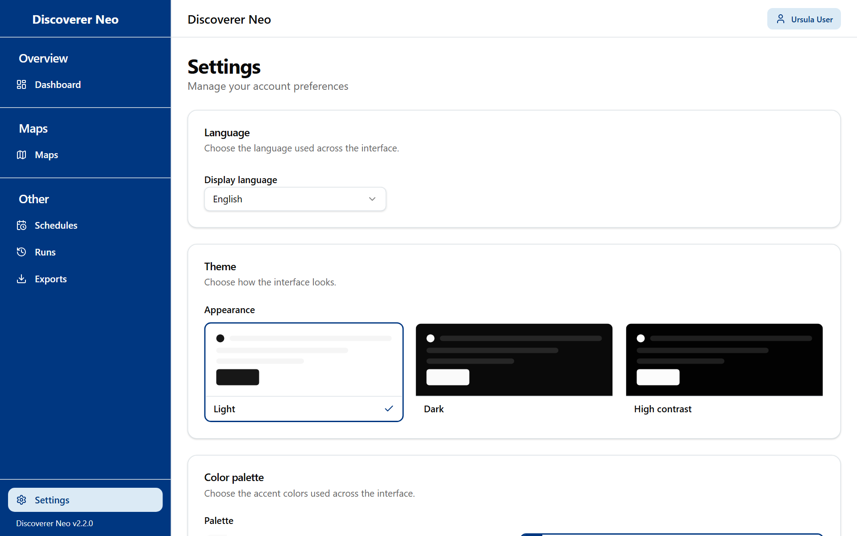
The Settings page with the Language, Theme and Color palette cards.
Control | What it does
Display language | English, Português (Portugal), Français (France) or Español (España).
Appearance | Light, Dark or High contrast.
Palette | Classic, Navy, Forest, Wine, Ocean or Ochre. Off while High contrast is on.
Save | Keeps your choices.

If you leave without saving, this browser shows the new choice, but your account still holds the old one.

Common questions
Why do I see a map but the run says "Not entitled to run"? You see every map as a Manager. Its data needs a business-area grant on each folder it uses. Ask an administrator.
Why is there no Pencil icon on a map? You may edit only your own maps and maps shared with you at Can edit. Click the Copy icon, then change your copy. Or ask the owner to share it with you at Can edit.
Where are Business Areas, Folders, Items, Joins and Hierarchies? Changing the data model is for administrators only, so these pages are not in your sidebar. If a folder or item is wrong or missing, ask an administrator.
I clicked something and got "Forbidden" or "Save failed". The screen offered it, but your role or grant does not allow it. The most common case is saving a map you do not own.
I cannot see another person's runs, exports or schedules. Runs, exports and schedules belong to the person who made them. Nobody but that person sees them in the list, and the same is true for you.
A colleague left. How do I keep their maps? Open Users, click Maps this user can open, then use the owner icon on each map to give it to someone else.
My monthly schedule always shows the same dates. Its date parameters have a Fixed value. Edit the schedule and set them to Relative to the run date.
A schedule I made does not run. Check that its Status is Active, that the dates in Valid from and Valid until cover today, and that you still hold a grant on the data. A schedule runs as you.
My export download says it failed. Files are kept for 7 days. Run the map again and export the new result.
I cannot change my password when I forget it. There is no reset link. Ask an administrator.

Glossary
Term | Meaning
Map | A report. In Oracle Discoverer this was a worksheet.
Workbook | A group of maps.
Business area | A group of related data.
Folder | One table, view or query inside a business area.
Item | One column of a folder. A dimension groups rows. A measure holds values that are totalled.
Join | The rule that connects two folders.
Hierarchy | An ordered list of items for drill-down.
Grant | Access to a business area given by an administrator, at a level.
Share | Access to one map given to one person, at a level: Can view, Can export or Can edit.
Public map | A map anyone signed in can view and export. Their data rights still apply.
Run | One execution of a map. Its rows are stored for 24 hours.
Export | A file (Excel, CSV or PDF) made from a finished run.
Schedule | A timetable that runs a map by itself and stores the result.

