Discoverer Neo
Quick guide
For the VIEWER role
Version 2.2.0

Contents
Your role in one page 1
Dashboard and Maps 2
Run and read a map 3
Runs and Exports 4
Schedules 5
Settings 6

Your role in one page
You have the VIEWER role. Your main job is to open maps and read their results. A map is a report. A business area is a group of related data.
You can | You cannot
See your own, public and shared maps | See other people's private maps
Run maps, sort, filter and drill down | Copy a map or workbook
Export, if the map is public or shared as Can export or Can edit | Export a map shared as Can view
Change your language and theme | Open administration pages

Share levels: Can view = run only. Can export = run, export, schedule. Can edit = all of that plus change the map. The share, not your role, decides this.
Sign in with Email and Password, then Sign in. A temporary password must be changed first (at least 12 characters). To leave, click your name, then Log out.
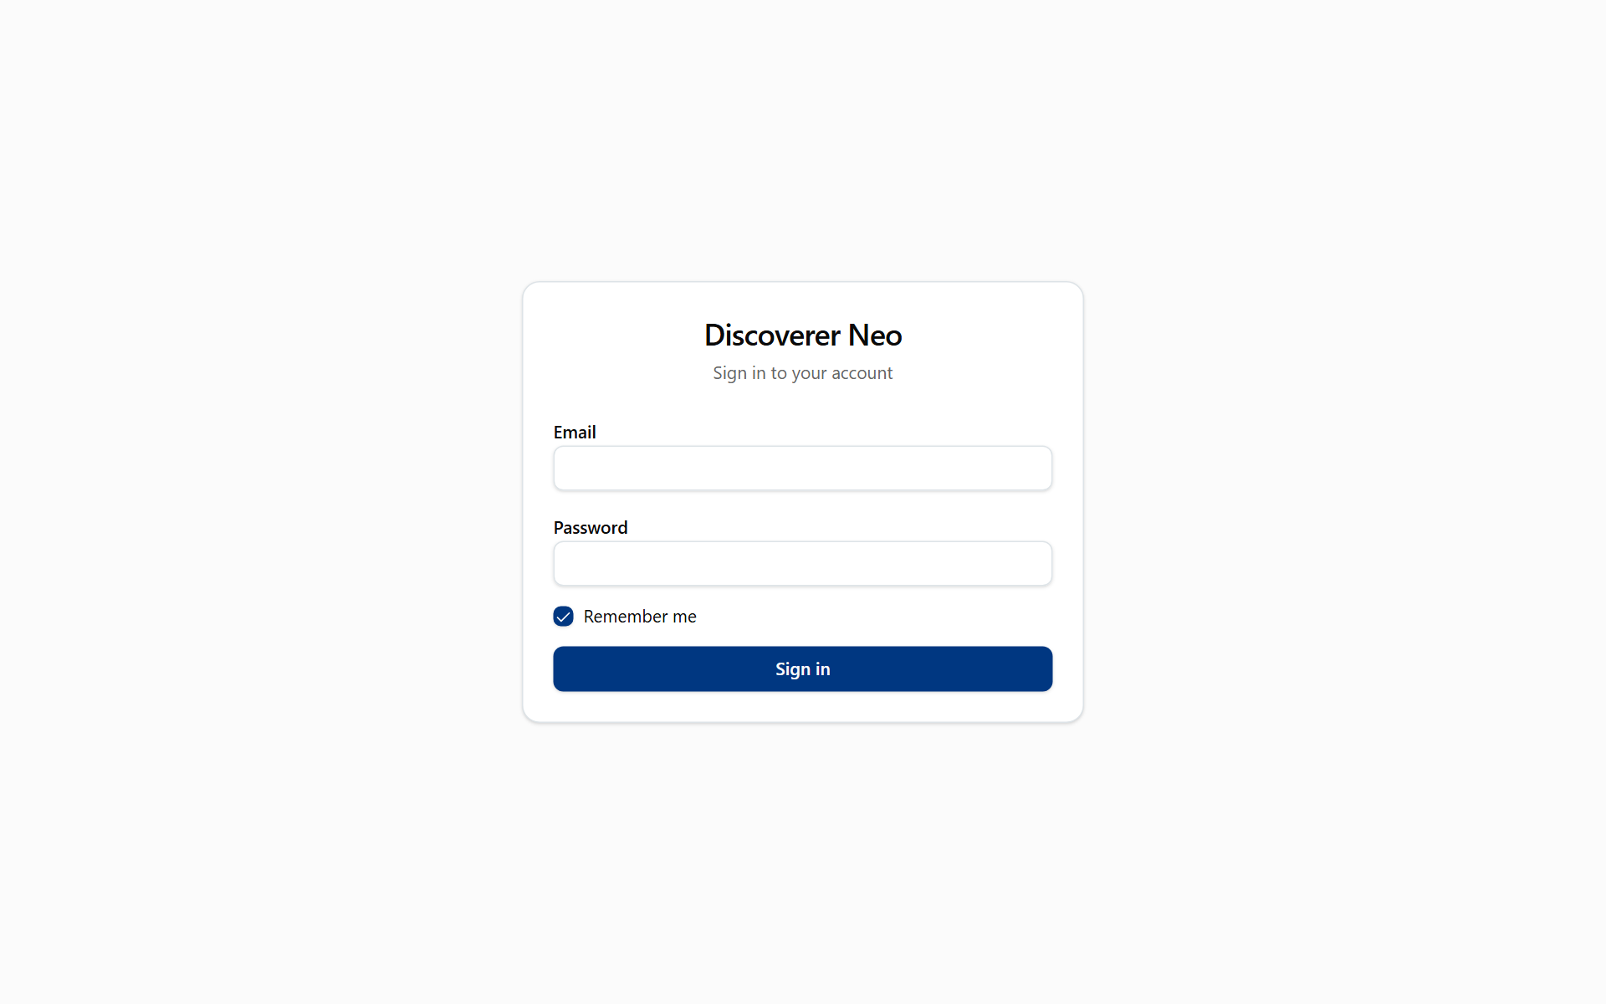
The sign-in page with Email, Password, Remember me and the Sign in button.

Dashboard and Maps
Dashboard is a read-only summary. Maps lists what you can open.
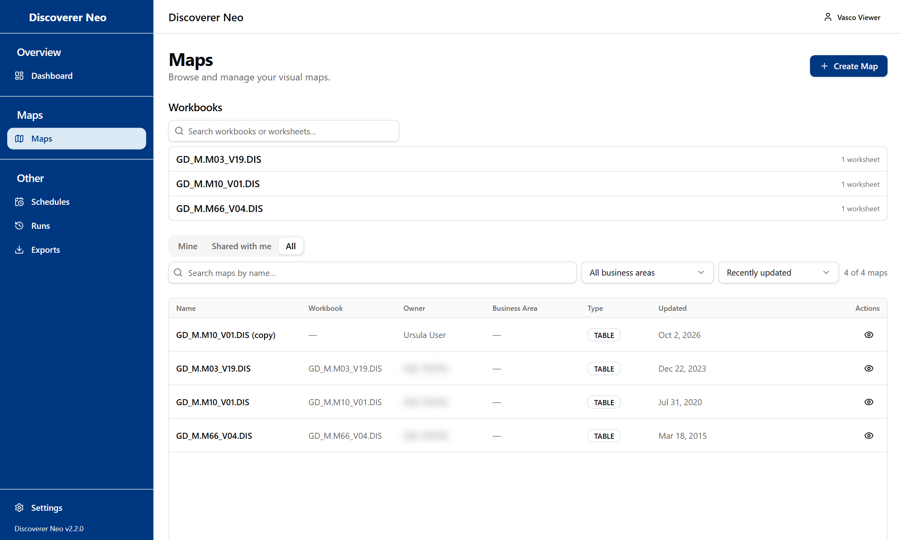
The Maps list, All tab, where each map has only the Open icon.
- Click Maps in the sidebar.
- Open Shared with me or All.
- Search by name or pick a Business Area.
- Click the map name or the eye icon.

Choice | Line
Mine / Shared with me / All | Your own, shared, or everything you can see
Copy | Not available for your role
Other icons | Work only if you own the map or hold Can edit or Can export

Run and read a map
The viewer runs a map and shows its rows.
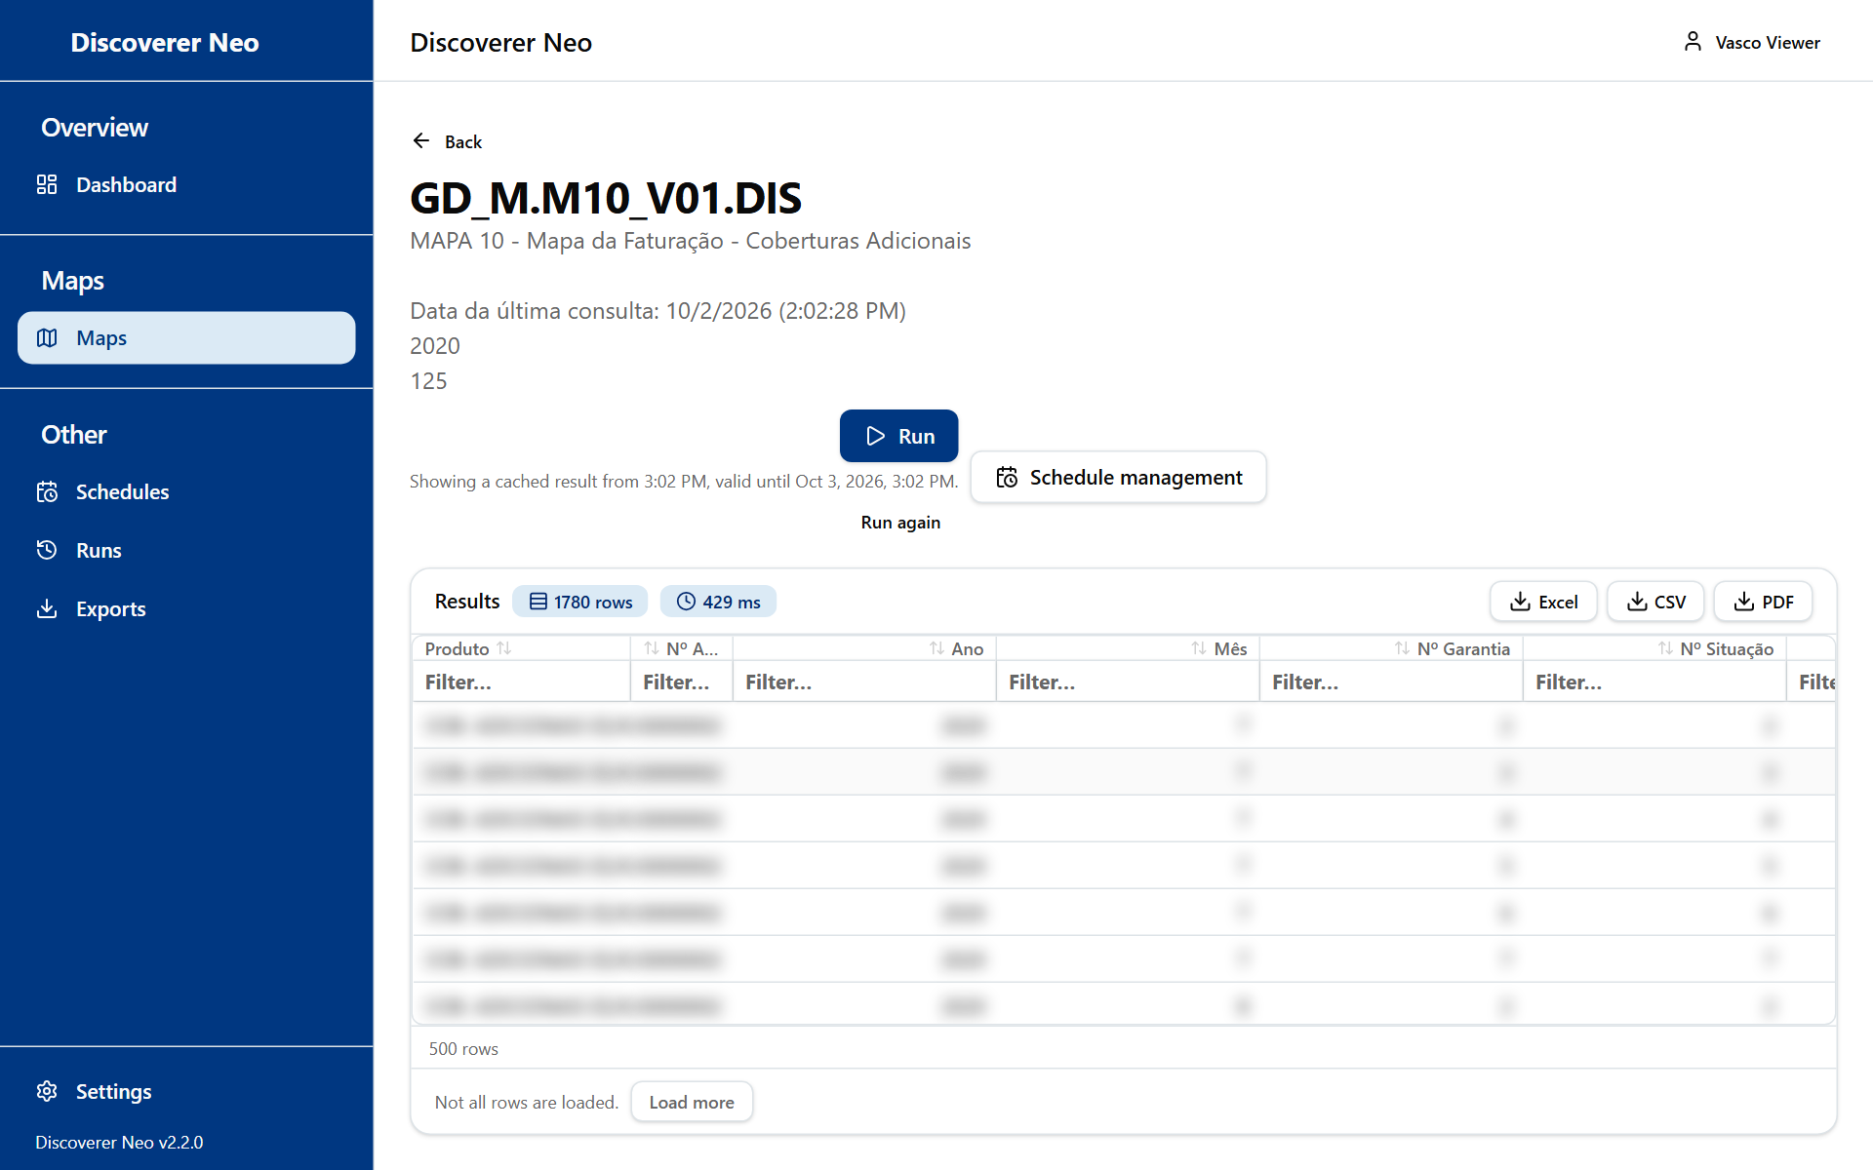
A completed run with Excel, CSV and PDF buttons over the results grid.
- Click Run. Fill in Run parameters if asked.
- Read the rows. Click a header to sort. Type in Filter… to narrow.
- Double-click a row for Drill to Detail.
- Click Load more if not all rows are shown.
- Click Run again for fresh data. A result stays valid for 24 hours.

Choice | Line
Excel, CSV, PDF | Export. Only with Can export or Can edit, or on a public map. Otherwise "Forbidden"
Not entitled to run | No access to the data. Ask your administrator
Cancel | Only while the run is queued

Runs and Exports
Runs lists your runs. Exports lists your files.
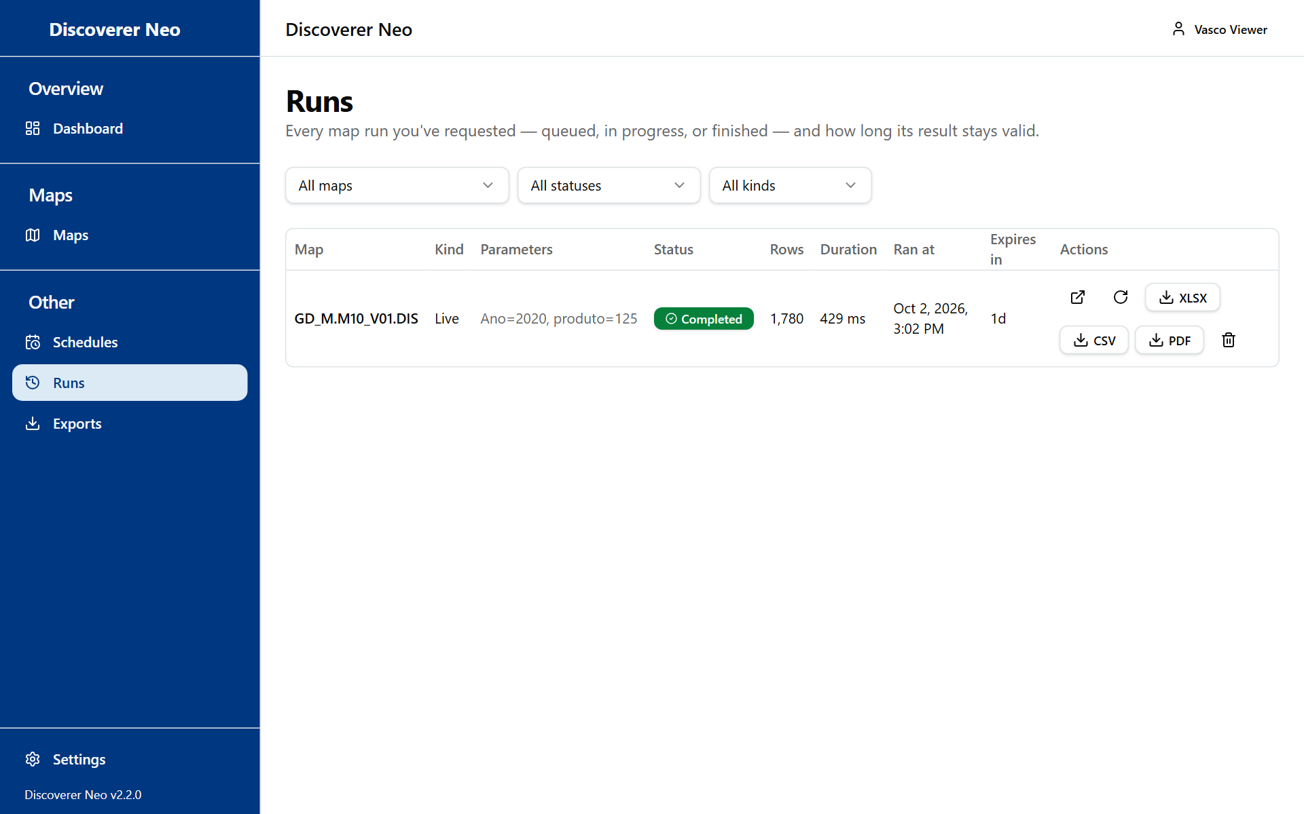
The Runs page listing the Viewer's own runs.
- Open Runs to see status and Expires in.
- Click Open to see a stored result, or Run again.
- Open Exports and click Download on a finished file.

Choice | Line
Delete | Removes a run for good
Files | Kept 7 days

Schedules
Schedules run a map by themselves. You can create one only for a map you own or that is shared as Can export or Can edit. Public maps and Can view shares cannot be scheduled.
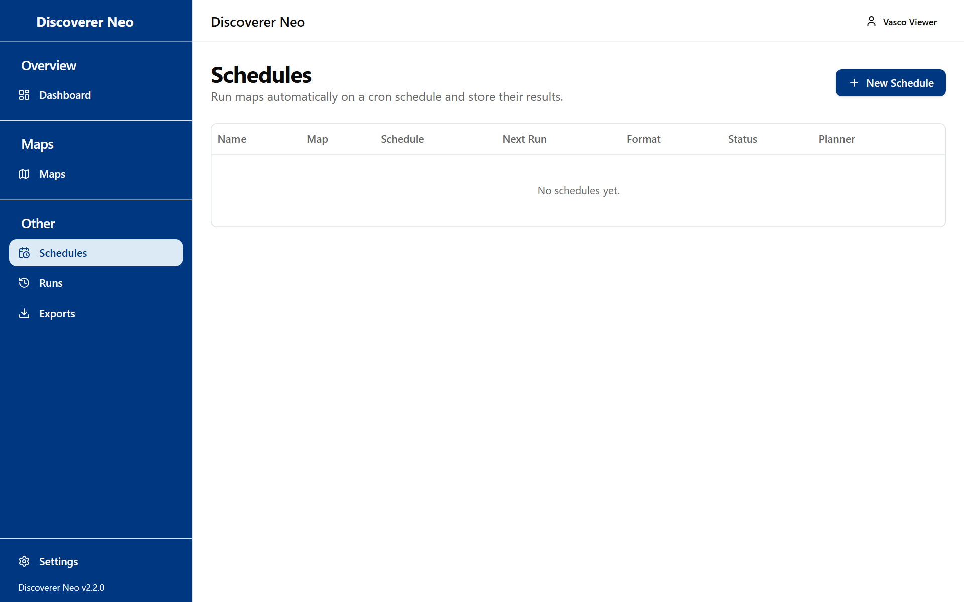
The Schedules page with the message No schedules yet.
- Click New Schedule, or the calendar icon on Maps.
- Choose the Map and a Name.
- Choose Frequency, Timezone and Output Format.
- Click Save.

Choice | Line
Frequency | Daily, Weekly, Fortnightly, Monthly, every 2, 3, 4 or 6 months, Yearly, or Custom (cron)
Output Format | Excel (.xlsx) or CSV

Settings
Open Settings from the sidebar.
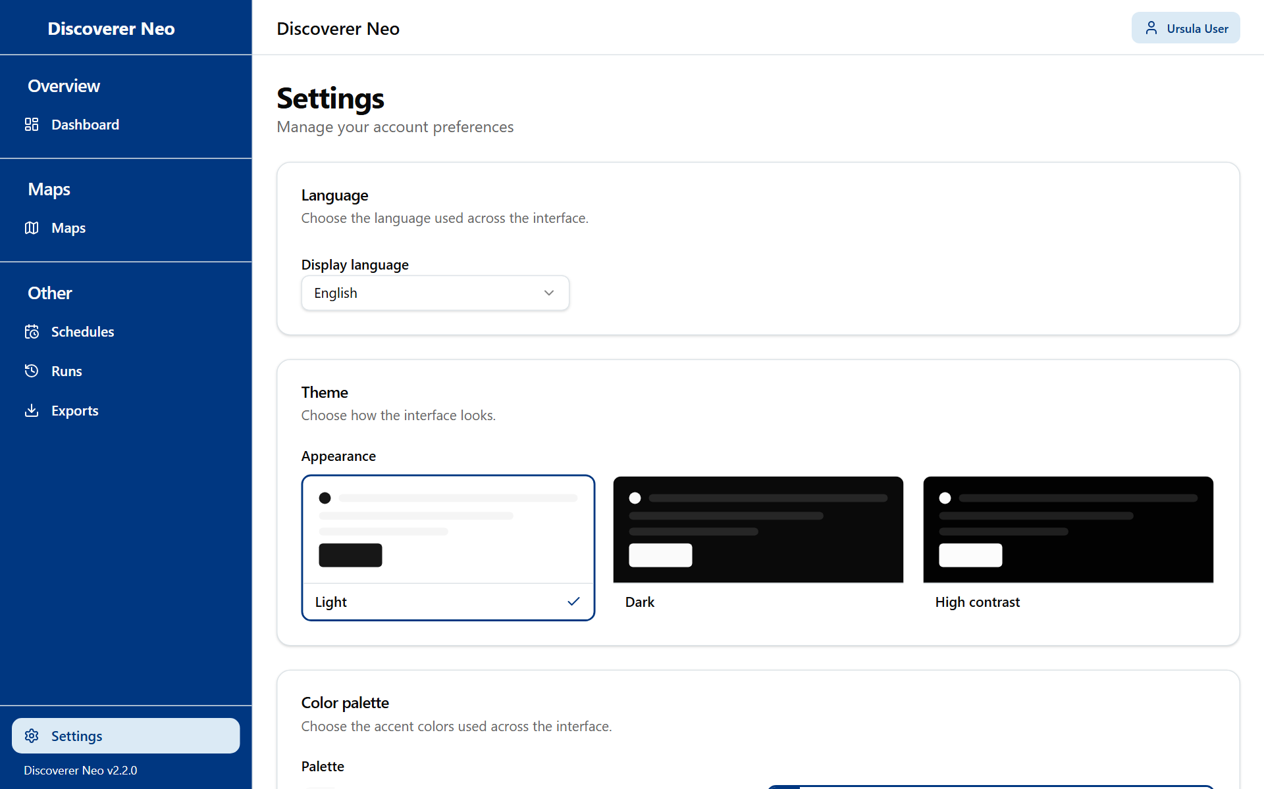
The Settings page with the Language, Theme and Color palette cards.
- Pick a Display language.
- Pick Light, Dark or High contrast.
- Pick a Palette (not with High contrast).
- Click Save. Without it the choice stays on this browser only.

