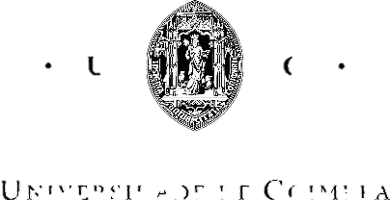

João Miguel Roque Almeida

Computational Discovery of Genetic Markers for Type 2 Diabetes

Thesis submitted to the University of Coimbra in compliance with the requirements for the degree of Master in Biomedical Engineering

July 2018

