**SUPPORTING INFORMATION**

**Nature Communications**

**Hotspot getting hotter: Increased knowledge on Tetrapod endemism, habitat loss and the plight of the Cerrado savannas**

**João Paulo Santos Vieira-Alencar, Ana Paula Carmignotto, Ricardo J. Sawaya, Luis Fábio Silveira, Paula Hanna Valdujo & Cristiano de Campos Nogueira**

**Figure S2:**

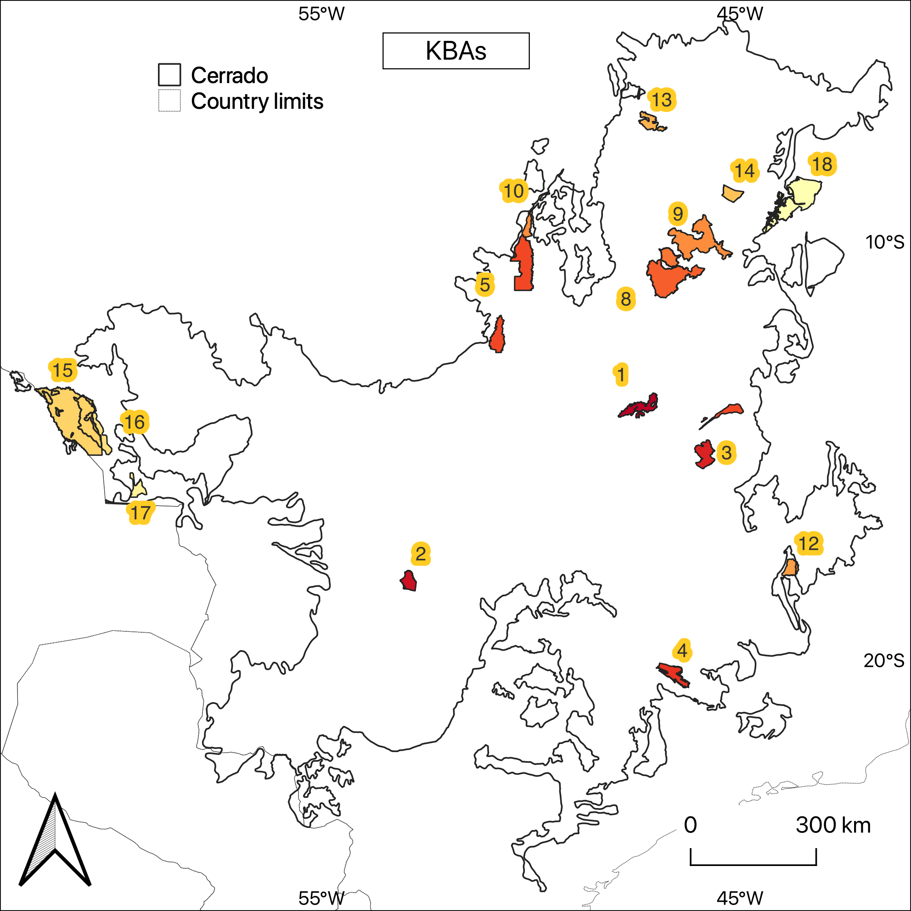

**Supplementary figure X:** Potential Key Biodiversity Areas for Cerrado endemic terrestrial vertebrates. Codes near each protected area follow a sequence starting from the richest conservation unit and details can be found in Supplementary table 1 (see below).

**Supplementary table 1:** Potential Key Biodiversity Areas for Cerrado endemic terrestrial vertebrates.

| **Code** | **Name** | **Designation** | **Year** | **N** | **Area** | |
| --- | --- | --- | --- | --- | --- | --- |
| 1 | Parque Nacional Chapada dos Veadeiros | National Park | 1961 | 108 | 240,585 |
| 2 | Parque Nacional das Emas | National Park | 1961 | 99 | 132,785 |
| 3 | Parque Nacional Grande Sertão Veredas | National Park | 1989 | 94 | 230,854 |
| 4 | Parque Nacional da Serra da Canastra | National Park | 1972 | 84 | 197,971 |
| 5 | Parque Estadual do Araguaia | State Park | 2001 | 78 | 229,921 |
| 6 | Refúgio de Vida Silvestre Veredas do Oeste Baiano | Wildlife Refuge | 2002 | 78 | 128,050 |
| 7 | Estação Ecológica Serra Geral do Tocantins | Ecological Station | 2001 | 77 | 707.087 |
| 8 | Parque Nacional do Araguaia | National Park | 1959 | 75 | 555,503 |
| 9 | Parque Estadual do Jalapão | State Park | 2001 | 65 | 158,972 |
| 10 | Parque Nacional das Nascentes do Rio Parnaiba | National Park | 2002 | 60 | 749,770 |
| 11 | Parque Estadual do Cantão | State Park | 1998 | 60 | 100,414 |
| 12 | Parque Nacional das Sempre Vivas | National Park | 2002 | 57 | 124,156 |
| 13 | Parque Nacional da Chapada das Mesas | National Park | 2005 | 46 | 159,953 |
| 14 | Estação Ecológica de Uruçuí-Una | Ecological Station | 1981 | 41 | 135,125 |
| 15 | Parque Nacional Noel Kempff Mercado | National Park | 1979 | 37 | 1,617,204 |
| 16 | Parque Estadual Serra de Ricardo Franco | State Park | 1997 | 36 | 157,831 |
| 17 | Parque Estadual Serra de Santa Bárbara | State Park | 1997 | 33 | 120,432 |
| 18 | Parque Nacional Serra das Confusões | National Park | 1998 | 27 | 823,845 |

Code = PA code ID linked to supplementary figure X (see above); Year = Year of PA designation; N = Number of Cerrado endemic terrestrial vertebrates whose geographical range intersects with PA limits; Area in hectares (ha).