EUR Title – I2202275 – Production Demand Processing Module

Document Approval
Approver | Approved Date | Rejected Date | Comments

Part I Functionality Overview

Objectives (Why are we doing this?)
Golden Technologies currently uses an in-house custom Access-based utility to create Purchase Orders and Work Orders alike across both Make and Buy items. This tool allows one person to manage the production needs of the facility against purchasing requirements for like items that may be either bought or made.

Business Process

Process Formalization and Documentation

User Roles and Responsibilities

Interactions with Other Systems

Production Rollout Considerations

Terminology

Part II – Flow Chart and Mock-ups
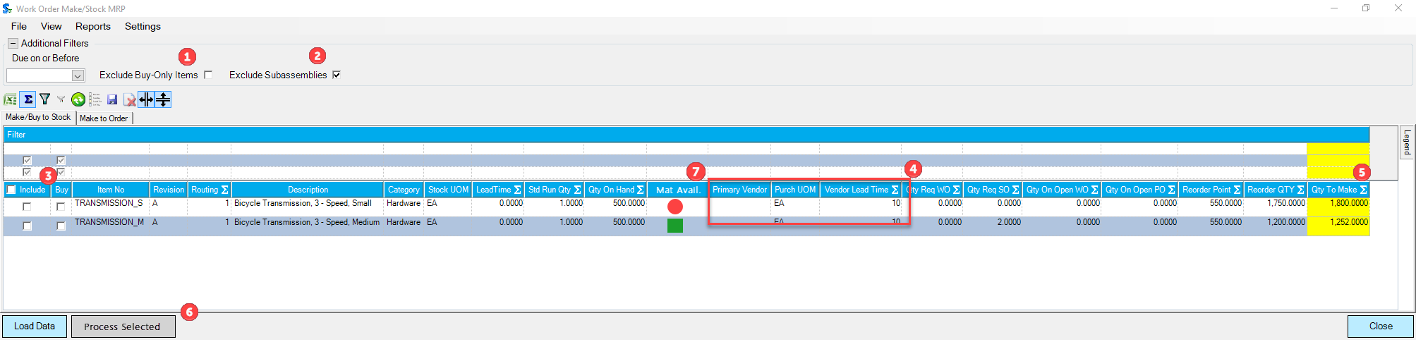
Make / Buy to Stock – Main Tab

- Option to exclude items set to Buy only on data load.
  - Settings to allow for saving this as default preference.
- Option to exclude assembly items that are not solely Finished Goods on data load.
  - Settings to allow for saving this as default preference.
- The “Include” column will be instead “Make”, accompanied by a new “Buy” column. If an item is Buy only, then the Make option will be un-selectable for that line. If an item is Make only, the Buy column will be un-selectable for that line. If an item is set to both Make and Buy, either can be selected, though not both.
- New Purchasing related columns for items with Vendor information.
- Qty to Make will be “Qty to Process”. Still editable, this will allow for setting the quantity prior to processing. If the qty is less than original total demand, it will reappear on data reload. Each separate processing of the same item can be handled differently. For instance, a Buy/Make item may have 100 selected to Make, then the next 100 selected to Buy.
- Sends the selected items with their chosen handling to the Batch Processing form (shown later in document).
- Material Availability Check. Similar to the version used in the Scheduling module, it performs a cursory check that there will be enough material when processed to make this item. Color coding will also include a N/A indicator for those items that are Buy only. Can be turned off or on using the form Settings and saved as default preference.
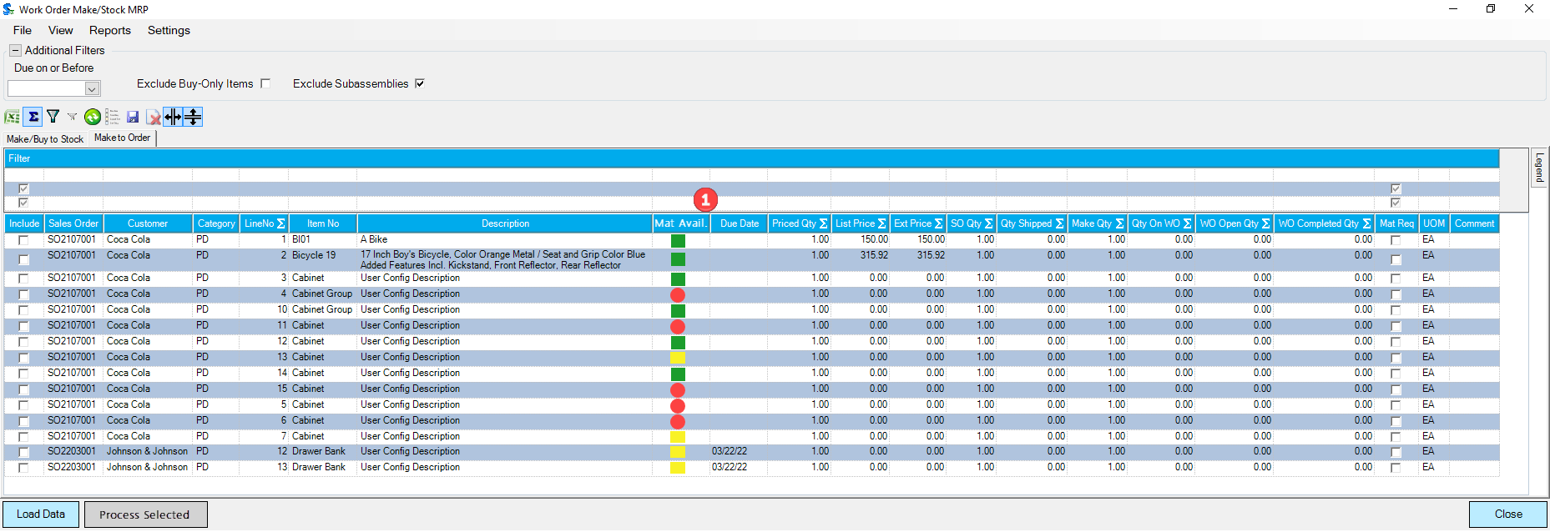
Work Order Generator – Secondary Tab
This form will be a near direct conversion of the Work Order Generator to .NET, allowing for customization as a search, rather than via the HistorySQL setup record.
- Material Availability Check. Performs the same function as on the Main tab.

Batch Processing Form
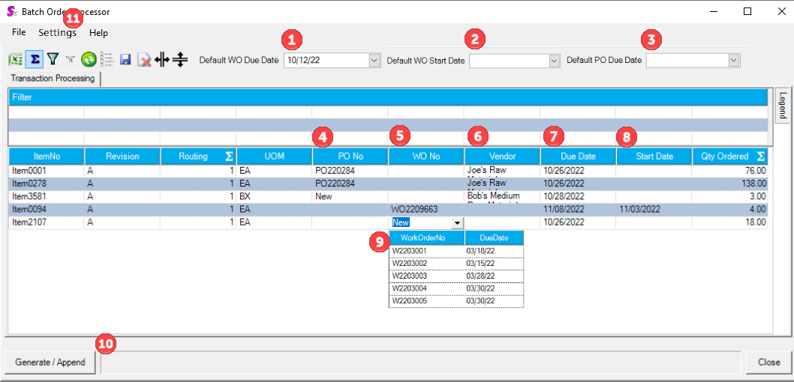
- Default Work Order Due Date – selecting this date will update all Work Order Generation Due Dates to this date.
- Default Work Order Start Date – selecting this date will update all Work Order Generation Start Dates to this date.
- Default PO Due Date – selecting this date will update all Purchase Order Generation Due Dates to this date.
- PO No – “New” by default, though can add to existing, un-approved, not received PO for the matching Vendor. Selecting an existing PO will set the Due Date for this line, which will then be un-editable from this form. The columns in the combo will include the PO Number and PO Due Date for visibility.
- WO No – “New” by default, though can add to existing Make-Stock Work Order not already completed. This will populate the Due with the existing Work Order’s header Due Date, though the Start Date will be left as is and can be edited. If the Due Date is updated for a line after selection of an existing Work Order, only the resultant Work Order line will have the modified Due Date, and the Work Order’s header date will remain unaffected.
- Vendor – for items selected to Buy, the primary Vendor for the item by default. If additional Vendors are available, the alternative Vendor can be selected here. Selecting a different Vendor will reload the list of available POs to use.
- Due Date – Applies to either Purchase Order or Work Order. Due Date calendar picker will respect the exclusions in the OrderStream calendar by shading those dates an obvious color.
- Start Date – Applies to Work Order. Due Date calendar picker will respect the exclusions in the OrderStream calendar by shading those dates an obvious color.
- Example combo box for transaction selection. Combo boxes to show the available transaction numbers as well as those transactions’ current Due Dates.
- Will generate new or append transactions according to the combination of selections in the form. Will also respect the options in new Settings menu (#11).
- Settings
  - Generate One Work Order Per Line – For all Make item lines without an existing transaction selected, this option will result in generation of one new Work Order for each line.
  - Generate Work Order by Standard Run Qty – For all Make item lines without an existing transaction selected, this option will result in generation of Work Order lines split by Standard Run Qty or separate Work Orders by Standard Run Qty if the “Generate One Work Order Per Line” is also selected.
  - Generate Mat Req – Will call Mat Req for newly generated Work Order lines or re-run Mat Req for transactions where appending to existing.
  - Serialize Work Order lines – Will call the auto-serialization of serial-tracked Work Order line items, including separately detailed functionality (EUR to be created) for customized Serial Gen Key.

Part III – Functional Requirements
- Modified .NET Make/Stock MRP as base of operations. The current form for Make-Stock MRP will serve as the centralized location for the included functionality.
- New module for the advanced functions will be independent form the Work Order module, implemented independently.
  - Items processed here can either create new or add to existing Work Orders and/or Purchase Orders.
- Multiple tabs will be required for transactional document generation, depending upon the item type needing to be sent to either a Purchase Order or Work Order.
  - The main tab will be similar to the current Make-Stock MRP form, with additional features and columns.
    - The main tab will display items that are Make to Stock, Buy to Stock, or a combination of both (details of how this will relationship functions are detailed in prior approved EUR, I2202286).
    - The secondary tab will perform functions now done through Work Order Generator for Make to Order Items.
- Option to set Work Order Start and Due Dates / PO Due Dates when not adding to existing Work Orders or Purchase Orders.
- Material availability check option for Make Items to indicate whether the shown item has or will have enough material to make the suggested Quantity to Make.
- Header options for both tabs to filter out / exclude Buy or Make items on refresh, also the option to save these filtering methods as user defaults.
- New sub-forms to process transaction and line generation.
- Automated Serial No generation for Serial Tracked Items added to Work Orders, adhering to Golden Tech serialization logic.
  - Customization for serialization logic to be handles through separate EUR. Serialization of Work Order line items will otherwise be handled via standard logic, though automated upon Work Order generation.
- Font and grid sizes to be modifiable as a user setting. This should be made available through the right-click context menu from the form grids, including all forms shown in this EUR.
- Checking of Due/Start Dates for transactions against OrderStream Shop Calendar to inform of non-working days.
- Automatic addition to or creation of Purchase Orders for flagged components when a Work Order is generated for parent assembly item.
  - This portion likely to be handled as custom for Golden Tech only. Default behavior for the form would include these components on refresh / reload the data when transactions are created, where a component item’s demand is increased by previous generations. This customization would allow flagging a component item for automatic PO generation at the Item Editor level. For Golden Technologies, this would most often be chair shells purchased to fulfill demand for the Work Orders just generated.
    - Upon auto-generation of these additional POs, a pop-up will display “Additional POs created: “ followed by the list of those transactions. No special interaction with these is available for interaction on the new module, as it is to be automated directly. Transactions listed in this message may be accessed via click-through on transaction number.
- New Creator Type for transaction header and details created from this method to enable better accessibility of data for related reporting.
- Custom Reports to be made available for use against this module.
- Maintain processing batch IDs. For each successful batch of transactions created through this new module, a unique ID to be saved against the transaction headers and details.
  - Columns stored in association with this ID would minimally be the user and time stamp.
  - After a batch is processed, selection of any report from the Reports menu will be able to access the last batch ID as the main filter (similar to other modules). This would allow for filtering of records similar to how it is performed in main transactional module custom reports.
- Messaging to user for indications of:
  - Switching between tabs with unprocessed changes will result in loss of changes from current tab.
  - Processing completions.

Part IV – Change Order Details
Date | Enhancement | Requested By | Notes | Priority | Release Status

