EUR – MV Consolidated Work Order Import – I2206272 – R3

Document Approval
Approver | Approved Date | Rejected Date | Comments

Part I Functionality Overview

Objectives (Why are we doing this?)
Hoff has implemented the Microvellum consolidated work order functionality. This uses a SQL Server database; the ability to export work orders to a SQL Compact Edition database is not available.

Business Process

Process Formalization and Documentation
- A new estimate will be created from JobCosting for the products being imported from MV. Each MV work order corresponds to an OrderStream estimate. The transaction identifier will be the cabinet no / MV Product No. This combination will be unique per job.
- To import from MV, the user would open the import tool from an estimate and would be able to filter the information shown on the grid based on column filters. Ultimately only the products selected in the include column would be imported. An Include All right click option will be available to include all rows that are currently visible on the grid.

The following is a sample of the MV fields to appear on the import form. Being as the query that populates the import form is customizable, more columns are able to be added at any time. If the MV import form is loaded from the estimate module with an estimate selected AND if the selected estimate is associated to a job, inject the job number into the Job No column filter.
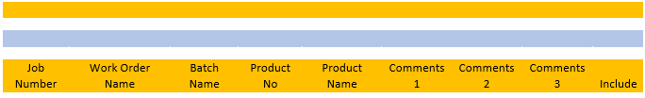
- Items will be imported from MV as the actual items that have been created in OrderStream, provided that the items already exist. Since the MV import is bound to product lines, will be achieved by creating a product line for each item. The MV product will be mapped to the corresponding product line automatically at the time of import. Any MV product that does not have a corresponding item already set up in OrderStream will be imported under the generic Products product line. If required, the item can then be set up in OrderStream and the order reimported to update the item being used. The creation of product lines will be automated upon item creation to simplify the set up process. The product line set up and mapping will be completed as part of a separate ticket (I2302247).
- During the import process, the BOM import queries will construct the bill of material according to the criteria that has been established (essentially a “flat” MV BOM with MV phantom items excluded, restructured to use OrderStream phantom items for BOM organization).
- During the import process, the labour import queries will assign labour operations as per the labour mappings to be established. The labour import queries will not be completed as part of this project; they will be completed via another ticket (I2302248)
- If missing items (an item being imported from MV that does not have a corresponding item in OrderStream as defined by the CAD Link field) are detected during the import process, the current MV 2 exception form will be displayed. This form will be displayed once, regardless of the number of lines being imported.
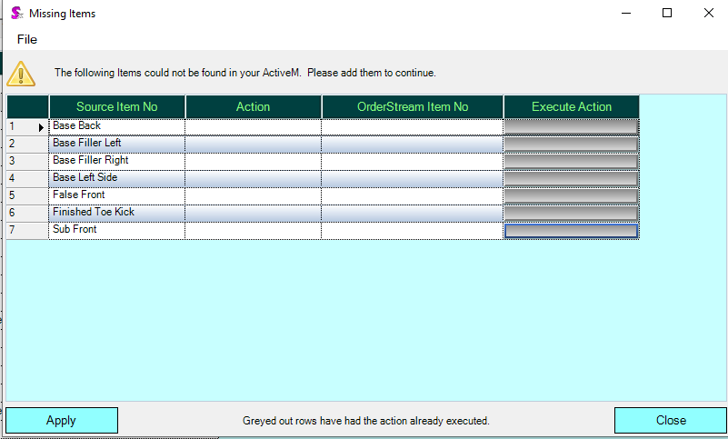
- Once BOM is established in Microvellum (MV), the import from MV is completed using the same estimate. If a match is found when comparing the AppIntegrationSourceIdentifier of the incoming lines to the AppIntegrationSourceIdentifier of the existing estimate lines, the existing line will be updated. If no match is found, a new line will be added to the estimate.
- Multiple imports from MV may be required in order to determine the entire BOM of a transaction (estimate) line as different materials for the same line may be within multiple MV work order batches due to how materials are optimized. This means that multiple MV batches will need to be imported for each estimate in many cases. The batch identifier in MV is manually defined by the user; thus, the user can state a batch identifier that will make it possible to differentiate one batch from another when multiple batches are required to be imported for the same estimate.
- One or more Sales Orders are generated from the Estimate using the Advanced Estimate Sales Order Generator. The Advanced Estimate Sales Order Generator is customizable and additional columns may be added to its data grid. Fields to be added to the Advanced Estimate Sales Order Generator include: Most recent import date, Batch Name, Work Order Name, Cabinet No, Comments 1, Comments 2, Comments 3. These fields will be added via ticket I2302250.
- If an estimate line for which an open sales order line exists is modified, the sales order line will be modified to reflect these changes. An open sales order line is defined as a sales order line that has a SOStatus that is less than Shipped. If an open sales order line has an open work order generated for it AND the work order is NOT a consolidated work order, the work order line should be updated as well. An open work order is defined as a work order line where Complete is false; the work order quantity completed will not be a factor in determining if a work is open or completed. Note: Consolidated work orders cannot be updated from sales order; a consolidated work order must be deleted and regenerated if changes are required to be applied to it.

User Roles and Responsibilities

Interactions with Other Systems
Microvellum Consolidated Work Order: The OrderStream MV import will be modified to support reading from the MV Consolidated Work Order SQL Server database(s). The OrderStream MV Import will not write back to the MV Consolidated Work Order database(s).
There are 2 databases:
1. Microvellum Biesse Sandbox: This holds the tables for the project, products and work orders.
2. Sandbox WO: This holds the tables for the batches and BOM.
The MV batch/job/part/work order hierarchy is represented in the following diagram:

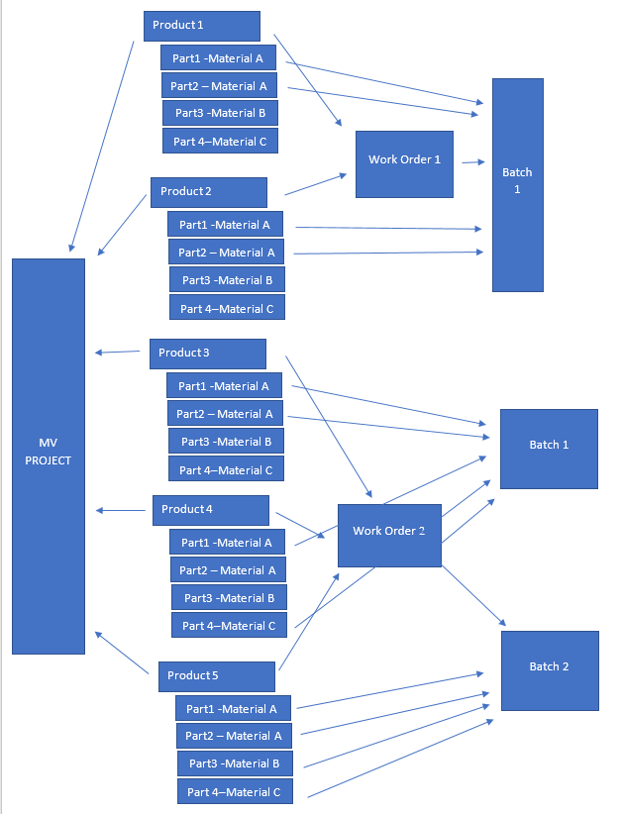
Key Points:
- 1 Material Per Part.
- Work orders are linked to products, not projects.
- It is possible to add products from different projects onto the same work order. This does not occur now, but could be beneficial in the future for optimization reasons.
- Batches are linked to work orders and 1 batch can only be linked to 1 work order, however a batch is created by selecting specific parts, not products.
- It is possible for 1 product to be included in 2 different batches, however this is not good business practice and per SOP our users should not do this. If they do, they must understand and intend for some materials to be doubled.
- Batches may be rerun multiple times – it is the responsibility of the user to select the correct batch(s) for upload.

Production Rollout Considerations
Fields in Microvellum must be designated for the following:
- AppIntegrationSourceIdentifier: to identify estimate lines (using the Cabinet No / MV Product No) that have already been imported for the purpose of updating during a re-import.

Terminology

Part II – Flow Chart

Part III – Functional Requirements
1. EstimateDetails. AppIntegrationSourceIdentifier will be the method used in determining when updating existing lines or create new lines. This requires a minor change in one of the MV import queries.
2. The ability to update related sales orders from the estimate during the MV import process requires a code modification in the Estimate module to cascade the changes to the related sales orders. If an open non-consolidated work order exists against the sales order line that was updated, existing “Reflect Changes” logic and validations will be called to handle the work order update. If a consolidated work order has been generated for the sales order, only the sales order will be updated as consolidated work orders cannot be updated from sales order.
3. A modification to the App Integration MV import process to be able to get the data from the "Consolidated Work Order" database requires a location to specify the SQL server "Consolidated Work Order" database to connect to (this will be an alternative to the existing import method that reads from MicrovellumWorkOrder.sdf file). All logic that references the MicrovellumWorkOrder.sdf will be bypassed.
It is not a requirement to identify MV batches as ready to import.
Also, because the process is going to be driven by the Work Order batch information, we need to provide a way for the user to select the batches they want to process. This is important since Hoff can optimize different materials for the same work order in different batches (note that the Batch is a higher level in the MV hierarchy in relation to the Product).
Logic is not needed to determine the batches which have been previously imported. It is the responsibility of the user to import the correct products on their corresponding batches. An in module search may be utilized to show the user the currently imported products and their corresponding Work orders/batches or elevations (elevations will be stored in the comments field)

Part IV – Change Order Details

Date | Enhancement | Requested By | Notes | Priority | Release Status

