EUR – MV Consolidated Work Order Import – I2206272 – R5

Document Approval
Approver | Approved Date | Rejected Date | Comments

Part I Functionality Overview

Objectives (Why are we doing this?)
Hoff has implemented the Microvellum consolidated work order functionality. This uses a SQL Server database; the ability to export work orders to a SQL Compact Edition database is not available.

Business Process

Process Formalization and Documentation
- A new estimate will be created from JobCosting for the products being imported from MV. Multiple MV Work Orders may be imported into a single estimate. Each MV Job number will likely correspond to an Orderstream estimate, however the user may determine if they prefer to import 1 or multiple work orders into a single estimate. The transaction identifier will be the Cabinet No aka MV Item No. The combination of job number + MV Item No will be unique and will be used as the AppIntegrationSourceIdentifier.

- To import from MV, the user would open the import tool from an estimate and would be able to filter the information shown on the grid based on column filtering capabilities of the OrderStream search control. Ultimately only the products selected in the include column would be imported. An Include All right click option will be available to include all rows that are currently visible on the grid.

The following is a sample of the MV fields to appear on the import form. Being as the query that populates the import form is customizable, more columns are able to be added at any time. If the MV import form is loaded from the estimate module with an estimate selected AND if the selected estimate is associated to a job, inject the job number into the Job No column filter.
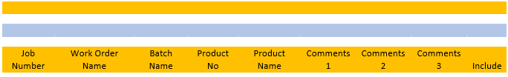
- Items will be imported from MV as the actual items that have been created in OrderStream, provided that the items already exist. A one-time bulk update will be needed of the existing items to ensure their item setup is correct for import. This import will be completed via I2302247. Since the MV import is bound to product lines, will be achieved by creating a product line for each item. The MV product will be mapped to the corresponding product line automatically at the time of import. Any MV product that does not have a corresponding item already set up in OrderStream will be imported under the generic Products product line. If required, the item can then be set up in OrderStream and the order reimported to update the item being used. The creation of product lines will be automated upon item creation to simplify the setup process. The product line set up and mapping will be completed as part of a separate ticket (I2302247).

Background / Explanation: The Microvellum import (both the original and V2) uses code used in the dynamic creation of the BOM and routing for configured product lines due to the similarity of the concepts: both involve passing parameters (i.e. child items, links to parents etc) from an outside source (i.e. Excel, MV database) to create a BOM and Routing schedule on the fly. Detaching the MV import from this product line logic will be a significant undertaking and is not being considered.

Currently, all MV imports you perform, regardless of the product being imported, is mapped to the Products product line. This mapping is completed automatically at the time of import via a database trigger. To accommodate your wish to be able to show the MV product code on the transaction line, this requires that a product line exists for each product code in OrderStream.

The proposal will not require extra maintenance or interaction from your users as product line creation will be automated and the mapping that is completed at the time of import from MV will be altered to automatically map to the product line that corresponds to the product being imported from MV, rather than always mapping to the Products product line.

The following will be completed to uncouple the MV import from the Products product line:
- A script will be created to create product line records for each MV product item that currently exists (based on assignment to the Products category). Base data that is assigned to the items, such as Location, Category, Job Cost Category, will be assigned to the product line records. Further, the sales account setup from the item’s category will be applied to the product line since OrderStream reads sales account setup from the product line setup for product line items.
- A trigger will be created to create new product line records in the same fashion as described for the script above, when a new item is created and assigned to the Products category
- A trigger will be created to update existing product lines whenever data that is common between items and product lines is modified for an item assigned to the Products category
- The trigger that currently maps all MV products to the Products product line at the time of MV import will be modified to look up the product line that corresponds to the MV product being imported and, if such a product line is found AND a mapping between the MV product and the product lines does not already exist in the AppIntegrationProductLineLinks table of the ActiveM database, the mapping will be created. In the event that the MV item has not yet been created in OrderStream, which in turn means that the trigger referenced above would not have fired and created the companion product line, the MV product will be mapped to the Products product line at the time of import from MV. This can be corrected if desired by creating the Product item in OrderStream then reimporting the MV product. The existing mapping to the Products product line that was created during the initial import will be replaced by a mapping to the product line that was created for the MV product.

- During the import process, the BOM import queries will construct the bill of material according to the criteria that has been established (essentially a “flat” MV BOM with MV phantom items excluded, restructured to use OrderStream phantom items for BOM organization).
- The BOM Requirements to import the correct quantities as researched by HOFF are outlined below. Another method of achieving the same result is acceptable as long as we can ensure that the imported quantities are acceptable.
- During the import process, the labour import queries will assign labour operations as per the labour mappings to be established. The labour import queries will not be completed as part of this project; they will be completed via another ticket (I2302248)
  - Labor routings cannot be assigned to a material item, they can only be assigned to a make product. However, the labor queries should be able to query the materials in each BOM and dynamically create a labor routing based on a combination of these materials and the finished product. The labor routings should be able to be adjusted as needed.
- If missing items (an item being imported from MV that does not have a corresponding item in OrderStream as defined by the CAD Link field) are detected during the import process, the current MV 2 exception form will be displayed. This form will be displayed once, regardless of the number of lines being imported.
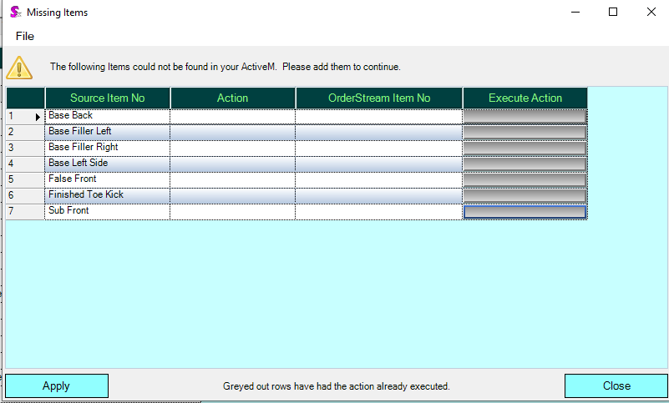
- Once BOM is established in Microvellum (MV), the import from MV is completed using the same estimate. If a match is found when comparing the AppIntegrationSourceIdentifier of the incoming lines to the AppIntegrationSourceIdentifier of the existing estimate lines, the existing line will be updated. If no match is found, a new line will be added to the estimate.
- Multiple imports from MV may be required in order to determine the entire BOM of a transaction (estimate) line as different materials for the same line may be within multiple MV work order batches due to how materials are optimized.
- This means that multiple MV batches will need to be imported for each estimate in many cases. The batch identifier in MV is manually defined by the user; thus, the user can state a batch identifier that will make it possible to differentiate one batch from another when multiple batches are required to be imported for the same estimate.
- The work order batches are created for optimization of parts. Per Hoff SOP, a single part does not exist in multiple batches. However, a single product may exist in multiple batches. The selection of a batch or multiple batches is needed to determine the parts which have been optimized vs. not optimized and the records needed from the placed sheets table. The remaining tables used for compiling the full BOM should not be affected by the batch selection and should not be duplicated if multiple batches are selected.
- One or more Sales Orders are generated from the Estimate using the Advanced Estimate Sales Order Generator. The Advanced Estimate Sales Order Generator is customizable and additional columns may be added to its data grid. Fields to be added to the Advanced Estimate Sales Order Generator include: Most recent import date, Batch Name, Work Order Name, Cabinet No, Comments 1, Comments 2, Comments 3. These fields will be added via ticket I2302250.
- The function to move sales order lines to another sales order must also be modified to include the addtional columns necessary to identify the correct lines to move. Most recent import date, Batch Name, Work Order Name, Cabinet No, Comments 1, Comments 2, Comments 3. The customization of the search will be completed via I2302250.
- If an estimate line for which an open sales order line exists is modified, the sales order line will be modified to reflect these changes. An open sales order line is defined as a sales order line that has a SOStatus that is less than Shipped. If an open sales order line has an open work order generated for it AND the work order is NOT a consolidated work order, the work order line should be updated as well. An open work order is defined as a work order line where Complete is false; the work order quantity completed will not be a factor in determining if a work is open or completed. Note: Consolidated work orders cannot be updated from sales order; a consolidated work order must be deleted and regenerated if changes are required to be applied to it.

BOM Requirements
The BOM is compiled using both the Microvellum Biesse Sandbox database as well as the Sandbox WO Database.

BuyOuts
Products or Subassemblies can be designated as BuyOut via a checkbox in MV. If buyout is designated at the product level, the column ISBuyout will be true in the table dbo.products. If buyout is designated at the subassembly level, the column ISBuyout will be true in the subassembly table.
If a product is designated as a buyout, the item imported should be linked to the item BuyOut Product. This product will be linked to the Project but will not be present on a work order. It will not have a BOM in the parts table but will have hardware listed. (Possibly edgebanding). The material name in the hardware table will be formatted with a “-“ in front of the material name. No materials should be imported.
If the subassembly of a part is designated as a buyout, only that part will not appear in the parts table. The hardware and edgebanding will be populated with materials formatted with a “-“ in front of the material name. Materials related to this part should not be imported.
- Determining which materials to exclude from the import can be accomplished by looking at either the ISBUYOUT field or by looking at the “-“ indicator in front of the material name.

dbo.Hardware:
*Exclude Hardware linked to Buyout products or buyout subassemblies.
dbo.Hardware.Name = this the material name which will link to the SX item number.
dbo.Hardware.Quantity = MV UOM is EACH and will be converted as 1:1

dbo.Edgebanding:
*Exclude Edgebanding associated with a Buyout Product or a buyout subassembly.
dbo.Edgebanding.Name = this is the material name which will link to the SX item number.
dbo.Edgebanding.LinFt = this is the total qty per part. Although the column is called LinFt, the value is the table represents mm.
dbo.Edgebanding.Quantity = This is the total per part * product quantity: MV UOM=mm
Waste: There is a total waste of approx. 2” or 25.4mm per Edge. (The beginning has about 1.5” waste and the end has about .5” waste). The number of edges are found by looking at the parts table inner joined with the edgebanding table. Columns = EdgeName Bottom, EdgeName Right, EdgeName Left, and EdgeName Top . When the name in that column = The edgebanding name then add 25.4mm (or 2”) to that part multiplied by the product qty.
Quantity Conversion – The quantity conversion should use the item conversion from the MV UOM of mm to the stock UOM. In our case, this is LF.

dbo.parts:
The dbo.parts table is used to find the materials required for parts which have NOT been optimized. All parts which have been optimized should be excluded here and included in the dbo.placedsheets section.
An identifier is necessary to determine what type of measurement is needed. Count, Linear or Square.
Therefore, The dbo.parts table must be linked to the dbo.sheets table via the LinkIDMaterial Column to identify the XMaterialData1 value for those materials with a material type of 2.
dbo.parts.materialname = this is the material name which will link to the SX item number
dbo.parts.quantity = The Part Quantity *not the material quantity
dbo.parts.Total Quantity = The Part Quantity * The product quantity.
To get the material quantity:
Determine the Material Type in dbo.parts.materialtype and if needed determine the XMaterialData1 value in dbo.sheets.XmaterialData1.
Material Types in parts table
2=Sheet Stock = See XMaterialData1 below
3=Solid Stock: Cannot define sizes. Qty should be determined using the column dbo.parts.length – this is the length for a single unit and the MV UOM is mm. Use dbo.parts.quantity with product qty or dbo.parts.totalquantity to find the total quantity required. Upon import this will need to be converted using the item conversion to find the correct SX item UOM.
4=Buy Out: UOM is each. Use dbo.parts.quantity with product qty or dbo.parts.totalquantity to find the total quantity required.
5=Edgeband – not used as all edgebanding is found in the edgebanding table
6=Hardware – not used as all hardware is found in the hardware table.
7=Countertop – not used in the parts table.
8=Moulding – not used in the parts table
9=Cut Parts – not used in the parts table
10=Sheets – not used in the parts table
dbo.sheets.XMaterialData1 = When material type = 2 This field should be used to determine the appropriate column used for quantity.
1=dbo.parts.length
2=dbo.parts.quantity
3=dbo.parts.width
Blank or Null or 0 = dbo.parts.length * dbo.parts.width

dbo.placedsheets
The dbo.placedsheets table only contains quantities for those parts which have been optimized.
To allocate these totals appropriately, find the unoptimized total material for the group of parts which have been optimized from the dbo.parts table. (excluding those unoptimized parts) Then find the allocation percentage for each part.
If multiple batches are selected and a product exists in multiple batches, the placed sheets table should be a combination of all batches selected for the purposes of determining the appropriate optimized v. unoptimized parts as well as compiling the full BOM.
dbo.placedsheets.handlingcode = this is the material name which will link to the SX item number.
dbo.placedsheets.quantity = when grouped by material name, the sum of this column will provide the total quantity of that material to be reallocated back to the respective parts based on their original allocation quantity. Note that it is possible for the optimization to result in 2 different handling codes linked to 1 material name. This is because the material name does not identify the size of the panel being optimized and the handling code does identify the size.
dbo.placedsheets.ISGrainContainer = this field must be filtered to be false or 0. There are instances where a portion of the full sheet is used to make perfect grain cuts. This will result in the same full sheet being listed multiple times with the perfect grain cut having true in this column.

User Roles and Responsibilities

Interactions with Other Systems
Microvellum Consolidated Work Order: The OrderStream MV import will be modified to support reading from the MV Consolidated Work Order SQL Server database(s). The OrderStream MV Import will not write back to the MV Consolidated Work Order database(s).
There are 2 databases:
1. Microvellum Biesse Sandbox: This holds the tables for the project, products and work orders.
2. Sandbox WO: This holds the tables for the batches and BOM.
The MV batch/job/part/work order hierarchy is represented in the following diagram:

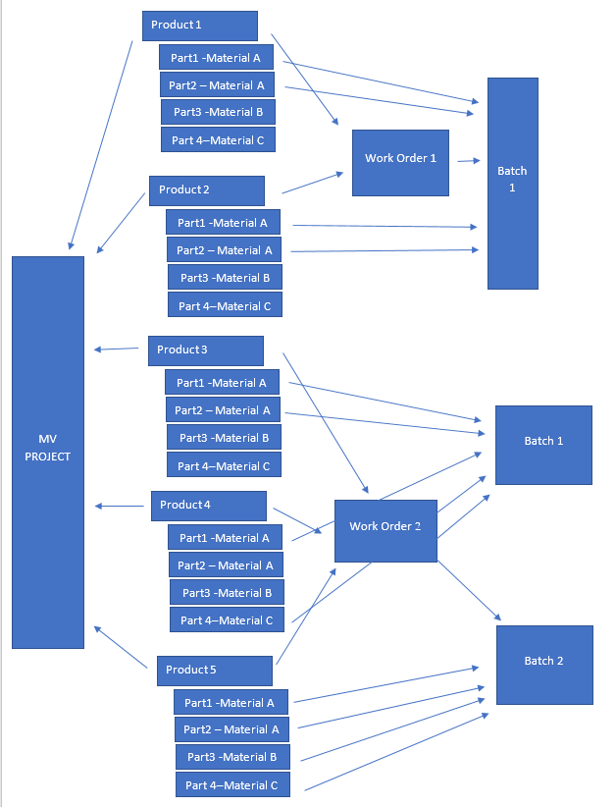
Key Points:
- 1 Material Per Part.
- Work orders are linked to products, not projects.
- It is possible to add products from different projects onto the same work order. This does not occur now, but could be beneficial in the future for optimization reasons.
- Batches are linked to work orders and 1 batch can only be linked to 1 work order, however a batch is created by selecting specific parts, not products.
- It is possible for 1 product to be included in 2 different batches, however this is not good business practice and per SOP our users should not do this. If they do, they must understand and intend for some materials to be doubled.
- Batches may be rerun multiple times – it is the responsibility of the user to select the correct batch(s) for upload.

Production Rollout Considerations
Fields in Microvellum must be designated for the following:
- AppIntegrationSourceIdentifier: to identify estimate lines (using the Cabinet No / MV Product No) that have already been imported for the purpose of updating during a re-import.

Terminology

Part II – Flow Chart

Part III – Functional Requirements
1. EstimateDetails. AppIntegrationSourceIdentifier will be the method used in determining when updating existing lines or create new lines. This requires a minor change in one of the MV import queries.
2. The ability to update related sales orders from the estimate during the MV import process requires a code modification in the Estimate module to cascade the changes to the related sales orders. If an open non-consolidated work order exists against the sales order line that was updated, existing “Reflect Changes” logic and validations will be called to handle the work order update. If a consolidated work order has been generated for the sales order, only the sales order will be updated as consolidated work orders cannot be updated from sales order.
3. A modification to the App Integration MV import process to be able to get the data from the "Consolidated Work Order" database requires a location to specify the SQL server "Consolidated Work Order" database to connect to (this will be an alternative to the existing import method that reads from MicrovellumWorkOrder.sdf file). All logic that references the MicrovellumWorkOrder.sdf will be bypassed.
It is not a requirement to identify MV batches as ready to import.
Also, because the process is going to be driven by the Work Order batch information, we need to provide a way for the user to select the batches they want to process. This is important since Hoff can optimize different materials for the same work order in different batches (note that the Batch is a higher level in the MV hierarchy in relation to the Product).
Logic is not needed to determine the batches which have been previously imported. It is the responsibility of the user to import the correct products on their corresponding batches. An in module search may be utilized to show the user the currently imported products and their corresponding Work orders/batches or elevations (elevations will be stored in the comments field)

Part IV – Change Order Details

Date | Enhancement | Requested By | Notes | Priority | Release Status

