Integration with Woocommerce

Processing online orders in Seradex

I2303269

SharkCrates

Document Approval
Approver | Approved Date | Rejected Date | Comments

Part 1 Functionality Overview
Objectives (Why are we doing this?)
- SharkCrates would like to have the ability to import orders from Woocommerce into OrderStream using APIs.
- When the order is processed, completed and shipped then OrderStream to update the Woocommerce status to ‘Completed’
- SharkCrates has several online forms that customers can fill out (they are all designed from the WP Forms plugin https://wpforms.com/developers/).
An integration with Seradex would be to create a prospect / lead in Seradex when the customer completes these forms on the website. This will reduce the amount of duplicate entries.
- SharkCrates would like to explore the option the API calling Woocommerce every 30 minutes or so instead of having to manually click "import orders."

Business Process
SharkCrates uses Woocommerce to get online orders. The orders are for stock crates. Under the sales order module Tools menu to be added a new tool – “Import Orders” that will import the newest orders from the website and will create separate sales orders or estimates in OrderStream. Having in mind the possible integration with Wpforms and Seradex creating prospects then this tool should be added to the Estimate module because sales order cannot be created for a prospect.
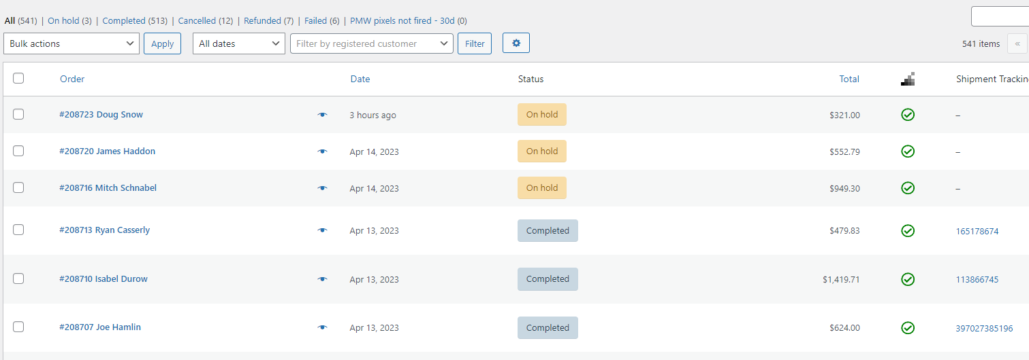
When the order is processed – the creates are packed and shipped, then upon Approving the Packing slip, Seradex to update the status in the Woocommerce order to “Completed”. This will trigger an invoice to be sent to the customer through the Woocommerce website.

User Roles and Responsibilities
Seradex to complete a solution design if this EUR and the time quote for completion of this enhancement is approved by SharkCrates.
Interactions with Other Systems
Woocommerce, Wpforms
Production Rollout Considerations
N/A
Terminology
N/A

Part II – Functional Requirements
Statement of Functionality

Part III – Change Order Details

NOTE: Custom report, searches or event (email) alerts are not part of this EUR scope.

Date | Enhancement | Requested By | Notes | Priority | Release Status

