Hello Chris.

Based on the first error message, it seems like the ActiveM database was no longer available.
The only other option I can think of is that they were somehow redirected to a different SQL Server as if their “SeradexMasterConfiguration.xml” was somehow overwritten, but that should not be possible.
Note that Bryan has confirmed that this file is not on our FTP server, so it could not have been replaced during a web update.

The error received by the Talius server is from the blocking update issue we have encountered, and can be ignored (click ignore). You can tell because our normal file has a random suffix added to the name (ywbmr0ol).
The only thing I do not know is if the file would be deleted after a reboot or not.
The one thing I am not doing in the message is providing additional context to the user such as the path (full or relative) of the file, and the fact that this can be ignored.
Also, perhaps the use of the red X circle instead of the yellow exclamation mark triangle in this case is also not great and should be changed.

The last error does not make sense as explained since DT (DataTransfer) does not affect files. I would need more information to provide useful feedback.

 | Mark Dell
 | Senior Software Analyst
www.seradex.com | Office: 905.332.5051

From: Chris LeBlanc <cleblanc@seradex.com>
Sent: February 27, 2023 9:34 AM
To: Mark Dell <mdell@seradex.com>
Subject: FW: Hosted Updates: Significant Errors
Importance: High

Hi Mark,

Lisa was unable to update the servers today, at some point I’ll need to get her some help, any insight based on the email below as to root cause?

Thanks,

Chris

 | Chris LeBlanc
 | Chief Operations Officer
 | Office: 905.332.5051 ext. 425
www.seradex.com | Mobile: 905.467.6998

From: Lisa Corker <lcorker@seradex.com>
Sent: February 27, 2023 8:17 AM
To: Shawn Lovell <slovell@seradex.com>; Chris LeBlanc <cleblanc@seradex.com>; Mark Corker <mcorker@seradex.com>
Cc: Brian Chapple <bchapple@seradex.com>
Subject: Hosted Updates: Significant Errors
Importance: High

Good morning,

While attempting to update Seradex on hosted this morning, a significant portion of our customers received errors when attempting to Web Update post Data Transfer. This occurred after DT was run and Web Updated. New updates downloaded after would get this error;
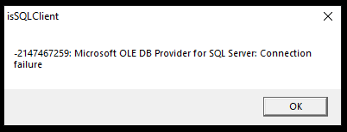
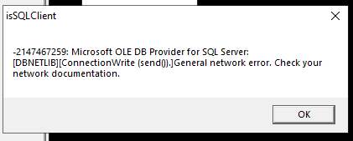
The following customer machines were affected;
-Hosted01 (Altispace-in-Testing)
-Hosted02 (CISupply)
-Hosted03 (Naizil)
-Hosted04 (Fontrick)
-Hosted06 (Findlay)
-Hosted08 (Premier)
-Hosted09 (CabinetsPlus)
-sxOTR
-sxDucDuc

Additionally, Hosted05 (Talius) got this error when attempting to apply updates post DT (I could not get it to resolve);
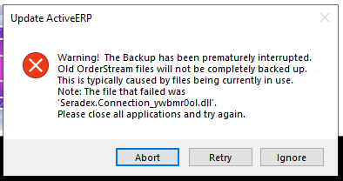
Lastly, when attempting Data Transfer on sxAltispace (their live server) I was receiving repetitive errors stating it could not run on certain files. I did not get a screenshot of this, but the errors were so persistent (as in on everything it attempted to run DT on) that I rolled the box back immediately.
It appears we do have three unaffected customers;
-sxTopDrawer
-Hosted07 (Go)
-Hosted10 (SharkCrates)
I have made no attempt to update Hosted00 (Demo).
Due to all these errors, I have successfully rolled back all affected customers.

 | Lisa Corker
 | IT Manager
 | Office: 905.332.5051 ext. 480
www.seradex.com | Mobile: 905.467.1269

