All remaining testing has been done using ActiveM_Norstar_I2203238-SL on SQL17

- Receive following exception when double clicking on the scheduling grid after levelling:
************** Exception Text **************
System.ArgumentOutOfRangeException: Index was out of range. Must be non-negative and less than the size of the collection.
Parameter name: index
at System.Collections.ArrayList.get_Item(Int32 index)
at Infragistics.Win.UltraWinGrid.CellsCollection.GetItem(Int32 index)
at Infragistics.Win.UltraWinGrid.CellsCollection.get_Item(UltraGridColumn column)
at Infragistics.Win.UltraWinGrid.RefCellCollection.RefCellCollectionEnumerator.MoveNext()
at Infragistics.Win.CalcEngine.RangeCalcInfo.EvaluateNextRow()
at Infragistics.Win.CalcEngine.UltraCalcEngine.Evaluate(Int64 ticks)
at Infragistics.Win.CalcEngine.UltraCalcEngine.Recalc(Int64 ticks, Boolean isStartOfRecalcOperation)
at Infragistics.Win.UltraWinCalcManager.UltraCalcManager.ReCalcInternal(Int64 ticks)
at Infragistics.Win.UltraWinCalcManager.UltraCalcManager.ReCalc(Int64 millis)
at Infragistics.Win.UltraWinCalcManager.UltraCalcManager.onTimerTick(Object sender, EventArgs e)
at System.Windows.Forms.Timer.OnTick(EventArgs e)
at System.Windows.Forms.Timer.TimerNativeWindow.WndProc(Message& m)
at System.Windows.Forms.NativeWindow.Callback(IntPtr hWnd, Int32 msg, IntPtr wparam, IntPtr lparam)
Notes: It does not appear to occur on the first doubt click attempt. On the details tab after levelling and after I receive the notification that not all operations could be levelled, I double clicked the row labeled one in the image below then I double clicked the row labeled two. After the second double click the exception was raised.
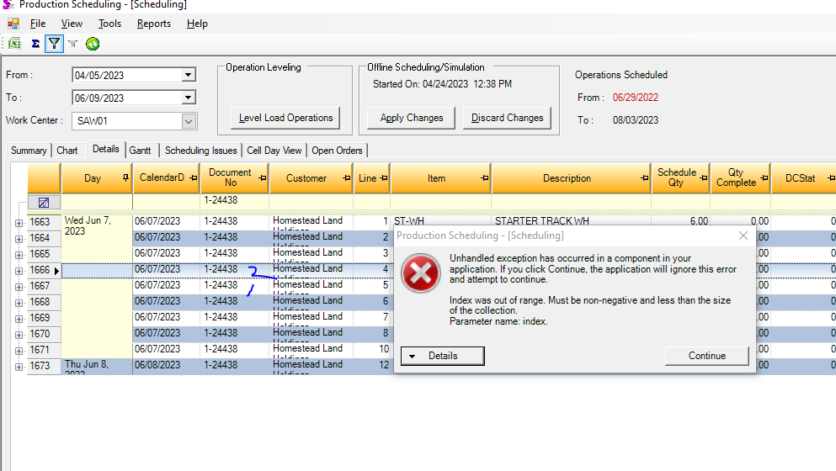
- After levelling, work order 1-24438 will start after it ends:
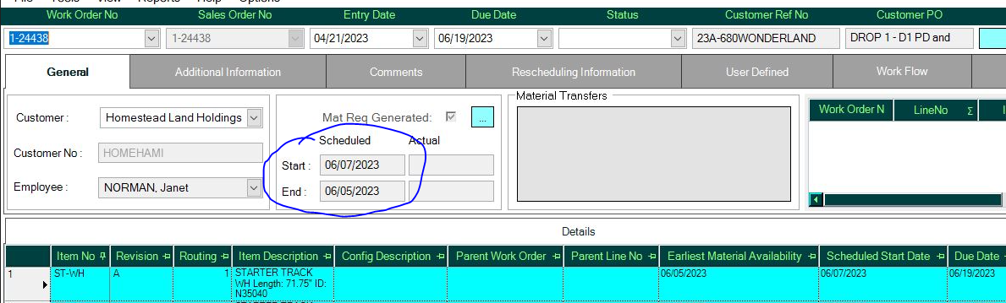
However, after levelling again, the Scheduled Start was prior to the Scheduled End. I have adjusted crew sizes of all cells and levelled again, applied the off line to the live and the start and end dates are in the proper sequence. While something occurred to make this happen I cannot make it recur, nor can I find another work order where this scenario exists, though I confess, I did not look all that hard to find another one.
- I am unsure of the data I am seeing in the Charts. I have increased the crew size to large numbers (there is an army of 150 for each Cell), levelled and applied off line to live. Opened scheduling then viewed the chart:

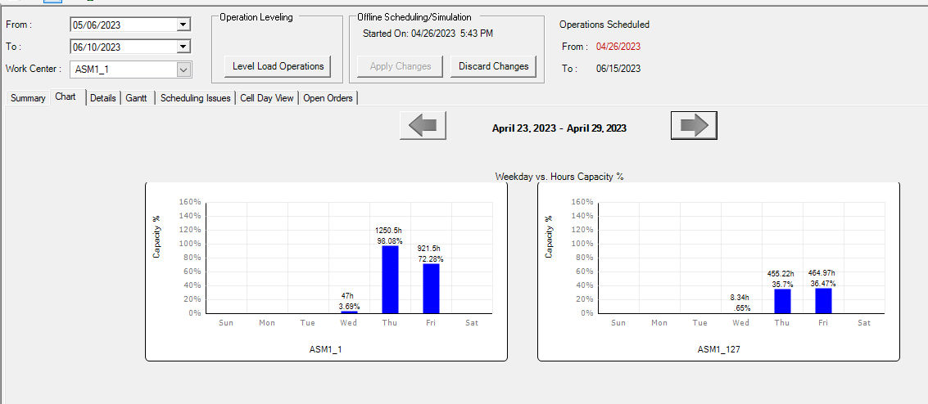

I am unsure of the under capacity days and why they are not filled up before moving to the next day. I had run an update query to set WorkOrderDetails.StartConstr to today (April 26). This may be legitimate, but I’d like a second look if possible.

ASM1_1 looks right as the remainder of today has a bit, tomorrow is at 98% then the remainder is scheduled for Friday. There are no more work orders after Friday. However, for ASM1_127 there are work orders for several weeks even though the days are not scheduled to capacity.

