
Demography and Agriculture: How Aging and Education Shape Land Use in Alentejo

Final Project Report

Análise e Visualização de Dados Complexos Agro-Ambientais

Master's Degree: Green Data Science
UNIVERSIDADE DE LISBOA
INSTITUTO SUPERIOR DE AGRONOMIA

Authors:
Catarina Silva (n.º 23421)
João Alexandre (n.º 29602)

Lisboa, 2026

Introduction
Agriculture within the Alentejo region constitutes a fundamental pillar of Portugal's socioeconomic fabric and environmental equilibrium, playing a vital role in territorial cohesion and rural development. In recent decades, however, the structural sustainability of this primary sector has been increasingly compromised by a profound, dual sociodemographic crisis characterized by an accelerating demographic aging trend among farm managers coupled with a pervasive deficit in formal educational attainment. These interconnected human capital constraints do not merely represent isolated demographic anomalies; rather, they fundamentally condition the regional capacity for technological modernization, operational resilience, and strategic territorial management, thereby exerting a definitive influence on the geographic configuration of landscape dynamics. Within this context, the present study establishes a granular spatial and statistical analysis to examine how the specific sociodemographic profiles of agricultural producers are associated with localized land-use choices—specifically the structural equilibrium between temporary and permanent crop systems—across the 299 civil parishes comprising the Alentejo matrix.
By evaluating these dynamics at the parish level (NUTS III), this research seeks to bridge a critical gap in agrarian geography and econometrics regarding the human drivers of land allocation. Consequently, the central research question guiding this empirical inquiry seeks to determine how the demographic and educational profile of agricultural producers systematically influences land-use patterns across the civil parishes of Alentejo. To address this query, the overarching objective of this investigation is to analyze whether demographic aging and educational limitations are associated with statistically significant spatial divides in crop selection.
In pursuit of this objective, the analytical framework is directed by four core hypotheses embedded directly within the statistical modeling. It is posited, firstly, that parishes characterized by older agricultural populations exhibit a lower prevalence and proportion of temporary crops, which are traditionally tied to intensive annual management cycles. Conversely, the second hypothesis dictates that advanced producer aging is positively associated with a greater prevalence and proportion of permanent crops, reflecting a structural shift toward systems with lower annual operational demands. Furthermore, it is hypothesized that lower formal education levels are positively linked with the demographic aging threshold of farm managers, suggesting a compounding socio-educational vulnerability. Ultimately, the study operates under the premise that these demographic and educational characteristics do not act in isolation but rather jointly explain a significant and statistically quantifiable portion of the territorial variation observed in Alentejo’s agricultural land-use distribution.

Research Objectives and Theoretical Hypotheses
To establish a systematic evaluation of the spatial and structural intersections between human geography and agrarian configurations, this research outlines a clear analytical target and a series of testable propositions. The primary objective of this investigation is to determine whether demographic aging and the specific educational characteristics of agricultural populations are systematically associated with observable spatial and statistical variances in land-use allocation across the entirety of the 299 civil parishes that constitute the Alentejo region within the NUTS II framework. By operating at this granular geographic scale, the study aims to uncover how localized sociodemographic vulnerabilities translate into broader territorial patterns of agrarian specialization, providing an empirical basis for regional planning and targeted rural policies.
To guide this empirical assessment, the core inquiry is broken down into four interconnected, non-bulleted hypotheses that link demographic and educational inputs to specific crop dynamics. First, it is hypothesized that civil parishes characterized by older agricultural populations exhibit a lower prevalence and smaller land proportion dedicated to temporary crops. The underlying theoretical rationale assumes that annual, rotating crop systems demand intensive, uninterrupted labor inputs and highly active seasonal management cycles—operational requirements that typically exceed the physical and structural capacities of aging farm managers. Conversely, the second hypothesis posits that advanced producer aging is positively associated with a greater prevalence and higher relative proportion of permanent crop systems. This expectation reflects a long-term territorial adaptation wherein older cohorts gravitate toward orchards, olive groves, or vineyards, which generally require fewer intensive soil preparation mechanisms and offer more stable, multi-annual crop structures.
Beyond these direct demographic impacts on crop typologies, the multivariate nature of rural vulnerability requires assessing the internal relationship within human capital parameters. Accordingly, the third hypothesis establishes that lower formal educational attainment levels are positively associated with the demographic aging threshold of agricultural producers. This relationship implies a compounding socio-educational barrier, suggesting that the oldest agricultural cohorts are structurally tied to the lowest levels of school instruction or lack formal training entirely. Finally, the fourth hypothesis integrates these distinct variables into a cohesive econometric framework, postulating that demographic aging and educational limitations do not operate as isolated vectors but rather jointly explain a significant and statistically quantifiable portion of the territorial variation observed in Alentejo's agricultural land-use distribution. Together, these hypotheses form the structural framework through which the primary census data is modeled and interpreted.

Database Description and Methodology

Study Design and Data Sources
To establish a systematic empirical assessment, this study employs a cross-sectional observational design executed at the civil parish level across a final sample matrix of 299 administrative units ($n=299$). The primary micro-level data was sourced directly from five independent agricultural and demographic micro-datasets acquired from the Portuguese National Statistics Institute (Instituto Nacional de Estatística — INE). These data structures reflect the institutional parameters and organizational standards of the most recent national agricultural census.
To model the socio-agrarian interactions effectively, specific administrative vectors were isolated across the individual files. The total universe of active agricultural producers within each administrative boundary was extracted from Produtores_Total.csv, while the absolute count of farm managers aged 65 years or older was derived from Produtores_Idosos.csv. Human capital and socio-educational profiles were mapped using Produtores_Educacao.csv, which monitors formal educational attainment metrics among farm managers, strictly focusing on the prevalence of managers reporting either a complete lack of formal school instruction or qualifications limited exclusively to the first cycle of basic education. Agrarian physical dimensions and land allocations were compiled from Superficie_Culturas.csv, which tracks the total surface areas allocated to annual temporary and multi-annual permanent crop cultivation systems measured in hectares, while macro-structural territorial attributes were integrated via Superficie_Media.csv to register the average physical farm size per agricultural exploitation within each spatial polygon.

Data Preprocessing and Indicator Construction (Python)
Because raw public administrative databases frequently present substantial structural irregularities, an automated programmatic data cleaning and feature engineering workflow was developed within a Jupyter Notebook environment utilizing the Python programming language. This pipeline relied on the computational architecture of the Pandas library coupled with advanced string parsing via regular expressions (re) to systematically clean the intricate metadata headers, footers, and non-standard alphanumeric formatting characteristic of raw INE text outputs.
A primary technical challenge involved mitigating potential administrative overlay and geographic synchronization errors caused by parish homonyms, where identical civil parish names recur across different municipalities. To resolve this vulnerability, regular expressions were deployed to parse the raw regional string fields and extract a robust, standardized 6-digit unique geographic identifier (Chave_Geo), which subsequently served as the immutable key to anchor a chained sequence of inner and left join database operations.
Following successful database integration, absolute census metrics were converted into normalized relative indicators to eliminate structural scale bias and enable a mathematically rigorous comparison across civil parishes with highly uneven geographic dimensions and land-holding characteristics. The relative producer aging index was calculated as the percentage proportion of elderly farm managers over the total active agricultural producer population. Concurrently, to evaluate land-use profiles independently of the absolute physical size of each parish, agricultural land-use prevalence proportions were constructed by normalizing specific crop categories against the aggregate agricultural area of the parish, thereby effectively capturing the localized internal agrarian equilibrium between temporary and permanent cultivation systems. The formal mathematical specifications for these normalized indices are established as follows:
- Relative Producer Aging Index:
$$\text{Percentagem Envelhecimento}=\left(\frac{\text{Total Idosos}}{\text{Total Produtores}}\right)×100$$
- Agricultural Land-Use Prevalence Proportions:
$$\text{Perc Temporárias}=\left(\frac{\text{Área Temporárias}}{\text{Área Temporárias}+\text{Área Permanentes}}\right)×100$$
$$\text{Perc Permanentes}=\left(\frac{\text{Área Permanentes}}{\text{Área Temporárias}+\text{Área Permanentes}}\right)×100$$

Spatial Analysis and Cartographic Methodology (GIS)
Following the preprocessing and feature engineering stages, the finalized analytical dataset (Dataset_Final_Alentejo.csv) was integrated into a Geographic Information System (GIS) environment utilizing QGIS for advanced spatial modeling and cartographic representation. To merge the tabular socioeconomic attributes with the official spatial boundary vector layer derived from the Official Administrative Map of Portugal (Carta Administrativa Oficial de Portugal — CAOP), a virtual joining field was engineered via alphanumeric expression parsers. This algorithmic operation re-encoded the raw, structurally mismatched string identifier dtmnfr into a uniform numerical key that directly cross-referenced the previously generated Chave_Geo variable. Concurrently, this parsing routine was calibrated to filter out non-conforming administrative polygons and statistical anomalies, such as specialized regional maritime or frontier zones (e.g., '0302FA'), which would otherwise compromise the topological integrity of the spatial database.
Once the structural boundaries of the Alentejo NUTS II territory were isolated, thematic choropleth mapping was implemented to visualize the regional distribution of the socio-agrarian variables. The cartographic classification was standardized using the Jenks Natural Breaks optimization algorithm partitioned into five distinct classes. This iterative mathematical clustering method minimizes statistical variance within each defined class while maximizing the variance between them, thereby accurately accentuating authentic spatial boundaries and deep-seated geographic divides across the regional landscape. To prevent visual distortion and ensure high-fidelity communication of the spatial data, the thematic layers were superimposed onto a minimalist, low-contrast canvas layout configured via the CartoDB Positron baseline map, which was subsequently supplemented with standardized scale benchmarks, precise orientation indicators, and meticulously refined legends.

Exploratory Data Analysis and Spatial Interpretation

Demographic and Land-Use Distributions
To evaluate the underlying properties and statistical behaviors governing the compiled database, the primary structural distribution profiles were scrutinized utilizing central tendency metrics and density visualizations. This initial exploratory phase provides a necessary mathematical overview of the human capital and agricultural land allocation parameters across the region. The empirical analysis reveals that the demographic aging index among farm managers exhibits an approximately symmetric Gaussian distribution centered around a regional mean of 50.6%. This structural symmetry indicates that advanced demographic aging is a structural, widespread phenomenon embedded across the entire Alentejo matrix rather than an isolated localized anomaly. Extreme statistical values, such as parishes characterized by exceptionally young agricultural cohorts or entirely elderly populations, are rare, highlighting a homogenous regional shift toward an older farm leadership paradigm.
In stark contrast to the symmetric distribution of age, the socio-educational profile of the region exhibits a profound imbalance. The low education index displays a distinct negative skew, with data heavily clustering at the higher end of the scale, yielding a critical regional mean of 69.9%. This severe skew underscores a persistent socio-educational challenge, demonstrating that in the vast majority of Alentejo parishes, more than two-thirds of the active agricultural workforce relies exclusively on primary basic education or holds no formal school qualifications.
When analyzing the agricultural land-use metrics for temporary and permanent cultivation systems, the data reveals heavy positive, right-skewed distributions that behave differently from the sociodemographic variables. The elongated right tails of these land-use curves indicate that while the absolute majority of parishes maintain modest structural agricultural outputs, a highly specialized and select subset contains massive concentrations of production surface. This specific macro-structural pattern reflects the historic and contemporary legacy of the classic Alentejo latifúndio structure, characterized by highly consolidated territorial landholdings where extensive, large-scale specialized production drives the vast majority of the regional agrarian volume.
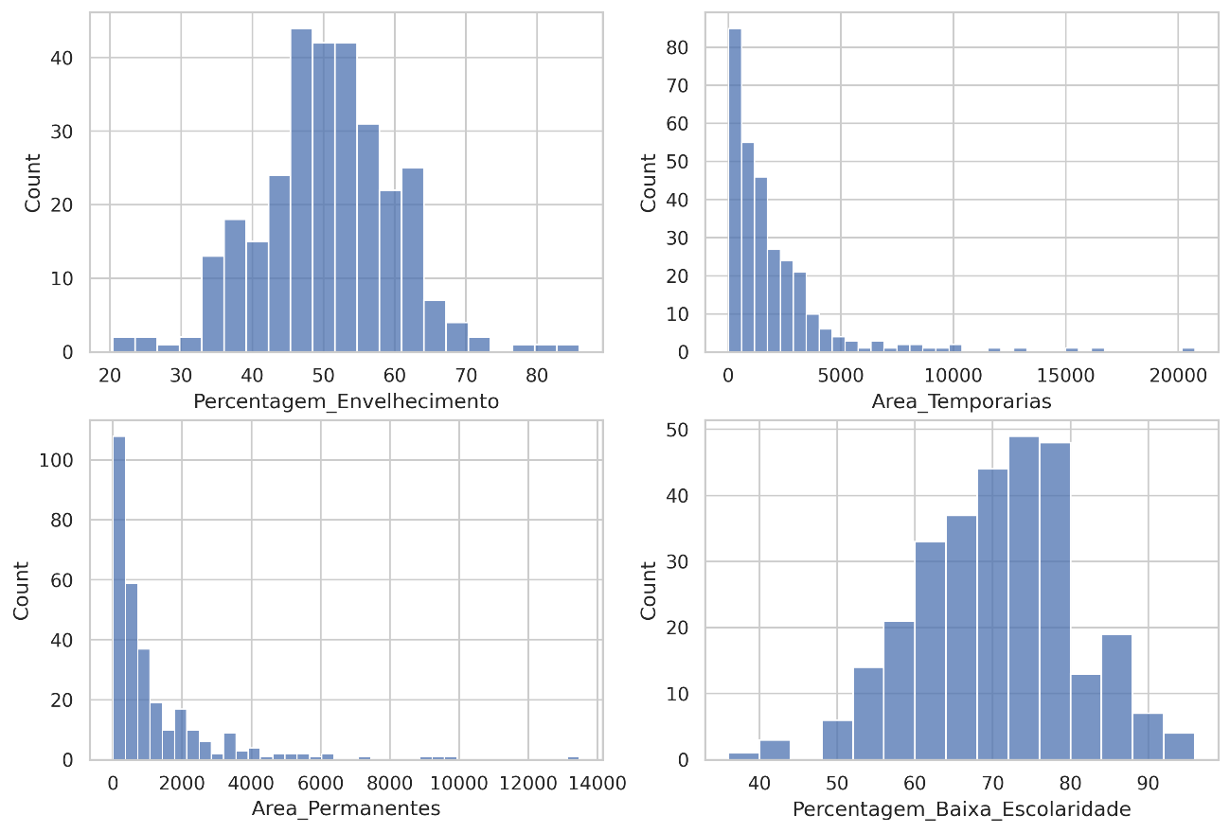
Figure 1. Structural frequency distributions of sociodemographic profile indices and crop system areas across Alentejo parishes.
The foundational analysis of the compiled dataset relies on a rigorous evaluation of the underlying statistical properties and distribution profiles governing the sociodemographic and land-use variables. As systematically visualized in the four-panel frequency distributions presented in Figure 1, these indicators reveal contrasting structural behaviors across the 299 civil parishes comprising the Alentejo region.
The relative index tracking the demographic aging of agricultural producers exhibits an approximately symmetric Gaussian distribution centered around a regional mean of 50.6%. This localized normal distribution provides clear empirical evidence that agrarian aging is a structural, widespread phenomenon embedded across the entire Alentejo territorial matrix rather than a localized or fragmented anomaly. The statistical rarity of extreme outliers—specifically, civil parishes characterized by either exceptionally young farm cohorts or entirely elderly leadership—further underscores a highly homogenous regional shift toward older farm management profiles, indicating a uniform demographic transition.
In sharp contrast to the normal distribution observed in producer age, the parameter evaluating formal educational attainment among agricultural managers demonstrates a profound negative skew, with data points heavily clustering at the upper end of the percentage scale, yielding a critical regional mean of 69.9%. As illustrated by Figure 1, this pronounced leftward skew highlights a persistent and deeply entrenched socio-educational challenge within the region’s primary sector. In the vast majority of the analyzed civil parishes, more than two-thirds of the active agricultural workforce relies exclusively on primary basic education or holds no formal school qualifications whatsoever. This severe educational deficit represents a uniform structural vulnerability that directly restricts human capital capitalization and complicates the diffusion of innovative agronomic practices.
Furthermore, a distinctly different statistical behavior emerges when cross-referencing these human capital variables with the agricultural land-use metrics allocated to temporary and permanent cultivation systems. Unlike the sociodemographic parameters, both land-use metrics exhibit highly asymmetrical, positive (right-skewed) distributions characterized by elongated right tails, as captured in Figure 1. This specific distributional profile demonstrates that while the absolute majority of Alentejo parishes maintain modest baseline agricultural outputs, a highly specialized and restricted subset of administrative units contains massive physical concentrations of production surface.
This macro-structural pattern reflects the enduring historical and contemporary legacy of the classic Alentejo latifúndio system—a territorial arrangement dominated by highly consolidated agrarian landholdings where large-scale, automated, and specialized production dynamics drive the overwhelming majority of the regional agrarian volume. Consequently, the visual outputs in Figure 1 effectively confirm that human capital attributes follow a widespread, regionalized paradigm, whereas physical land allocation remains highly concentrated within specialized geographic nodes.

Spatial Autocorrelation and Choropleth Map Interpretation
Integrating the processed analytical database into a Geographic Information System (GIS) environment enables the direct observation and empirical evaluation of these sociodemographic and agrarian phenomena across continuous geographic space. The resulting four choropleth maps, structured via the Jenks Natural Breaks optimization algorithm, unveil distinct territorial divides and sharp regional contrasts across the Alentejo landscape.
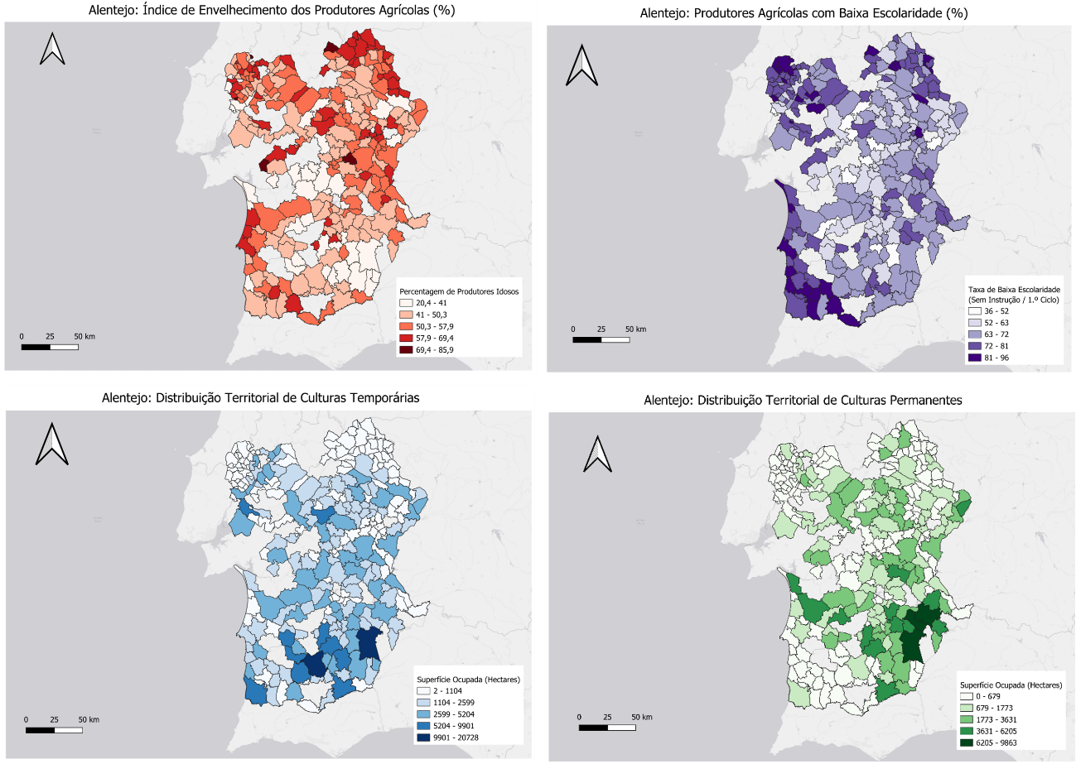
Figure 2. Choropleth mapping of Alentejo at the parish level: (A) Producer Aging (%), (B) Low Educational Attainment (%), (C) Temporary Crops (ha), and (D) Permanent Crops (ha).

Socioeconomic Vulnerability Core (Maps A & B)
The geographic configurations modeled in Maps A and B exhibit a remarkable spatial symmetry across the civil parishes. The darkest clusters, which isolate areas of critical demographic aging where elderly individuals constitute 60% or more of the agricultural managers, visually overlap with the highest regional concentrations of low formal educational attainment. This intense cartographic co-location highlights a compounding demographic-educational vulnerability core. This structural fragility does not manifest randomly across the territory but primarily strikes the inland, isolated border parishes of the Alentejo hinterland, where peripheral geographic positioning structurally exacerbates human capital constraints.
Regarding specific cartographic observations, the isolated null values, represented visually as unshaded polygons or "white holes" within the continuous Alentejo boundary, correspond directly to major regional hydrographic bodies—most notably the Alqueva reservoir and the Sado estuary—or reflect restricted spatial sectors subjected to strict statistical masking protocols enforced by the National Statistics Institute (INE). This masking is programmatically deployed to guard individual data anonymity within low-population zones, thereby ensuring authentic cartographic reporting and structural data integrity across the spatial model.

Agrarian Specialization Divides (Maps C & D)
Shifting the analytical lens to the physical dimensions of land allocation, Maps C and D effectively capture the absolute operational scale, measured in hectares, of Alentejo's primary agricultural production systems. The spatial patterns reveal a stark division in regional agrarian specialization. Temporary cultivation systems, as delineated in Map C, settle prominently into the expansive, flat, and open low-lying plains of the central Alentejo matrix, which provide biophysical configurations that are highly optimal for large-scale, automated cereal and fodder farming.
Conversely, permanent crop configurations highlighted in Map D reveal highly specialized agricultural hotspots that map directly onto modernized, high-input irrigated infrastructure. These modern systems cluster intensely surrounding the Beja and Alqueva irrigation perimeters, where capital-intensive, high-density olive groves and technical vineyards dominate the contemporary agrarian landscape.

Bivariate Correlations and Inter-variable Connections
To quantify the visual linkages observed in the spatial mapping and transition from geographic intuition to statistical validation, a pairwise Pearson correlation analysis was executed across the compiled dataset. The resulting empirical metrics, systematically consolidated within the symmetric correlation matrix presented in Figure 3, provide a mathematically rigorous foundation to evaluate the strength and direction of linear dependencies operating between human capital constraints and localized land allocation choices.
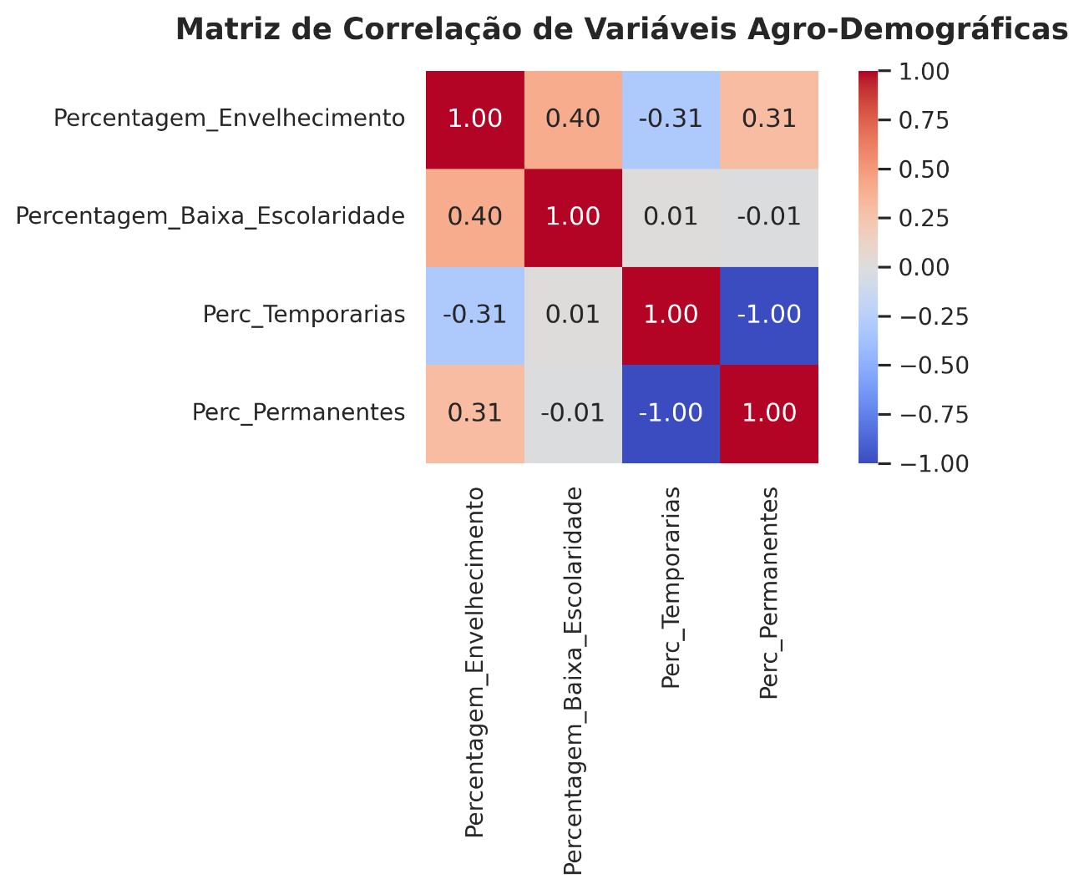
Figure 3. Pearson correlation matrix cross-referencing sociodemographic indicators and land-use proportions.
Regarding the internal dynamics of human capital parameters, the correlation matrix confirms a moderate, statistically significant positive relationship between relative producer aging and low formal educational attainment ($r=0.40$). This empirical finding formally validates hypothesis H3, establishing that the oldest demographic brackets within the regional agricultural ecosystem are structurally coupled with the lowest tiers of formal instruction. This systematic coupling reinforces the spatial observations from the choropleth mapping, demonstrating a compounding socioeconomic vulnerability where generational maturation is bound to persistent historical deficits in formal school training across the Alentejo agrarian matrix.
When analyzing the interface between these demographic vectors and agricultural typologies, producer aging exhibits a clear divergence in how it interacts with specific cultivation systems. The relative aging index is negatively correlated with temporary crop proportions ($r=-0.31$), providing initial statistical backing for hypothesis H1. This reliable negative coefficient suggests a systematic retreat from intensive, labor-demanding annual crop cycles in administrative units dominated by older farm managers. Conversely, advanced aging maintains a positive correlation of identical magnitude with permanent crop proportions ($r=0.31$), directly matching the baseline premise of hypothesis H2 and supporting the theoretical assumption that older cohorts align with multi-annual cultivation structures requiring lower annual soil-preparation inputs.
Finally, the perfect inverse linear relationship ($r=-1.00$) recorded between the percentage shares of temporary and permanent crops must be interpreted exclusively as a structural artifact of the mathematical normalization process rather than an exogenous causal mechanism. Because individual crop surface areas were programmatically scaled into relative percentages against the aggregate agricultural area within the feature engineering pipeline, this perfect negative dependency reflects the internal, zero-sum trade-off within each individual parish's crop allocation equilibrium. It represents a direct spatial competition for finite available agricultural land resources rather than an interactive economic behavior.

Inferential Statistics and Modeling

Bivariate Inferential Confirmations (Correlation & ANOVA)
To transition from exploratory visual patterns to rigorous statistical confirmation, a suite of inferential tests was conducted to verify whether the observed territorial relationships could be attributed to random stochastic variation or if they reflect systemic underlying dependencies within the agrarian matrix. A formal Pearson correlation test executed between the relative producer aging index and temporary crop prevalence confirms a statistically significant negative relationship ($r=-0.31$, $p<0.001$). While the baseline correlation magnitude is moderate, the highly significant $p$-value provides definitive mathematical backing to reject the null hypothesis, thereby supporting hypothesis H1. This establishes that civil parishes marked by an advanced demographic aging threshold systematically exhibit lower relative proportions of temporary agricultural cultivation. This structural divergence is visually reinforced by the bivariate scatter plots and linear trend lines presented in Figure 5, which contrast the contraction of annual temporary systems (left, $r=-0.31$) against the expansion of permanent crop surfaces (right, $r=0.31$) across the aging spectrum.
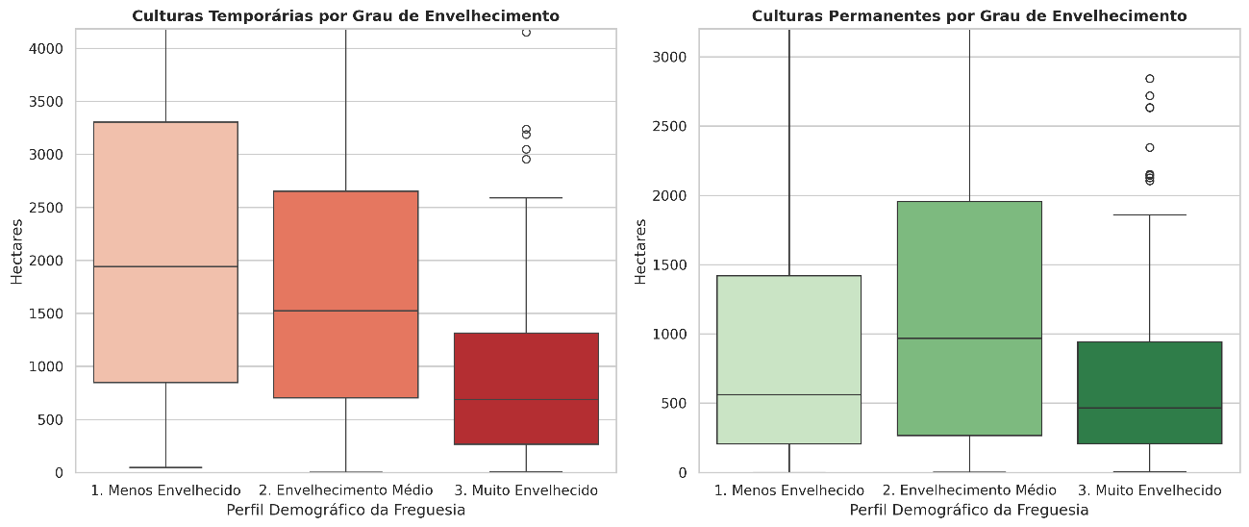
Figure 4. Comparison of temporary and permanent crop prevalence across producer aging categories based on sample terciles.
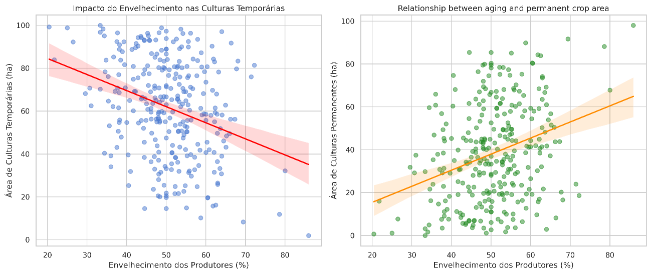
Figure 5. Bivariate scatter plots with linear trend lines illustrating the negative relationship between producer aging and temporary crops (left, $r=-0.31$) and the positive relationship with permanent crops (right, $r=0.31$).
To further investigate the structural mechanics of this agrarian transition and evaluate the distribution of land allocation across distinct demographic cohorts, a One-Way Analysis of Variance (ANOVA) was executed. The categorical framework for this test was derived from the sample terciles constructed during the exploratory phase, which partitioned the 299 civil parishes into three balanced demographic profiles: (1) Less Aged, (2) Medium Aging, and (3) Highly Aged. The comparative distribution of agricultural metrics across these groups is systematically visualized in the boxplot panels of Figure 4.
The empirical ANOVA results yield a robust $F$-statistic of $12.09$ with an associated $p$-value of $<0.001$, proving that the variance in agricultural land-use equilibrium across the defined demographic tiers is highly significant and mathematically reliable. As demonstrated by the boxplots in Figure 4, civil parishes governed by younger agricultural cohorts preserve a significantly higher median proportion of temporary crop cultivation. However, as the demographic bracket shifts progressively toward the "Highly Aged" classification, this median contraction occurs sharply, while permanent crop metrics display a concurrent expansion. This analysis formally confirms that macro-structural demographic shifts within the human capital profile correspond directly to distinct, measurable adjustments in localized land-use specialization across the Alentejo landscape.

Multiple Linear Regression Model (OLS)
To assess the simultaneous impacts of demographic aging and educational limitations on agricultural organization, an Ordinary Least Squares (OLS) multiple linear regression model was constructed. The formal econometric model is specified as follows:
$$Y_{\text{Perc_Temporarias}}=β_{0}+β_{1}X_{\text{Envelhecimento}}+β_{2}X_{\text{Baixa_Escolaridade}}+ϵ$$
where $Y_{\text{Perc_Temporarias}}$ represents the percentage prevalence of temporary crops, $X_{\text{Envelhecimento}}$ is the relative producer aging index, $X_{\text{Baixa_Escolaridade}}$ captures low educational attainment, and $ϵ$ represents the stochastic error term. The empirical results of the OLS estimation are summarized in Table 1 below.
Table 1. Ordinary Least Squares (OLS) Regression Results.
Predictor Variable | Coefficient (β) | Standard Error | t-statistic | p-value
Intercept ($β_{0}$) | 63.21 | 8.42 | 7.51 | $$<0.001$$
Producer Aging ($β_{1}$) | -0.91 | 0.16 | -5.69 | $$<0.001$$
Low Education ($β_{2}$) | 0.36 | 0.12 | 3.00 | $$<0.01$$
Model Metrics | $$R^{2}=0.118$$ | Adjusted $R^{2}=0.112$ | $$F_{2,296}=19.81$$ | $$p<0.001$$
Interpretation of Coefficients
In evaluating the global model fit ($R^{2}=0.118$), the empirical results demonstrate that the specified independent variables explain 11.8% of the total variation in temporary crop prevalence across the civil parishes of Alentejo. While an $R^{2}$ value of this magnitude might appear modest in controlled laboratory settings, it is highly typical and scientifically acceptable within cross-sectional demographic, socioeconomic, and ecological modeling frameworks. Land-use patterns are inherently multi-causal, heavily driven by critical exogenous factors that are not captured within demographic census matrices—such as soil quality classification, microclimatic constraints, Common Agricultural Policy (CAP) subsidies, and geographic access to water infrastructure. Despite these omitted biophysical and macroeconomic determinants, the model remains highly valid as an explanatory tool, as conclusively evidenced by the overall $F$-test statistical significance ($p<0.001$).
Analyzing the specific structural parameters reveals a highly significant demographic vector, termed the aging effect ($β_{1}=-0.91$). Holding localized educational attainment levels constant, a 10 percentage-point increase in the parish agricultural aging index is systematically associated with an estimated 9 percentage-point reduction in temporary crop prevalence ($p<0.001$). This strong negative impact implies that as a civil parish's agricultural workforce grows older, there is a pronounced and statistically reliable shift away from annual, labor-intensive crop cycles, reflecting an operational retreat from demanding seasonal cultivation tasks.
Conversely, the model uncovers a counter-directional relationship designated as the education effect ($β_{2}=0.36$). Holding the producer aging baseline constant, a 10 percentage-point increase in low formal educational attainment corresponds to an estimated 3.6 percentage-point increase in temporary crop prevalence ($p<0.01$). This positive coefficient suggests that lower formal educational levels tend to keep regional agricultural production anchored within traditional, less complex temporary systems, potentially due to persistent structural and cognitive barriers that restrict managers from adopting the capital-intensive and digitally complex precision technologies required for modern permanent crop infrastructures. Comparing the relative magnitudes of these coefficients clearly reveals that producer aging exerts a significantly stronger overall influence on shaping the region's agricultural landscape than formal educational backgrounds within this framework, thereby providing crucial structural guidance for the design of targeted rural development and generational renewal policies.

Econometric Diagnostics
To safeguard the mathematical integrity of the regression coefficients and ensure unbiased parameter estimation, a rigorous suite of econometric diagnostic tests was systematically applied to the Ordinary Least Squares (OLS) model.
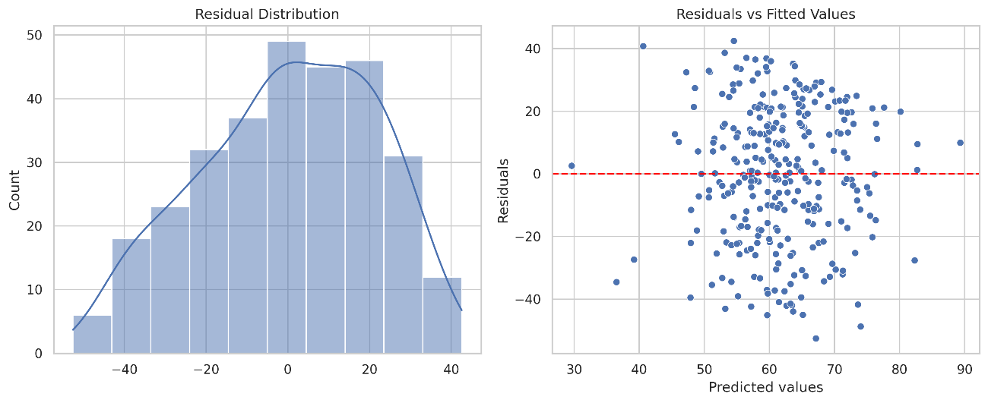
Figure 6. Regression diagnostic panel: (Left) Frequency distribution of model residuals; (Right) Residuals versus fitted values scatterplot.

Residual Evaluation
The distribution of the model residuals, as systematically visualized in the left panel of Figure 6, is tightly centered around zero, demonstrating a reasonable and statistically acceptable approximation of normality necessary for stable, valid hypothesis testing. Concurrently, the residuals versus fitted values scatterplot presented in the right panel of Figure 6 exhibits a balanced, homoscedastic dispersion of error terms across the entire range of predicted operational values. The complete absence of severe funneling configurations or structural, non-linear patterns within the scatter distribution confirms that the variance of the stochastic error terms remains constant across observations. This homoscedastic behavior fully validates the mathematical reliability of the computed standard errors, thereby ensuring the structural integrity of the associated significance levels and t-statistics.

Multicollinearity Assessment
Because the independent predictors of producer aging and low educational attainment are moderately correlated ($r=0.40$), executing a formal check for multicollinearity is imperative to ensure that variance inflation does not destabilize the model's coefficients or distort parameter estimations. To evaluate this potential vulnerability, Variance Inflation Factors (VIF) were formally computed for each independent variable within the econometric framework:
$$VIF_{\text{Producer_Aging}}=1.19$$
$$VIF_{\text{Low_Education}}=1.19$$
Given that both computed VIF values are extremely close to 1.00—and stand far below the standard conservative diagnostic threshold of 5.00—the presence of problematic multicollinearity within the regression architecture is completely ruled out. This diagnostic clearance confirms that the distinct explanatory influences of demographic aging and educational limitations were successfully isolated and parsed by the multiple linear regression model, ensuring that the individual beta coefficients reflect independent structural pressures within Alentejo's civil parishes.
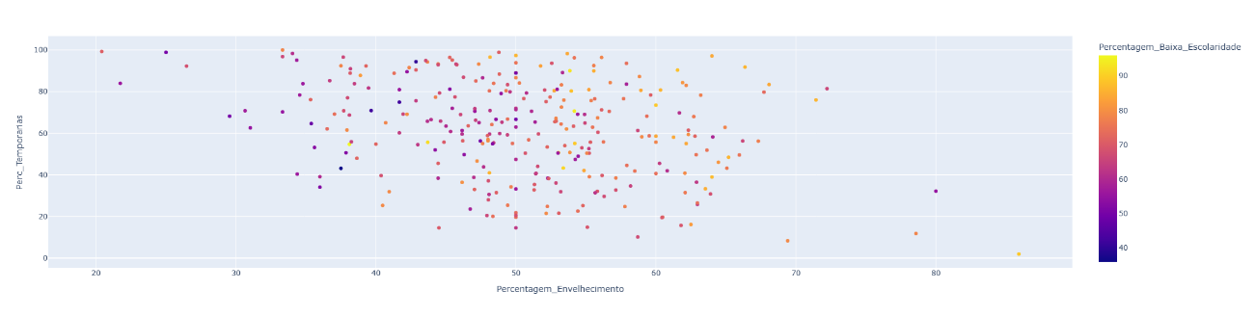
Figure 7. Multidimensional parish-level scatterplot mapping aging against temporary crop prevalence, colored by educational levels (Interactive Plotly platform).

Discussion
The empirical findings derived from this investigation reveal a clear, statistically verifiable relationship between the sociodemographic profile of agricultural managers and the spatial organization of land-use typologies across the civil parishes of Alentejo. By systematically cross-referencing geographic choropleth maps with inferential econometric models, this research provides critical structural insights into the operational challenges and vulnerabilities facing the long-term sustainability of the region's primary sector.
The formal statistical validation of hypothesis H1, which establishes a significant negative association between producer aging and temporary crop prevalence ($β_{1}=-0.91$, $p<0.001$; $r=-0.31$, $p<0.001$), demonstrates a profound structural transition occurring within aging agricultural communities. Temporary crop systems—predominantly composed of annual cereals, rotating forage crops, and open-field systems—inherently demand intensive, ongoing physical labor inputs and highly active seasonal management cycles. As the regional agricultural workforce progressively ages past the critical 65-year threshold, there is a clear, quantifiable operational shift away from these demanding annual setups, signaling a behavioral contraction in traditional labor-intensive cultivation.
Concurrently, the confirmation of hypothesis H2 through a moderate positive bivariate correlation ($r=0.31$, $p<0.001$) indicates that highly aged civil parishes systematically align with a greater relative proportion of surface area dedicated to permanent crops. Permanent agricultural systems, such as traditional olive groves or stone fruit orchards, typically demand fewer intensive, disruptive soil preparation and seeding cycles each year when compared directly to temporary annual systems. This lower annual operational volatility renders permanent crops a more manageable and structurally stable option for an aging demographic seeking to maintain land utility under diminishing physical capacity constraints.
However, the multiple linear regression model introduces an essential, complex nuance to this paradigm through the formal estimation of the low education coefficient ($β_{2}=0.36$, $p<0.01$). When statistically controlling for the effects of producer age, a higher localized prevalence of low educational attainment is positively associated with an increase in temporary crop cultivation. This relationship suggests that while demographic aging forces a parish away from annual systems, low formal education acts as a conservative structural counterweight that limits agricultural adaptation. Modern permanent crops in the Alentejo matrix, such as intensive drip-irrigated olive groves and high-yield technical vineyards, are heavily financialized, capital-intensive, and fundamentally reliant on precision agricultural technologies. Farmers constrained by limited formal education face steeper institutional and cognitive barriers when attempting to secure bank credit, navigate complex European agricultural subsidies within the Common Agricultural Policy (CAP) framework, or adopt digital agrarian innovations, thereby leaving them structurally anchored to traditional annual crop cycles.
Finally, the partial mathematical support found for hypothesis H4 ($R^{2}=0.118$, $p<0.001$) demonstrates that while demographic parameters represent highly significant structural drivers, they operate within a much larger, multi-causal regional ecosystem. The remaining unexplained variance in land-use allocation is likely governed by an array of physical, environmental, and macroeconomic determinants, highlighting that human geography is a vital explanatory piece—but not the sole driver—shaping Alentejo’s complex agricultural landscape.

Study Limitations
While this investigation offers robust statistical and spatial insights into the agrarian dynamics of the region, several core methodological limitations must be explicitly acknowledged to accurately contextualize the empirical boundaries of the findings.
First, significant analytical constraints arise from the cross-sectional nature of the project design, as the analytical framework relies entirely on cross-sectional census data that captures a single, static snapshot in time. Consequently, it is mathematically impossible to establish direct, directional causality between the observed human capital profiles and land allocation choices; instead, the developed models identify structural associations and statistical alignments rather than explicit directional causal mechanisms.
Second, the econometric framework is inherently susceptible to omitted variable bias. The multiple linear regression model's total explanatory power ($R^{2}=0.118$) clearly indicates that highly influential biophysical, structural, and macroeconomic variables were omitted from the specification due to data availability constraints. Exogenous factors such as biophysical soil quality classifications, localized water access parameters—particularly geographic proximity to the Alqueva primary and secondary irrigation channels—microclimatic variations, and the unequal territorial distribution of Common Agricultural Policy (CAP) subsidies play major roles in dictating real-world land-use decisions, yet could not be integrated into the current tabular dataset.
Third, the data scale transitions implemented during the preprocessing phase introduce specific analytical trade-offs. Transforming raw, absolute land-use metrics into relative percentage proportions was mathematically necessary to eliminate profound parish-level scale bias and allow for a standardized spatial comparison across unevenly sized administrative units. However, this normalization technique inevitably masks the absolute physical volume of regional agricultural production, thereby treating small, fragmented family-farm parishes and massive, capital-intensive industrial latifúndio parishes as mathematically equivalent entities within the percentage matrix.
Finally, a significant methodological limitation stems from the absence of advanced spatial econometrics within the current modeling workflow. The OLS regression estimation operates under the standard assumption of independent observations across administrative boundaries. In reality, land-use choices, geographic specializations, and demographic traits exhibit strong spatial dependence and spatial autocorrelation across neighboring civil parish borders. The absence of explicit spatial lag or spatial error modeling frameworks means that localized spillover effects, spatial clustering tendencies, and trans-border geographic dependencies were not formally captured by the empirical parameters.

Conclusion and Policy Implications
This research demonstrates that the sociodemographic landscape of the Alentejo region is profoundly intertwined with its territorial agricultural configurations and land-use allocation patterns. The empirical intersections analyzed between human geography and agrarian structures reveal that the dual pressures of an accelerating aging farm leadership and a pervasive deficit in formal educational attainment converge to forge a distinct structural vulnerability core, which is most acute within isolated, inland peripheral parishes. Within this matrix, advanced chronological age operates as a reliable structural signal for a behavioral retreat from labor-intensive, high-input annual temporary crop cycles. Concurrently, low educational thresholds establish persistent systemic barriers that restrict the adoption of modernized, capital-intensive permanent crop infrastructures, which fundamentally require advanced precision methodologies, financial literacy, and technological proficiency.
For the field of green data science applications and the strategic execution of rural regional planning, these conclusions explicitly highlight that future agricultural and environmental policies cannot be effectively formulated within an institutional vacuum detached from human geography vectors. If the Alentejo agrarian sector is to successfully build resilience against shifting macroclimatic conditions and preserve its long-term economic viability, institutional frameworks must move away from generic top-down subsidies and prioritize targeted socio-structural interventions.
On one hand, policymaking must execute targeted generational renewal strategies by engineering active financial mechanisms, specialized credit lines, and streamlined land-access incentives specifically calibrated to attract younger, technologically literate managers into the region's aging agricultural pockets. On the other hand, this framework must be supported by the deployment of decentralized technical training frameworks and accessible, localized agrarian extension programs. These programs must be structurally tailored to match the socio-educational realities of older or less-educated producers, thereby smoothing the territorial transition toward modern, sustainable, and climate-adaptive land-use practices. In summary, the granular spatial configurations and statistical parameters mapped out throughout this study confirm that the ecological stability and economic future of Alentejo's soil resources remain fundamentally dependent upon the human capital profile and capacity of those who manage them.

Appendix: Technical Script
This appendix presents the complete, fully reproducible Python programmatic architecture developed to execute the data integration, preprocessing, feature engineering, inferential testing, and econometric modeling workflows detailed throughout this study. The pipeline was constructed within a Jupyter Notebook environment using Python 3, leveraging the Pandas and Numpy libraries for high-performance matrix manipulation, the standard regular expressions (re) engine for advanced alphanumeric metadata parsing, SciPy for inferential analysis, and Statsmodels for Ordinary Least Squares (OLS) estimation and multi-variable diagnostic verification.
The script is structured as a cohesive, production-ready pipeline to guarantee full computational transparency and academic reproducibility:

