**COMMON SETUP (v.2021-07-20)**

* Software requirement: OpenJDK 11

<https://adoptium.net/download>

* Install node.js (Windows installer) from:

<https://nodejs.org/download/>

* Install GitBash from:

<https://gitforwindows.org/>

* Now, when positioned in a folder and using the right button of the mouse, you can see something like this:

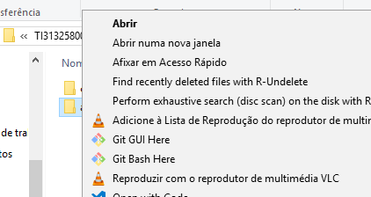

* (optional and more related with development than with production stages) Install nodemon: open Git Bash and, in the command line, write: npm install -g nodemon

**MONGODB SETUP (v.2021-07-20)**

* Download the database from: [MongoDB Community Download | MongoDB](https://www.mongodb.com/try/download/community).
* Create a database named **aitam** (otherwise, change connections string to MongoDB accordingly in the projects configuration files).
* Inside database, create three collections: **audits**, **recommendations** and **research** (otherwise, change connections string to MongoDB accordingly in the projects configuration files).
* Create text index (<https://docs.mongodb.com/manual/core/index-text/>) on **recommendations** collection:
  + Access the bin folder in the installation path;
  + Run the shell/command line, writing: mongo
  + Change database, and write: use aitam;
  + Create index on **recommendations** collection:  
    db.recommendations.createIndex({data:”text”})

**NEO4J SETUP (v.2021-08-03)**

* Download the database from: [NEO4J Community Server](https://neo4j.com/download-center/#community).
* You may use the default databasename for **aitam** (otherwise, change connections string accordingly in the projects configuration files), namely in neo4j.conf:

dbms.default_database=graph.db.

* The instance **must be running before starting AITAM** website, to allow this one to crawl and create automatically the working gazeeter.
* Neo4j can also be run as a Windows service. Install the service with:

bin\neo4j windows-service install

, and start it with

bin\neo4j start.

**AITAM WEBSITE SETUP (v.2021-07-20)**

* Download the project from GitHub: <https://github.com/joaocarloscardoso/AITAM>.
* On code tab you have a green button named clone or download. Push it and select Download Zip:

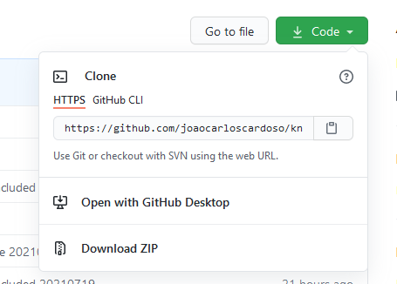

* Extract and install the project in the selected folder.
* Use the the file “credentials.txt”. Rename the file extension to from “.txt”to “.js”. Place it in the project root folder and edit it, updating the file/folder paths and connections strings to MongoDB and Neo4j accordingly:
  + Connection settings for MongoDB,
  + Connection settings for Neo4j,
  + Address and connection for contact mail subsystem,
  + Local file path for log files,
  + Local path for temporary working files,
  + Public URL paths,
  + Working and Web Language (uses ISO 639-1 standard).
* Open Git Bash in the root folder of the project and, in the command line, write:   
  npm install (may need the parameter --force)

(it will start installing all the modules and dependencies present in package.json)

* Repeat the operation in db folder
* To use SSL, the PEM files (key.pem and cert.pem) must be placed in the root folder:
  + If you plan to use HTTP, uncomment code fragment under label “//use app in http server” and comment “//use app in https server “in app.js
  + If you plan to use HTTPS, comment code fragment under label “//use app in http server” and uncomment “//use app in https server “in app.js

To run the project:

* Go to to db folder, open Open Git Bash and, in the command line, write: npm run json:server

(Leave this window open. To finish in end, interrupt first the process running inside using CTRL+C)

* Go to root folder, open Open Git Bash and, write: node app (if nodemon is installed just write: nodemon).
* Now you can test if the internal site is providing credentials: <http://localhost:5000/users?email=test@test.com>
* And, test the AITAM website: <http://localhost:3000>

**AITAM WEBSITE MAINTENANCE (v.2021-07-20)**

* Install npm-check-updates: npm install –g npm-check-updates
* Update package.json to last versions:
  + Open Git Bash in the root folder of the project and, in the command line
  + Write: ncu -u –packagefile package.json
  + write: npm install

**Install AITAM as a service (v.2019-06-24)**

* Download and install NSSM - the Non-Sucking Service Manager: <https://nssm.cc/>
* Write for each service (and configure):
  + nssm install aitam
  + nssm install aitam_db
* To edit service:
  + nssm edit aitam
  + nssm edit aitam_db

Configuration parameters for each service

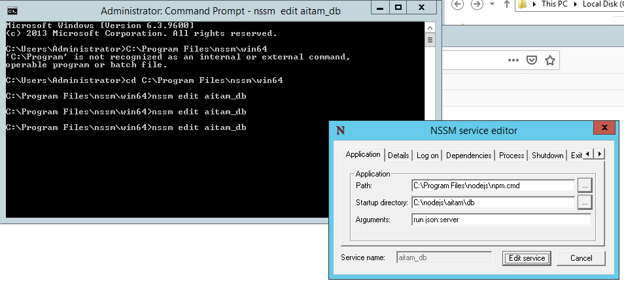

* Parameters for service “aitam_db”:
  + Path: <path where nodejs is installed>\npm.cmd
  + Startup directory: <path where AITAM is installed>\db
  + Arguments: run json:server
* Parameters for service “aitam”:
  + Path: <path where nodejs is installed>\node
  + Startup directory: <path where AITAM is installed>
  + Arguments: app

**Redirect traffic from http to https or to desired http port**

Enable IIS and the required IIS components on Windows Server:

* Open Server Manager and click Manage > Add Roles and Features. Click Next.
* Select Role-based or feature-based installation and click Next.
* Select the appropriate server. The local server is selected by default. Click Next.
* Enable Web Server (IIS) and click Next.
* No additional features are necessary to install the Web Adaptor, so click Next.
* On the Web Server Role (IIS) dialog box, click Next.
* On the Select role services dialog box, verify that the web server components listed in the next section are enabled. Click Next.
* Verify that your settings are correct and click Install.
* When the installation completes, click Close to exit the wizard.
* Open IIS Manager by going to Start -> Administrative Tools -> IIS Manager
* Once IIS Manager opens, expand the WebServer, then the Sites folder, and choose the Default Web site
* Click on HTTP REDIRECT in the main panel
* Place a check next to Redirect requests to this destination: and fill in the target url in the text box below.