**AITAM WEBSITE SETUP (v.2019-06-21)**

* Install node.js (Windows installer) from:

<https://nodejs.org/download/>

* Install GitBash from:

<https://gitforwindows.org/>

* Now, when positioned in a folder and using the right button of the mouse, you can see something like this:

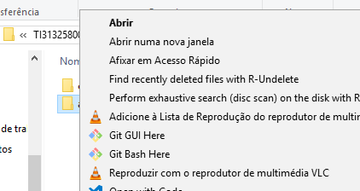

* Install nodemon: open Git Bash and, in the command line, write: npm install -g nodemon
* Download the project from GitHub: on code tab you have a green button named clone or download. Push it and select Download Zip:

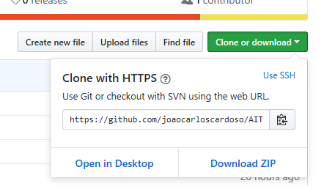

* Extract and install the project in the selected folder.
* (If not blocked) place the credentials.js file in the project root folder and edit it, updating the file/folder paths accordingly. Forget cookie secret object.
* Open Git Bash in the root folder of the project and, in the command line, write: npm install

(it will start installing all the modules and dependencies present in package.json)

* Repeat the operation in db folder

To run the project:

* Go to to db folder, open Open Git Bash and, in the command line, write: npm run json:server

(Leave this window open. To finish in end, interrupt first the process runnin inside using CTRL+C)

* Go to root folder, open Open Git Bash and, in the command line, write: nodemon

Now you can test if the internal site is providing credentials: <http://localhost:5000/users?email=test@test.com>

And, test the AITAM website: <http://localhost:3000>