**COMMON SETUP (v.2021-07-20)**

* Install node.js (Windows installer) from:

<https://nodejs.org/download/>

* Install GitBash from:

<https://gitforwindows.org/>

* Now, when positioned in a folder and using the right button of the mouse, you can see something like this:

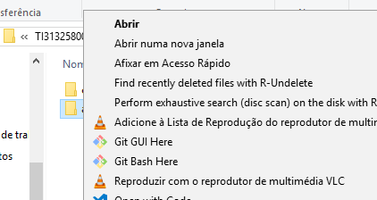

* (optional and more related with development than with production stages) Install nodemon: open Git Bash and, in the command line, write: npm install -g nodemon

**MONGODB SETUP (v.2021-07-20)**

* Download the database from: [MongoDB Community Download | MongoDB](https://www.mongodb.com/try/download/community).
* Create a database named **aitam** (otherwise, change connections string to MongoDB accordingly in the projects configuration files).
* Inside database, create three collections: **audits**, **recommendations** and **research** (otherwise, change connections string to MongoDB accordingly in the projects configuration files).
* Create text index (<https://docs.mongodb.com/manual/core/index-text/>) on **recsearch** collection:
  + Access the bin folder in the installation path;
  + Run the shell/command line, writing: mongo
  + Change database, and write: use aitam;
  + Create index on **recsearch** collection:  
    db.recsearch.createIndex({data:”text”})

**KNAOREC WEBSITE SETUP (v.2021-07-20)**

* Download the project from GitHub: <https://github.com/joaocarloscardoso/knaorec>.
* On code tab you have a green button named clone or download. Push it and select Download Zip:

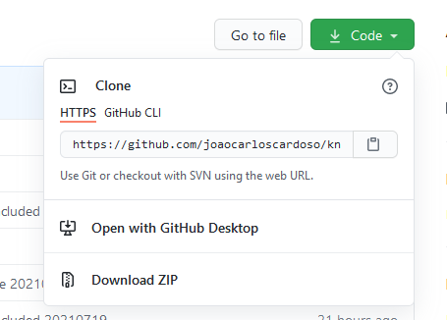

* Extract and install the project in the selected folder.
* (If not blocked) place the credentials.js file in the project root folder and edit it, updating the file/folder paths and connections string to MongoDB accordingly:
  + URL connection string for MongoDB;
  + User for MongoDB access (if necessary),
  + Password for MongoDB access (if necessary),
  + Local file path for log files,
  + Local path for temporary working files,
  + Working and Web Language (uses ISO 639-1 standard).
* Open Git Bash in the root folder of the project and, in the command line, write:   
  npm install

(it will start installing all the modules and dependencies present in package.json)

* Open Git Bash in the root folder of the project and, in the command line, write:   
  npm install
* To use SSL, the PEM files (key.pem and cert.pem) must be placed in the root folder.
* To launch, write: node app (if nodemon is installed just write: nodemon).

**KNAOREC_WS WEB SERVICE SETUP (v.2021-07-20)**

The project Integrates Auth0, with a free subscription. The API will be parsing JWT formatted access RS256 signed tokens.

* Download the project from GitHub: <https://github.com/joaocarloscardoso/knaorec_ws>.
* On code tab you have a green button named clone or download. Push it and select Download Zip:



* Extract and install the project in the selected folder.
* (If not blocked) place the credentials.js file in the project root folder and edit it, updating the file/folder paths and connections string to MongoDB accordingly.
* Open Git Bash in the root folder of the project and, in the command line, write:   
  npm install

(it will start installing all the modules and dependencies present in package.json)

* Run the following command: npm i express-jwt jwks-rsa
  + express-jwt: A middleware that validates JSON Web Tokens (JWTs) and sets the req.user with its attributes.
  + jwks-rsa: A library to retrieve RSA public keys from a JWKS (JSON Web Key Set) endpoint.
* To use SSL, the PEM files (key.pem and cert.pem) must be placed in the root folder.
* Fill the config.js file in the project env folder and edit it, updating the port, user, application endpoints, and connections string to MongoDB accordingly.
* To launch, write: node src (if nodemon is installed just write: nodemon).

For a client test, please refer to project: <https://github.com/joaocarloscardoso/knaorec_ws_client>

**KNAOREC WEBSITE AND KNAOREC_WS WEB SERVICE MAINTENANCE (v.2021-07-20)**

* Install npm-check-updates: npm install –g npm-check-updates
* Update package.json to last versions:
  + Open Git Bash in the root folder of the project and, in the command line
  + Write: ncu -u –packagefile package.json
  + write: npm install