--------------------

0

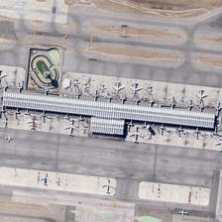

**Descrição original:**

many planes are parked next to a long building in an airport .

**Descrição editada:**

many planes are parked next to a long building in an airport .

--------------------

1

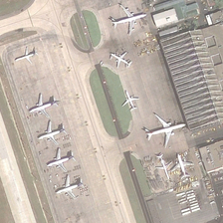

**Descrição original:**

some planes are parked in an airport .

**Descrição editada:**

some planes are parked in an airport .

--------------------

2

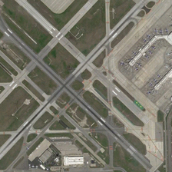

**Descrição original:**

many planes are parked in an airport near many runways .

**Descrição editada:**

many planes are parked in an airport near many runways .

--------------------

3

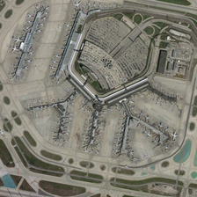

**Descrição original:**

many planes are parked near a large building on an airport .

**Descrição editada:**

many planes are parked near a large building on an airport .

--------------------

4

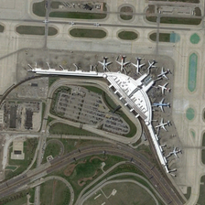

**Descrição original:**

several buildings and green trees are around a piece of bareland .

**Descrição editada:**

several buildings and green trees are around a piece of bareland .

--------------------

5

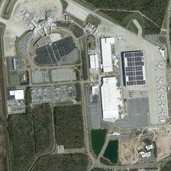

**Descrição original:**

some green trees are near a large piece of bareland .

**Descrição editada:**

some green trees are near a large piece of bareland .

--------------------

6

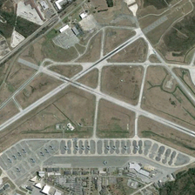

**Descrição original:**

many planes are parked between several buildings and many runways .

**Descrição editada:**

many planes are parked between several buildings and many runways .

--------------------

7

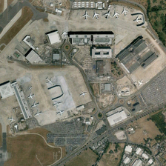

**Descrição original:**

many planes and buildings are in an airport .

**Descrição editada:**

many planes and buildings are in an airport .

--------------------

8

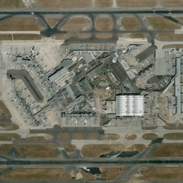

**Descrição original:**

is a airport in the middle and many planes in it .

**Descrição editada:**

is a airport in the middle and many planes in it .

--------------------

9

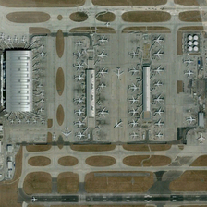

**Descrição original:**

many planes are parked near several buildings in an airport .

**Descrição editada:**

many planes are parked near several buildings in an airport .