RELATÓRIO DO TESTE
Cadastro de Contratos – Cenário 1: Preenchimento completo e salvamento.
Data do teste: 18/11/2025 14:37:17
🔄 Acessando sistema...
✅ Acessando sistema realizada com sucesso.
Screenshot: acessando_sistema
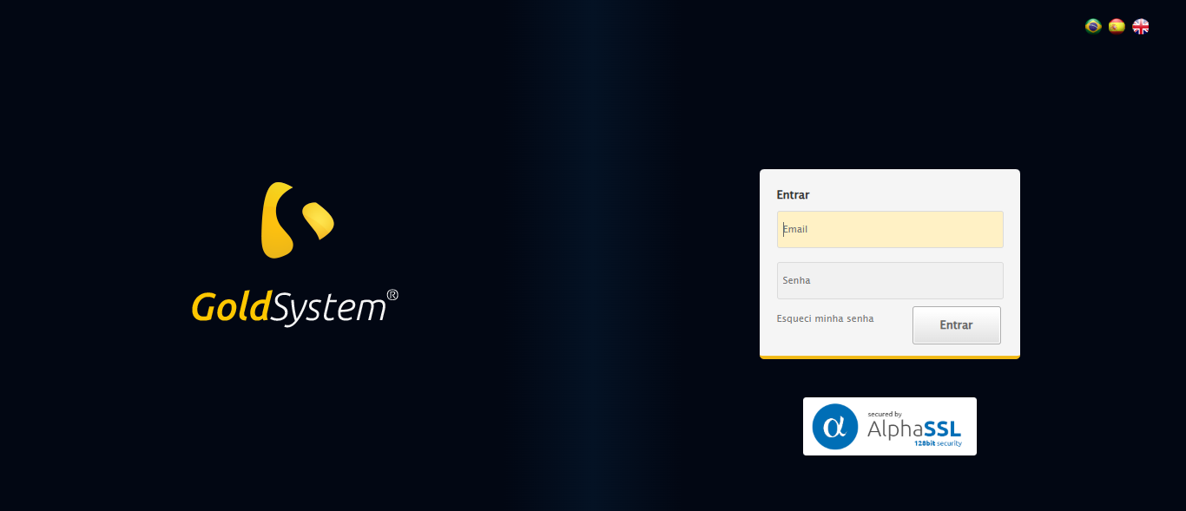
🔄 Realizando login...
✅ Realizando login realizada com sucesso.
Screenshot: realizando_login
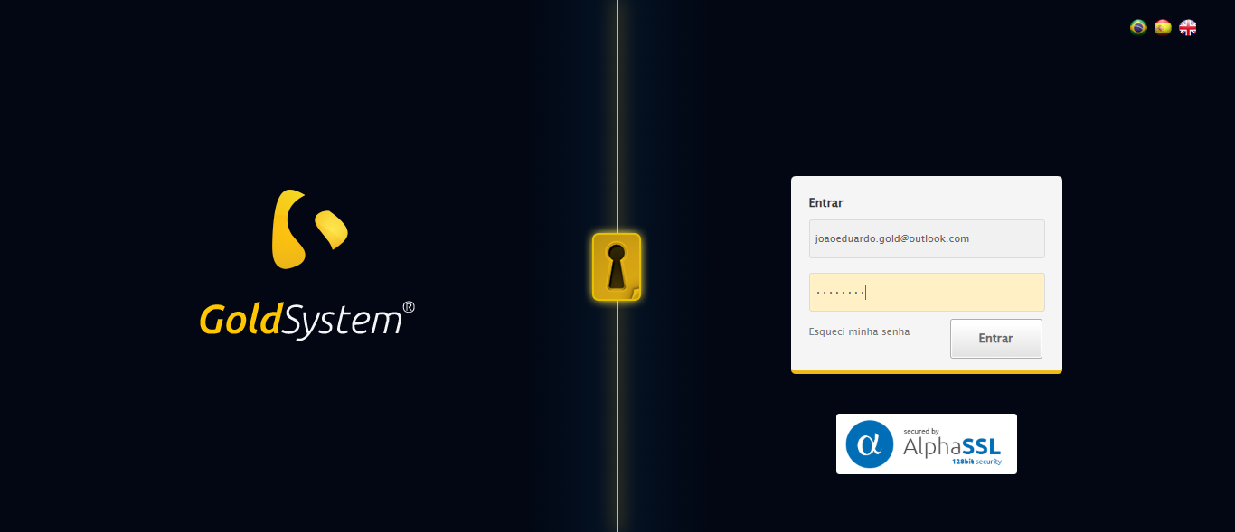
🔄 Esperando sistema carregar e ajustando zoom...
⚠️ Erro ao ajustar zoom: Message: target frame detached
(failed to check if window was closed: disconnected: Unable to receive message from renderer)
(Session info: chrome=142.0.7444.163)
Stacktrace:
Symbols not available. Dumping unresolved backtrace:
0xf84103
0xf84144
0xd8e56b
0xd7e91d
0xd7daca
0xd9c714
0xd9ba11
0xd9bb57
0xe1ed26
0xdfc706
0xdcda30
0xdced54
0x11f57b4
0x11f098a
0xfac392
0xf9c4c8
0xfa324d
0xf8c478
0xf8c63c
0xf767ca
0x764afcc9
0x77de82ae
0x77de827e
✅ Esperando sistema carregar e ajustando zoom realizada com sucesso.
❌ Erro ao esperando sistema carregar e ajustando zoom: Message: invalid session id: session deleted as the browser has closed the connection
from disconnected: not connected to DevTools
(Session info: chrome=142.0.7444.163); For documentation on this error, please visit: https://www.selenium.dev/documentation/webdriver/troubleshooting/errors#invalidsessionidexception
Stacktrace:
Symbols not available. Dumping unresolved backtrace:
0xf84103
0xf84144
0xd8e71d
0xd7d910
0xd9c714
0xe03475
0xe1e749
0xdfc706
0xdcda30
0xdced54
0x11f57b4
0x11f098a
0xfac392
0xf9c4c8
0xfa324d
0xf8c478
0xf8c63c
0xf767ca
0x764afcc9
0x77de82ae
0x77de827e
❌ ERRO FATAL: Message: invalid session id; For documentation on this error, please visit: https://www.selenium.dev/documentation/webdriver/troubleshooting/errors#invalidsessionidexception
Stacktrace:
Symbols not available. Dumping unresolved backtrace:
0xf84103
0xf84144
0xd8e56b
0xdcce58
0xdfc7c6
0xdf8030
0xdf7563
0xd5e4dd
0xd5ea6e
0xd5ef3d
0x11f57b4
0x11f098a
0xfac392
0xf9c4c8
0xfa324d
0xd5e193
0xd5d848
0x134b0cf
0x764afcc9
0x77de82ae
0x77de827e
✅ Teste concluído com sucesso.

