RELATÓRIO DO TESTE
Processo: Separar Entregas – Cenário 1: Preenchimento completo e salvamento.
Data do teste: 26/11/2025 17:27:19
[17:27:23] INFO: Executando: Acessando sistema
[17:27:24] INFO: ✅ Acessando sistema - Sucesso
Screenshot: acessando_sistema

[17:27:25] INFO: Executando: Realizando login
[17:27:25] INFO: ✅ Realizando login - Sucesso
Screenshot: realizando_login

[17:27:25] INFO: Executando: Esperando sistema carregar e ajustando zoom
[17:27:31] INFO: 🔍 Zoom ajustado para 90%.
[17:27:31] INFO: ✅ Esperando sistema carregar e ajustando zoom - Sucesso
Screenshot: esperando_sistema_carregar_e_ajustando_zoom
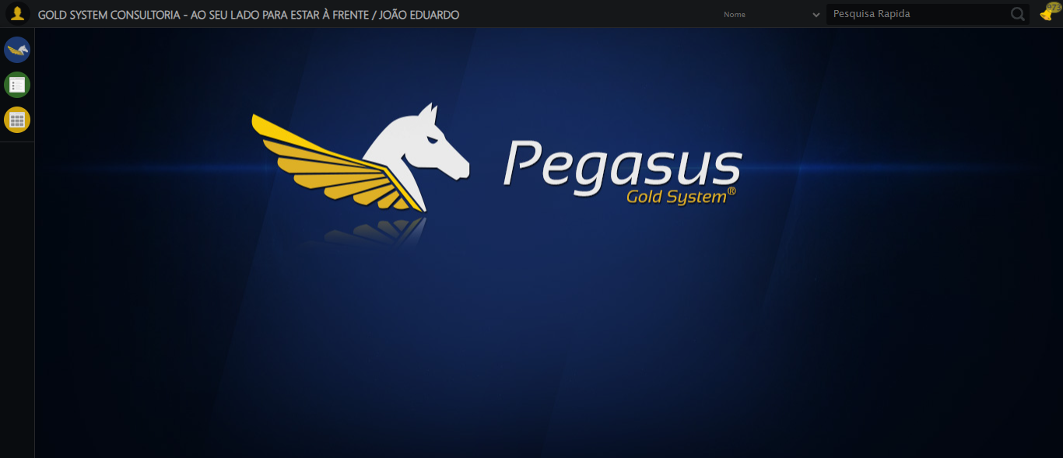
[17:27:32] INFO: Executando: Abrindo menu Contratos
[17:27:32] INFO: ✅ Abrindo menu Contratos - Sucesso
Screenshot: abrindo_menu_contratos
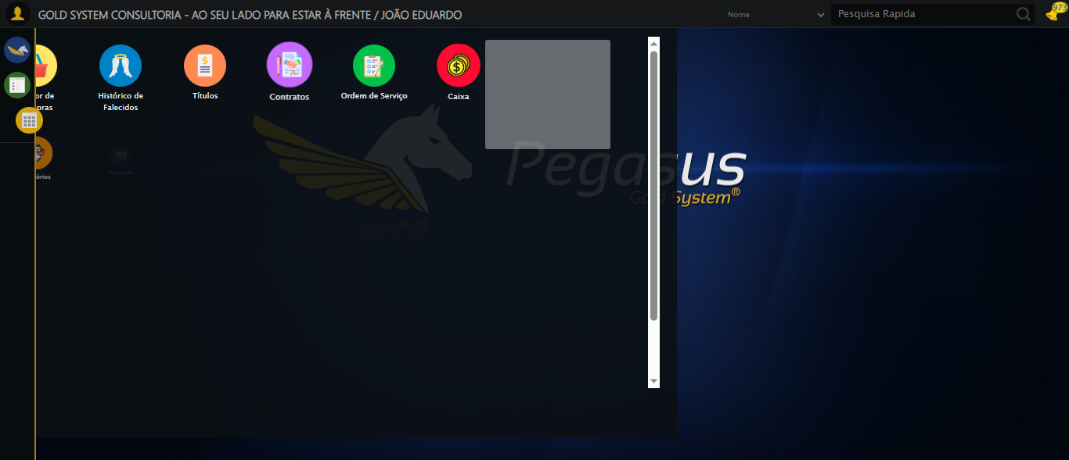
[17:27:33] INFO: Executando: Clicando em 'Controle de Entrega'
[17:27:33] INFO: ✅ Clicando em 'Controle de Entrega' - Sucesso
Screenshot: clicando_em_'controle_de_entrega'
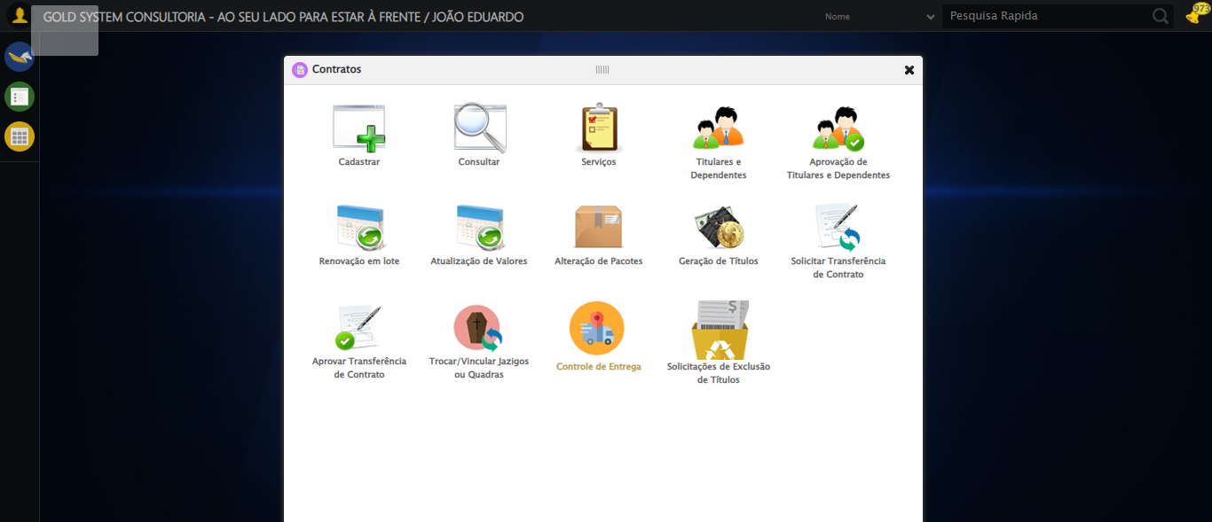
[17:27:34] INFO: Executando: Clicando em 'Separar Entregas'
[17:27:34] INFO: ✅ Clicando em 'Separar Entregas' - Sucesso
Screenshot: clicando_em_'separar_entregas'
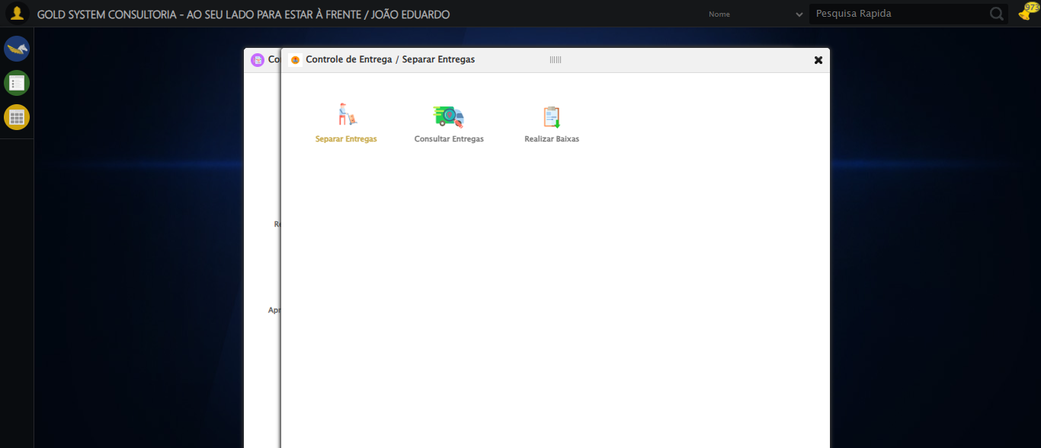
[17:27:34] INFO: Executando: Preenchendo Número do Contrato Inicial
[17:27:34] INFO: ✏️ Preenchimento forçado: //input[@type='text' and @class='fc contratoInicial mandatory inteiro' and @name='contratoInicial' and @maxlength='8' and @style='width: 100px; text-align: right;'] = '113060'
[17:27:35] INFO: Tentativa 1.2...
Erro JavaScript: Message: javascript error: Campo não encontrado
(Session info: chrome=142.0.7444.176)
Stacktrace:
Symbols not available. Dumping unresolved backtrac
Tentativa 2/3
Erro JavaScript: Message: javascript error: Campo não encontrado
(Session info: chrome=142.0.7444.176)
Stacktrace:
Symbols not available. Dumping unresolved backtrac
Tentativa 3/3
Erro JavaScript: Message: javascript error: Campo não encontrado
(Session info: chrome=142.0.7444.176)
Stacktrace:
Symbols not available. Dumping unresolved backtrac
[17:27:40] INFO: Tentativa 1.3...
Erro JavaScript: Message: javascript error: Campo não encontrado
(Session info: chrome=142.0.7444.176)
Stacktrace:
Symbols not available. Dumping unresolved backtrac
Tentativa 2/3
Erro JavaScript: Message: javascript error: Campo não encontrado
(Session info: chrome=142.0.7444.176)
Stacktrace:
Symbols not available. Dumping unresolved backtrac
Tentativa 3/3
Erro JavaScript: Message: javascript error: Campo não encontrado
(Session info: chrome=142.0.7444.176)
Stacktrace:
Symbols not available. Dumping unresolved backtrac
[17:27:46] INFO: Tentativa 1.4...
Erro JavaScript: Message: javascript error: Campo não encontrado
(Session info: chrome=142.0.7444.176)
Stacktrace:
Symbols not available. Dumping unresolved backtrac
Tentativa 2/3
Erro JavaScript: Message: javascript error: Campo não encontrado
(Session info: chrome=142.0.7444.176)
Stacktrace:
Symbols not available. Dumping unresolved backtrac
Tentativa 3/3
Erro JavaScript: Message: javascript error: Campo não encontrado
(Session info: chrome=142.0.7444.176)
Stacktrace:
Symbols not available. Dumping unresolved backtrac
[17:27:52] INFO: Tentativa 2.1...
Erro JavaScript: Message: javascript error: Campo não encontrado
(Session info: chrome=142.0.7444.176)
Stacktrace:
Symbols not available. Dumping unresolved backtrac
Tentativa 2/3
Erro JavaScript: Message: javascript error: Campo não encontrado
(Session info: chrome=142.0.7444.176)
Stacktrace:
Symbols not available. Dumping unresolved backtrac
Tentativa 3/3
Erro JavaScript: Message: javascript error: Campo não encontrado
(Session info: chrome=142.0.7444.176)
Stacktrace:
Symbols not available. Dumping unresolved backtrac
[17:27:58] INFO: Tentativa 2.2...
Erro JavaScript: Message: javascript error: Campo não encontrado
(Session info: chrome=142.0.7444.176)
Stacktrace:
Symbols not available. Dumping unresolved backtrac
Tentativa 2/3
Erro JavaScript: Message: javascript error: Campo não encontrado
(Session info: chrome=142.0.7444.176)
Stacktrace:
Symbols not available. Dumping unresolved backtrac
Tentativa 3/3
Erro JavaScript: Message: javascript error: Campo não encontrado
(Session info: chrome=142.0.7444.176)
Stacktrace:
Symbols not available. Dumping unresolved backtrac
[17:28:03] INFO: Tentativa 2.3...
Erro JavaScript: Message: javascript error: Campo não encontrado
(Session info: chrome=142.0.7444.176)
Stacktrace:
Symbols not available. Dumping unresolved backtrac
Tentativa 2/3
Erro JavaScript: Message: javascript error: Campo não encontrado
(Session info: chrome=142.0.7444.176)
Stacktrace:
Symbols not available. Dumping unresolved backtrac
Tentativa 3/3
Erro JavaScript: Message: javascript error: Campo não encontrado
(Session info: chrome=142.0.7444.176)
Stacktrace:
Symbols not available. Dumping unresolved backtrac
[17:28:09] INFO: Tentativa 2.4...
Erro JavaScript: Message: javascript error: Campo não encontrado
(Session info: chrome=142.0.7444.176)
Stacktrace:
Symbols not available. Dumping unresolved backtrac
Tentativa 2/3
Erro WebDriver: Message: invalid session id: session deleted as the browser has closed the connection
from disconnected: not connected to DevTools
(Session info: ch
Tentativa 3/3
Erro WebDriver: Message: invalid session id; For documentation on this error, please visit: https://www.selenium.dev/documentation/webdriver/troubleshooting/errors#in
[17:28:14] INFO: Tentativa 3.1...
[17:28:14] INFO: Estratégia 1 falhou: Message: invalid session id; For documentation on this error, please visit: http
[17:28:14] INFO: Tentativa 3.2...
[17:28:14] INFO: Estratégia 2 falhou: Message: invalid session id; For documentation on this error, please visit: http
[17:28:14] INFO: Tentativa 3.3...
[17:28:14] INFO: Estratégia 3 falhou: Message: invalid session id; For documentation on this error, please visit: http
[17:28:14] INFO: Tentativa 3.4...
[17:28:14] INFO: Estratégia 4 falhou: Message: invalid session id; For documentation on this error, please visit: http
[17:28:16] INFO: Tentativa 4.1...
[17:28:16] INFO: Estratégia 1 falhou: Message: invalid session id; For documentation on this error, please visit: http
[17:28:16] INFO: Tentativa 4.2...
[17:28:16] INFO: Estratégia 2 falhou: Message: invalid session id; For documentation on this error, please visit: http
[17:28:16] INFO: Tentativa 4.3...
[17:28:16] INFO: Estratégia 3 falhou: Message: invalid session id; For documentation on this error, please visit: http
[17:28:16] INFO: Tentativa 4.4...
[17:28:16] INFO: Estratégia 4 falhou: Message: invalid session id; For documentation on this error, please visit: http
[17:28:19] INFO: Tentativa 5.1...
[17:28:19] INFO: Estratégia 1 falhou: Message: invalid session id; For documentation on this error, please visit: http
[17:28:19] INFO: Tentativa 5.2...
[17:28:19] INFO: Estratégia 2 falhou: Message: invalid session id; For documentation on this error, please visit: http
[17:28:19] INFO: Tentativa 5.3...
[17:28:19] INFO: Estratégia 3 falhou: Message: invalid session id; For documentation on this error, please visit: http
[17:28:19] INFO: Tentativa 5.4...
[17:28:19] INFO: Estratégia 4 falhou: Message: invalid session id; For documentation on this error, please visit: http
[17:28:19] ERROR: ❌ Erro inesperado em Preenchendo Número do Contrato Inicial: Falha ao preencher após 5 tentativas: //input[@type='text' and @class='fc contratoInicial mandatory inteiro' and @name='contratoInicial' and @maxlength='8' and @style='width: 100px; text-align: right;']
[17:28:19] INFO: ❌ ERRO FATAL: Message: invalid session id; For documentation on this error, please visit: https://www.selenium.dev/documentation/webdriver/troubleshooting/errors#invalidsessionidexception
Stacktrace:
Symbols not available. Dumping unresolved backtrace:
0xca4103
0xca4144
0xaae56b
0xaece58
0xb1c7c6
0xb18030
0xb17563
0xa7e4dd
0xa7ea6e
0xa7ef3d
0xf157b4
0xf1098a
0xccc392
0xcbc4c8
0xcc324d
0xa7e193
0xa7d848
0x106b0cf
0x75ebfcc9
0x76f682ae
0x76f6827e
[17:28:19] INFO: ✅ Teste concluído com sucesso.

