RELATÓRIO DO TESTE
Aprovação de Trocar/Vincular Jazigos ou Quadras – Cenário 1: Preenchimento completo e salvamento.
Data do teste: 26/11/2025 16:11:47
[16:11:51] INFO: Executando: Acessando sistema
[16:11:51] INFO: ✅ Acessando sistema - Sucesso
Screenshot: acessando_sistema
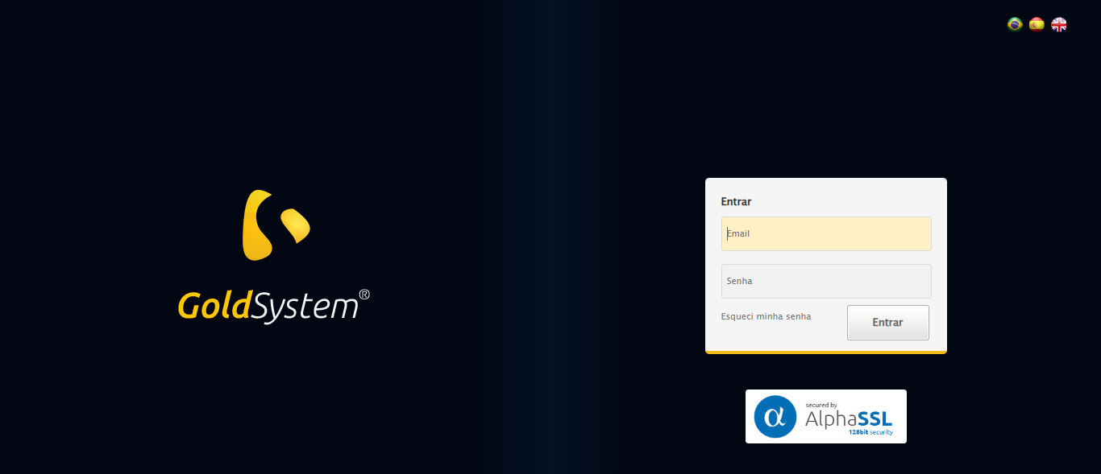
[16:11:52] INFO: Executando: Realizando login
[16:11:52] INFO: ✅ Realizando login - Sucesso
Screenshot: realizando_login
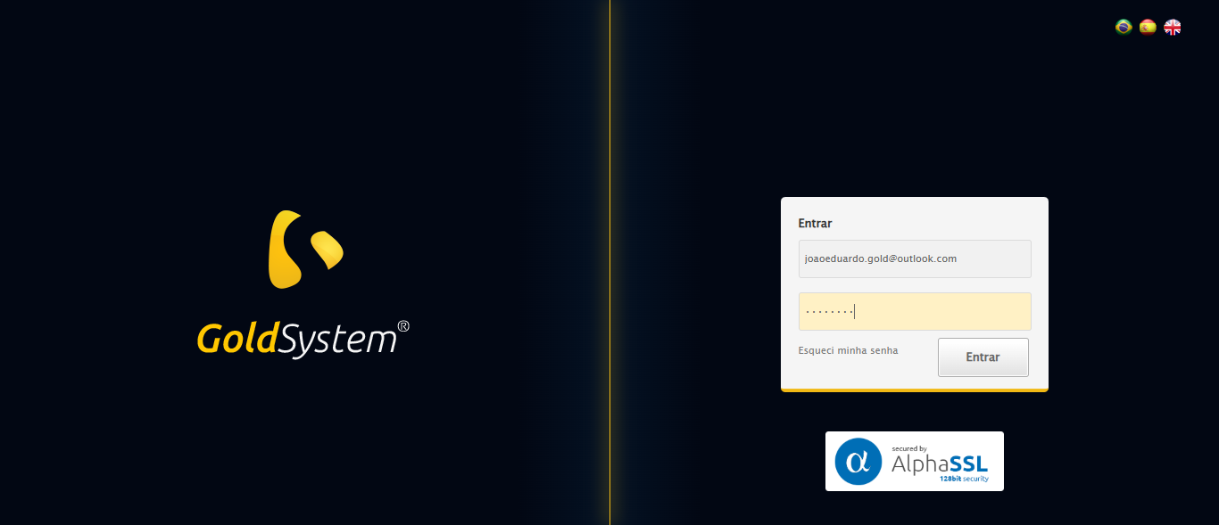
[16:11:52] INFO: Executando: Esperando sistema carregar e ajustando zoom
[16:12:00] INFO: 🔍 Zoom ajustado para 90%.
[16:12:00] INFO: ✅ Esperando sistema carregar e ajustando zoom - Sucesso
Screenshot: esperando_sistema_carregar_e_ajustando_zoom
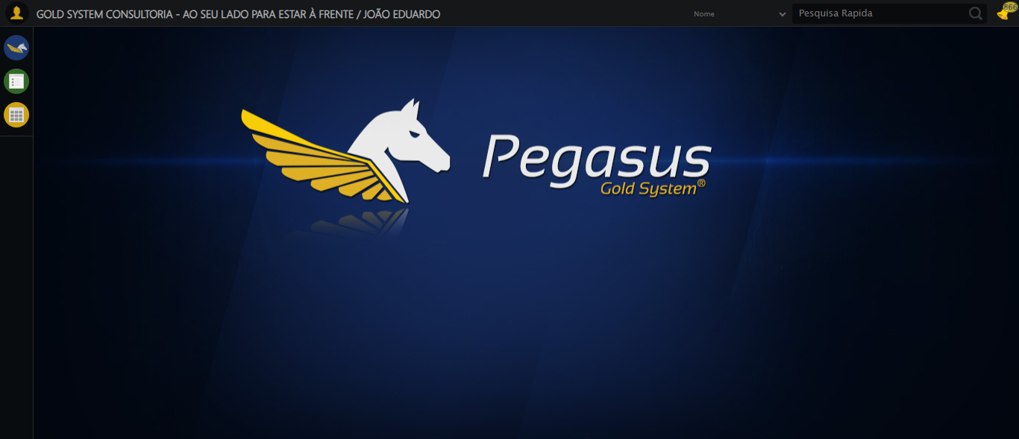
[16:12:00] INFO: Executando: Abrindo menu Contratos
[16:12:01] INFO: ✅ Abrindo menu Contratos - Sucesso
Screenshot: abrindo_menu_contratos
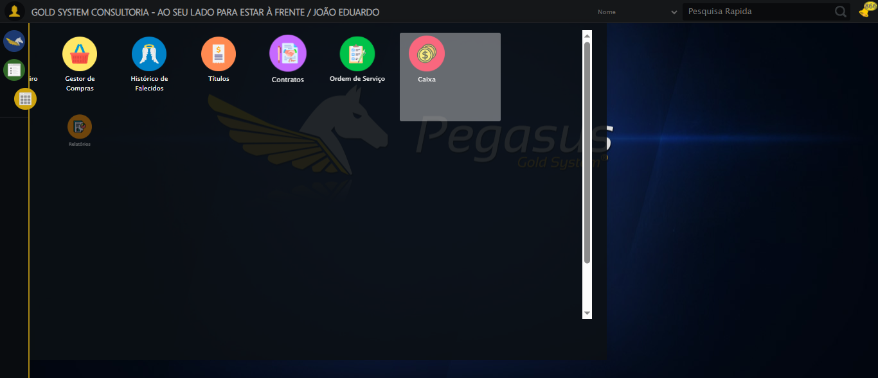
[16:12:01] INFO: Executando: Clicando em 'Trocar ouVincular Jazigos ou Quadras'
[16:12:02] INFO: ✅ Clicando em 'Trocar ouVincular Jazigos ou Quadras' - Sucesso
Screenshot: clicando_em_'trocar_ouvincular_jazigos_ou_quadras'
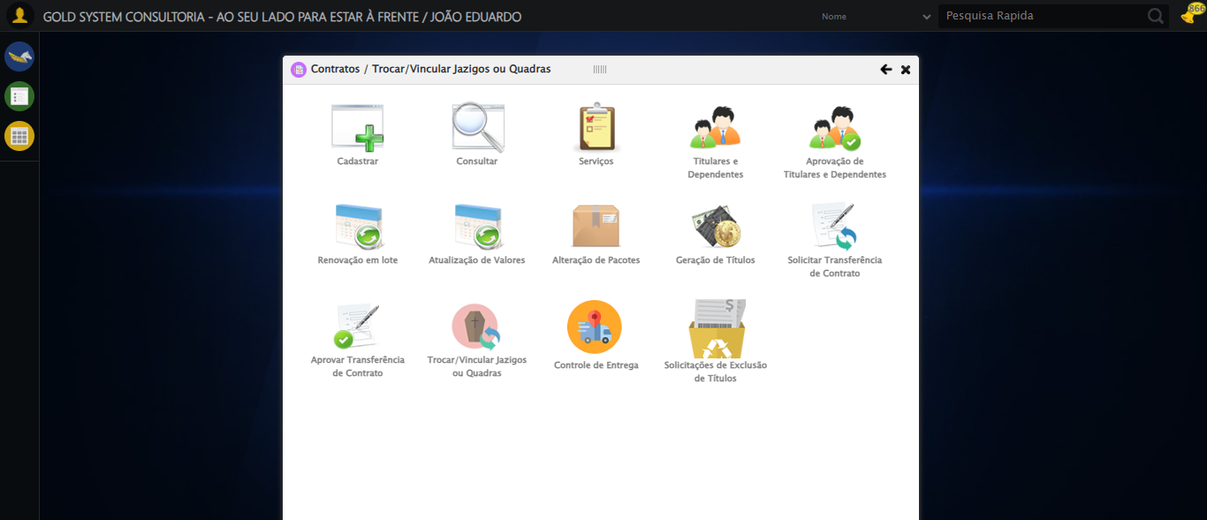
[16:12:02] INFO: Executando: Preenchendo Número do Contrato
[16:12:02] INFO: ✏️ Preenchimento forçado: //div[@class='buscaContrato' and label[normalize-space()='Numero do Contrato']]/input = '112883'
[16:12:03] INFO: ✅ Campo preenchido (estratégia 1)
[16:12:03] INFO: ✅ Preenchendo Número do Contrato - Sucesso
Screenshot: preenchendo_número_do_contrato
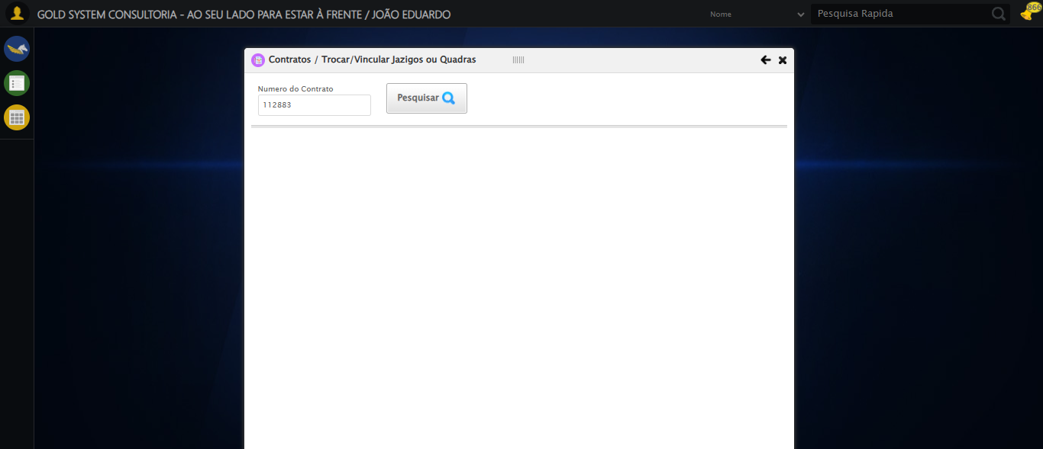
[16:12:03] INFO: Executando: Clicando em todos os botões 'Pesquisar'
[16:12:03] INFO: 🔍 Foram encontrados 1 botão(ões) 'Pesquisar' na tela.
[16:12:03] INFO: 🎯 Clicando no botão 'Pesquisar' (índice 1/1)...
[16:12:03] INFO: 🎯 Clique forçado em: (//a[contains(@class,'btModel btGray') and contains(normalize-space(.),'Pesquisar')])[1]
[16:12:03] INFO: ✅ Clique bem-sucedido (estratégia 1)
[16:12:18] INFO: ✅ Clique no botão 'Pesquisar' (índice 1) realizado com sucesso.
[16:12:19] INFO: 🧾 Resumo: 1/1 botões 'Pesquisar' clicados com sucesso.
[16:12:19] INFO: ✅ Clicando em todos os botões 'Pesquisar' - Sucesso
Screenshot: clicando_em_todos_os_botões_'pesquisar'
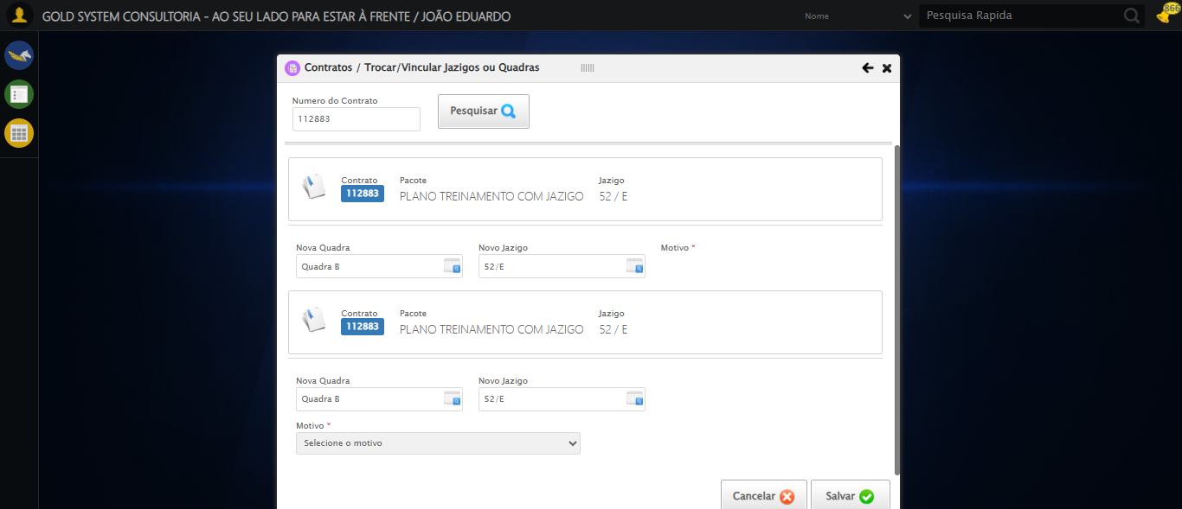
[16:12:24] INFO: Executando: Alterando Quadra
[16:12:24] INFO: ℹ️ 🔍 LOV sequencial | filtro='None' | pesquisa='QUADRA TESTE SELENIUM AUTOMATIZADO' | índice atual=0
[16:12:24] INFO: 🔍 🔎 Localizando botão LOV: (//a[@class='sprites sp-openLov'])[1]
[16:12:24] INFO: ℹ️ ℹ️ Abrindo LOV...
[16:12:24] INFO: 🔍 Tentativa 1/10: Clique Padrão
[16:12:24] INFO: ✅ ✓ Clique Padrão funcionou!
[16:12:26] INFO: ✅ Preenchidos 1 campos de pesquisa
[16:12:38] INFO: ❌ Tentativa 1 falhou: Message:
Stacktrace:
Symbols not available. Dumping unresolved backtrace:
0xbe4103
0xbe4144
0x9ee71d
0xa3a03d
0xa3
[16:12:40] INFO: 🔍 🔎 Localizando botão LOV: (//a[@class='sprites sp-openLov'])[1]
[16:12:40] INFO: ℹ️ ℹ️ Abrindo LOV...
[16:12:40] INFO: 🔍 Tentativa 1/10: Clique Padrão
[16:12:41] INFO: 🔍 ✗ Clique Padrão: Message: element click intercepted: Element <a cla
[16:12:41] INFO: 🔍 Tentativa 1/10: JavaScript Simples
[16:12:41] INFO: ✅ ✓ JavaScript Simples funcionou!
[16:12:43] INFO: ✅ Preenchidos 1 campos de pesquisa
[16:12:54] INFO: ❌ Tentativa 2 falhou: Message:
Stacktrace:
Symbols not available. Dumping unresolved backtrace:
0xbe4103
0xbe4144
0x9ee71d
0xa3a03d
0xa3
[16:12:58] INFO: 🔍 🔎 Localizando botão LOV: (//a[@class='sprites sp-openLov'])[1]
[16:12:59] INFO: ℹ️ ℹ️ Abrindo LOV...
[16:12:59] INFO: 🔍 Tentativa 1/10: Clique Padrão
[16:13:00] INFO: 🔍 ✗ Clique Padrão: Message: element click intercepted: Element <a cla
[16:13:00] INFO: 🔍 Tentativa 1/10: JavaScript Simples
[16:13:00] INFO: ✅ ✓ JavaScript Simples funcionou!
[16:13:02] INFO: ✅ Preenchidos 1 campos de pesquisa
[16:13:13] INFO: ❌ Tentativa 3 falhou: Message:
Stacktrace:
Symbols not available. Dumping unresolved backtrace:
0xbe4103
0xbe4144
0x9ee71d
0xa3a03d
0xa3
[16:13:19] INFO: 🔍 🔎 Localizando botão LOV: (//a[@class='sprites sp-openLov'])[1]
[16:13:19] INFO: ℹ️ ℹ️ Abrindo LOV...
[16:13:19] INFO: 🔍 Tentativa 1/10: Clique Padrão
[16:13:20] INFO: 🔍 ✗ Clique Padrão: Message: element click intercepted: Element <a cla
[16:13:20] INFO: 🔍 Tentativa 1/10: JavaScript Simples
[16:13:21] INFO: ✅ ✓ JavaScript Simples funcionou!
[16:13:23] INFO: ✅ Preenchidos 1 campos de pesquisa
[16:13:34] INFO: ❌ Tentativa 4 falhou: Message:
Stacktrace:
Symbols not available. Dumping unresolved backtrace:
0xbe4103
0xbe4144
0x9ee71d
0xa3a03d
0xa3
[16:13:42] INFO: 🔍 🔎 Localizando botão LOV: (//a[@class='sprites sp-openLov'])[1]
[16:13:42] INFO: ℹ️ ℹ️ Abrindo LOV...
[16:13:42] INFO: 🔍 Tentativa 1/10: Clique Padrão
[16:13:43] INFO: 🔍 ✗ Clique Padrão: Message: element click intercepted: Element <a cla
[16:13:43] INFO: 🔍 Tentativa 1/10: JavaScript Simples
[16:13:43] INFO: ✅ ✓ JavaScript Simples funcionou!
[16:13:45] INFO: ✅ Preenchidos 1 campos de pesquisa
[16:13:57] INFO: ❌ Tentativa 5 falhou: Message:
Stacktrace:
Symbols not available. Dumping unresolved backtrace:
0xbe4103
0xbe4144
0x9ee71d
0xa3a03d
0xa3
[16:13:57] INFO: ❌ ❌ LOV falhou após 5 tentativas.
[16:13:57] INFO: ✅ Alterando Quadra - Sucesso
Screenshot: alterando_quadra
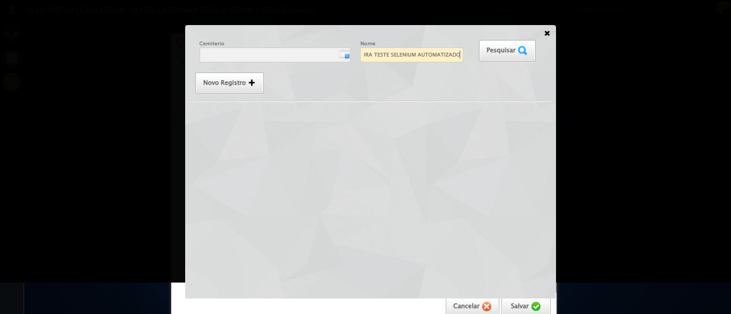
[16:13:57] INFO: Executando: Selecionando jazigo por Número
[16:13:57] INFO: ℹ️ 🔍 LOV sequencial | filtro='None' | pesquisa='1' | índice atual=0
[16:13:57] INFO: 🔍 🔎 Localizando botão LOV: (//a[@class='sprites sp-openLov'])[2]
[16:13:57] INFO: ℹ️ ℹ️ Abrindo LOV...
[16:13:57] INFO: 🔍 Tentativa 1/10: Clique Padrão
[16:13:58] INFO: 🔍 ✗ Clique Padrão: Message: element click intercepted: Element <a cla
[16:13:58] INFO: 🔍 Tentativa 1/10: JavaScript Simples
[16:13:58] INFO: ✅ ✓ JavaScript Simples funcionou!
[16:14:00] INFO: ✅ Preenchidos 1 campos de pesquisa
[16:14:12] INFO: ❌ Tentativa 1 falhou: Message:
Stacktrace:
Symbols not available. Dumping unresolved backtrace:
0xbe4103
0xbe4144
0x9ee71d
0xa3a03d
0xa3
[16:14:14] INFO: 🔍 🔎 Localizando botão LOV: (//a[@class='sprites sp-openLov'])[2]
[16:14:14] INFO: ℹ️ ℹ️ Abrindo LOV...
[16:14:14] INFO: 🔍 Tentativa 1/10: Clique Padrão
[16:14:15] INFO: 🔍 ✗ Clique Padrão: Message: element click intercepted: Element <a cla
[16:14:15] INFO: 🔍 Tentativa 1/10: JavaScript Simples
[16:14:15] INFO: ✅ ✓ JavaScript Simples funcionou!
[16:14:17] INFO: ✅ Preenchidos 1 campos de pesquisa
[16:14:29] INFO: ❌ Tentativa 2 falhou: Message:
Stacktrace:
Symbols not available. Dumping unresolved backtrace:
0xbe4103
0xbe4144
0x9ee71d
0xa3a03d
0xa3
[16:14:33] INFO: 🔍 🔎 Localizando botão LOV: (//a[@class='sprites sp-openLov'])[2]
[16:14:33] INFO: ℹ️ ℹ️ Abrindo LOV...
[16:14:33] INFO: 🔍 Tentativa 1/10: Clique Padrão
[16:14:34] INFO: 🔍 ✗ Clique Padrão: Message: element click intercepted: Element <a cla
[16:14:34] INFO: 🔍 Tentativa 1/10: JavaScript Simples
[16:14:34] INFO: ✅ ✓ JavaScript Simples funcionou!
[16:14:36] INFO: ✅ Preenchidos 1 campos de pesquisa
[16:14:47] INFO: ❌ Tentativa 3 falhou: Message:
Stacktrace:
Symbols not available. Dumping unresolved backtrace:
0xbe4103
0xbe4144
0x9ee71d
0xa3a03d
0xa3
[16:14:53] INFO: 🔍 🔎 Localizando botão LOV: (//a[@class='sprites sp-openLov'])[2]
[16:14:53] INFO: ℹ️ ℹ️ Abrindo LOV...
[16:14:53] INFO: 🔍 Tentativa 1/10: Clique Padrão
[16:14:54] INFO: 🔍 ✗ Clique Padrão: Message: element click intercepted: Element <a cla
[16:14:54] INFO: 🔍 Tentativa 1/10: JavaScript Simples
[16:14:54] INFO: ✅ ✓ JavaScript Simples funcionou!
[16:14:56] INFO: ✅ Preenchidos 1 campos de pesquisa
[16:15:08] INFO: ℹ️ 🔁 Reforçando clique no resultado (5x)
[16:15:08] INFO: 🔍 Reforço 1/5
[16:15:08] INFO: 🔍 Tentativa 1/10: Clique Padrão
[16:15:08] INFO: 🔍 ✗ Clique Padrão: Message: element not interactable
(Session info:
[16:15:08] INFO: 🔍 Tentativa 1/10: JavaScript Simples
[16:15:09] INFO: ✅ ✓ JavaScript Simples funcionou!
[16:15:09] INFO: ⚠️ Erro no reforço 2: Message: no such element: Unable to locate element
[16:15:09] INFO: ⚠️ Erro no reforço 3: Message: no such element: Unable to locate element
[16:15:10] INFO: ⚠️ Erro no reforço 4: Message: no such element: Unable to locate element
[16:15:10] INFO: ⚠️ Erro no reforço 5: Message: no such element: Unable to locate element
[16:15:10] INFO: ✅ ✅ Reforço de cliques concluído
[16:15:11] INFO: ✅ ✅ LOV concluído com sucesso (linha índice 0)
[16:15:11] INFO: ✅ Selecionando jazigo por Número - Sucesso
[16:15:11] ERROR: ❌ Erro inesperado em Selecionando jazigo por Número: Message: target frame detached
(failed to check if window was closed: disconnected: Unable to receive message from renderer)
(Session info: chrome=142.0.7444.176)
Stacktrace:
Symbols not available. Dumping unresolved backtrace:
0xbe4103
0xbe4144
0x9ee56b
0x9de91d
0x9ddaca
0x9fc714
0x9fba11
0xa7ed26
0xa5c706
0xa2da30
0xa2ed54
0xe557b4
0xe5098a
0xc0c392
0xbfc4c8
0xc0324d
0xbec478
0xbec63c
0xbd67ca
0x75ebfcc9
0x76f682ae
0x76f6827e
[16:15:12] INFO: ❌ ERRO FATAL: Message: invalid session id: session deleted as the browser has closed the connection
from disconnected: not connected to DevTools
(Session info: chrome=142.0.7444.176); For documentation on this error, please visit: https://www.selenium.dev/documentation/webdriver/troubleshooting/errors#invalidsessionidexception
Stacktrace:
Symbols not available. Dumping unresolved backtrace:
0xbe4103
0xbe4144
0x9ee71d
0x9dd910
0x9fc714
0xa63475
0xa7e749
0xa5c706
0xa2da30
0xa2ed54
0xe557b4
0xe5098a
0xc0c392
0xbfc4c8
0xc0324d
0xbec478
0xbec63c
0xbd67ca
0x75ebfcc9
0x76f682ae
0x76f6827e
[16:15:12] INFO: ✅ Teste concluído com sucesso.

