RELATÓRIO DO TESTE
Controle de Caixa - Caixa – Cenário 2: Rotina parcial de Fluxo de Caixa ⭢ Retirada do Caixa, Estorno de Venda, e Estorno Retirada
Data do teste: 06/11/2025 14:55:53
🚀 Iniciando teste de Fluxo de Caixa
======================================================================
✅ Driver inicializado com sucesso
🔄 Acessando sistema...
✅ Acessando sistema realizada com sucesso.
Screenshot: acessando sistema
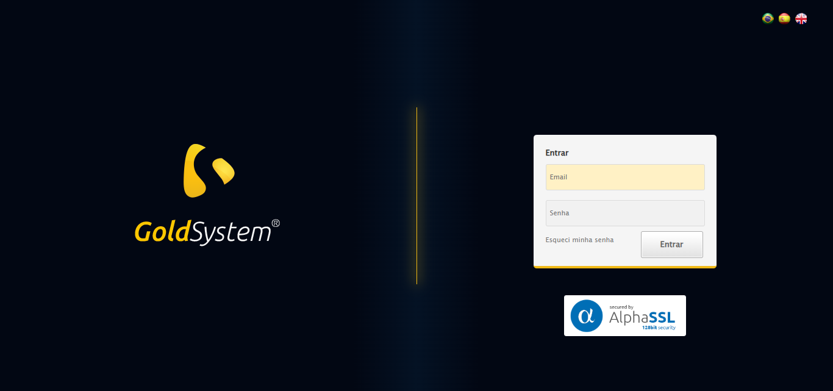
🔄 Realizando login...
✅ Realizando login realizada com sucesso.
⚠️ Erro ao tirar screenshot realizando login: Message: target frame detached
(failed to check if window was closed: disconnected: Unable to receive message from renderer)
(Session info: chrome=142.0.7444.60)
Stacktrace:
Symbols not available. Dumping unresolved backtrace:
0xf058d3
0xf05914
0xd1e5bb
0xd0e98d
0xd0db3a
0xd2c734
0xd2ba31
0xd2bb77
0xdaedb5
0xd8c766
0xd5dac0
0xd5ede4
0x1187974
0x1182bea
0xf2e5c4
0xf1dd38
0xf24d9d
0xf0dee8
0xf0e0ac
0xef7d2a
0x774dfcc9
0x776282ae
0x7762827e
❌ ERRO FATAL: Message: invalid session id: session deleted as the browser has closed the connection
from disconnected: not connected to DevTools
(Session info: chrome=142.0.7444.60); For documentation on this error, please visit: https://www.selenium.dev/documentation/webdriver/troubleshooting/errors#invalidsessionidexception
Stacktrace:
Symbols not available. Dumping unresolved backtrace:
0xf058d3
0xf05914
0xd1e76d
0xd0d980
0xd2c734
0xd934c5
0xdae799
0xd8c766
0xd5dac0
0xd5ede4
0x1187974
0x1182bea
0xf2e5c4
0xf1dd38
0xf24d9d
0xf0dee8
0xf0e0ac
0xef7d2a
0x774dfcc9
0x776282ae
0x7762827e
⚠️ Erro ao tirar screenshot erro_fatal: Message: invalid session id; For documentation on this error, please visit: https://www.selenium.dev/documentation/webdriver/troubleshooting/errors#invalidsessionidexception
Stacktrace:
Symbols not available. Dumping unresolved backtrace:
0xf058d3
0xf05914
0xd1e5bb
0xd5ceea
0xd8c826
0xd88090
0xd875c3
0xcee4ed
0xceea7e
0xceef3d
0x1187974
0x1182bea
0xf2e5c4
0xf1dd38
0xf24d9d
0xcee1a3
0xced858
0x12dffdf
0x774dfcc9
0x776282ae
0x7762827e
======================================================================
❌ TESTE FINALIZADO COM ERROS

