RELATÓRIO DO TESTE
Adição de Titulares e Dependentes – Cenário 1: Preenchimento completo e salvamento.
Data do teste: 24/11/2025 17:18:58
🔄 Acessando sistema...
✅ Acessando sistema realizada com sucesso.
Screenshot: acessando_sistema
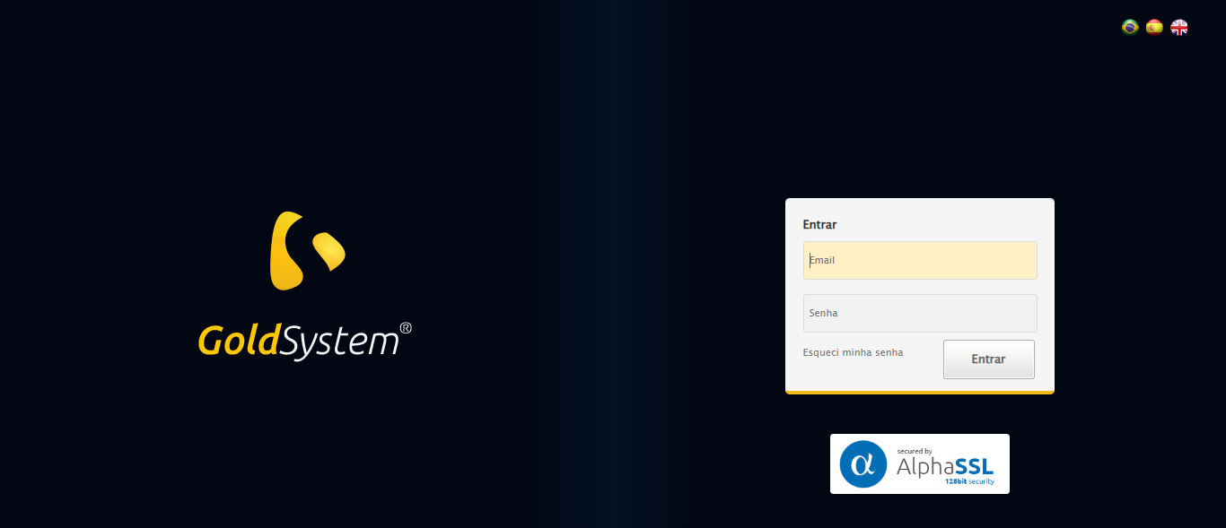
🔄 Realizando login...
✅ Realizando login realizada com sucesso.
Screenshot: realizando_login
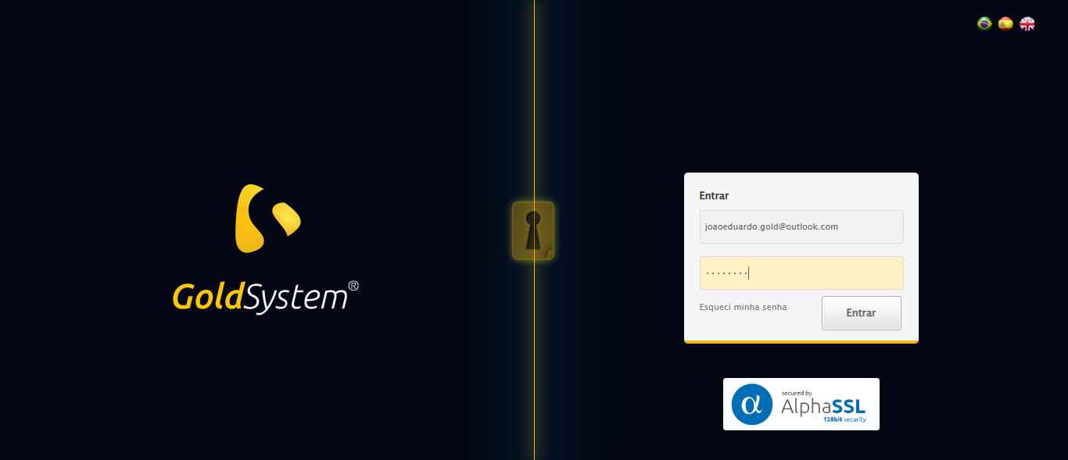
🔄 Esperando sistema carregar e ajustando zoom...
⚠️ Erro ao ajustar zoom: Message: target frame detached
(failed to check if window was closed: disconnected: Unable to receive message from renderer)
(Session info: chrome=142.0.7444.163)
Stacktrace:
Symbols not available. Dumping unresolved backtrace:
0x8c4103
0x8c4144
0x6ce56b
0x6be91d
0x6bdaca
0x6dc714
0x6dba11
0x75ed26
0x73c706
0x70da30
0x70ed54
0xb357b4
0xb3098a
0x8ec392
0x8dc4c8
0x8e324d
0x8cc478
0x8cc63c
0x8b67ca
0x75ebfcc9
0x76f682ae
0x76f6827e
✅ Esperando sistema carregar e ajustando zoom realizada com sucesso.
❌ Erro ao esperando sistema carregar e ajustando zoom: Message: invalid session id: session deleted as the browser has closed the connection
from disconnected: not connected to DevTools
(Session info: chrome=142.0.7444.163); For documentation on this error, please visit: https://www.selenium.dev/documentation/webdriver/troubleshooting/errors#invalidsessionidexception
Stacktrace:
Symbols not available. Dumping unresolved backtrace:
0x8c4103
0x8c4144
0x6ce71d
0x6bd910
0x6dc714
0x743475
0x75e749
0x73c706
0x70da30
0x70ed54
0xb357b4
0xb3098a
0x8ec392
0x8dc4c8
0x8e324d
0x8cc478
0x8cc63c
0x8b67ca
0x75ebfcc9
0x76f682ae
0x76f6827e
❌ ERRO FATAL: Message: invalid session id; For documentation on this error, please visit: https://www.selenium.dev/documentation/webdriver/troubleshooting/errors#invalidsessionidexception
Stacktrace:
Symbols not available. Dumping unresolved backtrace:
0x8c4103
0x8c4144
0x6ce56b
0x70ce58
0x73c7c6
0x738030
0x737563
0x69e4dd
0x69ea6e
0x69ef3d
0xb357b4
0xb3098a
0x8ec392
0x8dc4c8
0x8e324d
0x69e193
0x69d848
0xc8b0cf
0x75ebfcc9
0x76f682ae
0x76f6827e
✅ Teste concluído com sucesso.

