RELATÓRIO DO TESTE
Cadastro de Agenda de Ambulância – Cenário 1: Preenchimento completo e salvamento.
Data do teste: 14/11/2025 11:07:25
🚀 Iniciando teste de cadastro de Agenda de Ambulância...
🔄 Acessando sistema...
✅ Acessando sistema realizada com sucesso.
Screenshot: acessando_sistema

🔄 Realizando login...
✅ Realizando login realizada com sucesso.
Screenshot: realizando_login
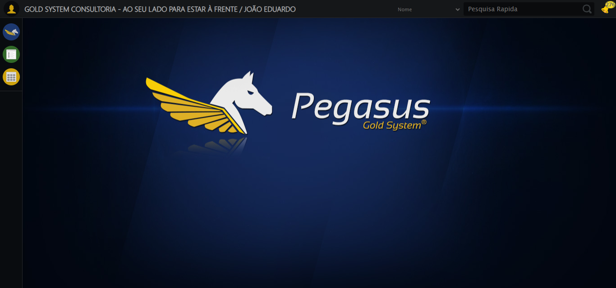
🔄 Ajustando zoom e abrindo menu...
🔍 Zoom ajustado para 90%.
✅ Ajustando zoom e abrindo menu realizada com sucesso.
Screenshot: ajustando_zoom_e_abrindo_menu
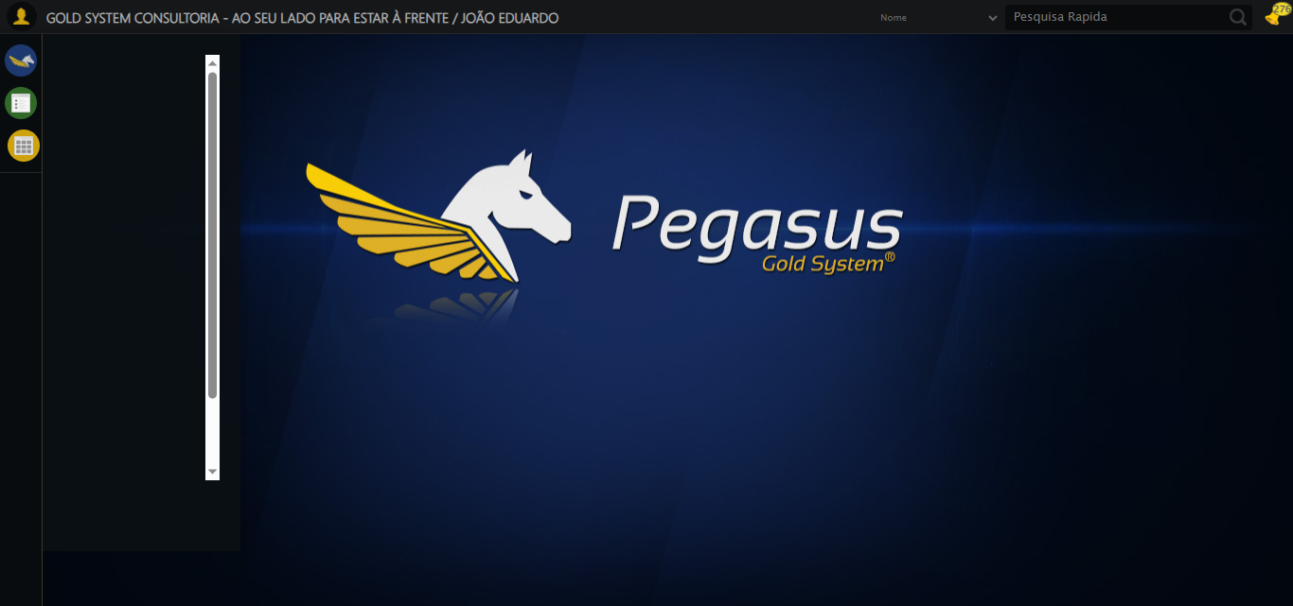
🔄 Acessando Agenda Ambulância...
✅ Acessando Agenda Ambulância realizada com sucesso.
Screenshot: acessando_agenda_ambulância
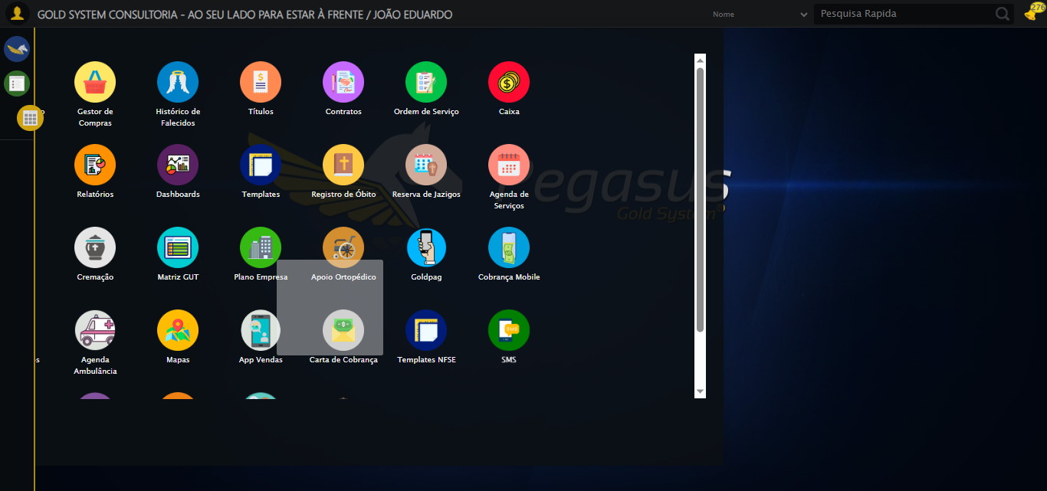
🔄 Clicando em Cadastrar...
✅ Clicando em Cadastrar realizada com sucesso.
Screenshot: clicando_em_cadastrar
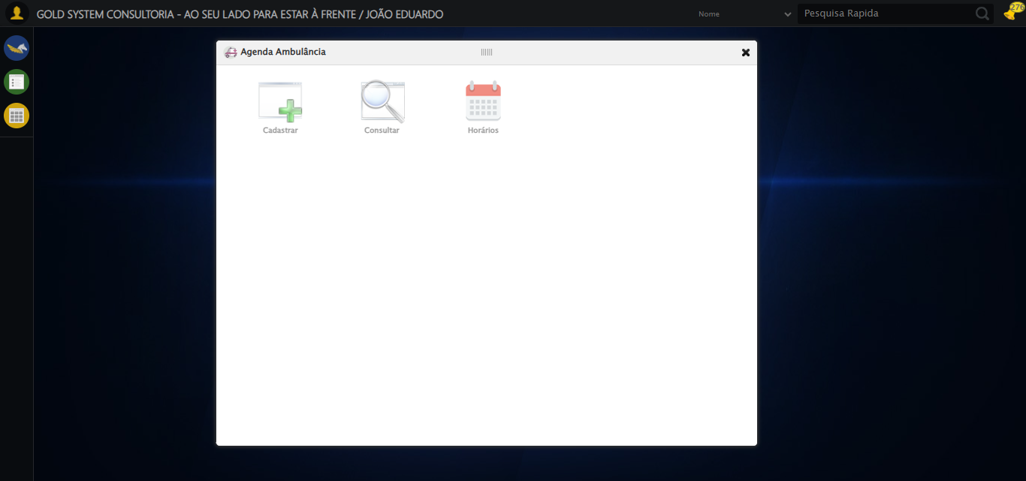
🔄 Preenchendo Número do Contrato...
✅ Preenchendo Número do Contrato realizada com sucesso.
Screenshot: preenchendo_número_do_contrato
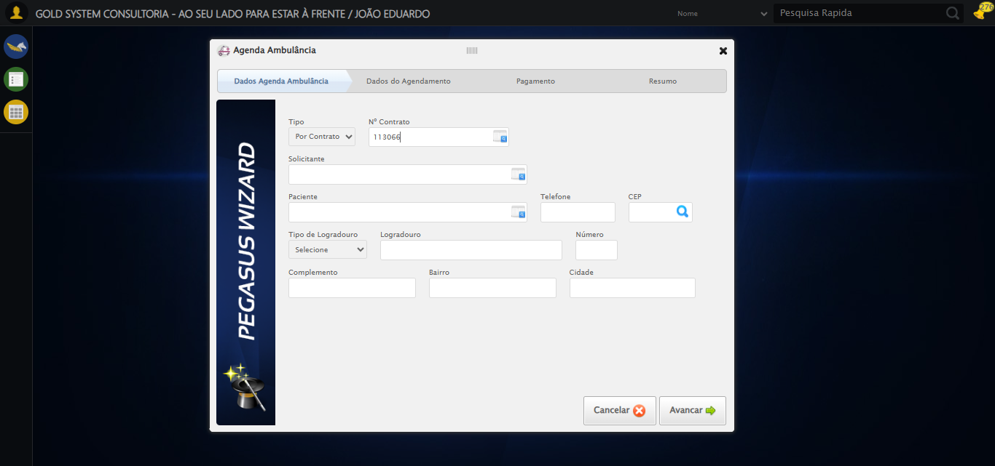
🔄 Selecionando Paciente...
✅ Selecionando Paciente realizada com sucesso.
Screenshot: selecionando_paciente
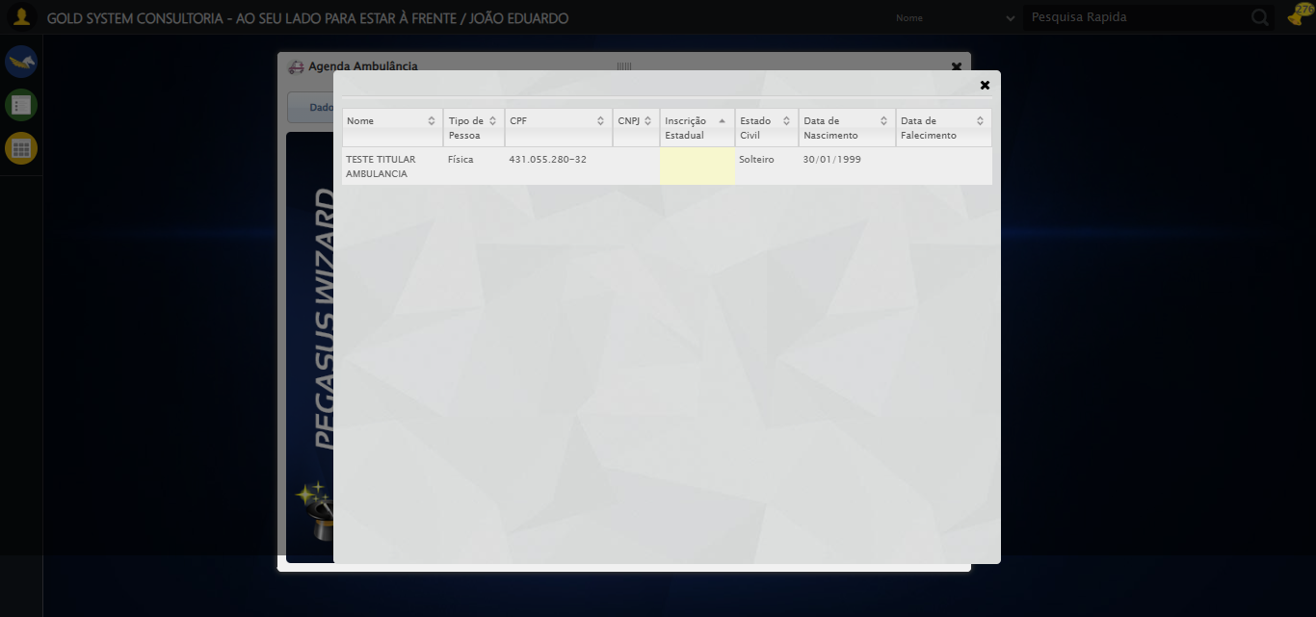
⚠️ Tentativa 1 falhou: Message: element click intercepted: Element <input type="text" style="width: 100px"> is not clickable at point (793, 292). Other element would receive the click: <div class="modal overflow" style="z-index: 10002; left: 50%; top: 50%; width: 750px; height: 550px; margin-left: -375px; margin-top: -275px;">...</div>
(Session info: chrome=142.0.7444.60); For documentation on this error, please visit: https://www.selenium.dev/documentation/webdriver/troubleshooting/errors#elementclickinterceptedexception
Stacktrace:
Symbols not available. Dumping unresolved backtrace:
0x414093
0x4140d4
0x21e71d
0x270580
0x26e8e3
0x26c387
0x26b5fd
0x25fd65
0x28c90c
0x25f7c4
0x28cac4
0x2aee17
0x28c706
0x25da30
0x25ed54
0x685744
0x68091a
0x43c322
0x42c458
0x4331dd
0x41c408
0x41c5cc
0x40675a
0x762afcc9
0x77a782ae
0x77a7827e
🔄 Preenchendo Telefone...
❌ Erro inesperado ao preenchendo telefone: 'bool' object is not callable
Screenshot: erro_preenchendo_telefone
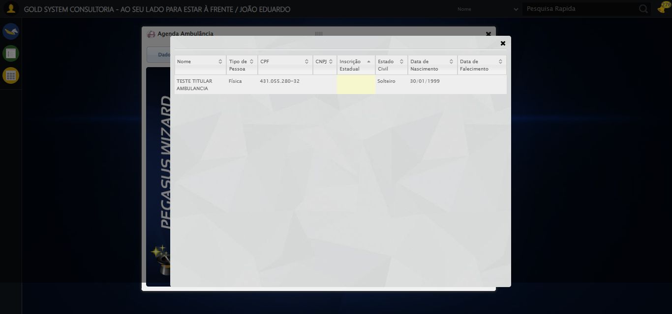
🔄 Preenchendo Complemento...
✅ Preenchendo Complemento realizada com sucesso.
Screenshot: preenchendo_complemento
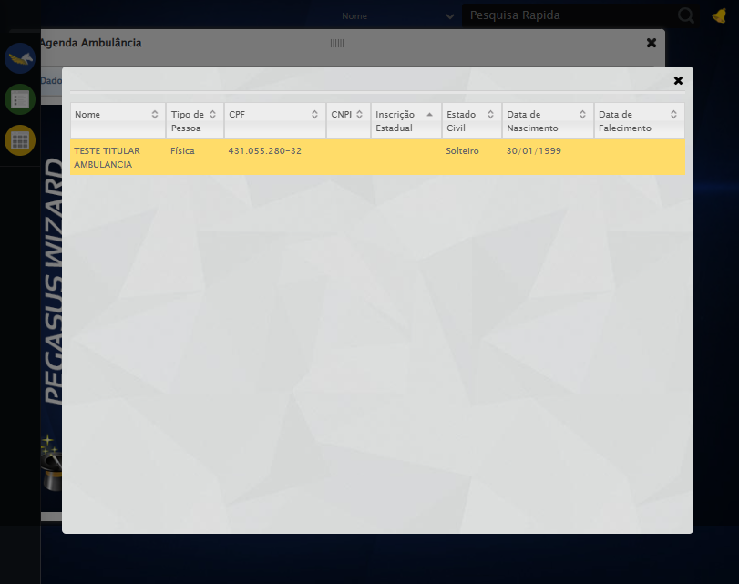
🔄 Avançando para próxima etapa...
❌ Erro inesperado ao avançando para próxima etapa: Message: element click intercepted: Element <a class="btModel btGray" style="display: inline-block;">...</a> is not clickable at point (673, 542). Other element would receive the click: <div class="modal overflow" style="z-index: 10002; left: 50%; top: 50%; width: 750px; height: 550px; margin-left: -375px; margin-top: -275px;">...</div>
(Session info: chrome=142.0.7444.60); For documentation on this error, please visit: https://www.selenium.dev/documentation/webdriver/troubleshooting/errors#elementclickinterceptedexception
Stacktrace:
Symbols not available. Dumping unresolved backtrace:
0x414093
0x4140d4
0x21e71d
0x270580
0x26e8e3
0x26c387
0x26b5fd
0x25fd65
0x28c90c
0x25f7c4
0x28cac4
0x2aee17
0x28c706
0x25da30
0x25ed54
0x685744
0x68091a
0x43c322
0x42c458
0x4331dd
0x41c408
0x41c5cc
0x40675a
0x762afcc9
0x77a782ae
0x77a7827e
Screenshot: erro_avançando_para_próxima_etapa
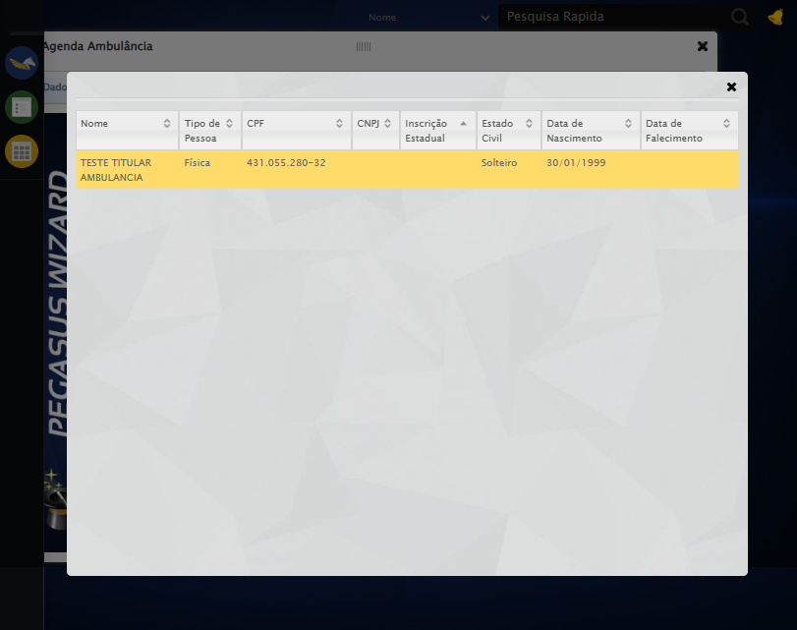
🔄 Clicando no Lov para consultar um motorista...
⚠️ Tentativa 1 falhou para Clicando no Lov para consultar um motorista, tentando novamente...
🔄 Clicando no Lov para consultar um motorista... (Tentativa 2)
❌ Erro inesperado ao clicando no lov para consultar um motorista: 'NoneType' object has no attribute 'is_displayed'
⚠️ Erro ao tirar screenshot erro_clicando_no_lov_para_consultar_um_motorista: Message: no such window: target window already closed
from unknown error: web view not found
(Session info: chrome=142.0.7444.60)
Stacktrace:
Symbols not available. Dumping unresolved backtrace:
0x414093
0x4140d4
0x21e71d
0x1fc32d
0x29329e
0x2ae749
0x28c706
0x25da30
0x25ed54
0x685744
0x68091a
0x43c322
0x42c458
0x4331dd
0x41c408
0x41c5cc
0x40675a
0x762afcc9
0x77a782ae
0x77a7827e
🔄 Selecionando segundo motorista da lista...
❌ Erro inesperado ao selecionando segundo motorista da lista: Message: no such window: target window already closed
from unknown error: web view not found
(Session info: chrome=142.0.7444.60)
Stacktrace:
Symbols not available. Dumping unresolved backtrace:
0x414093
0x4140d4
0x21e71d
0x1fc32d
0x29329e
0x2ae749
0x28c706
0x25da30
0x25ed54
0x685744
0x68091a
0x43c322
0x42c458
0x4331dd
0x41c408
0x41c5cc
0x40675a
0x762afcc9
0x77a782ae
0x77a7827e
⚠️ Erro ao tirar screenshot erro_selecionando_segundo_motorista_da_lista: Message: no such window: target window already closed
from unknown error: web view not found
(Session info: chrome=142.0.7444.60)
Stacktrace:
Symbols not available. Dumping unresolved backtrace:
0x414093
0x4140d4
0x21e71d
0x1fc32d
0x29329e
0x2ae749
0x28c706
0x25da30
0x25ed54
0x685744
0x68091a
0x43c322
0x42c458
0x4331dd
0x41c408
0x41c5cc
0x40675a
0x762afcc9
0x77a782ae
0x77a7827e
🔄 Preenchendo Nome do Acompanhante...
❌ Erro ao interagir com elemento #gsAgendaAmbulancia > div.wdTelas > div.wdWizard.clearfix.telaConsulta > div.wizardHolder > div > div.step2 > div:nth-child(2) > div:nth-child(6) > input[type=text]: Message: no such window: target window already closed
from unknown error: web view not found
(Session info: chrome=142.0.7444.60)
Stacktrace:
Symbols not available. Dumping unresolved backtrace:
0x414093
0x4140d4
0x21e71d
0x1fc32d
0x29329e
0x2ae749
0x28c706
0x25da30
0x25ed54
0x685744
0x68091a
0x43c322
0x42c458
0x4331dd
0x41c408
0x41c5cc
0x40675a
0x762afcc9
0x77a782ae
0x77a7827e
❌ Erro inesperado ao preenchendo nome do acompanhante: Não foi possível encontrar o elemento: #gsAgendaAmbulancia > div.wdTelas > div.wdWizard.clearfix.telaConsulta > div.wizardHolder > div > div.step2 > div:nth-child(2) > div:nth-child(6) > input[type=text]
⚠️ Erro ao tirar screenshot erro_preenchendo_nome_do_acompanhante: Message: no such window: target window already closed
from unknown error: web view not found
(Session info: chrome=142.0.7444.60)
Stacktrace:
Symbols not available. Dumping unresolved backtrace:
0x414093
0x4140d4
0x21e71d
0x1fc32d
0x29329e
0x2ae749
0x28c706
0x25da30
0x25ed54
0x685744
0x68091a
0x43c322
0x42c458
0x4331dd
0x41c408
0x41c5cc
0x40675a
0x762afcc9
0x77a782ae
0x77a7827e
🔄 Preenchendo Local Transporte...
❌ Erro ao interagir com elemento #gsAgendaAmbulancia > div.wdTelas > div.wdWizard.clearfix.telaConsulta > div.wizardHolder > div > div.step2 > div:nth-child(2) > div:nth-child(7) > input[type=text]: Message: no such window: target window already closed
from unknown error: web view not found
(Session info: chrome=142.0.7444.60)
Stacktrace:
Symbols not available. Dumping unresolved backtrace:
0x414093
0x4140d4
0x21e71d
0x1fc32d
0x29329e
0x2ae749
0x28c706
0x25da30
0x25ed54
0x685744
0x68091a
0x43c322
0x42c458
0x4331dd
0x41c408
0x41c5cc
0x40675a
0x762afcc9
0x77a782ae
0x77a7827e
❌ Erro inesperado ao preenchendo local transporte: Não foi possível encontrar o elemento: #gsAgendaAmbulancia > div.wdTelas > div.wdWizard.clearfix.telaConsulta > div.wizardHolder > div > div.step2 > div:nth-child(2) > div:nth-child(7) > input[type=text]
⚠️ Erro ao tirar screenshot erro_preenchendo_local_transporte: Message: no such window: target window already closed
from unknown error: web view not found
(Session info: chrome=142.0.7444.60)
Stacktrace:
Symbols not available. Dumping unresolved backtrace:
0x414093
0x4140d4
0x21e71d
0x1fc32d
0x29329e
0x2ae749
0x28c706
0x25da30
0x25ed54
0x685744
0x68091a
0x43c322
0x42c458
0x4331dd
0x41c408
0x41c5cc
0x40675a
0x762afcc9
0x77a782ae
0x77a7827e
🔄 Preenchendo Cidade Transporte...
❌ Erro ao interagir com elemento #gsAgendaAmbulancia > div.wdTelas > div.wdWizard.clearfix.telaConsulta > div.wizardHolder > div > div.step2 > div:nth-child(2) > div:nth-child(8) > input: Message: no such window: target window already closed
from unknown error: web view not found
(Session info: chrome=142.0.7444.60)
Stacktrace:
Symbols not available. Dumping unresolved backtrace:
0x414093
0x4140d4
0x21e71d
0x1fc32d
0x29329e
0x2ae749
0x28c706
0x25da30
0x25ed54
0x685744
0x68091a
0x43c322
0x42c458
0x4331dd
0x41c408
0x41c5cc
0x40675a
0x762afcc9
0x77a782ae
0x77a7827e
❌ Erro inesperado ao preenchendo cidade transporte: Não foi possível encontrar o elemento: #gsAgendaAmbulancia > div.wdTelas > div.wdWizard.clearfix.telaConsulta > div.wizardHolder > div > div.step2 > div:nth-child(2) > div:nth-child(8) > input
⚠️ Erro ao tirar screenshot erro_preenchendo_cidade_transporte: Message: no such window: target window already closed
from unknown error: web view not found
(Session info: chrome=142.0.7444.60)
Stacktrace:
Symbols not available. Dumping unresolved backtrace:
0x414093
0x4140d4
0x21e71d
0x1fc32d
0x29329e
0x2ae749
0x28c706
0x25da30
0x25ed54
0x685744
0x68091a
0x43c322
0x42c458
0x4331dd
0x41c408
0x41c5cc
0x40675a
0x762afcc9
0x77a782ae
0x77a7827e
🔄 Preenchendo Retorno...
❌ Erro ao interagir com elemento #gsAgendaAmbulancia > div.wdTelas > div.wdWizard.clearfix.telaConsulta > div.wizardHolder > div > div.step2 > div:nth-child(2) > div:nth-child(9) > input[type=text]: Message: no such window: target window already closed
from unknown error: web view not found
(Session info: chrome=142.0.7444.60)
Stacktrace:
Symbols not available. Dumping unresolved backtrace:
0x414093
0x4140d4
0x21e71d
0x1fc32d
0x29329e
0x2ae749
0x28c706
0x25da30
0x25ed54
0x685744
0x68091a
0x43c322
0x42c458
0x4331dd
0x41c408
0x41c5cc
0x40675a
0x762afcc9
0x77a782ae
0x77a7827e
❌ Erro inesperado ao preenchendo retorno: Não foi possível encontrar o elemento: #gsAgendaAmbulancia > div.wdTelas > div.wdWizard.clearfix.telaConsulta > div.wizardHolder > div > div.step2 > div:nth-child(2) > div:nth-child(9) > input[type=text]
⚠️ Erro ao tirar screenshot erro_preenchendo_retorno: Message: no such window: target window already closed
from unknown error: web view not found
(Session info: chrome=142.0.7444.60)
Stacktrace:
Symbols not available. Dumping unresolved backtrace:
0x414093
0x4140d4
0x21e71d
0x1fc32d
0x29329e
0x2ae749
0x28c706
0x25da30
0x25ed54
0x685744
0x68091a
0x43c322
0x42c458
0x4331dd
0x41c408
0x41c5cc
0x40675a
0x762afcc9
0x77a782ae
0x77a7827e
🔄 Preenchendo Observação...
❌ Erro ao interagir com elemento #gsAgendaAmbulancia > div.wdTelas > div.wdWizard.clearfix.telaConsulta > div.wizardHolder > div > div.step2 > div:nth-child(3) > div:nth-child(1) > textarea: Message: no such window: target window already closed
from unknown error: web view not found
(Session info: chrome=142.0.7444.60)
Stacktrace:
Symbols not available. Dumping unresolved backtrace:
0x414093
0x4140d4
0x21e71d
0x1fc32d
0x29329e
0x2ae749
0x28c706
0x25da30
0x25ed54
0x685744
0x68091a
0x43c322
0x42c458
0x4331dd
0x41c408
0x41c5cc
0x40675a
0x762afcc9
0x77a782ae
0x77a7827e
❌ Erro inesperado ao preenchendo observação: Não foi possível encontrar o elemento: #gsAgendaAmbulancia > div.wdTelas > div.wdWizard.clearfix.telaConsulta > div.wizardHolder > div > div.step2 > div:nth-child(3) > div:nth-child(1) > textarea
⚠️ Erro ao tirar screenshot erro_preenchendo_observação: Message: no such window: target window already closed
from unknown error: web view not found
(Session info: chrome=142.0.7444.60)
Stacktrace:
Symbols not available. Dumping unresolved backtrace:
0x414093
0x4140d4
0x21e71d
0x1fc32d
0x29329e
0x2ae749
0x28c706
0x25da30
0x25ed54
0x685744
0x68091a
0x43c322
0x42c458
0x4331dd
0x41c408
0x41c5cc
0x40675a
0x762afcc9
0x77a782ae
0x77a7827e
🔄 Preenchendo Situação do Paciente...
❌ Erro ao interagir com elemento #gsAgendaAmbulancia > div.wdTelas > div.wdWizard.clearfix.telaConsulta > div.wizardHolder > div > div.step2 > div:nth-child(3) > div:nth-child(2) > textarea: Message: no such window: target window already closed
from unknown error: web view not found
(Session info: chrome=142.0.7444.60)
Stacktrace:
Symbols not available. Dumping unresolved backtrace:
0x414093
0x4140d4
0x21e71d
0x1fc32d
0x29329e
0x2ae749
0x28c706
0x25da30
0x25ed54
0x685744
0x68091a
0x43c322
0x42c458
0x4331dd
0x41c408
0x41c5cc
0x40675a
0x762afcc9
0x77a782ae
0x77a7827e
❌ Erro inesperado ao preenchendo situação do paciente: Não foi possível encontrar o elemento: #gsAgendaAmbulancia > div.wdTelas > div.wdWizard.clearfix.telaConsulta > div.wizardHolder > div > div.step2 > div:nth-child(3) > div:nth-child(2) > textarea
⚠️ Erro ao tirar screenshot erro_preenchendo_situação_do_paciente: Message: no such window: target window already closed
from unknown error: web view not found
(Session info: chrome=142.0.7444.60)
Stacktrace:
Symbols not available. Dumping unresolved backtrace:
0x414093
0x4140d4
0x21e71d
0x1fc32d
0x29329e
0x2ae749
0x28c706
0x25da30
0x25ed54
0x685744
0x68091a
0x43c322
0x42c458
0x4331dd
0x41c408
0x41c5cc
0x40675a
0x762afcc9
0x77a782ae
0x77a7827e
🔄 Avançando para próxima etapa...
❌ Erro inesperado ao avançando para próxima etapa: Message: no such window: target window already closed
from unknown error: web view not found
(Session info: chrome=142.0.7444.60)
Stacktrace:
Symbols not available. Dumping unresolved backtrace:
0x414093
0x4140d4
0x21e71d
0x1fc32d
0x29329e
0x2ae749
0x28c706
0x25da30
0x25ed54
0x685744
0x68091a
0x43c322
0x42c458
0x4331dd
0x41c408
0x41c5cc
0x40675a
0x762afcc9
0x77a782ae
0x77a7827e
🔄 Avançando para finalização...
❌ Erro inesperado ao avançando para finalização: Message: no such window: target window already closed
from unknown error: web view not found
(Session info: chrome=142.0.7444.60)
Stacktrace:
Symbols not available. Dumping unresolved backtrace:
0x414093
0x4140d4
0x21e71d
0x1fc32d
0x29329e
0x2ae749
0x28c706
0x25da30
0x25ed54
0x685744
0x68091a
0x43c322
0x42c458
0x4331dd
0x41c408
0x41c5cc
0x40675a
0x762afcc9
0x77a782ae
0x77a7827e
⚠️ Erro ao tirar screenshot erro_avançando_para_finalização: Message: no such window: target window already closed
from unknown error: web view not found
(Session info: chrome=142.0.7444.60)
Stacktrace:
Symbols not available. Dumping unresolved backtrace:
0x414093
0x4140d4
0x21e71d
0x1fc32d
0x29329e
0x2ae749
0x28c706
0x25da30
0x25ed54
0x685744
0x68091a
0x43c322
0x42c458
0x4331dd
0x41c408
0x41c5cc
0x40675a
0x762afcc9
0x77a782ae
0x77a7827e
🔄 Finalizando cadastro...
❌ Erro ao interagir com elemento #gsAgendaAmbulancia > div.wdTelas > div.wdWizard.clearfix.telaConsulta > div.btnHolder > div: Message: no such window: target window already closed
from unknown error: web view not found
(Session info: chrome=142.0.7444.60)
Stacktrace:
Symbols not available. Dumping unresolved backtrace:
0x414093
0x4140d4
0x21e71d
0x1fc32d
0x29329e
0x2ae749
0x28c706
0x25da30
0x25ed54
0x685744
0x68091a
0x43c322
0x42c458
0x4331dd
0x41c408
0x41c5cc
0x40675a
0x762afcc9
0x77a782ae
0x77a7827e
❌ Erro inesperado ao finalizando cadastro: Não foi possível clicar no elemento: #gsAgendaAmbulancia > div.wdTelas > div.wdWizard.clearfix.telaConsulta > div.btnHolder > div
⚠️ Erro ao tirar screenshot erro_finalizando_cadastro: Message: no such window: target window already closed
from unknown error: web view not found
(Session info: chrome=142.0.7444.60)
Stacktrace:
Symbols not available. Dumping unresolved backtrace:
0x414093
0x4140d4
0x21e71d
0x1fc32d
0x29329e
0x2ae749
0x28c706
0x25da30
0x25ed54
0x685744
0x68091a
0x43c322
0x42c458
0x4331dd
0x41c408
0x41c5cc
0x40675a
0x762afcc9
0x77a782ae
0x77a7827e
🔄 Fechando modal após o salvamento...
❌ Erro ao interagir com elemento #gsAgendaAmbulancia > div.wdTop.ui-draggable-handle > div > a: Message: no such window: target window already closed
from unknown error: web view not found
(Session info: chrome=142.0.7444.60)
Stacktrace:
Symbols not available. Dumping unresolved backtrace:
0x414093
0x4140d4
0x21e71d
0x1fc32d
0x29329e
0x2ae749
0x28c706
0x25da30
0x25ed54
0x685744
0x68091a
0x43c322
0x42c458
0x4331dd
0x41c408
0x41c5cc
0x40675a
0x762afcc9
0x77a782ae
0x77a7827e
❌ Erro inesperado ao fechando modal após o salvamento: Não foi possível clicar no elemento: #gsAgendaAmbulancia > div.wdTop.ui-draggable-handle > div > a
⚠️ Erro ao tirar screenshot erro_fechando_modal_após_o_salvamento: Message: no such window: target window already closed
from unknown error: web view not found
(Session info: chrome=142.0.7444.60)
Stacktrace:
Symbols not available. Dumping unresolved backtrace:
0x414093
0x4140d4
0x21e71d
0x1fc32d
0x29329e
0x2ae749
0x28c706
0x25da30
0x25ed54
0x685744
0x68091a
0x43c322
0x42c458
0x4331dd
0x41c408
0x41c5cc
0x40675a
0x762afcc9
0x77a782ae
0x77a7827e
🔍 Verificando mensagens de alerta...
ℹ️ Nenhuma mensagem de alerta encontrada.
✅ Teste concluído.
✅ Teste executado com sucesso!

