RELATÓRIO DO TESTE
Consulta de Devolução de Equipamentos - Apoio Ortopédico – Cenário 2: Teste de disparo das mensagens de alerta e erro.
Data do teste: 14/11/2025 14:49:51
[14:49:51] [INFO] 🚀 Iniciando teste de Consulta de Devolução de Equipamentos
[14:49:55] [INFO] 🔄 Acessando sistema...
[14:49:56] [INFO] ✅ Acessando sistema realizada com sucesso.
Screenshot: acessando_sistema
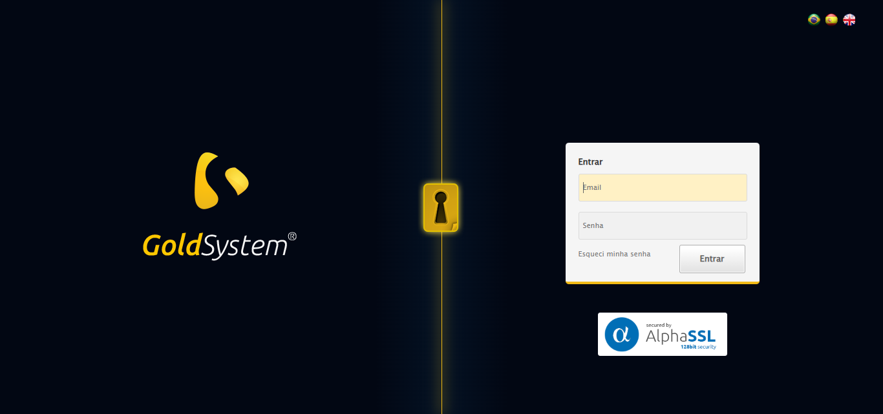
[14:49:57] [INFO] 🔄 Realizando login...
[14:50:02] [INFO] ✅ Realizando login realizada com sucesso.
Screenshot: realizando_login
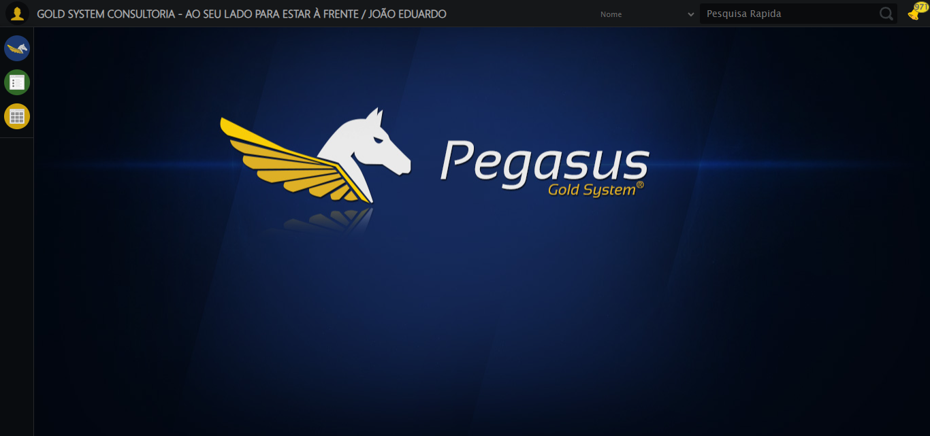
[14:50:05] [INFO] 🔄 Ajustando zoom e abrindo menu...
[14:50:06] [INFO] 🔍 Zoom ajustado para 90%.
[14:50:06] [INFO] ✅ Ajustando zoom e abrindo menu realizada com sucesso.
Screenshot: ajustando_zoom_e_abrindo_menu
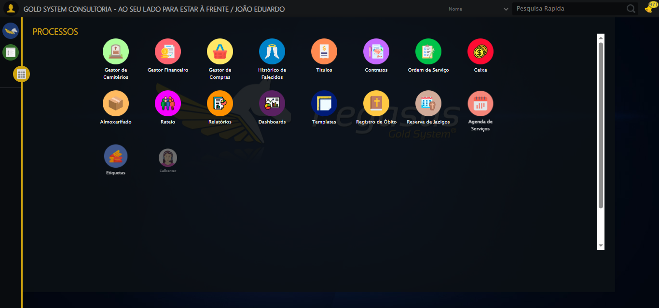
[14:50:07] [INFO] 🔄 Acessando Apoio Ortopédico...
[14:50:09] [INFO] ✅ Acessando Apoio Ortopédico realizada com sucesso.
Screenshot: acessando_apoio_ortopédico
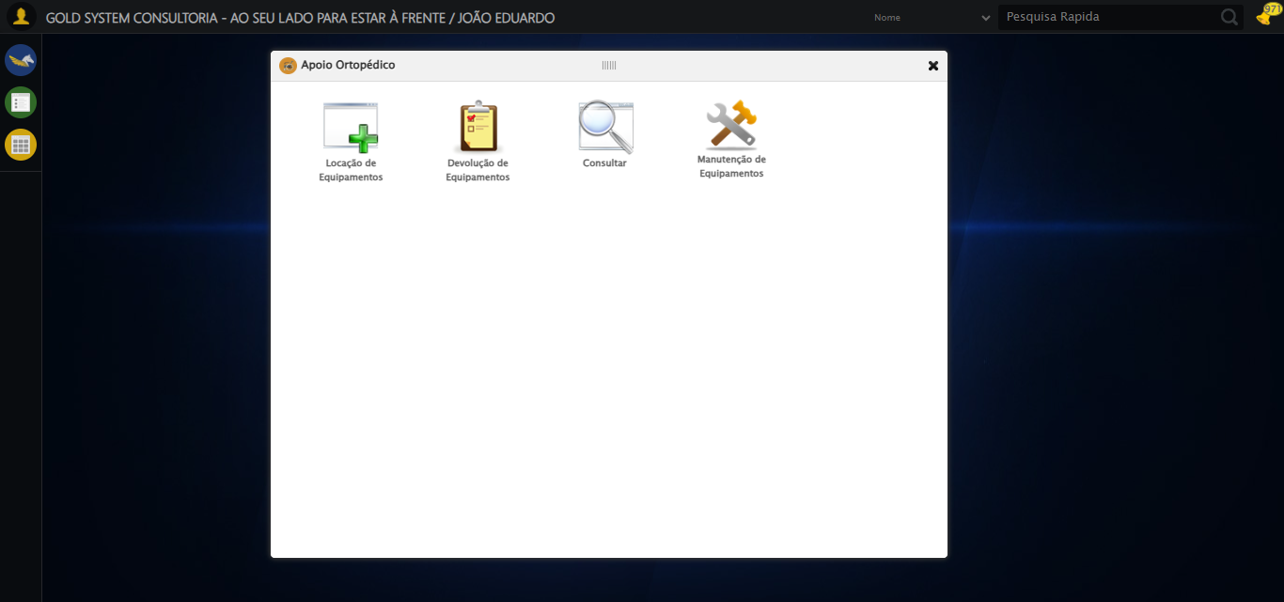
[14:50:10] [INFO] 🔄 Clicando em Devolução de Equipamentos...
[14:50:10] [INFO] ✅ Clicando em Devolução de Equipamentos realizada com sucesso.
Screenshot: clicando_em_devolução_de_equipamentos
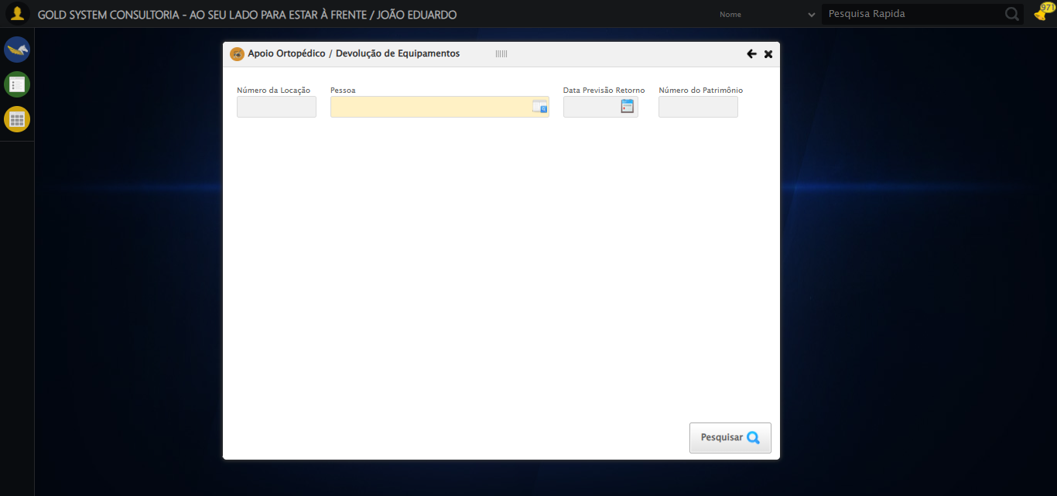
[14:50:16] [INFO] 🔄 Preenchendo o Número da Locação...
[14:50:17] [INFO] ✅ Preenchendo o Número da Locação realizada com sucesso.
Screenshot: preenchendo_o_número_da_locação
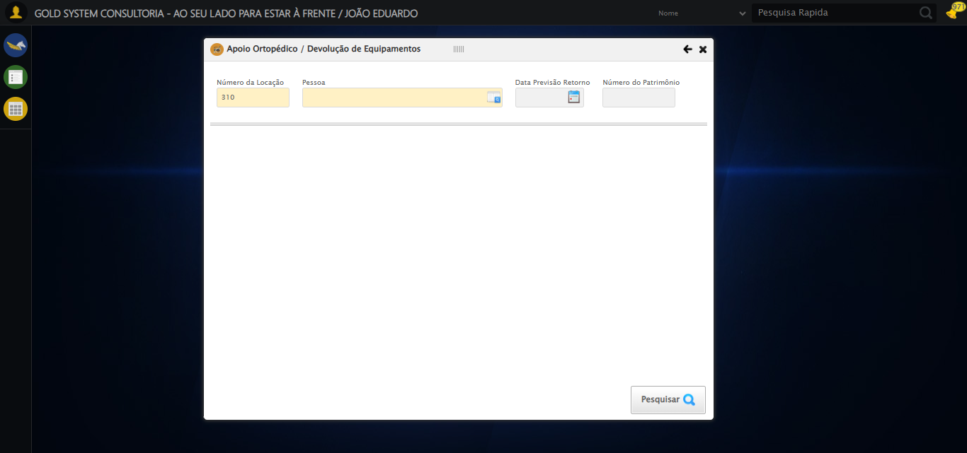
[14:50:19] [INFO] 🔄 Selecionando Pessoa...
[14:50:19] [INFO] ✅ Selecionando Pessoa realizada com sucesso.
Screenshot: selecionando_pessoa

[14:50:20] [INFO] 🔄 Abrindo Lov de Pessoas...
[14:50:20] [INFO] ✅ Abrindo Lov de Pessoas realizada com sucesso.
Screenshot: abrindo_lov_de_pessoas
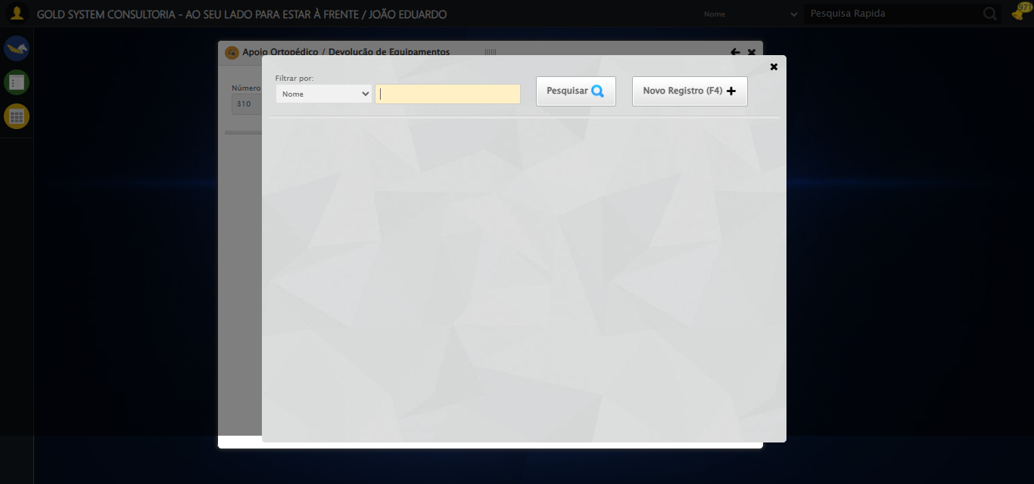
[14:50:21] [INFO] 🔄 Preenchendo o Nome do Titular...
[14:50:22] [INFO] ✅ Preenchendo o Nome do Titular realizada com sucesso.
Screenshot: preenchendo_o_nome_do_titular
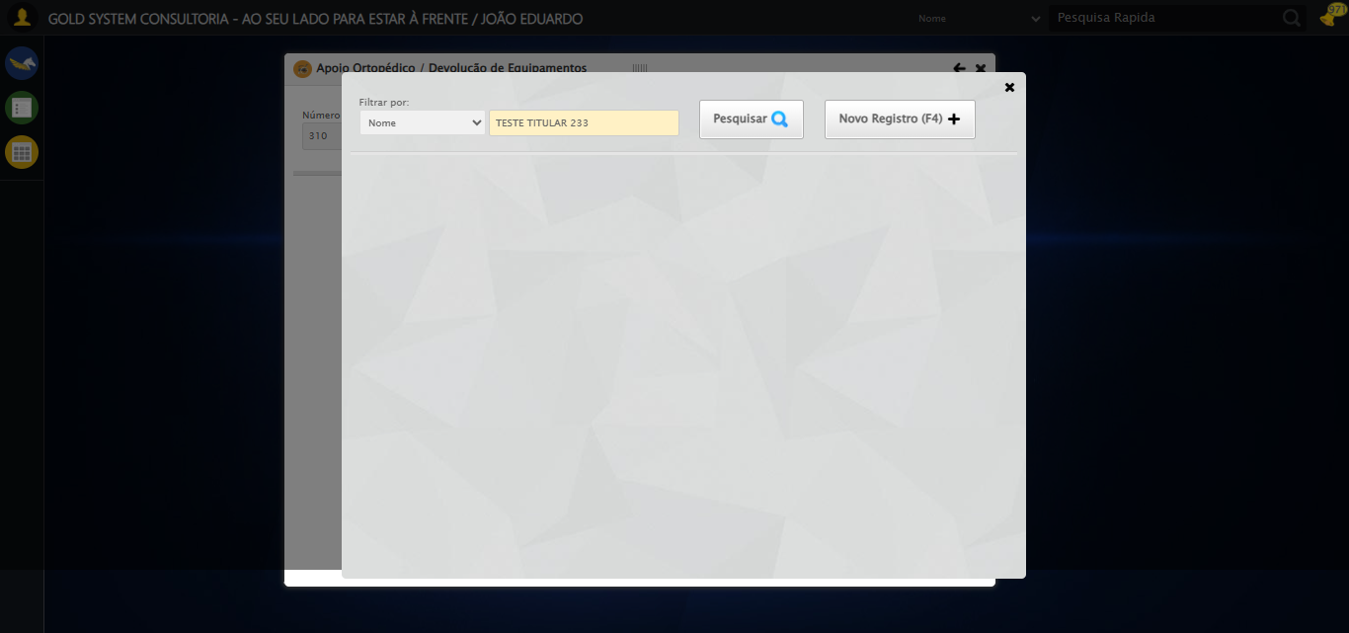
[14:50:23] [INFO] 🔄 Pesquisando Titular...
[14:50:34] [INFO] ✅ Pesquisando Titular realizada com sucesso.
Screenshot: pesquisando_titular
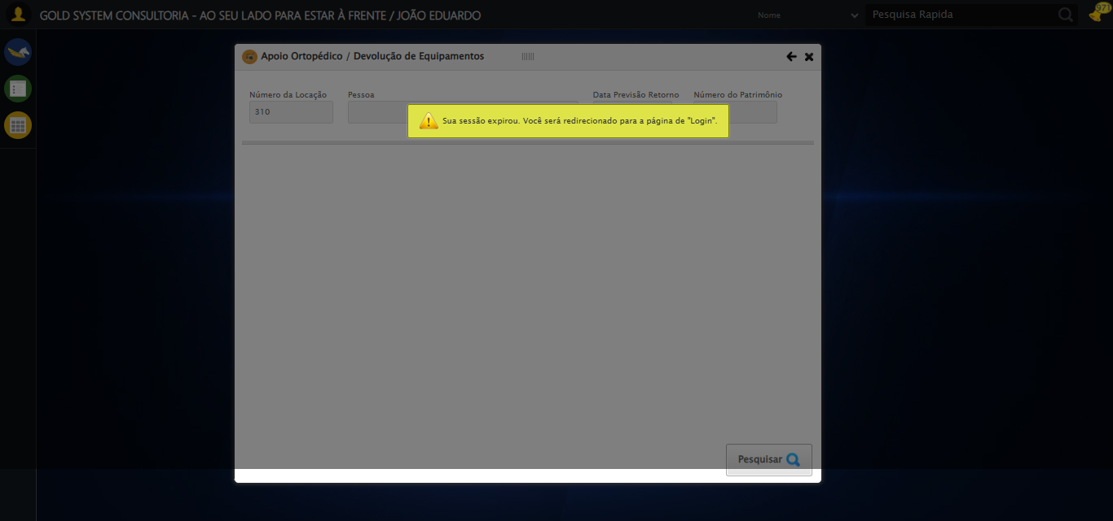
[14:50:35] [INFO] 🔄 Selecionando Titular...
[14:50:38] [INFO] ❌ Erro ao clicar robusto: Message: invalid session id: session deleted as the browser has closed the connection
from disconnected: not connected to DevTools
(Session info: chrome=142.0.7444.60); For documentation on this error, please visit: https://www.selenium.dev/documentation/webdriver/troubleshooting/errors#invalidsessionidexception
Stacktrace:
Symbols not available. Dumping unresolved backtrace:
0x9e4093
0x9e40d4
0x7ee71d
0x7dd910
0x7fc714
0x863475
0x87e749
0x85c706
0x82da30
0x82ed54
0xc55744
0xc5091a
0xa0c322
0x9fc458
0xa031dd
0x9ec408
0x9ec5cc
0x9d675a
0x762afcc9
0x77a782ae
0x77a7827e
[14:50:38] [INFO] ✅ Selecionando Titular realizada com sucesso.
[14:50:39] [INFO] ⚠️ Erro ao tirar screenshot selecionando_titular: Message: invalid session id; For documentation on this error, please visit: https://www.selenium.dev/documentation/webdriver/troubleshooting/errors#invalidsessionidexception
Stacktrace:
Symbols not available. Dumping unresolved backtrace:
0x9e4093
0x9e40d4
0x7ee56b
0x82ce58
0x85c7c6
0x858030
0x857563
0x7be4dd
0x7bea6e
0x7bef3d
0xc55744
0xc5091a
0xa0c322
0x9fc458
0xa031dd
0x7be193
0x7bd848
0xdab05f
0x762afcc9
0x77a782ae
0x77a7827e
[14:50:39] [INFO] 🔄 Preenchendo Número do Patrimônio...
[14:50:39] [INFO] ⚠️ Tentativa 1 falhou: Message: invalid session id; For documentation on this error, please visit: https://www.selenium.dev/documentation/webdriver/troubleshooting/errors#invalidsessionidexception
Stacktrace:
Symbols not available. Dumping unresolved backtrace:
0x9e4093
0x9e40d4
0x7ee56b
0x82ce58
0x85c7c6
0x858030
0x857563
0x7be4dd
0x7bea6e
0x7bef3d
0xc55744
0xc5091a
0xa0c322
0x9fc458
0xa031dd
0x7be193
0x7bd848
0xdab05f
0x762afcc9
0x77a782ae
0x77a7827e
[14:50:40] [INFO] ⚠️ Tentativa 2 falhou: Message: invalid session id; For documentation on this error, please visit: https://www.selenium.dev/documentation/webdriver/troubleshooting/errors#invalidsessionidexception
Stacktrace:
Symbols not available. Dumping unresolved backtrace:
0x9e4093
0x9e40d4
0x7ee56b
0x82ce58
0x85c7c6
0x858030
0x857563
0x7be4dd
0x7bea6e
0x7bef3d
0xc55744
0xc5091a
0xa0c322
0x9fc458
0xa031dd
0x7be193
0x7bd848
0xdab05f
0x762afcc9
0x77a782ae
0x77a7827e
[14:50:41] [INFO] ⚠️ Tentativa 3 falhou: Message: invalid session id; For documentation on this error, please visit: https://www.selenium.dev/documentation/webdriver/troubleshooting/errors#invalidsessionidexception
Stacktrace:
Symbols not available. Dumping unresolved backtrace:
0x9e4093
0x9e40d4
0x7ee56b
0x82ce58
0x85c7c6
0x858030
0x857563
0x7be4dd
0x7bea6e
0x7bef3d
0xc55744
0xc5091a
0xa0c322
0x9fc458
0xa031dd
0x7be193
0x7bd848
0xdab05f
0x762afcc9
0x77a782ae
0x77a7827e
[14:50:41] [INFO] ✅ Preenchendo Número do Patrimônio realizada com sucesso.
[14:50:42] [INFO] ⚠️ Erro ao tirar screenshot preenchendo_número_do_patrimônio: Message: invalid session id; For documentation on this error, please visit: https://www.selenium.dev/documentation/webdriver/troubleshooting/errors#invalidsessionidexception
Stacktrace:
Symbols not available. Dumping unresolved backtrace:
0x9e4093
0x9e40d4
0x7ee56b
0x82ce58
0x85c7c6
0x858030
0x857563
0x7be4dd
0x7bea6e
0x7bef3d
0xc55744
0xc5091a
0xa0c322
0x9fc458
0xa031dd
0x7be193
0x7bd848
0xdab05f
0x762afcc9
0x77a782ae
0x77a7827e
[14:50:42] [INFO] 🔄 Realizando consulta...
[14:50:42] [INFO] ⚠️ Erro ao tirar screenshot erro_realizando_consulta: Message: invalid session id; For documentation on this error, please visit: https://www.selenium.dev/documentation/webdriver/troubleshooting/errors#invalidsessionidexception
Stacktrace:
Symbols not available. Dumping unresolved backtrace:
0x9e4093
0x9e40d4
0x7ee56b
0x82ce58
0x85c7c6
0x858030
0x857563
0x7be4dd
0x7bea6e
0x7bef3d
0xc55744
0xc5091a
0xa0c322
0x9fc458
0xa031dd
0x7be193
0x7bd848
0xdab05f
0x762afcc9
0x77a782ae
0x77a7827e
[14:50:42] [ERROR] ❌ Realizando consulta falhou: InvalidSessionIdException: Message: invalid session id; For documentation on this error, please visit: https://www.selenium.dev/documentation/webdriver/troubleshooting/errors#invalidsessionidexception
Stacktrace:
Symbols not available. Dumping unresolved backtrace:
0x9e4093
0x9e40d4
0x7ee56b
0x82ce58
0x85c7c6
0x858030
0x857563
0x7be4dd
0x7bea6e
0x7bef3d
0xc55744
0xc5091a
0xa0c322
0x9fc458
0xa031dd
0x7be193
0x7bd848
0xdab05f
0x762afcc9
0x77a782ae
0x77a7827e
[14:50:42] [WARN] ⚠️ Continuando execução apesar do erro em: Realizando consulta
[14:50:52] [INFO] 🔄 Validando resultados da consulta...
[14:50:52] [INFO] 🔍 Iniciando validação de registros...
[14:50:57] [WARN] ⚠️ Erro ao buscar tabela com #DataTables_Table_0: Message: invalid session id; For documentation on this error, please visit: https://www.selenium.dev/documentation/webdriver/troubleshooting/errors#invalidsessionidexception
Stacktrace:
Symbols not available. Dumping unresolved backtrace:
0x9e4093
0x9e40d4
0x7ee56b
0x82ce58
0x85c7c6
0x858030
0x857563
0x7be4dd
0x7bea6e
0x7bef3d
0xc55744
0xc5091a
0xa0c322
0x9fc458
0xa031dd
0x7be193
0x7bd848
0xdab05f
0x762afcc9
0x77a782ae
0x77a7827e
[14:50:57] [WARN] ⚠️ Erro ao buscar tabela com #DataTables_Table_0 tbody: Message: invalid session id; For documentation on this error, please visit: https://www.selenium.dev/documentation/webdriver/troubleshooting/errors#invalidsessionidexception
Stacktrace:
Symbols not available. Dumping unresolved backtrace:
0x9e4093
0x9e40d4
0x7ee56b
0x82ce58
0x85c7c6
0x858030
0x857563
0x7be4dd
0x7bea6e
0x7bef3d
0xc55744
0xc5091a
0xa0c322
0x9fc458
0xa031dd
0x7be193
0x7bd848
0xdab05f
0x762afcc9
0x77a782ae
0x77a7827e
[14:50:57] [WARN] ⚠️ Erro ao buscar tabela com #DataTables_Table_1: Message: invalid session id; For documentation on this error, please visit: https://www.selenium.dev/documentation/webdriver/troubleshooting/errors#invalidsessionidexception
Stacktrace:
Symbols not available. Dumping unresolved backtrace:
0x9e4093
0x9e40d4
0x7ee56b
0x82ce58
0x85c7c6
0x858030
0x857563
0x7be4dd
0x7bea6e
0x7bef3d
0xc55744
0xc5091a
0xa0c322
0x9fc458
0xa031dd
0x7be193
0x7bd848
0xdab05f
0x762afcc9
0x77a782ae
0x77a7827e
[14:50:58] [WARN] ⚠️ Erro ao buscar tabela com #DataTables_Table_2: Message: invalid session id; For documentation on this error, please visit: https://www.selenium.dev/documentation/webdriver/troubleshooting/errors#invalidsessionidexception
Stacktrace:
Symbols not available. Dumping unresolved backtrace:
0x9e4093
0x9e40d4
0x7ee56b
0x82ce58
0x85c7c6
0x858030
0x857563
0x7be4dd
0x7bea6e
0x7bef3d
0xc55744
0xc5091a
0xa0c322
0x9fc458
0xa031dd
0x7be193
0x7bd848
0xdab05f
0x762afcc9
0x77a782ae
0x77a7827e
[14:50:58] [WARN] ⚠️ Erro ao buscar tabela com table[id*="DataTables"]: Message: invalid session id; For documentation on this error, please visit: https://www.selenium.dev/documentation/webdriver/troubleshooting/errors#invalidsessionidexception
Stacktrace:
Symbols not available. Dumping unresolved backtrace:
0x9e4093
0x9e40d4
0x7ee56b
0x82ce58
0x85c7c6
0x858030
0x857563
0x7be4dd
0x7bea6e
0x7bef3d
0xc55744
0xc5091a
0xa0c322
0x9fc458
0xa031dd
0x7be193
0x7bd848
0xdab05f
0x762afcc9
0x77a782ae
0x77a7827e
[14:50:58] [WARN] ⚠️ Erro ao buscar tabela com .wdGrid table: Message: invalid session id; For documentation on this error, please visit: https://www.selenium.dev/documentation/webdriver/troubleshooting/errors#invalidsessionidexception
Stacktrace:
Symbols not available. Dumping unresolved backtrace:
0x9e4093
0x9e40d4
0x7ee56b
0x82ce58
0x85c7c6
0x858030
0x857563
0x7be4dd
0x7bea6e
0x7bef3d
0xc55744
0xc5091a
0xa0c322
0x9fc458
0xa031dd
0x7be193
0x7bd848
0xdab05f
0x762afcc9
0x77a782ae
0x77a7827e
[14:50:58] [WARN] ⚠️ Erro ao buscar tabela com table tbody: Message: invalid session id; For documentation on this error, please visit: https://www.selenium.dev/documentation/webdriver/troubleshooting/errors#invalidsessionidexception
Stacktrace:
Symbols not available. Dumping unresolved backtrace:
0x9e4093
0x9e40d4
0x7ee56b
0x82ce58
0x85c7c6
0x858030
0x857563
0x7be4dd
0x7bea6e
0x7bef3d
0xc55744
0xc5091a
0xa0c322
0x9fc458
0xa031dd
0x7be193
0x7bd848
0xdab05f
0x762afcc9
0x77a782ae
0x77a7827e
[14:50:58] [WARN] ⚠️ Erro ao buscar tabela com .resultados table: Message: invalid session id; For documentation on this error, please visit: https://www.selenium.dev/documentation/webdriver/troubleshooting/errors#invalidsessionidexception
Stacktrace:
Symbols not available. Dumping unresolved backtrace:
0x9e4093
0x9e40d4
0x7ee56b
0x82ce58
0x85c7c6
0x858030
0x857563
0x7be4dd
0x7bea6e
0x7bef3d
0xc55744
0xc5091a
0xa0c322
0x9fc458
0xa031dd
0x7be193
0x7bd848
0xdab05f
0x762afcc9
0x77a782ae
0x77a7827e
[14:50:58] [WARN] ⚠️ Erro ao buscar tabela com [class*="grid"][class*="result"]: Message: invalid session id; For documentation on this error, please visit: https://www.selenium.dev/documentation/webdriver/troubleshooting/errors#invalidsessionidexception
Stacktrace:
Symbols not available. Dumping unresolved backtrace:
0x9e4093
0x9e40d4
0x7ee56b
0x82ce58
0x85c7c6
0x858030
0x857563
0x7be4dd
0x7bea6e
0x7bef3d
0xc55744
0xc5091a
0xa0c322
0x9fc458
0xa031dd
0x7be193
0x7bd848
0xdab05f
0x762afcc9
0x77a782ae
0x77a7827e
[14:50:58] [WARN] ⚠️ Erro ao buscar tabela com table[class*="dataTable"]: Message: invalid session id; For documentation on this error, please visit: https://www.selenium.dev/documentation/webdriver/troubleshooting/errors#invalidsessionidexception
Stacktrace:
Symbols not available. Dumping unresolved backtrace:
0x9e4093
0x9e40d4
0x7ee56b
0x82ce58
0x85c7c6
0x858030
0x857563
0x7be4dd
0x7bea6e
0x7bef3d
0xc55744
0xc5091a
0xa0c322
0x9fc458
0xa031dd
0x7be193
0x7bd848
0xdab05f
0x762afcc9
0x77a782ae
0x77a7827e
[14:50:58] [ERROR] ❌ Erro geral na validação: Message: invalid session id; For documentation on this error, please visit: https://www.selenium.dev/documentation/webdriver/troubleshooting/errors#invalidsessionidexception
Stacktrace:
Symbols not available. Dumping unresolved backtrace:
0x9e4093
0x9e40d4
0x7ee56b
0x82ce58
0x85c7c6
0x858030
0x857563
0x7be4dd
0x7bea6e
0x7bef3d
0xc55744
0xc5091a
0xa0c322
0x9fc458
0xa031dd
0x7be193
0x7bd848
0xdab05f
0x762afcc9
0x77a782ae
0x77a7827e
[14:50:58] [INFO] ✅ Validando resultados da consulta realizada com sucesso.
[14:50:59] [INFO] ⚠️ Erro ao tirar screenshot validando_resultados_da_consulta: Message: invalid session id; For documentation on this error, please visit: https://www.selenium.dev/documentation/webdriver/troubleshooting/errors#invalidsessionidexception
Stacktrace:
Symbols not available. Dumping unresolved backtrace:
0x9e4093
0x9e40d4
0x7ee56b
0x82ce58
0x85c7c6
0x858030
0x857563
0x7be4dd
0x7bea6e
0x7bef3d
0xc55744
0xc5091a
0xa0c322
0x9fc458
0xa031dd
0x7be193
0x7bd848
0xdab05f
0x762afcc9
0x77a782ae
0x77a7827e
[14:50:59] [INFO] ✅ Processando 1 registro(s) encontrado(s)
[14:50:59] [INFO] 🔄 Visualizando Detalhes da Locação...
[14:50:59] [INFO] ❌ Erro ao clicar robusto: Message: invalid session id; For documentation on this error, please visit: https://www.selenium.dev/documentation/webdriver/troubleshooting/errors#invalidsessionidexception
Stacktrace:
Symbols not available. Dumping unresolved backtrace:
0x9e4093
0x9e40d4
0x7ee56b
0x82ce58
0x85c7c6
0x858030
0x857563
0x7be4dd
0x7bea6e
0x7bef3d
0xc55744
0xc5091a
0xa0c322
0x9fc458
0xa031dd
0x7be193
0x7bd848
0xdab05f
0x762afcc9
0x77a782ae
0x77a7827e
[14:50:59] [INFO] ✅ Visualizando Detalhes da Locação realizada com sucesso.
[14:51:00] [INFO] ⚠️ Erro ao tirar screenshot visualizando_detalhes_da_locação: Message: invalid session id; For documentation on this error, please visit: https://www.selenium.dev/documentation/webdriver/troubleshooting/errors#invalidsessionidexception
Stacktrace:
Symbols not available. Dumping unresolved backtrace:
0x9e4093
0x9e40d4
0x7ee56b
0x82ce58
0x85c7c6
0x858030
0x857563
0x7be4dd
0x7bea6e
0x7bef3d
0xc55744
0xc5091a
0xa0c322
0x9fc458
0xa031dd
0x7be193
0x7bd848
0xdab05f
0x762afcc9
0x77a782ae
0x77a7827e
[14:51:00] [INFO] 🔄 Preenchendo Observações...
[14:51:00] [INFO] ⚠️ Tentativa 1 falhou: Message: invalid session id; For documentation on this error, please visit: https://www.selenium.dev/documentation/webdriver/troubleshooting/errors#invalidsessionidexception
Stacktrace:
Symbols not available. Dumping unresolved backtrace:
0x9e4093
0x9e40d4
0x7ee56b
0x82ce58
0x85c7c6
0x858030
0x857563
0x7be4dd
0x7bea6e
0x7bef3d
0xc55744
0xc5091a
0xa0c322
0x9fc458
0xa031dd
0x7be193
0x7bd848
0xdab05f
0x762afcc9
0x77a782ae
0x77a7827e
[14:51:01] [INFO] ⚠️ Tentativa 2 falhou: Message: invalid session id; For documentation on this error, please visit: https://www.selenium.dev/documentation/webdriver/troubleshooting/errors#invalidsessionidexception
Stacktrace:
Symbols not available. Dumping unresolved backtrace:
0x9e4093
0x9e40d4
0x7ee56b
0x82ce58
0x85c7c6
0x858030
0x857563
0x7be4dd
0x7bea6e
0x7bef3d
0xc55744
0xc5091a
0xa0c322
0x9fc458
0xa031dd
0x7be193
0x7bd848
0xdab05f
0x762afcc9
0x77a782ae
0x77a7827e
[14:51:02] [INFO] ⚠️ Tentativa 3 falhou: Message: invalid session id; For documentation on this error, please visit: https://www.selenium.dev/documentation/webdriver/troubleshooting/errors#invalidsessionidexception
Stacktrace:
Symbols not available. Dumping unresolved backtrace:
0x9e4093
0x9e40d4
0x7ee56b
0x82ce58
0x85c7c6
0x858030
0x857563
0x7be4dd
0x7bea6e
0x7bef3d
0xc55744
0xc5091a
0xa0c322
0x9fc458
0xa031dd
0x7be193
0x7bd848
0xdab05f
0x762afcc9
0x77a782ae
0x77a7827e
[14:51:02] [INFO] ✅ Preenchendo Observações realizada com sucesso.
[14:51:04] [INFO] ⚠️ Erro ao tirar screenshot preenchendo_observações: Message: invalid session id; For documentation on this error, please visit: https://www.selenium.dev/documentation/webdriver/troubleshooting/errors#invalidsessionidexception
Stacktrace:
Symbols not available. Dumping unresolved backtrace:
0x9e4093
0x9e40d4
0x7ee56b
0x82ce58
0x85c7c6
0x858030
0x857563
0x7be4dd
0x7bea6e
0x7bef3d
0xc55744
0xc5091a
0xa0c322
0x9fc458
0xa031dd
0x7be193
0x7bd848
0xdab05f
0x762afcc9
0x77a782ae
0x77a7827e
[14:51:04] [INFO] 🔄 Preenchendo Data Devolução inválida...
[14:51:04] [INFO] 📊 Encontrados 0 campos datepicker
[14:51:04] [WARN] ⚠️ Nenhum campo datepicker encontrado, tentativa 1/5
[14:51:06] [INFO] 📊 Encontrados 0 campos datepicker
[14:51:06] [WARN] ⚠️ Nenhum campo datepicker encontrado, tentativa 2/5
[14:51:08] [INFO] 📊 Encontrados 0 campos datepicker
[14:51:08] [WARN] ⚠️ Nenhum campo datepicker encontrado, tentativa 3/5
[14:51:10] [INFO] 📊 Encontrados 0 campos datepicker
[14:51:10] [WARN] ⚠️ Nenhum campo datepicker encontrado, tentativa 4/5
[14:51:12] [INFO] 📊 Encontrados 0 campos datepicker
[14:51:12] [INFO] ⚠️ Erro ao tirar screenshot erro_preenchendo_data_devolução_inválida: Message: invalid session id; For documentation on this error, please visit: https://www.selenium.dev/documentation/webdriver/troubleshooting/errors#invalidsessionidexception
Stacktrace:
Symbols not available. Dumping unresolved backtrace:
0x9e4093
0x9e40d4
0x7ee56b
0x82ce58
0x85c7c6
0x858030
0x857563
0x7be4dd
0x7bea6e
0x7bef3d
0xc55744
0xc5091a
0xa0c322
0x9fc458
0xa031dd
0x7be193
0x7bd848
0xdab05f
0x762afcc9
0x77a782ae
0x77a7827e
[14:51:12] [ERROR] ❌ Preenchendo Data Devolução inválida falhou: Exception: Nenhum campo datepicker encontrado na página
[14:51:12] [WARN] ⚠️ Continuando execução apesar do erro em: Preenchendo Data Devolução inválida
[14:51:12] [INFO] 🔄 Tentando salvar Detalhes da Locação...
[14:51:12] [INFO] ❌ Erro ao clicar robusto: Message: invalid session id; For documentation on this error, please visit: https://www.selenium.dev/documentation/webdriver/troubleshooting/errors#invalidsessionidexception
Stacktrace:
Symbols not available. Dumping unresolved backtrace:
0x9e4093
0x9e40d4
0x7ee56b
0x82ce58
0x85c7c6
0x858030
0x857563
0x7be4dd
0x7bea6e
0x7bef3d
0xc55744
0xc5091a
0xa0c322
0x9fc458
0xa031dd
0x7be193
0x7bd848
0xdab05f
0x762afcc9
0x77a782ae
0x77a7827e
[14:51:12] [INFO] ✅ Tentando salvar Detalhes da Locação realizada com sucesso.
[14:51:13] [INFO] ⚠️ Erro ao tirar screenshot tentando_salvar_detalhes_da_locação: Message: invalid session id; For documentation on this error, please visit: https://www.selenium.dev/documentation/webdriver/troubleshooting/errors#invalidsessionidexception
Stacktrace:
Symbols not available. Dumping unresolved backtrace:
0x9e4093
0x9e40d4
0x7ee56b
0x82ce58
0x85c7c6
0x858030
0x857563
0x7be4dd
0x7bea6e
0x7bef3d
0xc55744
0xc5091a
0xa0c322
0x9fc458
0xa031dd
0x7be193
0x7bd848
0xdab05f
0x762afcc9
0x77a782ae
0x77a7827e
[14:51:13] [INFO] 🔍 Verificando mensagens de alerta...
[14:51:13] [INFO] ℹ️ Nenhuma mensagem de alerta encontrada.
[14:51:13] [INFO] 🔄 Limpando campo Data Devolução...
[14:51:13] [INFO] ⚠️ Erro ao tirar screenshot erro_limpando_campo_data_devolução: Message: invalid session id; For documentation on this error, please visit: https://www.selenium.dev/documentation/webdriver/troubleshooting/errors#invalidsessionidexception
Stacktrace:
Symbols not available. Dumping unresolved backtrace:
0x9e4093
0x9e40d4
0x7ee56b
0x82ce58
0x85c7c6
0x858030
0x857563
0x7be4dd
0x7bea6e
0x7bef3d
0xc55744
0xc5091a
0xa0c322
0x9fc458
0xa031dd
0x7be193
0x7bd848
0xdab05f
0x762afcc9
0x77a782ae
0x77a7827e
[14:51:13] [ERROR] ❌ Limpando campo Data Devolução falhou: ValueError: Data inválida:
[14:51:13] [WARN] ⚠️ Continuando execução apesar do erro em: Limpando campo Data Devolução
[14:51:13] [INFO] 🔄 Tentando salvar Detalhes da Locação...
[14:51:13] [INFO] ❌ Erro ao clicar robusto: Message: invalid session id; For documentation on this error, please visit: https://www.selenium.dev/documentation/webdriver/troubleshooting/errors#invalidsessionidexception
Stacktrace:
Symbols not available. Dumping unresolved backtrace:
0x9e4093
0x9e40d4
0x7ee56b
0x82ce58
0x85c7c6
0x858030
0x857563
0x7be4dd
0x7bea6e
0x7bef3d
0xc55744
0xc5091a
0xa0c322
0x9fc458
0xa031dd
0x7be193
0x7bd848
0xdab05f
0x762afcc9
0x77a782ae
0x77a7827e
[14:51:13] [INFO] ✅ Tentando salvar Detalhes da Locação realizada com sucesso.
[14:51:14] [INFO] ⚠️ Erro ao tirar screenshot tentando_salvar_detalhes_da_locação: Message: invalid session id; For documentation on this error, please visit: https://www.selenium.dev/documentation/webdriver/troubleshooting/errors#invalidsessionidexception
Stacktrace:
Symbols not available. Dumping unresolved backtrace:
0x9e4093
0x9e40d4
0x7ee56b
0x82ce58
0x85c7c6
0x858030
0x857563
0x7be4dd
0x7bea6e
0x7bef3d
0xc55744
0xc5091a
0xa0c322
0x9fc458
0xa031dd
0x7be193
0x7bd848
0xdab05f
0x762afcc9
0x77a782ae
0x77a7827e
[14:51:14] [INFO] 🔍 Verificando mensagens de alerta...
[14:51:14] [INFO] ℹ️ Nenhuma mensagem de alerta encontrada.
[14:51:14] [INFO] 🔄 Preenchendo Data Devolução válida...
[14:51:14] [INFO] 📊 Encontrados 0 campos datepicker
[14:51:14] [WARN] ⚠️ Nenhum campo datepicker encontrado, tentativa 1/5
[14:51:16] [INFO] 📊 Encontrados 0 campos datepicker
[14:51:16] [WARN] ⚠️ Nenhum campo datepicker encontrado, tentativa 2/5
[14:51:18] [INFO] 📊 Encontrados 0 campos datepicker
[14:51:18] [WARN] ⚠️ Nenhum campo datepicker encontrado, tentativa 3/5
[14:51:20] [INFO] 📊 Encontrados 0 campos datepicker
[14:51:20] [WARN] ⚠️ Nenhum campo datepicker encontrado, tentativa 4/5
[14:51:22] [INFO] 📊 Encontrados 0 campos datepicker
[14:51:22] [INFO] ⚠️ Erro ao tirar screenshot erro_preenchendo_data_devolução_válida: Message: invalid session id; For documentation on this error, please visit: https://www.selenium.dev/documentation/webdriver/troubleshooting/errors#invalidsessionidexception
Stacktrace:
Symbols not available. Dumping unresolved backtrace:
0x9e4093
0x9e40d4
0x7ee56b
0x82ce58
0x85c7c6
0x858030
0x857563
0x7be4dd
0x7bea6e
0x7bef3d
0xc55744
0xc5091a
0xa0c322
0x9fc458
0xa031dd
0x7be193
0x7bd848
0xdab05f
0x762afcc9
0x77a782ae
0x77a7827e
[14:51:22] [ERROR] ❌ Preenchendo Data Devolução válida falhou: Exception: Nenhum campo datepicker encontrado na página
[14:51:22] [WARN] ⚠️ Continuando execução apesar do erro em: Preenchendo Data Devolução válida
[14:51:22] [INFO] 🔄 Registrando Devolução para os Itens marcados...
[14:51:22] [INFO] ❌ Erro ao clicar robusto: Message: invalid session id; For documentation on this error, please visit: https://www.selenium.dev/documentation/webdriver/troubleshooting/errors#invalidsessionidexception
Stacktrace:
Symbols not available. Dumping unresolved backtrace:
0x9e4093
0x9e40d4
0x7ee56b
0x82ce58
0x85c7c6
0x858030
0x857563
0x7be4dd
0x7bea6e
0x7bef3d
0xc55744
0xc5091a
0xa0c322
0x9fc458
0xa031dd
0x7be193
0x7bd848
0xdab05f
0x762afcc9
0x77a782ae
0x77a7827e
[14:51:22] [INFO] ✅ Registrando Devolução para os Itens marcados realizada com sucesso.
[14:51:23] [INFO] ⚠️ Erro ao tirar screenshot registrando_devolução_para_os_itens_marcados: Message: invalid session id; For documentation on this error, please visit: https://www.selenium.dev/documentation/webdriver/troubleshooting/errors#invalidsessionidexception
Stacktrace:
Symbols not available. Dumping unresolved backtrace:
0x9e4093
0x9e40d4
0x7ee56b
0x82ce58
0x85c7c6
0x858030
0x857563
0x7be4dd
0x7bea6e
0x7bef3d
0xc55744
0xc5091a
0xa0c322
0x9fc458
0xa031dd
0x7be193
0x7bd848
0xdab05f
0x762afcc9
0x77a782ae
0x77a7827e
[14:51:23] [INFO] 🔄 Fechando modal Apoio Ortopédico...
[14:51:23] [INFO] ❌ Erro ao clicar robusto: Message: invalid session id; For documentation on this error, please visit: https://www.selenium.dev/documentation/webdriver/troubleshooting/errors#invalidsessionidexception
Stacktrace:
Symbols not available. Dumping unresolved backtrace:
0x9e4093
0x9e40d4
0x7ee56b
0x82ce58
0x85c7c6
0x858030
0x857563
0x7be4dd
0x7bea6e
0x7bef3d
0xc55744
0xc5091a
0xa0c322
0x9fc458
0xa031dd
0x7be193
0x7bd848
0xdab05f
0x762afcc9
0x77a782ae
0x77a7827e
[14:51:23] [INFO] ✅ Fechando modal Apoio Ortopédico realizada com sucesso.
[14:51:24] [INFO] ⚠️ Erro ao tirar screenshot fechando_modal_apoio_ortopédico: Message: invalid session id; For documentation on this error, please visit: https://www.selenium.dev/documentation/webdriver/troubleshooting/errors#invalidsessionidexception
Stacktrace:
Symbols not available. Dumping unresolved backtrace:
0x9e4093
0x9e40d4
0x7ee56b
0x82ce58
0x85c7c6
0x858030
0x857563
0x7be4dd
0x7bea6e
0x7bef3d
0xc55744
0xc5091a
0xa0c322
0x9fc458
0xa031dd
0x7be193
0x7bd848
0xdab05f
0x762afcc9
0x77a782ae
0x77a7827e
[14:51:24] [INFO] 🔍 Verificando mensagens de alerta...
[14:51:24] [INFO] ℹ️ Nenhuma mensagem de alerta encontrada.
[14:51:24] [INFO] ✅ Teste concluído.
[14:51:24] [INFO] ✅ Teste executado com sucesso!

