RELATÓRIO DO TESTE
Solicitação de Transferência de Contrato – Cenário 1: Preenchimento completo e Aprovação da requisição.
Data do teste: 25/11/2025 15:40:26
🔄 Acessando sistema...
✅ Acessando sistema realizada com sucesso.
Screenshot: acessando_sistema
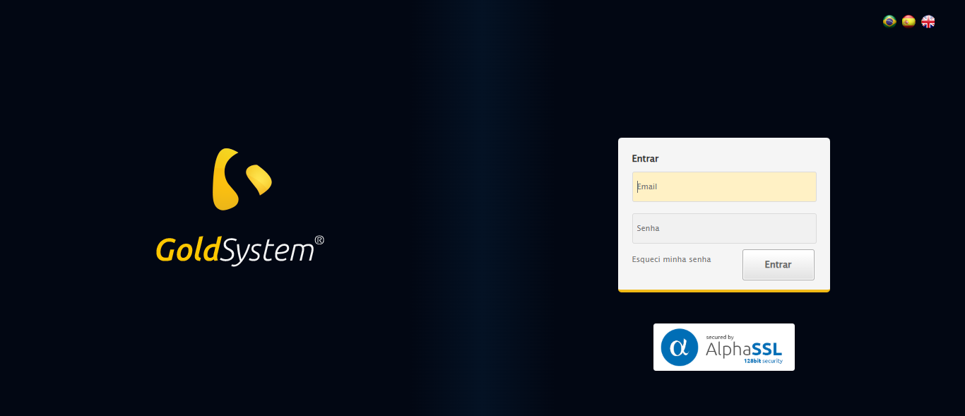
🔄 Realizando login...
✅ Realizando login realizada com sucesso.
Screenshot: realizando_login
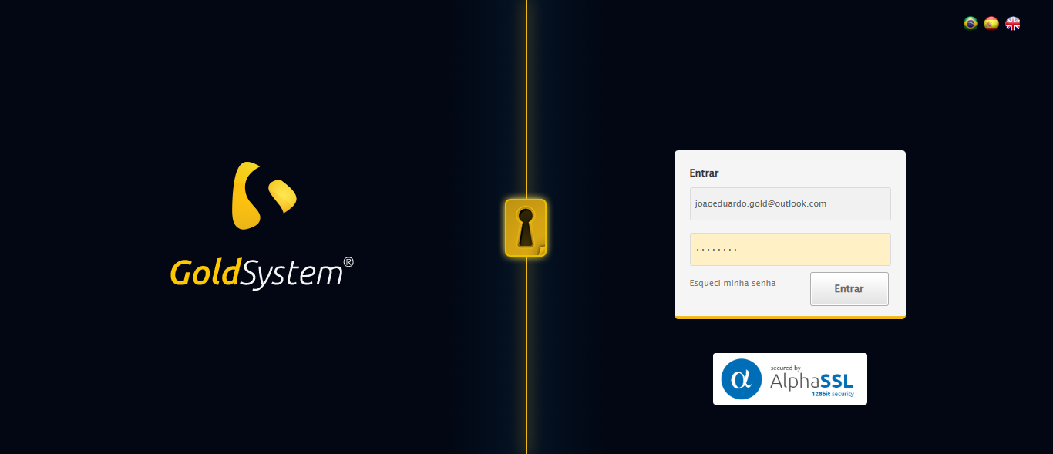
🔄 Esperando sistema carregar e ajustando zoom...
⚠️ Erro ao ajustar zoom: Message: invalid session id: session deleted as the browser has closed the connection
from disconnected: not connected to DevTools
(Session info: chrome=142.0.7444.176); For documentation on this error, please visit: https://www.selenium.dev/documentation/webdriver/troubleshooting/errors#invalidsessionidexception
Stacktrace:
Symbols not available. Dumping unresolved backtrace:
0x10a4103
0x10a4144
0xeae71d
0xe9d910
0xebc714
0xf23475
0xf3e749
0xf1c706
0xeeda30
0xeeed54
0x13157b4
0x131098a
0x10cc392
0x10bc4c8
0x10c324d
0x10ac478
0x10ac63c
0x10967ca
0x75ebfcc9
0x76f682ae
0x76f6827e
✅ Esperando sistema carregar e ajustando zoom realizada com sucesso.
❌ Erro ao esperando sistema carregar e ajustando zoom: Message: invalid session id; For documentation on this error, please visit: https://www.selenium.dev/documentation/webdriver/troubleshooting/errors#invalidsessionidexception
Stacktrace:
Symbols not available. Dumping unresolved backtrace:
0x10a4103
0x10a4144
0xeae56b
0xeece58
0xf1c7c6
0xf18030
0xf17563
0xe7e4dd
0xe7ea6e
0xe7ef3d
0x13157b4
0x131098a
0x10cc392
0x10bc4c8
0x10c324d
0xe7e193
0xe7d848
0x146b0cf
0x75ebfcc9
0x76f682ae
0x76f6827e
❌ ERRO FATAL: Message: invalid session id; For documentation on this error, please visit: https://www.selenium.dev/documentation/webdriver/troubleshooting/errors#invalidsessionidexception
Stacktrace:
Symbols not available. Dumping unresolved backtrace:
0x10a4103
0x10a4144
0xeae56b
0xeece58
0xf1c7c6
0xf18030
0xf17563
0xe7e4dd
0xe7ea6e
0xe7ef3d
0x13157b4
0x131098a
0x10cc392
0x10bc4c8
0x10c324d
0xe7e193
0xe7d848
0x146b0cf
0x75ebfcc9
0x76f682ae
0x76f6827e
✅ Teste concluído com sucesso.

