RELATÓRIO DO TESTE

Cadastro de Pet – Cenário 1: Preenchimento completo e salvamento.

Data do teste: 12/09/2025 17:54:15

🔄 Acessando sistema...

✅ Acessando sistema realizada com sucesso.

Screenshot: acessando_sistema

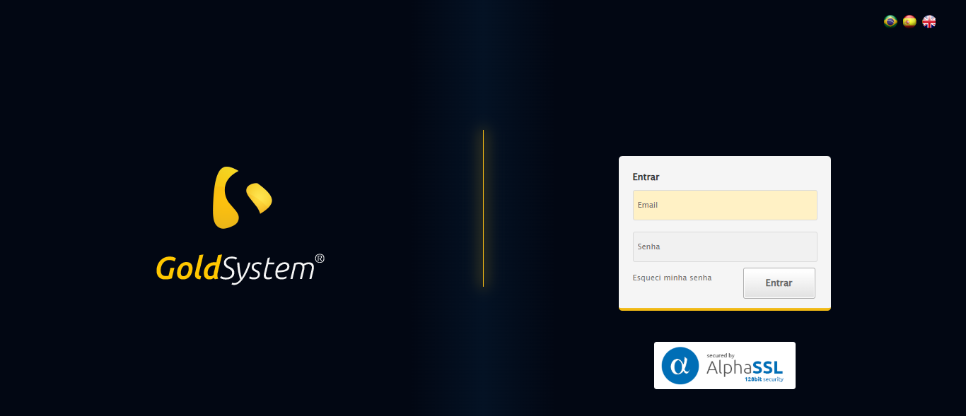

🔄 Realizando login...

✅ Realizando login realizada com sucesso.

Screenshot: realizando_login

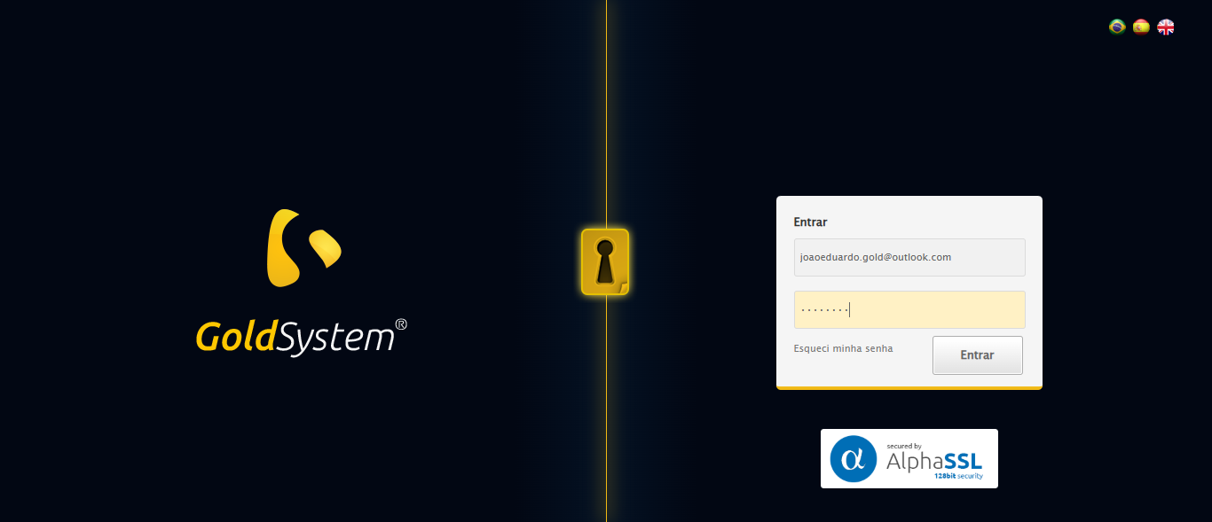

🔄 Esperando sistema carregar e ajustando zoom...

🔍 Zoom ajustado para 90%.

✅ Esperando sistema carregar e ajustando zoom realizada com sucesso.

Screenshot: esperando_sistema_carregar_e_ajustando_zoom

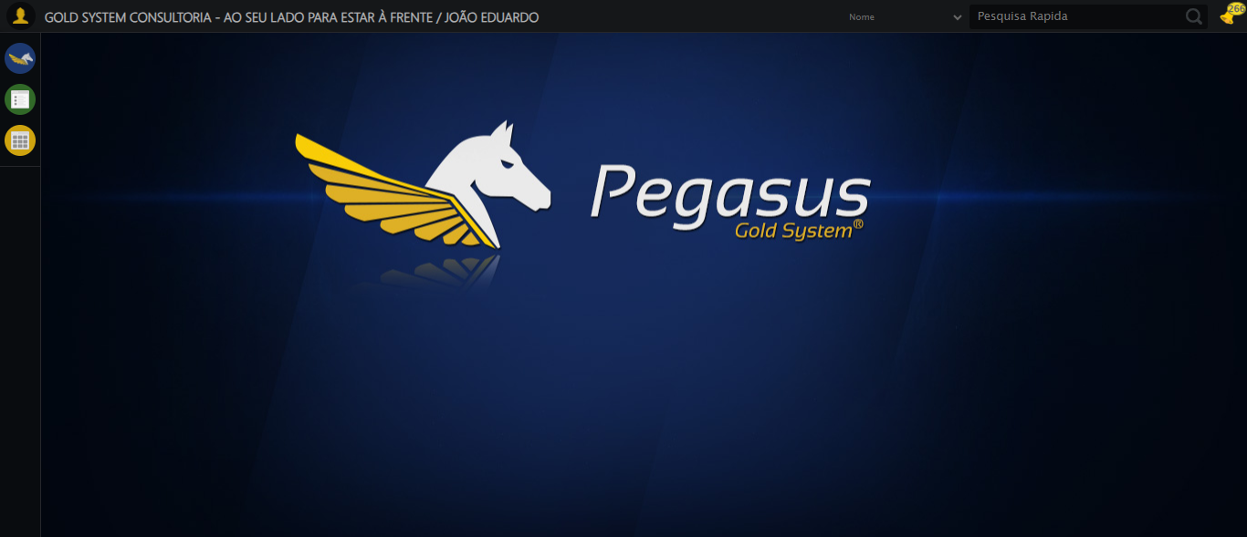

🔄 Abrindo menu Pet...

❌ Erro ao abrindo menu pet: Message:

Screenshot: erro_abrindo_menu_pet

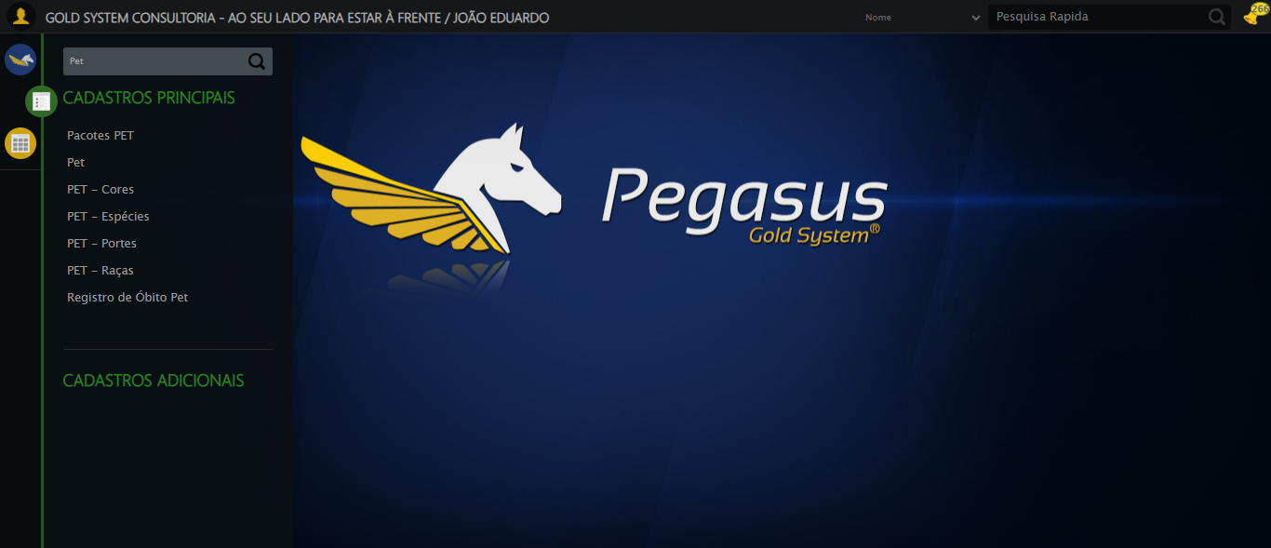

🔄 Clicando em Cadastrar...

❌ Erro ao clicando em cadastrar: Message:   
Stacktrace:  
 GetHandleVerifier [0x0x5ea8a3+63283]  
 GetHandleVerifier [0x0x5ea8e4+63348]  
 (No symbol) [0x0x423e43]  
 (No symbol) [0x0x46c8de]  
 (No symbol) [0x0x46cc7b]  
 (No symbol) [0x0x4b4ef2]  
 (No symbol) [0x0x491464]  
 (No symbol) [0x0x4b271a]  
 (No symbol) [0x0x491216]  
 (No symbol) [0x0x460855]  
 (No symbol) [0x0x4616f4]  
 GetHandleVerifier [0x0x85bb43+2623955]  
 GetHandleVerifier [0x0x856daa+2604090]  
 GetHandleVerifier [0x0x61069a+218410]  
 GetHandleVerifier [0x0x600ed8+154984]  
 GetHandleVerifier [0x0x60742d+180925]  
 GetHandleVerifier [0x0x5f22b8+94536]  
 GetHandleVerifier [0x0x5f2442+94930]  
 GetHandleVerifier [0x0x5dd5ea+9338]  
 BaseThreadInitThunk [0x0x76b1fcc9+25]  
 RtlGetAppContainerNamedObjectPath [0x0x776a82ae+286]  
 RtlGetAppContainerNamedObjectPath [0x0x776a827e+238]

Screenshot: erro_clicando_em_cadastrar

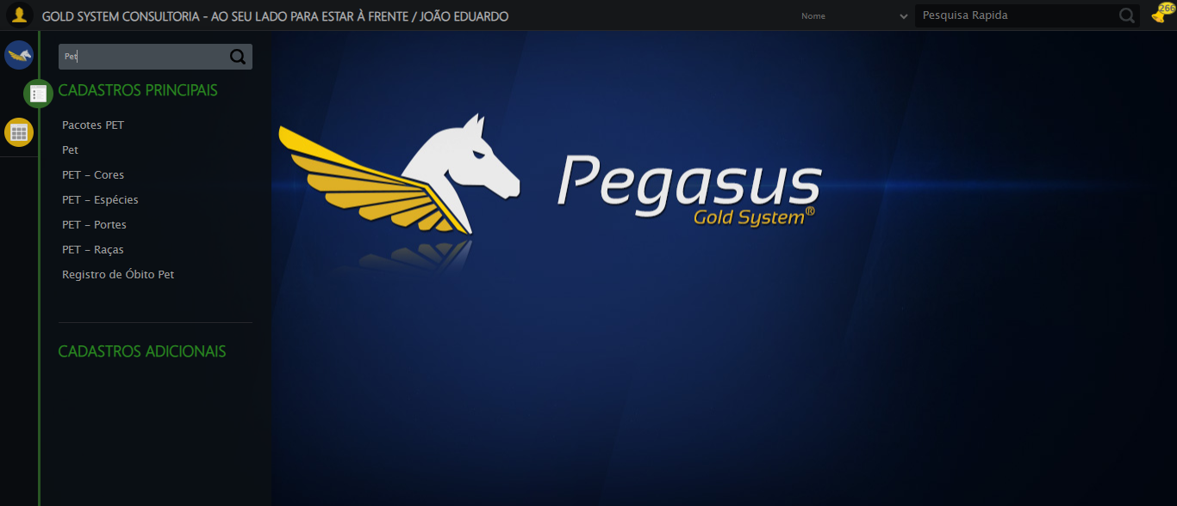

🔄 Preenchendo o Nome do Pet...

❌ Erro ao preenchendo o nome do pet: Message:   
Stacktrace:  
 GetHandleVerifier [0x0x5ea8a3+63283]  
 GetHandleVerifier [0x0x5ea8e4+63348]  
 (No symbol) [0x0x423e43]  
 (No symbol) [0x0x46c8de]  
 (No symbol) [0x0x46cc7b]  
 (No symbol) [0x0x4b4ef2]  
 (No symbol) [0x0x491464]  
 (No symbol) [0x0x4b271a]  
 (No symbol) [0x0x491216]  
 (No symbol) [0x0x460855]  
 (No symbol) [0x0x4616f4]  
 GetHandleVerifier [0x0x85bb43+2623955]  
 GetHandleVerifier [0x0x856daa+2604090]  
 GetHandleVerifier [0x0x61069a+218410]  
 GetHandleVerifier [0x0x600ed8+154984]  
 GetHandleVerifier [0x0x60742d+180925]  
 GetHandleVerifier [0x0x5f22b8+94536]  
 GetHandleVerifier [0x0x5f2442+94930]  
 GetHandleVerifier [0x0x5dd5ea+9338]  
 BaseThreadInitThunk [0x0x76b1fcc9+25]  
 RtlGetAppContainerNamedObjectPath [0x0x776a82ae+286]  
 RtlGetAppContainerNamedObjectPath [0x0x776a827e+238]

Screenshot: erro_preenchendo_o_nome_do_pet

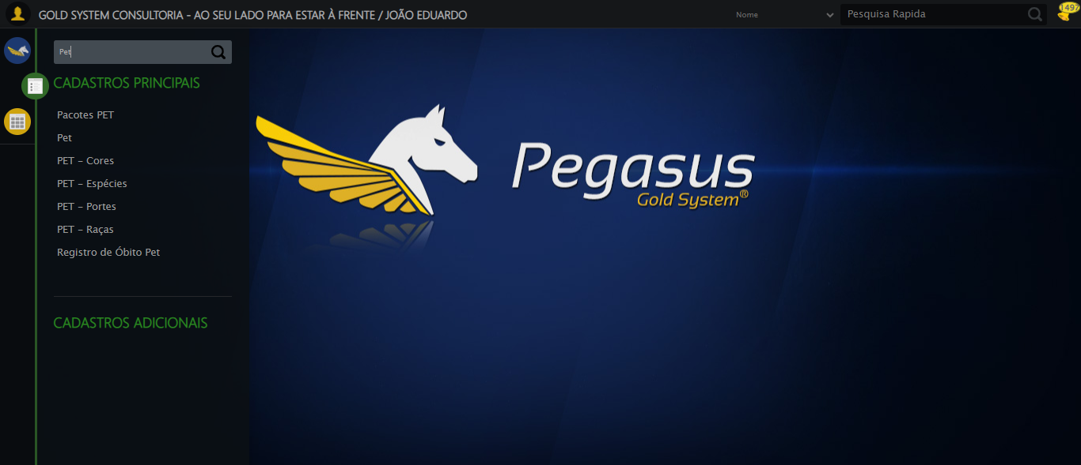

🔄 Preenchendo a Idade do Pet...

❌ Erro ao preenchendo a idade do pet: Message:   
Stacktrace:  
 GetHandleVerifier [0x0x5ea8a3+63283]  
 GetHandleVerifier [0x0x5ea8e4+63348]  
 (No symbol) [0x0x423e43]  
 (No symbol) [0x0x46c8de]  
 (No symbol) [0x0x46cc7b]  
 (No symbol) [0x0x4b4ef2]  
 (No symbol) [0x0x491464]  
 (No symbol) [0x0x4b271a]  
 (No symbol) [0x0x491216]  
 (No symbol) [0x0x460855]  
 (No symbol) [0x0x4616f4]  
 GetHandleVerifier [0x0x85bb43+2623955]  
 GetHandleVerifier [0x0x856daa+2604090]  
 GetHandleVerifier [0x0x61069a+218410]  
 GetHandleVerifier [0x0x600ed8+154984]  
 GetHandleVerifier [0x0x60742d+180925]  
 GetHandleVerifier [0x0x5f22b8+94536]  
 GetHandleVerifier [0x0x5f2442+94930]  
 GetHandleVerifier [0x0x5dd5ea+9338]  
 BaseThreadInitThunk [0x0x76b1fcc9+25]  
 RtlGetAppContainerNamedObjectPath [0x0x776a82ae+286]  
 RtlGetAppContainerNamedObjectPath [0x0x776a827e+238]

Screenshot: erro_preenchendo_a_idade_do_pet

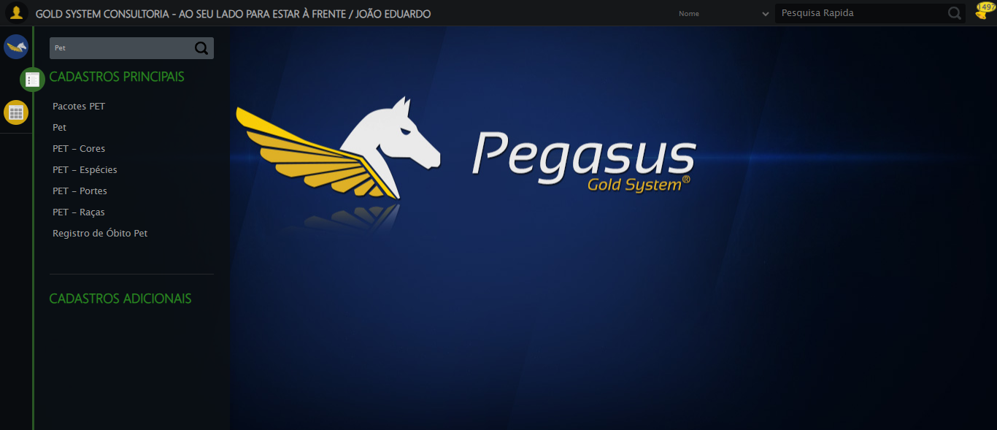

🔄 Preenchendo o RG do Pet...

❌ Erro ao preenchendo o rg do pet: Message:   
Stacktrace:  
 GetHandleVerifier [0x0x5ea8a3+63283]  
 GetHandleVerifier [0x0x5ea8e4+63348]  
 (No symbol) [0x0x423e43]  
 (No symbol) [0x0x46c8de]  
 (No symbol) [0x0x46cc7b]  
 (No symbol) [0x0x4b4ef2]  
 (No symbol) [0x0x491464]  
 (No symbol) [0x0x4b271a]  
 (No symbol) [0x0x491216]  
 (No symbol) [0x0x460855]  
 (No symbol) [0x0x4616f4]  
 GetHandleVerifier [0x0x85bb43+2623955]  
 GetHandleVerifier [0x0x856daa+2604090]  
 GetHandleVerifier [0x0x61069a+218410]  
 GetHandleVerifier [0x0x600ed8+154984]  
 GetHandleVerifier [0x0x60742d+180925]  
 GetHandleVerifier [0x0x5f22b8+94536]  
 GetHandleVerifier [0x0x5f2442+94930]  
 GetHandleVerifier [0x0x5dd5ea+9338]  
 BaseThreadInitThunk [0x0x76b1fcc9+25]  
 RtlGetAppContainerNamedObjectPath [0x0x776a82ae+286]  
 RtlGetAppContainerNamedObjectPath [0x0x776a827e+238]

Screenshot: erro_preenchendo_o_rg_do_pet



🔄 Selecionando a Raça TESTE RAÇA SELENIUM AUTOMATIZADO...

❌ Erro ao selecionando a raça teste raça selenium automatizado: Message:   
Stacktrace:  
 GetHandleVerifier [0x0x5ea8a3+63283]  
 GetHandleVerifier [0x0x5ea8e4+63348]  
 (No symbol) [0x0x423e43]  
 (No symbol) [0x0x46c8de]  
 (No symbol) [0x0x46cc7b]  
 (No symbol) [0x0x4b4ef2]  
 (No symbol) [0x0x491464]  
 (No symbol) [0x0x4b271a]  
 (No symbol) [0x0x491216]  
 (No symbol) [0x0x460855]  
 (No symbol) [0x0x4616f4]  
 GetHandleVerifier [0x0x85bb43+2623955]  
 GetHandleVerifier [0x0x856daa+2604090]  
 GetHandleVerifier [0x0x61069a+218410]  
 GetHandleVerifier [0x0x600ed8+154984]  
 GetHandleVerifier [0x0x60742d+180925]  
 GetHandleVerifier [0x0x5f22b8+94536]  
 GetHandleVerifier [0x0x5f2442+94930]  
 GetHandleVerifier [0x0x5dd5ea+9338]  
 BaseThreadInitThunk [0x0x76b1fcc9+25]  
 RtlGetAppContainerNamedObjectPath [0x0x776a82ae+286]  
 RtlGetAppContainerNamedObjectPath [0x0x776a827e+238]

Screenshot: erro_selecionando_a_raça_teste_raça_selenium_automatizado



🔄 Selecionando a Cor TESTE COR SELENIUM AUTOMATIZADO...

❌ Erro ao selecionando a cor teste cor selenium automatizado: Message:   
Stacktrace:  
 GetHandleVerifier [0x0x5ea8a3+63283]  
 GetHandleVerifier [0x0x5ea8e4+63348]  
 (No symbol) [0x0x423e43]  
 (No symbol) [0x0x46c8de]  
 (No symbol) [0x0x46cc7b]  
 (No symbol) [0x0x4b4ef2]  
 (No symbol) [0x0x491464]  
 (No symbol) [0x0x4b271a]  
 (No symbol) [0x0x491216]  
 (No symbol) [0x0x460855]  
 (No symbol) [0x0x4616f4]  
 GetHandleVerifier [0x0x85bb43+2623955]  
 GetHandleVerifier [0x0x856daa+2604090]  
 GetHandleVerifier [0x0x61069a+218410]  
 GetHandleVerifier [0x0x600ed8+154984]  
 GetHandleVerifier [0x0x60742d+180925]  
 GetHandleVerifier [0x0x5f22b8+94536]  
 GetHandleVerifier [0x0x5f2442+94930]  
 GetHandleVerifier [0x0x5dd5ea+9338]  
 BaseThreadInitThunk [0x0x76b1fcc9+25]  
 RtlGetAppContainerNamedObjectPath [0x0x776a82ae+286]  
 RtlGetAppContainerNamedObjectPath [0x0x776a827e+238]

Screenshot: erro_selecionando_a_cor_teste_cor_selenium_automatizado



🔄 Preenchendo o Peso do Pet...

❌ Erro ao preenchendo o peso do pet: Message:   
Stacktrace:  
 GetHandleVerifier [0x0x5ea8a3+63283]  
 GetHandleVerifier [0x0x5ea8e4+63348]  
 (No symbol) [0x0x423e43]  
 (No symbol) [0x0x46c8de]  
 (No symbol) [0x0x46cc7b]  
 (No symbol) [0x0x4b4ef2]  
 (No symbol) [0x0x491464]  
 (No symbol) [0x0x4b271a]  
 (No symbol) [0x0x491216]  
 (No symbol) [0x0x460855]  
 (No symbol) [0x0x4616f4]  
 GetHandleVerifier [0x0x85bb43+2623955]  
 GetHandleVerifier [0x0x856daa+2604090]  
 GetHandleVerifier [0x0x61069a+218410]  
 GetHandleVerifier [0x0x600ed8+154984]  
 GetHandleVerifier [0x0x60742d+180925]  
 GetHandleVerifier [0x0x5f22b8+94536]  
 GetHandleVerifier [0x0x5f2442+94930]  
 GetHandleVerifier [0x0x5dd5ea+9338]  
 BaseThreadInitThunk [0x0x76b1fcc9+25]  
 RtlGetAppContainerNamedObjectPath [0x0x776a82ae+286]  
 RtlGetAppContainerNamedObjectPath [0x0x776a827e+238]

Screenshot: erro_preenchendo_o_peso_do_pet



🔄 Salvando cadastro...

❌ Erro ao salvando cadastro: Message: no such element: Unable to locate element: {"method":"css selector","selector":"#fmod_10085 > div.wdTelas > div.telaCadastro.clearfix.telaCadastroPet > div.btnHolder > a.btModel.btGray.btsave"}  
 (Session info: chrome=139.0.7258.155); For documentation on this error, please visit: https://www.selenium.dev/documentation/webdriver/troubleshooting/errors#nosuchelementexception  
Stacktrace:  
 GetHandleVerifier [0x0x5ea8a3+63283]  
 GetHandleVerifier [0x0x5ea8e4+63348]  
 (No symbol) [0x0x423e43]  
 (No symbol) [0x0x46c8de]  
 (No symbol) [0x0x46cc7b]  
 (No symbol) [0x0x4b4ef2]  
 (No symbol) [0x0x491464]  
 (No symbol) [0x0x4b271a]  
 (No symbol) [0x0x491216]  
 (No symbol) [0x0x460855]  
 (No symbol) [0x0x4616f4]  
 GetHandleVerifier [0x0x85bb43+2623955]  
 GetHandleVerifier [0x0x856daa+2604090]  
 GetHandleVerifier [0x0x61069a+218410]  
 GetHandleVerifier [0x0x600ed8+154984]  
 GetHandleVerifier [0x0x60742d+180925]  
 GetHandleVerifier [0x0x5f22b8+94536]  
 GetHandleVerifier [0x0x5f2442+94930]  
 GetHandleVerifier [0x0x5dd5ea+9338]  
 BaseThreadInitThunk [0x0x76b1fcc9+25]  
 RtlGetAppContainerNamedObjectPath [0x0x776a82ae+286]  
 RtlGetAppContainerNamedObjectPath [0x0x776a827e+238]

Screenshot: erro_salvando_cadastro



🔄 Fechando modal após salvamento...

❌ Erro ao fechando modal após salvamento: ('Connection aborted.', ConnectionResetError(10054, 'Foi forçado o cancelamento de uma conexão existente pelo host remoto', None, 10054, None))

❌ ERRO FATAL: HTTPConnectionPool(host='localhost', port=64731): Max retries exceeded with url: /session/0be22f16a8abec7e45e3b64db6d8ea9d/screenshot (Caused by NewConnectionError('<urllib3.connection.HTTPConnection object at 0x0000028DF88F7460>: Failed to establish a new connection: [WinError 10061] Nenhuma conexão pôde ser feita porque a máquina de destino as recusou ativamente'))

✅ Teste concluído com sucesso.