RELATÓRIO DO TESTE

Cadastro de Pet – Cenário 4: Preenchimento dos campos NÃO obrigatórios e salvamento.

Data do teste: 12/09/2025 18:02:25

🔄 Acessando sistema...

✅ Acessando sistema realizada com sucesso.

Screenshot: acessando_sistema

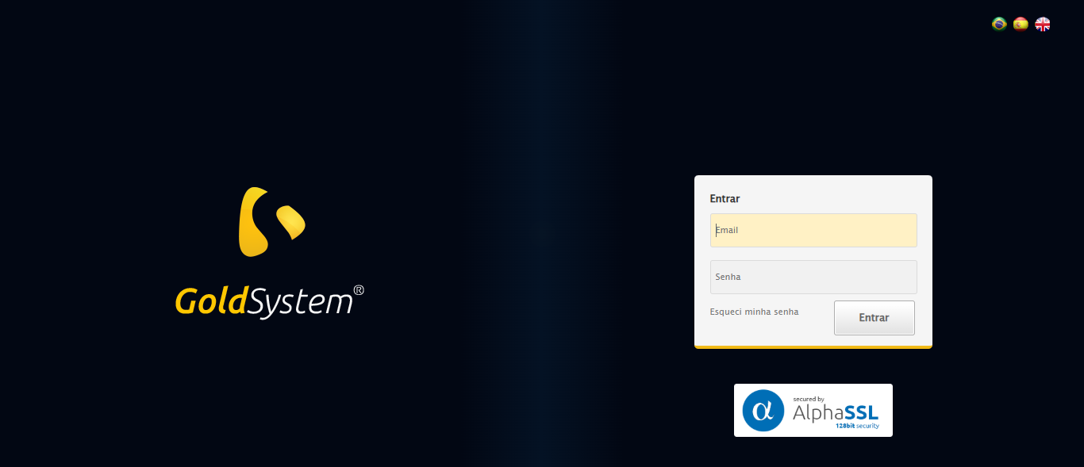

🔄 Realizando login...

✅ Realizando login realizada com sucesso.

Screenshot: realizando_login

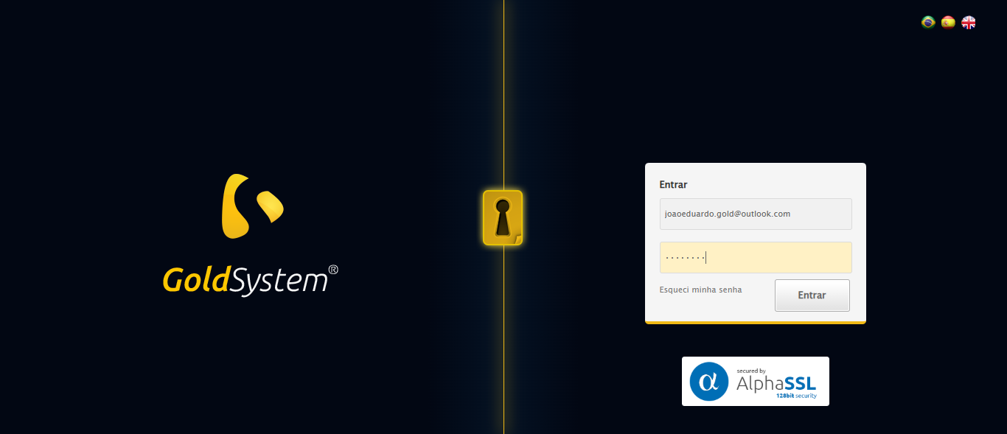

🔄 Esperando sistema carregar e ajustando zoom...

🔍 Zoom ajustado para 90%.

✅ Esperando sistema carregar e ajustando zoom realizada com sucesso.

Screenshot: esperando_sistema_carregar_e_ajustando_zoom

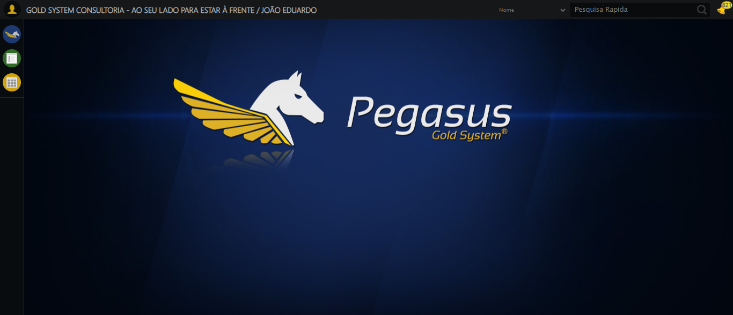

🔄 Abrindo menu Pet...

❌ Erro ao abrindo menu pet: Message:

Screenshot: erro_abrindo_menu_pet

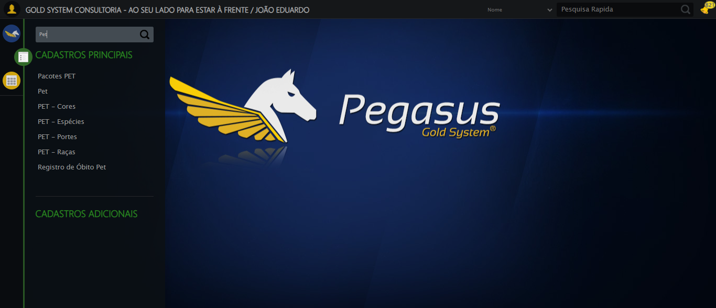

🔄 Clicando em Cadastrar...

❌ Erro ao clicando em cadastrar: Message:   
Stacktrace:  
 GetHandleVerifier [0x0x5ea8a3+63283]  
 GetHandleVerifier [0x0x5ea8e4+63348]  
 (No symbol) [0x0x423e43]  
 (No symbol) [0x0x46c8de]  
 (No symbol) [0x0x46cc7b]  
 (No symbol) [0x0x4b4ef2]  
 (No symbol) [0x0x491464]  
 (No symbol) [0x0x4b271a]  
 (No symbol) [0x0x491216]  
 (No symbol) [0x0x460855]  
 (No symbol) [0x0x4616f4]  
 GetHandleVerifier [0x0x85bb43+2623955]  
 GetHandleVerifier [0x0x856daa+2604090]  
 GetHandleVerifier [0x0x61069a+218410]  
 GetHandleVerifier [0x0x600ed8+154984]  
 GetHandleVerifier [0x0x60742d+180925]  
 GetHandleVerifier [0x0x5f22b8+94536]  
 GetHandleVerifier [0x0x5f2442+94930]  
 GetHandleVerifier [0x0x5dd5ea+9338]  
 BaseThreadInitThunk [0x0x76b1fcc9+25]  
 RtlGetAppContainerNamedObjectPath [0x0x776a82ae+286]  
 RtlGetAppContainerNamedObjectPath [0x0x776a827e+238]

Screenshot: erro_clicando_em_cadastrar



🔄 Preenchendo a Idade do Pet...

❌ Erro ao preenchendo a idade do pet: Message:   
Stacktrace:  
 GetHandleVerifier [0x0x5ea8a3+63283]  
 GetHandleVerifier [0x0x5ea8e4+63348]  
 (No symbol) [0x0x423e43]  
 (No symbol) [0x0x46c8de]  
 (No symbol) [0x0x46cc7b]  
 (No symbol) [0x0x4b4ef2]  
 (No symbol) [0x0x491464]  
 (No symbol) [0x0x4b271a]  
 (No symbol) [0x0x491216]  
 (No symbol) [0x0x460855]  
 (No symbol) [0x0x4616f4]  
 GetHandleVerifier [0x0x85bb43+2623955]  
 GetHandleVerifier [0x0x856daa+2604090]  
 GetHandleVerifier [0x0x61069a+218410]  
 GetHandleVerifier [0x0x600ed8+154984]  
 GetHandleVerifier [0x0x60742d+180925]  
 GetHandleVerifier [0x0x5f22b8+94536]  
 GetHandleVerifier [0x0x5f2442+94930]  
 GetHandleVerifier [0x0x5dd5ea+9338]  
 BaseThreadInitThunk [0x0x76b1fcc9+25]  
 RtlGetAppContainerNamedObjectPath [0x0x776a82ae+286]  
 RtlGetAppContainerNamedObjectPath [0x0x776a827e+238]

Screenshot: erro_preenchendo_a_idade_do_pet



🔄 Preenchendo o RG do Pet...

❌ Erro ao preenchendo o rg do pet: Message: target frame detached  
 (failed to check if window was closed: disconnected: Unable to receive message from renderer)  
 (Session info: chrome=139.0.7258.155)  
Stacktrace:  
 GetHandleVerifier [0x0x5ea8a3+63283]  
 GetHandleVerifier [0x0x5ea8e4+63348]  
 (No symbol) [0x0x423ca0]  
 (No symbol) [0x0x4147d0]  
 (No symbol) [0x0x413941]  
 (No symbol) [0x0x431602]  
 (No symbol) [0x0x497cdc]  
 (No symbol) [0x0x4b1ff9]  
 (No symbol) [0x0x491216]  
 (No symbol) [0x0x460855]  
 (No symbol) [0x0x4616f4]  
 GetHandleVerifier [0x0x85bb43+2623955]  
 GetHandleVerifier [0x0x856daa+2604090]  
 GetHandleVerifier [0x0x61069a+218410]  
 GetHandleVerifier [0x0x600ed8+154984]  
 GetHandleVerifier [0x0x60742d+180925]  
 GetHandleVerifier [0x0x5f22b8+94536]  
 GetHandleVerifier [0x0x5f2442+94930]  
 GetHandleVerifier [0x0x5dd5ea+9338]  
 BaseThreadInitThunk [0x0x76b1fcc9+25]  
 RtlGetAppContainerNamedObjectPath [0x0x776a82ae+286]  
 RtlGetAppContainerNamedObjectPath [0x0x776a827e+238]

❌ ERRO FATAL: Message: invalid session id: session deleted as the browser has closed the connection  
from disconnected: not connected to DevTools  
 (Session info: chrome=139.0.7258.155); For documentation on this error, please visit: https://www.selenium.dev/documentation/webdriver/troubleshooting/errors#invalidsessionidexception  
Stacktrace:  
 GetHandleVerifier [0x0x5ea8a3+63283]  
 GetHandleVerifier [0x0x5ea8e4+63348]  
 (No symbol) [0x0x423e43]  
 (No symbol) [0x0x413790]  
 (No symbol) [0x0x431602]  
 (No symbol) [0x0x497cdc]  
 (No symbol) [0x0x4b1ff9]  
 (No symbol) [0x0x491216]  
 (No symbol) [0x0x460855]  
 (No symbol) [0x0x4616f4]  
 GetHandleVerifier [0x0x85bb43+2623955]  
 GetHandleVerifier [0x0x856daa+2604090]  
 GetHandleVerifier [0x0x61069a+218410]  
 GetHandleVerifier [0x0x600ed8+154984]  
 GetHandleVerifier [0x0x60742d+180925]  
 GetHandleVerifier [0x0x5f22b8+94536]  
 GetHandleVerifier [0x0x5f2442+94930]  
 GetHandleVerifier [0x0x5dd5ea+9338]  
 BaseThreadInitThunk [0x0x76b1fcc9+25]  
 RtlGetAppContainerNamedObjectPath [0x0x776a82ae+286]  
 RtlGetAppContainerNamedObjectPath [0x0x776a827e+238]

✅ Teste concluído com sucesso.