RELATÓRIO DO TESTE

Cadastro de Reagrupamento de Rateios - Rateio – Cenário 1: Nesse teste, será realizado um Reagrupamento de Rateio.

Data do teste: 29/08/2025 17:43:04

2025-08-29 17:43:04 ℹ️ [INFO] 🚀 Iniciando teste de Reagrupamento de Rateios

2025-08-29 17:43:12 ℹ️ [INFO] 🔄 Acessando sistema...

2025-08-29 17:43:13 ℹ️ [INFO] ✅ Acessando sistema realizada com sucesso.

Screenshot: acessando sistema

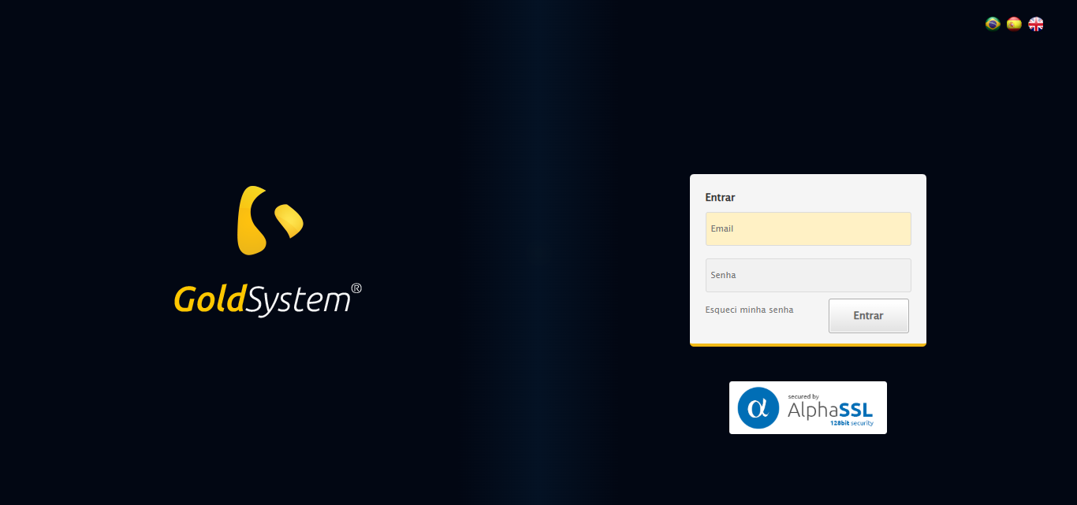

2025-08-29 17:43:14 ℹ️ [INFO] 🔄 Realizando login...

2025-08-29 17:43:20 ℹ️ [INFO] ✅ Realizando login realizada com sucesso.

Screenshot: realizando login

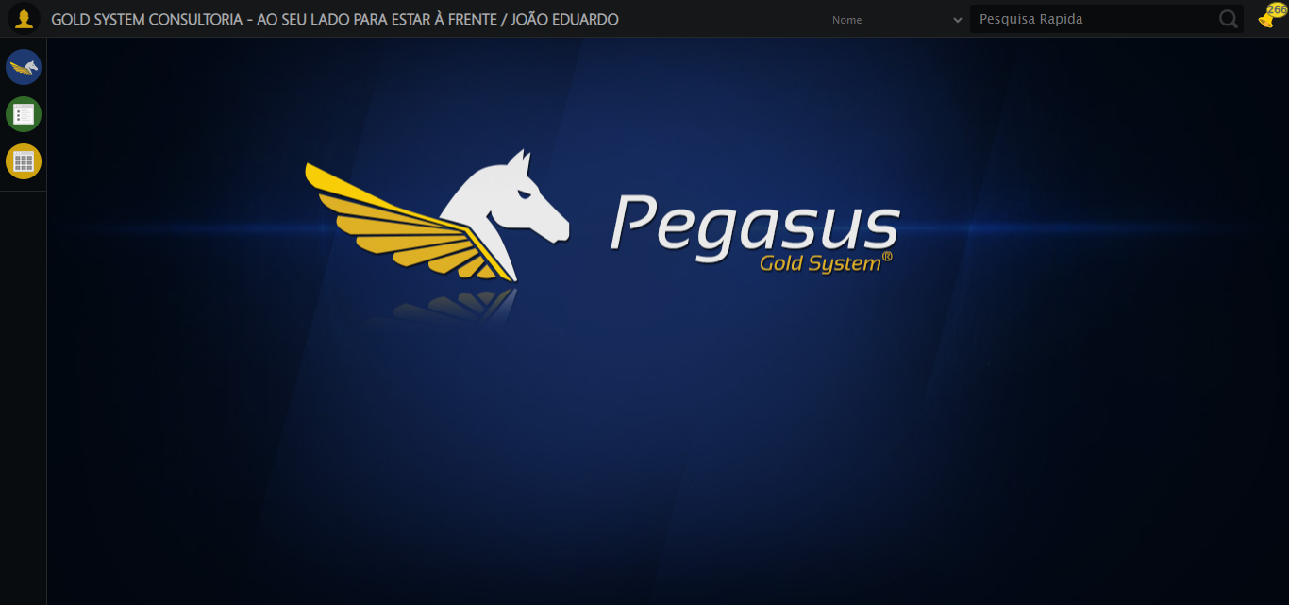

2025-08-29 17:43:23 ℹ️ [INFO] 🔄 Ajustando zoom e abrindo menu...

2025-08-29 17:43:23 ℹ️ [INFO] 🔍 Zoom ajustado para 90%.

2025-08-29 17:43:23 ℹ️ [INFO] ✅ Ajustando zoom e abrindo menu realizada com sucesso.

Screenshot: ajustando zoom e abrindo menu

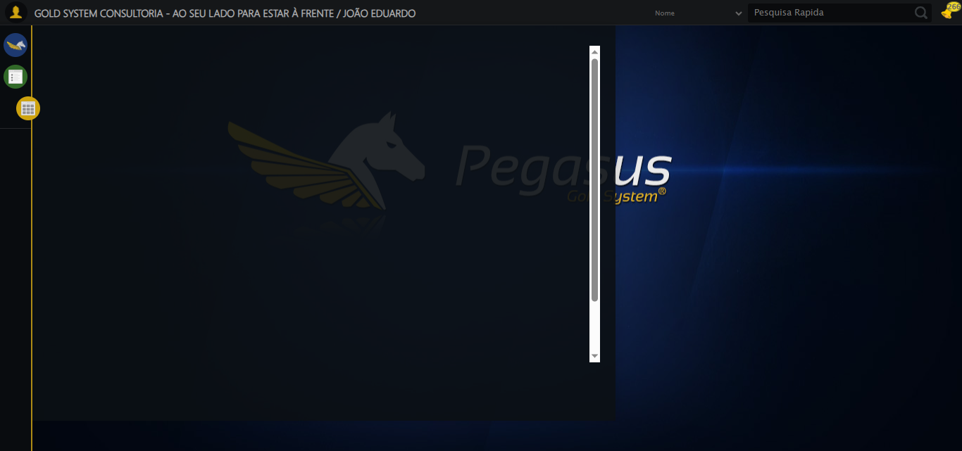

2025-08-29 17:43:23 ℹ️ [INFO] 🔄 Acessando Rateio...

2025-08-29 17:43:24 ℹ️ [INFO] ✅ Acessando Rateio realizada com sucesso.

Screenshot: acessando rateio

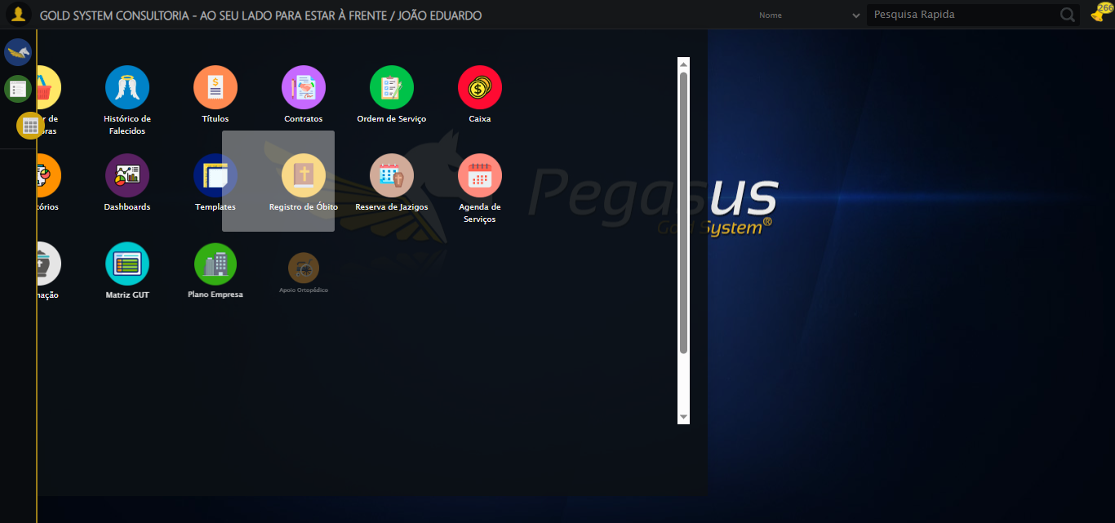

2025-08-29 17:43:24 ℹ️ [INFO] 🔄 Clicando em Reagrupamento de Rateios...

2025-08-29 17:43:25 ℹ️ [INFO] ✅ Clicando em Reagrupamento de Rateios realizada com sucesso.

Screenshot: clicando em reagrupamento de rateios

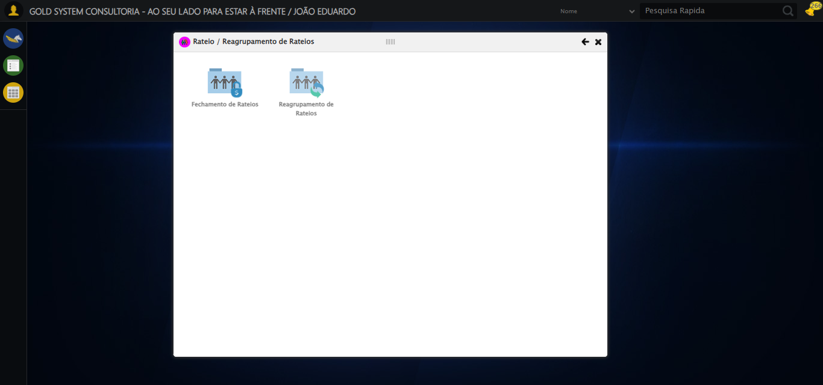

2025-08-29 17:43:30 ℹ️ [INFO] 🔄 Abrindo Lov de Grupo de Rateio Origem...

2025-08-29 17:43:31 ℹ️ [INFO] ✅ Abrindo Lov de Grupo de Rateio Origem realizada com sucesso.

Screenshot: abrindo lov de grupo de rateio origem

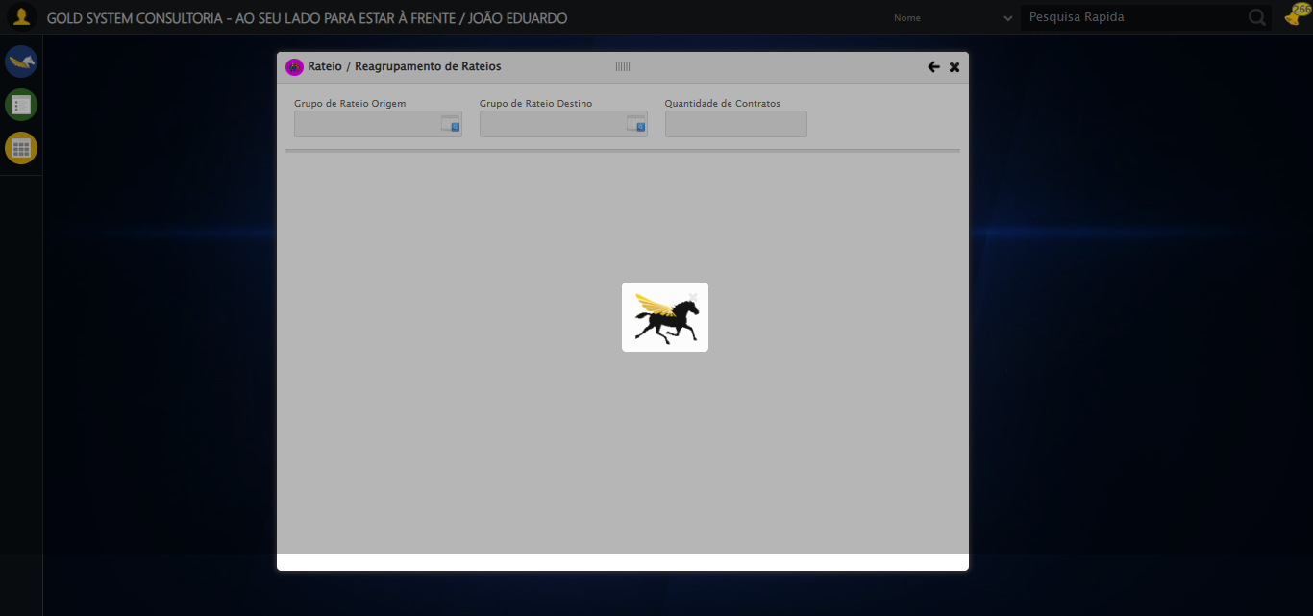

2025-08-29 17:43:31 ℹ️ [INFO] 🔄 Preenchendo Grupo de Rateio...

2025-08-29 17:43:33 ℹ️ [INFO] ✅ Preenchendo Grupo de Rateio realizada com sucesso.

Screenshot: preenchendo grupo de rateio

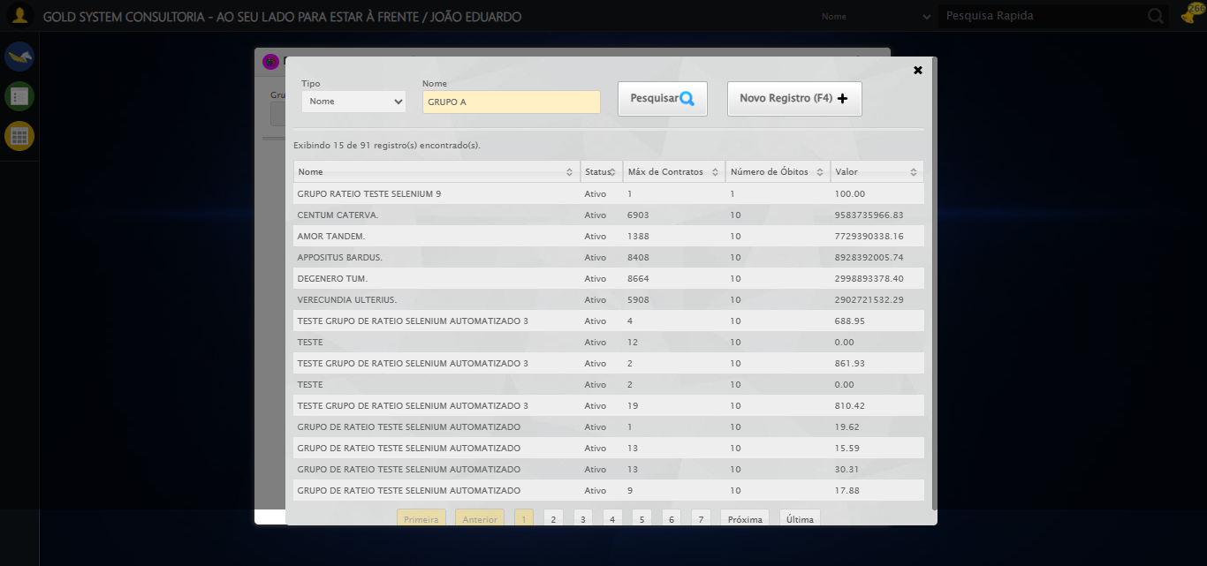

2025-08-29 17:43:34 ℹ️ [INFO] 🔄 Pesquisando Grupo de Rateio...

2025-08-29 17:43:34 ℹ️ [INFO] ✅ Pesquisando Grupo de Rateio realizada com sucesso.

Screenshot: pesquisando grupo de rateio

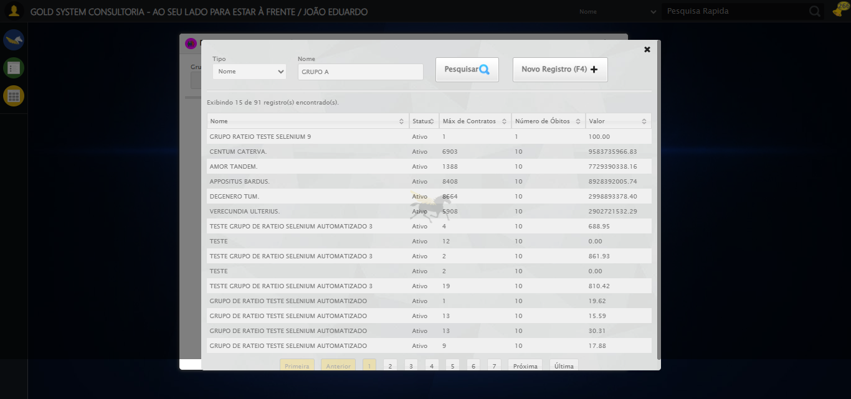

2025-08-29 17:43:34 ℹ️ [INFO] 🔄 Selecionando Grupo de Rateio...

2025-08-29 17:43:35 ℹ️ [INFO] ✅ Selecionando Grupo de Rateio realizada com sucesso.

Screenshot: selecionando grupo de rateio

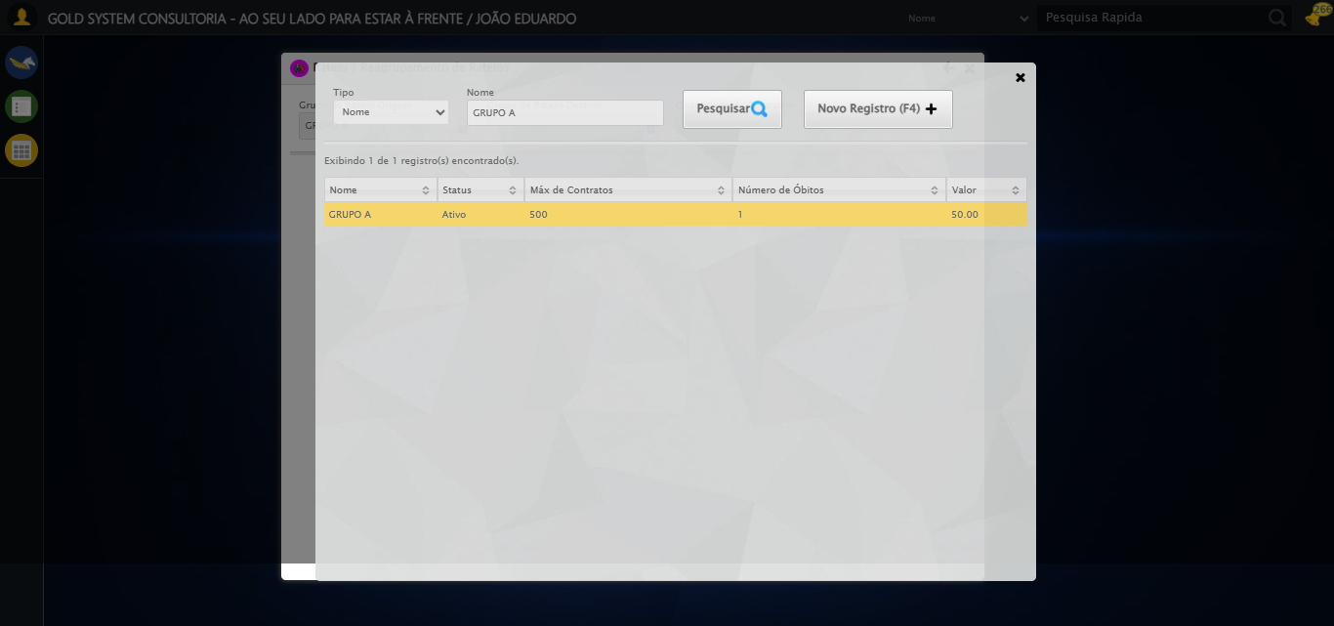

2025-08-29 17:43:35 ℹ️ [INFO] 🔄 Abrindo Lov de Grupo de Rateio Destino...

2025-08-29 17:43:35 ℹ️ [INFO] ❌ Erro inesperado ao abrindo lov de grupo de rateio destino: Message: invalid selector: Unable to locate an element with the xpath expression //*[@id=1gsRateio']/div[2]/div[2]/div[1]/div[2]/div/a because of the following error:  
SyntaxError: Failed to execute 'evaluate' on 'Document': The string '//*[@id=1gsRateio']/div[2]/div[2]/div[1]/div[2]/div/a' is not a valid XPath expression.  
 (Session info: chrome=139.0.7258.128); For documentation on this error, please visit: https://www.selenium.dev/documentation/webdriver/troubleshooting/errors#invalid-selector-exception  
Stacktrace:  
 GetHandleVerifier [0x0xeca8a3+63283]  
 GetHandleVerifier [0x0xeca8e4+63348]  
 (No symbol) [0x0xd03e43]  
 (No symbol) [0x0xd0a609]  
 (No symbol) [0x0xd0c97a]  
 (No symbol) [0x0xd0c9f7]  
 (No symbol) [0x0xd4c174]  
 (No symbol) [0x0xd4cc7b]  
 (No symbol) [0x0xd94ef2]  
 (No symbol) [0x0xd71464]  
 (No symbol) [0x0xd9271a]  
 (No symbol) [0x0xd71216]  
 (No symbol) [0x0xd40855]  
 (No symbol) [0x0xd416f4]  
 GetHandleVerifier [0x0x113bb43+2623955]  
 GetHandleVerifier [0x0x1136daa+2604090]  
 GetHandleVerifier [0x0xef069a+218410]  
 GetHandleVerifier [0x0xee0ed8+154984]  
 GetHandleVerifier [0x0xee742d+180925]  
 GetHandleVerifier [0x0xed22b8+94536]  
 GetHandleVerifier [0x0xed2442+94930]  
 GetHandleVerifier [0x0xebd5ea+9338]  
 BaseThreadInitThunk [0x0x76b1fcc9+25]  
 RtlGetAppContainerNamedObjectPath [0x0x776a82ae+286]  
 RtlGetAppContainerNamedObjectPath [0x0x776a827e+238]

Screenshot: erro_abrindo lov de grupo de rateio destino

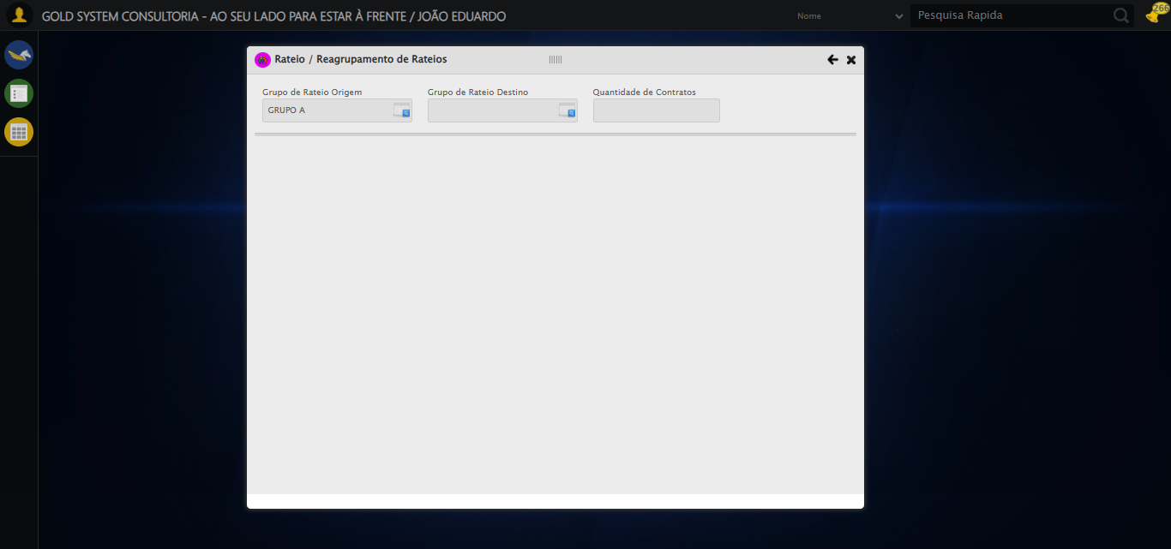

2025-08-29 17:43:36 ℹ️ [INFO] 🔄 Preenchendo Grupo de Rateio...

2025-08-29 17:43:56 ℹ️ [INFO] ⚠️ Tentativa 1 falhou: Message:   
Stacktrace:  
 GetHandleVerifier [0x0xeca8a3+63283]  
 GetHandleVerifier [0x0xeca8e4+63348]  
 (No symbol) [0x0xd03e43]  
 (No symbol) [0x0xd4c8de]  
 (No symbol) [0x0xd4cc7b]  
 (No symbol) [0x0xd94ef2]  
 (No symbol) [0x0xd71464]  
 (No symbol) [0x0xd9271a]  
 (No symbol) [0x0xd71216]  
 (No symbol) [0x0xd40855]  
 (No symbol) [0x0xd416f4]  
 GetHandleVerifier [0x0x113bb43+2623955]  
 GetHandleVerifier [0x0x1136daa+2604090]  
 GetHandleVerifier [0x0xef069a+218410]  
 GetHandleVerifier [0x0xee0ed8+154984]  
 GetHandleVerifier [0x0xee742d+180925]  
 GetHandleVerifier [0x0xed22b8+94536]  
 GetHandleVerifier [0x0xed2442+94930]  
 GetHandleVerifier [0x0xebd5ea+9338]  
 BaseThreadInitThunk [0x0x76b1fcc9+25]  
 RtlGetAppContainerNamedObjectPath [0x0x776a82ae+286]  
 RtlGetAppContainerNamedObjectPath [0x0x776a827e+238]

2025-08-29 17:44:17 ℹ️ [INFO] ⚠️ Tentativa 2 falhou: Message:   
Stacktrace:  
 GetHandleVerifier [0x0xeca8a3+63283]  
 GetHandleVerifier [0x0xeca8e4+63348]  
 (No symbol) [0x0xd03e43]  
 (No symbol) [0x0xd4c8de]  
 (No symbol) [0x0xd4cc7b]  
 (No symbol) [0x0xd94ef2]  
 (No symbol) [0x0xd71464]  
 (No symbol) [0x0xd9271a]  
 (No symbol) [0x0xd71216]  
 (No symbol) [0x0xd40855]  
 (No symbol) [0x0xd416f4]  
 GetHandleVerifier [0x0x113bb43+2623955]  
 GetHandleVerifier [0x0x1136daa+2604090]  
 GetHandleVerifier [0x0xef069a+218410]  
 GetHandleVerifier [0x0xee0ed8+154984]  
 GetHandleVerifier [0x0xee742d+180925]  
 GetHandleVerifier [0x0xed22b8+94536]  
 GetHandleVerifier [0x0xed2442+94930]  
 GetHandleVerifier [0x0xebd5ea+9338]  
 BaseThreadInitThunk [0x0x76b1fcc9+25]  
 RtlGetAppContainerNamedObjectPath [0x0x776a82ae+286]  
 RtlGetAppContainerNamedObjectPath [0x0x776a827e+238]

2025-08-29 17:44:38 ℹ️ [INFO] ⚠️ Tentativa 3 falhou: Message:   
Stacktrace:  
 GetHandleVerifier [0x0xeca8a3+63283]  
 GetHandleVerifier [0x0xeca8e4+63348]  
 (No symbol) [0x0xd03e43]  
 (No symbol) [0x0xd4c8de]  
 (No symbol) [0x0xd4cc7b]  
 (No symbol) [0x0xd94ef2]  
 (No symbol) [0x0xd71464]  
 (No symbol) [0x0xd9271a]  
 (No symbol) [0x0xd71216]  
 (No symbol) [0x0xd40855]  
 (No symbol) [0x0xd416f4]  
 GetHandleVerifier [0x0x113bb43+2623955]  
 GetHandleVerifier [0x0x1136daa+2604090]  
 GetHandleVerifier [0x0xef069a+218410]  
 GetHandleVerifier [0x0xee0ed8+154984]  
 GetHandleVerifier [0x0xee742d+180925]  
 GetHandleVerifier [0x0xed22b8+94536]  
 GetHandleVerifier [0x0xed2442+94930]  
 GetHandleVerifier [0x0xebd5ea+9338]  
 BaseThreadInitThunk [0x0x76b1fcc9+25]  
 RtlGetAppContainerNamedObjectPath [0x0x776a82ae+286]  
 RtlGetAppContainerNamedObjectPath [0x0x776a827e+238]

2025-08-29 17:44:39 ℹ️ [INFO] ✅ Preenchendo Grupo de Rateio realizada com sucesso.

2025-08-29 17:44:39 ℹ️ [INFO] 🔄 Pesquisando Grupo de Rateio...

2025-08-29 17:44:59 ℹ️ [INFO] ⚠️ Tentativa 1 falhou: Message:   
Stacktrace:  
 GetHandleVerifier [0x0xeca8a3+63283]  
 GetHandleVerifier [0x0xeca8e4+63348]  
 (No symbol) [0x0xd03e43]  
 (No symbol) [0x0xd4c8de]  
 (No symbol) [0x0xd4cc7b]  
 (No symbol) [0x0xd94ef2]  
 (No symbol) [0x0xd71464]  
 (No symbol) [0x0xd9271a]  
 (No symbol) [0x0xd71216]  
 (No symbol) [0x0xd40855]  
 (No symbol) [0x0xd416f4]  
 GetHandleVerifier [0x0x113bb43+2623955]  
 GetHandleVerifier [0x0x1136daa+2604090]  
 GetHandleVerifier [0x0xef069a+218410]  
 GetHandleVerifier [0x0xee0ed8+154984]  
 GetHandleVerifier [0x0xee742d+180925]  
 GetHandleVerifier [0x0xed22b8+94536]  
 GetHandleVerifier [0x0xed2442+94930]  
 GetHandleVerifier [0x0xebd5ea+9338]  
 BaseThreadInitThunk [0x0x76b1fcc9+25]  
 RtlGetAppContainerNamedObjectPath [0x0x776a82ae+286]  
 RtlGetAppContainerNamedObjectPath [0x0x776a827e+238]

2025-08-29 17:45:01 ℹ️ [INFO] 🔄 Pesquisando Grupo de Rateio... (Tentativa 2)

2025-08-29 17:45:22 ℹ️ [INFO] ⚠️ Tentativa 2 falhou: Message:   
Stacktrace:  
 GetHandleVerifier [0x0xeca8a3+63283]  
 GetHandleVerifier [0x0xeca8e4+63348]  
 (No symbol) [0x0xd03e43]  
 (No symbol) [0x0xd4c8de]  
 (No symbol) [0x0xd4cc7b]  
 (No symbol) [0x0xd94ef2]  
 (No symbol) [0x0xd71464]  
 (No symbol) [0x0xd9271a]  
 (No symbol) [0x0xd71216]  
 (No symbol) [0x0xd40855]  
 (No symbol) [0x0xd416f4]  
 GetHandleVerifier [0x0x113bb43+2623955]  
 GetHandleVerifier [0x0x1136daa+2604090]  
 GetHandleVerifier [0x0xef069a+218410]  
 GetHandleVerifier [0x0xee0ed8+154984]  
 GetHandleVerifier [0x0xee742d+180925]  
 GetHandleVerifier [0x0xed22b8+94536]  
 GetHandleVerifier [0x0xed2442+94930]  
 GetHandleVerifier [0x0xebd5ea+9338]  
 BaseThreadInitThunk [0x0x76b1fcc9+25]  
 RtlGetAppContainerNamedObjectPath [0x0x776a82ae+286]  
 RtlGetAppContainerNamedObjectPath [0x0x776a827e+238]

2025-08-29 17:45:24 ℹ️ [INFO] 🔄 Pesquisando Grupo de Rateio... (Tentativa 3)

2025-08-29 17:45:26 ℹ️ [INFO] ❌ Erro inesperado ao pesquisando grupo de rateio: 'NoneType' object has no attribute 'is_displayed'

2025-08-29 17:45:26 ℹ️ [INFO] ⚠️ Erro ao tirar screenshot erro_pesquisando grupo de rateio: Message: no such window: target window already closed  
from unknown error: web view not found  
 (Session info: chrome=139.0.7258.128)  
Stacktrace:  
 GetHandleVerifier [0x0xeca8a3+63283]  
 GetHandleVerifier [0x0xeca8e4+63348]  
 (No symbol) [0x0xd03e43]  
 (No symbol) [0x0xce2c49]  
 (No symbol) [0x0xd77b0e]  
 (No symbol) [0x0xd91ff9]  
 (No symbol) [0x0xd71216]  
 (No symbol) [0x0xd40855]  
 (No symbol) [0x0xd416f4]  
 GetHandleVerifier [0x0x113bb43+2623955]  
 GetHandleVerifier [0x0x1136daa+2604090]  
 GetHandleVerifier [0x0xef069a+218410]  
 GetHandleVerifier [0x0xee0ed8+154984]  
 GetHandleVerifier [0x0xee742d+180925]  
 GetHandleVerifier [0x0xed22b8+94536]  
 GetHandleVerifier [0x0xed2442+94930]  
 GetHandleVerifier [0x0xebd5ea+9338]  
 BaseThreadInitThunk [0x0x76b1fcc9+25]  
 RtlGetAppContainerNamedObjectPath [0x0x776a82ae+286]  
 RtlGetAppContainerNamedObjectPath [0x0x776a827e+238]

2025-08-29 17:45:26 ℹ️ [INFO] 🔄 Selecionando Grupo de Rateio...

2025-08-29 17:45:26 ℹ️ [INFO] ❌ Erro inesperado ao selecionando grupo de rateio: Message: no such window: target window already closed  
from unknown error: web view not found  
 (Session info: chrome=139.0.7258.128)  
Stacktrace:  
 GetHandleVerifier [0x0xeca8a3+63283]  
 GetHandleVerifier [0x0xeca8e4+63348]  
 (No symbol) [0x0xd03e43]  
 (No symbol) [0x0xce2c49]  
 (No symbol) [0x0xd77b0e]  
 (No symbol) [0x0xd91ff9]  
 (No symbol) [0x0xd71216]  
 (No symbol) [0x0xd40855]  
 (No symbol) [0x0xd416f4]  
 GetHandleVerifier [0x0x113bb43+2623955]  
 GetHandleVerifier [0x0x1136daa+2604090]  
 GetHandleVerifier [0x0xef069a+218410]  
 GetHandleVerifier [0x0xee0ed8+154984]  
 GetHandleVerifier [0x0xee742d+180925]  
 GetHandleVerifier [0x0xed22b8+94536]  
 GetHandleVerifier [0x0xed2442+94930]  
 GetHandleVerifier [0x0xebd5ea+9338]  
 BaseThreadInitThunk [0x0x76b1fcc9+25]  
 RtlGetAppContainerNamedObjectPath [0x0x776a82ae+286]  
 RtlGetAppContainerNamedObjectPath [0x0x776a827e+238]

2025-08-29 17:45:26 ℹ️ [INFO] ⚠️ Erro ao tirar screenshot erro_selecionando grupo de rateio: Message: no such window: target window already closed  
from unknown error: web view not found  
 (Session info: chrome=139.0.7258.128)  
Stacktrace:  
 GetHandleVerifier [0x0xeca8a3+63283]  
 GetHandleVerifier [0x0xeca8e4+63348]  
 (No symbol) [0x0xd03e43]  
 (No symbol) [0x0xce2c49]  
 (No symbol) [0x0xd77b0e]  
 (No symbol) [0x0xd91ff9]  
 (No symbol) [0x0xd71216]  
 (No symbol) [0x0xd40855]  
 (No symbol) [0x0xd416f4]  
 GetHandleVerifier [0x0x113bb43+2623955]  
 GetHandleVerifier [0x0x1136daa+2604090]  
 GetHandleVerifier [0x0xef069a+218410]  
 GetHandleVerifier [0x0xee0ed8+154984]  
 GetHandleVerifier [0x0xee742d+180925]  
 GetHandleVerifier [0x0xed22b8+94536]  
 GetHandleVerifier [0x0xed2442+94930]  
 GetHandleVerifier [0x0xebd5ea+9338]  
 BaseThreadInitThunk [0x0x76b1fcc9+25]  
 RtlGetAppContainerNamedObjectPath [0x0x776a82ae+286]  
 RtlGetAppContainerNamedObjectPath [0x0x776a827e+238]

2025-08-29 17:45:26 ℹ️ [INFO] 🔄 Reagrupando Rateios...

2025-08-29 17:45:26 ℹ️ [INFO] ❌ Erro inesperado ao reagrupando rateios: Message: no such window: target window already closed  
from unknown error: web view not found  
 (Session info: chrome=139.0.7258.128)  
Stacktrace:  
 GetHandleVerifier [0x0xeca8a3+63283]  
 GetHandleVerifier [0x0xeca8e4+63348]  
 (No symbol) [0x0xd03e43]  
 (No symbol) [0x0xce2c49]  
 (No symbol) [0x0xd77b0e]  
 (No symbol) [0x0xd91ff9]  
 (No symbol) [0x0xd71216]  
 (No symbol) [0x0xd40855]  
 (No symbol) [0x0xd416f4]  
 GetHandleVerifier [0x0x113bb43+2623955]  
 GetHandleVerifier [0x0x1136daa+2604090]  
 GetHandleVerifier [0x0xef069a+218410]  
 GetHandleVerifier [0x0xee0ed8+154984]  
 GetHandleVerifier [0x0xee742d+180925]  
 GetHandleVerifier [0x0xed22b8+94536]  
 GetHandleVerifier [0x0xed2442+94930]  
 GetHandleVerifier [0x0xebd5ea+9338]  
 BaseThreadInitThunk [0x0x76b1fcc9+25]  
 RtlGetAppContainerNamedObjectPath [0x0x776a82ae+286]  
 RtlGetAppContainerNamedObjectPath [0x0x776a827e+238]

2025-08-29 17:45:26 ℹ️ [INFO] ⚠️ Erro ao tirar screenshot erro_reagrupando rateios: Message: no such window: target window already closed  
from unknown error: web view not found  
 (Session info: chrome=139.0.7258.128)  
Stacktrace:  
 GetHandleVerifier [0x0xeca8a3+63283]  
 GetHandleVerifier [0x0xeca8e4+63348]  
 (No symbol) [0x0xd03e43]  
 (No symbol) [0x0xce2c49]  
 (No symbol) [0x0xd77b0e]  
 (No symbol) [0x0xd91ff9]  
 (No symbol) [0x0xd71216]  
 (No symbol) [0x0xd40855]  
 (No symbol) [0x0xd416f4]  
 GetHandleVerifier [0x0x113bb43+2623955]  
 GetHandleVerifier [0x0x1136daa+2604090]  
 GetHandleVerifier [0x0xef069a+218410]  
 GetHandleVerifier [0x0xee0ed8+154984]  
 GetHandleVerifier [0x0xee742d+180925]  
 GetHandleVerifier [0x0xed22b8+94536]  
 GetHandleVerifier [0x0xed2442+94930]  
 GetHandleVerifier [0x0xebd5ea+9338]  
 BaseThreadInitThunk [0x0x76b1fcc9+25]  
 RtlGetAppContainerNamedObjectPath [0x0x776a82ae+286]  
 RtlGetAppContainerNamedObjectPath [0x0x776a827e+238]

2025-08-29 17:45:26 ℹ️ [INFO] 🔍 Verificando mensagens de alerta...

2025-08-29 17:45:26 ℹ️ [INFO] ℹ️ Nenhuma mensagem de alerta encontrada.

2025-08-29 17:45:26 ℹ️ [INFO] 🔄 Fechando modal Rateio...

2025-08-29 17:45:26 ℹ️ [INFO] ❌ Erro inesperado ao fechando modal rateio: Message: no such window: target window already closed  
from unknown error: web view not found  
 (Session info: chrome=139.0.7258.128)  
Stacktrace:  
 GetHandleVerifier [0x0xeca8a3+63283]  
 GetHandleVerifier [0x0xeca8e4+63348]  
 (No symbol) [0x0xd03e43]  
 (No symbol) [0x0xce2c49]  
 (No symbol) [0x0xd77b0e]  
 (No symbol) [0x0xd91ff9]  
 (No symbol) [0x0xd71216]  
 (No symbol) [0x0xd40855]  
 (No symbol) [0x0xd416f4]  
 GetHandleVerifier [0x0x113bb43+2623955]  
 GetHandleVerifier [0x0x1136daa+2604090]  
 GetHandleVerifier [0x0xef069a+218410]  
 GetHandleVerifier [0x0xee0ed8+154984]  
 GetHandleVerifier [0x0xee742d+180925]  
 GetHandleVerifier [0x0xed22b8+94536]  
 GetHandleVerifier [0x0xed2442+94930]  
 GetHandleVerifier [0x0xebd5ea+9338]  
 BaseThreadInitThunk [0x0x76b1fcc9+25]  
 RtlGetAppContainerNamedObjectPath [0x0x776a82ae+286]  
 RtlGetAppContainerNamedObjectPath [0x0x776a827e+238]

2025-08-29 17:45:26 ℹ️ [INFO] ⚠️ Erro ao tirar screenshot erro_fechando modal rateio: Message: no such window: target window already closed  
from unknown error: web view not found  
 (Session info: chrome=139.0.7258.128)  
Stacktrace:  
 GetHandleVerifier [0x0xeca8a3+63283]  
 GetHandleVerifier [0x0xeca8e4+63348]  
 (No symbol) [0x0xd03e43]  
 (No symbol) [0x0xce2c49]  
 (No symbol) [0x0xd77b0e]  
 (No symbol) [0x0xd91ff9]  
 (No symbol) [0x0xd71216]  
 (No symbol) [0x0xd40855]  
 (No symbol) [0x0xd416f4]  
 GetHandleVerifier [0x0x113bb43+2623955]  
 GetHandleVerifier [0x0x1136daa+2604090]  
 GetHandleVerifier [0x0xef069a+218410]  
 GetHandleVerifier [0x0xee0ed8+154984]  
 GetHandleVerifier [0x0xee742d+180925]  
 GetHandleVerifier [0x0xed22b8+94536]  
 GetHandleVerifier [0x0xed2442+94930]  
 GetHandleVerifier [0x0xebd5ea+9338]  
 BaseThreadInitThunk [0x0x76b1fcc9+25]  
 RtlGetAppContainerNamedObjectPath [0x0x776a82ae+286]  
 RtlGetAppContainerNamedObjectPath [0x0x776a827e+238]

2025-08-29 17:45:26 ℹ️ [INFO] ✅ Teste concluído.

2025-08-29 17:45:26 ℹ️ [INFO] ✅ Teste executado com sucesso!