RELATÓRIO DO TESTE

Cadastro de Agenda de Ambulância – Cenário 1: Preenchimento completo e salvamento.

Data do teste: 06/08/2025 17:30:16

🚀 Iniciando teste de cadastro de registro de óbito...

🔄 Acessando sistema...

✅ Acessando sistema realizada com sucesso.

Screenshot: acessando_sistema

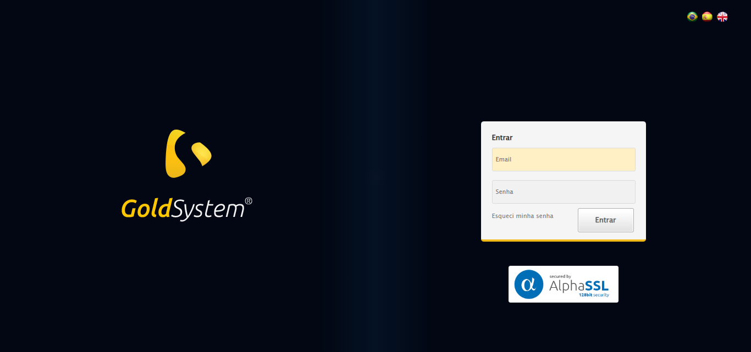

🔄 Realizando login...

✅ Realizando login realizada com sucesso.

Screenshot: realizando_login

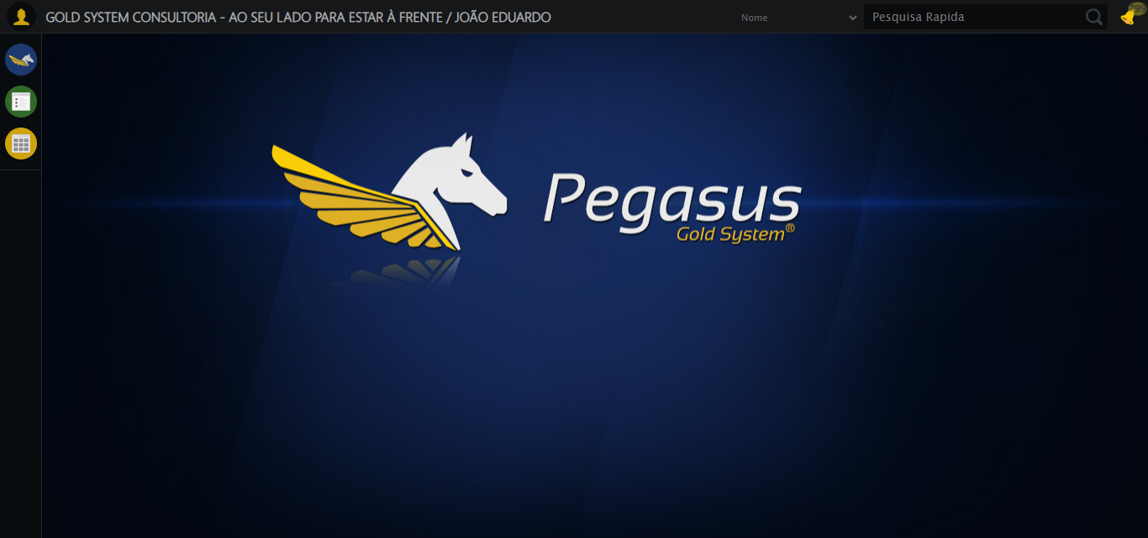

🔄 Ajustando zoom e abrindo menu...

🔍 Zoom ajustado para 90%.

✅ Ajustando zoom e abrindo menu realizada com sucesso.

Screenshot: ajustando_zoom_e_abrindo_menu

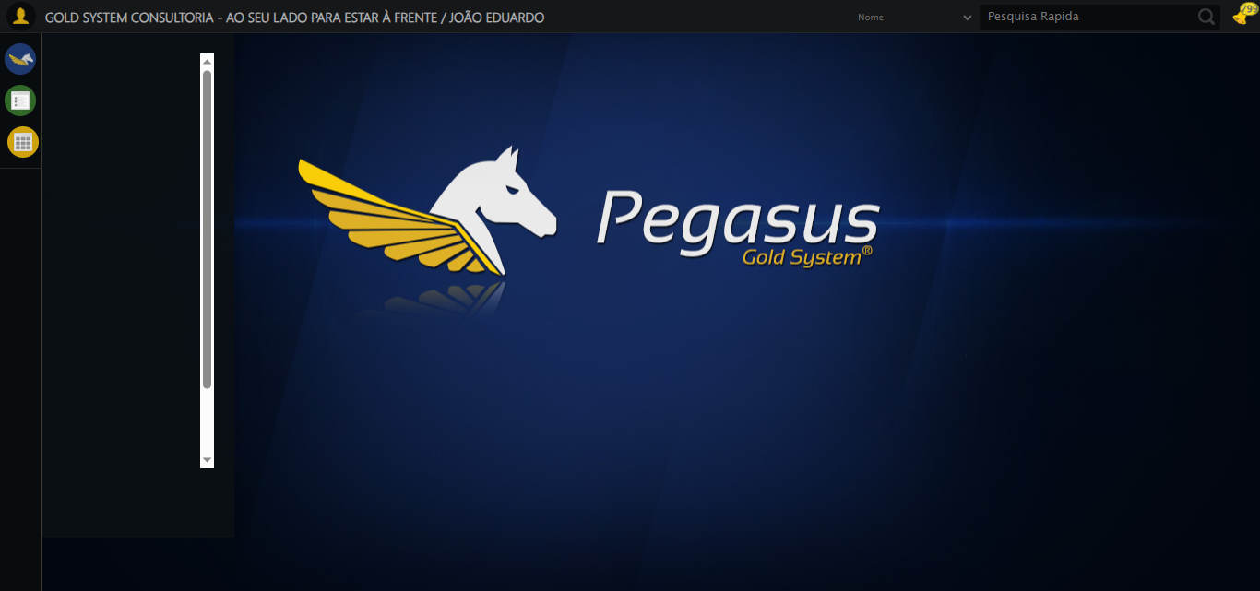

🔄 Acessando Agenda Ambulância...

✅ Acessando Agenda Ambulância realizada com sucesso.

Screenshot: acessando_agenda_ambulância

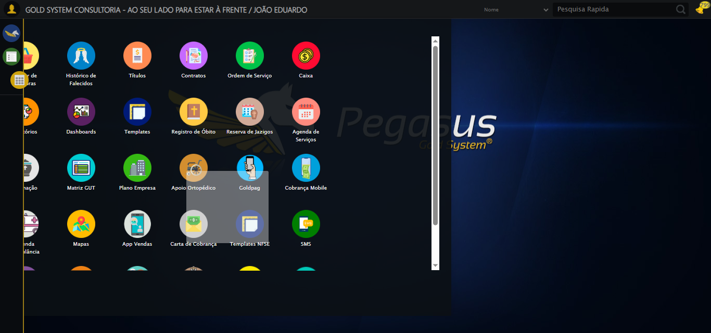

🔄 Clicando em Cadastrar...

✅ Clicando em Cadastrar realizada com sucesso.

Screenshot: clicando_em_cadastrar

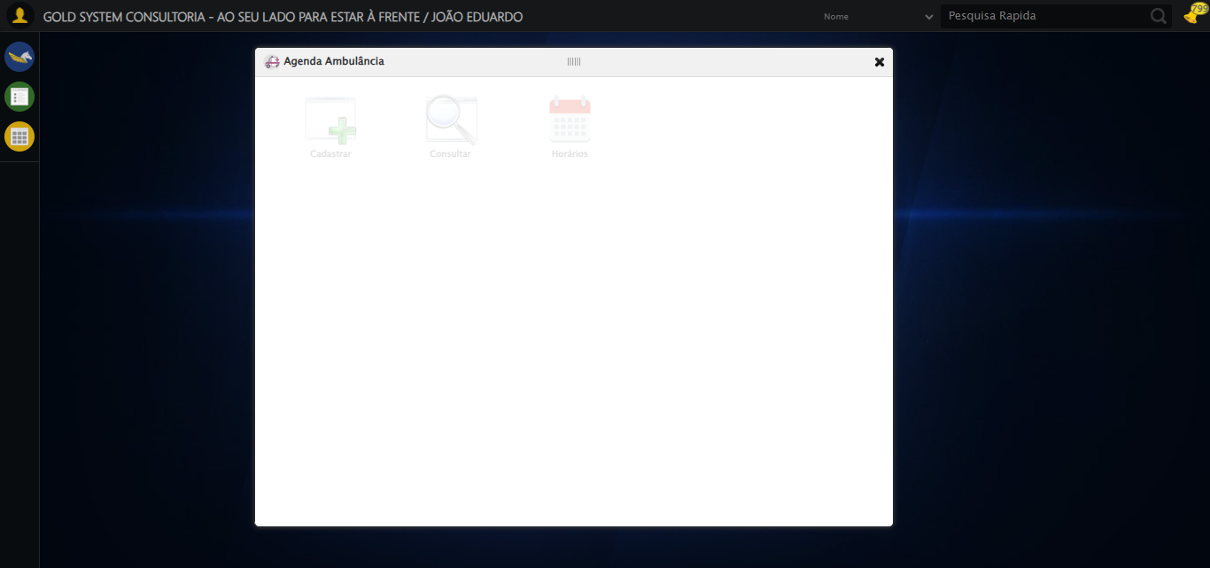

🔄 Selecionando Contrato...

✅ Selecionando Contrato realizada com sucesso.

Screenshot: selecionando_contrato

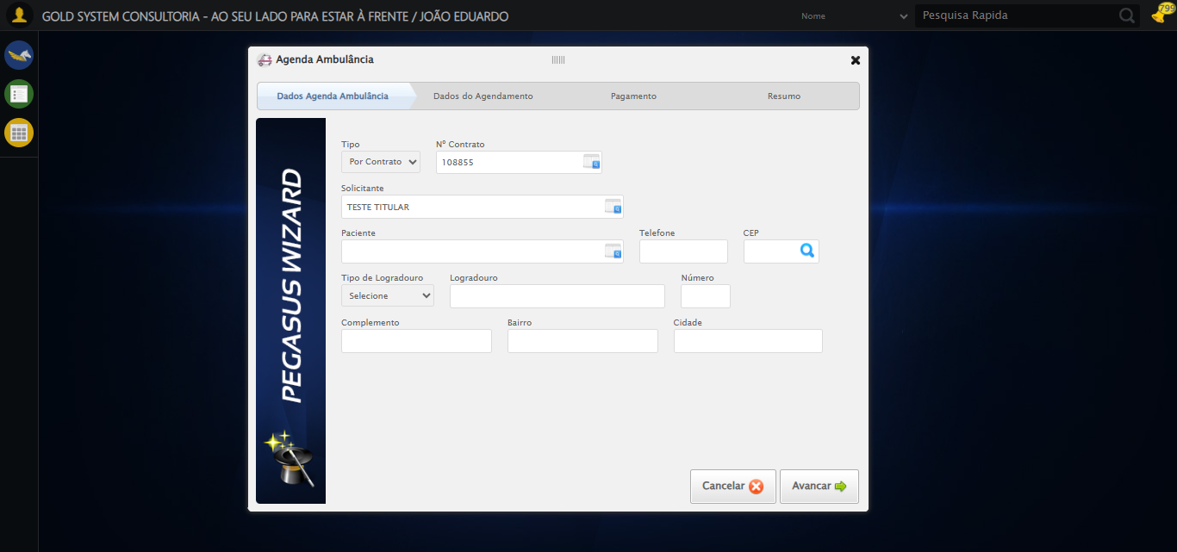

🔄 Abrindo lov do Paciente...

✅ Abrindo lov do Paciente realizada com sucesso.

Screenshot: abrindo_lov_do_paciente

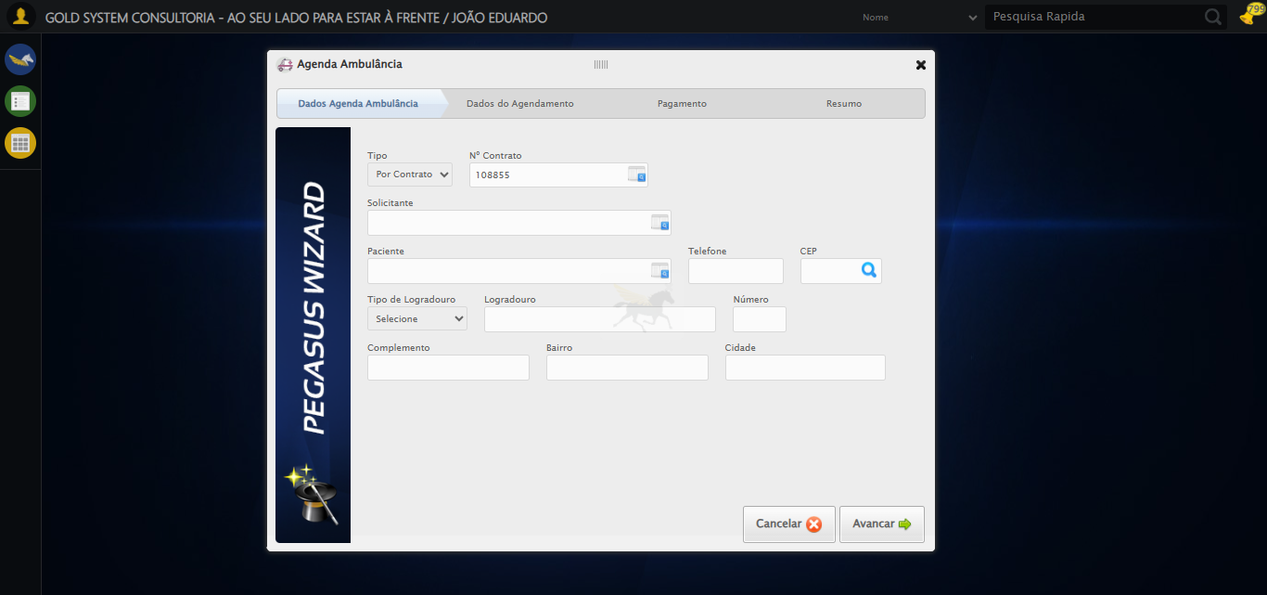

🔄 Selecionando Paciente...

❌ Erro ao interagir com elemento //a[contains(@class, 'linkAlterar')]: Message: invalid selector: An invalid or illegal selector was specified  
 (Session info: chrome=138.0.7204.185); For documentation on this error, please visit: https://www.selenium.dev/documentation/webdriver/troubleshooting/errors#invalid-selector-exception  
Stacktrace:  
 GetHandleVerifier [0x0x3fba83+63395]  
 GetHandleVerifier [0x0x3fbac4+63460]  
 (No symbol) [0x0x242113]  
 (No symbol) [0x0x2488e9]  
 (No symbol) [0x0x24ac7a]  
 (No symbol) [0x0x24acf7]  
 (No symbol) [0x0x28a0f4]  
 (No symbol) [0x0x28abfb]  
 (No symbol) [0x0x2d2f92]  
 (No symbol) [0x0x2af3f4]  
 (No symbol) [0x0x2d07ba]  
 (No symbol) [0x0x2af1a6]  
 (No symbol) [0x0x27e7b2]  
 (No symbol) [0x0x27f654]  
 GetHandleVerifier [0x0x678883+2672035]  
 GetHandleVerifier [0x0x673cba+2652634]  
 GetHandleVerifier [0x0x422bca+223466]  
 GetHandleVerifier [0x0x412cb8+158168]  
 GetHandleVerifier [0x0x41978d+185517]  
 GetHandleVerifier [0x0x403b78+96408]  
 GetHandleVerifier [0x0x403d02+96802]  
 GetHandleVerifier [0x0x3ee90a+9770]  
 BaseThreadInitThunk [0x0x773dfcc9+25]  
 RtlGetAppContainerNamedObjectPath [0x0x77ba82ae+286]  
 RtlGetAppContainerNamedObjectPath [0x0x77ba827e+238]

❌ Erro inesperado ao selecionando paciente: Não foi possível clicar no elemento: //a[contains(@class, 'linkAlterar')]

Screenshot: erro_selecionando_paciente

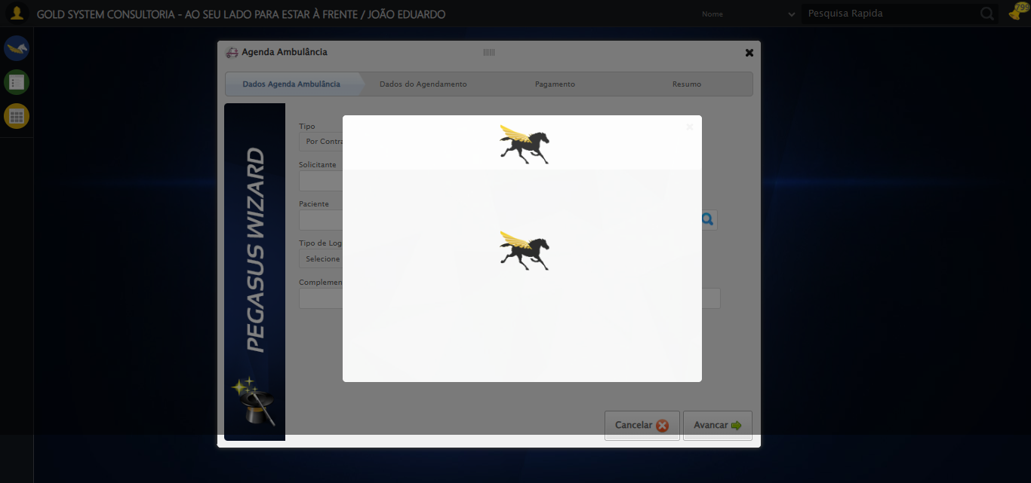

🔄 Preenchendo Telefone...

✅ Preenchendo Telefone realizada com sucesso.

Screenshot: preenchendo_telefone

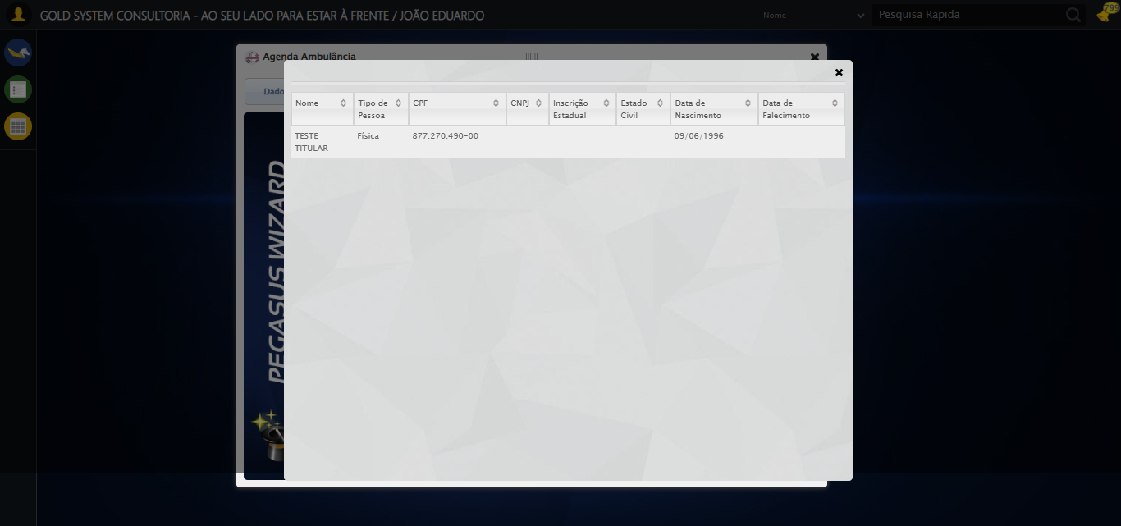

🔄 Preenchendo Complemento...

✅ Preenchendo Complemento realizada com sucesso.

Screenshot: preenchendo_complemento

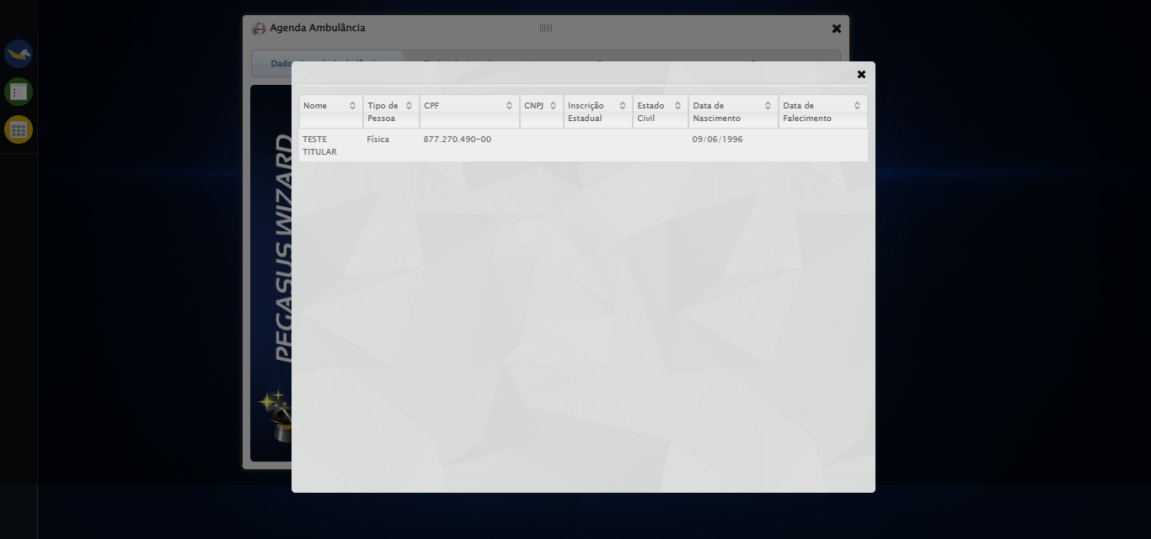

🔄 Preenchendo Complemento...

✅ Preenchendo Complemento realizada com sucesso.

🔄 Preenchendo Complemento...

✅ Preenchendo Complemento realizada com sucesso.

🔄 Avançando para próxima etapa...

❌ Erro inesperado ao avançando para próxima etapa: Message: element click intercepted: Element <a class="btModel btGray" style="display: inline-block;">...</a> is not clickable at point (951, 529). Other element would receive the click: <div class="modal overflow" style="z-index: 10002; left: 50%; top: 50%; width: 750px; height: 550px; margin-left: -375px; margin-top: -275px;">...</div>  
 (Session info: chrome=138.0.7204.185)  
Stacktrace:  
 GetHandleVerifier [0x0x3fba83+63395]  
 GetHandleVerifier [0x0x3fbac4+63460]  
 (No symbol) [0x0x242113]  
 (No symbol) [0x0x290ba0]  
 (No symbol) [0x0x28ef5a]  
 (No symbol) [0x0x28cab7]  
 (No symbol) [0x0x28bd6d]  
 (No symbol) [0x0x280515]  
 (No symbol) [0x0x2af3ac]  
 (No symbol) [0x0x27ffa4]  
 (No symbol) [0x0x2af624]  
 (No symbol) [0x0x2d07ba]  
 (No symbol) [0x0x2af1a6]  
 (No symbol) [0x0x27e7b2]  
 (No symbol) [0x0x27f654]  
 GetHandleVerifier [0x0x678883+2672035]  
 GetHandleVerifier [0x0x673cba+2652634]  
 GetHandleVerifier [0x0x422bca+223466]  
 GetHandleVerifier [0x0x412cb8+158168]  
 GetHandleVerifier [0x0x41978d+185517]  
 GetHandleVerifier [0x0x403b78+96408]  
 GetHandleVerifier [0x0x403d02+96802]  
 GetHandleVerifier [0x0x3ee90a+9770]  
 BaseThreadInitThunk [0x0x773dfcc9+25]  
 RtlGetAppContainerNamedObjectPath [0x0x77ba82ae+286]  
 RtlGetAppContainerNamedObjectPath [0x0x77ba827e+238]

Screenshot: erro_avançando_para_próxima_etapa



🔄 Clicando no Lov para consultar um motorista...

⚠️ Tentativa 1 falhou para Clicando no Lov para consultar um motorista, tentando novamente...

🔄 Clicando no Lov para consultar um motorista... (Tentativa 2)

⚠️ Tentativa 2 falhou para Clicando no Lov para consultar um motorista, tentando novamente...

🔄 Clicando no Lov para consultar um motorista... (Tentativa 3)

❌ Erro inesperado ao clicando no lov para consultar um motorista: 'NoneType' object has no attribute 'is_displayed'

⚠️ Erro ao tirar screenshot erro_clicando_no_lov_para_consultar_um_motorista: Message: no such window: target window already closed  
from unknown error: web view not found  
 (Session info: chrome=138.0.7204.185)  
Stacktrace:  
 GetHandleVerifier [0x0x3fba83+63395]  
 GetHandleVerifier [0x0x3fbac4+63460]  
 (No symbol) [0x0x242113]  
 (No symbol) [0x0x220fb9]  
 (No symbol) [0x0x2b5ace]  
 (No symbol) [0x0x2d0099]  
 (No symbol) [0x0x2af1a6]  
 (No symbol) [0x0x27e7b2]  
 (No symbol) [0x0x27f654]  
 GetHandleVerifier [0x0x678883+2672035]  
 GetHandleVerifier [0x0x673cba+2652634]  
 GetHandleVerifier [0x0x422bca+223466]  
 GetHandleVerifier [0x0x412cb8+158168]  
 GetHandleVerifier [0x0x41978d+185517]  
 GetHandleVerifier [0x0x403b78+96408]  
 GetHandleVerifier [0x0x403d02+96802]  
 GetHandleVerifier [0x0x3ee90a+9770]  
 BaseThreadInitThunk [0x0x773dfcc9+25]  
 RtlGetAppContainerNamedObjectPath [0x0x77ba82ae+286]  
 RtlGetAppContainerNamedObjectPath [0x0x77ba827e+238]

🔄 Selecionando Motorista...

❌ Erro ao interagir com elemento //td[contains(text(), 'MOTORISTA TREINAMENTO')]: Message: no such window: target window already closed  
from unknown error: web view not found  
 (Session info: chrome=138.0.7204.185)  
Stacktrace:  
 GetHandleVerifier [0x0x3fba83+63395]  
 GetHandleVerifier [0x0x3fbac4+63460]  
 (No symbol) [0x0x242113]  
 (No symbol) [0x0x220fb9]  
 (No symbol) [0x0x2b5ace]  
 (No symbol) [0x0x2d0099]  
 (No symbol) [0x0x2af1a6]  
 (No symbol) [0x0x27e7b2]  
 (No symbol) [0x0x27f654]  
 GetHandleVerifier [0x0x678883+2672035]  
 GetHandleVerifier [0x0x673cba+2652634]  
 GetHandleVerifier [0x0x422bca+223466]  
 GetHandleVerifier [0x0x412cb8+158168]  
 GetHandleVerifier [0x0x41978d+185517]  
 GetHandleVerifier [0x0x403b78+96408]  
 GetHandleVerifier [0x0x403d02+96802]  
 GetHandleVerifier [0x0x3ee90a+9770]  
 BaseThreadInitThunk [0x0x773dfcc9+25]  
 RtlGetAppContainerNamedObjectPath [0x0x77ba82ae+286]  
 RtlGetAppContainerNamedObjectPath [0x0x77ba827e+238]

❌ Erro inesperado ao selecionando motorista: Não foi possível clicar no elemento: //td[contains(text(), 'MOTORISTA TREINAMENTO')]

⚠️ Erro ao tirar screenshot erro_selecionando_motorista: Message: no such window: target window already closed  
from unknown error: web view not found  
 (Session info: chrome=138.0.7204.185)  
Stacktrace:  
 GetHandleVerifier [0x0x3fba83+63395]  
 GetHandleVerifier [0x0x3fbac4+63460]  
 (No symbol) [0x0x242113]  
 (No symbol) [0x0x220fb9]  
 (No symbol) [0x0x2b5ace]  
 (No symbol) [0x0x2d0099]  
 (No symbol) [0x0x2af1a6]  
 (No symbol) [0x0x27e7b2]  
 (No symbol) [0x0x27f654]  
 GetHandleVerifier [0x0x678883+2672035]  
 GetHandleVerifier [0x0x673cba+2652634]  
 GetHandleVerifier [0x0x422bca+223466]  
 GetHandleVerifier [0x0x412cb8+158168]  
 GetHandleVerifier [0x0x41978d+185517]  
 GetHandleVerifier [0x0x403b78+96408]  
 GetHandleVerifier [0x0x403d02+96802]  
 GetHandleVerifier [0x0x3ee90a+9770]  
 BaseThreadInitThunk [0x0x773dfcc9+25]  
 RtlGetAppContainerNamedObjectPath [0x0x77ba82ae+286]  
 RtlGetAppContainerNamedObjectPath [0x0x77ba827e+238]

🔄 Preenchendo Nome do Acompanhante...

❌ Erro ao interagir com elemento #gsAgendaAmbulancia > div.wdTelas > div.wdWizard.clearfix.telaConsulta > div.wizardHolder > div > div.step2 > div:nth-child(2) > div:nth-child(6) > input[type=text]: Message: no such window: target window already closed  
from unknown error: web view not found  
 (Session info: chrome=138.0.7204.185)  
Stacktrace:  
 GetHandleVerifier [0x0x3fba83+63395]  
 GetHandleVerifier [0x0x3fbac4+63460]  
 (No symbol) [0x0x242113]  
 (No symbol) [0x0x220fb9]  
 (No symbol) [0x0x2b5ace]  
 (No symbol) [0x0x2d0099]  
 (No symbol) [0x0x2af1a6]  
 (No symbol) [0x0x27e7b2]  
 (No symbol) [0x0x27f654]  
 GetHandleVerifier [0x0x678883+2672035]  
 GetHandleVerifier [0x0x673cba+2652634]  
 GetHandleVerifier [0x0x422bca+223466]  
 GetHandleVerifier [0x0x412cb8+158168]  
 GetHandleVerifier [0x0x41978d+185517]  
 GetHandleVerifier [0x0x403b78+96408]  
 GetHandleVerifier [0x0x403d02+96802]  
 GetHandleVerifier [0x0x3ee90a+9770]  
 BaseThreadInitThunk [0x0x773dfcc9+25]  
 RtlGetAppContainerNamedObjectPath [0x0x77ba82ae+286]  
 RtlGetAppContainerNamedObjectPath [0x0x77ba827e+238]

❌ Erro inesperado ao preenchendo nome do acompanhante: Não foi possível encontrar o elemento: #gsAgendaAmbulancia > div.wdTelas > div.wdWizard.clearfix.telaConsulta > div.wizardHolder > div > div.step2 > div:nth-child(2) > div:nth-child(6) > input[type=text]

⚠️ Erro ao tirar screenshot erro_preenchendo_nome_do_acompanhante: Message: no such window: target window already closed  
from unknown error: web view not found  
 (Session info: chrome=138.0.7204.185)  
Stacktrace:  
 GetHandleVerifier [0x0x3fba83+63395]  
 GetHandleVerifier [0x0x3fbac4+63460]  
 (No symbol) [0x0x242113]  
 (No symbol) [0x0x220fb9]  
 (No symbol) [0x0x2b5ace]  
 (No symbol) [0x0x2d0099]  
 (No symbol) [0x0x2af1a6]  
 (No symbol) [0x0x27e7b2]  
 (No symbol) [0x0x27f654]  
 GetHandleVerifier [0x0x678883+2672035]  
 GetHandleVerifier [0x0x673cba+2652634]  
 GetHandleVerifier [0x0x422bca+223466]  
 GetHandleVerifier [0x0x412cb8+158168]  
 GetHandleVerifier [0x0x41978d+185517]  
 GetHandleVerifier [0x0x403b78+96408]  
 GetHandleVerifier [0x0x403d02+96802]  
 GetHandleVerifier [0x0x3ee90a+9770]  
 BaseThreadInitThunk [0x0x773dfcc9+25]  
 RtlGetAppContainerNamedObjectPath [0x0x77ba82ae+286]  
 RtlGetAppContainerNamedObjectPath [0x0x77ba827e+238]

🔄 Preenchendo Local Transporte...

❌ Erro ao interagir com elemento #gsAgendaAmbulancia > div.wdTelas > div.wdWizard.clearfix.telaConsulta > div.wizardHolder > div > div.step2 > div:nth-child(2) > div:nth-child(7) > input[type=text]]: Message: no such window: target window already closed  
from unknown error: web view not found  
 (Session info: chrome=138.0.7204.185)  
Stacktrace:  
 GetHandleVerifier [0x0x3fba83+63395]  
 GetHandleVerifier [0x0x3fbac4+63460]  
 (No symbol) [0x0x242113]  
 (No symbol) [0x0x220fb9]  
 (No symbol) [0x0x2b5ace]  
 (No symbol) [0x0x2d0099]  
 (No symbol) [0x0x2af1a6]  
 (No symbol) [0x0x27e7b2]  
 (No symbol) [0x0x27f654]  
 GetHandleVerifier [0x0x678883+2672035]  
 GetHandleVerifier [0x0x673cba+2652634]  
 GetHandleVerifier [0x0x422bca+223466]  
 GetHandleVerifier [0x0x412cb8+158168]  
 GetHandleVerifier [0x0x41978d+185517]  
 GetHandleVerifier [0x0x403b78+96408]  
 GetHandleVerifier [0x0x403d02+96802]  
 GetHandleVerifier [0x0x3ee90a+9770]  
 BaseThreadInitThunk [0x0x773dfcc9+25]  
 RtlGetAppContainerNamedObjectPath [0x0x77ba82ae+286]  
 RtlGetAppContainerNamedObjectPath [0x0x77ba827e+238]

❌ Erro inesperado ao preenchendo local transporte: Não foi possível encontrar o elemento: #gsAgendaAmbulancia > div.wdTelas > div.wdWizard.clearfix.telaConsulta > div.wizardHolder > div > div.step2 > div:nth-child(2) > div:nth-child(7) > input[type=text]]

⚠️ Erro ao tirar screenshot erro_preenchendo_local_transporte: Message: no such window: target window already closed  
from unknown error: web view not found  
 (Session info: chrome=138.0.7204.185)  
Stacktrace:  
 GetHandleVerifier [0x0x3fba83+63395]  
 GetHandleVerifier [0x0x3fbac4+63460]  
 (No symbol) [0x0x242113]  
 (No symbol) [0x0x220fb9]  
 (No symbol) [0x0x2b5ace]  
 (No symbol) [0x0x2d0099]  
 (No symbol) [0x0x2af1a6]  
 (No symbol) [0x0x27e7b2]  
 (No symbol) [0x0x27f654]  
 GetHandleVerifier [0x0x678883+2672035]  
 GetHandleVerifier [0x0x673cba+2652634]  
 GetHandleVerifier [0x0x422bca+223466]  
 GetHandleVerifier [0x0x412cb8+158168]  
 GetHandleVerifier [0x0x41978d+185517]  
 GetHandleVerifier [0x0x403b78+96408]  
 GetHandleVerifier [0x0x403d02+96802]  
 GetHandleVerifier [0x0x3ee90a+9770]  
 BaseThreadInitThunk [0x0x773dfcc9+25]  
 RtlGetAppContainerNamedObjectPath [0x0x77ba82ae+286]  
 RtlGetAppContainerNamedObjectPath [0x0x77ba827e+238]

🔄 Preenchendo Cidade Transporte...

❌ Erro ao interagir com elemento #gsAgendaAmbulancia > div.wdTelas > div.wdWizard.clearfix.telaConsulta > div.wizardHolder > div > div.step2 > div:nth-child(2) > div:nth-child(7) > input[type=text]]: Message: no such window: target window already closed  
from unknown error: web view not found  
 (Session info: chrome=138.0.7204.185)  
Stacktrace:  
 GetHandleVerifier [0x0x3fba83+63395]  
 GetHandleVerifier [0x0x3fbac4+63460]  
 (No symbol) [0x0x242113]  
 (No symbol) [0x0x220fb9]  
 (No symbol) [0x0x2b5ace]  
 (No symbol) [0x0x2d0099]  
 (No symbol) [0x0x2af1a6]  
 (No symbol) [0x0x27e7b2]  
 (No symbol) [0x0x27f654]  
 GetHandleVerifier [0x0x678883+2672035]  
 GetHandleVerifier [0x0x673cba+2652634]  
 GetHandleVerifier [0x0x422bca+223466]  
 GetHandleVerifier [0x0x412cb8+158168]  
 GetHandleVerifier [0x0x41978d+185517]  
 GetHandleVerifier [0x0x403b78+96408]  
 GetHandleVerifier [0x0x403d02+96802]  
 GetHandleVerifier [0x0x3ee90a+9770]  
 BaseThreadInitThunk [0x0x773dfcc9+25]  
 RtlGetAppContainerNamedObjectPath [0x0x77ba82ae+286]  
 RtlGetAppContainerNamedObjectPath [0x0x77ba827e+238]

❌ Erro inesperado ao preenchendo cidade transporte: Não foi possível encontrar o elemento: #gsAgendaAmbulancia > div.wdTelas > div.wdWizard.clearfix.telaConsulta > div.wizardHolder > div > div.step2 > div:nth-child(2) > div:nth-child(7) > input[type=text]]

⚠️ Erro ao tirar screenshot erro_preenchendo_cidade_transporte: Message: no such window: target window already closed  
from unknown error: web view not found  
 (Session info: chrome=138.0.7204.185)  
Stacktrace:  
 GetHandleVerifier [0x0x3fba83+63395]  
 GetHandleVerifier [0x0x3fbac4+63460]  
 (No symbol) [0x0x242113]  
 (No symbol) [0x0x220fb9]  
 (No symbol) [0x0x2b5ace]  
 (No symbol) [0x0x2d0099]  
 (No symbol) [0x0x2af1a6]  
 (No symbol) [0x0x27e7b2]  
 (No symbol) [0x0x27f654]  
 GetHandleVerifier [0x0x678883+2672035]  
 GetHandleVerifier [0x0x673cba+2652634]  
 GetHandleVerifier [0x0x422bca+223466]  
 GetHandleVerifier [0x0x412cb8+158168]  
 GetHandleVerifier [0x0x41978d+185517]  
 GetHandleVerifier [0x0x403b78+96408]  
 GetHandleVerifier [0x0x403d02+96802]  
 GetHandleVerifier [0x0x3ee90a+9770]  
 BaseThreadInitThunk [0x0x773dfcc9+25]  
 RtlGetAppContainerNamedObjectPath [0x0x77ba82ae+286]  
 RtlGetAppContainerNamedObjectPath [0x0x77ba827e+238]

🔄 Preenchendo Cidade Transporte...

❌ Erro ao interagir com elemento #gsAgendaAmbulancia > div.wdTelas > div.wdWizard.clearfix.telaConsulta > div.wizardHolder > div > div.step2 > div:nth-child(2) > div:nth-child(7) > input[type=text]]: Message: no such window: target window already closed  
from unknown error: web view not found  
 (Session info: chrome=138.0.7204.185)  
Stacktrace:  
 GetHandleVerifier [0x0x3fba83+63395]  
 GetHandleVerifier [0x0x3fbac4+63460]  
 (No symbol) [0x0x242113]  
 (No symbol) [0x0x220fb9]  
 (No symbol) [0x0x2b5ace]  
 (No symbol) [0x0x2d0099]  
 (No symbol) [0x0x2af1a6]  
 (No symbol) [0x0x27e7b2]  
 (No symbol) [0x0x27f654]  
 GetHandleVerifier [0x0x678883+2672035]  
 GetHandleVerifier [0x0x673cba+2652634]  
 GetHandleVerifier [0x0x422bca+223466]  
 GetHandleVerifier [0x0x412cb8+158168]  
 GetHandleVerifier [0x0x41978d+185517]  
 GetHandleVerifier [0x0x403b78+96408]  
 GetHandleVerifier [0x0x403d02+96802]  
 GetHandleVerifier [0x0x3ee90a+9770]  
 BaseThreadInitThunk [0x0x773dfcc9+25]  
 RtlGetAppContainerNamedObjectPath [0x0x77ba82ae+286]  
 RtlGetAppContainerNamedObjectPath [0x0x77ba827e+238]

❌ Erro inesperado ao preenchendo cidade transporte: Não foi possível encontrar o elemento: #gsAgendaAmbulancia > div.wdTelas > div.wdWizard.clearfix.telaConsulta > div.wizardHolder > div > div.step2 > div:nth-child(2) > div:nth-child(7) > input[type=text]]

⚠️ Erro ao tirar screenshot erro_preenchendo_cidade_transporte: Message: no such window: target window already closed  
from unknown error: web view not found  
 (Session info: chrome=138.0.7204.185)  
Stacktrace:  
 GetHandleVerifier [0x0x3fba83+63395]  
 GetHandleVerifier [0x0x3fbac4+63460]  
 (No symbol) [0x0x242113]  
 (No symbol) [0x0x220fb9]  
 (No symbol) [0x0x2b5ace]  
 (No symbol) [0x0x2d0099]  
 (No symbol) [0x0x2af1a6]  
 (No symbol) [0x0x27e7b2]  
 (No symbol) [0x0x27f654]  
 GetHandleVerifier [0x0x678883+2672035]  
 GetHandleVerifier [0x0x673cba+2652634]  
 GetHandleVerifier [0x0x422bca+223466]  
 GetHandleVerifier [0x0x412cb8+158168]  
 GetHandleVerifier [0x0x41978d+185517]  
 GetHandleVerifier [0x0x403b78+96408]  
 GetHandleVerifier [0x0x403d02+96802]  
 GetHandleVerifier [0x0x3ee90a+9770]  
 BaseThreadInitThunk [0x0x773dfcc9+25]  
 RtlGetAppContainerNamedObjectPath [0x0x77ba82ae+286]  
 RtlGetAppContainerNamedObjectPath [0x0x77ba827e+238]

🔄 Preenchendo Retorno...

❌ Erro ao interagir com elemento #gsAgendaAmbulancia > div.wdTelas > div.wdWizard.clearfix.telaConsulta > div.wizardHolder > div > div.step2 > div:nth-child(2) > div:nth-child(9) > input[type=text]: Message: no such window: target window already closed  
from unknown error: web view not found  
 (Session info: chrome=138.0.7204.185)  
Stacktrace:  
 GetHandleVerifier [0x0x3fba83+63395]  
 GetHandleVerifier [0x0x3fbac4+63460]  
 (No symbol) [0x0x242113]  
 (No symbol) [0x0x220fb9]  
 (No symbol) [0x0x2b5ace]  
 (No symbol) [0x0x2d0099]  
 (No symbol) [0x0x2af1a6]  
 (No symbol) [0x0x27e7b2]  
 (No symbol) [0x0x27f654]  
 GetHandleVerifier [0x0x678883+2672035]  
 GetHandleVerifier [0x0x673cba+2652634]  
 GetHandleVerifier [0x0x422bca+223466]  
 GetHandleVerifier [0x0x412cb8+158168]  
 GetHandleVerifier [0x0x41978d+185517]  
 GetHandleVerifier [0x0x403b78+96408]  
 GetHandleVerifier [0x0x403d02+96802]  
 GetHandleVerifier [0x0x3ee90a+9770]  
 BaseThreadInitThunk [0x0x773dfcc9+25]  
 RtlGetAppContainerNamedObjectPath [0x0x77ba82ae+286]  
 RtlGetAppContainerNamedObjectPath [0x0x77ba827e+238]

❌ Erro inesperado ao preenchendo retorno: Não foi possível encontrar o elemento: #gsAgendaAmbulancia > div.wdTelas > div.wdWizard.clearfix.telaConsulta > div.wizardHolder > div > div.step2 > div:nth-child(2) > div:nth-child(9) > input[type=text]

⚠️ Erro ao tirar screenshot erro_preenchendo_retorno: Message: no such window: target window already closed  
from unknown error: web view not found  
 (Session info: chrome=138.0.7204.185)  
Stacktrace:  
 GetHandleVerifier [0x0x3fba83+63395]  
 GetHandleVerifier [0x0x3fbac4+63460]  
 (No symbol) [0x0x242113]  
 (No symbol) [0x0x220fb9]  
 (No symbol) [0x0x2b5ace]  
 (No symbol) [0x0x2d0099]  
 (No symbol) [0x0x2af1a6]  
 (No symbol) [0x0x27e7b2]  
 (No symbol) [0x0x27f654]  
 GetHandleVerifier [0x0x678883+2672035]  
 GetHandleVerifier [0x0x673cba+2652634]  
 GetHandleVerifier [0x0x422bca+223466]  
 GetHandleVerifier [0x0x412cb8+158168]  
 GetHandleVerifier [0x0x41978d+185517]  
 GetHandleVerifier [0x0x403b78+96408]  
 GetHandleVerifier [0x0x403d02+96802]  
 GetHandleVerifier [0x0x3ee90a+9770]  
 BaseThreadInitThunk [0x0x773dfcc9+25]  
 RtlGetAppContainerNamedObjectPath [0x0x77ba82ae+286]  
 RtlGetAppContainerNamedObjectPath [0x0x77ba827e+238]

🔄 Preenchendo Observação...

❌ Erro ao interagir com elemento #gsAgendaAmbulancia > div.wdTelas > div.wdWizard.clearfix.telaConsulta > div.wizardHolder > div > div.step2 > div:nth-child(3) > div:nth-child(1) > textarea: Message: no such window: target window already closed  
from unknown error: web view not found  
 (Session info: chrome=138.0.7204.185)  
Stacktrace:  
 GetHandleVerifier [0x0x3fba83+63395]  
 GetHandleVerifier [0x0x3fbac4+63460]  
 (No symbol) [0x0x242113]  
 (No symbol) [0x0x220fb9]  
 (No symbol) [0x0x2b5ace]  
 (No symbol) [0x0x2d0099]  
 (No symbol) [0x0x2af1a6]  
 (No symbol) [0x0x27e7b2]  
 (No symbol) [0x0x27f654]  
 GetHandleVerifier [0x0x678883+2672035]  
 GetHandleVerifier [0x0x673cba+2652634]  
 GetHandleVerifier [0x0x422bca+223466]  
 GetHandleVerifier [0x0x412cb8+158168]  
 GetHandleVerifier [0x0x41978d+185517]  
 GetHandleVerifier [0x0x403b78+96408]  
 GetHandleVerifier [0x0x403d02+96802]  
 GetHandleVerifier [0x0x3ee90a+9770]  
 BaseThreadInitThunk [0x0x773dfcc9+25]  
 RtlGetAppContainerNamedObjectPath [0x0x77ba82ae+286]  
 RtlGetAppContainerNamedObjectPath [0x0x77ba827e+238]

❌ Erro inesperado ao preenchendo observação: Não foi possível encontrar o elemento: #gsAgendaAmbulancia > div.wdTelas > div.wdWizard.clearfix.telaConsulta > div.wizardHolder > div > div.step2 > div:nth-child(3) > div:nth-child(1) > textarea

⚠️ Erro ao tirar screenshot erro_preenchendo_observação: Message: no such window: target window already closed  
from unknown error: web view not found  
 (Session info: chrome=138.0.7204.185)  
Stacktrace:  
 GetHandleVerifier [0x0x3fba83+63395]  
 GetHandleVerifier [0x0x3fbac4+63460]  
 (No symbol) [0x0x242113]  
 (No symbol) [0x0x220fb9]  
 (No symbol) [0x0x2b5ace]  
 (No symbol) [0x0x2d0099]  
 (No symbol) [0x0x2af1a6]  
 (No symbol) [0x0x27e7b2]  
 (No symbol) [0x0x27f654]  
 GetHandleVerifier [0x0x678883+2672035]  
 GetHandleVerifier [0x0x673cba+2652634]  
 GetHandleVerifier [0x0x422bca+223466]  
 GetHandleVerifier [0x0x412cb8+158168]  
 GetHandleVerifier [0x0x41978d+185517]  
 GetHandleVerifier [0x0x403b78+96408]  
 GetHandleVerifier [0x0x403d02+96802]  
 GetHandleVerifier [0x0x3ee90a+9770]  
 BaseThreadInitThunk [0x0x773dfcc9+25]  
 RtlGetAppContainerNamedObjectPath [0x0x77ba82ae+286]  
 RtlGetAppContainerNamedObjectPath [0x0x77ba827e+238]

🔄 Preenchendo Situação do Paciente...

❌ Erro ao interagir com elemento #gsAgendaAmbulancia > div.wdTelas > div.wdWizard.clearfix.telaConsulta > div.wizardHolder > div > div.step2 > div:nth-child(3) > div:nth-child(2) > textarea: Message: no such window: target window already closed  
from unknown error: web view not found  
 (Session info: chrome=138.0.7204.185)  
Stacktrace:  
 GetHandleVerifier [0x0x3fba83+63395]  
 GetHandleVerifier [0x0x3fbac4+63460]  
 (No symbol) [0x0x242113]  
 (No symbol) [0x0x220fb9]  
 (No symbol) [0x0x2b5ace]  
 (No symbol) [0x0x2d0099]  
 (No symbol) [0x0x2af1a6]  
 (No symbol) [0x0x27e7b2]  
 (No symbol) [0x0x27f654]  
 GetHandleVerifier [0x0x678883+2672035]  
 GetHandleVerifier [0x0x673cba+2652634]  
 GetHandleVerifier [0x0x422bca+223466]  
 GetHandleVerifier [0x0x412cb8+158168]  
 GetHandleVerifier [0x0x41978d+185517]  
 GetHandleVerifier [0x0x403b78+96408]  
 GetHandleVerifier [0x0x403d02+96802]  
 GetHandleVerifier [0x0x3ee90a+9770]  
 BaseThreadInitThunk [0x0x773dfcc9+25]  
 RtlGetAppContainerNamedObjectPath [0x0x77ba82ae+286]  
 RtlGetAppContainerNamedObjectPath [0x0x77ba827e+238]

❌ Erro inesperado ao preenchendo situação do paciente: Não foi possível encontrar o elemento: #gsAgendaAmbulancia > div.wdTelas > div.wdWizard.clearfix.telaConsulta > div.wizardHolder > div > div.step2 > div:nth-child(3) > div:nth-child(2) > textarea

⚠️ Erro ao tirar screenshot erro_preenchendo_situação_do_paciente: Message: no such window: target window already closed  
from unknown error: web view not found  
 (Session info: chrome=138.0.7204.185)  
Stacktrace:  
 GetHandleVerifier [0x0x3fba83+63395]  
 GetHandleVerifier [0x0x3fbac4+63460]  
 (No symbol) [0x0x242113]  
 (No symbol) [0x0x220fb9]  
 (No symbol) [0x0x2b5ace]  
 (No symbol) [0x0x2d0099]  
 (No symbol) [0x0x2af1a6]  
 (No symbol) [0x0x27e7b2]  
 (No symbol) [0x0x27f654]  
 GetHandleVerifier [0x0x678883+2672035]  
 GetHandleVerifier [0x0x673cba+2652634]  
 GetHandleVerifier [0x0x422bca+223466]  
 GetHandleVerifier [0x0x412cb8+158168]  
 GetHandleVerifier [0x0x41978d+185517]  
 GetHandleVerifier [0x0x403b78+96408]  
 GetHandleVerifier [0x0x403d02+96802]  
 GetHandleVerifier [0x0x3ee90a+9770]  
 BaseThreadInitThunk [0x0x773dfcc9+25]  
 RtlGetAppContainerNamedObjectPath [0x0x77ba82ae+286]  
 RtlGetAppContainerNamedObjectPath [0x0x77ba827e+238]

🔄 Avançando para próxima etapa...

❌ Erro inesperado ao avançando para próxima etapa: Message: no such window: target window already closed  
from unknown error: web view not found  
 (Session info: chrome=138.0.7204.185)  
Stacktrace:  
 GetHandleVerifier [0x0x3fba83+63395]  
 GetHandleVerifier [0x0x3fbac4+63460]  
 (No symbol) [0x0x242113]  
 (No symbol) [0x0x220fb9]  
 (No symbol) [0x0x2b5ace]  
 (No symbol) [0x0x2d0099]  
 (No symbol) [0x0x2af1a6]  
 (No symbol) [0x0x27e7b2]  
 (No symbol) [0x0x27f654]  
 GetHandleVerifier [0x0x678883+2672035]  
 GetHandleVerifier [0x0x673cba+2652634]  
 GetHandleVerifier [0x0x422bca+223466]  
 GetHandleVerifier [0x0x412cb8+158168]  
 GetHandleVerifier [0x0x41978d+185517]  
 GetHandleVerifier [0x0x403b78+96408]  
 GetHandleVerifier [0x0x403d02+96802]  
 GetHandleVerifier [0x0x3ee90a+9770]  
 BaseThreadInitThunk [0x0x773dfcc9+25]  
 RtlGetAppContainerNamedObjectPath [0x0x77ba82ae+286]  
 RtlGetAppContainerNamedObjectPath [0x0x77ba827e+238]

🔄 Avançando para finalização...

❌ Erro inesperado ao avançando para finalização: Message: no such window: target window already closed  
from unknown error: web view not found  
 (Session info: chrome=138.0.7204.185)  
Stacktrace:  
 GetHandleVerifier [0x0x3fba83+63395]  
 GetHandleVerifier [0x0x3fbac4+63460]  
 (No symbol) [0x0x242113]  
 (No symbol) [0x0x220fb9]  
 (No symbol) [0x0x2b5ace]  
 (No symbol) [0x0x2d0099]  
 (No symbol) [0x0x2af1a6]  
 (No symbol) [0x0x27e7b2]  
 (No symbol) [0x0x27f654]  
 GetHandleVerifier [0x0x678883+2672035]  
 GetHandleVerifier [0x0x673cba+2652634]  
 GetHandleVerifier [0x0x422bca+223466]  
 GetHandleVerifier [0x0x412cb8+158168]  
 GetHandleVerifier [0x0x41978d+185517]  
 GetHandleVerifier [0x0x403b78+96408]  
 GetHandleVerifier [0x0x403d02+96802]  
 GetHandleVerifier [0x0x3ee90a+9770]  
 BaseThreadInitThunk [0x0x773dfcc9+25]  
 RtlGetAppContainerNamedObjectPath [0x0x77ba82ae+286]  
 RtlGetAppContainerNamedObjectPath [0x0x77ba827e+238]

⚠️ Erro ao tirar screenshot erro_avançando_para_finalização: Message: no such window: target window already closed  
from unknown error: web view not found  
 (Session info: chrome=138.0.7204.185)  
Stacktrace:  
 GetHandleVerifier [0x0x3fba83+63395]  
 GetHandleVerifier [0x0x3fbac4+63460]  
 (No symbol) [0x0x242113]  
 (No symbol) [0x0x220fb9]  
 (No symbol) [0x0x2b5ace]  
 (No symbol) [0x0x2d0099]  
 (No symbol) [0x0x2af1a6]  
 (No symbol) [0x0x27e7b2]  
 (No symbol) [0x0x27f654]  
 GetHandleVerifier [0x0x678883+2672035]  
 GetHandleVerifier [0x0x673cba+2652634]  
 GetHandleVerifier [0x0x422bca+223466]  
 GetHandleVerifier [0x0x412cb8+158168]  
 GetHandleVerifier [0x0x41978d+185517]  
 GetHandleVerifier [0x0x403b78+96408]  
 GetHandleVerifier [0x0x403d02+96802]  
 GetHandleVerifier [0x0x3ee90a+9770]  
 BaseThreadInitThunk [0x0x773dfcc9+25]  
 RtlGetAppContainerNamedObjectPath [0x0x77ba82ae+286]  
 RtlGetAppContainerNamedObjectPath [0x0x77ba827e+238]

🔄 Finalizando cadastro...

❌ Erro ao interagir com elemento #gsAgendaAmbulancia > div.wdTelas > div.wdWizard.clearfix.telaConsulta > div.btnHolder > div: Message: no such window: target window already closed  
from unknown error: web view not found  
 (Session info: chrome=138.0.7204.185)  
Stacktrace:  
 GetHandleVerifier [0x0x3fba83+63395]  
 GetHandleVerifier [0x0x3fbac4+63460]  
 (No symbol) [0x0x242113]  
 (No symbol) [0x0x220fb9]  
 (No symbol) [0x0x2b5ace]  
 (No symbol) [0x0x2d0099]  
 (No symbol) [0x0x2af1a6]  
 (No symbol) [0x0x27e7b2]  
 (No symbol) [0x0x27f654]  
 GetHandleVerifier [0x0x678883+2672035]  
 GetHandleVerifier [0x0x673cba+2652634]  
 GetHandleVerifier [0x0x422bca+223466]  
 GetHandleVerifier [0x0x412cb8+158168]  
 GetHandleVerifier [0x0x41978d+185517]  
 GetHandleVerifier [0x0x403b78+96408]  
 GetHandleVerifier [0x0x403d02+96802]  
 GetHandleVerifier [0x0x3ee90a+9770]  
 BaseThreadInitThunk [0x0x773dfcc9+25]  
 RtlGetAppContainerNamedObjectPath [0x0x77ba82ae+286]  
 RtlGetAppContainerNamedObjectPath [0x0x77ba827e+238]

❌ Erro inesperado ao finalizando cadastro: Não foi possível clicar no elemento: #gsAgendaAmbulancia > div.wdTelas > div.wdWizard.clearfix.telaConsulta > div.btnHolder > div

⚠️ Erro ao tirar screenshot erro_finalizando_cadastro: Message: no such window: target window already closed  
from unknown error: web view not found  
 (Session info: chrome=138.0.7204.185)  
Stacktrace:  
 GetHandleVerifier [0x0x3fba83+63395]  
 GetHandleVerifier [0x0x3fbac4+63460]  
 (No symbol) [0x0x242113]  
 (No symbol) [0x0x220fb9]  
 (No symbol) [0x0x2b5ace]  
 (No symbol) [0x0x2d0099]  
 (No symbol) [0x0x2af1a6]  
 (No symbol) [0x0x27e7b2]  
 (No symbol) [0x0x27f654]  
 GetHandleVerifier [0x0x678883+2672035]  
 GetHandleVerifier [0x0x673cba+2652634]  
 GetHandleVerifier [0x0x422bca+223466]  
 GetHandleVerifier [0x0x412cb8+158168]  
 GetHandleVerifier [0x0x41978d+185517]  
 GetHandleVerifier [0x0x403b78+96408]  
 GetHandleVerifier [0x0x403d02+96802]  
 GetHandleVerifier [0x0x3ee90a+9770]  
 BaseThreadInitThunk [0x0x773dfcc9+25]  
 RtlGetAppContainerNamedObjectPath [0x0x77ba82ae+286]  
 RtlGetAppContainerNamedObjectPath [0x0x77ba827e+238]

🔄 Fechando modal após o salvamento...

❌ Erro ao interagir com elemento #gsAgendaAmbulancia > div.wdTop.ui-draggable-handle > div > a: Message: no such window: target window already closed  
from unknown error: web view not found  
 (Session info: chrome=138.0.7204.185)  
Stacktrace:  
 GetHandleVerifier [0x0x3fba83+63395]  
 GetHandleVerifier [0x0x3fbac4+63460]  
 (No symbol) [0x0x242113]  
 (No symbol) [0x0x220fb9]  
 (No symbol) [0x0x2b5ace]  
 (No symbol) [0x0x2d0099]  
 (No symbol) [0x0x2af1a6]  
 (No symbol) [0x0x27e7b2]  
 (No symbol) [0x0x27f654]  
 GetHandleVerifier [0x0x678883+2672035]  
 GetHandleVerifier [0x0x673cba+2652634]  
 GetHandleVerifier [0x0x422bca+223466]  
 GetHandleVerifier [0x0x412cb8+158168]  
 GetHandleVerifier [0x0x41978d+185517]  
 GetHandleVerifier [0x0x403b78+96408]  
 GetHandleVerifier [0x0x403d02+96802]  
 GetHandleVerifier [0x0x3ee90a+9770]  
 BaseThreadInitThunk [0x0x773dfcc9+25]  
 RtlGetAppContainerNamedObjectPath [0x0x77ba82ae+286]  
 RtlGetAppContainerNamedObjectPath [0x0x77ba827e+238]

❌ Erro inesperado ao fechando modal após o salvamento: Não foi possível clicar no elemento: #gsAgendaAmbulancia > div.wdTop.ui-draggable-handle > div > a

⚠️ Erro ao tirar screenshot erro_fechando_modal_após_o_salvamento: Message: no such window: target window already closed  
from unknown error: web view not found  
 (Session info: chrome=138.0.7204.185)  
Stacktrace:  
 GetHandleVerifier [0x0x3fba83+63395]  
 GetHandleVerifier [0x0x3fbac4+63460]  
 (No symbol) [0x0x242113]  
 (No symbol) [0x0x220fb9]  
 (No symbol) [0x0x2b5ace]  
 (No symbol) [0x0x2d0099]  
 (No symbol) [0x0x2af1a6]  
 (No symbol) [0x0x27e7b2]  
 (No symbol) [0x0x27f654]  
 GetHandleVerifier [0x0x678883+2672035]  
 GetHandleVerifier [0x0x673cba+2652634]  
 GetHandleVerifier [0x0x422bca+223466]  
 GetHandleVerifier [0x0x412cb8+158168]  
 GetHandleVerifier [0x0x41978d+185517]  
 GetHandleVerifier [0x0x403b78+96408]  
 GetHandleVerifier [0x0x403d02+96802]  
 GetHandleVerifier [0x0x3ee90a+9770]  
 BaseThreadInitThunk [0x0x773dfcc9+25]  
 RtlGetAppContainerNamedObjectPath [0x0x77ba82ae+286]  
 RtlGetAppContainerNamedObjectPath [0x0x77ba827e+238]

🔍 Verificando mensagens de alerta...

ℹ️ Nenhuma mensagem de alerta encontrada.

✅ Teste concluído.

✅ Teste executado com sucesso!