RELATÓRIO DO TESTE

Cadastro de Agenda de Ambulância – Cenário 3: Preenchimento dos campos obrigatórios e salvamento.

Data do teste: 07/08/2025 14:46:59

🚀 Iniciando teste de cadastro de registro de óbito...

🔄 Acessando sistema...

✅ Acessando sistema realizada com sucesso.

Screenshot: acessando_sistema

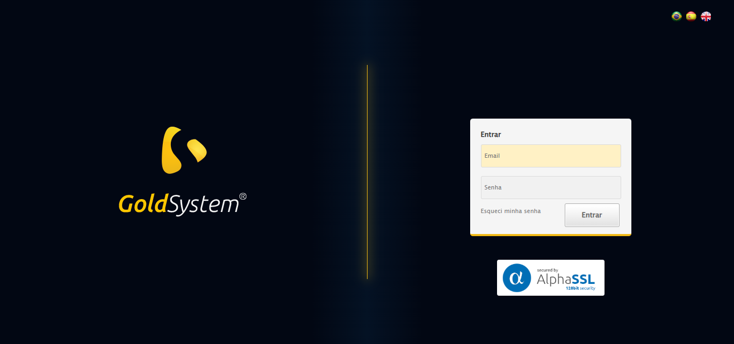

🔄 Realizando login...

✅ Realizando login realizada com sucesso.

Screenshot: realizando_login

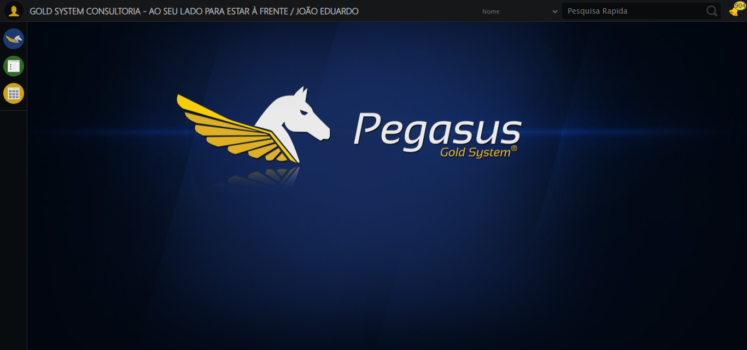

🔄 Ajustando zoom e abrindo menu...

🔍 Zoom ajustado para 90%.

✅ Ajustando zoom e abrindo menu realizada com sucesso.

Screenshot: ajustando_zoom_e_abrindo_menu

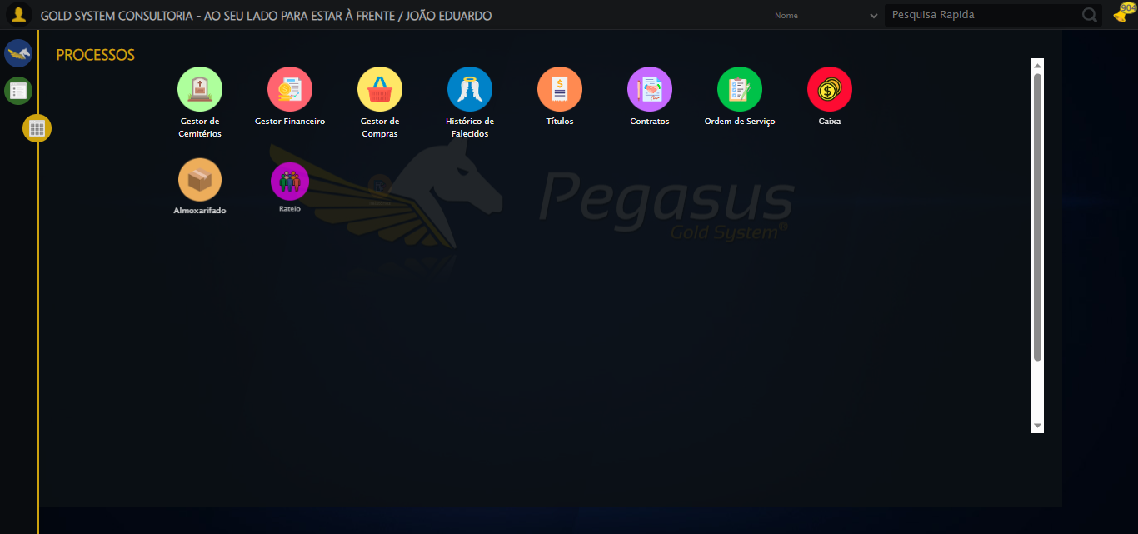

🔄 Acessando Agenda Ambulância...

✅ Acessando Agenda Ambulância realizada com sucesso.

Screenshot: acessando_agenda_ambulância

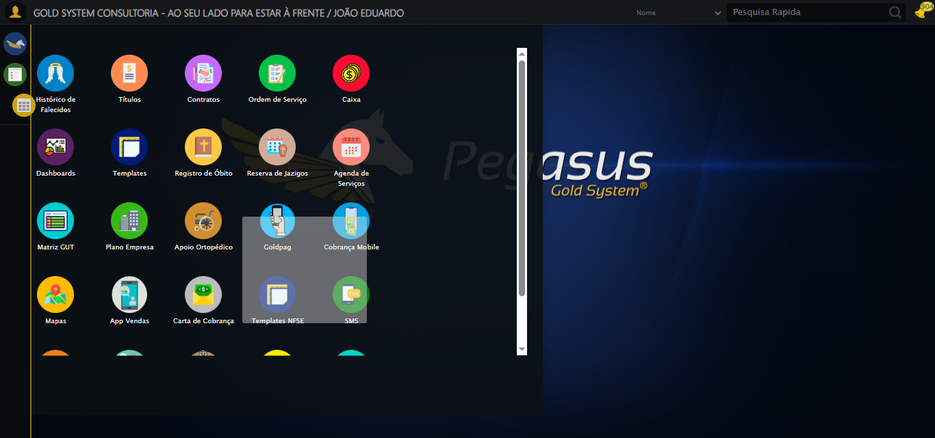

🔄 Clicando em Cadastrar...

✅ Clicando em Cadastrar realizada com sucesso.

Screenshot: clicando_em_cadastrar

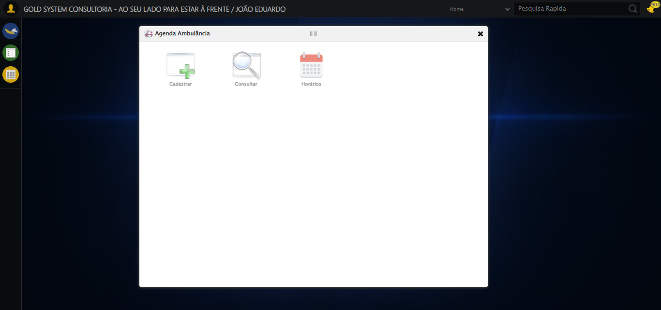

🔄 Preenchendo Número do Contrato...

✅ Preenchendo Número do Contrato realizada com sucesso.

Screenshot: preenchendo_número_do_contrato

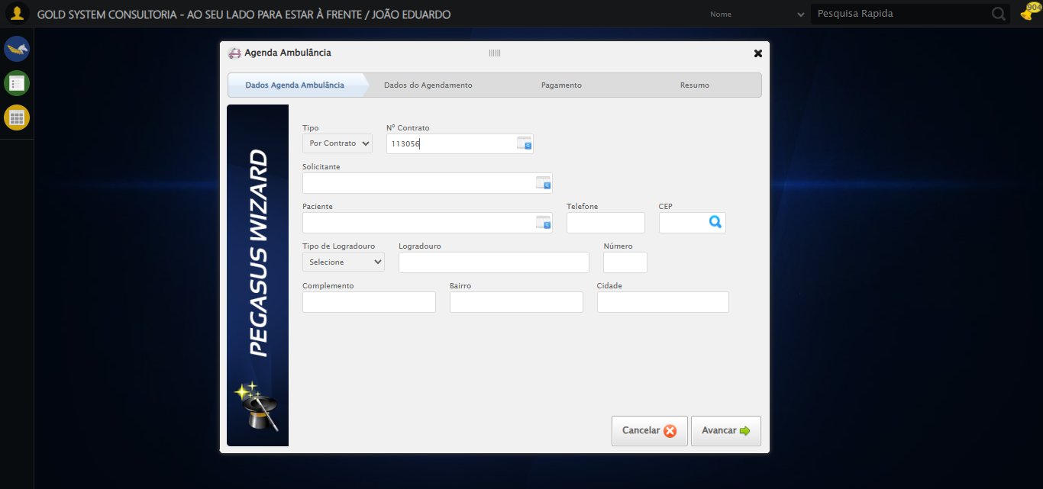

🔄 Abrindo lov do Solicitante...

✅ Abrindo lov do Solicitante realizada com sucesso.

Screenshot: abrindo_lov_do_solicitante

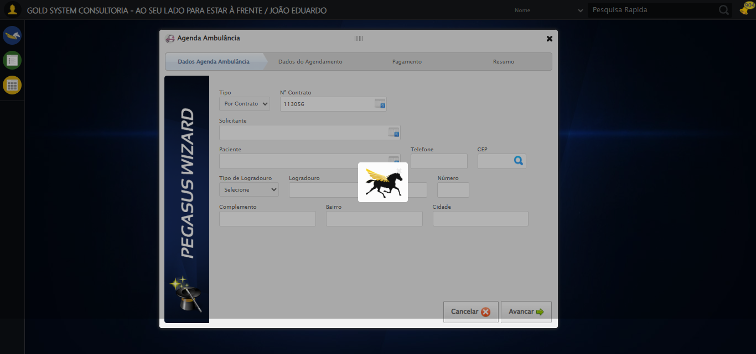

🔄 Clicando na linha do 'TESTE TITULAR'...

✅ Clicando na linha do 'TESTE TITULAR' realizada com sucesso.

Screenshot: clicando_na_linha_do_'teste_titular'

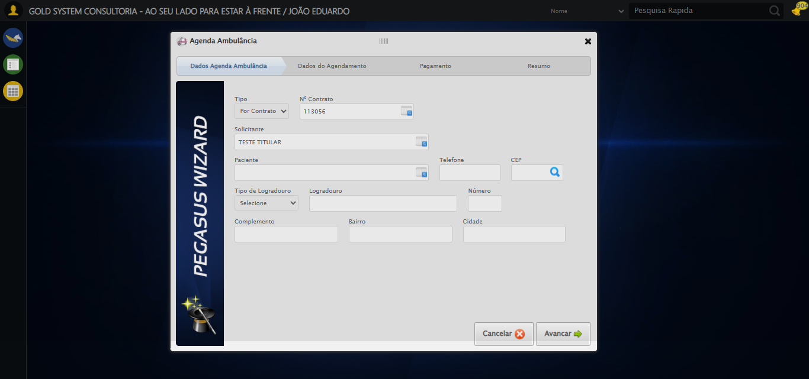

🔄 Abrindo lov do Paciente...

✅ Abrindo lov do Paciente realizada com sucesso.

Screenshot: abrindo_lov_do_paciente

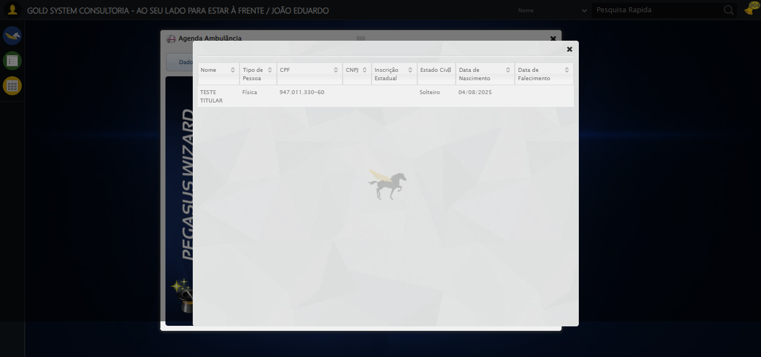

🔄 Clicando na linha do 'TESTE TITULAR'...

✅ Clicando na linha do 'TESTE TITULAR' realizada com sucesso.

🔄 Preenchendo Telefone...

✅ Preenchendo Telefone realizada com sucesso.

Screenshot: preenchendo_telefone

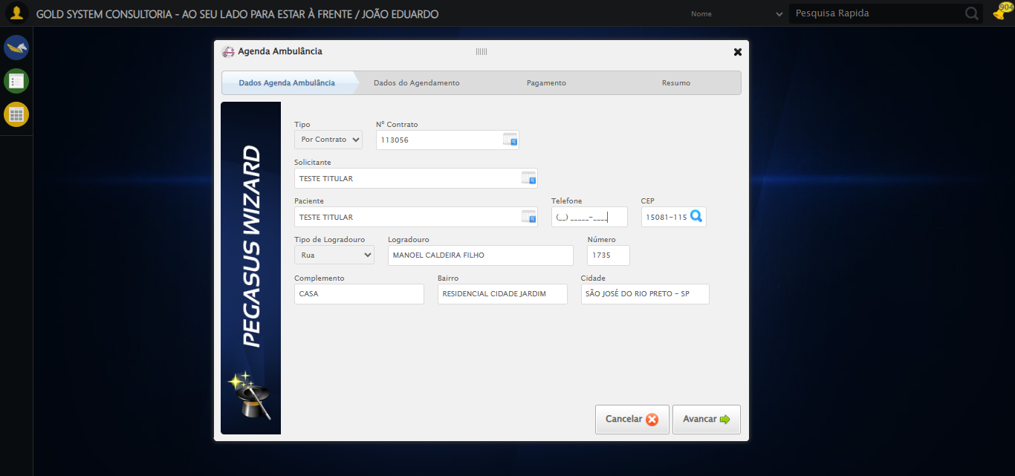

🔄 Preenchendo Complemento...

✅ Preenchendo Complemento realizada com sucesso.

Screenshot: preenchendo_complemento

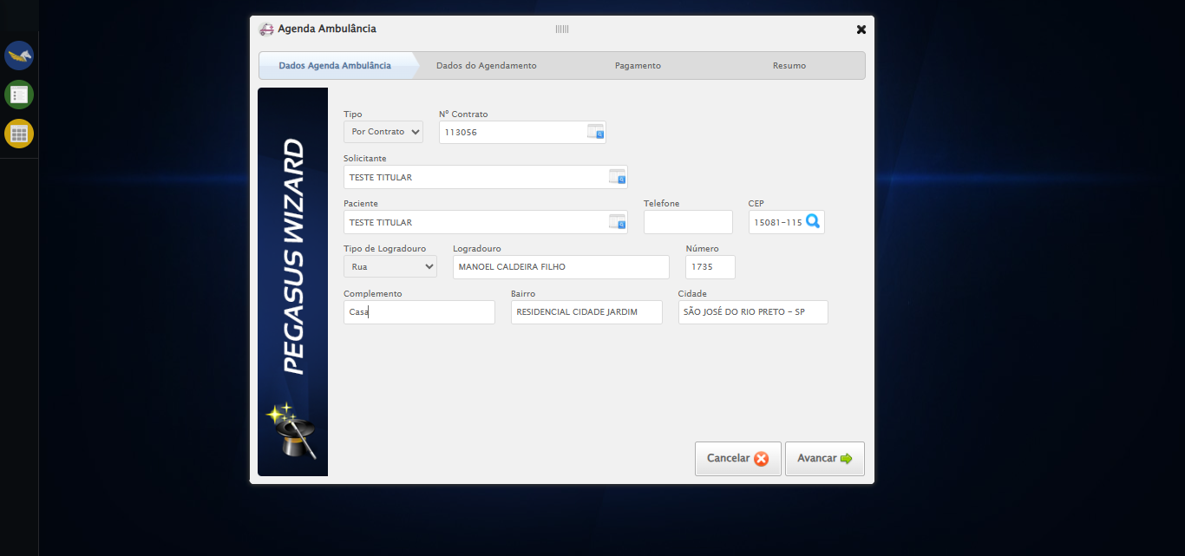

🔄 Avançando para próxima etapa...

✅ Avançando para próxima etapa realizada com sucesso.

Screenshot: avançando_para_próxima_etapa

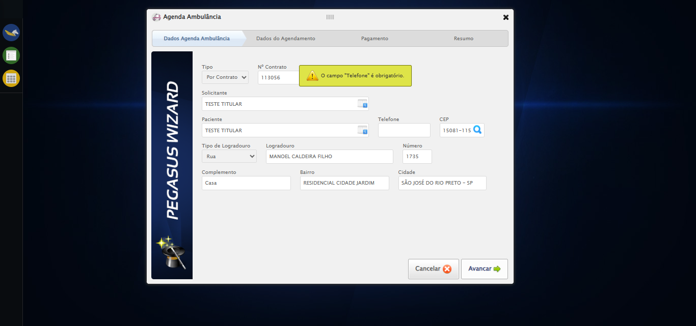

🔄 Clicando no Lov para consultar um motorista...

⚠️ Tentativa 1 falhou para Clicando no Lov para consultar um motorista, tentando novamente...

🔄 Clicando no Lov para consultar um motorista... (Tentativa 2)

❌ Erro inesperado ao clicando no lov para consultar um motorista: Message: target frame detached  
 (failed to check if window was closed: disconnected: unable to send message to renderer)  
 (Session info: chrome=138.0.7204.185)  
Stacktrace:  
 GetHandleVerifier [0x0x95ba83+63395]  
 GetHandleVerifier [0x0x95bac4+63460]  
 (No symbol) [0x0x7a1f70]  
 (No symbol) [0x0x792b60]  
 (No symbol) [0x0x791cd1]  
 (No symbol) [0x0x7af922]  
 (No symbol) [0x0x815c9c]  
 (No symbol) [0x0x830099]  
 (No symbol) [0x0x80f1a6]  
 (No symbol) [0x0x7de7b2]  
 (No symbol) [0x0x7df654]  
 GetHandleVerifier [0x0xbd8883+2672035]  
 GetHandleVerifier [0x0xbd3cba+2652634]  
 GetHandleVerifier [0x0x982bca+223466]  
 GetHandleVerifier [0x0x972cb8+158168]  
 GetHandleVerifier [0x0x97978d+185517]  
 GetHandleVerifier [0x0x963b78+96408]  
 GetHandleVerifier [0x0x963d02+96802]  
 GetHandleVerifier [0x0x94e90a+9770]  
 BaseThreadInitThunk [0x0x773dfcc9+25]  
 RtlGetAppContainerNamedObjectPath [0x0x77ba82ae+286]  
 RtlGetAppContainerNamedObjectPath [0x0x77ba827e+238]

⚠️ Erro ao tirar screenshot erro_clicando_no_lov_para_consultar_um_motorista: Message: invalid session id: session deleted as the browser has closed the connection  
from disconnected: not connected to DevTools  
 (Session info: chrome=138.0.7204.185)  
Stacktrace:  
 GetHandleVerifier [0x0x95ba83+63395]  
 GetHandleVerifier [0x0x95bac4+63460]  
 (No symbol) [0x0x7a2113]  
 (No symbol) [0x0x791b20]  
 (No symbol) [0x0x7af922]  
 (No symbol) [0x0x815c9c]  
 (No symbol) [0x0x830099]  
 (No symbol) [0x0x80f1a6]  
 (No symbol) [0x0x7de7b2]  
 (No symbol) [0x0x7df654]  
 GetHandleVerifier [0x0xbd8883+2672035]  
 GetHandleVerifier [0x0xbd3cba+2652634]  
 GetHandleVerifier [0x0x982bca+223466]  
 GetHandleVerifier [0x0x972cb8+158168]  
 GetHandleVerifier [0x0x97978d+185517]  
 GetHandleVerifier [0x0x963b78+96408]  
 GetHandleVerifier [0x0x963d02+96802]  
 GetHandleVerifier [0x0x94e90a+9770]  
 BaseThreadInitThunk [0x0x773dfcc9+25]  
 RtlGetAppContainerNamedObjectPath [0x0x77ba82ae+286]  
 RtlGetAppContainerNamedObjectPath [0x0x77ba827e+238]

🔄 Selecionando Motorista...

❌ Erro inesperado ao selecionando motorista: Message: invalid session id  
Stacktrace:  
 GetHandleVerifier [0x0x95ba83+63395]  
 GetHandleVerifier [0x0x95bac4+63460]  
 (No symbol) [0x0x7a1f70]  
 (No symbol) [0x0x7ddaa8]  
 (No symbol) [0x0x80f266]  
 (No symbol) [0x0x80ae65]  
 (No symbol) [0x0x80a3e6]  
 (No symbol) [0x0x773a45]  
 (No symbol) [0x0x773f9e]  
 (No symbol) [0x0x77442d]  
 GetHandleVerifier [0x0xbd8883+2672035]  
 GetHandleVerifier [0x0xbd3cba+2652634]  
 GetHandleVerifier [0x0x982bca+223466]  
 GetHandleVerifier [0x0x972cb8+158168]  
 GetHandleVerifier [0x0x97978d+185517]  
 (No symbol) [0x0x773710]  
 (No symbol) [0x0x772f1d]  
 GetHandleVerifier [0x0xd0db9c+3938492]  
 BaseThreadInitThunk [0x0x773dfcc9+25]  
 RtlGetAppContainerNamedObjectPath [0x0x77ba82ae+286]  
 RtlGetAppContainerNamedObjectPath [0x0x77ba827e+238]

⚠️ Erro ao tirar screenshot erro_selecionando_motorista: Message: invalid session id  
Stacktrace:  
 GetHandleVerifier [0x0x95ba83+63395]  
 GetHandleVerifier [0x0x95bac4+63460]  
 (No symbol) [0x0x7a1f70]  
 (No symbol) [0x0x7ddaa8]  
 (No symbol) [0x0x80f266]  
 (No symbol) [0x0x80ae65]  
 (No symbol) [0x0x80a3e6]  
 (No symbol) [0x0x773a45]  
 (No symbol) [0x0x773f9e]  
 (No symbol) [0x0x77442d]  
 GetHandleVerifier [0x0xbd8883+2672035]  
 GetHandleVerifier [0x0xbd3cba+2652634]  
 GetHandleVerifier [0x0x982bca+223466]  
 GetHandleVerifier [0x0x972cb8+158168]  
 GetHandleVerifier [0x0x97978d+185517]  
 (No symbol) [0x0x773710]  
 (No symbol) [0x0x772f1d]  
 GetHandleVerifier [0x0xd0db9c+3938492]  
 BaseThreadInitThunk [0x0x773dfcc9+25]  
 RtlGetAppContainerNamedObjectPath [0x0x77ba82ae+286]  
 RtlGetAppContainerNamedObjectPath [0x0x77ba827e+238]

🔄 Preenchendo Nome do Acompanhante...

❌ Erro ao interagir com elemento #gsAgendaAmbulancia > div.wdTelas > div.wdWizard.clearfix.telaConsulta > div.wizardHolder > div > div.step2 > div:nth-child(2) > div:nth-child(6) > input[type=text]: Message: invalid session id  
Stacktrace:  
 GetHandleVerifier [0x0x95ba83+63395]  
 GetHandleVerifier [0x0x95bac4+63460]  
 (No symbol) [0x0x7a1f70]  
 (No symbol) [0x0x7ddaa8]  
 (No symbol) [0x0x80f266]  
 (No symbol) [0x0x80ae65]  
 (No symbol) [0x0x80a3e6]  
 (No symbol) [0x0x773a45]  
 (No symbol) [0x0x773f9e]  
 (No symbol) [0x0x77442d]  
 GetHandleVerifier [0x0xbd8883+2672035]  
 GetHandleVerifier [0x0xbd3cba+2652634]  
 GetHandleVerifier [0x0x982bca+223466]  
 GetHandleVerifier [0x0x972cb8+158168]  
 GetHandleVerifier [0x0x97978d+185517]  
 (No symbol) [0x0x773710]  
 (No symbol) [0x0x772f1d]  
 GetHandleVerifier [0x0xd0db9c+3938492]  
 BaseThreadInitThunk [0x0x773dfcc9+25]  
 RtlGetAppContainerNamedObjectPath [0x0x77ba82ae+286]  
 RtlGetAppContainerNamedObjectPath [0x0x77ba827e+238]

❌ Erro inesperado ao preenchendo nome do acompanhante: Não foi possível encontrar o elemento: #gsAgendaAmbulancia > div.wdTelas > div.wdWizard.clearfix.telaConsulta > div.wizardHolder > div > div.step2 > div:nth-child(2) > div:nth-child(6) > input[type=text]

⚠️ Erro ao tirar screenshot erro_preenchendo_nome_do_acompanhante: Message: invalid session id  
Stacktrace:  
 GetHandleVerifier [0x0x95ba83+63395]  
 GetHandleVerifier [0x0x95bac4+63460]  
 (No symbol) [0x0x7a1f70]  
 (No symbol) [0x0x7ddaa8]  
 (No symbol) [0x0x80f266]  
 (No symbol) [0x0x80ae65]  
 (No symbol) [0x0x80a3e6]  
 (No symbol) [0x0x773a45]  
 (No symbol) [0x0x773f9e]  
 (No symbol) [0x0x77442d]  
 GetHandleVerifier [0x0xbd8883+2672035]  
 GetHandleVerifier [0x0xbd3cba+2652634]  
 GetHandleVerifier [0x0x982bca+223466]  
 GetHandleVerifier [0x0x972cb8+158168]  
 GetHandleVerifier [0x0x97978d+185517]  
 (No symbol) [0x0x773710]  
 (No symbol) [0x0x772f1d]  
 GetHandleVerifier [0x0xd0db9c+3938492]  
 BaseThreadInitThunk [0x0x773dfcc9+25]  
 RtlGetAppContainerNamedObjectPath [0x0x77ba82ae+286]  
 RtlGetAppContainerNamedObjectPath [0x0x77ba827e+238]

🔄 Preenchendo Local Transporte...

❌ Erro ao interagir com elemento #gsAgendaAmbulancia > div.wdTelas > div.wdWizard.clearfix.telaConsulta > div.wizardHolder > div > div.step2 > div:nth-child(2) > div:nth-child(7) > input[type=text]: Message: invalid session id  
Stacktrace:  
 GetHandleVerifier [0x0x95ba83+63395]  
 GetHandleVerifier [0x0x95bac4+63460]  
 (No symbol) [0x0x7a1f70]  
 (No symbol) [0x0x7ddaa8]  
 (No symbol) [0x0x80f266]  
 (No symbol) [0x0x80ae65]  
 (No symbol) [0x0x80a3e6]  
 (No symbol) [0x0x773a45]  
 (No symbol) [0x0x773f9e]  
 (No symbol) [0x0x77442d]  
 GetHandleVerifier [0x0xbd8883+2672035]  
 GetHandleVerifier [0x0xbd3cba+2652634]  
 GetHandleVerifier [0x0x982bca+223466]  
 GetHandleVerifier [0x0x972cb8+158168]  
 GetHandleVerifier [0x0x97978d+185517]  
 (No symbol) [0x0x773710]  
 (No symbol) [0x0x772f1d]  
 GetHandleVerifier [0x0xd0db9c+3938492]  
 BaseThreadInitThunk [0x0x773dfcc9+25]  
 RtlGetAppContainerNamedObjectPath [0x0x77ba82ae+286]  
 RtlGetAppContainerNamedObjectPath [0x0x77ba827e+238]

❌ Erro inesperado ao preenchendo local transporte: Não foi possível encontrar o elemento: #gsAgendaAmbulancia > div.wdTelas > div.wdWizard.clearfix.telaConsulta > div.wizardHolder > div > div.step2 > div:nth-child(2) > div:nth-child(7) > input[type=text]

⚠️ Erro ao tirar screenshot erro_preenchendo_local_transporte: Message: invalid session id  
Stacktrace:  
 GetHandleVerifier [0x0x95ba83+63395]  
 GetHandleVerifier [0x0x95bac4+63460]  
 (No symbol) [0x0x7a1f70]  
 (No symbol) [0x0x7ddaa8]  
 (No symbol) [0x0x80f266]  
 (No symbol) [0x0x80ae65]  
 (No symbol) [0x0x80a3e6]  
 (No symbol) [0x0x773a45]  
 (No symbol) [0x0x773f9e]  
 (No symbol) [0x0x77442d]  
 GetHandleVerifier [0x0xbd8883+2672035]  
 GetHandleVerifier [0x0xbd3cba+2652634]  
 GetHandleVerifier [0x0x982bca+223466]  
 GetHandleVerifier [0x0x972cb8+158168]  
 GetHandleVerifier [0x0x97978d+185517]  
 (No symbol) [0x0x773710]  
 (No symbol) [0x0x772f1d]  
 GetHandleVerifier [0x0xd0db9c+3938492]  
 BaseThreadInitThunk [0x0x773dfcc9+25]  
 RtlGetAppContainerNamedObjectPath [0x0x77ba82ae+286]  
 RtlGetAppContainerNamedObjectPath [0x0x77ba827e+238]

🔄 Avançando para próxima etapa...

❌ Erro inesperado ao avançando para próxima etapa: Message: invalid session id  
Stacktrace:  
 GetHandleVerifier [0x0x95ba83+63395]  
 GetHandleVerifier [0x0x95bac4+63460]  
 (No symbol) [0x0x7a1f70]  
 (No symbol) [0x0x7ddaa8]  
 (No symbol) [0x0x80f266]  
 (No symbol) [0x0x80ae65]  
 (No symbol) [0x0x80a3e6]  
 (No symbol) [0x0x773a45]  
 (No symbol) [0x0x773f9e]  
 (No symbol) [0x0x77442d]  
 GetHandleVerifier [0x0xbd8883+2672035]  
 GetHandleVerifier [0x0xbd3cba+2652634]  
 GetHandleVerifier [0x0x982bca+223466]  
 GetHandleVerifier [0x0x972cb8+158168]  
 GetHandleVerifier [0x0x97978d+185517]  
 (No symbol) [0x0x773710]  
 (No symbol) [0x0x772f1d]  
 GetHandleVerifier [0x0xd0db9c+3938492]  
 BaseThreadInitThunk [0x0x773dfcc9+25]  
 RtlGetAppContainerNamedObjectPath [0x0x77ba82ae+286]  
 RtlGetAppContainerNamedObjectPath [0x0x77ba827e+238]

⚠️ Erro ao tirar screenshot erro_avançando_para_próxima_etapa: Message: invalid session id  
Stacktrace:  
 GetHandleVerifier [0x0x95ba83+63395]  
 GetHandleVerifier [0x0x95bac4+63460]  
 (No symbol) [0x0x7a1f70]  
 (No symbol) [0x0x7ddaa8]  
 (No symbol) [0x0x80f266]  
 (No symbol) [0x0x80ae65]  
 (No symbol) [0x0x80a3e6]  
 (No symbol) [0x0x773a45]  
 (No symbol) [0x0x773f9e]  
 (No symbol) [0x0x77442d]  
 GetHandleVerifier [0x0xbd8883+2672035]  
 GetHandleVerifier [0x0xbd3cba+2652634]  
 GetHandleVerifier [0x0x982bca+223466]  
 GetHandleVerifier [0x0x972cb8+158168]  
 GetHandleVerifier [0x0x97978d+185517]  
 (No symbol) [0x0x773710]  
 (No symbol) [0x0x772f1d]  
 GetHandleVerifier [0x0xd0db9c+3938492]  
 BaseThreadInitThunk [0x0x773dfcc9+25]  
 RtlGetAppContainerNamedObjectPath [0x0x77ba82ae+286]  
 RtlGetAppContainerNamedObjectPath [0x0x77ba827e+238]

🔄 Avançando para finalização...

❌ Erro inesperado ao avançando para finalização: Message: invalid session id  
Stacktrace:  
 GetHandleVerifier [0x0x95ba83+63395]  
 GetHandleVerifier [0x0x95bac4+63460]  
 (No symbol) [0x0x7a1f70]  
 (No symbol) [0x0x7ddaa8]  
 (No symbol) [0x0x80f266]  
 (No symbol) [0x0x80ae65]  
 (No symbol) [0x0x80a3e6]  
 (No symbol) [0x0x773a45]  
 (No symbol) [0x0x773f9e]  
 (No symbol) [0x0x77442d]  
 GetHandleVerifier [0x0xbd8883+2672035]  
 GetHandleVerifier [0x0xbd3cba+2652634]  
 GetHandleVerifier [0x0x982bca+223466]  
 GetHandleVerifier [0x0x972cb8+158168]  
 GetHandleVerifier [0x0x97978d+185517]  
 (No symbol) [0x0x773710]  
 (No symbol) [0x0x772f1d]  
 GetHandleVerifier [0x0xd0db9c+3938492]  
 BaseThreadInitThunk [0x0x773dfcc9+25]  
 RtlGetAppContainerNamedObjectPath [0x0x77ba82ae+286]  
 RtlGetAppContainerNamedObjectPath [0x0x77ba827e+238]

⚠️ Erro ao tirar screenshot erro_avançando_para_finalização: Message: invalid session id  
Stacktrace:  
 GetHandleVerifier [0x0x95ba83+63395]  
 GetHandleVerifier [0x0x95bac4+63460]  
 (No symbol) [0x0x7a1f70]  
 (No symbol) [0x0x7ddaa8]  
 (No symbol) [0x0x80f266]  
 (No symbol) [0x0x80ae65]  
 (No symbol) [0x0x80a3e6]  
 (No symbol) [0x0x773a45]  
 (No symbol) [0x0x773f9e]  
 (No symbol) [0x0x77442d]  
 GetHandleVerifier [0x0xbd8883+2672035]  
 GetHandleVerifier [0x0xbd3cba+2652634]  
 GetHandleVerifier [0x0x982bca+223466]  
 GetHandleVerifier [0x0x972cb8+158168]  
 GetHandleVerifier [0x0x97978d+185517]  
 (No symbol) [0x0x773710]  
 (No symbol) [0x0x772f1d]  
 GetHandleVerifier [0x0xd0db9c+3938492]  
 BaseThreadInitThunk [0x0x773dfcc9+25]  
 RtlGetAppContainerNamedObjectPath [0x0x77ba82ae+286]  
 RtlGetAppContainerNamedObjectPath [0x0x77ba827e+238]

🔄 Finalizando cadastro...

❌ Erro ao interagir com elemento #gsAgendaAmbulancia > div.wdTelas > div.wdWizard.clearfix.telaConsulta > div.btnHolder > div: Message: invalid session id  
Stacktrace:  
 GetHandleVerifier [0x0x95ba83+63395]  
 GetHandleVerifier [0x0x95bac4+63460]  
 (No symbol) [0x0x7a1f70]  
 (No symbol) [0x0x7ddaa8]  
 (No symbol) [0x0x80f266]  
 (No symbol) [0x0x80ae65]  
 (No symbol) [0x0x80a3e6]  
 (No symbol) [0x0x773a45]  
 (No symbol) [0x0x773f9e]  
 (No symbol) [0x0x77442d]  
 GetHandleVerifier [0x0xbd8883+2672035]  
 GetHandleVerifier [0x0xbd3cba+2652634]  
 GetHandleVerifier [0x0x982bca+223466]  
 GetHandleVerifier [0x0x972cb8+158168]  
 GetHandleVerifier [0x0x97978d+185517]  
 (No symbol) [0x0x773710]  
 (No symbol) [0x0x772f1d]  
 GetHandleVerifier [0x0xd0db9c+3938492]  
 BaseThreadInitThunk [0x0x773dfcc9+25]  
 RtlGetAppContainerNamedObjectPath [0x0x77ba82ae+286]  
 RtlGetAppContainerNamedObjectPath [0x0x77ba827e+238]

❌ Erro inesperado ao finalizando cadastro: Não foi possível clicar no elemento: #gsAgendaAmbulancia > div.wdTelas > div.wdWizard.clearfix.telaConsulta > div.btnHolder > div

⚠️ Erro ao tirar screenshot erro_finalizando_cadastro: Message: invalid session id  
Stacktrace:  
 GetHandleVerifier [0x0x95ba83+63395]  
 GetHandleVerifier [0x0x95bac4+63460]  
 (No symbol) [0x0x7a1f70]  
 (No symbol) [0x0x7ddaa8]  
 (No symbol) [0x0x80f266]  
 (No symbol) [0x0x80ae65]  
 (No symbol) [0x0x80a3e6]  
 (No symbol) [0x0x773a45]  
 (No symbol) [0x0x773f9e]  
 (No symbol) [0x0x77442d]  
 GetHandleVerifier [0x0xbd8883+2672035]  
 GetHandleVerifier [0x0xbd3cba+2652634]  
 GetHandleVerifier [0x0x982bca+223466]  
 GetHandleVerifier [0x0x972cb8+158168]  
 GetHandleVerifier [0x0x97978d+185517]  
 (No symbol) [0x0x773710]  
 (No symbol) [0x0x772f1d]  
 GetHandleVerifier [0x0xd0db9c+3938492]  
 BaseThreadInitThunk [0x0x773dfcc9+25]  
 RtlGetAppContainerNamedObjectPath [0x0x77ba82ae+286]  
 RtlGetAppContainerNamedObjectPath [0x0x77ba827e+238]

🔄 Fechando modal após o salvamento...

❌ Erro ao interagir com elemento #gsAgendaAmbulancia > div.wdTop.ui-draggable-handle > div > a: Message: invalid session id  
Stacktrace:  
 GetHandleVerifier [0x0x95ba83+63395]  
 GetHandleVerifier [0x0x95bac4+63460]  
 (No symbol) [0x0x7a1f70]  
 (No symbol) [0x0x7ddaa8]  
 (No symbol) [0x0x80f266]  
 (No symbol) [0x0x80ae65]  
 (No symbol) [0x0x80a3e6]  
 (No symbol) [0x0x773a45]  
 (No symbol) [0x0x773f9e]  
 (No symbol) [0x0x77442d]  
 GetHandleVerifier [0x0xbd8883+2672035]  
 GetHandleVerifier [0x0xbd3cba+2652634]  
 GetHandleVerifier [0x0x982bca+223466]  
 GetHandleVerifier [0x0x972cb8+158168]  
 GetHandleVerifier [0x0x97978d+185517]  
 (No symbol) [0x0x773710]  
 (No symbol) [0x0x772f1d]  
 GetHandleVerifier [0x0xd0db9c+3938492]  
 BaseThreadInitThunk [0x0x773dfcc9+25]  
 RtlGetAppContainerNamedObjectPath [0x0x77ba82ae+286]  
 RtlGetAppContainerNamedObjectPath [0x0x77ba827e+238]

❌ Erro inesperado ao fechando modal após o salvamento: Não foi possível clicar no elemento: #gsAgendaAmbulancia > div.wdTop.ui-draggable-handle > div > a

⚠️ Erro ao tirar screenshot erro_fechando_modal_após_o_salvamento: Message: invalid session id  
Stacktrace:  
 GetHandleVerifier [0x0x95ba83+63395]  
 GetHandleVerifier [0x0x95bac4+63460]  
 (No symbol) [0x0x7a1f70]  
 (No symbol) [0x0x7ddaa8]  
 (No symbol) [0x0x80f266]  
 (No symbol) [0x0x80ae65]  
 (No symbol) [0x0x80a3e6]  
 (No symbol) [0x0x773a45]  
 (No symbol) [0x0x773f9e]  
 (No symbol) [0x0x77442d]  
 GetHandleVerifier [0x0xbd8883+2672035]  
 GetHandleVerifier [0x0xbd3cba+2652634]  
 GetHandleVerifier [0x0x982bca+223466]  
 GetHandleVerifier [0x0x972cb8+158168]  
 GetHandleVerifier [0x0x97978d+185517]  
 (No symbol) [0x0x773710]  
 (No symbol) [0x0x772f1d]  
 GetHandleVerifier [0x0xd0db9c+3938492]  
 BaseThreadInitThunk [0x0x773dfcc9+25]  
 RtlGetAppContainerNamedObjectPath [0x0x77ba82ae+286]  
 RtlGetAppContainerNamedObjectPath [0x0x77ba827e+238]

🔍 Verificando mensagens de alerta...

ℹ️ Nenhuma mensagem de alerta encontrada.

✅ Teste concluído.

✅ Teste executado com sucesso!