RELATÓRIO DO TESTE

Cadastro de Agenda de Compromissos – Cenário 1: Preenchimento completo e salvamento.

Data do teste: 10/09/2025 17:45:16

🔄 Acessando sistema...

✅ Acessando sistema realizada com sucesso.

Screenshot: acessando_sistema

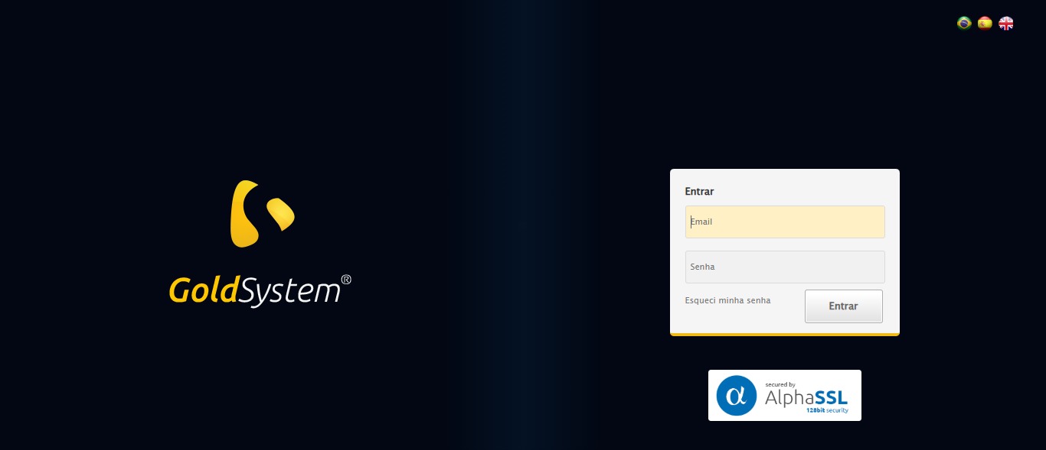

🔄 Realizando login...

✅ Realizando login realizada com sucesso.

Screenshot: realizando_login

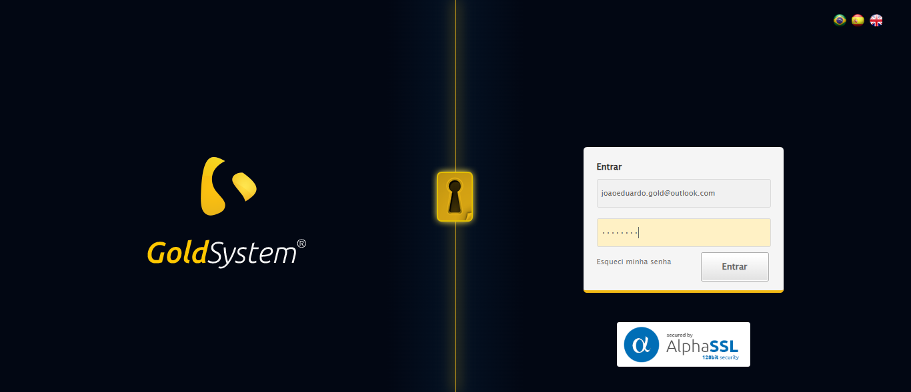

🔄 Esperando ícone dos módulos aparecer e ajustando zoom...

❌ Erro ao esperando ícone dos módulos aparecer e ajustando zoom: Message: target frame detached  
 (failed to check if window was closed: disconnected: Unable to receive message from renderer)  
 (Session info: chrome=139.0.7258.155)  
Stacktrace:  
 GetHandleVerifier [0x0x10da8a3+63283]  
 GetHandleVerifier [0x0x10da8e4+63348]  
 (No symbol) [0x0xf13ca0]  
 (No symbol) [0x0xf047d0]  
 (No symbol) [0x0xf03941]  
 (No symbol) [0x0xf21602]  
 (No symbol) [0x0xf20938]  
 (No symbol) [0x0xfa2629]  
 (No symbol) [0x0xf81216]  
 (No symbol) [0x0xf50855]  
 (No symbol) [0x0xf516f4]  
 GetHandleVerifier [0x0x134bb43+2623955]  
 GetHandleVerifier [0x0x1346daa+2604090]  
 GetHandleVerifier [0x0x110069a+218410]  
 GetHandleVerifier [0x0x10f0ed8+154984]  
 GetHandleVerifier [0x0x10f742d+180925]  
 GetHandleVerifier [0x0x10e22b8+94536]  
 GetHandleVerifier [0x0x10e2442+94930]  
 GetHandleVerifier [0x0x10cd5ea+9338]  
 BaseThreadInitThunk [0x0x76b1fcc9+25]  
 RtlGetAppContainerNamedObjectPath [0x0x776a82ae+286]  
 RtlGetAppContainerNamedObjectPath [0x0x776a827e+238]

❌ ERRO FATAL: Message: invalid session id: session deleted as the browser has closed the connection  
from disconnected: not connected to DevTools  
 (Session info: chrome=139.0.7258.155); For documentation on this error, please visit: https://www.selenium.dev/documentation/webdriver/troubleshooting/errors#invalidsessionidexception  
Stacktrace:  
 GetHandleVerifier [0x0x10da8a3+63283]  
 GetHandleVerifier [0x0x10da8e4+63348]  
 (No symbol) [0x0xf13e43]  
 (No symbol) [0x0xf03790]  
 (No symbol) [0x0xf21602]  
 (No symbol) [0x0xf87cdc]  
 (No symbol) [0x0xfa1ff9]  
 (No symbol) [0x0xf81216]  
 (No symbol) [0x0xf50855]  
 (No symbol) [0x0xf516f4]  
 GetHandleVerifier [0x0x134bb43+2623955]  
 GetHandleVerifier [0x0x1346daa+2604090]  
 GetHandleVerifier [0x0x110069a+218410]  
 GetHandleVerifier [0x0x10f0ed8+154984]  
 GetHandleVerifier [0x0x10f742d+180925]  
 GetHandleVerifier [0x0x10e22b8+94536]  
 GetHandleVerifier [0x0x10e2442+94930]  
 GetHandleVerifier [0x0x10cd5ea+9338]  
 BaseThreadInitThunk [0x0x76b1fcc9+25]  
 RtlGetAppContainerNamedObjectPath [0x0x776a82ae+286]  
 RtlGetAppContainerNamedObjectPath [0x0x776a827e+238]

✅ Teste concluído com sucesso.