RELATÓRIO DO TESTE

Agenda CRM – Cenário 1: Consulta teste de Eventos na Agenda CRM

Data do teste: 12/08/2025 17:44:11

🚀 Iniciando teste de consulta da Agenda/CRM

🔄 Acessando sistema...

✅ Acessando sistema realizada com sucesso.

Screenshot: acessando sistema

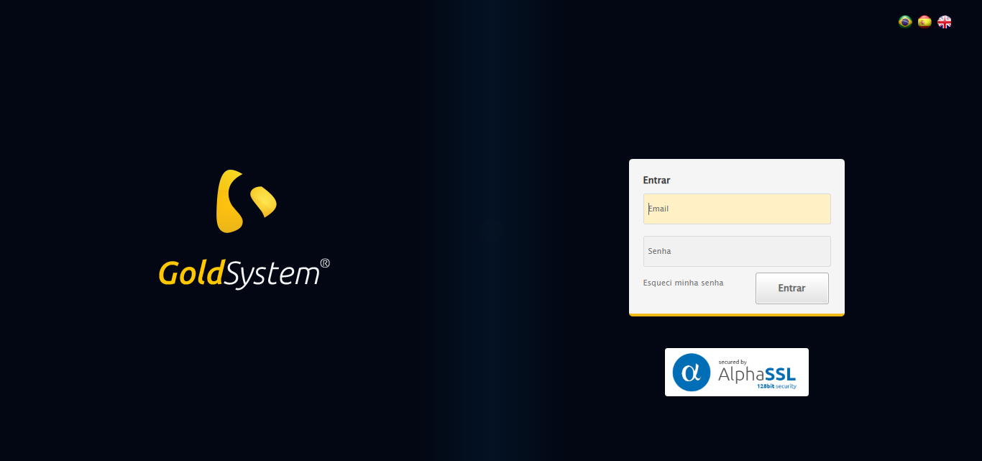

🔄 Realizando login...

✅ Realizando login realizada com sucesso.

Screenshot: realizando login

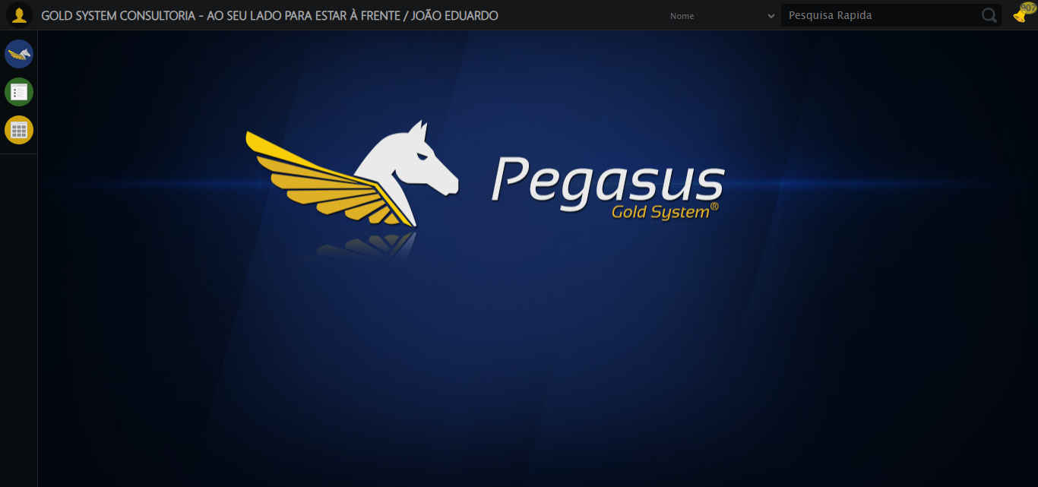

🔄 Ajustando zoom e abrindo menu...

🔍 Zoom ajustado para 90%.

✅ Ajustando zoom e abrindo menu realizada com sucesso.

Screenshot: ajustando zoom e abrindo menu

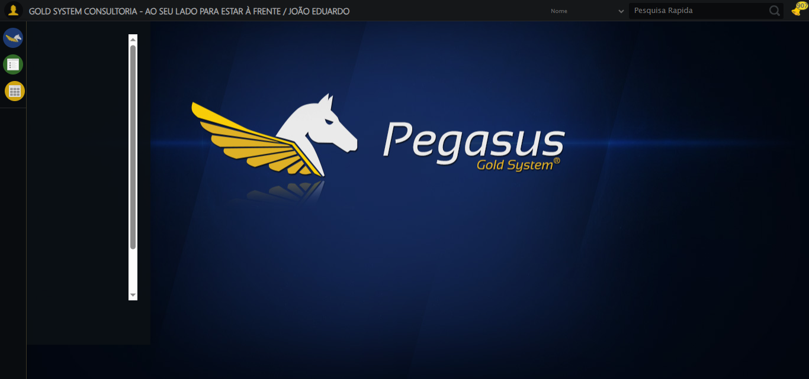

🔄 Acessando CRM...

✅ Acessando CRM realizada com sucesso.

Screenshot: acessando crm

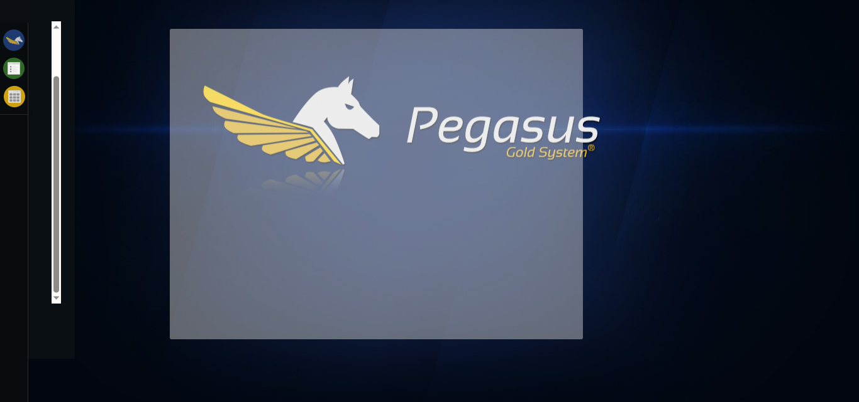

🔄 Clicando em Agenda CRM...

✅ Clicando em Agenda CRM realizada com sucesso.

Screenshot: clicando em agenda crm

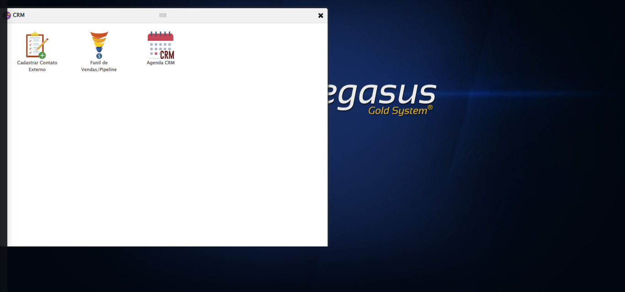

🔄 Abrindo o Lov de Contatos...

✅ Abrindo o Lov de Contatos realizada com sucesso.

Screenshot: abrindo o lov de contatos

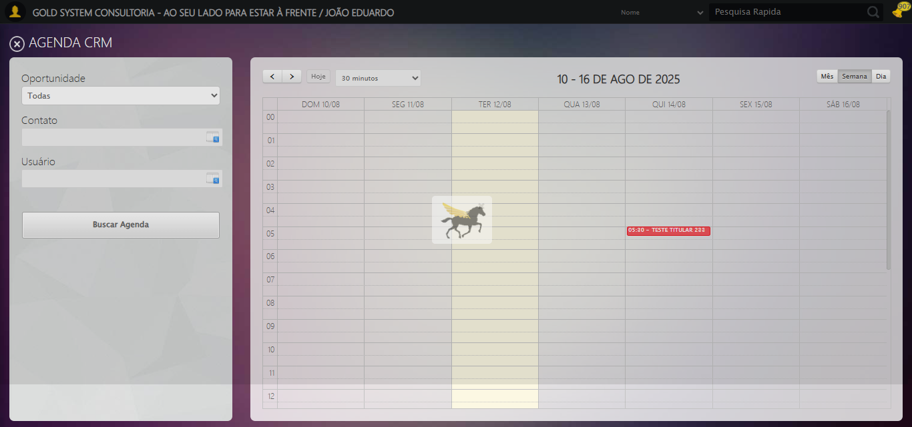

🔄 Selecionando Filtro como: Número CRM...

✅ Selecionando Filtro como: Número CRM realizada com sucesso.

Screenshot: selecionando filtro como_ número crm

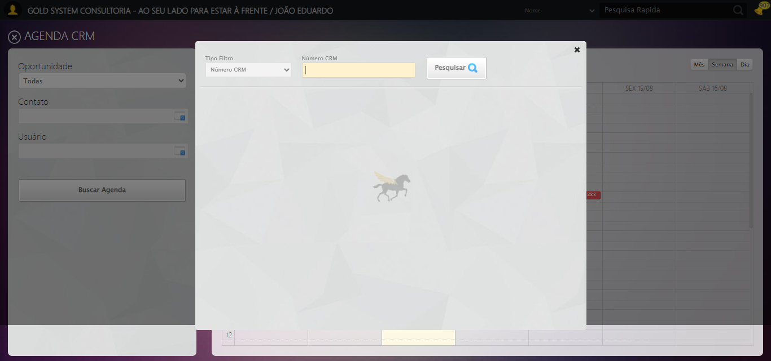

🔄 Preechendo Número CRM...

✅ Preechendo Número CRM realizada com sucesso.

Screenshot: preechendo número crm

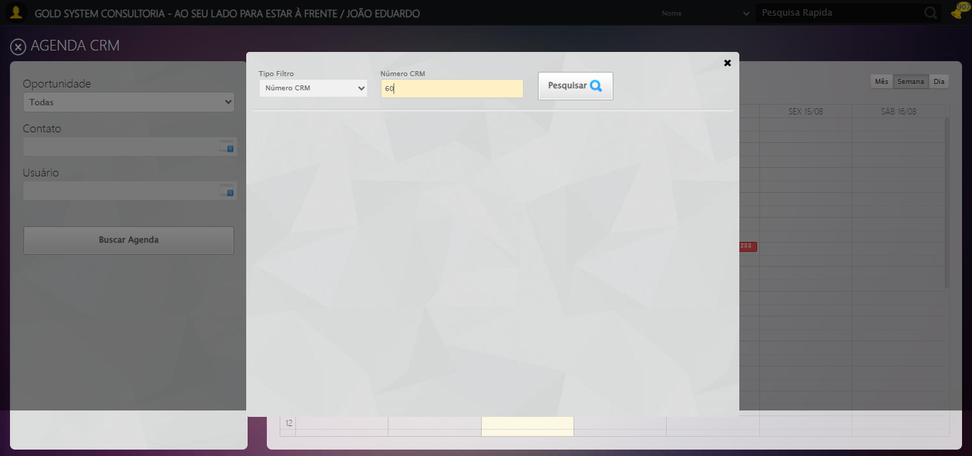

🔄 Pesquisando:...

❌ Erro ao clicar robusto: Message: invalid session id: session deleted as the browser has closed the connection  
from disconnected: not connected to DevTools  
 (Session info: chrome=138.0.7204.185)  
Stacktrace:  
 GetHandleVerifier [0x0x121ba83+63395]  
 GetHandleVerifier [0x0x121bac4+63460]  
 (No symbol) [0x0x1062113]  
 (No symbol) [0x0x1051b20]  
 (No symbol) [0x0x106f922]  
 (No symbol) [0x0x10d5c9c]  
 (No symbol) [0x0x10f0099]  
 (No symbol) [0x0x10cf1a6]  
 (No symbol) [0x0x109e7b2]  
 (No symbol) [0x0x109f654]  
 GetHandleVerifier [0x0x1498883+2672035]  
 GetHandleVerifier [0x0x1493cba+2652634]  
 GetHandleVerifier [0x0x1242bca+223466]  
 GetHandleVerifier [0x0x1232cb8+158168]  
 GetHandleVerifier [0x0x123978d+185517]  
 GetHandleVerifier [0x0x1223b78+96408]  
 GetHandleVerifier [0x0x1223d02+96802]  
 GetHandleVerifier [0x0x120e90a+9770]  
 BaseThreadInitThunk [0x0x773dfcc9+25]  
 RtlGetAppContainerNamedObjectPath [0x0x77ba82ae+286]  
 RtlGetAppContainerNamedObjectPath [0x0x77ba827e+238]

✅ Pesquisando: realizada com sucesso.

⚠️ Erro ao tirar screenshot pesquisando_: Message: invalid session id  
Stacktrace:  
 GetHandleVerifier [0x0x121ba83+63395]  
 GetHandleVerifier [0x0x121bac4+63460]  
 (No symbol) [0x0x1061f70]  
 (No symbol) [0x0x109daa8]  
 (No symbol) [0x0x10cf266]  
 (No symbol) [0x0x10cae65]  
 (No symbol) [0x0x10ca3e6]  
 (No symbol) [0x0x1033a45]  
 (No symbol) [0x0x1033f9e]  
 (No symbol) [0x0x103442d]  
 GetHandleVerifier [0x0x1498883+2672035]  
 GetHandleVerifier [0x0x1493cba+2652634]  
 GetHandleVerifier [0x0x1242bca+223466]  
 GetHandleVerifier [0x0x1232cb8+158168]  
 GetHandleVerifier [0x0x123978d+185517]  
 (No symbol) [0x0x1033710]  
 (No symbol) [0x0x1032f1d]  
 GetHandleVerifier [0x0x15cdb9c+3938492]  
 BaseThreadInitThunk [0x0x773dfcc9+25]  
 RtlGetAppContainerNamedObjectPath [0x0x77ba82ae+286]  
 RtlGetAppContainerNamedObjectPath [0x0x77ba827e+238]

🔄 Selecionando Contato...

❌ Erro inesperado ao selecionando contato: Message: invalid session id  
Stacktrace:  
 GetHandleVerifier [0x0x121ba83+63395]  
 GetHandleVerifier [0x0x121bac4+63460]  
 (No symbol) [0x0x1061f70]  
 (No symbol) [0x0x109daa8]  
 (No symbol) [0x0x10cf266]  
 (No symbol) [0x0x10cae65]  
 (No symbol) [0x0x10ca3e6]  
 (No symbol) [0x0x1033a45]  
 (No symbol) [0x0x1033f9e]  
 (No symbol) [0x0x103442d]  
 GetHandleVerifier [0x0x1498883+2672035]  
 GetHandleVerifier [0x0x1493cba+2652634]  
 GetHandleVerifier [0x0x1242bca+223466]  
 GetHandleVerifier [0x0x1232cb8+158168]  
 GetHandleVerifier [0x0x123978d+185517]  
 (No symbol) [0x0x1033710]  
 (No symbol) [0x0x1032f1d]  
 GetHandleVerifier [0x0x15cdb9c+3938492]  
 BaseThreadInitThunk [0x0x773dfcc9+25]  
 RtlGetAppContainerNamedObjectPath [0x0x77ba82ae+286]  
 RtlGetAppContainerNamedObjectPath [0x0x77ba827e+238]

⚠️ Erro ao tirar screenshot erro_selecionando contato: Message: invalid session id  
Stacktrace:  
 GetHandleVerifier [0x0x121ba83+63395]  
 GetHandleVerifier [0x0x121bac4+63460]  
 (No symbol) [0x0x1061f70]  
 (No symbol) [0x0x109daa8]  
 (No symbol) [0x0x10cf266]  
 (No symbol) [0x0x10cae65]  
 (No symbol) [0x0x10ca3e6]  
 (No symbol) [0x0x1033a45]  
 (No symbol) [0x0x1033f9e]  
 (No symbol) [0x0x103442d]  
 GetHandleVerifier [0x0x1498883+2672035]  
 GetHandleVerifier [0x0x1493cba+2652634]  
 GetHandleVerifier [0x0x1242bca+223466]  
 GetHandleVerifier [0x0x1232cb8+158168]  
 GetHandleVerifier [0x0x123978d+185517]  
 (No symbol) [0x0x1033710]  
 (No symbol) [0x0x1032f1d]  
 GetHandleVerifier [0x0x15cdb9c+3938492]  
 BaseThreadInitThunk [0x0x773dfcc9+25]  
 RtlGetAppContainerNamedObjectPath [0x0x77ba82ae+286]  
 RtlGetAppContainerNamedObjectPath [0x0x77ba827e+238]

🔄 Abrindo o Lov de Usuário...

❌ Erro inesperado ao abrindo o lov de usuário: Message: invalid session id  
Stacktrace:  
 GetHandleVerifier [0x0x121ba83+63395]  
 GetHandleVerifier [0x0x121bac4+63460]  
 (No symbol) [0x0x1061f70]  
 (No symbol) [0x0x109daa8]  
 (No symbol) [0x0x10cf266]  
 (No symbol) [0x0x10cae65]  
 (No symbol) [0x0x10ca3e6]  
 (No symbol) [0x0x1033a45]  
 (No symbol) [0x0x1033f9e]  
 (No symbol) [0x0x103442d]  
 GetHandleVerifier [0x0x1498883+2672035]  
 GetHandleVerifier [0x0x1493cba+2652634]  
 GetHandleVerifier [0x0x1242bca+223466]  
 GetHandleVerifier [0x0x1232cb8+158168]  
 GetHandleVerifier [0x0x123978d+185517]  
 (No symbol) [0x0x1033710]  
 (No symbol) [0x0x1032f1d]  
 GetHandleVerifier [0x0x15cdb9c+3938492]  
 BaseThreadInitThunk [0x0x773dfcc9+25]  
 RtlGetAppContainerNamedObjectPath [0x0x77ba82ae+286]  
 RtlGetAppContainerNamedObjectPath [0x0x77ba827e+238]

⚠️ Erro ao tirar screenshot erro_abrindo o lov de usuário: Message: invalid session id  
Stacktrace:  
 GetHandleVerifier [0x0x121ba83+63395]  
 GetHandleVerifier [0x0x121bac4+63460]  
 (No symbol) [0x0x1061f70]  
 (No symbol) [0x0x109daa8]  
 (No symbol) [0x0x10cf266]  
 (No symbol) [0x0x10cae65]  
 (No symbol) [0x0x10ca3e6]  
 (No symbol) [0x0x1033a45]  
 (No symbol) [0x0x1033f9e]  
 (No symbol) [0x0x103442d]  
 GetHandleVerifier [0x0x1498883+2672035]  
 GetHandleVerifier [0x0x1493cba+2652634]  
 GetHandleVerifier [0x0x1242bca+223466]  
 GetHandleVerifier [0x0x1232cb8+158168]  
 GetHandleVerifier [0x0x123978d+185517]  
 (No symbol) [0x0x1033710]  
 (No symbol) [0x0x1032f1d]  
 GetHandleVerifier [0x0x15cdb9c+3938492]  
 BaseThreadInitThunk [0x0x773dfcc9+25]  
 RtlGetAppContainerNamedObjectPath [0x0x77ba82ae+286]  
 RtlGetAppContainerNamedObjectPath [0x0x77ba827e+238]

🔄 Preechendo Nome do Usuário...

❌ Erro inesperado ao preechendo nome do usuário: Message: invalid session id  
Stacktrace:  
 GetHandleVerifier [0x0x121ba83+63395]  
 GetHandleVerifier [0x0x121bac4+63460]  
 (No symbol) [0x0x1061f70]  
 (No symbol) [0x0x109daa8]  
 (No symbol) [0x0x10cf266]  
 (No symbol) [0x0x10cae65]  
 (No symbol) [0x0x10ca3e6]  
 (No symbol) [0x0x1033a45]  
 (No symbol) [0x0x1033f9e]  
 (No symbol) [0x0x103442d]  
 GetHandleVerifier [0x0x1498883+2672035]  
 GetHandleVerifier [0x0x1493cba+2652634]  
 GetHandleVerifier [0x0x1242bca+223466]  
 GetHandleVerifier [0x0x1232cb8+158168]  
 GetHandleVerifier [0x0x123978d+185517]  
 (No symbol) [0x0x1033710]  
 (No symbol) [0x0x1032f1d]  
 GetHandleVerifier [0x0x15cdb9c+3938492]  
 BaseThreadInitThunk [0x0x773dfcc9+25]  
 RtlGetAppContainerNamedObjectPath [0x0x77ba82ae+286]  
 RtlGetAppContainerNamedObjectPath [0x0x77ba827e+238]

⚠️ Erro ao tirar screenshot erro_preechendo nome do usuário: Message: invalid session id  
Stacktrace:  
 GetHandleVerifier [0x0x121ba83+63395]  
 GetHandleVerifier [0x0x121bac4+63460]  
 (No symbol) [0x0x1061f70]  
 (No symbol) [0x0x109daa8]  
 (No symbol) [0x0x10cf266]  
 (No symbol) [0x0x10cae65]  
 (No symbol) [0x0x10ca3e6]  
 (No symbol) [0x0x1033a45]  
 (No symbol) [0x0x1033f9e]  
 (No symbol) [0x0x103442d]  
 GetHandleVerifier [0x0x1498883+2672035]  
 GetHandleVerifier [0x0x1493cba+2652634]  
 GetHandleVerifier [0x0x1242bca+223466]  
 GetHandleVerifier [0x0x1232cb8+158168]  
 GetHandleVerifier [0x0x123978d+185517]  
 (No symbol) [0x0x1033710]  
 (No symbol) [0x0x1032f1d]  
 GetHandleVerifier [0x0x15cdb9c+3938492]  
 BaseThreadInitThunk [0x0x773dfcc9+25]  
 RtlGetAppContainerNamedObjectPath [0x0x77ba82ae+286]  
 RtlGetAppContainerNamedObjectPath [0x0x77ba827e+238]

🔄 Pesquisando:...

❌ Erro ao clicar robusto: Message: invalid session id  
Stacktrace:  
 GetHandleVerifier [0x0x121ba83+63395]  
 GetHandleVerifier [0x0x121bac4+63460]  
 (No symbol) [0x0x1061f70]  
 (No symbol) [0x0x109daa8]  
 (No symbol) [0x0x10cf266]  
 (No symbol) [0x0x10cae65]  
 (No symbol) [0x0x10ca3e6]  
 (No symbol) [0x0x1033a45]  
 (No symbol) [0x0x1033f9e]  
 (No symbol) [0x0x103442d]  
 GetHandleVerifier [0x0x1498883+2672035]  
 GetHandleVerifier [0x0x1493cba+2652634]  
 GetHandleVerifier [0x0x1242bca+223466]  
 GetHandleVerifier [0x0x1232cb8+158168]  
 GetHandleVerifier [0x0x123978d+185517]  
 (No symbol) [0x0x1033710]  
 (No symbol) [0x0x1032f1d]  
 GetHandleVerifier [0x0x15cdb9c+3938492]  
 BaseThreadInitThunk [0x0x773dfcc9+25]  
 RtlGetAppContainerNamedObjectPath [0x0x77ba82ae+286]  
 RtlGetAppContainerNamedObjectPath [0x0x77ba827e+238]

✅ Pesquisando: realizada com sucesso.

⚠️ Erro ao tirar screenshot pesquisando_: Message: invalid session id  
Stacktrace:  
 GetHandleVerifier [0x0x121ba83+63395]  
 GetHandleVerifier [0x0x121bac4+63460]  
 (No symbol) [0x0x1061f70]  
 (No symbol) [0x0x109daa8]  
 (No symbol) [0x0x10cf266]  
 (No symbol) [0x0x10cae65]  
 (No symbol) [0x0x10ca3e6]  
 (No symbol) [0x0x1033a45]  
 (No symbol) [0x0x1033f9e]  
 (No symbol) [0x0x103442d]  
 GetHandleVerifier [0x0x1498883+2672035]  
 GetHandleVerifier [0x0x1493cba+2652634]  
 GetHandleVerifier [0x0x1242bca+223466]  
 GetHandleVerifier [0x0x1232cb8+158168]  
 GetHandleVerifier [0x0x123978d+185517]  
 (No symbol) [0x0x1033710]  
 (No symbol) [0x0x1032f1d]  
 GetHandleVerifier [0x0x15cdb9c+3938492]  
 BaseThreadInitThunk [0x0x773dfcc9+25]  
 RtlGetAppContainerNamedObjectPath [0x0x77ba82ae+286]  
 RtlGetAppContainerNamedObjectPath [0x0x77ba827e+238]

🔄 Clicando no checkbox...

❌ Erro inesperado ao clicando no checkbox: Message: invalid session id  
Stacktrace:  
 GetHandleVerifier [0x0x121ba83+63395]  
 GetHandleVerifier [0x0x121bac4+63460]  
 (No symbol) [0x0x1061f70]  
 (No symbol) [0x0x109daa8]  
 (No symbol) [0x0x10cf266]  
 (No symbol) [0x0x10cae65]  
 (No symbol) [0x0x10ca3e6]  
 (No symbol) [0x0x1033a45]  
 (No symbol) [0x0x1033f9e]  
 (No symbol) [0x0x103442d]  
 GetHandleVerifier [0x0x1498883+2672035]  
 GetHandleVerifier [0x0x1493cba+2652634]  
 GetHandleVerifier [0x0x1242bca+223466]  
 GetHandleVerifier [0x0x1232cb8+158168]  
 GetHandleVerifier [0x0x123978d+185517]  
 (No symbol) [0x0x1033710]  
 (No symbol) [0x0x1032f1d]  
 GetHandleVerifier [0x0x15cdb9c+3938492]  
 BaseThreadInitThunk [0x0x773dfcc9+25]  
 RtlGetAppContainerNamedObjectPath [0x0x77ba82ae+286]  
 RtlGetAppContainerNamedObjectPath [0x0x77ba827e+238]

⚠️ Erro ao tirar screenshot erro_clicando no checkbox: Message: invalid session id  
Stacktrace:  
 GetHandleVerifier [0x0x121ba83+63395]  
 GetHandleVerifier [0x0x121bac4+63460]  
 (No symbol) [0x0x1061f70]  
 (No symbol) [0x0x109daa8]  
 (No symbol) [0x0x10cf266]  
 (No symbol) [0x0x10cae65]  
 (No symbol) [0x0x10ca3e6]  
 (No symbol) [0x0x1033a45]  
 (No symbol) [0x0x1033f9e]  
 (No symbol) [0x0x103442d]  
 GetHandleVerifier [0x0x1498883+2672035]  
 GetHandleVerifier [0x0x1493cba+2652634]  
 GetHandleVerifier [0x0x1242bca+223466]  
 GetHandleVerifier [0x0x1232cb8+158168]  
 GetHandleVerifier [0x0x123978d+185517]  
 (No symbol) [0x0x1033710]  
 (No symbol) [0x0x1032f1d]  
 GetHandleVerifier [0x0x15cdb9c+3938492]  
 BaseThreadInitThunk [0x0x773dfcc9+25]  
 RtlGetAppContainerNamedObjectPath [0x0x77ba82ae+286]  
 RtlGetAppContainerNamedObjectPath [0x0x77ba827e+238]

🔄 Selecionando usuário:...

❌ Erro inesperado ao selecionando usuário:: Message: invalid session id  
Stacktrace:  
 GetHandleVerifier [0x0x121ba83+63395]  
 GetHandleVerifier [0x0x121bac4+63460]  
 (No symbol) [0x0x1061f70]  
 (No symbol) [0x0x109daa8]  
 (No symbol) [0x0x10cf266]  
 (No symbol) [0x0x10cae65]  
 (No symbol) [0x0x10ca3e6]  
 (No symbol) [0x0x1033a45]  
 (No symbol) [0x0x1033f9e]  
 (No symbol) [0x0x103442d]  
 GetHandleVerifier [0x0x1498883+2672035]  
 GetHandleVerifier [0x0x1493cba+2652634]  
 GetHandleVerifier [0x0x1242bca+223466]  
 GetHandleVerifier [0x0x1232cb8+158168]  
 GetHandleVerifier [0x0x123978d+185517]  
 (No symbol) [0x0x1033710]  
 (No symbol) [0x0x1032f1d]  
 GetHandleVerifier [0x0x15cdb9c+3938492]  
 BaseThreadInitThunk [0x0x773dfcc9+25]  
 RtlGetAppContainerNamedObjectPath [0x0x77ba82ae+286]  
 RtlGetAppContainerNamedObjectPath [0x0x77ba827e+238]

⚠️ Erro ao tirar screenshot erro_selecionando usuário_: Message: invalid session id  
Stacktrace:  
 GetHandleVerifier [0x0x121ba83+63395]  
 GetHandleVerifier [0x0x121bac4+63460]  
 (No symbol) [0x0x1061f70]  
 (No symbol) [0x0x109daa8]  
 (No symbol) [0x0x10cf266]  
 (No symbol) [0x0x10cae65]  
 (No symbol) [0x0x10ca3e6]  
 (No symbol) [0x0x1033a45]  
 (No symbol) [0x0x1033f9e]  
 (No symbol) [0x0x103442d]  
 GetHandleVerifier [0x0x1498883+2672035]  
 GetHandleVerifier [0x0x1493cba+2652634]  
 GetHandleVerifier [0x0x1242bca+223466]  
 GetHandleVerifier [0x0x1232cb8+158168]  
 GetHandleVerifier [0x0x123978d+185517]  
 (No symbol) [0x0x1033710]  
 (No symbol) [0x0x1032f1d]  
 GetHandleVerifier [0x0x15cdb9c+3938492]  
 BaseThreadInitThunk [0x0x773dfcc9+25]  
 RtlGetAppContainerNamedObjectPath [0x0x77ba82ae+286]  
 RtlGetAppContainerNamedObjectPath [0x0x77ba827e+238]

🔄 Buscando Agenda:...

❌ Erro inesperado ao buscando agenda:: Message: invalid session id  
Stacktrace:  
 GetHandleVerifier [0x0x121ba83+63395]  
 GetHandleVerifier [0x0x121bac4+63460]  
 (No symbol) [0x0x1061f70]  
 (No symbol) [0x0x109daa8]  
 (No symbol) [0x0x10cf266]  
 (No symbol) [0x0x10cae65]  
 (No symbol) [0x0x10ca3e6]  
 (No symbol) [0x0x1033a45]  
 (No symbol) [0x0x1033f9e]  
 (No symbol) [0x0x103442d]  
 GetHandleVerifier [0x0x1498883+2672035]  
 GetHandleVerifier [0x0x1493cba+2652634]  
 GetHandleVerifier [0x0x1242bca+223466]  
 GetHandleVerifier [0x0x1232cb8+158168]  
 GetHandleVerifier [0x0x123978d+185517]  
 (No symbol) [0x0x1033710]  
 (No symbol) [0x0x1032f1d]  
 GetHandleVerifier [0x0x15cdb9c+3938492]  
 BaseThreadInitThunk [0x0x773dfcc9+25]  
 RtlGetAppContainerNamedObjectPath [0x0x77ba82ae+286]  
 RtlGetAppContainerNamedObjectPath [0x0x77ba827e+238]

⚠️ Erro ao tirar screenshot erro_buscando agenda_: Message: invalid session id  
Stacktrace:  
 GetHandleVerifier [0x0x121ba83+63395]  
 GetHandleVerifier [0x0x121bac4+63460]  
 (No symbol) [0x0x1061f70]  
 (No symbol) [0x0x109daa8]  
 (No symbol) [0x0x10cf266]  
 (No symbol) [0x0x10cae65]  
 (No symbol) [0x0x10ca3e6]  
 (No symbol) [0x0x1033a45]  
 (No symbol) [0x0x1033f9e]  
 (No symbol) [0x0x103442d]  
 GetHandleVerifier [0x0x1498883+2672035]  
 GetHandleVerifier [0x0x1493cba+2652634]  
 GetHandleVerifier [0x0x1242bca+223466]  
 GetHandleVerifier [0x0x1232cb8+158168]  
 GetHandleVerifier [0x0x123978d+185517]  
 (No symbol) [0x0x1033710]  
 (No symbol) [0x0x1032f1d]  
 GetHandleVerifier [0x0x15cdb9c+3938492]  
 BaseThreadInitThunk [0x0x773dfcc9+25]  
 RtlGetAppContainerNamedObjectPath [0x0x77ba82ae+286]  
 RtlGetAppContainerNamedObjectPath [0x0x77ba827e+238]

🔄 Clicando em algum evento:...

❌ Erro inesperado ao clicando em algum evento:: Message: invalid session id  
Stacktrace:  
 GetHandleVerifier [0x0x121ba83+63395]  
 GetHandleVerifier [0x0x121bac4+63460]  
 (No symbol) [0x0x1061f70]  
 (No symbol) [0x0x109daa8]  
 (No symbol) [0x0x10cf266]  
 (No symbol) [0x0x10cae65]  
 (No symbol) [0x0x10ca3e6]  
 (No symbol) [0x0x1033a45]  
 (No symbol) [0x0x1033f9e]  
 (No symbol) [0x0x103442d]  
 GetHandleVerifier [0x0x1498883+2672035]  
 GetHandleVerifier [0x0x1493cba+2652634]  
 GetHandleVerifier [0x0x1242bca+223466]  
 GetHandleVerifier [0x0x1232cb8+158168]  
 GetHandleVerifier [0x0x123978d+185517]  
 (No symbol) [0x0x1033710]  
 (No symbol) [0x0x1032f1d]  
 GetHandleVerifier [0x0x15cdb9c+3938492]  
 BaseThreadInitThunk [0x0x773dfcc9+25]  
 RtlGetAppContainerNamedObjectPath [0x0x77ba82ae+286]  
 RtlGetAppContainerNamedObjectPath [0x0x77ba827e+238]

⚠️ Erro ao tirar screenshot erro_clicando em algum evento_: Message: invalid session id  
Stacktrace:  
 GetHandleVerifier [0x0x121ba83+63395]  
 GetHandleVerifier [0x0x121bac4+63460]  
 (No symbol) [0x0x1061f70]  
 (No symbol) [0x0x109daa8]  
 (No symbol) [0x0x10cf266]  
 (No symbol) [0x0x10cae65]  
 (No symbol) [0x0x10ca3e6]  
 (No symbol) [0x0x1033a45]  
 (No symbol) [0x0x1033f9e]  
 (No symbol) [0x0x103442d]  
 GetHandleVerifier [0x0x1498883+2672035]  
 GetHandleVerifier [0x0x1493cba+2652634]  
 GetHandleVerifier [0x0x1242bca+223466]  
 GetHandleVerifier [0x0x1232cb8+158168]  
 GetHandleVerifier [0x0x123978d+185517]  
 (No symbol) [0x0x1033710]  
 (No symbol) [0x0x1032f1d]  
 GetHandleVerifier [0x0x15cdb9c+3938492]  
 BaseThreadInitThunk [0x0x773dfcc9+25]  
 RtlGetAppContainerNamedObjectPath [0x0x77ba82ae+286]  
 RtlGetAppContainerNamedObjectPath [0x0x77ba827e+238]

🔄 Screenshot do evento...

⚠️ Erro ao tirar screenshot evento_selecionado: Message: invalid session id  
Stacktrace:  
 GetHandleVerifier [0x0x121ba83+63395]  
 GetHandleVerifier [0x0x121bac4+63460]  
 (No symbol) [0x0x1061f70]  
 (No symbol) [0x0x109daa8]  
 (No symbol) [0x0x10cf266]  
 (No symbol) [0x0x10cae65]  
 (No symbol) [0x0x10ca3e6]  
 (No symbol) [0x0x1033a45]  
 (No symbol) [0x0x1033f9e]  
 (No symbol) [0x0x103442d]  
 GetHandleVerifier [0x0x1498883+2672035]  
 GetHandleVerifier [0x0x1493cba+2652634]  
 GetHandleVerifier [0x0x1242bca+223466]  
 GetHandleVerifier [0x0x1232cb8+158168]  
 GetHandleVerifier [0x0x123978d+185517]  
 (No symbol) [0x0x1033710]  
 (No symbol) [0x0x1032f1d]  
 GetHandleVerifier [0x0x15cdb9c+3938492]  
 BaseThreadInitThunk [0x0x773dfcc9+25]  
 RtlGetAppContainerNamedObjectPath [0x0x77ba82ae+286]  
 RtlGetAppContainerNamedObjectPath [0x0x77ba827e+238]

📸 Screenshot do evento selecionado tirada.

✅ Screenshot do evento realizada com sucesso.

⚠️ Erro ao tirar screenshot screenshot do evento: Message: invalid session id  
Stacktrace:  
 GetHandleVerifier [0x0x121ba83+63395]  
 GetHandleVerifier [0x0x121bac4+63460]  
 (No symbol) [0x0x1061f70]  
 (No symbol) [0x0x109daa8]  
 (No symbol) [0x0x10cf266]  
 (No symbol) [0x0x10cae65]  
 (No symbol) [0x0x10ca3e6]  
 (No symbol) [0x0x1033a45]  
 (No symbol) [0x0x1033f9e]  
 (No symbol) [0x0x103442d]  
 GetHandleVerifier [0x0x1498883+2672035]  
 GetHandleVerifier [0x0x1493cba+2652634]  
 GetHandleVerifier [0x0x1242bca+223466]  
 GetHandleVerifier [0x0x1232cb8+158168]  
 GetHandleVerifier [0x0x123978d+185517]  
 (No symbol) [0x0x1033710]  
 (No symbol) [0x0x1032f1d]  
 GetHandleVerifier [0x0x15cdb9c+3938492]  
 BaseThreadInitThunk [0x0x773dfcc9+25]  
 RtlGetAppContainerNamedObjectPath [0x0x77ba82ae+286]  
 RtlGetAppContainerNamedObjectPath [0x0x77ba827e+238]

🔄 Fechando modal do evento:...

❌ Erro ao clicar robusto: Message: invalid session id  
Stacktrace:  
 GetHandleVerifier [0x0x121ba83+63395]  
 GetHandleVerifier [0x0x121bac4+63460]  
 (No symbol) [0x0x1061f70]  
 (No symbol) [0x0x109daa8]  
 (No symbol) [0x0x10cf266]  
 (No symbol) [0x0x10cae65]  
 (No symbol) [0x0x10ca3e6]  
 (No symbol) [0x0x1033a45]  
 (No symbol) [0x0x1033f9e]  
 (No symbol) [0x0x103442d]  
 GetHandleVerifier [0x0x1498883+2672035]  
 GetHandleVerifier [0x0x1493cba+2652634]  
 GetHandleVerifier [0x0x1242bca+223466]  
 GetHandleVerifier [0x0x1232cb8+158168]  
 GetHandleVerifier [0x0x123978d+185517]  
 (No symbol) [0x0x1033710]  
 (No symbol) [0x0x1032f1d]  
 GetHandleVerifier [0x0x15cdb9c+3938492]  
 BaseThreadInitThunk [0x0x773dfcc9+25]  
 RtlGetAppContainerNamedObjectPath [0x0x77ba82ae+286]  
 RtlGetAppContainerNamedObjectPath [0x0x77ba827e+238]

✅ Fechando modal do evento: realizada com sucesso.

⚠️ Erro ao tirar screenshot fechando modal do evento_: Message: invalid session id  
Stacktrace:  
 GetHandleVerifier [0x0x121ba83+63395]  
 GetHandleVerifier [0x0x121bac4+63460]  
 (No symbol) [0x0x1061f70]  
 (No symbol) [0x0x109daa8]  
 (No symbol) [0x0x10cf266]  
 (No symbol) [0x0x10cae65]  
 (No symbol) [0x0x10ca3e6]  
 (No symbol) [0x0x1033a45]  
 (No symbol) [0x0x1033f9e]  
 (No symbol) [0x0x103442d]  
 GetHandleVerifier [0x0x1498883+2672035]  
 GetHandleVerifier [0x0x1493cba+2652634]  
 GetHandleVerifier [0x0x1242bca+223466]  
 GetHandleVerifier [0x0x1232cb8+158168]  
 GetHandleVerifier [0x0x123978d+185517]  
 (No symbol) [0x0x1033710]  
 (No symbol) [0x0x1032f1d]  
 GetHandleVerifier [0x0x15cdb9c+3938492]  
 BaseThreadInitThunk [0x0x773dfcc9+25]  
 RtlGetAppContainerNamedObjectPath [0x0x77ba82ae+286]  
 RtlGetAppContainerNamedObjectPath [0x0x77ba827e+238]

🔄 Fechando modal da Agenda CRM...

❌ Erro ao clicar robusto: Message: invalid session id  
Stacktrace:  
 GetHandleVerifier [0x0x121ba83+63395]  
 GetHandleVerifier [0x0x121bac4+63460]  
 (No symbol) [0x0x1061f70]  
 (No symbol) [0x0x109daa8]  
 (No symbol) [0x0x10cf266]  
 (No symbol) [0x0x10cae65]  
 (No symbol) [0x0x10ca3e6]  
 (No symbol) [0x0x1033a45]  
 (No symbol) [0x0x1033f9e]  
 (No symbol) [0x0x103442d]  
 GetHandleVerifier [0x0x1498883+2672035]  
 GetHandleVerifier [0x0x1493cba+2652634]  
 GetHandleVerifier [0x0x1242bca+223466]  
 GetHandleVerifier [0x0x1232cb8+158168]  
 GetHandleVerifier [0x0x123978d+185517]  
 (No symbol) [0x0x1033710]  
 (No symbol) [0x0x1032f1d]  
 GetHandleVerifier [0x0x15cdb9c+3938492]  
 BaseThreadInitThunk [0x0x773dfcc9+25]  
 RtlGetAppContainerNamedObjectPath [0x0x77ba82ae+286]  
 RtlGetAppContainerNamedObjectPath [0x0x77ba827e+238]

✅ Fechando modal da Agenda CRM realizada com sucesso.

⚠️ Erro ao tirar screenshot fechando modal da agenda crm: Message: invalid session id  
Stacktrace:  
 GetHandleVerifier [0x0x121ba83+63395]  
 GetHandleVerifier [0x0x121bac4+63460]  
 (No symbol) [0x0x1061f70]  
 (No symbol) [0x0x109daa8]  
 (No symbol) [0x0x10cf266]  
 (No symbol) [0x0x10cae65]  
 (No symbol) [0x0x10ca3e6]  
 (No symbol) [0x0x1033a45]  
 (No symbol) [0x0x1033f9e]  
 (No symbol) [0x0x103442d]  
 GetHandleVerifier [0x0x1498883+2672035]  
 GetHandleVerifier [0x0x1493cba+2652634]  
 GetHandleVerifier [0x0x1242bca+223466]  
 GetHandleVerifier [0x0x1232cb8+158168]  
 GetHandleVerifier [0x0x123978d+185517]  
 (No symbol) [0x0x1033710]  
 (No symbol) [0x0x1032f1d]  
 GetHandleVerifier [0x0x15cdb9c+3938492]  
 BaseThreadInitThunk [0x0x773dfcc9+25]  
 RtlGetAppContainerNamedObjectPath [0x0x77ba82ae+286]  
 RtlGetAppContainerNamedObjectPath [0x0x77ba827e+238]

🔄 Fechando modal CRM...

❌ Erro ao clicar robusto: Message: invalid session id  
Stacktrace:  
 GetHandleVerifier [0x0x121ba83+63395]  
 GetHandleVerifier [0x0x121bac4+63460]  
 (No symbol) [0x0x1061f70]  
 (No symbol) [0x0x109daa8]  
 (No symbol) [0x0x10cf266]  
 (No symbol) [0x0x10cae65]  
 (No symbol) [0x0x10ca3e6]  
 (No symbol) [0x0x1033a45]  
 (No symbol) [0x0x1033f9e]  
 (No symbol) [0x0x103442d]  
 GetHandleVerifier [0x0x1498883+2672035]  
 GetHandleVerifier [0x0x1493cba+2652634]  
 GetHandleVerifier [0x0x1242bca+223466]  
 GetHandleVerifier [0x0x1232cb8+158168]  
 GetHandleVerifier [0x0x123978d+185517]  
 (No symbol) [0x0x1033710]  
 (No symbol) [0x0x1032f1d]  
 GetHandleVerifier [0x0x15cdb9c+3938492]  
 BaseThreadInitThunk [0x0x773dfcc9+25]  
 RtlGetAppContainerNamedObjectPath [0x0x77ba82ae+286]  
 RtlGetAppContainerNamedObjectPath [0x0x77ba827e+238]

✅ Fechando modal CRM realizada com sucesso.

⚠️ Erro ao tirar screenshot fechando modal crm: Message: invalid session id  
Stacktrace:  
 GetHandleVerifier [0x0x121ba83+63395]  
 GetHandleVerifier [0x0x121bac4+63460]  
 (No symbol) [0x0x1061f70]  
 (No symbol) [0x0x109daa8]  
 (No symbol) [0x0x10cf266]  
 (No symbol) [0x0x10cae65]  
 (No symbol) [0x0x10ca3e6]  
 (No symbol) [0x0x1033a45]  
 (No symbol) [0x0x1033f9e]  
 (No symbol) [0x0x103442d]  
 GetHandleVerifier [0x0x1498883+2672035]  
 GetHandleVerifier [0x0x1493cba+2652634]  
 GetHandleVerifier [0x0x1242bca+223466]  
 GetHandleVerifier [0x0x1232cb8+158168]  
 GetHandleVerifier [0x0x123978d+185517]  
 (No symbol) [0x0x1033710]  
 (No symbol) [0x0x1032f1d]  
 GetHandleVerifier [0x0x15cdb9c+3938492]  
 BaseThreadInitThunk [0x0x773dfcc9+25]  
 RtlGetAppContainerNamedObjectPath [0x0x77ba82ae+286]  
 RtlGetAppContainerNamedObjectPath [0x0x77ba827e+238]

🔍 Verificando mensagens de alerta...

ℹ️ Nenhuma mensagem de alerta encontrada.

✅ Teste concluído.

✅ Teste executado com sucesso!