RELATÓRIO DO TESTE

Agenda CRM – Cenário 1: Consulta teste de Eventos na Agenda CRM

Data do teste: 13/08/2025 14:33:52

🚀 Iniciando teste de consulta da Agenda/CRM

🔄 Acessando sistema...

✅ Acessando sistema realizada com sucesso.

Screenshot: acessando sistema

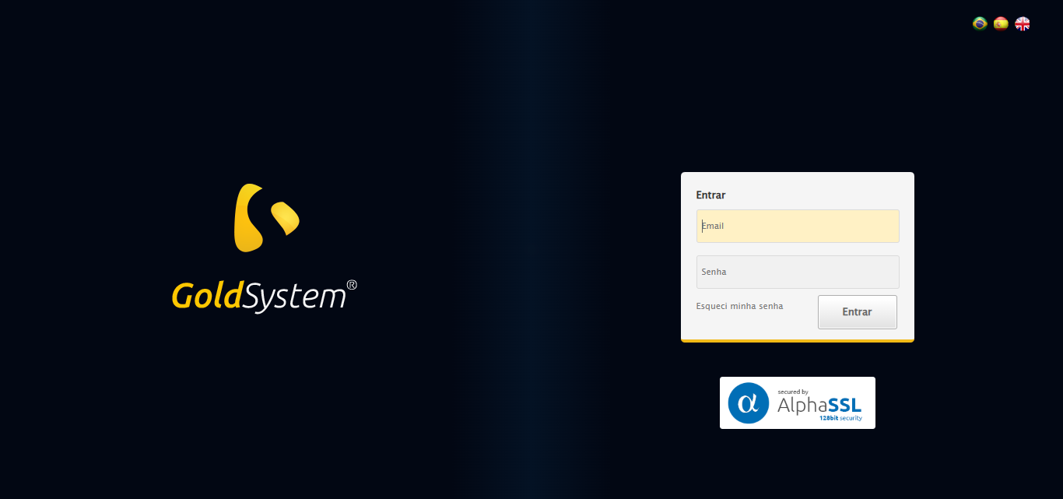

🔄 Realizando login...

✅ Realizando login realizada com sucesso.

Screenshot: realizando login

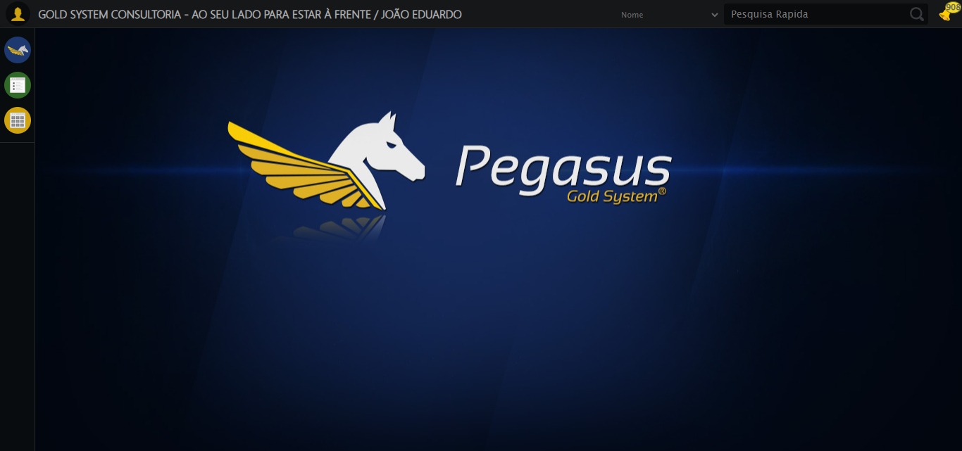

🔄 Ajustando zoom e abrindo menu...

🔍 Zoom ajustado para 90%.

✅ Ajustando zoom e abrindo menu realizada com sucesso.

Screenshot: ajustando zoom e abrindo menu

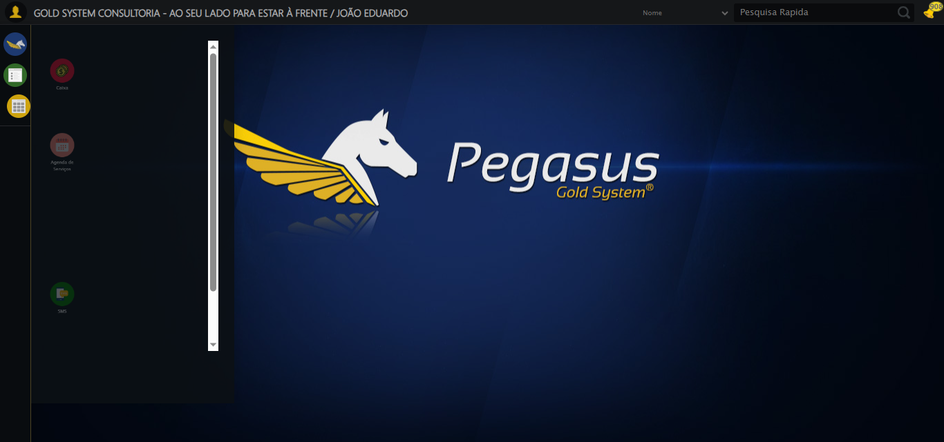

🔄 Acessando CRM...

✅ Acessando CRM realizada com sucesso.

Screenshot: acessando crm

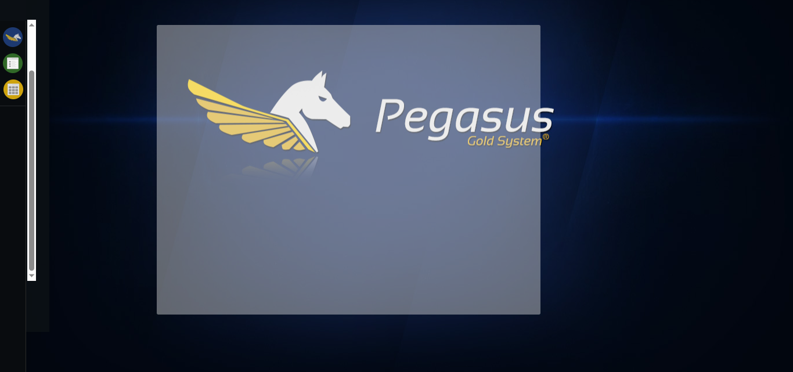

🔄 Clicando em Agenda CRM...

✅ Clicando em Agenda CRM realizada com sucesso.

Screenshot: clicando em agenda crm

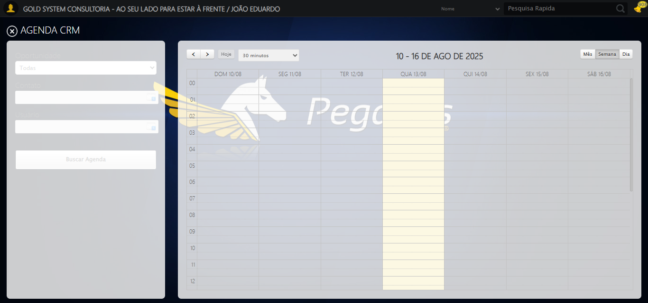

🔄 Abrindo o Lov de Contatos...

✅ Abrindo o Lov de Contatos realizada com sucesso.

Screenshot: abrindo o lov de contatos

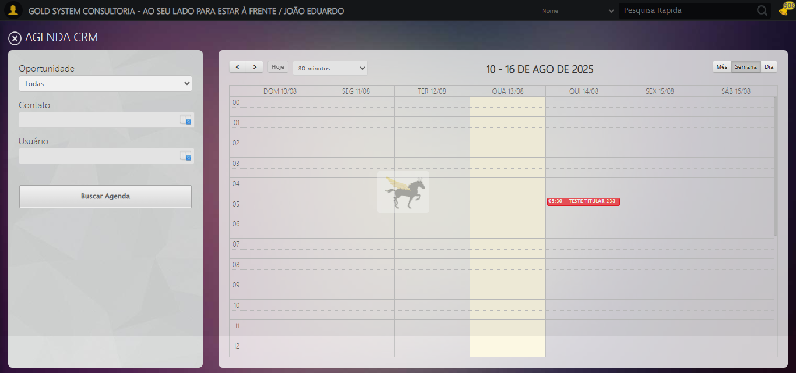

🔄 Selecionando Filtro como: Número CRM...

✅ Selecionando Filtro como: Número CRM realizada com sucesso.

Screenshot: selecionando filtro como_ número crm

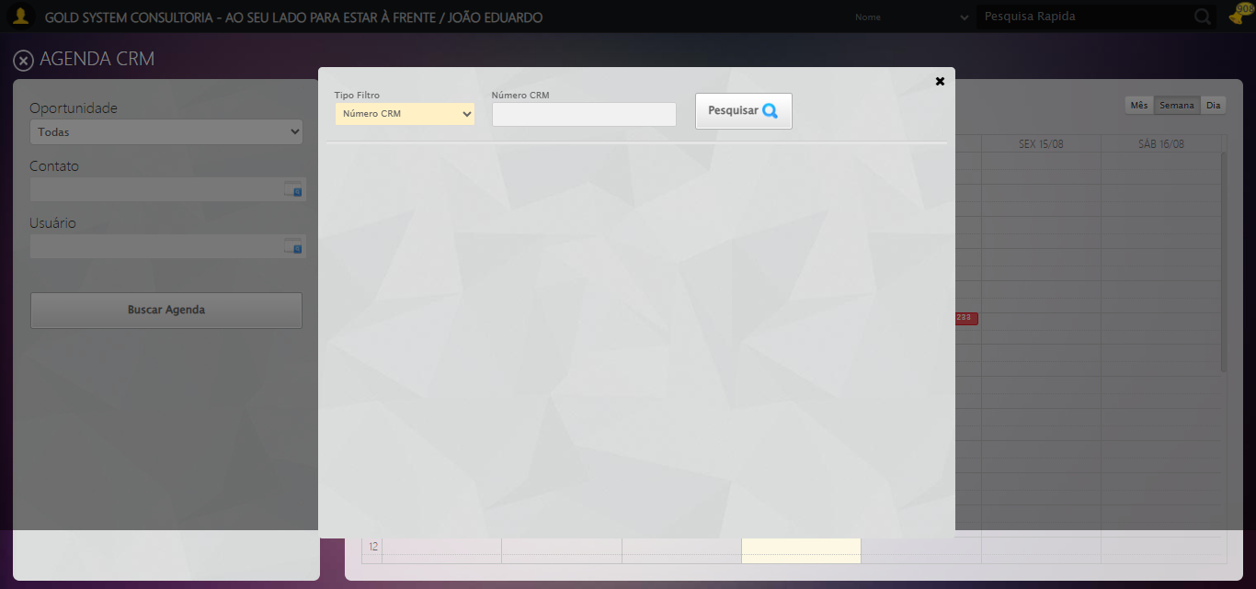

🔄 Preechendo Número CRM...

✅ Preechendo Número CRM realizada com sucesso.

Screenshot: preechendo número crm

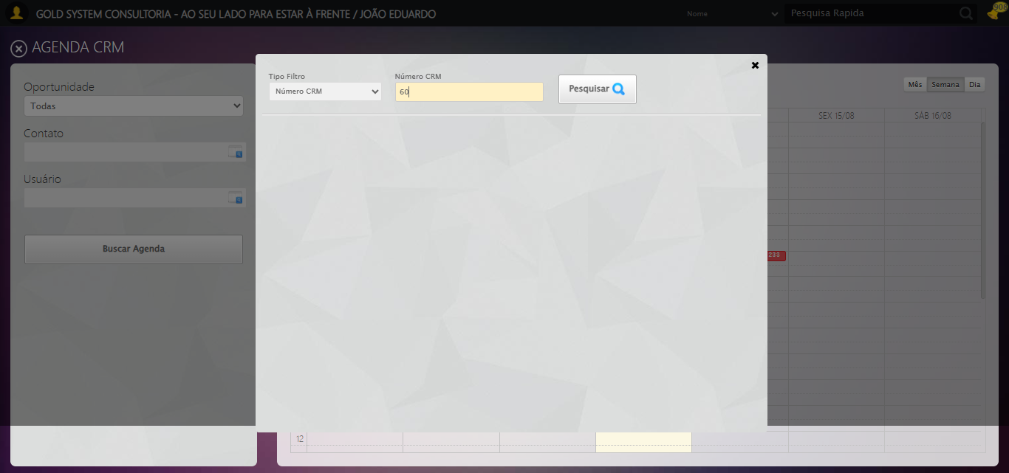

🔄 Pesquisando:...

✅ Pesquisando: realizada com sucesso.

Screenshot: pesquisando_

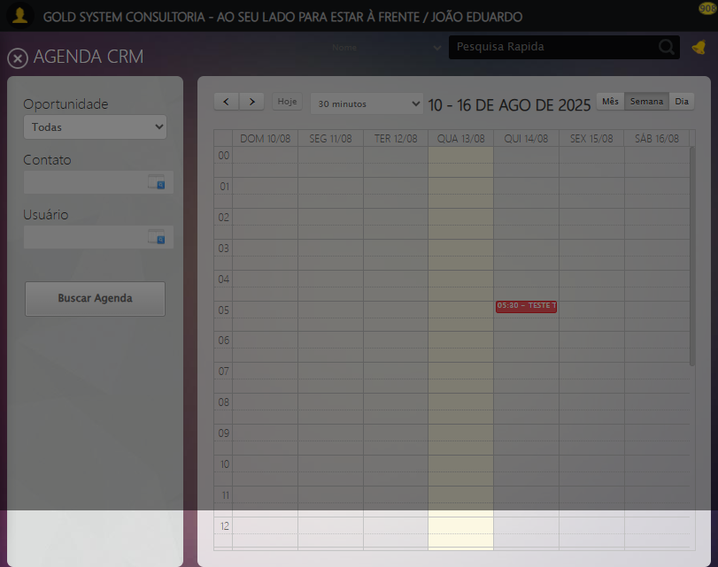

🔄 Selecionando Contato...

❌ Erro inesperado ao selecionando contato: 'NoneType' object has no attribute 'is_displayed'

⚠️ Erro ao tirar screenshot erro_selecionando contato: Message: no such window: target window already closed  
from unknown error: web view not found  
 (Session info: chrome=138.0.7204.185)  
Stacktrace:  
 GetHandleVerifier [0x0xdaba83+63395]  
 GetHandleVerifier [0x0xdabac4+63460]  
 (No symbol) [0x0xbf2113]  
 (No symbol) [0x0xbd0fb9]  
 (No symbol) [0x0xc65ace]  
 (No symbol) [0x0xc80099]  
 (No symbol) [0x0xc5f1a6]  
 (No symbol) [0x0xc2e7b2]  
 (No symbol) [0x0xc2f654]  
 GetHandleVerifier [0x0x1028883+2672035]  
 GetHandleVerifier [0x0x1023cba+2652634]  
 GetHandleVerifier [0x0xdd2bca+223466]  
 GetHandleVerifier [0x0xdc2cb8+158168]  
 GetHandleVerifier [0x0xdc978d+185517]  
 GetHandleVerifier [0x0xdb3b78+96408]  
 GetHandleVerifier [0x0xdb3d02+96802]  
 GetHandleVerifier [0x0xd9e90a+9770]  
 BaseThreadInitThunk [0x0x7633fcc9+25]  
 RtlGetAppContainerNamedObjectPath [0x0x76f182ae+286]  
 RtlGetAppContainerNamedObjectPath [0x0x76f1827e+238]

🔄 Abrindo o Lov de Usuário...

❌ Erro inesperado ao abrindo o lov de usuário: Message: no such window: target window already closed  
from unknown error: web view not found  
 (Session info: chrome=138.0.7204.185)  
Stacktrace:  
 GetHandleVerifier [0x0xdaba83+63395]  
 GetHandleVerifier [0x0xdabac4+63460]  
 (No symbol) [0x0xbf2113]  
 (No symbol) [0x0xbd0fb9]  
 (No symbol) [0x0xc65ace]  
 (No symbol) [0x0xc80099]  
 (No symbol) [0x0xc5f1a6]  
 (No symbol) [0x0xc2e7b2]  
 (No symbol) [0x0xc2f654]  
 GetHandleVerifier [0x0x1028883+2672035]  
 GetHandleVerifier [0x0x1023cba+2652634]  
 GetHandleVerifier [0x0xdd2bca+223466]  
 GetHandleVerifier [0x0xdc2cb8+158168]  
 GetHandleVerifier [0x0xdc978d+185517]  
 GetHandleVerifier [0x0xdb3b78+96408]  
 GetHandleVerifier [0x0xdb3d02+96802]  
 GetHandleVerifier [0x0xd9e90a+9770]  
 BaseThreadInitThunk [0x0x7633fcc9+25]  
 RtlGetAppContainerNamedObjectPath [0x0x76f182ae+286]  
 RtlGetAppContainerNamedObjectPath [0x0x76f1827e+238]

⚠️ Erro ao tirar screenshot erro_abrindo o lov de usuário: Message: no such window: target window already closed  
from unknown error: web view not found  
 (Session info: chrome=138.0.7204.185)  
Stacktrace:  
 GetHandleVerifier [0x0xdaba83+63395]  
 GetHandleVerifier [0x0xdabac4+63460]  
 (No symbol) [0x0xbf2113]  
 (No symbol) [0x0xbd0fb9]  
 (No symbol) [0x0xc65ace]  
 (No symbol) [0x0xc80099]  
 (No symbol) [0x0xc5f1a6]  
 (No symbol) [0x0xc2e7b2]  
 (No symbol) [0x0xc2f654]  
 GetHandleVerifier [0x0x1028883+2672035]  
 GetHandleVerifier [0x0x1023cba+2652634]  
 GetHandleVerifier [0x0xdd2bca+223466]  
 GetHandleVerifier [0x0xdc2cb8+158168]  
 GetHandleVerifier [0x0xdc978d+185517]  
 GetHandleVerifier [0x0xdb3b78+96408]  
 GetHandleVerifier [0x0xdb3d02+96802]  
 GetHandleVerifier [0x0xd9e90a+9770]  
 BaseThreadInitThunk [0x0x7633fcc9+25]  
 RtlGetAppContainerNamedObjectPath [0x0x76f182ae+286]  
 RtlGetAppContainerNamedObjectPath [0x0x76f1827e+238]

🔄 Preechendo Nome do Usuário...

❌ Erro inesperado ao preechendo nome do usuário: Message: no such window: target window already closed  
from unknown error: web view not found  
 (Session info: chrome=138.0.7204.185)  
Stacktrace:  
 GetHandleVerifier [0x0xdaba83+63395]  
 GetHandleVerifier [0x0xdabac4+63460]  
 (No symbol) [0x0xbf2113]  
 (No symbol) [0x0xbd0fb9]  
 (No symbol) [0x0xc65ace]  
 (No symbol) [0x0xc80099]  
 (No symbol) [0x0xc5f1a6]  
 (No symbol) [0x0xc2e7b2]  
 (No symbol) [0x0xc2f654]  
 GetHandleVerifier [0x0x1028883+2672035]  
 GetHandleVerifier [0x0x1023cba+2652634]  
 GetHandleVerifier [0x0xdd2bca+223466]  
 GetHandleVerifier [0x0xdc2cb8+158168]  
 GetHandleVerifier [0x0xdc978d+185517]  
 GetHandleVerifier [0x0xdb3b78+96408]  
 GetHandleVerifier [0x0xdb3d02+96802]  
 GetHandleVerifier [0x0xd9e90a+9770]  
 BaseThreadInitThunk [0x0x7633fcc9+25]  
 RtlGetAppContainerNamedObjectPath [0x0x76f182ae+286]  
 RtlGetAppContainerNamedObjectPath [0x0x76f1827e+238]

⚠️ Erro ao tirar screenshot erro_preechendo nome do usuário: Message: no such window: target window already closed  
from unknown error: web view not found  
 (Session info: chrome=138.0.7204.185)  
Stacktrace:  
 GetHandleVerifier [0x0xdaba83+63395]  
 GetHandleVerifier [0x0xdabac4+63460]  
 (No symbol) [0x0xbf2113]  
 (No symbol) [0x0xbd0fb9]  
 (No symbol) [0x0xc65ace]  
 (No symbol) [0x0xc80099]  
 (No symbol) [0x0xc5f1a6]  
 (No symbol) [0x0xc2e7b2]  
 (No symbol) [0x0xc2f654]  
 GetHandleVerifier [0x0x1028883+2672035]  
 GetHandleVerifier [0x0x1023cba+2652634]  
 GetHandleVerifier [0x0xdd2bca+223466]  
 GetHandleVerifier [0x0xdc2cb8+158168]  
 GetHandleVerifier [0x0xdc978d+185517]  
 GetHandleVerifier [0x0xdb3b78+96408]  
 GetHandleVerifier [0x0xdb3d02+96802]  
 GetHandleVerifier [0x0xd9e90a+9770]  
 BaseThreadInitThunk [0x0x7633fcc9+25]  
 RtlGetAppContainerNamedObjectPath [0x0x76f182ae+286]  
 RtlGetAppContainerNamedObjectPath [0x0x76f1827e+238]

🔄 Pesquisando:...

❌ Erro ao clicar robusto: Message: no such window: target window already closed  
from unknown error: web view not found  
 (Session info: chrome=138.0.7204.185)  
Stacktrace:  
 GetHandleVerifier [0x0xdaba83+63395]  
 GetHandleVerifier [0x0xdabac4+63460]  
 (No symbol) [0x0xbf2113]  
 (No symbol) [0x0xbd0fb9]  
 (No symbol) [0x0xc65ace]  
 (No symbol) [0x0xc80099]  
 (No symbol) [0x0xc5f1a6]  
 (No symbol) [0x0xc2e7b2]  
 (No symbol) [0x0xc2f654]  
 GetHandleVerifier [0x0x1028883+2672035]  
 GetHandleVerifier [0x0x1023cba+2652634]  
 GetHandleVerifier [0x0xdd2bca+223466]  
 GetHandleVerifier [0x0xdc2cb8+158168]  
 GetHandleVerifier [0x0xdc978d+185517]  
 GetHandleVerifier [0x0xdb3b78+96408]  
 GetHandleVerifier [0x0xdb3d02+96802]  
 GetHandleVerifier [0x0xd9e90a+9770]  
 BaseThreadInitThunk [0x0x7633fcc9+25]  
 RtlGetAppContainerNamedObjectPath [0x0x76f182ae+286]  
 RtlGetAppContainerNamedObjectPath [0x0x76f1827e+238]

✅ Pesquisando: realizada com sucesso.

🔄 Clicando no checkbox...

❌ Erro inesperado ao clicando no checkbox: Message: no such window: target window already closed  
from unknown error: web view not found  
 (Session info: chrome=138.0.7204.185)  
Stacktrace:  
 GetHandleVerifier [0x0xdaba83+63395]  
 GetHandleVerifier [0x0xdabac4+63460]  
 (No symbol) [0x0xbf2113]  
 (No symbol) [0x0xbd0fb9]  
 (No symbol) [0x0xc65ace]  
 (No symbol) [0x0xc80099]  
 (No symbol) [0x0xc5f1a6]  
 (No symbol) [0x0xc2e7b2]  
 (No symbol) [0x0xc2f654]  
 GetHandleVerifier [0x0x1028883+2672035]  
 GetHandleVerifier [0x0x1023cba+2652634]  
 GetHandleVerifier [0x0xdd2bca+223466]  
 GetHandleVerifier [0x0xdc2cb8+158168]  
 GetHandleVerifier [0x0xdc978d+185517]  
 GetHandleVerifier [0x0xdb3b78+96408]  
 GetHandleVerifier [0x0xdb3d02+96802]  
 GetHandleVerifier [0x0xd9e90a+9770]  
 BaseThreadInitThunk [0x0x7633fcc9+25]  
 RtlGetAppContainerNamedObjectPath [0x0x76f182ae+286]  
 RtlGetAppContainerNamedObjectPath [0x0x76f1827e+238]

⚠️ Erro ao tirar screenshot erro_clicando no checkbox: Message: no such window: target window already closed  
from unknown error: web view not found  
 (Session info: chrome=138.0.7204.185)  
Stacktrace:  
 GetHandleVerifier [0x0xdaba83+63395]  
 GetHandleVerifier [0x0xdabac4+63460]  
 (No symbol) [0x0xbf2113]  
 (No symbol) [0x0xbd0fb9]  
 (No symbol) [0x0xc65ace]  
 (No symbol) [0x0xc80099]  
 (No symbol) [0x0xc5f1a6]  
 (No symbol) [0x0xc2e7b2]  
 (No symbol) [0x0xc2f654]  
 GetHandleVerifier [0x0x1028883+2672035]  
 GetHandleVerifier [0x0x1023cba+2652634]  
 GetHandleVerifier [0x0xdd2bca+223466]  
 GetHandleVerifier [0x0xdc2cb8+158168]  
 GetHandleVerifier [0x0xdc978d+185517]  
 GetHandleVerifier [0x0xdb3b78+96408]  
 GetHandleVerifier [0x0xdb3d02+96802]  
 GetHandleVerifier [0x0xd9e90a+9770]  
 BaseThreadInitThunk [0x0x7633fcc9+25]  
 RtlGetAppContainerNamedObjectPath [0x0x76f182ae+286]  
 RtlGetAppContainerNamedObjectPath [0x0x76f1827e+238]

🔄 Selecionando Usuário:...

❌ Erro inesperado ao selecionando usuário:: Message: no such window: target window already closed  
from unknown error: web view not found  
 (Session info: chrome=138.0.7204.185)  
Stacktrace:  
 GetHandleVerifier [0x0xdaba83+63395]  
 GetHandleVerifier [0x0xdabac4+63460]  
 (No symbol) [0x0xbf2113]  
 (No symbol) [0x0xbd0fb9]  
 (No symbol) [0x0xc65ace]  
 (No symbol) [0x0xc80099]  
 (No symbol) [0x0xc5f1a6]  
 (No symbol) [0x0xc2e7b2]  
 (No symbol) [0x0xc2f654]  
 GetHandleVerifier [0x0x1028883+2672035]  
 GetHandleVerifier [0x0x1023cba+2652634]  
 GetHandleVerifier [0x0xdd2bca+223466]  
 GetHandleVerifier [0x0xdc2cb8+158168]  
 GetHandleVerifier [0x0xdc978d+185517]  
 GetHandleVerifier [0x0xdb3b78+96408]  
 GetHandleVerifier [0x0xdb3d02+96802]  
 GetHandleVerifier [0x0xd9e90a+9770]  
 BaseThreadInitThunk [0x0x7633fcc9+25]  
 RtlGetAppContainerNamedObjectPath [0x0x76f182ae+286]  
 RtlGetAppContainerNamedObjectPath [0x0x76f1827e+238]

⚠️ Erro ao tirar screenshot erro_selecionando usuário_: Message: no such window: target window already closed  
from unknown error: web view not found  
 (Session info: chrome=138.0.7204.185)  
Stacktrace:  
 GetHandleVerifier [0x0xdaba83+63395]  
 GetHandleVerifier [0x0xdabac4+63460]  
 (No symbol) [0x0xbf2113]  
 (No symbol) [0x0xbd0fb9]  
 (No symbol) [0x0xc65ace]  
 (No symbol) [0x0xc80099]  
 (No symbol) [0x0xc5f1a6]  
 (No symbol) [0x0xc2e7b2]  
 (No symbol) [0x0xc2f654]  
 GetHandleVerifier [0x0x1028883+2672035]  
 GetHandleVerifier [0x0x1023cba+2652634]  
 GetHandleVerifier [0x0xdd2bca+223466]  
 GetHandleVerifier [0x0xdc2cb8+158168]  
 GetHandleVerifier [0x0xdc978d+185517]  
 GetHandleVerifier [0x0xdb3b78+96408]  
 GetHandleVerifier [0x0xdb3d02+96802]  
 GetHandleVerifier [0x0xd9e90a+9770]  
 BaseThreadInitThunk [0x0x7633fcc9+25]  
 RtlGetAppContainerNamedObjectPath [0x0x76f182ae+286]  
 RtlGetAppContainerNamedObjectPath [0x0x76f1827e+238]

🔄 Buscando Agenda:...

❌ Erro inesperado ao buscando agenda:: Message: no such window: target window already closed  
from unknown error: web view not found  
 (Session info: chrome=138.0.7204.185)  
Stacktrace:  
 GetHandleVerifier [0x0xdaba83+63395]  
 GetHandleVerifier [0x0xdabac4+63460]  
 (No symbol) [0x0xbf2113]  
 (No symbol) [0x0xbd0fb9]  
 (No symbol) [0x0xc65ace]  
 (No symbol) [0x0xc80099]  
 (No symbol) [0x0xc5f1a6]  
 (No symbol) [0x0xc2e7b2]  
 (No symbol) [0x0xc2f654]  
 GetHandleVerifier [0x0x1028883+2672035]  
 GetHandleVerifier [0x0x1023cba+2652634]  
 GetHandleVerifier [0x0xdd2bca+223466]  
 GetHandleVerifier [0x0xdc2cb8+158168]  
 GetHandleVerifier [0x0xdc978d+185517]  
 GetHandleVerifier [0x0xdb3b78+96408]  
 GetHandleVerifier [0x0xdb3d02+96802]  
 GetHandleVerifier [0x0xd9e90a+9770]  
 BaseThreadInitThunk [0x0x7633fcc9+25]  
 RtlGetAppContainerNamedObjectPath [0x0x76f182ae+286]  
 RtlGetAppContainerNamedObjectPath [0x0x76f1827e+238]

⚠️ Erro ao tirar screenshot erro_buscando agenda_: Message: no such window: target window already closed  
from unknown error: web view not found  
 (Session info: chrome=138.0.7204.185)  
Stacktrace:  
 GetHandleVerifier [0x0xdaba83+63395]  
 GetHandleVerifier [0x0xdabac4+63460]  
 (No symbol) [0x0xbf2113]  
 (No symbol) [0x0xbd0fb9]  
 (No symbol) [0x0xc65ace]  
 (No symbol) [0x0xc80099]  
 (No symbol) [0x0xc5f1a6]  
 (No symbol) [0x0xc2e7b2]  
 (No symbol) [0x0xc2f654]  
 GetHandleVerifier [0x0x1028883+2672035]  
 GetHandleVerifier [0x0x1023cba+2652634]  
 GetHandleVerifier [0x0xdd2bca+223466]  
 GetHandleVerifier [0x0xdc2cb8+158168]  
 GetHandleVerifier [0x0xdc978d+185517]  
 GetHandleVerifier [0x0xdb3b78+96408]  
 GetHandleVerifier [0x0xdb3d02+96802]  
 GetHandleVerifier [0x0xd9e90a+9770]  
 BaseThreadInitThunk [0x0x7633fcc9+25]  
 RtlGetAppContainerNamedObjectPath [0x0x76f182ae+286]  
 RtlGetAppContainerNamedObjectPath [0x0x76f1827e+238]

🔄 Clicando em algum evento:...

❌ Erro inesperado ao clicando em algum evento:: Message: no such window: target window already closed  
from unknown error: web view not found  
 (Session info: chrome=138.0.7204.185)  
Stacktrace:  
 GetHandleVerifier [0x0xdaba83+63395]  
 GetHandleVerifier [0x0xdabac4+63460]  
 (No symbol) [0x0xbf2113]  
 (No symbol) [0x0xbd0fb9]  
 (No symbol) [0x0xc65ace]  
 (No symbol) [0x0xc80099]  
 (No symbol) [0x0xc5f1a6]  
 (No symbol) [0x0xc2e7b2]  
 (No symbol) [0x0xc2f654]  
 GetHandleVerifier [0x0x1028883+2672035]  
 GetHandleVerifier [0x0x1023cba+2652634]  
 GetHandleVerifier [0x0xdd2bca+223466]  
 GetHandleVerifier [0x0xdc2cb8+158168]  
 GetHandleVerifier [0x0xdc978d+185517]  
 GetHandleVerifier [0x0xdb3b78+96408]  
 GetHandleVerifier [0x0xdb3d02+96802]  
 GetHandleVerifier [0x0xd9e90a+9770]  
 BaseThreadInitThunk [0x0x7633fcc9+25]  
 RtlGetAppContainerNamedObjectPath [0x0x76f182ae+286]  
 RtlGetAppContainerNamedObjectPath [0x0x76f1827e+238]

⚠️ Erro ao tirar screenshot erro_clicando em algum evento_: Message: no such window: target window already closed  
from unknown error: web view not found  
 (Session info: chrome=138.0.7204.185)  
Stacktrace:  
 GetHandleVerifier [0x0xdaba83+63395]  
 GetHandleVerifier [0x0xdabac4+63460]  
 (No symbol) [0x0xbf2113]  
 (No symbol) [0x0xbd0fb9]  
 (No symbol) [0x0xc65ace]  
 (No symbol) [0x0xc80099]  
 (No symbol) [0x0xc5f1a6]  
 (No symbol) [0x0xc2e7b2]  
 (No symbol) [0x0xc2f654]  
 GetHandleVerifier [0x0x1028883+2672035]  
 GetHandleVerifier [0x0x1023cba+2652634]  
 GetHandleVerifier [0x0xdd2bca+223466]  
 GetHandleVerifier [0x0xdc2cb8+158168]  
 GetHandleVerifier [0x0xdc978d+185517]  
 GetHandleVerifier [0x0xdb3b78+96408]  
 GetHandleVerifier [0x0xdb3d02+96802]  
 GetHandleVerifier [0x0xd9e90a+9770]  
 BaseThreadInitThunk [0x0x7633fcc9+25]  
 RtlGetAppContainerNamedObjectPath [0x0x76f182ae+286]  
 RtlGetAppContainerNamedObjectPath [0x0x76f1827e+238]

🔄 Screenshot do evento...

⚠️ Erro ao tirar screenshot evento_selecionado: Message: no such window: target window already closed  
from unknown error: web view not found  
 (Session info: chrome=138.0.7204.185)  
Stacktrace:  
 GetHandleVerifier [0x0xdaba83+63395]  
 GetHandleVerifier [0x0xdabac4+63460]  
 (No symbol) [0x0xbf2113]  
 (No symbol) [0x0xbd0fb9]  
 (No symbol) [0x0xc65ace]  
 (No symbol) [0x0xc80099]  
 (No symbol) [0x0xc5f1a6]  
 (No symbol) [0x0xc2e7b2]  
 (No symbol) [0x0xc2f654]  
 GetHandleVerifier [0x0x1028883+2672035]  
 GetHandleVerifier [0x0x1023cba+2652634]  
 GetHandleVerifier [0x0xdd2bca+223466]  
 GetHandleVerifier [0x0xdc2cb8+158168]  
 GetHandleVerifier [0x0xdc978d+185517]  
 GetHandleVerifier [0x0xdb3b78+96408]  
 GetHandleVerifier [0x0xdb3d02+96802]  
 GetHandleVerifier [0x0xd9e90a+9770]  
 BaseThreadInitThunk [0x0x7633fcc9+25]  
 RtlGetAppContainerNamedObjectPath [0x0x76f182ae+286]  
 RtlGetAppContainerNamedObjectPath [0x0x76f1827e+238]

📸 Screenshot do evento selecionado tirada.

✅ Screenshot do evento realizada com sucesso.

⚠️ Erro ao tirar screenshot screenshot do evento: Message: no such window: target window already closed  
from unknown error: web view not found  
 (Session info: chrome=138.0.7204.185)  
Stacktrace:  
 GetHandleVerifier [0x0xdaba83+63395]  
 GetHandleVerifier [0x0xdabac4+63460]  
 (No symbol) [0x0xbf2113]  
 (No symbol) [0x0xbd0fb9]  
 (No symbol) [0x0xc65ace]  
 (No symbol) [0x0xc80099]  
 (No symbol) [0x0xc5f1a6]  
 (No symbol) [0x0xc2e7b2]  
 (No symbol) [0x0xc2f654]  
 GetHandleVerifier [0x0x1028883+2672035]  
 GetHandleVerifier [0x0x1023cba+2652634]  
 GetHandleVerifier [0x0xdd2bca+223466]  
 GetHandleVerifier [0x0xdc2cb8+158168]  
 GetHandleVerifier [0x0xdc978d+185517]  
 GetHandleVerifier [0x0xdb3b78+96408]  
 GetHandleVerifier [0x0xdb3d02+96802]  
 GetHandleVerifier [0x0xd9e90a+9770]  
 BaseThreadInitThunk [0x0x7633fcc9+25]  
 RtlGetAppContainerNamedObjectPath [0x0x76f182ae+286]  
 RtlGetAppContainerNamedObjectPath [0x0x76f1827e+238]

🔄 Fechando modal do evento:...

❌ Erro ao clicar robusto: Message: no such window: target window already closed  
from unknown error: web view not found  
 (Session info: chrome=138.0.7204.185)  
Stacktrace:  
 GetHandleVerifier [0x0xdaba83+63395]  
 GetHandleVerifier [0x0xdabac4+63460]  
 (No symbol) [0x0xbf2113]  
 (No symbol) [0x0xbd0fb9]  
 (No symbol) [0x0xc65ace]  
 (No symbol) [0x0xc80099]  
 (No symbol) [0x0xc5f1a6]  
 (No symbol) [0x0xc2e7b2]  
 (No symbol) [0x0xc2f654]  
 GetHandleVerifier [0x0x1028883+2672035]  
 GetHandleVerifier [0x0x1023cba+2652634]  
 GetHandleVerifier [0x0xdd2bca+223466]  
 GetHandleVerifier [0x0xdc2cb8+158168]  
 GetHandleVerifier [0x0xdc978d+185517]  
 GetHandleVerifier [0x0xdb3b78+96408]  
 GetHandleVerifier [0x0xdb3d02+96802]  
 GetHandleVerifier [0x0xd9e90a+9770]  
 BaseThreadInitThunk [0x0x7633fcc9+25]  
 RtlGetAppContainerNamedObjectPath [0x0x76f182ae+286]  
 RtlGetAppContainerNamedObjectPath [0x0x76f1827e+238]

✅ Fechando modal do evento: realizada com sucesso.

⚠️ Erro ao tirar screenshot fechando modal do evento_: Message: no such window: target window already closed  
from unknown error: web view not found  
 (Session info: chrome=138.0.7204.185)  
Stacktrace:  
 GetHandleVerifier [0x0xdaba83+63395]  
 GetHandleVerifier [0x0xdabac4+63460]  
 (No symbol) [0x0xbf2113]  
 (No symbol) [0x0xbd0fb9]  
 (No symbol) [0x0xc65ace]  
 (No symbol) [0x0xc80099]  
 (No symbol) [0x0xc5f1a6]  
 (No symbol) [0x0xc2e7b2]  
 (No symbol) [0x0xc2f654]  
 GetHandleVerifier [0x0x1028883+2672035]  
 GetHandleVerifier [0x0x1023cba+2652634]  
 GetHandleVerifier [0x0xdd2bca+223466]  
 GetHandleVerifier [0x0xdc2cb8+158168]  
 GetHandleVerifier [0x0xdc978d+185517]  
 GetHandleVerifier [0x0xdb3b78+96408]  
 GetHandleVerifier [0x0xdb3d02+96802]  
 GetHandleVerifier [0x0xd9e90a+9770]  
 BaseThreadInitThunk [0x0x7633fcc9+25]  
 RtlGetAppContainerNamedObjectPath [0x0x76f182ae+286]  
 RtlGetAppContainerNamedObjectPath [0x0x76f1827e+238]

🔄 Fechando modal da Agenda CRM...

❌ Erro ao clicar robusto: Message: no such window: target window already closed  
from unknown error: web view not found  
 (Session info: chrome=138.0.7204.185)  
Stacktrace:  
 GetHandleVerifier [0x0xdaba83+63395]  
 GetHandleVerifier [0x0xdabac4+63460]  
 (No symbol) [0x0xbf2113]  
 (No symbol) [0x0xbd0fb9]  
 (No symbol) [0x0xc65ace]  
 (No symbol) [0x0xc80099]  
 (No symbol) [0x0xc5f1a6]  
 (No symbol) [0x0xc2e7b2]  
 (No symbol) [0x0xc2f654]  
 GetHandleVerifier [0x0x1028883+2672035]  
 GetHandleVerifier [0x0x1023cba+2652634]  
 GetHandleVerifier [0x0xdd2bca+223466]  
 GetHandleVerifier [0x0xdc2cb8+158168]  
 GetHandleVerifier [0x0xdc978d+185517]  
 GetHandleVerifier [0x0xdb3b78+96408]  
 GetHandleVerifier [0x0xdb3d02+96802]  
 GetHandleVerifier [0x0xd9e90a+9770]  
 BaseThreadInitThunk [0x0x7633fcc9+25]  
 RtlGetAppContainerNamedObjectPath [0x0x76f182ae+286]  
 RtlGetAppContainerNamedObjectPath [0x0x76f1827e+238]

✅ Fechando modal da Agenda CRM realizada com sucesso.

⚠️ Erro ao tirar screenshot fechando modal da agenda crm: Message: no such window: target window already closed  
from unknown error: web view not found  
 (Session info: chrome=138.0.7204.185)  
Stacktrace:  
 GetHandleVerifier [0x0xdaba83+63395]  
 GetHandleVerifier [0x0xdabac4+63460]  
 (No symbol) [0x0xbf2113]  
 (No symbol) [0x0xbd0fb9]  
 (No symbol) [0x0xc65ace]  
 (No symbol) [0x0xc80099]  
 (No symbol) [0x0xc5f1a6]  
 (No symbol) [0x0xc2e7b2]  
 (No symbol) [0x0xc2f654]  
 GetHandleVerifier [0x0x1028883+2672035]  
 GetHandleVerifier [0x0x1023cba+2652634]  
 GetHandleVerifier [0x0xdd2bca+223466]  
 GetHandleVerifier [0x0xdc2cb8+158168]  
 GetHandleVerifier [0x0xdc978d+185517]  
 GetHandleVerifier [0x0xdb3b78+96408]  
 GetHandleVerifier [0x0xdb3d02+96802]  
 GetHandleVerifier [0x0xd9e90a+9770]  
 BaseThreadInitThunk [0x0x7633fcc9+25]  
 RtlGetAppContainerNamedObjectPath [0x0x76f182ae+286]  
 RtlGetAppContainerNamedObjectPath [0x0x76f1827e+238]

🔄 Fechando modal CRM...

❌ Erro ao clicar robusto: Message: no such window: target window already closed  
from unknown error: web view not found  
 (Session info: chrome=138.0.7204.185)  
Stacktrace:  
 GetHandleVerifier [0x0xdaba83+63395]  
 GetHandleVerifier [0x0xdabac4+63460]  
 (No symbol) [0x0xbf2113]  
 (No symbol) [0x0xbd0fb9]  
 (No symbol) [0x0xc65ace]  
 (No symbol) [0x0xc80099]  
 (No symbol) [0x0xc5f1a6]  
 (No symbol) [0x0xc2e7b2]  
 (No symbol) [0x0xc2f654]  
 GetHandleVerifier [0x0x1028883+2672035]  
 GetHandleVerifier [0x0x1023cba+2652634]  
 GetHandleVerifier [0x0xdd2bca+223466]  
 GetHandleVerifier [0x0xdc2cb8+158168]  
 GetHandleVerifier [0x0xdc978d+185517]  
 GetHandleVerifier [0x0xdb3b78+96408]  
 GetHandleVerifier [0x0xdb3d02+96802]  
 GetHandleVerifier [0x0xd9e90a+9770]  
 BaseThreadInitThunk [0x0x7633fcc9+25]  
 RtlGetAppContainerNamedObjectPath [0x0x76f182ae+286]  
 RtlGetAppContainerNamedObjectPath [0x0x76f1827e+238]

✅ Fechando modal CRM realizada com sucesso.

⚠️ Erro ao tirar screenshot fechando modal crm: Message: no such window: target window already closed  
from unknown error: web view not found  
 (Session info: chrome=138.0.7204.185)  
Stacktrace:  
 GetHandleVerifier [0x0xdaba83+63395]  
 GetHandleVerifier [0x0xdabac4+63460]  
 (No symbol) [0x0xbf2113]  
 (No symbol) [0x0xbd0fb9]  
 (No symbol) [0x0xc65ace]  
 (No symbol) [0x0xc80099]  
 (No symbol) [0x0xc5f1a6]  
 (No symbol) [0x0xc2e7b2]  
 (No symbol) [0x0xc2f654]  
 GetHandleVerifier [0x0x1028883+2672035]  
 GetHandleVerifier [0x0x1023cba+2652634]  
 GetHandleVerifier [0x0xdd2bca+223466]  
 GetHandleVerifier [0x0xdc2cb8+158168]  
 GetHandleVerifier [0x0xdc978d+185517]  
 GetHandleVerifier [0x0xdb3b78+96408]  
 GetHandleVerifier [0x0xdb3d02+96802]  
 GetHandleVerifier [0x0xd9e90a+9770]  
 BaseThreadInitThunk [0x0x7633fcc9+25]  
 RtlGetAppContainerNamedObjectPath [0x0x76f182ae+286]  
 RtlGetAppContainerNamedObjectPath [0x0x76f1827e+238]

🔍 Verificando mensagens de alerta...

ℹ️ Nenhuma mensagem de alerta encontrada.

✅ Teste concluído.

✅ Teste executado com sucesso!